TexGIS



Chase Chapman: Manager
Ryan Hilliard: Assistant Manager
Jason Snyder: Chief GIS Analyst
Marques Green: Webmaster

Geographic Analysis
of San Marcos Housing Affordability

A Final Report

Prepared By: TexGIS
Table of Contents

Section 1.1: Introduction and Problem Statement….………………….………….………4
Section 2: Data
2.1: Gathering Data…………………………………………………………….……....5
2.2: Refining Data….………………………………………………………….……….6
2.3: Data Problems…………………………………………………………….……….8
Section 3.1: Methods…………………………………………………….……….….……9
3.2: East and West San Marcos Single Family Threshold Maps…………….……….10
3.3: San Marcos Average Neighborhood Housing Values Map…………….………..11
3.4: Census Block Average Income Comparison Map……………………………….12
Section 4: Results
4.1: East and West San Marcos Single Family Threshold Maps……...……………...13
4.2: San Marcos Average Neighborhood Housing Values Map………...……………14
Section 5.1: Discussion…………………………………………………….…………….14
Section 6.1: Conclusion………………………………………………………………….17
Section 7.1: References…………………………………………………….…………….19

Appendix I: Metadata……………………………………………………………………21
Appendix II: Contributions of Each Team Member……………………………………..29
Appendix III: Graphs and Charts………………………………………….……………..34
Appendix IV: East San Marcos Single Family Threshold Maps………….……………..35
Appendix V: West San Marcos Single Family Threshold Maps…………...……………36
Appendix VI: San Marcos Average Neighborhood Housing Values Map........................37
Section 1.1: Introduction and Problem Statement

The recent phenomenon of urban sprawl plagues urban landscapes across the country. Developers are primarily constructing homes which yield the highest profit margins; those marketed toward medium and upper-medium class families. This puts money in developers’ pockets and leaves those who can only afford low-income housing with few choices of places to live. Concerns that this phenomenon was occurring in San Marcos led the city’s elected and appointed officials have great concern over the city’s current housing stock. As a result of that concern, the city is looking to draft a new, comprehensive housing policy; one that promotes particular types of single-family housing as well as home ownership. TexGIS has been asked to work with the City of San Marcos to develop such a policy. We used ArcGIS to analyze housing values, income distributions, and neighborhood associations. ArcGIS was an invaluable tool in completing our analysis because it allowed us to overlay and combine different data layers, run queries, and create chloropleth maps. Our analysis could not have been done without this program. Since everyone in our consulting firm goes to school in San Marcos, we felt that we had a pretty good idea of San Marcos’s housing situation. We predicted that our findings would show that San Marcos has a lack of low-income housing.
References:

City of San Marcos, Texas 4-1 Land Development Code, Final CHAPTER 4: ZONING, http://www.ci.sanmarcos.tx.us/scripts/texis.exe/webinator/search/?pr=COSM

Burgea, Gregory and Ihlanfeldt, Keith, Impact Fees and Single-Family Home Construction, Journal of Urban Economics Volume 60, Issue 2, September 2006, Pages 284-306

Section 2: Data
2.1 Gathering data

When TexGIS was put on the project to develop a new housing policy for the City of San Marcos, We had the great opportunity with working with Joan Hickey, GIS Analyst for the City of San Marcos. She gave us an original copy of all the data that was given to her to complete the project. We had to go into the geodatabase that she created and pull out the data pertinent to our project (Figure 2.1). We used a shapefile that had the County Boundary for the counties that San Marcos was a part of, and determined that our project mainly centered in Hays County. We then looked at the “SF_Parcels” shapefile which included the 2008 tax data for the City of San Marcos, and analyzed the values of each land parcel and the improvements on those lots. This is what gave us the values for the East and West San Marcos Single Family Threshold maps. The tax data showed us what county the lot fell into and the lots physical address. Most of the lots were located in Hays County, and the addresses were already geocoded to the city. Some of the data featured the owner’s names, which helped in concluding whether the lot was owned by a single family, by a company, or rented out. The data showed us exactly how many acres each lot occupied. The “Neighborhoods” shapefile gave us the location of the 39 neighborhood associations. The “RightofWay” file contains the streets located around Hays County, which assists in orienting oneself with locations in San Marcos when viewing the maps. The “StreetsMap_USA” shapefile only was only used to give the roads a background in which to make the maps more legible.

Figure 2.1 Original Data
Name | Description | File Type | Source | Date
County_Boundary | This showed the boundaries for Hays County | Shapefile | City of San Marcos | 2009
SF_Parcels | This gave us the locations of the Single Family homes in San Marcos. This also included the Tax Data for 2008. | Shapefile | City of San Marcos | 2009
Neighborhoods | This showed the location of the 39 Neighborhood Associations | Shapefile | City of San Marcos | 2009
RightofWay | This showed the streets within the City of San Marcos | Shapefile | City of San Marcos | 2009
StreetsMap_USA | This gave us the background for the streets within the city | Shapefile | Texas State servers | 2009

  - Refining Data

For the “County Boundary” we were just concerned with area contained within San Marcos’s city limits. To separate the area within our projects scope from the irrelevant areas, we used ArcMaps’s clip function. The “RightofWay_clip” was created the same way in ArcMap, to show the roads contained within the “County_Boundary_Clip.” “SF_Parcels” was the main ingredient for most of the other data. The attribute table had the all the information needed to classify each of the lots into their respective thresholds. This is what created the “NeighborhoodAvgCost” shapefile, which showed the average values for the single family lots within each of the 39 neighborhood associations. “Parcel_Imp_Val,” which shows all the single family lot improvements for the entire City of San Marcos, was created by taking out the parcels labeled SF in the tax data in the SF_Parcel attribute table.

Figure 2.2 Refined Data
Name | Description | File Type | Source | Date
County_Boundary_Clip | This showed the City Limits of San Marcos within Hays County | Shapefile | Jason Snyder | 2009
NeighborhoodAvgCost | This showed the values of the Average Costs of homes in the Neighborhood Associations | Shapefile | Jason Snyder | 2009
Parcel_Imp_Val | This showed us how much the improvements on each parcel cost | Shapefile | Jason Snyder | 2009
RighofWay_Clip | This was the roads that were within the City Limits of San Marcos | Shapefile | Jason Snyder | 2009

2.3 Data Problems

As both TexGIS and Joan Hickey were completing the project, problems were encountered within the data. Initially, we tried to get updated census data to make the map more precise by today’s (2009) standards. The census data was from 2000 and the tax data was from 2008, which was not a big problem, but we could not get the other part of our project going without it. When we tried making a formula for producing an updated Household income data, but that became too complex for the project. Since lots with in the tax data that were not single family were irrelevant to this project, we had to go through and exclude lots falling into any other category. We also had to exclude lots that were large in acreage but had a small amount of improvement, because the value of those respective parcels would skew our findings. For example, the largest lot by areage in San Marcos only has one house on it. Looking at the data on this parcel without considering its acreage, one could think that it contained a mansion. Another problem that we encountered pertained to the thresholds. Most of the residents in San Marcos made below the lowest threshold, Entry. To solve this, we ended up creating another threshold that was for Below Entry (refer to figure 3.1).
Section 3.1: Methods

TexGIS determined that the most beneficial way to analyze San Marcos housing affordability was to create a map showing the disparity in home values based on the single family parcel data provided by the city of San Marcos. The incorporation of the 2008 tax data gave us the ability to analyze the most recent property values and assess value thresholds in order to determine levels of affordability. The value thresholds of affordability were determined by the planning staff of San Marcos based on the U.S. Census Bureau 2005-2007 3-year Estimated Median Family Income. To calculate the mortgage amount lower and upper limits for each threshold, the planning staff assumed the following:
- A 30-year fixed rate mortgage at 6.5%
- No down payment
- 5% carrying costs for insurance, property taxes and utilities
Based on this criterion, the following housing categories were developed:
Figure 3.1
Housing Category | Lower Limit Value | Upper Limit Value
Below Entry | $0 | $82,400
Entry | $82,400 | $131,800
Workforce | $131,800 | $164,700
Upper-Level | $164,700 | $197,700
Executive | $197,700 | Unlimited
Note: “Below Entry” was created later as the project progressed, due to reasons discussed in Section 3.3

Using this data, the team came up with a three part approach to analyze the data and to display the results.

3.2 East and West San Marcos Single Family Threshold Maps

This first approach used the San Marcos parcel data to determine the number of homes whose total market value fell into each category. Total market value included the land value of the parcel and the improvement value; thus constituted any additions made to the land and, in the case of a single family zoned parcel, a built home. The first step to this approach was to exclude parcels with no improvement value from the study group due to their vacant lot status. This process greatly reduced the potential to display a disproportionate amount of below entry single family homes based on the fact that the total market value for these parcels only includes land value. The next step was to eliminate parcels whose area composed more than 2.5 acres of land. The group came up with the 2.5 acre limit based on the average size of the typical single family parcel. Most of the parcels larger than 2.5 acres were well above the Executive level housing threshold due to the high value of land in the total market value equation. Like in the previous step, this process eliminated a disproportional amount of Executive level parcels from skewing our results on San Marcos’s housing stock. The group then placed each parcel into its respective threshold and displayed the city, with a streets layer, overlaying the newly categorized, color-coded parcel layer. Due to the scale of the map and the small size of the parcels in comparison, a graduated color scheme of red-to-green was incorporated to better define the transition between those parcels above the median value workforce threshold and those below. Red was used to signify those parcels below the workforce level and green for those above.
The group decided to visually represent the results of the single family parcel map on two maps, dividing the city between east and west sectors. This allowed us to use a larger scale for each sector and get a closer look at the difference in inter-dispersion between parcel values. This was also created as a means to include outlying pockets of parcels along the outskirts of the city limits. The west sector was more condensed and therefore allowed us to use a larger scale than the more dispersed east sector.

  - San Marcos Average Neighborhood Housing Values Map

This approach made use of the current neighborhood associations around the San Marcos area to determine affordability ranges within these more distinct sections of the city. Much like what we tried to accomplish with the census blocks, this would give the city a better idea of areas of affordability in terms of average market values within each neighborhood. By placing the neighborhood layer over the parcel layer, the group was able to spatially join the parcels contained within each respective neighborhood and create a new layer with the information for the parcels now included in each neighborhood. This gave the group averages for each neighborhood association and enabled us to color-code each association based on where their average fell within the housing category threshold chart. We used a graduated color scheme of green to display the results and laid out the map using a landscape profile to eliminate open space and include all of the neighborhood associations within the San Marcos city limits. Main streets, or right-of-ways, were used to distinguish location of the neighborhoods in reference to the city.

  - Census Block Average Income Comparison Map

The approach used here was based on the idea that if we could display the average income of a particular area in accordance with the housing costs in the same area; we could get a better idea of the housing affordability of San Marcos for its general population. We gathered the census blocks for the San Marcos area from the U.S. Census Bureau and spatially joined the parcels with their respective census. This new layer then contained an attribute table with the average income and the average total market value for more specific areas throughout the San Marcos city limits. The one problem faced with comparing these averages was the fact that the census data was from 1999 and the parcel data was from 2008. Challenged with this dilemma, the group looked for an average income increase formula that could calculate the growth in wealth over the Central Texas region during the past ten years. The difficulty in discovering such a formula, coupled with the idea that the population of San Marcos has changed dramatically in the past ten years, turned out being a bite too large for our group to chew. The main problem with this was getting an accurate accountability of income levels. Taking data from ten years ago and adjusting it according to an estimate would not give us a dependable range of income averages. This is something that would be possible in the next couple of years once the 2010 census data becomes available. The final map revealed quite a disparity between the average income and average home value and thus, after consulting with the other members and our City of San Marcos liaison, GIS analyst Joan Hickey, a decision was made to omit this map from the final presentation.

Section 4: Results
  - East and West San Marcos Single Family Threshold Maps

The results of the single family color-coded parcel map displayed a pattern to the value based on accessibility and alignment to IH35. The areas closest to IH35 contained mostly parcels in the entry and below entry threshold categories. East of IH35 lends itself to more entry level parcels interspersed with workforce level parcels. West of IH35 shows a complete mixture of all the threshold levels, with below entry and entry level parcels having a strong presence, while executive level parcels tend to cluster together in pocket neighborhoods. This is an ideal housing situation. Out of all of the parcels in the study, 29.87% fell into the below entry threshold category and 29.60% fell into the entry level threshold category. This means that 59.47% of all the parcels in the study were in a price range lower than $131,800, while 76.58% fell below the upper limit workforce threshold of $164,700. Further detail is provided in the threshold percentage graphs (Appendix III) created to show a threshold percentage of all parcels.

  - San Marcos Average Neighborhood Housing Values Map

The results of this map showed similar results in terms of averages falling below the upper limit workforce threshold for a majority of the neighborhood associations. In fact, only two neighborhoods, Willow Creek and Spring Lake Hills, averaged values in the executive threshold (over $197,700) and two neighborhoods, Sierra Circle and Hunters Hill, fell into the upper level ($164,700 – $197,700). So, out of thirty seven total neighborhood associations, thirty three averaged below the upper limit of the workforce threshold of $164,700. A pattern of average value increase was, again, correlated to the distance away from IH35.

Section 5: Discussion

When we initially started on our project we theorized that San Marcos’s housing stock did not fit the economic make-up of its citizens. We thought this for several reasons; First of all, lack of low-income housing is a rampant problem across the country so we figured that the situation here was no different. Secondly, from our perceptions of San Marcos, which we have formulated during our years attending this university, we thought that the city offered more middle income housing. We perceived this despite the fact that we know the city has a decent lower-income population. This conclusion was merely a perception which we all had in common; it was not based on any scientific or geographic analysis. As we proceeded to work on our project and began to analyze both census and tax data, we started getting glimpses of the truth. After we successfully joined the 2000 census data with the data containing home values, we were able to look at demographic and housing data side by side. This brought us to a conclusion that was much different from what we expected; San Marcos’s housing stock does, indeed, meet the needs of its residents. Our findings were different from our initial hypothesis probably due to our initial narrow view of San Marcos. In thinking about the city we limited our train of thought to areas which we were most familiar with, single family neighborhoods around campus, despite the fact that the scope of our study encompassed the entire city limits. In formulating our hypothesis we failed to consider the neighborhoods literally on the other side of the tracks. This realization brought to our attention the need to have a more holistic view of a problem when tackling it. It is essential to consider every corner within the scope of your study area while approaching a problem.
When doing our analysis, the first problem we encountered was our outdated census information. We knew this would be an obstacle from the outset. Our tax data, being from 2008, was much more current than our 2000 census data. Initially we tried to extrapolate the census information to 2008 using an average income increase formula. This, however, proved much more complicated than we initially thought it would be and we had to abandon that approach. If this project were to be done again after the 2010 census became available than it would be possible to more accurately compare census information with tax data, and therefore complete our proposed Census Block Average Income Comparison map. A direct comparison between the percent of San Marcos residents who have an average household income of, say, $40,000 and the amount of housing available to that income bracket could be made with great accuracy. If we tried to make such a comparison with our available data, our results would have been arbitrary and misleading.
Another problem we encountered, but was quickly and easily fixed, was the fact that the Housing Category Thresholds supplied to us by the City had a lower limit value of $82,400. With the lowest threshold being what it initially was, an overwhelming number of households fell well below the “Entry” category. Given the fact that the purpose of our study was to see if lower-income residents had access to adequate housing, it was essential that there were housing thresholds which represented the population. To solve this problem, Joan Hickey advised us to add another threshold, “Below Entry”. This ensured that the every housing category was covered and correctly categorized, enabling us to perform adequate analysis.
We were able to make models based on the analysis we performed and the conclusions we drew from them. These models accurately depicted the housing values across the city given the data we had access to. More recent data would result in more up-to-date models. The conclusions we drew form our analysis still holds true and can still be used by the city to determine whether the ratio of various types of housing is appropriate. The city could accurately conclude whether or not housing is available to certain income levels based upon our model.
Our project would not have been realistic if not for GIS. However, the advantages of ArcGIS were at the same time its shortcomings. A definite pro to using GIS was the seemingly unlimited access to data. But at the same time, we could only use data which was available. We needed census data which was up to date with our housing data, but that just was not available to us. Had the census data only been a few years old than we could probably still do the analysis, but since the data was 10 years old it just was not feasible. This limited our analysis. GIS gave us the ability to put various data side by side. We could make a chloropleth map depicting housing values and compare it directly to another chloropleth map showing average household incomes in order to identify any correlation. This type of analysis would be both extremely tedious and time consuming or just impossible had it not been for GIS. GIS also allowed us to run queries on our data, a powerful tool that is not possible by any other means. We could pull up data on all homes in San Marcos and run a query to isolate only those properties which are owner-occupied. This was valuable because it allowed us to narrow our analysis to only properties which we were interested in. This prevented any skewing of data by rental or other properties outside our scope of study.

Section 6: Conclusion

TexGIS initially started this project with the idea that San Marcos was lacking in affordable housing for its residents. In the United States and Canada, a commonly accepted guideline for housing affordability is a housing cost that does not exceed 30% of a household's gross income. Housing costs considered in this guideline generally included taxes and insurance for owners and utility costs. When the monthly carrying costs of a home exceed 30–35% of household income, then the housing is considered unaffordable for that household. With the current rate that the housing market had been climbing in comparison with the increase in a household’s gross income, the team assumed that the analysis would show a disproportionate amount of homes in higher thresholds creating a demand for affordable housing in the San Marcos area. Since we could not gather current gross income data due to outdated census reports, we went solely off what the City of San Marcos deemed affordable in the threshold categories they provided to us. Based on this system, the San Marcos area has an abundance of affordable housing and many well established neighborhoods that can be deemed affordable based on housing value averages.
GIS was helpful in several different ways to achieve the end result. The main use of GIS in this project was for the spatial joining of the parcels to their relative neighborhood location. This provided extremely valuable information as the team was able to dissect the city into smaller communities and analyze location consistencies and variables. GIS also gave us the power to separate parcels into their appropriate thresholds, allowing TexGIS to spatially analyze the amount and locations of different thresholds with in the city limits. The ability to take tax data and turn it into something that could be visually represented on a 2-D surface was a very powerful tool of GIS. That being said, TexGIS believes that this is just a first step in this analysis and the City of San Marcos should use a similar strategy of analysis once the 2010 census data is released to get an accurate comparison of affordability based on current income figures. Much time and money was lost in trying to manipulate past income figures into current ones. Issues may also arise in how the blocks are laid out across the area due to their irregular shapes and sizes. TexGIS would also recommend using a metadata assistant, a program that could analyze and capture all information of the data used and store correctly for future use. Doing this would save valuable time and money.
Section 7: References

Zoning laws and regulations fall in a category along with the most highly disputed topics of peoples’ everyday lives. Zoning codes vary from city to city and from state to state, therefore knowing exactly what concerns you may create a considerable amount of confusion. The following serves as a very brief review of the literature available concerning the San Marcos zoning laws and regulations and the issues that concern other regions.
The City of San Marcos defines its many zoning districts by providing an abbreviation followed by the size of the parcel in question. The zoning codes that are being examined in our project are the Rural Residential District (SF-R), Single Family District with a minimum of 11,000 square foot lots (SF-11), Single Family District with a minimum of 6,000 square foot lots (SF-6), Single Family District with a minimum of 4,500 square foot lots (SF-4.5), and Patio Home, Zero-Lot-Line Residential District (PH-ZL). Without these codes discerning the types of single family homes that are relevant to our project is be impossible.
The City of San Marcos wants to establish a housing policy that is geared towards a greater number of affordable single-family homes. The costs of building a house are astronomical and lowering the fees for various services that are contracted out by the city could reduce the price of new homes to make them more affordable to single-families. The “impact fees may expand housing construction within suburban areas by reducing exclusionary regulations and increasing the percentage of proposed projects receiving local government approval” (Burgea and Ihlanfeldt, 2006) and those impact fees could vastly reduce the purchase price of home being built.
Around Texas the per capita personal income in the state in 2008 was nearly $38,600. Most homes being built around San Marcos fall in the range of $150,000 to $200,000 and the median price for homes for sale according to an online real estate guide is $189,900. Those prices alone illustrate the discrepancy with the levels of income here with the stock of available homes and homes being built.

Resources:

City of San Marcos, Texas 4-1 Land Development Code, Final CHAPTER 4: ZONING, http://www.ci.sanmarcos.tx.us/scripts/texis.exe/webinator/search/?pr=COSM

Burgea, Gregory and Ihlanfeldt, Keith, Impact Fees and Single-Family Home Construction, Journal of Urban Economics Volume 60, Issue 2, September 2006, Pages 284-306

Austin Business Journal, March 2009, http://www.bizjournals.com/austin/stories/2009/03/23/daily19.html

Appendix I: Metadata

Parcel_Imp_Val

Keywords
Theme: Improvements, Property

Description
Abstract
Improvement values on the actual property.

Purpose
Shows the value of improvements made on the actual properties.

Status of the data
Complete
Data update frequency: As needed

Time period for which the data is relevant
Date and time: 04/13/2009
Description:
ground condition

Publication Information
Who created the data: Jason Snyder
Date and time: 04/13/2009

Data storage and access information
File name: Parcel_Imp_Val
Type of data: vector digital data
Location of the data:
• \\geoserve\projects\G4427G4\Data\Jason Data\Parcel_Imp_Val.shp
Data processing environment: Microsoft Windows XP Version 5.1 (Build 2600) Service Pack 3; ESRI ArcCatalog 9.3.1.1850

Accessing the data
Size of the data: 1.057 MB
Data transfer size: 1.057 MB
Constraints on accessing and using the data
Access constraints: TexGIS employees only.
Use constraints: Used for San Marcos analysis only.

Details about this document
Contents last updated: 20090429 at time 13171000

Who completed this document
Ryan Hilliard
TexGIS
Texas State University-San Marcos: 601 University Dr.
San Marcos, Texas 78666
rh1224@txstate.edu

Standards used to create this document
Standard name: FGDC Content Standards for Digital Geospatial Metadata
Standard version: FGDC-STD-001-1998
Time convention used in this document: local time
Metadata profiles defining additional information
• ESRI Metadata Profile: http://www.esri.com/metadata/esriprof80.html

NeighborhoodAvgCost
Keywords
Theme: Neighborhood, Average

Description
Abstract
The average lot improvement values for lots in the City of San Marcos.

Purpose
Shows the value of the improvements for the different lots in the City of San Marcos.

Status of the data
Complete
Data update frequency: As needed

Time period for which the data is relevant
Date and time: 04/13/2009 at time 12:00
Description: ground condition
Publication Information
Who created the data: Jason Snyder
Date and time: 04/13/2009

Data storage and access information
File name: NeighborhoodAvgCost
Type of data: vector digital data
Location of the data:
• \\geoserve\projects\G4427G4\Data\Jason Data\NeighborhoodAvgCost.shp
Data processing environment: Microsoft Windows XP Version 5.1 (Build 2600) Service Pack 3; ESRI ArcCatalog 9.3.1.1850
Accessing the data
Size of the data: 0.020 MB
Data transfer size: 0.020 MB
Constraints on accessing and using the data
Access constraints: Can only be accessed by TexGIS employees.
Use constraints:
Only to be used for San Marcos Analysis.

Details about this document
Contents last updated: 20090429 at time 13200900
Who completed this document
Ryan Hilliard
TexGIS
physical address:
601 University Dr.
San Marcos, Texas 78666
rh1224@txstate.edu

Standards used to create this document
Standard name: FGDC Content Standards for Digital Geospatial Metadata
Standard version: FGDC-STD-001-1998
Time convention used in this document: local time
Metadata profiles defining additional information
• ESRI Metadata Profile: http://www.esri.com/metadata/esriprof80.html

Neighborhoods
Keywords
Theme: Neighborhood, Association

Description
Abstract
List of Neighborhood Associations in the City of San Marcos.

Purpose
Show the location of the Neighborhood Associations in the City of San Marcos.

Status of the data
Complete
Data update frequency: As needed

Time period for which the data is relevant
Date and time: 09/13/2009 at time 12:00
Description:
ground condition

Publication Information
Who created the data: Jason Snyder
Date and time: 04/13/2009

Data storage and access information
File name: Neighborhoods
Type of data: vector digital data
Location of the data:
• \\geoserve\projects\G4427G4\Data\Jason Data\Neighborhoods.shp
Data processing environment: Microsoft Windows XP Version 5.1 (Build 2600) Service Pack 3; ESRI ArcCatalog 9.3.1.1850

Accessing the data
Size of the data: 0.026 MB
Data transfer size: 0.026 MB
Constraints on accessing and using the data
Access constraints: TexGIS employees only.
Use constraints:
For San Marcos analysis only.

Details about this document
Contents last updated: 20090429 at time 13230300

Who completed this document
Ryan Hilliard
TexGIS
physical address:
601 University Dr.
San Marcos, Texas 78666
rh1224@txstate.edu

Standards used to create this document
Standard name: FGDC Content Standards for Digital Geospatial Metadata
Standard version: FGDC-STD-001-1998
Time convention used in this document: local time
Metadata profiles defining additonal information
• ESRI Metadata Profile: http://www.esri.com/metadata/esriprof80.html
County Boundary Clip
Keywords
Theme: County, Hays, San Marcos, City Limits

Description
Abstract
This is a Clip of Hays County that has only the City of San Marcos Limits.

Purpose
This is to show the extent of the San Marcos City Limts.

Status of the data
Complete
Data update frequency: As needed

Time period for which the data is relevant
Date and time: 04/08/2009
Description:
Ground condition

Publication Information
Who created the data: Jason Snyder
Date and time: 04/08/2009

Data storage and access information
File name: CountyBoundary_Clip
Type of data: vector digital data
Location of the data:
• \\geoserve\projects\G4427G4\Data\data\CountyBoundary_Clip.shp
Data processing environment: Microsoft Windows XP Version 5.1 (Build 2600) Service Pack 3; ESRI ArcCatalog 9.3.1.1850

Accessing the data
Size of the data: 0.057 MB
Data transfer size: 0.057 MB
Constraints on accessing and using the data
Access constraints: TexGIS employees only.
Use constraints:
To be used for San Marcos Housing development analysis only.

Details about this document
Contents last updated: 20090509 at time 12553300
Who completed this document
Ryan Hilliard
TexGIS
mailing address:
San Marcos, Texas 78666
512-245-2500 (voice)
Standards used to create this document
Standard name: FGDC Content Standards for Digital Geospatial Metadata
Standard version: FGDC-STD-001-1998
Time convention used in this document: local time
Metadata profiles defining additonal information
• ESRI Metadata Profile: http://www.esri.com/metadata/esriprof80.html

Right of Way Clip

Keywords
Theme: Steets, San Marcos

Description
Abstract
This file shows the streets for the City of San Marcos City Limits.

Purpose
This was made show the streets in the City Limits of San Marcos

Status of the data
Complete
Data update frequency: As needed

Time period for which the data is relevant
Date and time: 04/08/2009
Description:
ground condition

Publication Information
Who created the data: Jason Snyder
Date and time: 04/08/2009

Data storage and access information
File name: RightofWay_Clip
Type of data: vector digital data
Location of the data:
• \\geoserve\projects\G4427G4\Data\data\RightofWay_Clip.shp
Data processing environment: Microsoft Windows XP Version 5.1 (Build 2600) Service Pack 3; ESRI ArcCatalog 9.3.1.1850
Accessing the data
Size of the data: 1.787 MB
Data transfer size: 1.787 MB
Constraints on accessing and using the data
Access constraints: TexGIS Employees only.
Use constraints:
To be used only for Analysis of San Marcos housing development.

Details about this document
Contents last updated: 20090509 at time 13240500
Who completed this document
Ryan Hilliard
TexGIS
physical address:
San Marcos, Texas 78666
512-245-2500 (voice)
Standards used to create this document
Standard name: FGDC Content Standards for Digital Geospatial Metadata
Standard version: FGDC-STD-001-1998
Time convention used in this document: local time
Metadata profiles defining additional information
• ESRI Metadata Profile: http://www.esri.com/metadata/esriprof80.html

Appendix II: Contributions of Each Team Member

Task | Duration | Start | Finish | Completed By
Initial Meeting with Client  -discussed project parameters (data, scope, implications) | 1 day | 1/26/09 | 1/26/09 | Group
Received Data from Client | 1 day | 2/4/09 | 2/4/09 | Group
Data Analysis  -went through all the data; looked at attribute tables to get familiar with data | 3 days | 3/9/09 | 3/11/09 | Group
Data Analysis | 5 days | 3/25/09 | 3/31/09 | Group
Proposal: Purpose  -goals and objectives | 2 days | 1/28/09 | 1/29/09 | Chase Chapman
Proposal: Scope  -geographic extent of study area | 1 day | 2/2/09 | 2/2/09 | Chase Chapman
Proposal: Data  -data needed for analysis, data sources | 3 days | 2/9/09 | 2/11/09 | Chase Chapman
Proposal: Methodology  -what will be done with data, processing, programming, analysis techniques, hypothesis | 6 days | 2/4/09 | 2/11/09 | Chase Chapman
Assemble Proposal  -put all aspects of proposal together in an easy to read, organized format | 3 days | 2/16/09 | 2/18/09 | Chase Chapman
Proposal Presentation Preparation  -took aspects out of proposal and integrated them into PowerPoint | 2 days | 2/23/09 | 2/24/09 | Chase Chapman
Proposal PowerPoint Editing  -edited information (spelling, grammar), included maps, pictures, charts | 1 day | 2/25/09 | 2/25/09 | Chase Chapman
Task | Duration | Start | Finish | Completed By
Proposal Editing  -proofread proposal (spelling, grammar), formatted style (font, layout) | 2 day | 3/2/09 | 3/2/09 | Chase Chapman
Progress Report: Complications  -recorded complications encountered with data | 1 day | 3/25/09 | 3/25/09 | Chase Chapman
Progress Report: Works to be Completed  -reflected upon proposal to monitor progress toward ultimate goals and determine what more needed to be accomplished | 1 day | 3/30/09 | 3/30/09 | Chase Chapman
Progress Report: Works Completed  -looked back on progress made on project thus far and made a list of tasks completed | 1 day | 4/1/09 | 4/1/09 | Chase Chapman
Progress Report: PowerPoint  -integrated aspects of progress report into PowerPoint | 3 days | 4/1/09 | 4/3/09 | Chase Chapman
Formatting of Progress Report  -layout (selected legible font sizes, background colors), integrated maps and pictures | 1 day | 4/6/09 | 4/6/09 | Chase Chapman
PowerPoint Editing  -proofread grammar and spelling | 1 day | 4/6/09 | 4/6/09 | Chase Chapman
Metadata Creation  -entered specific information on organization, citiation, publication date, creator | 4 days | 4/15/09 | 4/20/09 | Chase Chapman
Task | Duration | Start | Finish | Completed By
Final Report: Intro and Problem Statement  -background and nature of project, formulated problem statement, explain use of GIS, hypothesis | 4 days | 4/22/09 | 4/27/09 | Chase Chapman
Final Report: Discussion  -addressed issues raised by project, implications, limitations | 7 days | 4/29/09 | 5/7/09 | Chase Chapman
Assemble Final Report  -put all aspects of report together (cover page, table of contents, all sections), format, proofread | 3 days | 5/8/09 | 5/10/09 | Chase Chapman
Logo  -created TexGIS logo using Macromedia Software | 4 days | 2/4/09 | 2/9/09 | Jason Snyder
Proposal: Budget  -reflected upon previous semesters projects’ budgets as basis of our own | 4 days | 2/9/09 | 2/12/09 | Jason Snyder
Single Family Map  -used data supplied by Joan Hickey to create a map displaying location of single family parcels (chloropleth map) | 5 days | 2/23/09 | 2/27/09 | Jason Snyder
Proposal PowerPoint Editing | 1 day | 2/25/09 | 2/25/09 | Jason Snyder
Block Group Map  -created a map based on census info; required the joining of census and parcel info | 3 days | 3/30/09 | 4/1/09 | Jason Snyder
Formulate Current Income Figures  -attempted to extrapolate income figures using average income increase formula | 2 days | 4/13/09 | 4/14/09 | Jason Snyder
Task | Duration | Start | Finish | Completed By
Create Pie Charts of Data  -using housing threshold numbers | 3 days | 4/13/09 | 4/15/09 | Jason Snyder
Proposal: Summary  -why project is worth studying | 1 day | 2/4/09 | 2/4/09 | Marques Green
Proposal: Implications  -described what data and results could be used for | 1 day | 2/11/09 | 2/11/09 | Marques Green
Proposal: Conclusion  -summarized what was contained in proposal | 3 days | 2/16/09 | 2/18/09 | Marques Green
Income Inflation Rates  -formulated inflation rates | 2.5 days | 2/12/09 | 2/16/09 | Marques Green
Slide Preparation for Proposal | 1 day | 2/23/09 | 2/23/09 | Marques Green
Proposal Editing  -proofread for spelling and grammar | 2 days | 2/25/09 | 2/26/09 | Marques Green
Census Downloads  -downloaded census information | 1 day | 3/30/09 | 3/30/09 | Marques Green
Manifold Tutorials  -completed tutorials contained in Manifold | 7 days | 4/1/09 | 4/9/09 | Marques Green
Website Construction  - Layout and design selection,  information selection, editing draft website, updating information with current documents, testing on the local server, publishing | 14 days | 4/21/09 | 5/8/09 | Marques Green
Proposal: References  -listed bibliographic references | 1 day | 2/9/09 | 2/9/09 | Ryan Hilliard
Proposal: Timeline  -formulated timeline to give client idea of how the project will progress; data collection, data processing, analysis, interpretation | 1 day | 2/11/09 | 2/11/09 | Ryan Hilliard
Proposal: Timeline Update | 1 day | 2/16/09 | 2/16/09 | Ryan Hilliard
Task | Duration | Start | Finish | Completed By
Proposal: PowerPoint  -assembled PowerPoint; integrating all parts | 2 days | 2/23/09 | 2/24/09 | Ryan Hilliard
Completed Timeline | 2 days | 2/18/09 | 2/19/09 | Ryan Hilliard
Proposal: PowerPoint Editing  -proofread for spelling and grammar | 1 day | 3/2/09 | 3/2/09 | Ryan Hilliard
Proposal: Editing  -proofread for spelling and grammar | 1 day | 3/2/09 | 3/2/09 | Ryan Hilliard
Metadata Instructions  -obtained ESRI certificate | 8 days | 3/30/09 | 4/8/09 | Ryan Hilliard
Metadata Creation  -entered specific info on organization, citation, publication, date, creator | 6 days | 4/13/09 | 4/20/09 | Ryan Hilliard
Data and Metadata for Final Deliverables  -created data and metadata descriptions | 2 days | 5/8/09 | 5/11/09 | Ryan Hilliard

Appendix III: Graphs and Charts

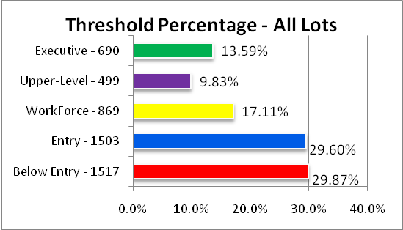

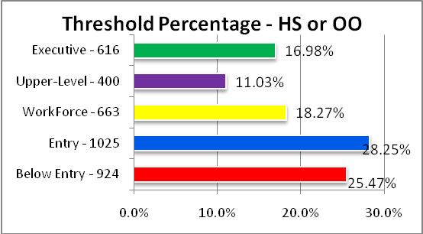

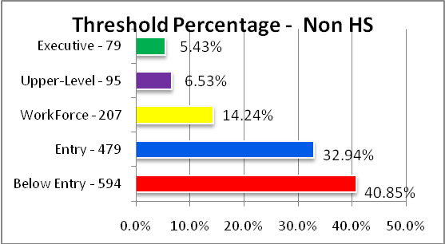
Housing Category | Lower Limit Value | Upper Limit Value
Executive | 197,700 | Unlimited
Upper level | 164,700 | 197,700
Workforce | 131,800 | 164,700
Entry | 82,400 | 131,800
Below Entry | n/a | 82,400
 | Lot Types
 | HS: Homestead
 | OO: Owner-Occupied
Appendix IV: East San Marcos Single Family Threshold Maps
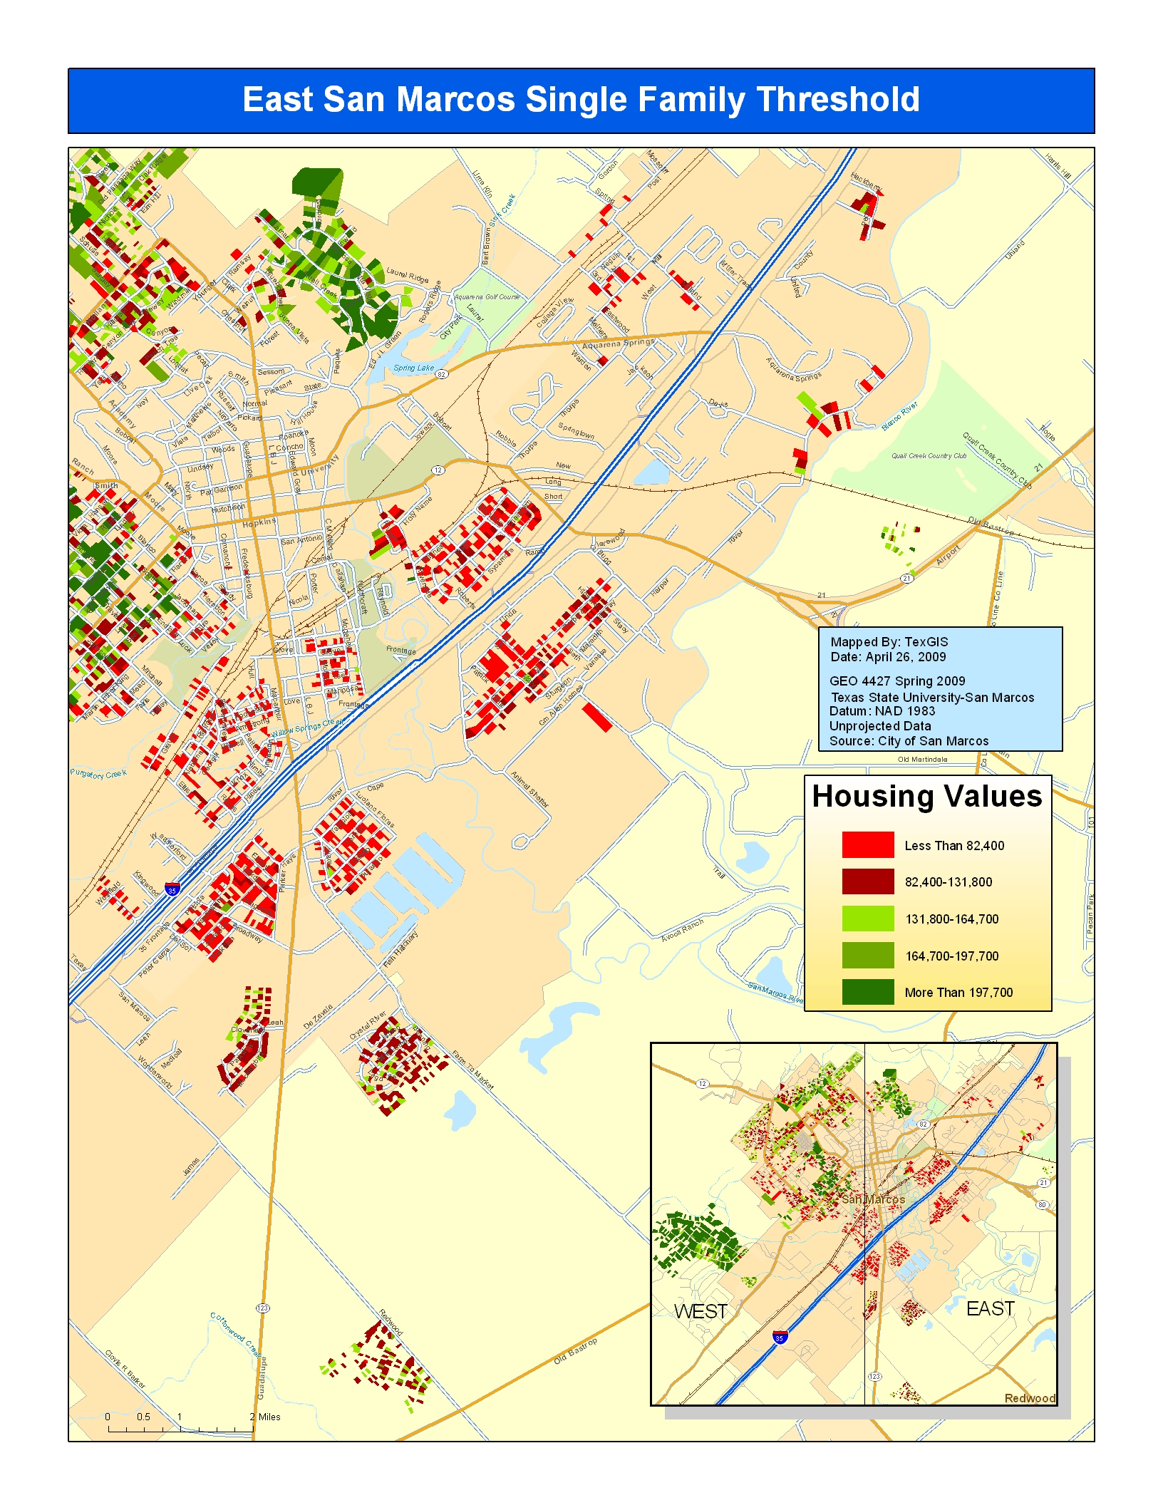
Appendix V: West San Marcos Single Family Threshold Maps
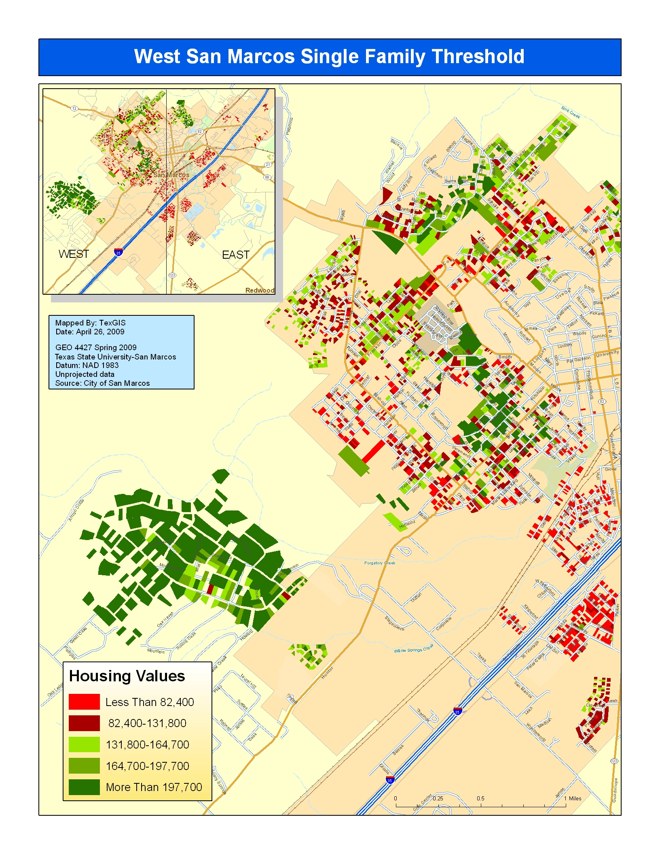
Appendix VI: San Marcos Average Neighborhood Housing Values Map



