CONSULTANTS:

Jennifer Zingery | Abel Avilez | Katie Kunz | Aya Udagawa

WATERSHED MAPPING PROJECT
Public Interest G.I.S. Mapping Project for the Guadalupe Blanco River Authority – 2009
Presented By:
GEO-TEX SPATIAL SOLUTIONS

Authors: | Project Manager:  Assistant Manager:  GIS Analyst:  GIS Analyst: | Jennifer Zingery  Abel Avilez  Katie Kunz  Aya Udagawa

TABLE OF CONTENTS

INTRODUCTION 4
Summary 4
Purpose 5
Scope 5
LITERATURE REVIEW 6
DATA 8
Data Collection and Quality 8
METHODOLOGY 10
RESULTS 13
DISCUSSION 16
Data Collection 16
GIS Data Assembly 17
Web GIS Assembly 21
Web Site Assembly 21
CONCLUSION 22
APPENDICES – I, II, III, IV
I. Metadata
II. Contribution of Each Team Member
III. Time Line and Budget
IV. Maps

INTRODUCTION

Summary

More and more, companies across the nation are turning to Geographic Information Systems (GIS) to distribute information, answer problems, and communicate more effectively - both within their organizations, as well as to the public who seek to utilize that data. One way to share this information is to publish interactive maps, which allow users to access, manipulate and gain specific information via the internet. Often, organizations such as the Guadalupe Blanco River Authority (GBRA) have a wealth of information available, but no means of visually communicating that information to the public. Geo-Tex Spatial Solutions has been contacted by the GBRA to create interactive maps for the organization’s web site. This new resource will further accomplish the GBRA’s mission statement - “to protect, conserve, reclaim, and steward the resources” of the water conservation district it oversees. Having interactive maps available to the public on the GBRA web site will not only provide users with a visual representation of the existing resources within the boundaries of the district, but it will allow users to see how those resources interact with each other, which encourages more responsible use.

Problem Statement: Currently, the only data that GBRA has available on its web site is accessed via the “Public Information” tab. This section includes a resource library for the general public and other interested parties, and allows users access to data, including Annual Reports, Publications, Fact Sheets, and Maps. However, the “Maps” section contains “Main Basin Map” which is a single static map that shows the contiguous boundaries of the ten-county statutory district that the GBRA oversees, with no additional data about the district provided. Because this static map is the only watershed map on the web site, the GBRA has expressed an interest in having new maps created, and has further requested that these maps have a web-GIS component that will allow users the ability to interface with the maps in order to gain additional information from them.

Purpose
The purpose of this project is to create web-accessible public interest maps to be included on the GBRA’s web site. The benefits of this project are three-fold. First, we are providing GBRA with additional public interest maps to be included on its web site. Second, the addition of a GIS component allows the maps to have an interactive content, which lets the maps be viewed over the internet via user-driven GIS software (in this case Manifold Software). Third, developing the maps with a GIS component allows the datasets that were used in the project to be made available on the GBRA’s web site for download.

In order to produce the final product, it was necessary to undertake a three-stage process, which included: 1) data collection, 2) assembly of collected data using GIS software, and 3) conversion of those maps into a web-GIS program – in this case Manifold Software – which will allow the maps to have a user-driven interface via the internet.

Scope
The scope of this project is comprised of 10 of the 11 watersheds the GBRA oversees. These 10 contiguous watersheds originate at the headwaters of the Guadalupe River in Kerr County above Comfort, Texas, and extend southeastward across the state, culminating in the terminus of the Guadalupe River near Port Lavaca, Texas. These 10 watersheds also encompass all rivers which feed into the Guadalupe River, including the Blanco, San Marcos, and Comal Rivers. The watersheds which define the scope of this project are as follows:

- Upper Guadalupe above Comfort Watershed
- Upper Guadalupe below Comfort Watershed
- Blanco Watershed
- San Marcos Watershed
- Plum Creek Watershed
- Middle Guadalupe Watershed (Parts A&B)
- Peach Creek Watershed
- Sandies Creek Watershed
- Coleto Creek Watershed
- Lower Guadalupe Watershed

It should be noted that the GBRA also manages the Lavaca-Guadalupe Coastal Basin, located along the Texas Gulf Coast in Calhoun County, Texas. However, as this basin is not a watershed for the Guadalupe River, but rather a coastal basin, it is considered to be outside of the scope of this project.

LITERATURE REVIEW
While maps have long been a way of communicating spatial data, in two dimensional form, advances in technology - in particular the internet - have forever changed the way that we transmit, access, and share this information. The resources that we reviewed in preparation for this project have further supported our understanding of the usefulness of the internet in GIS, and more specifically, how web-based programs are at the forefront of GIS technology. This literature review is not exhaustive.

GIS has an enormous potential for “increasing public participation in local environmental decision-making” (Kingston, 2000). More and more, the public is turning to the internet to solve a variety of problems. With the advent of faster servers, increased functionality, and improvements in software design, the use of the internet to distribute spatial information and maps has moved out of the private sector and into the public sector, and the public is using those maps to help in day-to-day decision-making processes. As the field of GIS has grown, “[t]he emerging field of distributed geographic information ... is gaining popularity among researchers and GIS vendors who are developing software evolving from simple raw data download... to pre-drawn maps on a Web page (web mapping) (Tuyen, 2008), such as we are developing for this project.

Because it is necessary to transmit such large packets of data in the most efficient way possible, client-side GIS is often plagued by low performance. However, this can be overcome by providing the user with only the ‘necessary data’ using a web- GIS program after original development and processing by another GIS program (Wei, 1999). Leading GIS manufacturers such as ESRI, Intergraph, and Map Info are “accelerating the development” and implementation of these web-based GIS programs, such as Arc View, Web Map, and Map Guide, in a format that is easily accessed by the public and that do not require any programming skill whatsoever, only a web page with a hyperlink to access (Jianya, 2001). The ease of access of web based mapping makes it ideal for public entities who want to better communicate spatial data via the internet. These interactive web maps can range from very simple to very complex, depending upon their architecture, and upon the user for whom they are intended (Alesheikh 2002).

DATA
As stated earlier, in order to produce the final product, it was necessary to undertake a three-stage process, which included: 1) data collection, 2) assembly of collected data using GIS software (Arc-GIS), and 3) conversion of those maps into a web-GIS program which allows the maps to have a user-driven interface via the internet.

Data Collection and Quality
The data for the project included 1) data received directly from GBRA, 2) data retrieved from outside sources, and 3) data which was created by our team. The following table shows the origin of each of the three types of data used in the project:

GBRA WATERSHED MAPPING PROJECT - DATA TYPE / SOURCE

GBRA Data: | GIS Watershed Data from GBRA’s 2007 Basin Highlights Report (CD)
Third-Party Data: | GIS Data from USGS, TX Parks & Wildlife, Edwards Aquifer Authority, National Atlas, Federal Emergency Management Agency (FEMA)
Data Created  by Geo-Tex: | Raw data (ex: latitude & longitude coordinates) which had to be assigned spatial qualities/attributes in order to be usable in a GIS.
Data Quality: All of the data was subjected to an extensive review process before it was determined suitable for use. This includes instances when we located “similar” data (ex: boat ramp data) from multiple sources. During this review process, all data was closely examined by our team in order to determine the best documented and most accurate data for the project. All the third-party data sources used in the project are considered reliable and fit for use for this project.

Data Creation: It was necessary to create data sets – in this case the “Paddling Trails” data - from raw data acquired from Texas Parks and Wildlife. The original data on TWPD’s web site was displayed in the form of GPS coordinates, with no spatial component that would allow it to be easily imported into the Arc-GIS software. In order to turn this raw data into a form that could be utilized by the software, it was necessary to convert the GPS coordinates into decimal degrees, then input the newly created latitude/longitude values into an excel spreadsheet for import into the Arc-GIS software.

Metadata: The metadata created for this project follows the Federal Geographic Data Committee (FDGC) standards, as well as the standards provided for geographic information by the International Organization for Standardization (ISO). These standards were chosen to provide a common language within organizations and different levels of government. We have included a copy of the metadata for this project in the Appendix of this report.

Coordinate System / Projection: The coordinate system used for this project was the North American Datum 1983. The original projection used was a custom format that was created specifically for the GBRA for use in the 2007 Basin Highlights Report. This custom projection attempts to minimize the distortion of the study area, which crosses two state-plane projections.

METHODOLOGY
On February 2, 2009, our team met with Ms. Cinde Thomas-Jimenez, Education Coordinator for the GBRA, to discuss the proposed project. At that time, it was communicated that the GBRA was interested in creating an interactive watershed map containing the following layers:

- Wildlife Management Areas
- State Parks
- Paddling Trails
- Dams / Portages for canoes & kayaks
- Public Boat Rams
- Public Campgrounds
- Floodplains
- USGS flow gauging stations
- Land Uses
- Underlying aquifers / Edwards Recharge Zone
- Springs

Following this meeting, we immediately began work on the proposal, which we delivered on March 1, 2009. The proposal included a summary of the work to be done, identified the scope and purpose of the project, and provided a list of the tasks necessary to complete the project. In the proposal, we discussed each task in order to better communicate the nature, methodology, and purpose of that particular step.

Project Time Line: We prepared a timeline for each phase of the project, and included a proposed budget, references for the resources discovered and utilized at that time, and qualifications of our team. A copy of the revised time line is included in the Appendix of this report.

Project Budget: In our original proposal, we estimated the expenses incurred during the course of this project would total approximately $16,296. However, following the presentation of our proposal on March 1, 2009, it was agreed that this original estimate for the project was not realistic for the amount of work to be done. As requested, we created a revised budget for the project and presented it with our progress report on April 8, 2009, which increased the total budget for the project to $25,460. A copy of the revised budget for this project is included in the Appendix of this report.

The overall purpose of this project is to create web-accessible public interest maps to be included on the GBRA’s web site. As stated above, in order to produce the final product, it was necessary to undertake a three-stage process, which included: 1) data collection, 2) assembly of collected data using GIS software (Arc-GIS), and 3) conversion of those maps into a web-GIS program – in this case Manifold Software – which will allow the maps to have a user-driven interface via the internet.
Phase 1: Data Collection: On February 2, 2009, Geo-Texas Spatial Solutions began the work of collecting the data for the GIS portion of the project. This process was considered to be three-fold:

- First, we obtained a disk from GBRA, which included GIS data regarding the same watersheds that are the scope of this report. This data was originally prepared for the GBRA’s 2007 Basin Highlights Report, and was already in a format which could be directly imported into Arc-GIS, the GIS software utilized by our group for the data analysis purposes of this project.

- Second, it was necessary to locate additional data from outside sources. These sources included: the United States Geological Survey (USGS), Texas Parks and Wildlife (TPWD), the Edwards Aquifer Authority, the National Atlas, and the Federal Emergency Management Agency (FEMA).

- Third, while we made every effort to locate data from reliable sources which was already prepared and easily imported into GIS software, it was sometimes necessary to locate raw data which had to be developed manually before it could be imported for use by the Arc-GIS software.

Phase2: Data Assembly (Arc-GIS Assembly): Once the Phase 1 data was acquired, we assembled the data using GIS software (Arc-GIS version 9.3). This Data Assembly process took a total of 3.6 weeks, and was initially considered to be concluded on February 25, 2009, well ahead of our original schedule. However, as was noted in our original proposal, it was expected that it might be necessary to reassess the data as the project progressed. After collecting, developing, and importing the data into Arc-GIS, we discovered that the data we had for the dams, boat ramps, and paddling trails was limited, and we did not consider them to meet the standards of this project. At that time, we began to research additional sources until we discovered additional data which we felt met the standards necessary for this project. Therefore, as noted in the original proposal, even after the scheduled completion date, we continued to collect, develop, and assemble data as determined by the needs of the project. The actual final completion date for the Data Assembly process was April 6, 2009.

Phase 3: Web GIS Assembly (Manifold Software Assembly): Web GIS Assembly began on March 30, 2009. The purpose of this task was to assemble the Arc-GIS components from Phase 2 into the web-GIS maps requested by GBRA. There were three components of the web portion of this project and included development of:

1) Static maps (jpegs),
2) Data sets for download (shape files), and
3) A user-interactive map (using Manifold software).

This process kept to the original schedule of 8.4 weeks, and concluded on April 29, 2009.

RESULTS
As noted in the problem statement, the only map located on the GBRA’s web site which shows the watersheds overseen by the GBRA is a “Main Basin Map,” which is pictured below.
Figure 1: Main Basin Map from GBRA Web Site
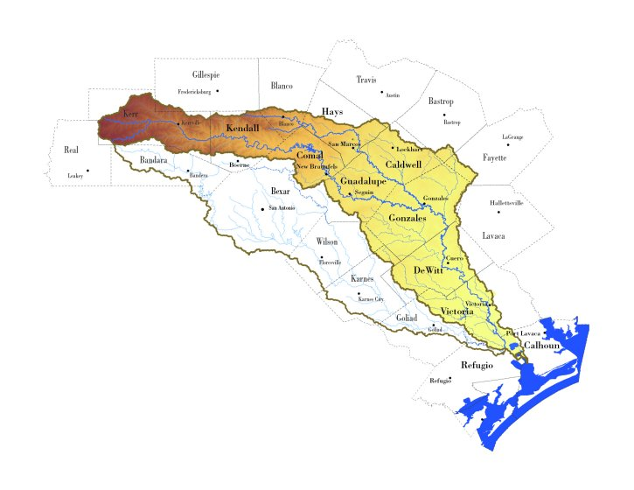

The map above was taken directly from the GBRA’s web site. It shows only the contiguous boundaries of the ten-county statutory district that the GBRA oversees. As this map is only a static map, which means that the information displayed is the only information available, and no additional data about the district is provided. Because the GBRA wishes to provide greater context to visitors about the watersheds under their jurisdiction, they have expressed an interest in developing new maps with an interactive component for their web site.

After conducting data collection and analysis using GIS software (Arc-GIS), and subsequent Web-GIS assembly using Manifold Software, we produced the final interactive maps which were the goal of this project. This new resource will allow the GBRA to further its goal of educating the public by providing an interactive map that will allow users to manipulate and gain specific information via the internet.

The following image is representative of the type of interactive maps created in a Web-GIS program such as Manifold Software. Creation of map layers such as this allow users to see how multiple resources interact with one another, which encourages more responsible use. Interactive maps educate the public about the different types of resources in an area – for example, the relationship of springs to aquifer location shown in the map below. 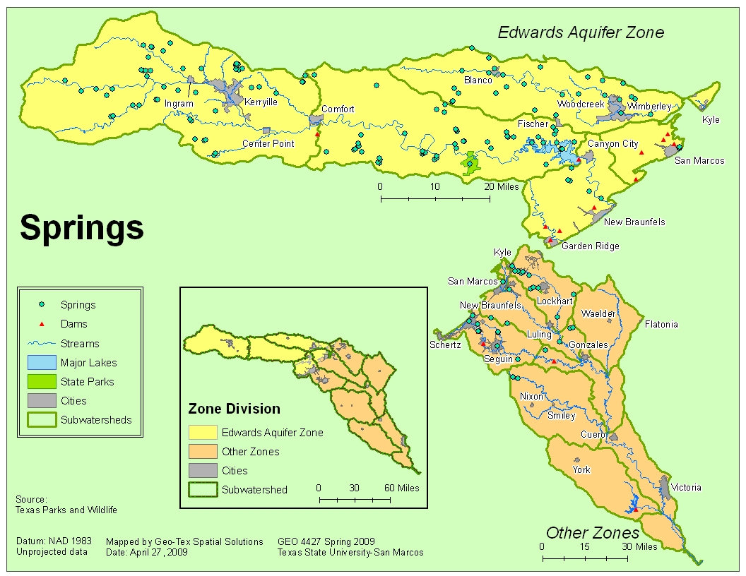
Figure 2: Interactive Map using Manifold Software
The map above and all the other maps created during this projet are included in the Appendix of this document.

DISCUSSION
In order to produce the interactive maps which are the purpose of this project, it was necessary to undertake the following steps: 1) Data Collection, 2) GIS Data Assembly (Arc-GIS), 3) Web GIS Assembly (Manifold), 4) Web Site Creation, and 5) Preparing Final Deliverables. The following discusses each, in turn.

Data Collection
As indicated in our proposal, the project data includes 1) data received directly from the GBRA, 2) data retrieved from outside sources, and 3) original data, which was created by our team.

GBRA Data: The data received directly from the GBRA was in the form of a CD containing GIS watershed data from the GBRA’s 2007 Basin Highlights Report. Because the data was prepared for the specific purpose of the 2007 Basin Highlights report, only some of the spatial data was considered suitable for our purposes. While we did not utilize much of the actual data from this CD in our project, we did consider the spatial framework (projection and coordinate system) used for the Basin Highlights Project to be ideal for our purposes.

Outside Data: After establishing the basic framework for the project using data provided by the GBRA, we began looking for data from reliable outside sources that would meet the needs of the project. These sources included the United States Geological Survey (USGS), Texas Parks and Wildlife, The Edwards Aquifer Authority, The National Atlas, and The Federal Emergency Management Agency (FEMA). While some of this data was available for immediate download online, in some instances, it became necessary to personally contact an organization by phone in order to access and/or gain permission to use their data.

Created Data: While we made every effort to locate data from reliable sources that was already prepared and easily imported into GIS software, it was sometimes necessary to locate raw data which had to be developed manually before it could be imported for use by the Arc-GIS software. Data which was developed in this way was carefully scrutinized and double-checked before being considered fit for use in this project.

GIS Data Assembly
All of the data retrieved during the Data Collection portion of the project was then subjected to an extensive review process before it was determined to be suitable for use in the project. This includes instances when we located “similar” data from multiple sources (for example, boat ramp data from both the GBRA and Texas Parks and Wildlife). During this review process, all data was closely examined by our team in order to determine the best documented and most accurate data for the project. Upon examination of the data, we discovered two issues, which are discussed below. The Data Assembly portion of the project had two parts: 1) importing the data into GIS software (Arc-GIS ver. 9.3), and 2) creating the metadata for the project.

Importing the Data into GIS Software: Once we selected the most accurate and appropriate data for each category, we began the creation of the map features using the GIS software (Arc-GIS). Crating the maps in this way is what prepared the data for import into the Web GIS software (Manifold). Once all the data was pulled into Arc-GIS, we focused on making the map look and function simply for final use when exported to the Web GIS software. As we worked with the data, we began encountering issues, primarily with the amount of time it took certain layers to load. This was particularly the case with the roads layer because the original data included all roads in the area – displaying the sheer number of roads on the map not only caused problems with loading times, but was also visually overwhelming. At first, we solved this problem by limiting the amount of roads shown to only major roadways and highways. Upon further review, however, we made the decision to attempt to locate new roads data to see if we could find one that was even more suitable. We were able to locate a layer through the Texas Department of Transportation that had a significantly shorter loading time than our original data. Also during this stage, we considered how the final map(s) were going to look. There was also a concern that the many colors and symbols represented on the map might cause issues with readability, and we took steps to avoid any potential color or symbol confusion to ensure that the audience could easily understand the map(s).

Creating the Metadata: Metadata is the internal documentation that provides support for that data and is governed by geospatial standards – in simpler terms; metadata is data about the data. All of the data that was acquired from outside sources were accompanied by their own metadata. However, it was necessary for us to create metadata for all data that was developed by our team. The only layer created by Geo-Tex was “Paddling Trails,” which consisted of two individual layers – Paddling Trails and Paddling Route. It was necessary when creating the metadata for this layer to understand who would be using the data. For this reason, Geo-Tex made the decision to include both a federal and international standard, which allows users worldwide to understand the metadata. The metadata follows the Federal Geographic Data Committee (FDGC) standards, as well as the standards provided for geographic information by the International Organization for Standardization (ISO). These standards provide a common language that will make it easier to communicate with other organizations and different levels of government.

Issues Encountered During Data Assembly:
As we began importing and assembling data into the GIS software, it became apparent that there were issues that would have to be considered. One major issue had to do with the projection selected for the project. The original projection (from the GBRA CD) was a custom format that was created specifically for the GBRA for use in the 2007 Basin Highlights Report. There was a question as to the need for this custom projection. Upon examination, the reason became evident - the study area crosses two state-plane projections, and a custom projection was necessary to accurately display the area across these two adjacent planes.

The second issue encountered was discovered when - upon the importation of the Flood Plain layer- the floodplain and Guadalupe River did not seem to match. At first, we thought the issue stemmed from either 1) problems with the custom projection or 2) was simply a bad map from an unreliable source. Every attempt was made to locate flood plain data from reliable sources, including directly from the Federal Emergency Management Agency (FEMA). After examining multiple sources for the floodplain data and comparing it to multiple Guadalupe River maps, we have serious reservations as to the appropriateness for the use of the floodplain data in the project. The disparity between the floodplain map and the Guadalupe River data from the CD provided to us by the GBRA (which was too inaccurate to be considered fit for use) and the data from the Texas Commission on Environmental Quality (TCEQ) (which was the data considered to be optimal for the purposes of this project) becomes readily apparent. Upon consideration, we do not recommend including floodplain data in the project, as it could potentially create problems and/or confusion for users / visitors to the GBRA’s web site. A figure showing this disparity is shown below.

Web GIS Assembly
Upon completion of the Data Assembly portion of the project, we began pulling the maps over to see how it performed in the Web GIS Software (Manifold). Over the course of the Web GIS assembly, we continually worked to locate and identify bugs, optimize user performance, and increase page download times. This included testing from various remote computers in order to achieve real-time reactions to the software and maps.

When setting up the software, we determined that it was in the best interest of the user to make the interactive components as simple as possible. As Manifold allows the creator to limit functions available to users, we chose to allow the user to make only the most basic changes such as adding or removing the layers and zooming in or out. Further, we disabled administrative functions that would permit the layers to be changed or edited, or to add outside layers or data.

Web Site Assembly
The web site created for this project was created using Microsoft Publisher 2007. The web site includes hyperlinks to all documents and PowerPoints created during this project, as well as all static maps and the interactive map.

Issues with Web Site Creation: A few issues were encountered while preparing the web site. The main problem occurred upon attempting to redirect the links for the serves where the Web GIS maps are located, as the location of the servers will change once the project is completed, which required the conversion from absolute paths (where the servers are now) to relative paths (after the web site is moved off the servers where it is currently located). We made every effort to construct the web site with the simplest navigation techniques possible to account for the varied Internet skill level of potential users.

Preparation of Final Deliverables
As requested, Geo-Tex prepared a detailed Final Report that communicates all of the research, data, and development undertaken during the course of the project. The data for this project is included on a separate CD, along with all other deliverables, including all Arc-GIS data, a web-site with links to the interactive public-interest map (developed with Manifold Software), all metadata, a copy of the project poster, and a copy of all written reports (original proposal, progress report, and final report) with their related PowerPoint presentations.

CONCLUSION
We, Geo-Tex Spatial Solutions, believe that this project will achieve the needs of GBRA. The interactive Web-GIS maps will provide the user with valuable information about the recreational resources within the watersheds. This new resource will further enable GBRA to “protect, conserve, reclaim, and steward the resources” that they oversee and will encourage more responsible use of those resources.

On a personal note: During the course of this project, we have gained valuable skills by working with both private corporations and government entities, learned time management skills, and –most significantly - how to work as a group. Overall, this has been a very valuable experience that we will be able to take with us as we move into the corporate sector and enter the work-force. As a result of this project, we have acquired knowledge by learning from our mistakes and missteps, particularly when it comes to understanding that not everything will work out as planned. This has been a very valuable experience for all of us, and we that Dr. Giordano, Ms. Thomas-Jimenez, and the GBRA for allowing us to be a part of it.

Sincerely,

THE GEO-TEX TEAM:
Jennifer Zingery – Project Manager
Abel Avilez – Assistant Manager
Katie Kunz – GIS Analyst
Aya Udagawa – GIS Analyst

REFERENCES

Alesheikh, AA, H. Helali, and HA Behroz. “Web GIS: Technologies and Its Applications.” Symposium, on Geospatial Theory, Processing, and Applications (2002)...ISPRS.org

Jianya, G. “Design and Implementation of an Internet GIS.” Geo-Spatial Information Science 4.2 (June 2001) : 1-7

Kingston, R, S Carver, A Evans, and I Thurton. “Web-based public participation geographical systems: an aid to local environmental decision-making.” Computers, Environment and Urban Systems 24 (2000) : 109-125

Tuyen, Dang Van, Do Duc Hanh and Tran Hung. “Developing Flash-Based Tool for GIS Applications on the Web.” Geo-Viet Consulting Company, Ltd. <geoviet.vn>

Wei, Zu-Kuan, Young-Hwan Oh, Jae-Dong Lee, Jae-Hong Kim, Dong-Sun Park, Young-Geol Lee, and Hae-Young Bae. “Efficient Spatial Data Transmission in Web-Based GIS.” Proceedings of the 2nd International Workshop on Web Information and Data Management (1999) : 38-42

APPENDIX I
Metadata

APPENDIX II
Contribution of Each Team Member
PARTICIPATION

Each member of the Geo-Tex Spatial Solutions team played an important role in the construction of the project as a whole. In order to streamline development of the project parts, a “partnership process” was developed which gave specific responsibilities to each team member. This team member is considered to be the ‘author’ of that project part, with each part then reviewed by all members before being included in the project.

Project Manager Jennifer Zingery was responsible overseeing the project, revising the timeline and budget, and writing the Proposal, Progress, and the Final Report, and helping with both the Proposal PowerPoint Report and Progress PowerPoint Report.

Assistant Manager Abel Avilez was responsible for helping coordinate the team, creating data, overseeing the development of the metadata for the project, helping with the Final Poster, and helping create the Progress PowerPoint Reports.

Katie Kunz was responsible for overseeing the creation of the Web Site and provides assistance creating the metadata for the project.

Aya Udagawa was responsible for creating the Arc-GIS maps, which she imported into the web-GIS program Manifold, creating the Final PowerPoint Report, making the original budget, and the Final Poster.

Everyone played important role in looking, locating, and calling organizations to obtain data.

APPENDIX III
Time Line and Budget

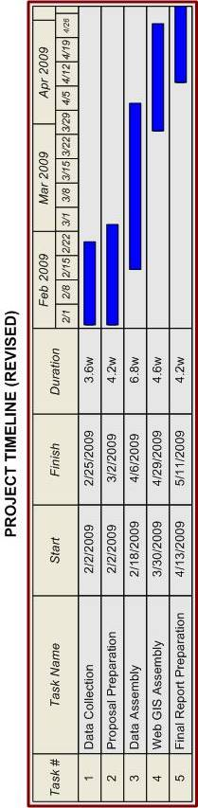

WATERSHED MAPPING PROJECT BUDGET (REVISED)

DATA COLLECTION

Consultants | Total Hours | (10 Hrs/Week x 5 Weeks x 2 Consultants) |  | 100 Hrs @
 | Rate of Pay |  |  | $15.00/Hr
 | Total Consultant Pay |  |  | $1,500
Assistant | Total Hours | (14 Hrs / Week x 5 Weeks x 1 Asst. Mgr.) |  | 70 Hrs @
Manager | Rate of Pay |  |  | $40.00/Hr
 | Total Asst Mgr. Pay |  |  | $2,800
Project | Total Hours | (14 Hrs/Week x 5 Weeks x 1 Proj. Mgr.) |  | 70 Hrs@
Manager | Rate of Pay |  |  | $50.00/Hr
 |  |  |  | $3,500
 |  | DATA COLLECTION TOTAL: |  |  | $7,800
DATA ASSEMBLY & WEB-GIS(MANIFOLD) ASSEMBLY

Consultants | Total Hours | (14 Hrs/Week x 7 Weeks x 2 Consultants) |  | 196 Hrs@
 | Rate of Pay |  |  | $40.00/Hr
 | Total Consultant Pay |  |  | $7,840
Assistant | Total Hours | (14 Hrs / Week x 7 Weeks x 1 Asst. Mgr.) |  | 98 Hrs@
Manager | Rate of Pay |  |  | $40.00/Hr
 | Total Asst Mgr. Pay |  |  | $3,920
Project | Total Hours | (14 Hrs/Week x 7 Weeks x 1 Project Mgr.) |  | 98 Hrs@
Manager | Rate of Pay |  |  | $50.00/Hr
 |  |  |  | $4,900
 |  | DATA / WEB GIS ASSEMBLY TOTAL: |  |  | $16,660
EQUIPMENT COSTS |  | N/A (Provided by Texas State) |  | N/A | $0
DATA |  | Purchased Data |  | $0.00 | $0
EXPENSES |  | None |  | $0.00 | $0
 |  | PROJECT TOTAL: |  | $25,460

APPENDIX IV
Maps
