Analysis of Stormwater Runoff and Proposed Sites for Detention Ponds on the Texas State University Campus- San Marcos
Final Report

Storm Water Solutions:

Brad Bixby- Manager
Nick Fowler- Assistant Manager
Adrian Camano- GIS Analyst
Dean Watson- GIS Analyst
J.D. Grosch- GIS Analyst

Abstract

Storm water runoff contains many harmful pollutants from impervious surfaces and eroded soils. The current storm water drainage system on the campus of Texas State University, allows a majority of storm water runoff to flow freely into the San Marcos River without treatment. In order to promote responsible development and improved water quality, Storm Water Solutions conducted research and analysis on the use of detention ponds as a preventative measure. This report outlines the purpose, methods, and results of our study. Our project included a detailed coverage and watershed analysis along with a soil loss estimate that helped us determine seven potential areas where detention ponds could be built. Our findings are meant for the planners and developers of the expanding Texas State campus.

Table of Contents

1. INTRODUCTION………………………………………………………………………… 3
1.1 Background……………………………………………………………………......3
1.2 Problem……………………………………………………………………………3
1.3 Scope……………………………………………………………………………....4
2. LITERATURE REVIEW…………………………………………………………………..3
2.1 Urban Storm Water Runoff……………………………………………………….4
2.2 Wet Detention Ponds……………………………………………………………...4
2.3 Soil Erosion………………………………………………………………………..6
3. DATA……………………………………………………………………………………….8
3.1 Coverage and Watershed Analysis………………………………………………...8
3.2 Soil Loss Analysis...................................................................................................10
4. METHODOLOGY...............................................................................................................12
4.1 Coverage Analysis...................................................................................................12
4.1.1 Impervious Surfaces.................................................................................13
4.1.2 Greenzones...............................................................................................14
4.2 Watershed Analysis.................................................................................................15
4.3 Soil Loss..................................................................................................................16
5. RESULTS..............................................................................................................................20
5.1 Coverage Analysis....................................................................................................20
5.2 Watershed Analysis..................................................................................................22
5.3 Soil Loss...................................................................................................................23
5.4 Proposed Pond Locations.........................................................................................25
6. DISCUSSION........................................................................................................................29
6.1 Coverage Analysis...................................................................................................29
6.2 Soil Loss..................................................................................................................29
6.3 Project in General....................................................................................................31
7. CONCLUSION....................................................................................................................33
8. REFERENCES.....................................................................................................................35
9. APPENDIX 1.......................................................................................................................37
10. APPENDIX 2.....................................................................................................................46
11. APPENDIX 3.....................................................................................................................48
12. APPENDIX 4.....................................................................................................................59
1. Introduction
1.1 Background
The San Marcos River is one of the most pristine and ecologically sensitive rivers in Texas. The river is not only aesthetically pleasing but it is also used for recreation such as swimming, snorkeling, diving, canoeing, kayaking and fishing. Texas State University (TSU) is located on and just uphill of the San Marcos River, therefore, when it rains much of the storm water runoff from campus ends up directly in the river with little or no treatment. The sensitive nature of the river and the proximity of the campus create a potentially detrimental situation.
One highly effective method to treat storm water runoff before it enters any waterbody is the use of a wet detention pond. Implementing theses ponds into the storm drain network on campus would not only show responsible land stewardship, but if engineered and maintained properly, could be the bench mark for the surrounding areas, and for future construction in sensitive watershed areas. The use of a GIS to locate the potential sites for storm water detention ponds on the campus of Texas State University, San Marcos, can model the best and most effective location of these ponds. By constructing these ponds we can potentially reduce and/or eliminate pollution from storm water runoff produced on the TSU campus. This will protect the native habitat of the San Marcos River and improve the water quality of the San Marcos community.
1.2 Problem
The Environmental Protection Agency (EPA) ranks urban runoff and storm sewer discharges together as the second most prevalent source of water quality impairment in the nation’s estuaries (NRDC, 2000). Storm water runoff, especially from impervious surfaces, when left untreated contains many pollutants and can reduce the water quality of any given water shed. Detention ponds are one of the most effective Best Management Practices (BMP) for controlling and cleaning storm water before it reaches our rivers (EPA, 1999).
Texas State’s current storm water drainage system is out of date and has not kept up with the expansion of campus that has occurred over the past several years or the construction that will occur over the next 10 years. There are some storm water controlling devices, but they do not capture a majority of storm water from impervious surfaces. Furthermore, the storm drain network is not connected entirely and there is no current treatment system for runoff. With all the factors weighed in, the current system will not be adequate. The goal of our research is to identify areas where storm water runoff, especially from impervious surfaces, can be collected and filtered in a detention pond before entering the San Marcos River. We will also look at future construction to ensure that these locations can accommodate future runoff from new buildings and parking structures.
Our project included a coverage analysis of campus to determine high risk areas that may contain pollutants. This was accomplished by merging and measuring a series of data. We also performed a watershed analysis to determine where and how the water would flow during a storm event using the ArcHydro extension in ArcMap. And finally we used the RUSLE equation to estimate soil erosion on campus in order to identify areas that release damaging sediments into runoff.

1.3 Scope
Storm Water Solutions will only look at the drainage areas on Texas State University’s main campus and will keep our analysis within property lines. We will focus solely on campus runoff patterns and analysis of the campus drainage system. The City of San Marcos’ drainage system that overlaps the campus will not be factor in for it is too broad and will require more time than this project can offer.
Our team will only locate the potential sites for detention ponds using GIS tools and will not be involved in the actual construction of the ponds. Although we do know how these ponds operate and perform, we will not consult others in the engineering and maintenance of these ponds.
2. Literature Review
Government agency websites were researched and many published journal articles were reviewed in order to develop a true knowledge of urban storm water runoff, detention ponds, and soil erosion equations. There has been an ample amount of studies done pertaining to urban storm water pollution and there is plenty of information on the effects that runoff has on native watersheds. Detention ponds, since the passage of the Clean Water Act of 1971, have been designed and used over the past 30 years as means for treating storm water runoff. Only a few completed projects were found that used a GIS to locate ponds, but there purpose differed from ours in both scope and methodology.
The problem of pollutants and sediment collecting in our streams and rivers through unrestricted storm water runoff should be of great concern to all of us. Over the past 20 years changes in land cover, grade changes from new construction, and especially an increase in impervious surfaces, such as streets and parking lots, has greatly increased the amounts pollutants reaching our surface water.
2.1 Urban Storm Water Runoff
Urban storm water runoff is precipitation or snowmelt that travels over a surface, does not enter the ground, and eventually ends up in waterbodies. Precipitation from rain events in urban areas falls onto a variety of surfaces including rooftops, sidewalks, parking lots, and streets where it picks up a variety of pollutants (Cornell, n.d.). Pollutant loadings from paved surfaces constitute a disproportionate fraction of the total urban loading for many pollutants, in particular metals and hydrocarbons (Minton, 2000).

As we continue to urbanize and change our landscape, we increase the amount of impervious surfaces. In an urban setting, storm water rushes over streets and parking lots during each rain event and carries with it, among other pollutants, chemicals, oils, heavy metals, and sediments which directly flow into our streams and rivers. According to the National Resources Defense Council, recent studies show that urban storm water equals and in some cases exceeds sewage plants and large factories as a source of damaging pollutants (2000). “Two hundred years of unregulated, unmanaged urban stormwater have contributed to many severe public health problems and expensive natural resource losses in the United States” (NRDC, 2000).

2.2 Wet Detention Ponds
A wet detention pond is a water management method that is designed to capture, hold, and filter storm water runoff (precipitation from storm events that does not enter the ground) It is commonly referred to as a Best Management Practice (BMP). As opposed to other storm water control devices such as dry ponds, ditches, dikes, sand traps, and infiltration ponds, a wet detention pond maintains a permanent pool of water (EPA, 1999).
Urbanization has necessitated innovative and effective methods for controlling and collecting pollutants before they reach our rivers. Referencing the EPA’s Best Management Practices (BMP), outlined in the Storm Water Best Management Practice Design Guide Volume 3 (2004), one of the very best overall methods for collecting and reducing the pollutants and sediment is a storm water detention system.

A wet detention pond is made up of several components, each of which serves a unique purpose in the overall efficiency and effectiveness of the pond. A basic layout of a wet detention pond is illustrated below.
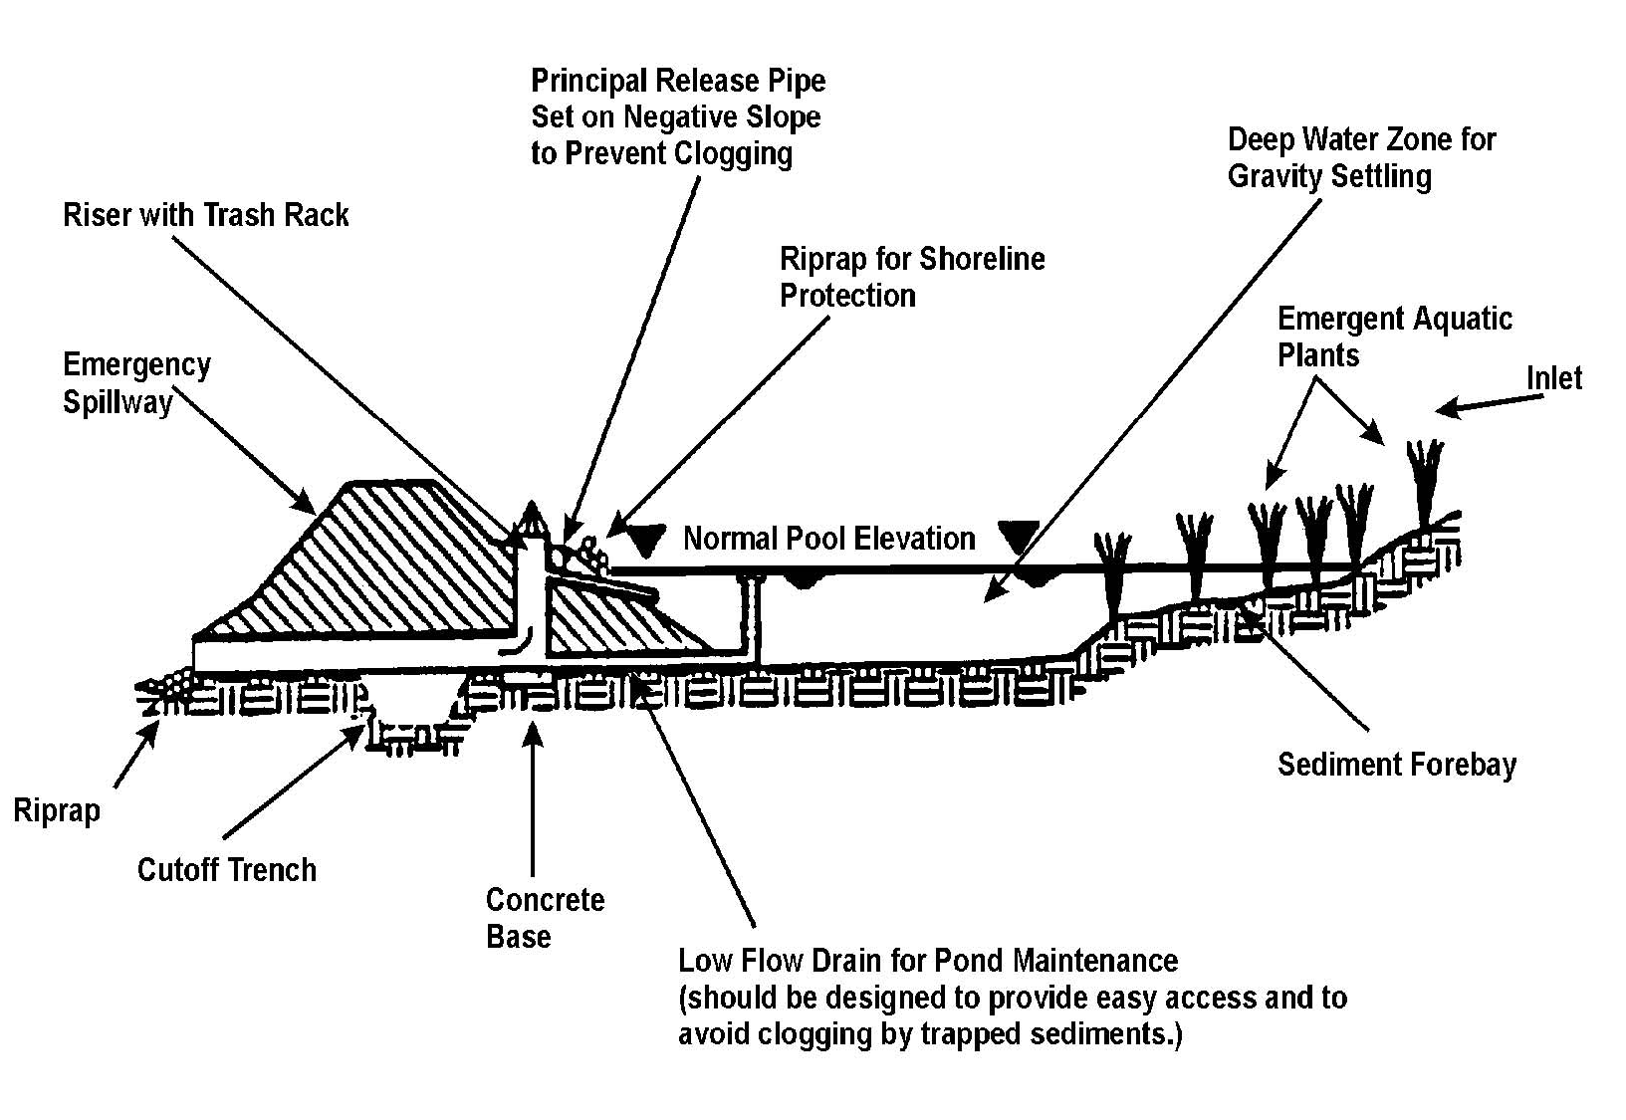
Figure 1. Basic design features of a wet detention pond. Source: (EPA, 1999)

A wet detention pond works by channeling storm water to the inlet of the pond where it then temporarily holds the water until being displaced by the next storm event. While being detained, sediments and other pollutants settle out of the water and plants absorb various nutrients. Clean water from the surface is then released through the outlet when the pond becomes full (EPA, 1995).
A wet detention pond serves two purposes: It decreases the speed and flow rate of storm water and significantly reduces the amount of pollutants that reach streams and rivers (EPA, 1995). The EPA proved that a wet detention pond is the preferred and best water management tool for controlling storm flows and maintaining the highest possible pollutant removal possible (Clar, Barfield, & O’Connor, 2004). “Benefits [of detention ponds] include decreased potential for downstream flooding and stream bank erosion and improved water quality due to the removal of suspended soils, metal, and dissolved nutrients (EPA, 1995). Ponds usually remove 30-80% of all pollution depending on the type of pollutants (England, 2001).

Wet Detention ponds should only be used for medium to large watersheds with drainage areas of 20 acres or more (Clar et.al, 2004). The ponds should not be built in extremely arid regions where there may not be sufficient rainfall during dry periods to maintain a constant pool of water. Wet detention ponds may also be restricted in small or highly dense urban areas where the space for a pond is limited. The developer should also consider the local climate and habitat when assessing the functionability of a pond (EPA, 1995).

2.3 Soil Erosion
The problem is two-fold, not only are the pollutants from impervious cover an issue but soil erosion and sediment build up are a concern as well. Steep slopes and the lack of water absorbing landscape can lead to an amazing amount of soil runoff, even in small areas. In the U.S. the erosion of topsoil has traditionally been remedied by applying artificial fertilizers. This has, over the years, proven to be less than environmentally responsible. Fish die offs and excessive algae blooms in streams and rivers have plagued many regions of the U.S.; these have been directly linked to the phenomena of soil erosion.
The USLE (original form) was created 50 years ago by W.H. Wieschmeier, D.D. Smith, and R.E. Uhland and is presented in very scientific terms in there article, “Evaluation of Factors in the Soil-Loss Equation” in the 39th volume of Agricultural Engineering. In this article the calculation of the six factors in the USLE is proved mathematically. The equation uses empirically determined multiplicative factors to account for the effect on erosion of rainfall energy (R), surface condition (CP), soil erodibility (K), and the combined effect of slope and slope length (LS). The equation was modified to include better description of two of these factors, the Length and Slope. This was necessary to more accurately describe the hydrological processes of changing slope geometries and the effect of sheet flow and rilling (Moore & Burch, 1986).
The RUSLE is the most extensively used empirical soil erosion model and is at present the state of the art in soil erosion modeling (Raghunath, 2002). A site dedicated entirely to the RUSLE has been created by the University of Michigan at, http://www.iwr.msu.edu/rusle/. On this site a great deal of general information on the history, links, and definitions of the variables used in the RUSLE algorithm are outlined and an erosion calculator has been developed for free use. There are limitations in the use of these calculators as they require the use of databases with more generalized and lower resolution information. These are very good for county and statewide predictions, but if one wants a truly detailed analysis or of a small location, collecting and creating quality high resolution factor layers is essential. In order to do this well one should go to the source to understand all the factors better.
Researchers Dunne and Leopold have also created graphs and charts from over 30 years of data collected by many agencies and private sources. These prove very useful in converting the USDA soil survey descriptions into a true K factor, and providing a nationwide R factor map to use.
3. Data
Storm Water Solutions had a number of data files we compiled in order to complete our project. Most of these data files were created and provided by our client, Mr. Bob Stafford of Texas State University-San Marcos. Other data that was not provided by Mr. Stafford was found on the W-Drive on the Department of Geography’s server at Texas State University. All the data presented in our project has been projected to the South Central Texas State Plane Coordinate System (NAD 83).
3.1 Coverage and Watershed Analysis
- 60’ Storm- Projection of impervious surfaces on campus that drain into the 60 inch storm drain on Concho Street. An attribute table with areas is included. Provided by Bob Stafford.
- Blg07 - This map shows every building in San Marcos digitized with area attributes. Campus buildings have additions attributes. Provided by Bob Stafford.
- Drainlinesp83 - This layer shows storm water drains and pipes in and around campus with dimension attributes. Provided by Bob Stafford.
- Fieldsspsc83 - This layer shows Texas State owned playing fields and fairways around campus. Provided by Bob Stafford.
- Greenzones - This layer projects all the spaces on campus not taken up by a building or impervious cover. It is divided into three categories: greenzone, redzone, and landzone. Provided by Bob Stafford.
- Lakes - This layer shows a polygon projection of Spring Lake, the San Marcos River, and all the ponds on campus. Provided by Bob Stafford.
- Parkingsp - This layer is a polygon projection of all the parking lots on campus with area and zoning attributes. Provided by Bob Stafford.
- Propertystsp - These polygons show the tracts of land and their boundaries that is Texas State University’s campus. It includes area attributes. Provided by Bob Stafford.
- Sidewalkssp83 - This layer shows all sidewalks and cement walkways on campus. Provided by Bob Stafford.
- Stormpipes - This polyline layer shows storm pipes on campus and where they drain. Provided by Bob Stafford.
- Surfacefeatures - This layer is a digital drawing of campus. Provided by Bob Stafford.
- SWTroads - This layer shows roads that are owned and maintained by Texas State University. Provided by Bob Stafford.
- GISMGR_NContours - This layer contains two-foot contours of northern San Marcos, Texas. Located on the W-Drive.
- TSU_sid - This is an orthophotograph of Texas State University. Located on the W-Drive.
Every piece of data listed was very helpful determining our detention pond locations. The 60’ Storm, Drianlinesp83, and Stormpipes were used to ascertain the flow of storm water. Parkingsp, sidewalkssp83, and SWTroads contained all the impervious surfaces on campus and, when linked with the drainage files, demonstrated the flow pattern of storm water runoff across campus. The two foot contour shapefile was the basis of our digital elevation model and watershed analysis.
3.2 Soil Loss Analysis
There were several sources of data, both primary and secondary, used to perform the potential soil loss analysis. A database was created in order to keep track of the files used and produced during the analysis as well as to maintain the same projection throughout. The Coordinate system used for all the data was the NAD83 State Plane Texas South Central, in foot units, with the Projection being the Lambert Conformal Conic. We were fortunate enough to have access to very good quality data that was also accurate to 1 foot. Having secondary data of this quality was thanks to Mr. Bob Stafford, the facilities manager of Texas State University, and his hard work in producing them. The files specifically used were the 1 Foot contour, the GreenSpace, and the Impervious files.
The 1 foot contour was very nice to have as it allowed the interpolation of a very high resolution Digital Elevation Model. This DEM was interpolated into 3 foot cells and this set the resolution for the rest of the layers. This was necessary because the analysis utilizes the raster calculator to perform math operations on the layers. Once the DEM was created a slope and a flow accumulation file were created called Slope, and FlowAcc. These files were necessary to calculate the LS Factor as described in the methodology.
The GreenSpace and Impervious files obtained from Mr. Stafford were merged with a tree coverage file, Coverage, created by Storm Water Solutions from primary data. A table from Dunne and Leopold’s book was used to assign C values to the resultant polygon file. This polygon file then had to be converted to a 3 foot raster file with the C values of the polygons in the respective cells and named C_Factor.
A K Factor layer had to be produced next. To best do this the USDA Soil Survey shapefile for the area was down loaded from the USDA Soil Survey website. This file was in the same projection as the data base, but the Soil Taxonomy column had to first be translated to with the Soil Taxonomy Key that was downloaded and then a K value assigned to that soil type using the Dunne and Leopold book.
The R factor, described in the methodology, has been calculated from 30 years of rainfall data. Not only is the amount of rain used to formulate the R Factor, but the intensity and duration of specific rainfall events are also factored into it. The Dunne and Leopold book has an isoline map of the USA with the R values already calculated. With this data in hand a 3 foot raster file was created and an R Factor value of 250 was used for the whole area. The P Factor was set to 1 and therefore did not need a raster layer made.
Finally, once all the raster files were created the raster calculator was used to multiply all the layers together. The resultant raster file has the desired potential soil loss values in its cells. This file was called SoilLoss and this was the final output of the analysis; statistics and values were obtained from it.

4. Methodology
4.1 Coverage Analysis
The major components of the coverage data used in this project were derived from two separate groups of shapefiles. The analysis of the shapefile data, provided by Mr. Stafford, allowed us to obtain accurate measurements of all the green zones and impervious cover on campus. The data quality was extremely accurate in terms of surface area terrain type. This proved to be very beneficial, for we needed to know the exact area of each cover type while at any location on campus in order to formulate our analysis. The two groups of shapefile data are as follows:
- Essential in determining the total impervious cover located on the TSU campus. This data included the impervious cover shape files such as parking, buildings, sidewalks, and TSU roads.
- Essential in determining the total greenzone space located on the TSU campus. The greenzones and fields shapefile data were the two individual datasets utilized in this process.
The projection used for our analysis is Lamberts Conformal Conic and the coordinate system is State Plane SouthCentral Texas- NAD 83. Several shapefiles used a different coordinate system and projection, so the first step was project the data in the same coordinate system and make sure that the data aligned perfectly. There were no flaws or inconsistencies in the datasets and the files fit together nicely.

A detailed examination of the campus terrain and cover type needed to be done to make the best informed decision on feasibility of a pond site. Figure 2 illustrates the general procedures done to obtain coverage type measurements within each catchment.
Merge coverage shapefiles
Add field
Intersect with Catchments
Measure
Figure 2. Basic procedures done to obtain coverage type measurements.

The following sections detail the procedures that were done to derive all impervious and greenzone measurements for each catchment located on the TSU campus.
4.1.1 Impervious Surfaces
The first important step in determining each individual catchment cover type measurement was to identify how many actual catchments are located within the TSU campus boundary. Without catchment areas, we had no detailed surface measurements of any kind. Having only a large surface measurement for each cover type would not be sufficient. The measurement of each cover type within each individual catchment needed to be done for a logical analysis.
Intersecting the TSU boundary and catchment shapefiles provided our team with the combined catchment shapefile. This was useful because we now had the total catchments within the TSU campus. Individual catchments were derived from the selection and export process in ArcMap, which gave our team a total of 48 individual catchment shapefiles.
The four impervious cover shapefiles (parking, buildings, sidewalks, TSU roads) were used to determine the total impervious cover type measurement, as well as the individual measurements of each catchment. These four shapefiles were merged together to form a total impervious cover shapefile. Our team then intersected the impervious cover merge shapefile with the previously formed individual catchment shapefiles. In the end, we were left with 48 shapefiles that contained the individual impervious cover for each catchment.

To better enhance our SQL processes, an extra field was added to each impervious cover attribute table. Adding the field ICT (impervious cover type), would allow our team to query by a specific cover type, i.e. (sidewalks, parking, streets, buildings), for each catchment if needed. The individual impervious catchment measurements were derived by using the calculate areas function in Arc Toolbox.
4.1.2 Greenzones
The next part of our coverage analysis involved the greenzone measurements for each individual catchment. This process mirrored our impervious cover measurement processes, except there were only two shapefiles (fields, greenzones) to initially merge. After the intersect with the individual catchments and calculating the area of each greenzone, we had an exact match of 48 separately measured greenzones shapefiles to correspond with our 48 impervious cover measurement shapefiles.
Once our team had all of our separately measured impervious cover and greenzone shapefiles, a merge function with each shapefile was accomplished to fuse the data together and deliver a distinct individual cover type measurement for each catchment. A more detailed visual representation of the previously stated processes can be found by observing the Impervious Cover Flowchart located in Appendix 4.

4.2 Watershed Analysis
Before locations for the storm water detention ponds could be established, a watershed analysis needed to be done to determine how and where water would flow on campus during a storm event. To be able to complete such a project in the allotted time, we only used elevation data to determine our catchments and did not factor the in infinite details that come with impervious features such as individual curbs, cracks, and road indentations. The ArcHydro extension in ArcMap was used to create our watershed; and once the watershed was established, detention ponds could be placed near the major drainage points of catchments.
We at Storm Water Solutions wanted to make this watershed as accurate as possible, so we created our own Digital Elevation Model (DEM). The DEM was fashioned from a two-foot contour shapefile, available on the TSU Department of Geography’s W: drive. The contour lines were clipped to our study area and converted into a Triangular Irregular Network (TIN). The TIN file was then converted to a raster DEM.
The next step in the watershed analysis was to smooth-out the DEM file. Sometimes a DEM can encounter sinks or depressions, usually erroneous data, which water cannot flow out of when doing calculations. We used the fill sinks tool to counter this effect. The result was a depression less DEM which allowed water to efficiently flow across all cells.
Once a smooth DEM had been established the first step in establishing our watershed, was using the flow direction tool. This produced a flow direction grid which assigned values to each cell based on where the water would go, i.e. downhill. A flow accumulation grid was then taken from the flow direction. This grid recorded the number of cells which flows into a single cell. The flow accumulation enables us to delineate stream networks because it demonstrates how cells with higher elevations flow into other cells with lower values. A series of stream definition operations was then carried out. This tool identified cells as streams based on a minimum number of cells which flowed into it. The minimum number was adjusted until the desired stream network appeared.
With the flow direction, stream definition, and stream segmentation completed, we were able to combine them into a catchment grid. These were the necessary inputs for the catchment tool to operate. Drainage points were then produced so that we could see where the streams flowed out of each catchment, in order to do this we combined: flow accumulation grid, catchment grid, and the catchment polygon.
A more detailed visual representation of the above stated process can be found by viewing the Watershed Flowchart located in Appendix 4.

4.3 Soil Loss
The RUSLE quantifies soil erosion as the product of six factors representing rainfall and runoff erosivity (R), soil erodibility (K), slope length (L), slope steepness (S), cover and management practices (C), and supporting conservation practices (P). The Equation is as follows:
A = R*K*L*S*C*P
Of all the factors only two, R and K, have units and thus determine the average annual soil loss per unit area (Raghumath, 2002). For this analysis the total soil loss will be in tons/acre/year. The resolution is 3ft. for all raster layer used in this calculation.
4.3.1 Calculation of the R factor
The R factor is a function of kinetic energy, it is the rainfall erosivity index that represents the energy that initiates the sheet and rill erosion (Renard & Freimund, 1993). The R factor in this case has been determined by the 30 year totals of 24hr rainfall with a return period of 2 years. The totals used are presented in map form in Water in Environmental Planning by Dunne and Leopold. The R factor used for the Central Texas area, including San Marcos, is 250 tons/acre, thus a raster layer was created for the campus area and a 250 value was applied to each cell.
4.3.2 Calculation of the K Factor
The TSU campus lies on the edge of the Texas hill country. It has a 100+ ft elevation drop from west to east, with some very steep slopes on the west. The soils underlying campus are mainly vertisols, which have a high clay content mixed with sand. Using this information the USDA soil survey classifications were adopted to K values for various types of soil using the soil erodibility chart in Water in Environmental Planning, they are as follows:
Sand and Cobble- 0.1
Sand -0.12
Variable- 0.12
Loamy- 0.23
Loamy sand- 0.3
Loamy clay- 0.27
A layer file was clipped to the campus area from the USDA soil survey shapefile and the polygons assigned the appropriate K values. The polygon file was then converted to a raster.
4.3.3 Calculation of the LS factor
The LS factor is the most challenging. Using Moore and Burch’s equation, which takes into account the up slope drainage area per unit of contour length and flow convergence, the final formula used is:
LSfactor = (flowacc*resolution / 72.6)^0.6 * (sin slope (3.14/180) / 0.0896)^1.3
ArcHydro was used to calculate the flow accumulation from a DEM which was created from a 1ft contour line shapefile. Slope was calculated in degrees, the (3.14/180) part of the formula was later determined to be a conversion to radians. Calculating slope in radians in ArcView would eliminate this part of the equation. The flow accumulation and the slope were both at a 3ft resolution. The layers were then added to the map and the raster calculator was used to input the formula. The resulting raster layer was the LS factor.
4.3.4 Calculating the C Factor
The C factor is the crop management factor, originally derived for farmer’s crops; it has been adopted by the USDA Forest Service for describing nearly all land cover types. The various values for the C factor are listed in Water in Environmental Planning as a chart that describes cover type in percentages and includes trees and understory as well as values for grass and bare soil.
For this analysis, the campus was physically surveyed by Storm Water Solutions and a visual assessment of the entire campus was recorded. Greenzone areas were visited and land cover type percentages were plotted. A shape file of the various cover types was created with the help of impervious surface shapefiles and green space shapefiles. These were assigned a C value of 0.0001 and .021 respectively to their polygons. These two shapefiles were then merged.
A tree coverage polygon file was created from a .25ft resolution orthophoto. The tree areas were outlined on their own polygon file and assigned a value of .001 from the chart above and merged into the above shapefiles to create three distinctive C values. Once done the shape file was converted into a raster and the C factor values were used to value the cells. The C factor values used are:
Impervious surface- 0.0001, Grass- 0.21, Tree cover- .001
4.3.5 Calculation of the P factor
The P factor is the support practice factor. For this analysis, support practices will not be used and thus a value of 1 was assigned to it.
4.3.6 Potential Soil Loss Calculation
Once the various raster files were assembled in ArcView, the raster calculator was used to multiply them together in order to create the Potential Soil Loss Raster of the TSU University campus. The result for each raster cell is in tons/acre/year. A more detailed visual representation of the above stated process can be found by viewing the Soil Loss Flowchart located in Appendix 4.

5. Results
5.1 Coverage Analysis
The measurements of both impervious cover and greenzone data improved the quality of our analysis as well as the overall presentation of our maps. The initial data that was given to us was more than what we needed to determine our results. Note Figure 3, you can see that the catchment locations as well as the multiple cover types are not yet merged and all the data is not processed.
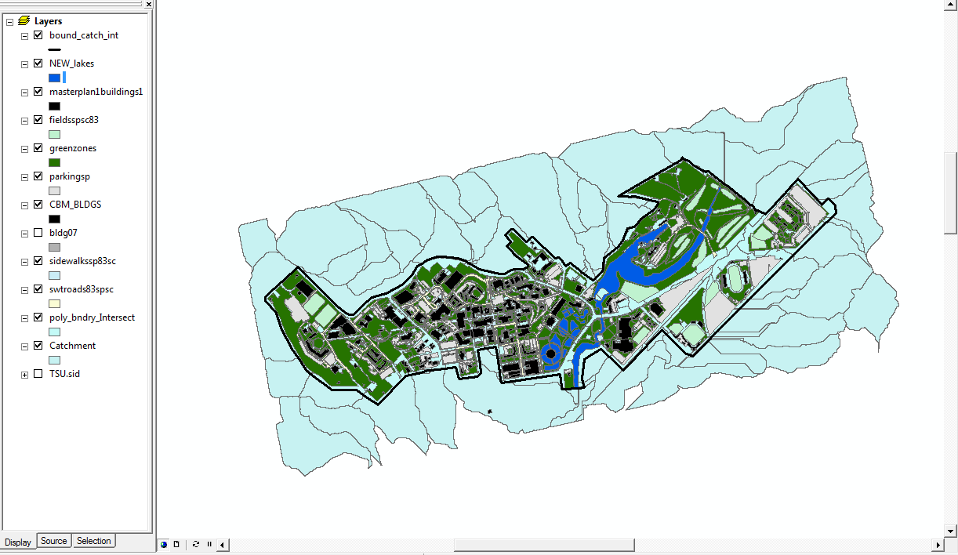
Figure 3. Screenshot of pre-processed coverage data.
Individual shapefiles

As stated, by adding the field ‘ICT’ to the cover type attribute tables, we were able to query our data. We determined how much impervious cover and/or greenspace occurs within each individual catchment on campus. This enabled us to identify high risk areas that might and quite possibly do produce polluted runoff during a storm. It also narrowed the search for potential locations down to areas with high amounts of impervious surfaces as opposed to areas of campus that have plenty of green space to naturally filter storm water. Once all of our cover type measurements were complete, the attribute table field F_AREA was added by the ArcMap. This field is the basis for all of our cover type measurements and without this data field our analysis would not have been possible, see Figure 4.
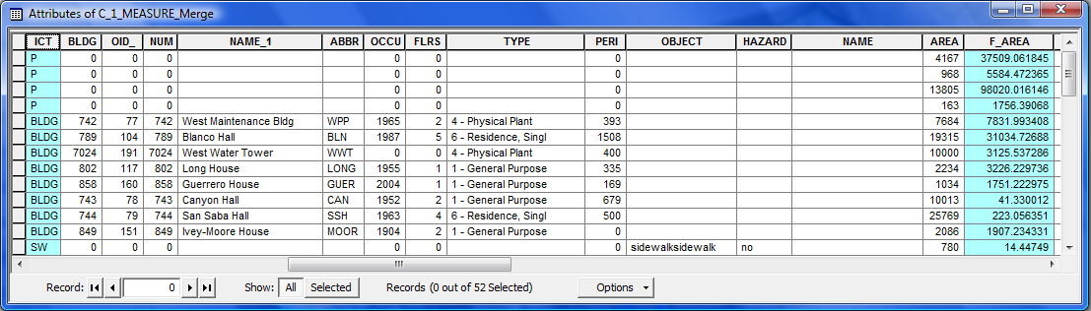
Figure 4. Screenshot of catchment attribute table after data processing.
New Fields

The completion of our cover type analysis gave us a better understanding of the campus landscape and made the data much more useful than what we started with. Note Figure 5, which depicts the merged cover type data into each of the separate catchments. Additionally, notice the created TSU boundary that enabled us to eradicate any superfluous terrain in our study area.
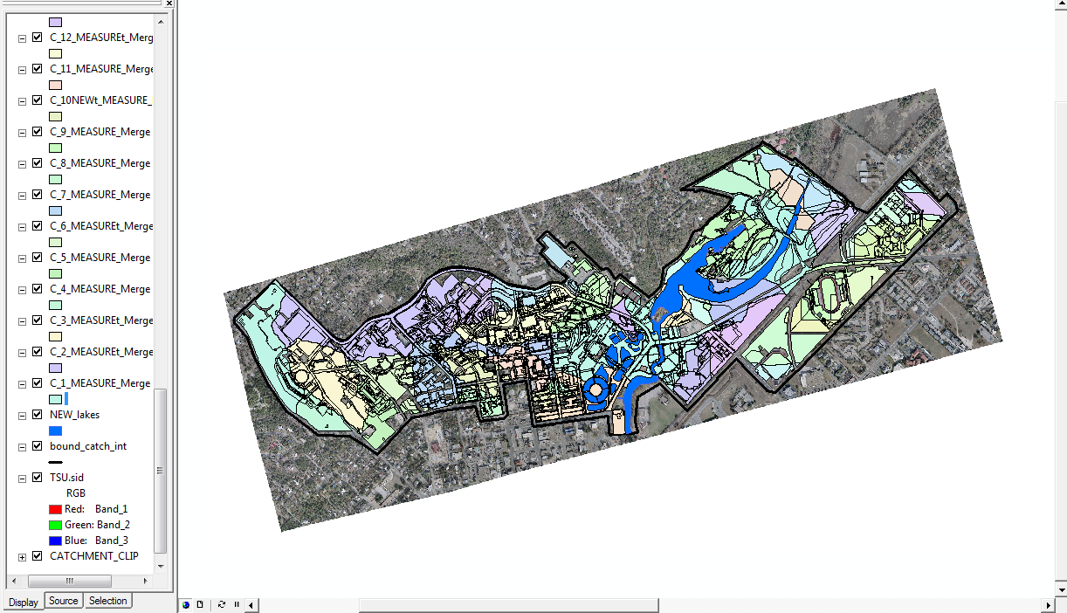
Figure 5. Screenshot of merged coverage files after data processing.
Merged Shapefiles

In order to process our measurement findings into a percentage based format our team exported the .dbf files created from ArcMap into Microsoft Excel and uploaded the end results into a pie chart format. This format was the best way to depict the overall scope of cover type measurements located throughout campus. Spreadsheets and pie charts, provided in Appendix 4, show the coverage totals for the catchments that flow into their respective pond locations.
5.2 Watershed Analysis
Our watershed analysis produced a total of 48 catchments spanning the TSU campus. The catchments were used as boundary files when measuring different types of coverage including impervious cover and green space. Catchments that aligned along a similar stream network, were selected and reorganized into seven major basins, see map in Appendix 3. Each basin gives a more general picture of the flow that occurs on campus during a rain event. They were used more as a reference than as calculating tools. There are seven different general stream directions hence seven basins.
There were 48 drainage points, one for each catchment used. A large number of points overlapped each other for they are depicting major collection areas for a series of streams and catchments within the same basin. These drainage points were crucial in deciding on our potential pond locations, for it would be logical to place ponds where runoff would collect. All potential pond locations are within a few hundred feet of major drainage points.
The stream network created show a general path that a raindrop would take when landing on different areas of campus. The connect all the drainage points and wer crucial in deciding what catchments fell into what basins. And furthermore what minor drainage points occur upstream of major runoff collection areas. See the watershed maps in Appendix 3 for details.
5.3 Soil Loss
The multiplication of the various layers, as described above, results in the “Potential Soil Loss of Texas State University - San Marcos” map, which is attached in Appendix 3. The final value assigned to each 3ftx3ft pixel is in units of tons/acre/year. To better visualize the data it has been classified into 7 geometrically related classes, with red being the worst erosion threats, and the green areas have acceptable erosion rates, see map. The mean soil loss for the entire campus is 0.85 tons/acre/year. When multiplied by the total area of the green area of the entire campus, according to this initial analysis, sheds 351.76 tons of soil per year into the San Marcos River.
Upon examination of the map, most of the campus area is not suspect to erosion of any major consequence with cell values very near zero. This can be directly related to the large amount of impervious surface on the campus i.e., buildings, sidewalks, parking lots and roads and green areas having very dense tree and grass cover, as well as landscaping. Tree and ground cover can be directly related to the reduction of soil erosion. There are however some problem areas. The most notable is in the west campus region that is along Ranch Road 12 (RR12) and the valley area just north and east of it. This area is some of the steepest on campus and has been suffering from the effects of erosion for some time. Physical examination of the area has revealed the top horizon of organic matter and top soil to be completely eroded in some areas, see Figure 6.
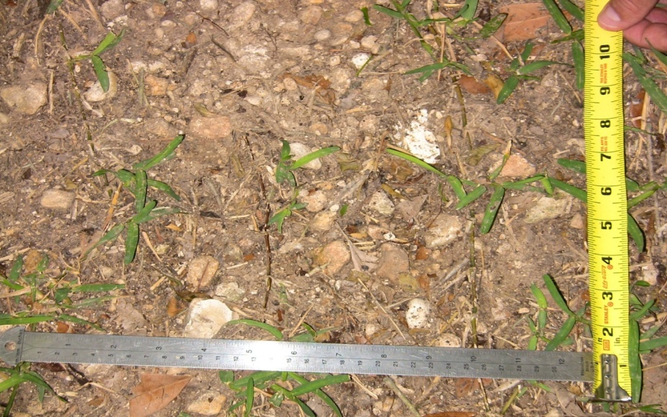
Figure 6. Photo of the topsoil from the west campus hillside adjacent to RR12.

The result is the loss of existing grass, or other vegetative cover, and the prevention of new growth in this nutrient deficient soil. This further increases the effects of erosion in this area. One benefit of using the “upslope contributing area” method when calculating the LS factor is that it can “predict” future rill formation. Rill formation is the forerunner of major erosion. These high probability areas seem to be on the steepest areas directly adjacent to RR12. When the sheeting action of rainfall runoff is allowed to form rills, the velocity of the runoff increases dramatically, thus increasing erosion of the areas feeding into them. This is an area of concern.
The valley area described above, north and east of RR12, is where the outdoor amphitheater is located. This is a very nice corner of campus with a large open area above the theater and nice tree cover. It is also an area suffering from severe soil erosion, see Figure 7.
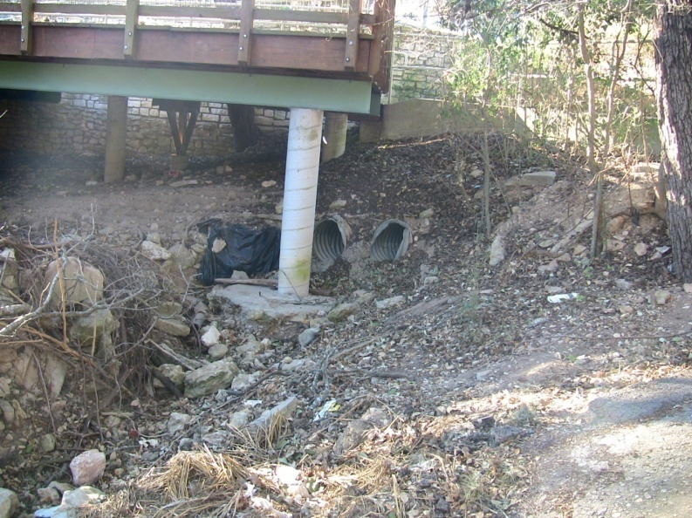
Figure 7. Photo of soil erosion underneath amphitheatre.

Closer inspection of the map reveals another problem area on the north/east side of campus running along both sides of Sessoms Drive. This area has some of the highest erosion rates on campus. This appears to be primarily due to the influence of the very steep terrain surrounding the stream channel, as the area is covered with dense tree and understory growth that would other wise reduce erosion to very low levels. The stream channel has a very rocky stream bed in areas that indicate a high velocity of water during large rainfall events.
5.4 Proposed Pond Locations
The final proposed pond locations were determined by combining the result of our three separate analysis along with a survey of available land within the campus property line. The sites are located in areas where there is either high risk for soil erosion or where there is an ample amount of impervious surfaces to produce a good amount of pollutants. In order for a wet detention pond to be feasible, it must have a drainage area of 20 acres or more. With this in mind, each location handles runoff from catchments that have a sum of 20 acres or more.
5.4.1 Location 1
The first proposed location is an open field located just to the west of Bobcat Stadium between the Collesium and Stadium commuter lots. New pipes connecting the nearby 60 inch drain pipe, which runs from Aquarena Springs to the major drainage ditch alongside the railroad tracks, should be laid to provide and inlet and outlet for this location.
This location will handle about 50 acres and will capture all the runoff from the 30 acres of impervious cover located in Bobcat Village as well as the stadium parking lots.
5.4.2 Location 2
The second proposed location is the open field adjacent to the east side of the Colesium. New pipes could be laid to connect this site to the nearby drainage ditch which runs along the tracks. This site is close to the San Marcos River and could be the last stop for runoff before being directly channeled into the river.
This location will handle about 30 acres and will capture the runoff from 17 acres of impervious cover which comes from the main east campus commuter lot.
5.4.3 Location 3
The third proposed location is just to the west of the intersection of Aquarena Springs and Sessoms Dr. next to the Aquatic Biology building. A majority of campus storm water runoff ends up near this site and flows directly into the river without treatment. This pond will be the largest by far and will involve redesigning the current fish hatchery ponds located on this site. Several of the current ponds in this area could be drained and redesigned into a multi-stage detention system for increased effectiveness.
This site will handle the 113 acres of campus on the north side of the ridge which runs west to east through the heart of campus. It will treat a mixture of 44 acres of greenzones contributing sediments and approximately 69 acres of impervious coverage contributing pollutants from major building and roads on the north side of campus.
5.4.4 Location 4
The fourth location is just south of the theater building on the corner of University Drive and CM Allen. This site houses and existing pond which could be redesigned to handle storm water runoff. There is a 60 inch storm pipe nearby that could funnel water from central campus into the pond, and once treated, into the river.
This site will handle about 60 acres in total, with about 41 acres of impervious cover which includes many of the roads, thoroughfares, and buildings of central campus, and a the runoff from a large amount of landscaping.
5.4.5 Location 5
The fifth location is directly to the south of the Lindsey Oaks Apartments and no less than a 100 ft. from Lindsey St. and Comanche Hills Apartments. There is a vacant lot here which covers the semi-steep slope of the major hill which leads from campus into the city of San Marcos. New drain pipes and/or ditches can be designed for the inlet and outlet on this site.
This site will handle a total of 24 acres with about half of the runoff coming from greenzones and the other half from a mixture of parking lots and buildings located in west-central campus.
5.4.6 Location 6
The sixth location is located in an open lot just to the west of the Bexar Hall parking garage. This site has plenty of space and is very versatile when it comes to the design of a pond. It is also located near a 60 inch storm drain which may be beneficial for inlet and outlet purposes.
This location will handle about 30 acres of land and should be very beneficial in capturing the steeply-sloped 19 acres of greenspace runoff that may contain harmful sediments. It will also filter runoff from the 11 acres of major parking garages and dorms located in west campus.
5.4.7 Location 7
The seventh and final pond location is proposed downhill from the Blanco parking garage, next to Ranch Road 12 on the frisbee golf course. This site is located near a major storm water drainage ditch that runs down the far west side of campus.
This location can handle the sediment coming from the 13 acre hillside as well as treat runoff coming from the 6 acres that make up the west campus commuter lot, the new commuter parking garage, and future buildings in this area.

6. Discussion
6.1 Coverage Analysis
The completed impervious cover analysis of TSU campus was a more detailed version of what we had in mind, due to the fact that we produced measurements to the scale of 48 catchments ranging in size and form. Before we began our analysis, we had fully envisioned that the central portion of campus was going to have a high impervious cover amount due to the high amount of streets, sidewalks, and parking lots that are in the area, but we initially did not comprehend the large amount of green space that seems to blend in with the impervious cover. We notice after our analysis that there was a large section of greenspace that is located in the eastern portion, better known as the golf course, and that this area didn’t need a detention pond. All other areas of campus show a potential need for a detention pond.
6.2 Soil Loss
The information gathered and examined during the soil loss analysis has produced some interesting results and some valuable insights. Some problems were encountered which, for the most part, were minimized during this analysis. There are however a few things worth mentioning.
First, there are a several existing detention ponds and barriers that have some influence on the sediment mediation of their respective areas. These ponds upon a visual inspection appear to indeed contain much of the sediment from the various green zones, but their influence was not included in the total amount of sediment estimated in this paper. Limitations on the data available did not allow the mediation efforts to be quantified. This was the P factor, discussed earlier, and set to have no influence on the RUSLE equation. It would be interesting to gather the necessary data for this P factor, in a quantifiable and repeatable manner, as different erosion control methods were employed and compare to and calibrate the RUSLE for the TSU campus. Many well used and time tested methods have been developed to curb erosion. The less intrusive methods include planting trees and landscaping. Using burlap mesh to contain topsoil, terracing, channeling the water to less hazardous zones, wet ponds, etc. are just some of the many more labor and material intensive methods that have been used with good results.
Second, the west campus zone not only has erosion problems but during high rainfall events the water travels nearly unrestricted down steep terrain and directly into a neighborhood adjacent to campus. A detention pond has the added benefit of controlling the surge and flow velocity of the runoff and offers the opportunity to direct flow into a storm water drainage system.
Lastly, the USDA soil survey of the area was originally interpolated from sample areas outside of the campus and may not be truly accurate for the campus area which has a large amount of disturbed and imported soils typical of construction areas. A soil survey of the campus area would add a more accurate description of the soil loss potential.
Soil erosion has made an enormous impact both on the planet and humankind. Irreversible loss of top soil combined with drought has reduced whole countries to famine in the recent past. Sediment builds up in streams and rivers and can displace native species and destroy habitat. While erosion is a natural process and has been going on for millions of years, much of the world’s recent major erosion problems can be directly linked to the influence of mankind, specifically the clearing of tree cover. This is very concerning as the world population over the next forty years is expected to nearly double, the impact of man on our environment is only going to grow. Closer to home, construction near Dripping Spring’s famous Dead man’s Hole caused the pristine blue waters to run muddy. Hamilton Pool suffered the same fate with Austin’s suburban expansion sullying the long pristine waters.
The results of our analysis have shown the campus of Texas State University is not going to wash away or cause irreversible harm to the river or springs anytime soon, but there are some areas that should be more closely looked into. The subject of soil erosion should weigh in for all of the future plans of campus. The pride of owning land in Texas should come with the added responsibility to take care of it and preserve it, not only for the quality of life now but for future generations to come.
6.3 Project in General
If our team had the ability to start the project all over again, I think the best plan of attack, in terms of the impervious cover data, would be to fully analyze each type of impervious cover type based upon the slope gradient that it lies on. If we could provide which parts of the impervious cover is concrete, asphalt, gravel, etc. Our team could further analyze each different cover type on how fast the water flows for a specific slope i.e. (10%, 40%, etc.) We could then take this data and apply it to a DEM slope map and find which cover type exists for a specified slope gradient. This would enable us to determine which areas of campus have a higher speed of runoff than others based on separate cover types.
The drainage pipe shapefiles we were provided with enabled us to perform a good analysis, but it was surprising to see that most drain pipes were not connected and really led to nowhere. Lucky for us, these gaps did not hinder our ICT analysis, but it led us to further conclude that there really was a need for such a project, for when runoff does go through the pipes it ends up untreated and enters the surface water. A more detailed storm drainage analysis is going to be needed in the next stage of the project to fully define where storm water is transported to throughout the campus. This is something that the engineers would have to examine before the dimensions of the storm detention ponds are completed. If the engineers have the ability to incorporate an extremely detailed CAD drainage file into their analysis then the detention pond size could become as exact as possible.
Our team concluded that the next stage of the project should focus on a more detailed analysis of the water flow on campus. We used an elevation model to determine our water flow, but didn’t take into account all the urban features such as curbs, small indentations, major cracks, steps and walls that could affect stream flow. We simply didn’t have time to gather such a vast amount of data, and the analysis would have taken more than a few weeks time. While doing research we did become aware of an urban watershed modeling feature of ArcGIS that could incorporate such features.
Upon completion of our project our team concluded that it may be in the best interest of the campus to incorporate, and/or redesign, the current lake system, located by the theatre building and in front of JCK, into a wetland system that would provide both detention of storm water runoff and aesthetic appeal. This area could potentially be scenic and provide refuge for endangered wetland flora and fauna that exist in local area. Conservation analysts and environmental engineers would have to be employed to fully discover the full scope of that vision.

7. Conclusion
There are several conclusions that our teams felt were pertinent enough to be discussed. Our team felt that there was more than enough data provided to us to fully analyze the entire TSU campus. The questions we were able to answer during this study included: Where does runoff flow, What coverage type is in a particular area, Where can there be soil loss, Where should detention ponds should be? These questions could not have been answered in the allotted time frame without the data provided by Mr. Stafford. Without this essential data, our projects would have been extended in the future in terms of months.
Everything from the photographs taken in the field, to analyzing drainage networks in the lab, was done while being fully self sufficient in our analysis efforts. A better way to improve the GIS Advance II class in the future might be to include the client in the lab for a few hours in order to help them familiarize themselves with GIS and too see what it takes to solve their problems. Looking back, if our team had the ability to work side by side with Mr. Stafford more often, then our analysis could have possibly been taken to a new level. This side by side partnership program may assist other teams in educating their clients who are less GIS informed on the processes and details that are required in accomplishing the tasks presented for the project.
Finally, Storm Water Solutions feels it has accomplished the goals and objectives presented in the RFP. We feel that we have gone beyond the basics, and have presented research worth looking at, if ever deciding to solve the polluted runoff issue on campus or elsewhere. This report has sufficiently shown where potential sites for detention ponds are located and how the goal of improving the water quality of the San Marcos River will necessitate the need for these ponds.
As stated in this report, the current storm water drain network of the TSU campus is out of date and needs to be improved if the campus continues to expand. Reducing storm water runoff pollution in the San Marcos River is essential for the maintaining the balance and aesthetic appeal of this beautiful region. Storm Water Solutions has a vision for cleaner and more responsible development of campus which has an eye on protecting the environment and improving the quality of life for San Marcos community. We are glad to be a part of this vision, not only as students, but as future alumni and rising stars of this great university.

8. References
Clar, M. L., Barfield, B. J., and O’Connor, T.P. 2004. EPA’s Stormwater Best Management Practice Design Guide, Vol. 3. Cincinnati, OH: U.S. EPA Office of Research and Development.

Cornell University. n.d. Erosion Control and Stormwater. http://counties.cce.cornell.edu/onondaga/002_environment/001_water_quality/000065.php Last accessed 16 April 2008.

Dunne, C. and L.B. Leopold. 1978. Water in Environmental Planning. W.H. Freeman: San Francisco. pp. 465-492.
England, G. (2001). The Use of Ponds for Bmp’s. http://www.stormcon.com/sw_0107_use.html. Last accessed 12 February 2008.

Environmental Protection Agency. February 2003. Protecting Water Quality From Urban Runoff. http://www.epa.gov/npdes/pubs/nps_urban-facts_final.pdf. Last accessed 16 April 2008.

Environmental Protection Agency. September 1999. Storm Water Technology Fact Sheet: Wet Detention Ponds. http://www.epa.gov/owmitnet/mtb/biortn.pdf. Last accessed 16 April 2008.

Environmental Protection Agency. September 1995. Polluted Runoff (Nonpoint Source Pollution): Economic Benefits of Runoff Controls. http://www.epa.gov/owow/nps/Ecology/. Last accessed 16 April 2008.

Minton, Gary. (2008). The Street Sweep-Gary Minton Looks at Permits, Water Quality, & More. http://www.stormwaterauthority.org/library/view_article.aspx?id=872. Last accessed 12 February 2008.
Moore, D. & Burch, L. 1986. Length slope Factor in Universal Soil Loss Equation. Soil Science Society of America Journal. Vol. 50:1294-1298.

Natural Resources Defense Council. November 2000. The Problem of Urban Stormwater Pollution. http://www.nrdc.org/water/pollution/fstorm.asp. Last accessed 16 April, 2008.

Natural Resources Defense Council. May 1999. Stormwater Strategies: Community Responses to Runoff Pollution. http://www.nrdc.org/water/pollution/storm/stoinx.asp. Last accessed 16 April 2008.

Ranhunath, J. 2002. Potential Erosion Map for Bagmati Basin Using GRASS. Open Source GIS-GRASS Users Conference. Trento, Italy, 11-13 September.

Wishchmeier, W.H., D.D. Smith, and R.E. Uhland. 1958. Evaluation of Factors in the Soil-Loss Equation. Agricultural Engineering. 39:458-462, 474.

9. Appendix 1.

9.1 Metadata

9.1.1 GISMGR_NContours
Identification_Information:
Citation_Information:
Originator: City of San Marcos, Texas
Publication_Date: November 21, 2007
Title: GISMGR_NContours
Geospatial_Data_Presentation_Form: vector digital data
Online_Linkage: \\GEO-306646\F\metadata\GISMGR_NContours.shp

Description:
Abstract:
Displays two-foot contour intervals for the northern area of San Marcos, Texas.
Purpose: Represents elevation of the city of San Marcos, Texas.
Time_Period_Information:
Calendar_Date: April 23, 2008
Time_of_Day: 5:00 P.M.
Currentness_Reference: ground condition
Status:
Progress: Complete
Maintenance_and_Update_Frequency: None planned
Spatial_Domain:
Bounding_Coordinates:
West_Bounding_Coordinate: -98.014901
East_Bounding_Coordinate: -97.838303
North_Bounding_Coordinate: 29.948250
South_Bounding_Coordinate: 29.873658
Theme_Keyword: Contours
Access_Constraints: none
Use_Constraints: none

Contact Information:
Contact_Organization: City of San Marcos, Texas
Native_Data_Set_Environment:
Microsoft Windows XP Version 5.1 (Build 2600) Service Pack 2; ESRI ArcCatalog 9.2.2.1350

Data_Quality_Information:
Attribute_Accuracy_Report: Accurate
Horizontal_Positional_Accuracy_Report: Accurate
Vertical_Positional_Accuracy_Report: Accurate
Contact_Organization: City of San Marcos, Texas
Spatial_Data_Organization_Information:
Direct_Spatial_Reference_Method: Vector
SDTS_Point_and_Vector_Object_Type: String
Point_and_Vector_Object_Count: 38120

Spatial_Reference_Information:
Map_Projection_Name: Lambert Conformal Conic
Lambert_Conformal_Conic:
Standard_Parallel: 28.383333
Standard_Parallel: 30.283333
Longitude_of_Central_Meridian: -99.000000
Latitude_of_Projection_Origin: 27.833333
False_Easting: 1968500.000000
False_Northing: 13123333.333333
Planar_Coordinate_Information:
Planar_Coordinate_Encoding_Method: coordinate pair
Coordinate_Representation:
Abscissa_Resolution: 0.000000
Ordinate_Resolution: 0.000000
Planar_Distance_Units: survey feet
Geodetic_Model:
Horizontal_Datum_Name: North American Datum of 1983
Ellipsoid_Name: Geodetic Reference System 80
Semi-major_Axis: 6378137.000000
Denominator_of_Flattening_Ratio: 298.257222
Vertical_Coordinate_System_Definition:
Altitude_Resolution: 1.000000
Altitude_Encoding_Method:
Explicit elevation coordinate included with horizontal coordinates
Entity_and_Attribute_Information:
Detailed_Description:
Entity_Type_Label: GISMGR_NContours
Attributes:
Attribute_Label: FID
Attribute_Definition: Internal feature number.
Attribute_Definition_Source: ESRI
Attribute_Domain_Values:
Unrepresentable_Domain:
Sequential unique whole numbers that are automatically generated.
Attribute_Measurement_Frequency: Unknown
Attribute:
Attribute_Label: Shape
Attribute_Definition: Feature geometry.
Attribute_Definition_Source: ESRI
Attribute_Domain_Values:
Unrepresentable_Domain: Coordinates defining the features.
Attribute_Labels: FNODE, TNODE, LPOLY, RPOLY, LENGTH, CONTOUR, CONTOUR_ID, FEA_CODE, ANNO_SEGME, ELEVATION, ID, SHAPE_LEN
Distribution_Information:
Resource_Description: Downloadable Data
Transfer_Size: 100.703

Metadata_Reference_Information:
Metadata_Date: April 25, 2008
Contact_Organization: City of San Marcos, Texas
Contact_Person: none
Address_Type: mailing address
Address: 630 E. Hopkins
City: San Marcos
State_or_Province: Texas
Postal_Code: 78666
Country: U.S.A.
Contact_Voice_Telephone: 512-393-8000
Metadata_Standard_Name: FGDC Content Standards for Digital Geospatial Metadata
Metadata_Standard_Version: FGDC-STD-001-1998
Metadata_Time_Convention: local time
Metadata_Extensions:
Online_Linkage: <http://www.esri.com/metadata/esriprof80.html>
Profile_Name: ESRI Metadata Profile
Generated by mp version 2.8.6 on Fri Apr 25 14:21:37 2008

9.1.2 Final_nomast
Identification_Information:
Citation:
Citation_Information:
Originator: Dean watson, Texas State University
Publication_Date: 21 Apr 08
Title: Final_nomast
Geospatial_Data_Presentation_Form: vector digital data
Online_Linkage: \\GEO-306643\F\4427\GIS SHAPE\crapfolder\Final_nomast.shp

Description:
Abstract: displays all impervious cover for the non-master plan
Purpose: to measure the total impervious cover for Texas State University
Time_Period_of_Content:
Time_Period_Information:
Single_Date/Time:
Calendar_Date: 21 Apr 08
Time_of_Day: 5:00PM
Currentness_Reference: ground condition
Status:
Progress: Complete
Maintenance_and_Update_Frequency: As needed
Spatial_Domain:
Bounding_Coordinates:
West_Bounding_Coordinate:
-97.955654
East_Bounding_Coordinate:
-97.9194563
North_Bounding_Coordinate:
29.897943
South_Bounding_Coordinate:
29.887656
Keywords:
Theme:
Theme_Keyword_Thesaurus: impervious cover, parking lots, steet cover
Theme_Keyword: total impervious cover
Access_Constraints: none
Use_Constraints: none
Point_of_Contact:

Contact Information:
Contact_Person: Dean Watson
Contact_Organization: Texas State University
Contact_Position: GIS Student
Contact_Address:
Address_Type: mailing address
Address: 800 North LBJ Dr.
City: San Marcos
State_or_Province: TX
Postal_Code: 78666
Contact_Voice_Telephone: 512-878-9582
Contact_Electronic_Mail_Address: dw1174@txstate.edu
Browse_Graphic:
Browse_Graphic_File_Name: E\4427\GIS Shape\crapfolder\Final_nomast.shp
Browse_Graphic_File_Description: impervious cover shapefile
Browse_Graphic_File_Type: CGM
Security_Information:
Security_Classification_System: none
Native_Data_Set_Environment:
Microsoft Windows XP Version 5.1 (Build 2600) Service Pack 2; ESRI ArcCatalog 9.2.2.1350

Data_Quality_Information:
Attribute_Accuracy:
Attribute_Accuracy_Report: Accurate
Logical_Consistency_Report:
information was created from numerous impervous cover shapefile merges, informationis an accurate accessment of the imprevious cover on Texas State University
Completeness_Report: Complete
Process_Description: Dataset copied.
Spatial_Data_Organization_Information:
Direct_Spatial_Reference_Method: Vector
Point_and_Vector_Object_Information:
SDTS_Terms_Description:
SDTS_Point_and_Vector_Object_Type: G-polygon
Point_and_Vector_Object_Count: 817
Spatial_Reference_Information:
Horizontal_Coordinate_System_Definition:
Geodetic_Model:
Horizontal_Datum_Name: North American Datum of 1983
Ellipsoid_Name: Geodetic Reference System 80
Entity_and_Attribute_Information:
Detailed_Description:
Entity_Type:
Entity_Type_Label: Final_nomast
Attribute:
Attribute_Label: FID
Attribute_Definition: Internal feature number.
Attribute_Definition_Source: ESRI
Attribute_Domain_Values:
Unrepresentable_Domain:
Sequential unique whole numbers that are automatically generated.
Attribute:
Attribute_Label: Shape
Attribute_Definition: Feature geometry.
Attribute_Definition_Source: ESRI
Attribute_Domain_Values:
Unrepresentable_Domain: Coordinates defining the features.
Attributes:
ID , LOT_,ZONE ,AREA , PERIMETER ,ACRES ,TOTALACRES ,SQ__FT_ ,TOTALSQFT, ICT , BLDG ,OID_,NUM , NAME_1 , ABBR ,OCCU
FLRS , TYPE , PERI ,OBJECT , HAZARD , NAME
Distribution_Information:
Resource_Description: Downloadable Data
Standard_Order_Process:
Digital_Form:
Digital_Transfer_Information:
Transfer_Size: 0.559
Technical_Prerequisites: must posess and ArcView liscence to view shapefile

Metadata_Reference_Information:
Metadata_Date: 20080425
Metadata_Review_Date: 21 Apr 08
Metadata_Future_Review_Date: TBD
Metadata_Contact:
Contact_Information:
Contact_Person_Primary:
Contact_Person: Dean Watson
Contact_Organization: Texas State University
Contact_Position: Student
Contact_Voice_Telephone: 512-878-9582
Metadata_Standard_Name: FGDC Content Standards for Digital Geospatial Metadata
Metadata_Standard_Version: FGDC-STD-001-1998
Metadata_Time_Convention: local time
Metadata_Extensions:
Online_Linkage: <http://www.esri.com/metadata/esriprof80.html>
Profile_Name: ESRI Metadata Profile

Generated by mp version 2.8.6 on Fri Apr 25 17:04:09 2008
9.1.3 soilloss

Identification_Information:
Citation_Information:
Originator: Bradford K. Bixby
Publication_Date: April 25, 2008
Publication_Time: 12:45
Title: soilloss
Geospatial_Data_Presentation_Form: raster digital data
Online_Linkage: \\GEO-305576\F\RUSLE\soilloss

Description:
Abstract: Potential soil loss of the Texas State University-San Marcos. Estimated by the Revised Universal Soil Loss Equation
Purpose: The intention of this data is to provide an accurate soil loss estimate for any point as well as highlight hazard areas on the Texas State University-San Marcos campus.
Calendar_Date: April 25, 2008
Time_of_Day: 12:45
Currentness_Reference: publication date
Status:
Progress: Complete
Maintenance_and_Update_Frequency: None planned
Spatial_Domain:
Bounding_Coordinates:
West_Bounding_Coordinate: -97.955541
East_Bounding_Coordinate: -97.919473
North_Bounding_Coordinate: 29.897896
South_Bounding_Coordinate: 29.884181
Keywords:
Theme:
Theme_Keyword_Thesaurus: RUSLE
Theme_Keyword: RUSLE
Theme_Keyword: Soil Loss
Theme_Keyword: Erosion
Theme:
Theme_Keyword_Thesaurus: Soil Loss
Theme:
Theme_Keyword_Thesaurus: erosion
Place:
Place_Keyword: Texas State University- San Marcos
Access_Constraints: There are no access constraints and may be used by all.
Use_Constraints: The creator of the data accepts no responibility for problems with the data set, or accuracy issues, etc. The data set is for reference only.

Contact_Information:
Contact_Person_Primary:
Contact_Person: Bradford K. Bixby
Contact_Organization: Student
Contact_Position: undergraduate
Contact_Address:
Address_Type: mailing and physical address
Address: 1719 Timber Ridge Dr.
City: Austin
State_or_Province: TX
Postal_Code: 78704
Country: USA
Contact_Voice_Telephone: 512 450-3128
Contact_Electronic_Mail_Address: bixby67@hotmail.com
Native_Data_Set_Environment: Microsoft Windows XP Version 5.1 (Build 2600) Service Pack 2; ESRI ArcCatalog 9.2.4.1420

Data_Quality_Information:
Logical_Consistency_Report: There has been no Accuracy assesment of this data set.
Cloud_Cover: none
Spatial_Data_Organization_Information:
Direct_Spatial_Reference_Method: Raster
Raster_Object_Information:
Raster_Object_Type: Grid Cell
Row_Count: 1628
Column_Count: 3795
Vertical_Count: 1
Spatial_Reference_Information:
Horizontal_Coordinate_System_Definition:
Planar:
Map_Projection:
Map_Projection_Name: Lambert Conformal Conic
Lambert_Conformal_Conic:
Standard_Parallel: 28.383333
Standard_Parallel: 30.283333
Longitude_of_Central_Meridian: -99.000000
Latitude_of_Projection_Origin: 27.833333
False_Easting: 1968500.000000
False_Northing: 13123333.333333
Planar_Coordinate_Information:
Planar_Coordinate_Encoding_Method: row and column
Coordinate_Representation:
Abscissa_Resolution: 3.000000
Ordinate_Resolution: 3.000000
Planar_Distance_Units: survey feet
Geodetic_Model:
Horizontal_Datum_Name: North American Datum of 1983
Ellipsoid_Name: Geodetic Reference System 80
Semi-major_Axis: 6378137.000000
Denominator_of_Flattening_Ratio: 298.257222
Distribution_Information:
Resource_Description: Downloadable Data
Standard_Order_Process:
Digital_Form:
Digital_Transfer_Information:
Transfer_Size: 25.477

Metadata_Reference_Information:
Metadata_Date: 20080425
Metadata_Contact:
Contact_Information:
Contact_Person_Primary:
Contact_Person: Bradford K. Bixby
Contact_Organization: Student
Contact_Position: Undergraduate
Contact_Address:
Address_Type: mailing and physical address
Address: 1719 Timber Ridge Dr.
City: Austin
State_or_Province: Texas
Postal_Code: 78704
Country: USA
Contact_Voice_Telephone: (512) 450-3128
Contact_Electronic_Mail_Address: BIXBY67@HOTMAIL.COM
Hours_of_Service: 8-5
Metadata_Standard_Name: FGDC Content Standards for Digital Geospatial Metadata
Metadata_Standard_Version: FGDC-STD-001-1998
Metadata_Time_Convention: local time
Metadata_Extensions:
Online_Linkage: http://www.esri.com/metadata/esriprof80.html
Profile_Name: ESRI Metadata Profile

10. Appendix 2

10.1 Contribution of Each Team Member

Brad Bixby
- Introduction
- Soil loss methodology, results, flowchart, metadata
- Literature review
- Soil loss map
- References

Nick Fowler
- Introduction
- Literature review
- Editing/compiling/formatting
- Watershed methodology, flowchart, results, conclusion,
- References and Abstract
- Watershed maps

Dean Watson
- Coverage methodology, results, discussion, flowchart, conclusion, metadata
- Coverage tables and charts
- Coverage maps
- 8 Pond Location maps

JD Grosch
- Website
- PowerPoint presentations
- Team Poster
- Photographs and other deliverables

Adrian Camano
- Watershed methodology, results, metadata
- Data
- Website
- Watershed maps
11. Appendix 3
11.1 Maps
12. Appendix 4
12.1 Flowcharts, Tables, & Pie Charts

