Clayton Hahn

Project Manager

Jeff King

Assistant Project Manager

John Refolo

Web-Master/GIS Analyst

Shannan Brent

GIS Analyst

William Marthes

GIS Analyst

A Final Report for
The Development of
Updated Digital Maps
and GIS Data

Prepared for

City of Martindale
Caldwell County, Texas

Prepared by
Bobcat Planning
Spring 2008

Abstract

Martindale, Texas is a small city located in the ever growing Central Texas region. As Central Texas grows, the surrounding cities continue to increase in population and sprawl outward. The need for current and organized maps is important aid for the City of Martindale to manage their city and communicate with surrounding cities in this growing region of Texas.
The City of Martindale requested the Bobcat Planning create updated maps and build a GIS foundation that the city could utilize. In addition to the creation of updated maps and GIS data for the city, Bobcat Planning has developed interactive map layers to be viewed using Google Earth and created maps to be used and manipulated in ESRI’s ArcReader. With these updated maps and GIS foundation, the City of Martindale is now more equipped to manage itself and communicate with the surrounding cities.

Table of Contents

1.0 Introduction………………………………………………………………1
1.1 Summary……………………………………………………………1
1.2 Purpose………………………………………………………………1
1.3 Scope………………………………………………………………….2
1.4 Problem Statement…………………………………………….3
2.0 Literature Review………………………………………………………4
3.0 Data…………………………………………………………………………..5
4.0 Methodology…………………………………………………………….7
5.0 Final Results…………………………………………………………….11
6.0 Conclusion……………………………………………………………….16
7.0 References……………………………………………………………….17
8.0 Appendix I………………………………………………………………..18
9.0 Appendix II……………………………………………………………….38

- Introduction

1.1 Summary

Martindale was established in 1855 by George and Nancy Martindale, pioneers from Mississippi. Together these founders, with the help of various merchants and farmers, established a strong communal foundation that can still be found within this city today. Although Martindale is very much reminiscent of what is was many years ago, this small city’s needs have changed and are growing right alongside the increase in population and popularity of Central Texas. The City of Martindale now seeks to update their maps and data that are vital to the City’s ability to manage their growth and communication with the growing cities that surround them. The creation of digital maps will allow the City of Martindale to modernize existing city policies, update zoning laws, and manage wastewater system expansion and development. In addition, city leaders will have ability to easily update maps as needed and to direct future growth appropriately.

1.2 Purpose

The purpose of this project is to update Martindale’s maps to reflect their current situation as a growing city in Central Texas. The GIS data and updated maps that Bobcat Planning will provide for the City of Martindale, will enhance the their ability to update and monitor changes that come with the future expansion of a city. Maps that will be made available to the city upon completion of Bobcat Planning’s work are current zoning, wastewater system, proposed extra territorial jurisdiction, current city limits, and property parcels with property information. Bobcat planning will provide maps in both paper and digital format to accommodate current needs of the city and any future modifications that will inevitably occur.

1.3 Scope

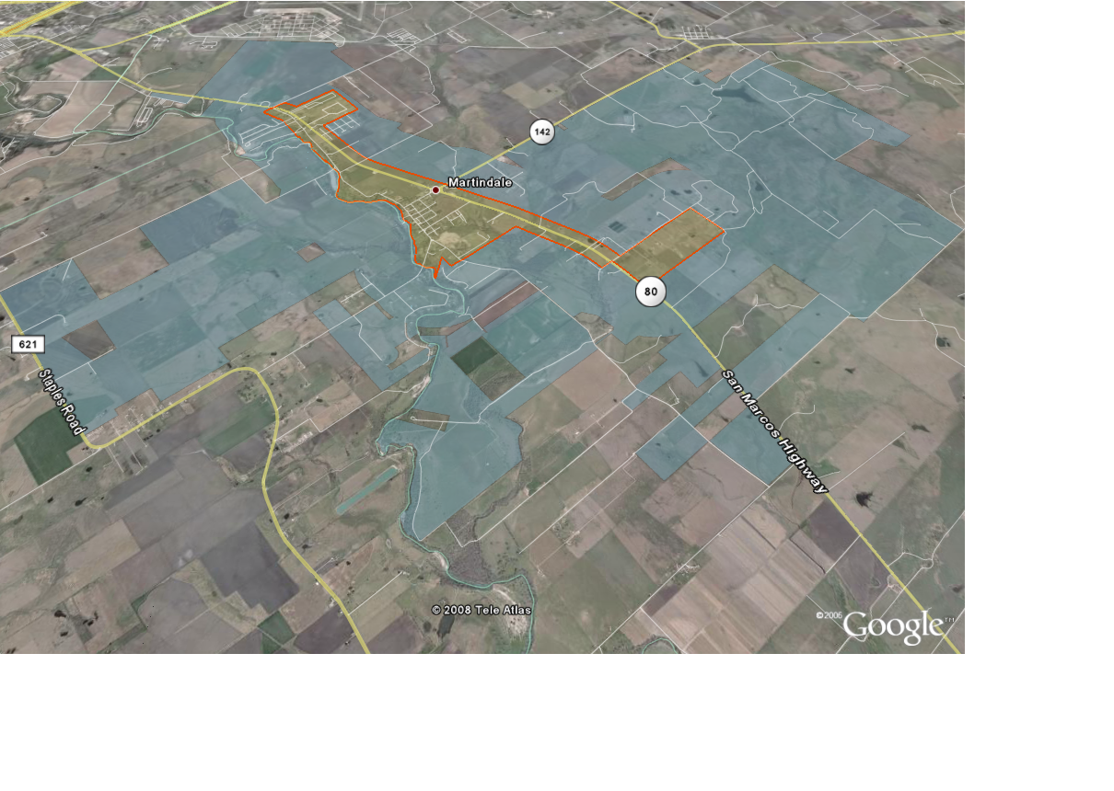Bobcat Planning’s study area will be the City of Martindale, located in Central Texas, its Extra Territorial Jurisdiction (ETJ) and land parcels within Caldwell County and Guadalupe County. The study area specific to the city limits include the wastewater system and zoning information. The City of Martindale lies within the counties of Caldwell and Guadalupe, and within the Capital Area Council of Government and Alamo Area Council of Government.

Figure 1

1.4 Problem Statement

The City of Martindale last updated city policies and ordinances approximately 20 years ago. The popularity of the Texas Hill Country has caused rapid expansion of all the cities surrounding Martindale. In order to maintain the standard of living and sense of community the city now enjoys as well as protect the city’s ability to expand and grow in the future, it has become necessary to modernize city policies and ordinances. The City of Martindale city leaders sought the help of Texas State University’s Advanced GIS students to assist in this process. The city is modifying their zoning policy, has recently expanded both the city limits and the ETJ, and has no readily accessible information about the location of their wastewater lines, manholes and clean-outs. The city is in need of updated maps showing zoning, city limit and ETJ changes and wastewater system layout as well as digital maps and data to facilitate future changes. An additional last minute request was to link the delinquent waste water clients to the parcel data in order to derive the physical location of the delinquent properties.

2.0 Literature Review

In researching possible solutions to the issues faced by The City of Martindale, Bobcat Planning relied, in part, on research conducted by Spatial Consulting Services. This past project provided insight into possible low-cost methods to provide current, updateable data to a small city with a very limited budget. It was determined that the Google Earth solution provided to the City of Woodcreek by Spatial Consulting Services provided an appropriate solution to meet our client’s need to view digital versions of the data provided. Bobcat Planning contacted Spatial Consulting Services who provided information on techniques used to make data available in Google Earth.

Bobcat Planning identified a client need to view and manipulate the maps and data provided. Initially three programs were identified that might meet these needs. To allow viewing of data ArcExplorer and Google Earth were compared for functionality and usability. ArcExplorer and Google Earth are both virtual Earth programs. ArcExplorer is able to read Shape Files created in ArcMap whereas Google Earth requires the Shape Files to be exported to .KMZ format. General functionality and ease of use are similar. Google Earth was selected to meet the clients need to view data from their desktop. Google Earth was given preference over ArcExplorer because of general product familiarity. Google provides on-line help and many people are familiar with Google Earth providing possible resources if questions about use arise.

ArcReader was evaluated for map viewing, printing and manipulation. ArcReader requires publishing of data into .PMF files. Users can then open the file in ArcReader and select which layers to view, zoom into specific areas of the map and pan across the map. Manipulated maps can be printed, exported to .PDF files or copied and pasted into Microsoft Word. ArcReader is provided by ESRI and download instructions are available. This product will meet the basic map manipulation needs of the City of Martindale.

3.0 Data

For the completion of this project, both secondary and primary data sets were needed. Secondary data is data that were collected and processed by another organization, whereas primary data is data that were collected by us. All data sets that were not already in Texas State Plane Coordinate System, central zone FIPS 4203, were converted to that.
3.1 Secondary Data

This project was created using mostly secondary data. These data sets were collected and assembled by other agencies. These agencies include: Capital Area Council of Governments (CAPCOG); Hejl-Lee & Associates, Inc.; Caldwell County Appraisal District (CCAD); Guadalupe County Appraisal District (GCAD); and the City of

Martindale. Bobcat Planning obtained these data sets by downloading from the source’s websites and by digitizing paper maps provided by the source.
Data and data sources:
- Wastewater System (Hejl-Lee & Associates, Inc.)
- Property Parcels (CCAD and GCAD)
- Current ETJ (City of Martindale)
- Proposed ETJ Information (City of Martindale)
- Current Zoning Information (City of Martindale)
- City Limits (CAPCOG)

3.2 Primary Data

The primary data collected for this project were the geographic coordinates of the stop signs within Martindale’s city limits. A Garmin eTrex Legend Global Positioning System (GPS) was used to collect these data and were provided to the group by the Texas State University Geography Department. The accuracy of this instrument is two to nine meters. Once the stop sign GPS waypoints were collected, they were uploaded into ArcEditor and converted to a shapefile. Due to the accuracy of the GPS instrument, a new identical shapefile was created from the original and the waypoints were manual positioned on their rightful corners. Street intersections were added to the adjusted layer attributes.

4.0 Methodology

ESRI’s ArcGIS 9.2 was used to create the maps that were used to complete this project.
The initial focus of Bobcat Planning was to collect and obtain data necessary to the creation of the maps needed by the City of Martindale. Bobcat Planning obtained parcel datasets for both Caldwell and Guadalupe counties from the county appraisal districts, current zoning policies and a paper zoning map from the City of Martindale, wastewater system data from Hejl, Lee & Associates, Inc, Caldwell and Guadalupe street data from ESRI, a paper city limits map from the City of Martindale and ETJ data from the City of San Marcos. In addition, Bobcat Planning collected primary data for the location of stop signs within the city limits of Martindale.

Five of the datasets required modification prior to use. The city limit data obtained by Bobcat Planning was a paper map provided by The City of Martindale. GIS Analysts created a digital map based on this paper map. The ETJ data for the City of Martindale was created by modifying the information received from the City of San Marcos to include specific parcels that were voluntary additions to the ETJ. The stop sign dataset that was collected required adjustment to accommodate variation in accuracy during GPS point collection. Stop sign intersection location was added to the attribute table. The wastewater dataset was obtained from Hejl, Lee & Associates in CAD format. This file was imported into ArcMap. This file was used as an underlay to create three

separate layers, one with waste water lines, one with manholes and clean outs and one with lift stations. The zoning layer was created based on the paper zoning map obtained from the City of Martindale. This dataset was then modified to accommodate the most recent changes to the zoning policy. An additional dataset was created that contains zoning overlay areas identified in the most current policy draft.

The production of the city limit map for the City of Martindale utilized Caldwell and Guadalupe County parcel data, Caldwell and Guadalupe County street data, the modified city limit data and the modified stop sign. Roads, parcel and city limit layers were combined to produce an 8” x 10” and an 11” x 17” map. Each was exported in PDF, JPG and MXD (ArcMap) format. Stop sign, road name labels and parcel ID labels were added to produce a 24” x 36” map. This map was then exported to PDF, JPG and MXD format.

The production of the ETJ map for the City of Martindale utilized Caldwell and Guadalupe County parcel data, Caldwell and Guadalupe County street data, the modified city limit data and the modified ETJ data. Roads, parcel, ETJ and city limit layers were combined to produce an 8” x 10” and an 11” x 17” map. Each was exported in PDF, JPG and MXD (ArcMap) format. Road name labels and parcel ID labels were added to produce a 24” x 36” map. This map was then exported to PDF, JPG and MXD format.

The production of the zoning map for the City of Martindale utilized Caldwell and Guadalupe County parcel data, Caldwell and Guadalupe County street data, the modified city limit data and the modified zoning data. Roads, parcel, zoning, zoning overlay and city limit layers were combined to produce an 8” x 10” and an 11” x 17” map. Each was exported in PDF, JPG and MXD (ArcMap) format. Road name labels, zoning code labels and parcel ID labels were added to produce a 24” x 36” map. This map was then exported to PDF, JPG and MXD format.

The production of the wastewater system map for the City of Martindale utilized Caldwell and Guadalupe County parcel data, Caldwell and Guadalupe County street data, the modified city limit data and the modified wasterwater system datasets including wastewater lines, wastewater manholes and cleanouts and wastewater lift stations. Roads, parcel, wastewater and city limit layers were combined to produce an 8” x 10” and an 11” x 17” map. Each was exported in PDF, JPG and MXD (ArcMap) format. Road name labels, parcel ID labels and wastewater flow direction were added to produce a 24” x 36” map. This map was then exported to PDF, JPG and MXD format.

Data Acquisition
Process Data for Map Creation
Process Data for Final Report
Process Data for Deployment to ArcReader
Process Data for Deployment to Google Earth
Export Maps to PDF
Export Data to Google Earth
Export Maps to ArcReader
Create Final Report
Create CD with All Maps and Data
Create Website with All Maps and Data
Methodology Flow Chart

Figure 2

5.0 Final Results

Upon completion of this project, Bobcat Planning is pleased to provide map documents to be used in maintaining the infrastructure of the City of Martindale. Along with maps in GIS format, Bobcat Planning has developed an interactive map viewer using Google Earth as well as ArcReader.

City Limits and ETJ:
The creation of a proposed ETJ was a major concern for the city. Central Texas has been rapidly growing in the past years and will continue to grow in the future. The City of Martindale needs to be sure they can independently maintain themselves without getting swallowed up by the more rapidly growing surrounding cities. Many land owners, from both Caldwell and Guadalupe County, requested admittance into Martindale’s ETJ as to remain a part of this historic city within a continually growing region.

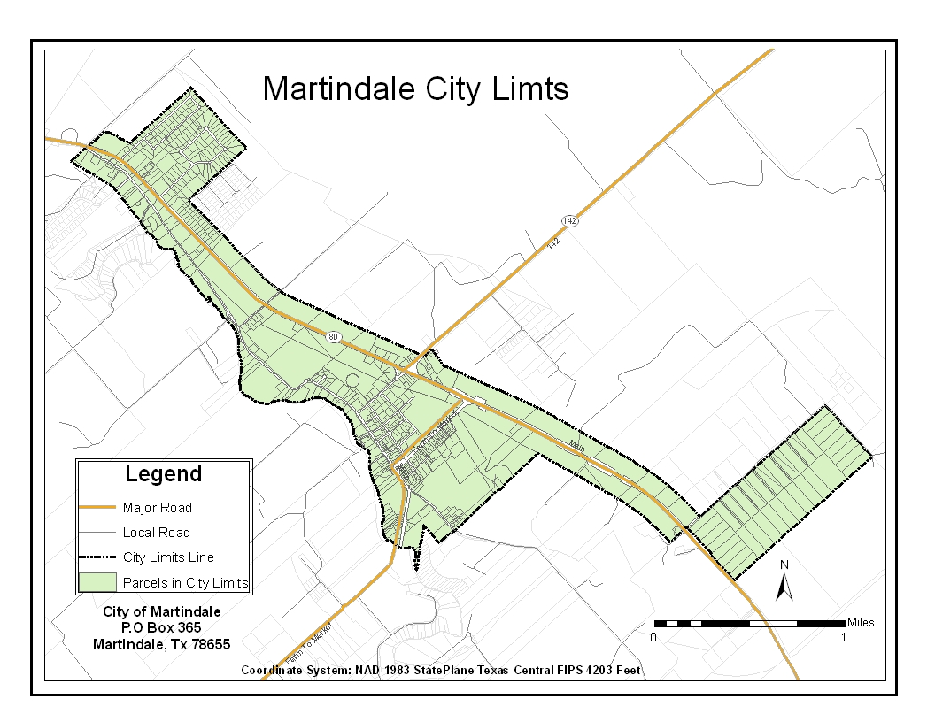
Figure 3
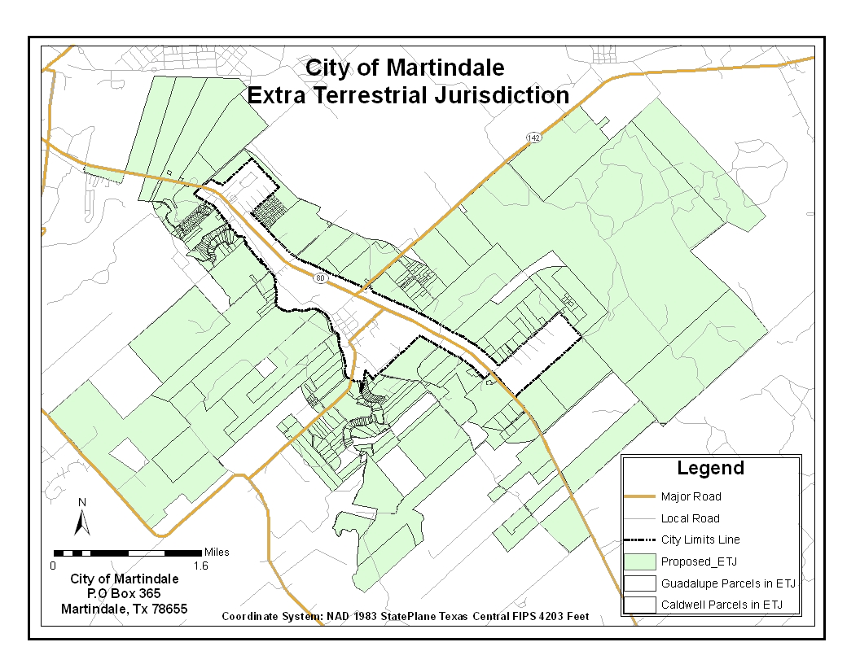
Figure 4

Wastewater:
A wastewater system map is necessary to the future growth of The City of Martindale. This map allows the city to view their current infrastructure as well as giving them a base map to build from. As additional neighborhoods and businesses are developed the city can now view the different ways to connect the new wastewater lines to the already existing wastewater system.
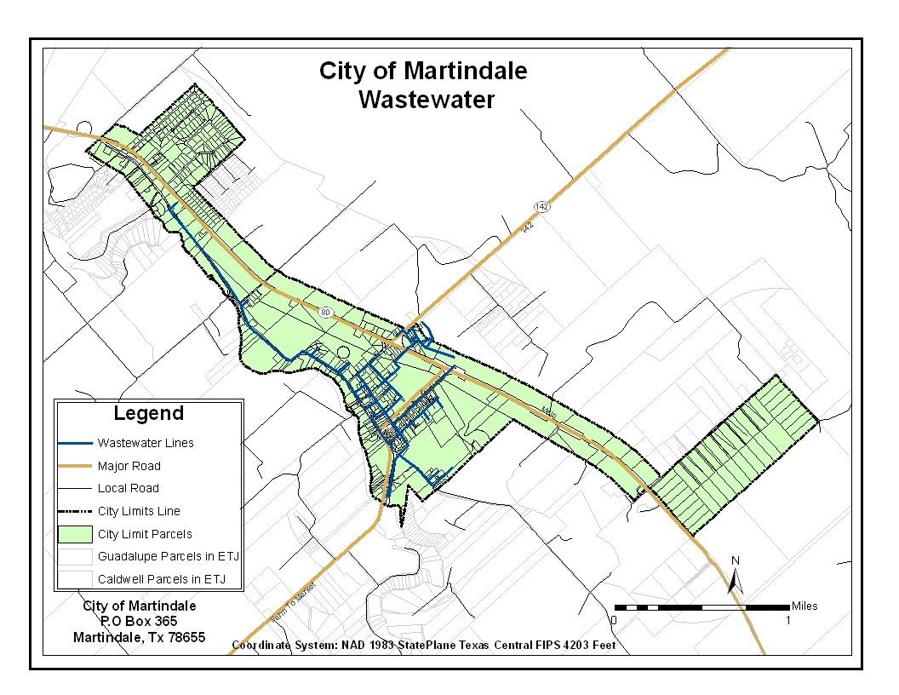
Figure 5

Zoning:
The City of Martindale is in the process of updating their current zoning policy. Policy updates are necessary to more accurately guide city growth and development to maintain the small town community that exists today. The GIS data as well as Google Earth files provided by Bobcat Planning will allow the city to update the zoning map as changes are made and the new zoning policy is finalized.

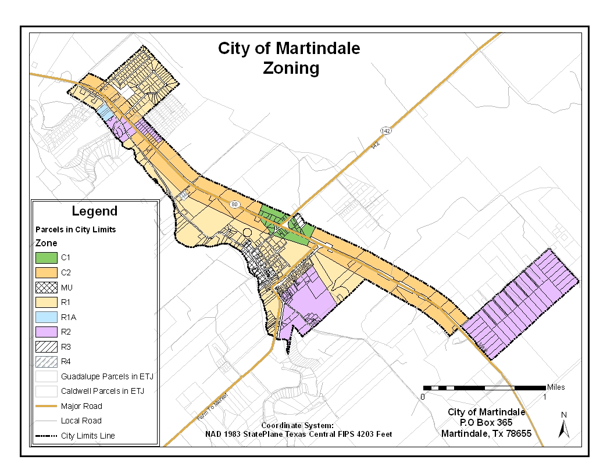
Figure 6

Overlays and Stop Signs:
Two new zoning overlays were created due to a new zoning code that is now in place. In addition to updating the zoning code, the city is in the process of reviewing the stop sign ordinance. The digital map of stop sign locations will allow updates to be made as stop signs are added or removed.

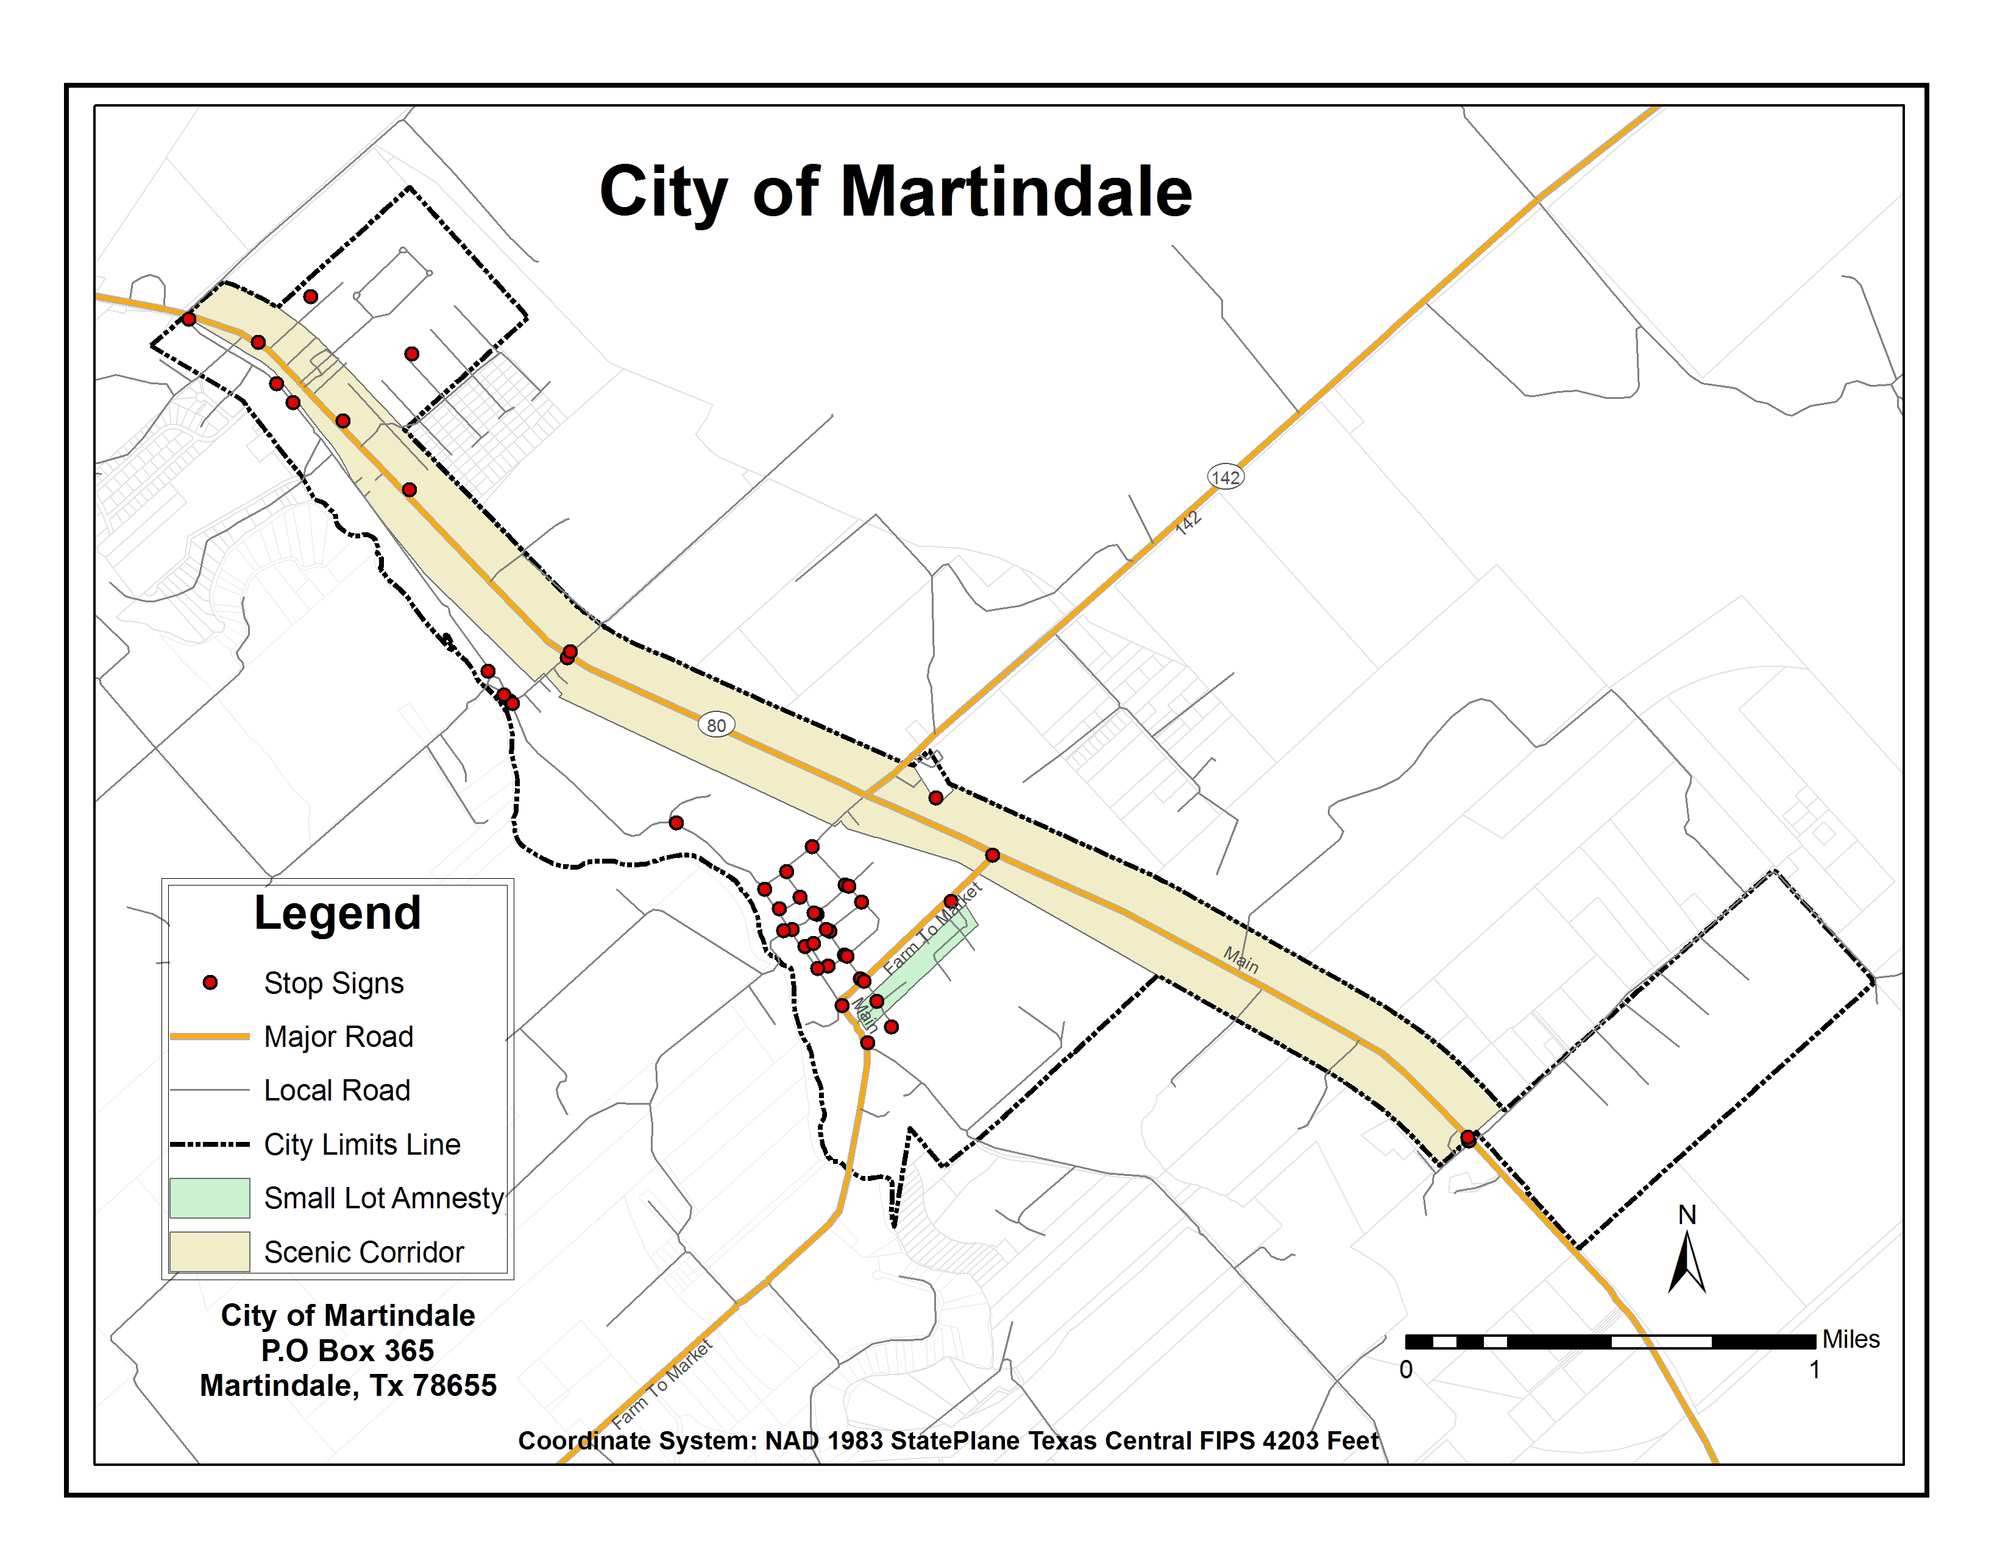
Figure 7

6.0 Conclusion

We successfully created a solid GIS foundation for the city to build on as growth increases in Central Texas. In addition to producing files in both GIS and Google Earth format for the city to print or view as a PDF, we converted the GIS data to KML to be viewed using Google Earth. The additional Google Earth compatible files will provide an inexpensive and easily obtainable alternative to the more complex and expensive software used in the GIS industry. Google Earth also provides users with relatively current and detailed aerial images that are otherwise expensive for a small city to purchase and possible difficult to obtain. Bobcat planning was unable to derive the delinquent waste water properties due to time limitations. The City of Martindale now possesses their own GIS infrastructure as an essential aid in planning and maintaining their city. They may now print various size maps and distribute the city’s data at their own discretion without having to use outside sources.

7.0 References

Spatial Consulting Services. 2007. GIS Development and Implementation Woodcreek, Texas. Student Group Project Advance GIS II (Geo 4427). Department of Geography Texas State University. http://geosites.evans.txstate.edu/~g4427f07-02/

8.0 Appendix I, Metadata

Stop Sign Adjusted
Data format: Shapefile
File or table name: StopSignAdjusted
Coordinate system: Universal Transverse Mercator
Theme keywords: Martindale Stop Sign
Abstract: This is an adjusted stop sign layer derived from the GPS points collected by Shannan Brent

FGDC and ESRI Metadata:
- Identification Information
- Spatial Data Organization Information
- Spatial Reference Information
- Entity and Attribute Information
- Distribution Information
- Metadata Reference Information
Metadata elements shown with blue text are defined in the Federal Geographic Data Committee's (FGDC) Content Standard for Digital Geospatial Metadata (CSDGM). Elements shown with green text are defined in the ESRI Profile of the CSDGM. Elements shown with a green asterisk (*) will be automatically updated by ArcCatalog. ArcCatalog adds hints indicating which FGDC elements are mandatory; these are shown with gray text.

Identification Information:
Citation:
Citation information:
Originators: Bobcat Planning
Title:
Stop Sign Adjusted
*File or table name: StopSignAdjusted
Publication date: 04-21-08
*Geospatial data presentation form: vector digital data
*Online linkage: \\BIGBLUE\C$\Documents and Settings\Admin\Desktop\Finalized_Data\Stop_Sign\StopSign_Adjusted\StopSignAdjusted.shp
Description:
Abstract:
This is an adjusted stop sign layer derived from the GPS points collected by Shannan Brent

Purpose:
This layer shows the locations of the stop signs in the city of Martindale.

*Language of dataset: en
Time period of content:
Time period information:
Single date/time:
Calendar date: 2008

Currentness reference:
publication date

Status:
Progress: Complete
Maintenance and update frequency: As needed

Spatial domain:
Bounding coordinates:
*West bounding coordinate: -97.868747
*East bounding coordinate: -97.817100
*North bounding coordinate: 29.865262
*South bounding coordinate: 29.830994

Local bounding coordinates:
*Left bounding coordinate: 29491.545556
*Right bounding coordinate: 34346.263258
*Top bounding coordinate: 3313620.612710
*Bottom bounding coordinate: 3310014.654285

Keywords:
Theme:
Theme keywords: Martindale Stop Sign

Access constraints: None
Use constraints:
This product has been compiled and developed for the City of Martindale, Texas. This product is for reference purposes only and not to be used as a legal document or survey instrument. Bobcat Planning assumes no responsibility for damages or other liabilities due to the accuracy, availability, use or misuse of the information herein provided, or any loss resulting there from.

Point of contact:
Contact information:
Contact organization primary:
Contact person: Shannan Brent
Contact organization: Bobcat Planning
Contact position: GIS analyst
Contact address:
Address type: physical address
Address:
601 University drive
City: San Marcos
State or province: TX
Postal code: 78666
Country: U.S.A.

Contact electronic mail address: sb1374@txstate.edu
*Native dataset format: Shapefile
*Native data set environment:
Microsoft Windows XP Version 5.1 (Build 2600) Service Pack 2; ESRI ArcCatalog 9.2.2.1350
Back to Top

Spatial Data Organization Information:
*Direct spatial reference method: Vector
Point and vector object information:
SDTS terms description:
*Name: StopSignAdjusted
*SDTS point and vector object type: Entity point
*Point and vector object count: 44

ESRI terms description:
*Name: StopSignAdjusted
*ESRI feature type: Simple
*ESRI feature geometry: Point
*ESRI topology: FALSE
*ESRI feature count: 44
*Spatial index: FALSE
*Linear referencing: FALSE
Back to Top

Spatial Reference Information:
Horizontal coordinate system definition:
Coordinate system name:
*Projected coordinate system name: NAD_1983_UTM_Zone_15N
*Geographic coordinate system name: GCS_North_American_1983

Planar:
Grid coordinate system:
*Grid coordinate system name: Universal Transverse Mercator
Universal Transverse Mercator:
*UTM zone number: 15
Transverse mercator:
*Scale factor at central meridian: 0.999600
*Longitude of central meridian: -93.000000
*Latitude of projection origin: 0.000000
*False easting: 500000.000000
*False northing: 0.000000

Planar coordinate information:
*Planar coordinate encoding method: coordinate pair
Coordinate representation:
*Abscissa resolution: 0.000000
*Ordinate resolution: 0.000000
*Planar distance units: meters

Geodetic model:
*Horizontal datum name: North American Datum of 1983
*Ellipsoid name: Geodetic Reference System 80
*Semi-major axis: 6378137.000000
*Denominator of flattening ratio: 298.257222

Back to Top

Entity and Attribute Information:
Detailed description:
*Name: StopSignAdjusted
Entity type:
*Entity type label: StopSignAdjusted
*Entity type type: Feature Class
*Entity type count: 44

Attribute:
*Attribute label: FID
*Attribute alias: FID
*Attribute definition:
Internal feature number.
*Attribute definition source:
ESRI

*Attribute type: OID
*Attribute width: 4
*Attribute precision: 0
*Attribute scale: 0
Attribute domain values:
*Unrepresentable domain:
Sequential unique whole numbers that are automatically generated.
Attribute:
*Attribute label: Shape
*Attribute alias: Shape
*Attribute definition:
Feature geometry.
*Attribute definition source:
ESRI

*Attribute type: Geometry
*Attribute width: 0
*Attribute precision: 0
*Attribute scale: 0
Attribute domain values:
*Unrepresentable domain:
Coordinates defining the features.
Attribute:
*Attribute label: STATE
*Attribute alias: STATE
*Attribute type: String
*Attribute width: 15
Attribute:
*Attribute label: INTERSECT
*Attribute alias: INTERSECT
*Attribute type: String
*Attribute width: 50
Back to Top

Distribution Information:
Distributor:
Contact information:
Contact organization primary:
Contact address:
Address type: physical address
Address:
601 university
City: San Marcos
State or province: TX
Postal code: 78666
Country: U.S.A.

Resource description: Downloadable Data
Standard order process:
Digital form:
Digital transfer information:
*Transfer size: 0.001
*Dataset size: 0.001

Back to Top

Metadata Reference Information:
Metadata date: 2008/04/27
*Language of metadata: en
Metadata contact:
Contact information:
Contact organization primary:
Contact person: Shannan Brent
Contact organization: Bobcat Planning

Contact address:
Address type: physical address
Address:
601 university
City: San Marcos
State or province: TX
Postal code: 78666
Country: U.S.A.

Contact voice telephone: none
Contact facsimile telephone: none
Contact electronic mail address: sb1374@txstate.edu
*Metadata standard name: FGDC Content Standards for Digital Geospatial Metadata
*Metadata standard version: FGDC-STD-001-1998
*Metadata time convention: local time
Metadata access constraints: none
Metadata use constraints:
This product has been compiled and developed for the City of Martindale, Texas. This product is for reference purposes only and not to be used as a legal document or survey instrument. Bobcat Planning assumes no responsibility for damages or other liabilities due to the accuracy, availability, use or misuse of the information herein provided, or any loss resulting there from.
Metadata extensions:
*Online linkage: http://www.esri.com/metadata/esriprof80.html
*Profile name: ESRI Metadata Profile

Back to Top

WW_Lines
Data format: Shapefile
File or table name: WW_Lines
Coordinate system: Lambert Conformal Conic
Theme keywords: waste water
Abstract: This layer was georefrenced from the Hejl Lee & associates cad file and then exported as a shp file in arcmap.

FGDC and ESRI Metadata:
- Identification Information
- Data Quality Information
- Spatial Data Organization Information
- Spatial Reference Information
- Entity and Attribute Information
- Distribution Information
- Metadata Reference Information
Metadata elements shown with blue text are defined in the Federal Geographic Data Committee's (FGDC) Content Standard for Digital Geospatial Metadata (CSDGM). Elements shown with green text are defined in the ESRI Profile of the CSDGM. Elements shown with a green asterisk (*) will be automatically updated by ArcCatalog. ArcCatalog adds hints indicating which FGDC elements are mandatory; these are shown with gray text.

Identification Information:
Citation:
Citation information:
Originators: Hejl Lee and Ascociates
*Title:
WW_Lines
*File or table name: WW_Lines
Publication date: Unpublished Material
*Geospatial data presentation form: vector digital data
Other citation details:
The original cad file was obtained from Hejl Lee and Ascociates
*Online linkage: \\BIGBLUE\C$\Documents and Settings\Admin\Desktop\Finalized_Data\WW_Lines.shp
Description:
Abstract:
This layer was georefrenced from the Hejl Lee & associates cad file and then exported as a shp file in arcmap.

Purpose:
To show the relitive location of the waste water lines for the City of Martindale.

*Language of dataset: en
Time period of content:
Time period information:
Single date/time:
Calendar date: 2008

Currentness reference:
publication date

Status:
Progress: Complete
Maintenance and update frequency: As needed

Spatial domain:
Bounding coordinates:
*West bounding coordinate: -97.862977
*East bounding coordinate: -97.834935
*North bounding coordinate: 29.857520
*South bounding coordinate: 29.832510

Local bounding coordinates:
*Left bounding coordinate: 3079898.185713
*Right bounding coordinate: 3088592.733613
*Top bounding coordinate: 9920616.611084
*Bottom bounding coordinate: 9911712.353302

*Minimum altitude: 0.000000
*Maximum altitude: 0.000000
Keywords:
Theme:
Theme keywords: waste water

Access constraints: none
Use constraints:
This product has been compiled and developed for the City of Martindale, Texas. This product is for reference purposes only and not to be used as a legal document or survey instrument. Bobcat Planning assumes no responsibility for damages or other liabilities due to the accuracy, availability, use or misuse of the information herein provided, or any loss resulting there from.

Point of contact:
Contact information:
Contact organization primary:
Contact person: William Marthes
Contact organization: Bobcat Planning
Contact position: Analyst
Contact address:
Address:
601 university
City: San Marcos
State or province: TX
Postal code: 78666
Country: U.S.A.

Contact electronic mail address: wm1057@txstate.edu
Security information:
Security classification: Confidential

*Native dataset format: Shapefile
*Native data set environment:
Microsoft Windows XP Version 5.1 (Build 2600) Service Pack 2; ESRI ArcCatalog 9.2.2.1350
Back to Top

Data Quality Information:
Lineage:
Process step:
Process description:
Metadata imported.

Source used citation abbreviation:
C:\DOCUME~1\Admin\LOCALS~1\Temp\xmlD7.tmp
Back to Top

Spatial Data Organization Information:
*Direct spatial reference method: Vector
Point and vector object information:
SDTS terms description:
*Name: WW_Lines
*SDTS point and vector object type: String
*Point and vector object count: 103

ESRI terms description:
*Name: WW_Lines
*ESRI feature type: Simple
*ESRI feature geometry: Polyline
*ESRI topology: FALSE
*ESRI feature count: 103
*Spatial index: TRUE
*Linear referencing: FALSE
Back to Top

Spatial Reference Information:
Horizontal coordinate system definition:
Coordinate system name:
*Projected coordinate system name: NAD_1983_StatePlane_Texas_Central_FIPS_4203_Feet
*Geographic coordinate system name: GCS_North_American_1983

Planar:
Map projection:
*Map projection name: Lambert Conformal Conic
Lambert conformal conic:
*Standard parallel: 30.116667
*Standard parallel: 31.883333
*Longitude of central meridian: -100.333333
*Latitude of projection origin: 29.666667
*False easting: 2296583.333333
*False northing: 9842500.000000

Planar coordinate information:
*Planar coordinate encoding method: coordinate pair
Coordinate representation:
*Abscissa resolution: 0.000000
*Ordinate resolution: 0.000000
*Planar distance units: survey feet

Geodetic model:
*Horizontal datum name: North American Datum of 1983
*Ellipsoid name: Geodetic Reference System 80
*Semi-major axis: 6378137.000000
*Denominator of flattening ratio: 298.257222

Vertical coordinate system definition:
Altitude system definition:
*Altitude resolution: 0.000100
*Altitude encoding method: Explicit elevation coordinate included with horizontal coordinates

Back to Top

Entity and Attribute Information:
Detailed description:
*Name: WW_Lines
Entity type:
*Entity type label: WW_Lines
*Entity type type: Feature Class
*Entity type count: 103

Attribute:
*Attribute label: FID
*Attribute alias: FID
*Attribute definition:
Internal feature number.
*Attribute definition source:
ESRI

*Attribute type: OID
*Attribute width: 4
*Attribute precision: 0
*Attribute scale: 0
Attribute domain values:
*Unrepresentable domain:
Sequential unique whole numbers that are automatically generated.
Attribute:
*Attribute label: Shape
*Attribute alias: Shape
*Attribute definition:
Feature geometry.
*Attribute definition source:
ESRI

*Attribute type: Geometry
*Attribute width: 0
*Attribute precision: 0
*Attribute scale: 0
Attribute domain values:
*Unrepresentable domain:
Coordinates defining the features.
Attribute:
*Attribute label: OBJECTID
*Attribute alias: OBJECTID
*Attribute type: Number
*Attribute width: 9
Attribute:
*Attribute label: Shape_Leng
*Attribute alias: Shape_Leng
*Attribute type: Float
*Attribute width: 19
*Attribute number of decimals: 11
Attribute:
*Attribute label: ROADNAME
*Attribute alias: ROADNAME
*Attribute type: String
*Attribute width: 30
Back to Top

Distribution Information:
Resource description: Downloadable Data
Standard order process:
Digital form:
Digital transfer information:
*Transfer size: 0.009
*Dataset size: 0.009

Back to Top

Metadata Reference Information:
*Metadata date: 20080427
*Language of metadata: en
Metadata contact:
Contact information:
Contact organization primary:
Contact person: William Marthes
Contact organization: Bobcat Planning
Contact position: Gis analyst
Contact address:
Address type: physical address
Address:
406 university
City: San Marcos
State or province: TX
Postal code: 78666
Country: U.S.A.

*Metadata standard name: FGDC Content Standards for Digital Geospatial Metadata
*Metadata standard version: FGDC-STD-001-1998
*Metadata time convention: local time
Metadata extensions:
*Online linkage: http://www.esri.com/metadata/esriprof80.html
*Profile name: ESRI Metadata Profile

Back to Top

parcels_In_City_limits
Data format: Shapefile
File or table name: parcels_In_City_limits
Coordinate system: Lambert Conformal Conic
Abstract: This layer was derived from the CAPCOG parcel file and edited to represent the 8 diffrent zoning codes.

FGDC and ESRI Metadata:
- Identification Information
- Spatial Data Organization Information
- Spatial Reference Information
- Entity and Attribute Information
- Distribution Information
- Metadata Reference Information
- Geoprocessing History
Metadata elements shown with blue text are defined in the Federal Geographic Data Committee's (FGDC) Content Standard for Digital Geospatial Metadata (CSDGM). Elements shown with green text are defined in the ESRI Profile of the CSDGM. Elements shown with a green asterisk (*) will be automatically updated by ArcCatalog. ArcCatalog adds hints indicating which FGDC elements are mandatory; these are shown with gray text.

Identification Information:
Citation:
Citation information:
Originators: Bobcat Planning
*Title:
parcels_In_City_limits
*File or table name: parcels_In_City_limits
Publication date: 2008
*Geospatial data presentation form: vector digital data
*Online linkage: \\BIGBLUE\C$\Documents and Settings\Admin\Desktop\Finalized_Data\parcels_In_City_limits.shp
Description:
Abstract:
This layer was derived from the CAPCOG parcel file and edited to represent the 8 diffrent zoning codes.

Purpose:
To show the different zoning codes in the City of Martindale

*Language of dataset: en
Time period of content:
Time period information:
Single date/time:
Calendar date: 2008

Currentness reference:
publication date

Status:
Progress: Complete
Maintenance and update frequency: As needed

Spatial domain:
Bounding coordinates:
*West bounding coordinate: -97.870921
*East bounding coordinate: -97.799916
*North bounding coordinate: 29.867610
*South bounding coordinate: 29.828602

Local bounding coordinates:
*Left bounding coordinate: 3077404.172328
*Right bounding coordinate: 3099615.562945
*Top bounding coordinate: 9924232.157331
*Bottom bounding coordinate: 9910539.901251

Keywords:
Access constraints: none
Use constraints:
This product has been compiled and developed for the City of Martindale, Texas. This product is for reference purposes only and not to be used as a legal document or survey instrument. Bobcat Planning assumes no responsibility for damages or other liabilities due to the accuracy, availability, use or misuse of the information herein provided, or any loss resulting there from.

Point of contact:
Contact information:
Contact organization primary:
Contact person: John Refolo
Contact organization: Bobcat Planning
Contact position: GIS Analyst
Contact electronic mail address: jr1363@txstate.edu
*Native dataset format: Shapefile
*Native data set environment:
Microsoft Windows XP Version 5.1 (Build 2600) Service Pack 2; ESRI ArcCatalog 9.2.2.1350
Back to Top

Spatial Data Organization Information:
*Direct spatial reference method: Vector
Point and vector object information:
SDTS terms description:
*Name: parcels_In_City_limits
*SDTS point and vector object type: G-polygon
*Point and vector object count: 641

ESRI terms description:
*Name: parcels_In_City_limits
*ESRI feature type: Simple
*ESRI feature geometry: Polygon
*ESRI topology: FALSE
*ESRI feature count: 641
*Spatial index: TRUE
*Linear referencing: FALSE
*XY rank: 1
*Z rank: 1
*Topology weight: 5.000000
*Events on validation: FALSE
Participates in topology rules:
*Rule identifier: 84
Participates in topology rules:
*Rule identifier: 85
Participates in topology rules:
*Rule identifier: 88

Back to Top

Spatial Reference Information:
Horizontal coordinate system definition:
Coordinate system name:
*Projected coordinate system name: NAD_1983_StatePlane_Texas_Central_FIPS_4203_Feet
*Geographic coordinate system name: GCS_North_American_1983

Planar:
Map projection:
*Map projection name: Lambert Conformal Conic
Lambert conformal conic:
*Standard parallel: 30.116667
*Standard parallel: 31.883333
*Longitude of central meridian: -100.333333
*Latitude of projection origin: 29.666667
*False easting: 2296583.333333
*False northing: 9842500.000000

Planar coordinate information:
*Planar coordinate encoding method: coordinate pair
Coordinate representation:
*Abscissa resolution: 0.000000
*Ordinate resolution: 0.000000
*Planar distance units: survey feet

Geodetic model:
*Horizontal datum name: North American Datum of 1983
*Ellipsoid name: Geodetic Reference System 80
*Semi-major axis: 6378137.000000
*Denominator of flattening ratio: 298.257222

Vertical coordinate system definition:
Altitude system definition:
*Altitude resolution: 0.000100
*Altitude encoding method: Explicit elevation coordinate included with horizontal coordinates

Back to Top

Entity and Attribute Information:
Detailed description:
*Name: parcels_In_City_limits
Entity type:
*Entity type label: parcels_In_City_limits
*Entity type type: Feature Class
*Entity type count: 641

Attribute:
*Attribute label: Shape
*Attribute alias: Shape
*Attribute definition:
Feature geometry.
*Attribute definition source:
ESRI

*Attribute type: Geometry
*Attribute width: 0
*Attribute precision: 0
*Attribute scale: 0
Attribute domain values:
*Unrepresentable domain:
Coordinates defining the features.
Attribute:
*Attribute label: AREA
*Attribute alias: AREA
*Attribute type: Double
*Attribute width: 8
*Attribute precision: 0
*Attribute scale: 0
Attribute:
*Attribute label: PERIMETER
*Attribute alias: PERIMETER
*Attribute type: Float
*Attribute width: 19
*Attribute number of decimals: 11
Attribute:
*Attribute label: PARCELS_
*Attribute alias: PARCELS_
*Attribute type: Float
*Attribute width: 19
*Attribute number of decimals: 11
Attribute:
*Attribute label: PARCELS_ID
*Attribute alias: PARCELS_ID
*Attribute type: Number
*Attribute width: 9
Attribute:
*Attribute label: ADJUST
*Attribute alias: ADJUST
*Attribute type: Number
*Attribute width: 9
Attribute:
*Attribute label: PROP_ID
*Attribute alias: PROP_ID
*Attribute type: String
*Attribute width: 8
Attribute:
*Attribute label: Shape_Area
*Attribute alias: Shape_Area
*Attribute definition:
Area of feature in internal units squared.
*Attribute definition source:
ESRI

*Attribute type: String
*Attribute width: 8
Attribute domain values:
*Unrepresentable domain:
Positive real numbers that are automatically generated.
Attribute:
*Attribute label: Prop_ID
*Attribute alias: Prop_ID
*Attribute type: Number
*Attribute width: 9
Attribute:
*Attribute label: OLDPROPID
*Attribute alias: OLDPROPID
*Attribute type: Float
*Attribute width: 19
*Attribute number of decimals: 11
Attribute:
*Attribute label: FID
*Attribute alias: FID
*Attribute definition:
Internal feature number.
*Attribute definition source:
ESRI

*Attribute type: Float
*Attribute width: 19
*Attribute number of decimals: 11
Attribute domain values:
*Unrepresentable domain:
Sequential unique whole numbers that are automatically generated.
Attribute:
*Attribute label: Zone
*Attribute alias: Zone
*Attribute type: String
*Attribute width: 50
Attribute:
*Attribute label: Shape_Leng
*Attribute alias: Shape_Leng
*Attribute type: Double
*Attribute width: 19
*Attribute precision: 0
*Attribute scale: 0
Back to Top

Distribution Information:
Resource description: Downloadable Data
Standard order process:
Digital form:
Digital transfer information:
*Transfer size: 0.165
*Dataset size: 0.165

Back to Top

Metadata Reference Information:
*Metadata date: 20080427
*Language of metadata: en
Metadata contact:
Contact information:
Contact organization primary:
Contact person: John Refolo
Contact organization: Bobcatplanning
Contact position: GIS analyst
Contact address:
Address type: physical address
Address:
601 university
City: San Marcos
State or province: TX
Postal code: 78666

Contact electronic mail address: jr1363@txstate.edu
*Metadata standard name: FGDC Content Standards for Digital Geospatial Metadata
*Metadata standard version: FGDC-STD-001-1998
*Metadata time convention: local time
Metadata extensions:
*Online linkage: http://www.esri.com/metadata/esriprof80.html
*Profile name: ESRI Metadata Profile

Back to Top

Geoprocessing History:
Process:
*Process name: FeatureClassToFeatureClass_3
*Date: 20061221
*Time: 134110
*Tool location: C:\Program Files\ArcGIS\ArcToolbox\Toolboxes\Conversion Tools.tbx\FeatureClassToFeatureClass
*Command issued: FeatureClassToFeatureClass \\Svgissde03e\GIS_Data\_Proposed_Clients\Caldwell\data1\parcels\polygon \\Svgissde03e\GIS_Data\_Proposed_Clients\Caldwell\Caldwell.gdb\Caldwell Parcels # "AREA AREA false false true 8 Double 0 0 ,First,#,\\Svgissde03e\GIS_Data\_Proposed_Clients\Caldwell\data1\parcels\polygon,AREA,-1,-1;PERIMETER PERIMETER false false true 8 Double 0 0 ,First,#,\\Svgissde03e\GIS_Data\_Proposed_Clients\Caldwell\data1\parcels\polygon,PERIMETER,-1,-1;PARCELS_ PARCELS_ false false true 4 Long 0 0 ,First,#,\\Svgissde03e\GIS_Data\_Proposed_Clients\Caldwell\data1\parcels\polygon,PARCELS#,-1,-1;PARCELS_ID PARCELS_ID true false true 4 Long 0 0 ,First,#,\\Svgissde03e\GIS_Data\_Proposed_Clients\Caldwell\data1\parcels\polygon,PARCELS-ID,-1,-1;ADJUST ADJUST true false false 8 Text 0 0 ,First,#,\\Svgissde03e\GIS_Data\_Proposed_Clients\Caldwell\data1\parcels\polygon,ADJUST,-1,-1;PROP_ID PROP_ID true false false 8 Text 0 0 ,First,#,\\Svgissde03e\GIS_Data\_Proposed_Clients\Caldwell\data1\parcels\polygon,PROP_ID,-1,-1;OLDPROPID OLDPROPID true false false 8 Text 0 0 ,First,#,\\Svgissde03e\GIS_Data\_Proposed_Clients\Caldwell\data1\parcels\polygon,OLDPROPID,-1,-1" # \\Svgissde03e\GIS_Data\_Proposed_Clients\Caldwell\Caldwell.gdb\Caldwell\Parcels
Process:
*Date: 20070112
*Time: 090125
*Tool location: C:\Program Files\ArcGIS\ArcToolbox\Toolboxes\Data Management Tools.tbx\CopyFeatures
*Command issued: CopyFeatures \\svgissde03e\GIS_Data\_Proposed_Clients\Caldwell\Caldwell.gdb\Caldwell\Parcels \\svgissde03e\GIS_Data\_Proposed_Clients\Caldwell\Caldwell_Central.gdb\Data\Parcels # 10000 0 0
Process:
*Date: 20080410
*Time: 095340
*Tool location: C:\Program Files\ArcGIS\ArcToolbox\Toolboxes\Data Management Tools.tbx\CopyFeatures
*Command issued: CopyFeatures C:\GISdata\Caldwell_Central.gdb\Data\Parcels C:\GISdata\Parcels.shp # 0 0 0
Process:
*Process name: Clip_1
*Date: 20080420
*Time: 135226
*Tool location: D:\Program Files\ArcGIS\ArcToolbox\Toolboxes\Analysis Tools.tbx\Clip
*Command issued: Clip Parcels City_Limits_Polygon F:\Finalized_Data\parcels_In_City_limits.shp #
Back to Top

9.0 Appendix II, Group Participation
Shannan Brent
Methodology
Flow Charts
Literature Review
Problem Statement

William Marthes
Data
Metadata
Website
Final Results

Clayton Hahn
Data
Final Report

Jeff King
Final Results
Maps
Final Report
Data

John Refolo
Website
Maps
Abstract
Data
Conclusion

