1. INTRODUCTION
Congestion on IH-35 is a problem for the Austin metropolitan area. The 1990 U.S. census population of Austin was 465,622, which grew to 656,562 by the year 2000 (Glasner, Table 1). This rapid growth has had a negative impact on the existing road network in Austin that was planned to support a population increase of 20.8%, based on the Brookings City Growth model, but the city and state transportation authorities did not plan for the growth of 41%. In addition to Austin growth, the counties north and south of Austin have experienced unprecedented growth as well. Williamson County has grown 79.1% between 1990 and 2000, and Hays County has grown 48.7% from 1990 to 2000 (Texas A&M, Austin Market Overview). The profound growth of the metropolitan area and its surrounding counties has created major traffic flow problems resulting in commuter time management, excess fuel consumption, and air pollution.
Presently, IH-35 is the only interstate corridor for Travis, Hays, and Williamson Counties. It is one of the most well traveled north and south interstate highways in the US, and as a corridor, the interstate connects major suburban towns and cities within its vicinity. A key element of traffic on IH-35 is the composition. A portion of the traffic is attributed to freight, another to work commuters to the Austin metro area, and the remainder is comprised of miscellaneous traffic. City and state organizations did not and could not plan for the rapid population growth which is directly correlated to the declining traffic conditions on IH-35. In addition to population growth, the 1990’s brought passage of the North American Free Trade Agreement (NAFTA). This trade reform has increased truck freight from Mexico “79% through Texas ports of entry” (TxDOT, Purpose and Need) This border traffic increase has directly increased overall truck freight growth to a constant rate of 17% annually on IH-35 (TxDOT, Purpose and Need). This additional freight traffic only contributes to congestion on IH-35 and yields a constant annual increase. Our study and analysis will look to diagnose the composition of traffic on IH-35, and offer some possible alternative ideas to alleviate some portion of the congestion.

2. PROBLEM STATEMENT
The purpose of this study is to determine the overall composition of the congestion on the Travis County portion of IH-35. In addition we will examine the feasibility of some solutions to allievate and/or reassign some traffic from IH-35. This study will address the following questions in order to examine the IH-35 congestion. Where is the traffic coming from and why is so much of it ending up on the IH-35 corridor? In order to answer these questions, this study will start by looking at the traffic composition going into and out of the Travis County’s IH-35 corridor. The objectives of this are to determine the amount of freight traffic, work-commuter traffic, and miscellaneous traffic originating in Hays and Williamson counties. This study will then determine where the traffic whose destination is Travis County is most commonly ending up. The objective of this is to find out where the traffic on the IH-35 corridor is going. The objective of this analysis is to take into account existing plans of Texas, Travis County, and Austin organizations that intend to help alleviate congestion and offer solutions that should be considered outside of the existing framework of ideas. These plans will be free of political restraint and could, with further analysis, show different and/or improved results.

3. LITERATURE REVIEW
3.1 Principles of Highway Engineering, and Traffic Analysis
The book, Principles of Highway Engineering, and Traffic Analysis, described the various components of traffic and provided greater insight into the definitions of attributes within the SAM data table. The SAM data table is based on the Transportation Research Boards’ 2000 Highway Capacity Manual. Chapter 5 provides explanation about speed-flow and the flow-density models, which in turn established a basis of understanding for how the speed and density of traffic interrelate and establishes the Level of Service (LOS) hyperbolic curve. LOS uses standard increments of traffic speed density data pairs to describe the relative ease or difficulty motorist experience. These standards are used in planning to assess the necessity of a new roadway, the effectiveness of roadway designs, the effects of population migration, and the need for service improvements. The curve starts at LOS A with free flowing traffic and progresses to LOS D which represents the maximum traffic volume per lane while the traffic speed diminishes only slightly. LOS F represents system failure. The letter assigned is based on a bracket of volume to capacity ratio values were 0 = no traffic, 1 = maximum design capacity achieved, and 1+ = the maximum design capacity exceeded and equals LOS E. At an LOS of F, the traffic design capacity is exceeded and speed drops off significantly, even to the point of stop and go traffic flow. This result is the classic traffic jam. Traffic jams can be caused by transitory of permanent factors such as accidents or reduction in the number of lanes respectively. LOS also varies with the time of day. In urban settings the commute cycle significantly influences the LOS. The morning, lunch, and evening commutes are of principle interest to planners because they present the highest volumes of vehicles and are therefore the volume to plan to and remediate from. The speed used in an LOS assignment is determined by the adjusted free flow speed (FFS). FFS is 70 mph for urban highways. This speed is reduced incrementally by the factors of the number of lanes, lane width, lateral clearance, passenger car equivalents, and the number of flow integrations per mile. The base values, representing optimum conditions, 5-6 lanes per direction, 12 ft width, 10 ft shoulder, passenger car equivalent (PCE) of 0, and one interchange per two miles. As these values change the FFS is decreased which directly reduces the LOS of a particular highway segment. PCE is a factor of non passenger cars ability to maintain speed while encountering positive or negative road grades.

3.2 IH 35/SH 130 through truck diversion analysis: A technical report
This is a study that identifies the estimated future increase for truck volumes on IH-35 in Travis County based on the increase from 1994 to 1996. The north end is estimated to be 50.07% and 60.77% at the south end. These percentages are used to compare with the TxDOT 1998 data and 2025 extrapolations from the SAM program.

3.3 Capital Metropolitan Transportation Authority website
This site gives a list of all the corporations who will be working on the commuter rail together. It also provides a website within each group to read more on the information. This site speaks of Austin’s All Systems Go Long-Range Plan to build the commuter rail which includes the commuter rail and the transportation buses to and from stations. This site claims commuter rail will be ready in 2008, and not 2007.

3.4 The Road Ahead: Innovations for Better Transportation in Texas
This site gives an extensive report on population growth in the US from 1990-2000. It ranks Austin as one of the fastest growing cities, leading to heavy traffic density congested on IH-35. It also provides many charts with growth percentages of traffic and population comparing Austin with other cities in the US. This site proves that Austin is need of some major mobility change and introduces the commuter rail and all of its benefits.

3.5 City of Austin, Downtown Neighborhood Plan
This site gives information on the future commuter rail and how it will divert traffic away from historical downtown Austin. Therefore, it speaks of relieving some congestion and density of traffic downtown, but the rail might have a negative economic effect on downtown by decreasing the volume of commuters.

4. DATA
4.1 Primary Data Sources
4.1.1 Statewide Analysis Model (SAM)
The key data used for this project was obtained from two primary sources. The first was the Statewide Analysis Model (SAM) and the Statewide Analysis Model Analyst Interface (SAM Analyst). Both versions are products created by the Programming Division of the Texas Department of Transportation (TxDOT). Spatial Remedies Inc. obtained copies of the SAM from the SAM Project Manager, Gurjeet Gill. The SAM data is comprehensive and quite accurate considering the size of the traffic equation in Texas.
Our original intention was to utilize all the data within the SAM for our analysis. The SAM data was collected by TxDOT and three Texas engineering firms. Once collected the SAM data was bundled into the SAM program for analysis and distribution to the public. The data from the SAM applications that we utilized in our project included the following GIS layers:
1). Highway layer- attributes including speed limit, road type, road name, auto flow, vehicle capacity, daily vehicle capacity, and congestion attributes
2). Traffic Analysis Zone (TAZ) layer- attributes including county, shape, state, area
3). Counties layer- location of counties, name, population, scope of study area
4). Urban Areas layer- representation of approximate boundaries of urban areas
5). State of Texas layer
Once the SAM Analyst became available to us, our impression was that the ArcGIS extensions would allow us to complete a comprehensive analysis of traffic composition on IH-35. However, the SAM Analyst is does not allow user manipulation of data. The SAM Analyst program is tied to specific shapefiles, and any editing or creation of new layers results in the application tools inability to complete their functions. Without the analysis functions of the SAM Analyst we were forced to revise our methodologies and procedures to accomplish our composition analysis. The SAM did provide most of the key attribute data that was required for our analysis.

4.1.2 Census Transportation Planning Package (CTPP)
Our second primary data source for data was the U.S. Department of Transportation Statistics (TransStats). TransStats is currently the government entity that distributes the digital version of the 2000 Census CTPP journey-to-work flow tables via download on their website. CTPP “data are tabulated from answers to the Census 2000 long form questionnaire, mailed to one in six U.S. households. Because of the large sample size, the data are reliable and accurate.”
(U.S. Department of Transportation Planning, 2005, http://www.fhwa.dot.gov/ctpp/about.htm)
The CTPP provided our project with the worker-commuter counts traveling into Travis County from both our primary study area transportation analysis zones (TAZ), and our secondary study area counties. The CTPP was modified slightly through a filter and summarizing process within ArcGIS 9.0. We retained the accuracy of the tables by using both the statistics function within ArcMap, and double checking the resulting summarizations.

4.2 Secondary Data
4.2.1Major Highways
Tthis shapefile was taken from Environmental Systems Research Institute’s (ESRI) Data & Maps. Its quality stands on the standards of ESRI. It is a shapefile of major highways of the United States, consisting of interstate, United States, and state highways. For this project, we modified this shapefile so as to only include the highways within our study areas.

4.2.2 Texas Transportation Analysis Zones
This shapefile was downloaded from the U.S. Census Bureau web site, http://www.census.gov/geo/www/cob/tz2000.html. It provided this project with Texas TAZ boundaries and identification numbers. In order to use this shapefile, we created multiple shapefiles from it for our primary and secondary study areas, then re-projected it to better portray our study areas. The projection changed from GCS North American NAD 83 to State Plane Texas Central FIPS 4203 (Feet).
5. METHODS
5.1 Northbound/Southbound IH-35 Traffic Density Analysis
This analysis was conducted in ArcGIS 9.0 to accurately represent and define the areas with the highest traffic count on IH-35 in Austin. 24-hour traffic count data points were digitized along the Austin area IH-35 and assigned an attribute value of traffic counts. Using the this point data, the spatial analyst extension was used to conduct a density analysis of the traffic counts for graphic representation. The output was symbolized from Very Low ranging from 80,000 vehicles to Very High 183,000 vehicles.

5.2 Congestion
The congestion maps where produced with the SAM Analyst. Within the highways layer, we selected the different Level of Service (LOS) values (A-F) in Travis County, and created a layer for each. Each LOS layer was then assigned a different display color and size. An urban areas layer was added from the General Land Office website to show the different cities in Hays, Travis and Williamson Counties.

5.3 Freight Analysis Methodology
The methodology for determining the volume of freight traffic in both the northbound and the southbound traffic flows consisted of mining existing data from the Statewide Analysis Model (SAM), and performing basic mathematical functions to derive results not included in the SAM. Within ESRI ArcMap, as portrayed on page 9 in FIGURE 5-2, with the target area SAM Analysis map and data table open, new attribute fields were created to facilitate performing the needed calculations and then having the new values available for further manipulations and display. We utilized the accompanying Readme text file to learn the SAM data attribute table definitions. We identified the need to calculate the southbound truck volume by subtracting the southbound values from the combination truck values for each highway segment.
Combo_Truck – Truck_AB = Truck _BA
Once the volume was determined for each traffic flow direction, the values were divided by the combination truck value to derive a percentage of the truck volume for a given direction.
Truck_XX / Combo_Truck = % Truck_XX
The current percentage of trucks in the total traffic volume was calculated by dividing the Average weekday total truck volume by the Average weekday total passenger vehicle volume. These values are used because they are the most similar in composition.
AWDTTruck / AWDTPass = %Trucks of total Volume
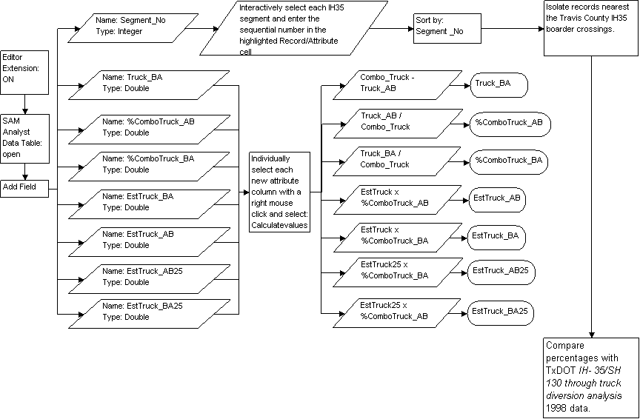
FIGURE 5-1. Freight analysis methodology flowchart

5.4 Worker-Commuter methodology
The methodology in which this study determined the percentage of worker commuter counts, as depicted on FIGURE 5-3, was to attach summarized 2000 Census Transportation Planning Package (CTPP) tables to transportation analysis zone (TAZ) shapefiles, determine which TAZs would most likely use IH-35 to commute, and then to use the resulting county TAZs to determine how many commuters traveled to each Travis County TAZ.
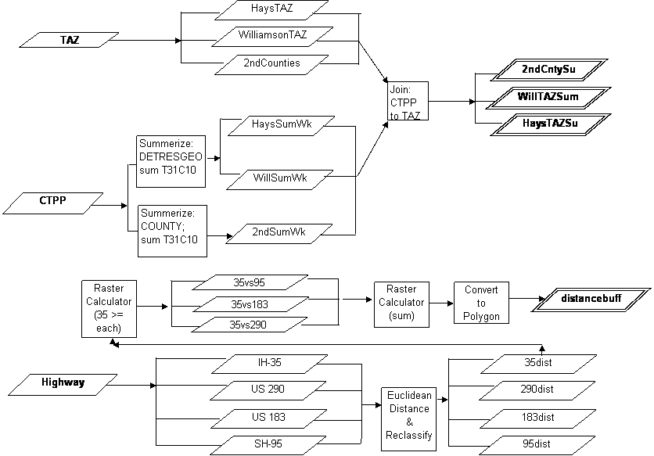
FIGURE 5-3. Worker-commuters flow chart

5.4.1 Summarize and Join Tables to TAZs
To begin summarizing the CTPP table, we used ArcGIS 9.0 to filter the table so as to select only the counties in our study areas, Hays and Williamson County for our primary study area, and Bexar, Caldwell, Comal, and Guadalupe for our secondary, which had their workplace destination in any Travis County TAZ. For these counties, we used the summarize function to create two types of tables; one type for the primary study area, and one type for the secondary. The resulting primary study area tables, one for Hays and one for Williamson, were summarized based on their residence TAZs with the sum of workers leaving those to go into any Travis County TAZ. The secondary study area table was summarized based on its county with the sum of workers leaving each county to go into a Travis County TAZ. The resulting tables were utilized to fill our TAZ shapefiles with the commuter data. The join was based on created “JoinTAZ” fields.

5.4.2 Distance Buffer
Now the tables only contained the number of workers for each respective county or TAZ, and we used the statistics function to determine the sum of all of the commuters. For the secondary study area, IH-35 was the primary route going into Travis County, so this sum of the summed workers was used. However, from our primary study area, there are multiple inputs into Travis County. Therefore, we used the Spatial Analyst’s Euclidean distance function in ArcGIS 9.0 to determine which primary study area TAZs were closer to IH-35 than the other major highways – US 290, US 183, and SH 95.
The Euclidean distance function was performed for each major highway and the results were reclassified within spatial analyst to allow for a common basis for comparison. Using the raster calculator, we then determined the areas closer to IH-35 than to each of the other major highways. Adding the resulting rasters together with the raster calculator, we now had a yes or no raster layer. The “yes” cells represented cells that were closer to IH-35 than to any other major highway, which we converted into a polygon shapefile. We used this polygon shapefile to select and define the Hays and Williamson County TAZs that use IH-35 to commuter to work, as seen on page 13 in FIGURE 5-4, and use the defined TAZs to produce the sum primary study area’s work commuters into Travis County.
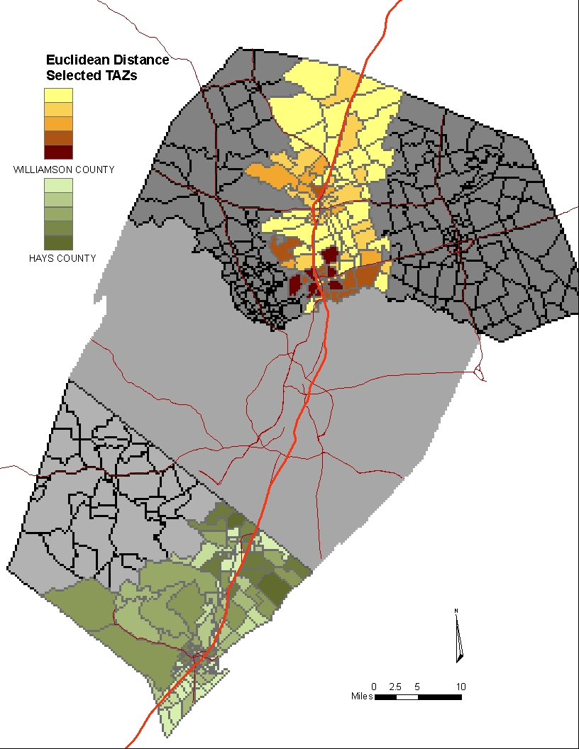.
FIGURE 5-4. Primary study area’s distance determined IH-35 worker-commuters

5.4.3 Interpolation to 2025
To derive the amount of worker-commuter traffic from the primary and secondary study areas for the year 2025, we used the Institute for Demographic and Socioeconomic Research’s population projections into the year 2025 for each county (IDSER, 2004). We divided the difference between the 2000 population and the 2025 projected population by the 2000 population and multiplied it by 100. The result was a percent increase. The resulting county worker-commuters were then increased by their county percent increase to provide the 2025 county work-commuter totals.

5.5 Methodology for Compiling Composition Percentages
The final step in which to compile the percentages of worker-commuter, freight, and miscellaneous traffic out of all of the traffic entering Travis County’s north and south borders was to determine the total amount of traffic. To do this, we used the 1998 SAM total traffic numbers at the north and south borders, 300,837 vehicles, and interpolated them to 2000 using TxDOT 2002 traffic counts at the same place, 396,500. Dividing the difference between the 1998 and 2002 traffic counts by the number of years between them, we added the result to the 1998 SAM total, year by year, until we reached the year 2000. From the total traffic count for 2000, we subtracted the sums of both commuter and freight traffic, and were left with the miscellaneous traffic count. We then derived the percentages for all three, (freight / total X 100), (commuter / total X 100), and (miscellaneous / 100 X 100).

5.6 Reassignment
The reassignment possibilities maps were created by selecting different roads from the attributes of the highway layer in the SAM Analyst that could effectively redirect traffic away from the heavily congested areas of IH-35. This was completed by first selecting the attributes of any roads or future roadways that were related to the SH 130 project, or were close to Austin and could connect IH-35 to SH 130. The interactive selection feature was used to select roadways that led from the SH 130 plan west to IH-35. Layers were then created from the selected road segments which produced the two different reassignment routes.
5.7 Commuter Rail
The commuter rail map for the city of Austin, Texas was created in ArcGIS. Data from ESRI was gathered and symbolized.

6. RESULTS
6.1 Northbound/Southbound IH-35 Traffic Density Analysis
This analysis’ output, as seen in on the maps in APPENDIX I-A and APPENDIX I-B, symbolizes the density of traffic counts recorded on IH-35 in Austin, Texas. They display the densities for 24 hour daily average traffic counts traveling north and south. The densest portion on this map is in the more urbanized areas near downtown. But, looking carefully, there is a slight indention in the very middle of the most congested area, and there is a significant drop-off in density north and south at US 290 East and US 290 West. Further North and Further South of these two exits, the number of daily average vehicles are significantly lower than the center density areas on IH-35.

6.2 Congestion
Our congestion analysis resulted in a display of all the areas along IH 35 that have a greater volume than capacity. These areas were primarily level of services (LOS) of E and F. However we displayed the LOS of D as well because these areas are approaching congestion levels great enough to impede traffic flow. Once the map was created it was evident that most all of IH 35 in Travis County is at some point highly congested. Traffic congestion begins on the south end of Travis County between Slaughter Lane and William Cannon and continues to stay at congested levels north through the Travis County line. There are two small areas of level of service D but they are surrounded by LOS E and F. Therefore virtually all of Travis County is heavily congested and needs alleviation.

6.3 Freight Analysis Results
The amount of freight traffic that enters into Travis County’s north and south borders, as portrayed in APPENDIX I-D and APPENDIX I-E, is equal to 28,848 average daily trucks in the year 2000. At the Williamson and Travis County border, there are a total of 18,724 average daily freight vehicles that is a combined value of 7,396 southbound, and 11,328 northbound freight vehicles. At the Hays and Travis County border, there are a total of 10,124 average daily freight vehicles that is a combined value of 3,999 southbound, and 6,125 northbound freight vehicles.
In the 2025, the total average daily freight vehicles for the combined north and south borders of Travis increases by about 121%, from 28,848 to 63,754 average daily freight vehicles. At the Williamson and Travis County border, the number of vehicles increases by 67%, from 18,724 vehicles to 31,775. At the Hays and Travis County border, there is a 216% increase, from 10,124 average daily freight vehicles to 31,979.

6.4 Worker-Commuter Analysis Results
The work-commuters traveling into Travis County in the year 2000, from its north and south borders equals a total of 105,642 average cars a day. As seen on page 16 in TABLE 6-1, this total of 105,642 cars is made up of 86,148 primary study area commuters, and 19,494 secondary study area commuters. The largest contributor of vehicles is Williamson County with 57,666 cars a day, and the smallest contributor is Comal County with 1,946 a day. The total number of commuters entering the southern border of Travis County consists of 47,976 cars a day and the total number of commuters entering from the northern border is equal to 57,666 cars. See APPENDIX I-F and APPENDIX I-G for the distributions of the primary and secondary study areas’ total average vehicles per day within Travis County.
TABLE 6-1. 2000 traffic composition
COUNTY | COUNT 2000
SECONDARY STUDY AREA
Bexar | 5,134
Caldwell | 9,894
Comal | 1,946
Guadalupe | 2,520
Secondary SUM | 19,494
PRIMARY STUDY AREA
Hays | 28,482
Williamson | 57,666
Primary SUM | 86,148
TOTAL | 105,642

In 2025, the amount of worker-commuters increases by a total 329%, or 320,222 commuters, of the 2000 total of 105,642 average daily commuters. The secondary counties increase by an average of 190% and the primary study area increases by 325%, as seen in on TABLE 6-2. The greatest increase in the amount of worker-commuter traffic will come from Williamson County, and the lowest increase will be from Bexar County.
TABLE 6-2. Traffic projection to 2025

COUNTYCOUNT 2000% INCREASE 2025COUNT 2025SECONDARY STUDY AREABexar5,134132%11,929Caldwell9,894229%32,561Comal1,946205%5,936Guadalupe2,520195%7,453Secondary Sum19,49457,880PRIMARY STUDY AREAHays28,482322%120,251Williamson57,666329%247,733Primary Sum86,148367,984TOTAL105,642329%425,864

6.5 composition
6.5.1 2000 Traffic Composition
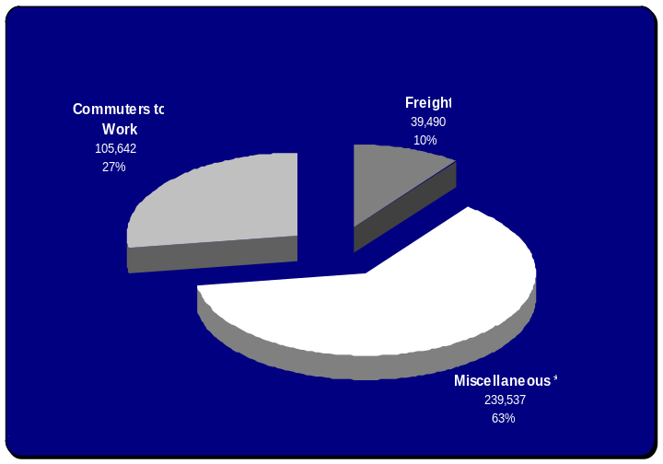
The total traffic composition coming into Travis County from its north and south borders, as seen in FIGURE 6-1, is made up of 27% worker-commuter traffic, 10% freight traffic, and 62% miscellaneous traffic. The 27% commuters to work traffic consists 22% of our primary study area, Hays and Williamson County, and 5% of our secondary study area, Bexar, Caldwell, Comal, and Guadalupe County. The 10% freight traffic consists of 6% freight traffic at the Williamson and Travis County border, and 4% at the Hays and Travis County border. See TABLE 6-3 for a complete listing of the traffic composition counts and percentages. The most dominant percentage is the miscellaneous traffic equaling 239,537 out of the 384,699 average daily vehicles that are not worker-commuter or freight.
FIGURE 6-1. 2000 IH-35 traffic composition entering Travis County
TRAFFIC TYPETRAFFIC COUNT% OF TOTAL TRAFFICCommuters to Work105,64227%Primary86,14822%Secondary19,4945%Freight39,49010%Miscellaneous*239,53762%
TABLE 6-3. 2000 composition of IH-35 traffic entering Travis County

6.5.2 2025 Traffic Composition
The total traffic count in 2025, as seen in TABLE 6-4, is made up of 38% worker-commuter traffic, 6% freight traffic, and 56% miscellaneous traffic. The commuter traffic is made up of 33% primary study area counties, and 5% secondary study area counties. The total increase in the amount of traffic entering Travis County from its north and south borders consists of an average of 730,389 more vehicles per day in 2025. The dominant percentage of traffic is the miscellaneous traffic.
TRAFFIC TYPETRAFFIC COUNT% OF TOTAL TRAFFICCommuters to Work425,86438%Primary367,98433%Secondary57,8805%Freight63,7546%Miscellaneous*625,44056%
TABLE 6-4. 2025 composition of IH-35 traffic entering Travis County

6.6 REASSIGNMENT RESULTS
The SH 130 project plans for the future highway to run from Williamson County around Austin and then paralleling IH 35 south to IH 10 at Seguin. Two other possibilities for routes that we derived, as seen in APPENDIX I-H, incorporate roads closer to the problem area. Reassignment route A originates from IH 35 on the south side of Travis County at FM 1327. This route utilizes FM 1327 to direct traffic from IH 35 east to SH 130/183. Reassignment route B utilizes roads in San Marcos to direct traffic off of IH 35 to the east and then north to SH 130/183. The southern point of origin for this route is the intersection of SH 80 and IH 35 where it follows SH 80 east for approximately one mile before turning on to SH 21. Route B then turns northeast and follows SH 21 until it intersects SH 130/183. This route follows the proposed SH 130 north where it meets up with IH 35 in Williamson County.

7. DISCUSSION
7.1 ANALYSIS
7.1.1 Congestion Analysis
Within our data, IH 35 in Travis County has been broken up into many different segments and each segment has differing characteristics that can impede traffic flow like number of lanes, presence or absence of shoulders and speed limits. All of these characteristics lead to a ratio of volume to capacity where the higher ratios equal higher levels of service (LOS A-F). Where LOS A equals free-flow and LOS F equals traffic flow breakdown. Since each segment of IH 35 has varying volume to capacity ratios and LOS’s we were able to look at these areas and define where there were problems and where there was need to alleviate traffic volume. While it might seem elementary that IH-35 in Travis County is heavily congested, mapping the areas of congestion enabled us to visualize the spatial extent of congestion. By looking at these same types of analyses in Hays and Williamson Counties we were able to look at possible through traffic reassignment routes to avoid these areas of severe congestion.

7.1.2 Freight Analysis
The Truck volume total percentage was compared to the values produced by TxDOT in IH 35/SH 130 through truck diversion analysis. Our calculations are only .27% less than TxDOT’s value (60.77%) for the truck volume at the Hays–Travis County line. For the Williamson—Travis County line our value is 10.57% less than TxDOT’s value (50.07%). The diversion analysis compared 1994 and 1996 truck counts. Our analysis used 1998 values and 2025 estimated values from the SAM. The results favor the conclusion that the freight traffic south of Austin is growing at the same pace as the rest of the traffic population. North of Austin, the freight traffic continues to grow but at a slower pace than the growth in passenger cars. This difference is due to the 80% unanticipated growth Williamson County has recently experienced. We then multiplied the percentage times the Estimated Truck values in the data table for each data year, which produced four new attributes of truck volumes broken down by direction and year for display and refined analysis.
The 1998 percentage of trucks in the traffic stream is 14.1% at the Hays-Travis boarder and 6.9% at the Williamson-Travis boarder. TxDOTs 1998 Truck Diversion report established a 14.52% and 28.28% growth respectively based on 1994 and 1996 data. Again, the unprecedented 80% growth in Williamson County, of primarily bedroom communities, accounts for the drop in the truck to car ratio. It is important to recognize that the truck volume is growing.
Additional consideration that needs to be taken into account for is the length of roadway a combination truck requires compared to passenger cars. Combination trucks can be as long as 80 feet with the newest and largest tractors pulling 53 ft and as much as 59 ft trailers. An average passenger car length is 17 ft. That is close to a five to one ratio. More importantly is the maneuvering and braking distance required to operate a commercial truck. According to Carvalu at http://www.carvalu.com/comparison.asp, cars take an average of 147 ft to stop after the reaction distance, which is much to variable. Empty combination trucks (35,000 lbs) take 130 yards to stop from 60 mph. A fully loaded standard size rig (80,000 lbs) takes three times as much distance to stop. Commercial trucks in some areas are as much as 120,000 lbs and take even further to stop. Since, in practice, car drivers do not allow trucks to maintain these great distances of open roadway in front of them truck collisions almost always result in fatalities for the auto. In addition, a commercial vehicle requires a larger open area available to change lanes which can cause traffic slow downs.

7.1.3 Work-Commuter Traffic
The work-commuter traffic makes up the second largest percentage of the traffic composition. It would be a good place to begin a reassignment or alternate transportation analysis. If the commuters going into Travis County had routes other than just IH-35 to move north or south in the east part of Austin, it would take off the pressure on the highway. With the amount of increase in population by 2025, if a new method of commuting to Travis County is not found, whether by reassignment or a provision of alternate transportation, then commuting will become impossible.

7.1.4 Miscellaneous Traffic
The miscellaneous traffic encompasses the majority of our traffic composition. It contains the remaining traffic consisting of anything that is not work-commuter traffic or freight traffic. The miscellaneous traffic is the undetermined traffic congesting the IH-35 corridor. It could possibly include the inner-county worker traffic within Travis County, the thru-traffic that is passing into and out of Travis County without stopping, the recreational, economic, and visiting traffic. The result of the miscellaneous traffic, it being such a large piece of the composition within Travis County, constitutes future studies to be done. The miscellaneous traffic is a good starting point for further analysis with this study.
7.1.5 Reassignment
Using the results from our congestion analysis, we were able to suggest two different possibilities for through traffic reassignment around Travis County. These two routes were named Route A and Route B. Route A directed traffic off of IH 35 before the congestion reached high levels but it originates in an area that will no doubt grow exponentially in size in the near future. This would mean that at some point in the future traffic flow from the south would experience heavy congestion before reaching the reassignment route. It is because of this reason that we looked at a reassignment route that originates farther to the south (Route B). Route B originates in San Marcos where traffic is diverted away from IH 35 and around two cities (Kyle and Buda) that are growing at a rate that will definitely cause volume to capacity problems in the future.

7.1.6 Commuter Rail
The main study on the map in APPENDIX I-I is to divert traffic on IH-35 and make those drivers become rail passengers to and from work. This will alleviate much of the congestion during rush hour. The trains are expected to open up as early as 2007 with trains running north and south. Other than a non-stop run during rush hour, the trains may also run all day and night in 30 minute intervals. Buses are planned to take people back and forth to the train station in 3-4 areas of Austin.

7.2 If we had more time…
If we had more time with this project, we would perform several more analyses based on both ideas we came across in our research, and methodologies. We have reached a point now where we feel that we understand enough about both transportation and geographic information science studies to accomplish a significant study of the traffic problems and possible solutions. The results of this semester’s work are a strong foundation to understanding the applications that a geographic information system and science poses for transportation, and strengthened our research and GIS techniques.
Some of the ideas that we found in our research that we think would be a good continuation for this study are a more thorough reassignment analysis of the Texas Department of Transportation’s (TxDOT) proposed solutions, alternate route creation, and mass transit and legislation impacts on the congestion. Lack of sufficient time hampered our efforts to complete a thorough analysis on the impacts that SH-130 and the Big T will have on the congestion on the IH-35 corridor. Both the Big T and SH-130 will create an alternate path for traffic to flow, and in essence will be creating a loop around Austin. Austin commuters need a more versatile means of traveling east to west. The Trans Texas Corridor, though still in its early planning stages, could alleviate a lot of the freight traffic, but again, lack of data did not allow for us to delve too deeply into the matter.
Another concept that was discussed, but time prevented any analysis, is the concept of a city to city loop system. San Antonio boasts a stable road network for a city of that size and continued growth is encouraged by the Loop 1604. This outer loop concept has been adopted by other cities on the IH-35 corridor. San Marcos and Kyle each have a Transportation Master Plan that lays out plans for an outer loop encircling the city. The interesting concept here is that the San Marcos and Kyle outer loops connect with each other. If every city on the corridor were to coordinate their transportation planning to connect a system of loops, an alternate path north and south of IH-35 would be created. This alternate path could also serve as a bypass and increase the connectivity between smaller metropolitan areas.
Methodologies, as previously mentioned, were the weak point of our study. All comprehensive reports completed by TxDOT on IH-35 and other similar roadways were unavailable due to the high cost of the reports. Any additional reports were completely outdated being conducted prior to the Austin population growth of the 1990s. The growth of Austin occurred so fast that only the government possessed the resources to study the IH-35 traffic situation. TxDOT’s man power, funding, and data collection capability is unmatched in Texas and this monopoly on data and resources has caused a lack of studies for our group to cite. If our study were to continue, we would expend the monetary cost to obtain some TxDOT reports to support our methodologies. One that we came across, though too late in the semester, was called a gravity model. It is based on origin and destination. A geographical area, commonly traffic analysis zones, has a certain weight to it based on certain criteria. This weighting criteria can be land use, economic factors, or all in all, special generators. They are places that generate a lot of input or destination traffic. The origins are basically places of residence. Where these people are traveling to is based on the “gravity” of the destination transportation analysis zones. The method in which we performed our analysis on the number of commuters going into Travis County is a good preliminary look at the amount of commuter congestion, but the gravity model is a tested method that would hold true to our stated standards.

7.3 If we were to do this project again…
As students we are all glad of the opportunity to have worked on a project for a whole semester and know that if we were to do this project again, we would do things differently from the start. Hindsight is always 20/20. First of all, we now have a good understanding about traffic data and how it relates to roadways and the spatial areas it passes through. This project was overwhelming from the very start. Unfortunately, things never seemed to run smoothly either. What we did not know was that the trials of learning how to formulate a geographic information science project on our own would be a challenge in its own right. Another obstacle was that no one in Spatial Remedies, Incorporated had any experience or education with transportation. As a result everything had to be researched and learned. What is a TAZ, a CTPP? What is the Texas Department of Transportation (TxDOT)? Not knowing information goes for all projects. It is why someone would do a study, to figure out something unknown. With the knowledge and experience that we have now, though, we would know how to communicate with our contacts, how to obtain data, and how to conduct a research project more smoothly.
Two types of contacts that this project has given us the opportunity to work with are the inner contacts of the university, and real world transportation organization contacts. The primary learning experiences came from our work with the university’s computer technicians, and the Texas Department of Transportation (TxDOT).
With the computer technicians, we saw a glimpse of inner department issues that will apply to future jobs. Our project required us to use multiple different computer software packages that could only be installed by the computer technicians. Initially, our lab assistant was our connection to the lab technicians. We would tell her what we needed installed, she would make time to talk to the technicians, and then they would take care of the installations. What we learned through the semester, and what we would do differently from the start if we were to do this project again, is to use a smaller chain of command, and take care of as many things as we could with our group members who are connected first hand with the project. During the last part of the software installations, we worked with our lab assistant in contacts with the technicians, and it worked better because we had someone who knew exactly what we needed, and our lab assistant who knew how to work professionally with the technicians.
Our experience with the Texas Department of Transportation (TxDOT) taught us a lesson in data collection and bureaucracy. Agencies have designated people for designated positions, and people using those agencies are expected to follow those designations in their dealings with said organization. In the experience of our project, we found someone to help us at TxDOT, but that person was not designated to do so even though she was the project manager for the software we were using. If we were to do this project again, we would know from the start to ask who could help us with our question before asking the question.
Data collection was impacted by these bureaucratic designations, but even more so by the way in which we asked for the data. With our dealings with TxDOT for data collection, we have learned the inefficiency of trying to gather data without defining our data need assessments. At the start of this study, we had problems with the way in which we were asking for data because we did not know exactly what we wanted. As a result, we had difficulties explaining what we needed. If we were to do this project again, we have learned to define our data needs before trying to gather the data. We could then consistently and confidently ask for the data.
The sum experience of this project has given us the first hand experience to the process in which to analyze a geographic problem with a geographic information system and science. Like all work, however, the process must be repeated time and again in order to reach a state where we are sufficiently productive researchers. The majority of our learning experiences from this project came from doing many aspects of the research process wrong due to this reason or that. If we were to do this project again, or when we do another in the future, we would and will know the trouble areas in which to thoroughly accomplish before moving on. We have learned that a research study and analysis is a process in which you build upon the steps you accomplish along the way. This experience will make us more efficient researchers and as a result, if we could do this study again, the process would run smoother and the results would be closer to our stated standards.

8. CONCLUSION
A GIS is used to “provide solutions in three generic roles, namely, GIS as an information base, GIS as an analytical tool, and GIS as a decision support system” (Eastman, Jin, Kyem, and Toledano,1995, p.61). This study primarily used GIS as an information base which lead to analytical processes to the composition of the traffic on the IH-35 corridor in Travis County. In spite of the technical difficulties our group experienced with the Statewide Analysis Model (SAM) Analyst Interface we were able to complete a preliminary analysis of IH-35 traffic in the Austin area. Research and data collection indicated the complexity and breadth of the IH-35 traffic equation. The traffic situation in Austin occurred so quickly over the last 10-15 years that no organization, except TxDOT has had the manpower, data collection ability, or resources to analyze the situation properly. TxDOT’s data collected is contained in the SAM, which we used for our analysis with data from the U.S. Census bureau in the form of Census Transportation Planning Package (CTPP) data. These two sources allowed us to conduct a rudimentary analysis of traffic composition, density, and congestion. Our analysis helps to summarize a wide variety of data and has many variables, but we hope our findings offer some insight into the present traffic situation on IH-35 in the Austin area.
9. REFERENCES

Earth Tech. 2003. Design Schematic of Interstate Highway 35: From South of Onion Creek Pkwy to South of Hays CR 104. Building a Better IH-35 for Central Texas.
http://www.i35austin.com/south_map.shtml. Last accessed 26 April 2005.

Earth Tech. 2003. Design Schematic of Interstate Highway 35: From North of US 79 to North of Grand Avenue Pkwy. Building a Better IH-35 for Central Texas.
http://www.i35austin.com/north_map.shtml. Last accessed 26 April 2005.

Eastman, R.J., Jin, W., Kyem, P.A.A. and Toledano, J. 1995. “Raster Procedures for Multi-Criteria\Multi-Objective Decisions,” Photogrammetric Engineering and Remote Sensing, p.61

Geographic Data Technology, Inc., ESRI. 2004. mjr_hwys.sdc. ESRI Data & Maps. Redlands, CA: ESRI.

Glaser, Edward. “Table 1: High Fliers – Cities that grew by more than 10%”, City Growth and the 2000 Census: Which Places Grew, and Why. Brookings Institution, Washington, DC. May 2001. www.brookings.edu/es/urban/census/whygrowth.pdf. Last accessed Feb 14, 2005

Mannering, Fred L., Kilareski, Walter P., Washburn, Scott S. 2005. Principles of highway engineering, and traffic analysis. 2nd ed. Hoboken, NJ: John Wiley and Sons. Ch 5 p. 144,145, Ch 6 p. 177.

McVey, G., Kou, C., February 12, 1998. IH 35/SH 130 through truck diversion analysis: A technical report. Prepared by the Texas Department of Transportation, Austin District, Advanced Project Development. http://www.dot.state.tx.us/aus/mis/i35mis/trkstudy.htm Last accessed April 22, 2005.

Miller, Harvey. Shaw, Shih-Lung. 2001. Geograpic Information Systems for Transportation: Principles and Applications. New York, NY: Oxford University Press. Ch.6, Ch.7 p 214, Ch.8, Ch. 5.

Programing Division of the Texas Department of Transportation. 2004. Statewide Analysis Model. Austin, TX: Texas Department of Transportation.

Texas A&M University, Real Estate Center. 2001- Austin Market OverviewSources: Texas State Data Center. July 10, 2002. http://recenter.tamu.edu/mreports01/austin1.html. Last accessed Feb 14, 2005

Texas Department of Transportation (TxDOT). “Purpose and Need”. Texas Transportation Plan Update. Cambridge Systematics, Inc. 2003. http://www.dot.state.tx.us/tpp/transplan/transplan.htm. Last accessed Feb 14, 2005

U.S. Census Bureau Geography Division Cartographic Products Management Branch. 2001. 2000 Traffic Analysis Zones Cartographic Boundary Files. Cartographic Boundary Files.
http://www.census.gov/geo/www/cob/tz2000.html Last accessed 26 April 2005.

U.S. Department of Transportation Planning. 2005. Census Transportation Planning Package 2000. http://www.fhwa.dot.gov/ctpp/dataprod.htm, http://www.fhwa.dot.gov/ctpp/about.htm. Last accessed 26 April 2005.

