Green Leaf Consulting
Texas State University 12/04/2016

Maxwell Piotrzkowski: Project Manager
Alyssa Carvajal: GIS Analyst & Design
Dustin Posey: GIS Analyst & Design
Benjamin Griffith: GIS Analyst & Research
Table of Contents

Introduction……………………………………………………………………………………4-5
Problem Statement………….……………………………………….…………………….4
Summary……………………………………………………………………….............….4
Scope……………………………………………………………………...……………….5
Data..……………………………………………………………………………………………5-6
Data Received from the City of Austin Portal..…….………………………….………….5
Data Created by Green Leaf Consulting……….………………………………………….5
Possible Tree Planting Locations..……………………………………………...…………5
Buffers……………………………………………………………………………………..5
Tree Canopy Combined with Median Percentage………………………………………5-6
Alan Halter’s Report.. …………………………………………………………………….6
Methodology……………………………………………………………………………………6-9
Aggregating Data………………………………………………………………………….6
City of Austin……………………………………………………………………………...6
Alan Halter’s Report………………………………………………………………………6
Determining Criteria………………………………………………………………………7
Client Request…………………………………………………………………………...7-8
Choosing Possible Planting Locations…….……………………………………………...8
Compare Areas to Criteria………………………………………………………………...8
Final Locations……………………………………………………………………………8
Analyze and Manipulate Data…………………………………………………………..8-9
Create Map Book and Final Deliverables…………………………………………………9
Results…………………………………………………………………………………………9-10
Discussion…………………………………………………………………………………....10-11
Conclusion…………………………………………………………………………………...11-12
References……………………………………………………………………………………….12
Appendix…………………………………………………………………………………...14-167
Appendix 1: Group Member Contribution…………………………………………………...…15
Appendix II: Study Area…………………………………………………………………….16-25
Appendix III: Mapbook Pages……………………………………………………………..26-166
Appendix IV: Metadata

1. INTRODUCTION
1.1 PROBLEM STATEMENT
The City of Austin is a highly populated city. While this high population can result in many positive economic benefits, it also brings about negative environmental issues. The City of Austin Public Works Department has a goal of planting one thousand trees each year. The addition of these trees can mitigate the harmful effects of urban development by alleviating factors such as urban heat island, traffic calming, crime, and air quality and water quality issues. While the city has been successfully planting trees, there is no system in place to determine these planting locations and this effort has been driven by public request. The application of a Geographic Information Systems (GIS) would provide the City of Austin a scoring system for priority areas that are in need of trees being planted. These areas will fit the criteria established to ensure that the locations with the highest need of trees get the most attention.
1.2 SUMMARY
This project’s goal is to design a scoring system that will determine ideal locations that the Public Works Department of the City of Austin can plant trees. This study will examine planting factors determined by Alan Halter, a former employee of the City of Austin Urban Forestry Department, from his Tree Planting Prioritization Report. These categories Halter designated significant included public health and safety, air quality, environmental justice, water quality, critical places, forest replenishment needs, tree preservation and development impacts, and urban heat islands. Each of these have multiple factors within them that determined their overall priority score. Other factors determining these locations will be overhead utility interference as well as locations with enough area to plant fifty or more trees, as this is more cost efficient for the city. Also, these areas will be focused around residential areas and ideally on medians. The areas of focus will be divided among the ten political districts within Austin. This study will identify the areas within Austin City Limits that will be the most beneficial as well as the most cost effective to plant trees.
1.3 SCOPE
This study was based within the full purpose Austin City Limits in locations with high priority for tree planting. These areas were divided between the ten political districts, with a focus on residential areas. A visual representation of not only the scope of the project, but the specific locations that will be examined is presented in Appendix II.
2. DATA
2.1 DATA RECEIVED FROM THE CITY OF AUSTIN PORAL
For the purposes of this project we have employed multiple different spatial datasets to create a workable map that shows tree planting prioritization and potential planting sites. Most of these datasets are readily available through the GIS open data portal on the City of Austin website. The datasets acquired from the City of Austin that will be used in this project will be as follows:
- City of Austin Jurisdictional Boundaries – our study area will only include sites within the full purpose jurisdictional boundaries
- Single Member Council Districts – we will find potential planting sites in each district with input from each respective council members
- Urban Roadways – to establish a reference for planting locations
- Tree Planting Prioritization 2014 – this dataset uses a 2014 study to show levels of tree planting prioritization by census tract by taking into account many different factors (air quality, water quality, etc.). This dataset is a good guide to finding high priority areas.
- Tree Canopy 2010 – this dataset will show which areas in Austin lack tree cover
2.2 DATA CREATED BY GREEN LEAF CONSULTING
2.2.1 POSSIBLE TREE PLANTING LOCATIONS
Google Earth Imagery of the entire city of Austin was analyzed to find any grass medians within the full purpose jurisdiction that could be a possible planting location. Ten grass medians that fit the planting criteria were recorded as points and imported into ArcMap for further analysis.
2.2.2 BUFFERS
The points imported from Google Earth imagery were used to locate and separate the sections of road containing grassy medians into individual layers. A two hundred feet buffer was then created around each section of road for analysis of the existing tree canopy.
2.2.3 TREE CANOPY COMBINED WITH MEDIAN PERCENTAGE
The tree canopy cover data that was received from the City of Austin Data Portal was initially a raster. This presented issues when trying to combine this data with the buffers we had previously created surrounding the medians. In order to amend this issue, we had to use the raster to polygon conversion tool to make these two datasets compatible. Once that step was complete, the layers were then combined with the tree canopy raster using a raster calculator. This yielded a raster layer with a count of pixels that contained tree canopy and a count of pixels with no tree canopy, allowing for a calculation of the percentage of the existing tree canopy that surrounds the possible tree locations.
2.3 ALAN HALTER’S REPORT
In Alan Halter’s 2014 report “Tree Planting Prioritization,” Halter analyzes the data of multiple factors that he deemed important in deciding the prioritization of tree planting locations. These factors include public health & safety, air quality, environmental justice, water quality, critical places, forest replenishment, forest preservation & development impacts, and urban heat islands. Halter standardized the data of each factor and ran a statistical analysis to score each census tract in Austin to identify high priority census tracts. The results of Halter’s report were imported into ArcMap to visualize the prioritized census tracts. The prioritization of the census tracts in Halter’s report were a major factor in determining the prioritization of the locations identified in this project.
3. METHODOLOGY
3.1 AGGREGATING DATA
3.1.1 CITY OF AUSTIN
Before beginning any analysis, a base map needed to be created in order to establish reference points for tree planting locations. This base map was created using data such as major roads, city council districts, and city boundaries, all from the City of Austin Open Data Portal. Much of this data included areas outside of the full purpose Austin City Limits and thus required some manipulation to only show the areas that were under the City of Public Works Department’s jurisdiction. For this process, we selected only areas that fell within the Full Purpose Austin City Limits and created new layers from this selection. This step in our project resulted in a map of major roads, ten city council districts, and a city boundary outline of just our area of interest. Once this step was complete, research was done to find any other information that we could use to determine which areas were in the most need for trees. Through this, we came across a report on tree planting prioritization done by a former employee of the City of Austin, Alan Halter, in 2014.
3.1.2 ALAN HALTER’S REPORT
Alan Halter’s Tree Planting Prioritization Report was used as a basis of where to look for possible tree planting locations. Halter adopted the methodology he used in his research and analysis from other cities that have done similar research projects in order to create his own scoring system for prioritization (Halter, 2014). His scoring system was developed through analysis of many factors that were deemed most valuable to both the city and the environment. These factors include public health & safety, air quality, environmental justice, water quality, critical places, forest replenishment, forest preservation & development impacts, and urban heat islands. The prioritization in Halter’s report showed locations of the city that had the most need when all of the factors were combined. Once adding Halter’s tree prioritization data to our working document, Green Leaf Consulting determined additional criteria that possible planting areas needed to adhere to.
3.2 DETERMINING CRITERIA
3.2.1 CLIENT REQUEST
Since the Public Works Department of the City of Austin would be responsible for planting the trees in the locations chosen through this research, it was important to take their requests and suggestions into consideration. Through a meeting with Rob Grotty, the Urban Forestry Program Manager for the City of Austin, all additional criteria were determined. The factors the possible tree planting locations had to meet in order to be a candidate for planting were that they needed to be on a median that was on an arterial/thoroughfare road in a residential area. The reasoning for this being that medians offered a greater amount of space than areas along sidewalks and in front of homes would and they are already owned by the city. Arterial roads were more probable because they have less of a chance of being property of the Texas Department of Transportation and they contain more medians than major roads would. There is a focus in residential areas because those areas tend to have higher needs. Trees would also improve the quality of life for those living in these areas. Another criterion is that areas need to be clear of overhead utilities to allow room for the trees to grow. It was also requested that the areas are big enough for fifty or more trees to be planted. The City of Austin is able to plant two large trees thirty feet apart with one medium tree in the middle, fifteen feet from the trees to either side. This is an important factor because maintaining one location with a greater amount of trees was much more efficient and cost effective than having many areas with a few trees at each.
3.3 CHOOSING POSSIBLE PLANTING LOCATIONS
With all criteria determined, Green Leaf Consulting moved forward in choosing actual locations to plant trees. Through examining aerial imagery from Google Earth, twenty locations were selected as possible planting locations. These areas were on medians along arterial roads in residential areas. Most of these locations also fell into the high priority zones determined in Alan Halter’s report. We converted the points we had placed in Google Earth to shapefiles so that we could further analyze and edit this data in ArcMap. Once these locations were chosen, further examination was needed to ensure the areas met the previously determined criteria.
3.4 COMPARE AREAS TO CRITERIA
Each of the twenty locations chosen previously were first checked for overhead utilities that could limit the tree’s growth. In this step, we found that ten out of twenty locations had utility interference. We then compared each of these locations to the other determined criteria, taking note of how well they met this criterion.
3.4.1 FINAL LOCATIONS
With the final ten locations chosen, we rated them based on which had the most planting space, which were in areas of most need according to Alan Halter’s report, how they compared to our other criteria and began our analysis.
3.5 ANALYZE AND MANIPULATE DATA
A buffer was created that contained the area surrounding the chosen medians by two hundred feet. We used the raster to polygon conversion tool to convert tree canopy cover data from the City of Austin Open Data Portal so that it could then be merged with the buffers previously created. Through this, we could compare the area within the buffer that contained tree canopy and the areas without it. This resulted in a percentage. We determined that the areas with the lower percentage, meaning less tree cover surrounding the medians, were in most need. We also created attribute information for our medians that will be used while generating final deliverables. This attribute includes spatial information of each proposed planting location, as well as the existing tree canopy, prioritization zone, district number, dominant surrounding land use, and total median length.
3.6 CREATE MAP BOOK AND FINAL DELIVERABLES
With all of the information gathered in previous steps, Green Leaf Consulting was ready to create a final product. We chose a mapbook as our final deliverable because it was an easy way for our client to see a visual of each location, as well as the attributes that that will be helpful in determining which locations have the highest need. A mapbook is also a convenient media that will allow our client to share our results with others. In order to create this, we made our map document into data-driven pages. This creates several pages in a format that we design from the data in our map document.
4. RESULTS
In the end, we were able to create a database depicting medians in high priority zones, based off Allen Halters prioritization map while following the clients request to focus on residential areas, large medians and low utility interaction. This database allows for easy identification of accessible medians within locations that have the biggest need for new tree planting. We have also created map books of ten prime locations that fall into major priority zones, and fit the criteria provided by the City of Austin. These locations are Howard Lane, Wells Branch Parkway, Metric Boulevard, Braker Lane, Samsung Boulevard, Koenig, Dean Keeton, Stassney Lane, Westgate Boulevard, and Slaughter Lane. Each of these roads represents one of the ten districts and at different levels of census tract priority, and includes buffered medians with a 200-foot radius and preexisting tree canopy. Within the buffer, the percentage of prior tree cover was calculated to produce a clear visualization of those locations needs. The two highest priority needs were Wells Branch three percent and Samsung ten percent tree cover. These locations already exist in high priority districts and clearly reflect a need for improvement and new planting in the area. The areas with the lowest priority were Stassney Lane at twenty-three percent and West Gate at fifty percent. West Gate represents the maximum existing tree cover percentage in our analysis, no other location contained above twenty-five percent tree cover. This means that even though a location may be in a low priority census tract, there are still locations that need vast improvement. From a subjective point of view, having roughly fifty percent tree cover in a location is ideal for the City of Austin’s goals. As the City of Austin is planning for the planting of one thousand trees a year, observing the percentage of existing tree cover in an area will greatly improve the location analysis and identification of ideal medians for future planting projects. To add to this analysis, the length, width and number of medians also plays an important role in this project, in order to allow for new planting and sustainability in the new locations.
The primary objective for this project was to locate medians that are large enough to plant around fifty trees, while avoiding underground utilities and having minimal interaction with above ground utilities. However due to time constraints, we were not able to gather a full detailed underground utility report from Texas 811 in regards to several primary medians. The ten selected locations provided by Green Leaf Consulting have undergone an initial underground utility checks and have been marked as clear. These selected medians are located in high priority areas with ample space for the planting of medium and large trees located within the ten districts.
After pinpointing these locations, we added a buffer to our selected medians and incorporated the preexisting tree canopy. This can be observed in Appendix III where preexisting tree cover is marked as green points. This reflects where the highest need for tree cover is located, along with priority level, the percentage of existing tree cover, median length, district number, number of available medians, and land use for this section. These mapbook pages have been ordered in Appendix III in such a way that the locations with the highest priority are first and the locations become less critical as it continues. Each location represents a priority area in each of the ten districts, and have been ranked from very high to very low in the census tract based of Allen Halters tree prioritization map, and the criteria created for the City of Austin.
By utilizing our primary attributes and the existing priority map, we were able to identify specific locations that are in high priority areas. This then reflects the impact area of new planting in these medians. While these sites should be used as a guideline for planting locations, we recommend that they be checked by Texas 811 prior to excavation.
5. DISCUSSION
The planting of trees along medians in Austin will help reduce the effects of urban heat islands by absorbing solar energy and providing shade to sun scorched roads, as well as reducing flooding, and add to the replenishment of the preexisting tree canopy. This will help not only the environment but make travel down these roads less strenuous, providing shade and better aesthetics for drivers. This should help improve driving conditions, as well as increasing property values due to better aesthetics.
We also contacted the council members in charge of the districts to see where each district needs help with tree planting. Each council member wants the best for his or her district and wants to improve upon areas that are most important to them. District 1, run by council member Houston, has a preference for historic land marks, and community centers. District 2 and 4 run by council member Garza and Casar respectively, are looking to improve neighborhoods, family centers and schools. District 3 run by council member Renteria, is looking to replenish natural areas, parks, and ecological zones. District 5 run by council member Kitchen is looking to improve areas around hospitals, medical facilities and neighborhoods. District 6 run by council member Zimmerman, is looking to add better aesthetics to local schools and businesses. District 7 run by council member Pool, is looking to improve community centers, recreational facilities, and neighborhoods. District 8 run by council member Troxclair, is looking to improve neighborhoods, and natural areas. District 9 run by council member Tovo, is looking to improve neighborhoods, schools and historic area. And finally district 10 run by council member Gallo is primarily looking to improve neighborhoods, and schools.
As the majority of council members are mainly concerned with the improvement of local neighborhoods and schools, medians in those areas should garner higher preference when looking for ideal locations. As with the provided map books, we selected locations that fit into the district’s request, while allotting ample room for planting trees in groups of ten and above while also avoiding known utility interference. These suggestions should be taken into account for future planting efforts in these locations when and where applicable.
The primary issues our group came into were with data collection. Usable source data was difficult to acquire from the City of Austin’s GIS portal without special clearance, slowing down production. Several other minor issues arose that our team had to find ways to work around however one in particular caused and unavoidable problem. We were asked to try and gain underground utility data from Texas 811, however due to the timeframe of this project, we ended up forgoing that task as some of our tickets are still being processed. Even though the data from Texas 811 has been postponed, we suggest that future endeavors using our preselected locations be examined when a longer amount of time is allotted to this project. Overall, the issues we ran into were all minor and were quickly fixed or worked around to produce a strong product that we believe the City of Austin can utilize to great effect in the future. During the finalization of our GIS, we ran into difficulties attaching the tree canopy layer to the buffer in a way that clearly represented the data we were trying to project. At the time the buffer was only overlaying to the base map and not including the tree canopy. To remedy this, we worked within the raster calculator to combine the layers and produce a zero to one image, where zero represents no existing tree cover and one representing existing tree cover. To reflect the importance of adding trees to these selected locations, we kept the buffer at two hundred feet. Prior to the set radius, we had tried a three-hundred-foot buffer, however it ended up capturing far too much of the area than was needed creating false negatives, any smaller and the buffer would not capture accurate data and represent false positives in our data. This would mean that with a false negative, the area would appear to have a much higher percentage of tree cover and reflect a much lower need for an area that is high priority based on Allen Halters reference map, where as a false positive would reflect a much higher need in areas that are lower priority. This analysis is based on a nearest neighbor analysis that weighs the points based on the nearness of similar points. As shown while a very sensitive form of analysis, it is also a very accurate one. There were also supplemental data errors that we ran into that caused us to reevaluate our goals and desires for this project, such as using Lidar imagery to create an in-depth map, however the area and data size far exceeded our usage capabilities.
The database that we are providing is easily to work with and edit to reflect the needs of the cities forestry program, this flexibility should be a useful feature to the City of Austin’s future endeavors. This can include tracking social and environmental data after trees have been planted and study what effects if any, new vegetation has had on the surrounding area. Examples of this are tracking traffic data, comparing crime rates before and after the planting of trees, or even surveying residents of these areas to see the general feeling to the new planted trees in the area.
6. CONCLUSION
In conclusion, the Tree Planting Prioritization project that was undertaken by Green Leaf Consulting resulted in ten possible planting locations for the City of Austin Public Works Department to further examine and possible plant trees. The total area these locations offered was twenty thousand feet. Through analysis and work in ArcGIS, a mapbook was created that includes the tree canopy percentage, the score of the area determined in Halter’s report, the length of the median, the district the area falls in, the number of medians that could possibly be planted on, the land use of that location, as well as a map as a visual aid to examine the locations.
Overall, the City of Austin will be able to implement the criteria that has been determined in the future as they continue to strive towards the goal of planting 1,000 trees each year. The ten locations that have been chosen are a good starting point and we hope that our criteria we created will aid in finding more locations in the years to come. This research has utilized many different types of analysis as well as project skills and has been an educational opportunity for all that took part in the project.
7. REFERENCES
Grove, J.M.; Nowak, D.; O'Neil-Dunne, J.; Pelletier, K; Walton, J. 2006. A report on New York City's present and possible urban tree canopy: Prepared for Fiona Watt, Chief of the Division of Forestry and Horticulture. New York Department of Parks and Recreation, USDA Forest Service, Northern Research Station. 28 pp
Maco, S. E., and E. G. McPherson. 2002. Assessing Canopy Cover over Streets and Sidewalks in Street Tree Populations. Journal of Arboriculture 28, No. 6 (November): 270-276.
Grove, J. Morgan; Galvin, Michael; Locke, Dexter H.; Murphy, Charles; and O'Neil-Dunne, Jarlath, P.M. 2013. Applications of Urban Tree Canopy Assessment and Prioritization Tools: Supporting Collaborative Decision Making to Achieve Urban Sustainability Goals. Cities and the Environment (CATE): Vol. 6: Iss. 1, Article 7.
Freer-Smith, Peter; Sinnett, Danielle; Tallis, Matthew; Taylor, Gail. 2011. Estimating the removal of atmospheric particulate pollution by the urban tree canopy of London, under current and future environments. Landscape and Urban Planning, v 103, n 2, p 129-138.
Bettinger, Pete; Bowker, J.M.; Siry, Jacek; Merry, Krista. 2013. Efficient assessments of urban tree planting potential within or near the southern Piedmont region of the United States. Computers, Environment and Urban Systems, v 39, 39-47.
City of Austin. Average Bid Price 2014, Web. 28 Sep 2016. http://www.austintexas.gov/page/average-bid-prices
8. Appendix
Appendix I: GROUP MEMBER CONTRIBUTION
Alyssa Carvajal-
For this project, I helped distribute tasks and sections for each of the reports that needed to be completed. My sections for all of the reports were the introductions, backgrounds, summaries, tasks, timeline, conclusion, table of contents, and appendixes. I also did the methodology section for the final report. I then put the proposal, progress report, and the final report together and formatted them according to the instructor’s request. I also proof read and edited the other team member’s sections to ensure the quality and that there were no mistakes. I made the proposal presentation as well as the progress report presentation. Since I had prior experience making project posters, I created our project poster as well.
During the project, I researched to find useful data online and manipulated this data to fit our project’s needs, such as the Austin City Limits data, the District Boundary data, and the Tree Planting Prioritization data from Alan Halter’s research. Together, our group determined what kind of final product we wanted. I took part in deciding on the criteria to choose planting locations as well as looking through Google Earth to find locations. Once these locations were found, I was given three of the locations to do a utility check on. This involved creating a ticket and then corresponding back and forth with the utility companies as this process progressed. Then through searching on Google, Dustin and I figured out how to do analysis to determine the percentage of tree canopy cover that fell within a 200 feet buffer that Max created from our chosen medians and shared that with the group. After this step was complete, I helped create the final product of the mapbook and taught my teammates how to create it.
Dustin Posey-
For the project, I designed the logo for Green Leaf Consulting in Adobe Illustrator. I also contacted council members from the ten districts that we were working with to inquire about what was most important for them within their zone. I assisted with median location and selection as well as with base map creation. Throughout the project, I also helped with supplemental data and research.
Ben Griffith-
I helped plan and collect the data needed to carry out the project. Also, clipped several of the layers to the full purpose boundary once we were certain we had the correct shape file. Helped with the group effort of deciding how to best display the information we wanted the reader to see. Once we reached this point we decided the best way to search for new planting areas would be to divide the city into four sections and scan street by street. I researched, wrote and rewrote the literature review for our groups progress report. I assisted with the many hours spent scouring Austin’s Full Purpose area for potential planting locations. We each then reviewed the locations we had found for overhead utilities that would automatically disqualify a planting location. Once we had our final locations we got back together and we all worked on the final report and deliverables. I completed the metadata and wrote the abstract for the final report of the project.
Maxwell Piotrzkowski-
As project manager my primary objective was to keep the project on track to completion. This often meant allocating tasks to the other group members and developing the processes that would help our team reach the final goal. However, the entire group, myself included, shared equal roles carrying out those tasks. Each group member searched Google Earth Imagery for planting locations and gave those locations to me. From that point I was largely responsible for creating and maintaining the ArcMap project. Many of the ideas for the project and problem solving solutions were a collective effort of the group, and those efforts were then reflected in the map project that I maintained which produced our final deliverables such as the mapbook. For the project proposal and project report I wrote the data & methodology sections and the data section for the final report.

APPENDIX II: STUDY AREA
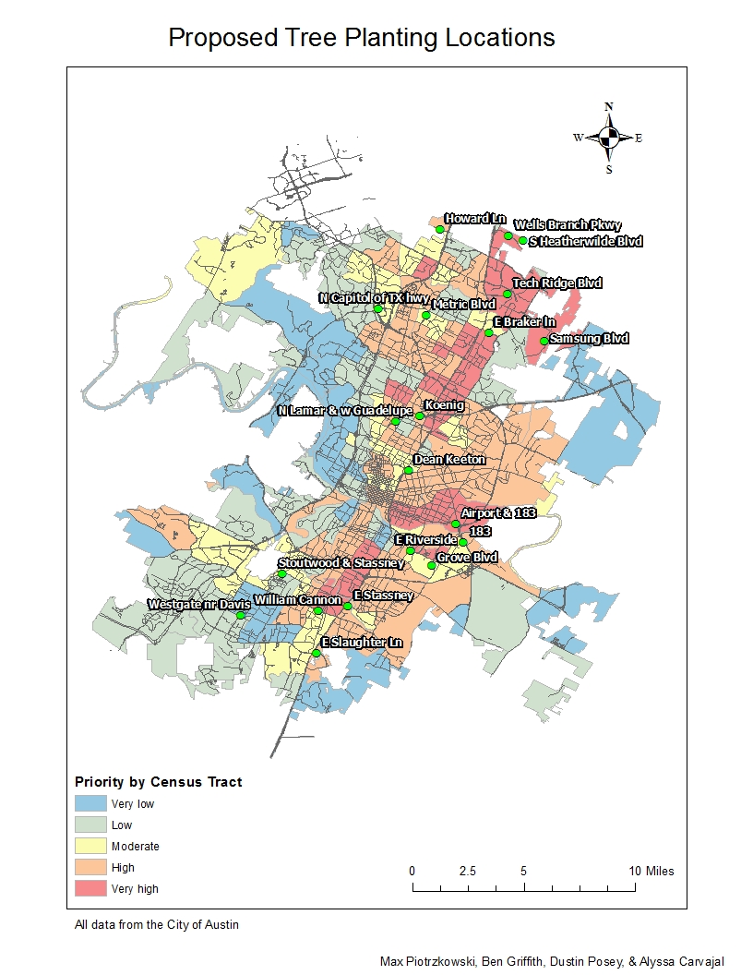 This figure is a visual representation of not only the scope of the project, but the specific locations that will be examined
Appendix IV: MAPBOOK PAGES 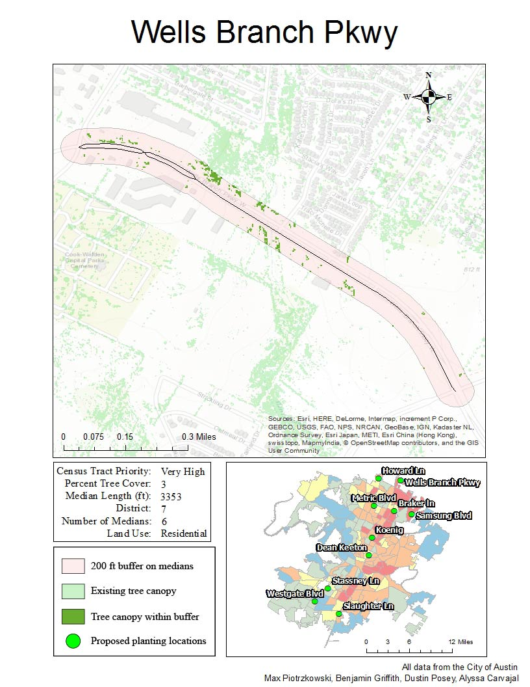

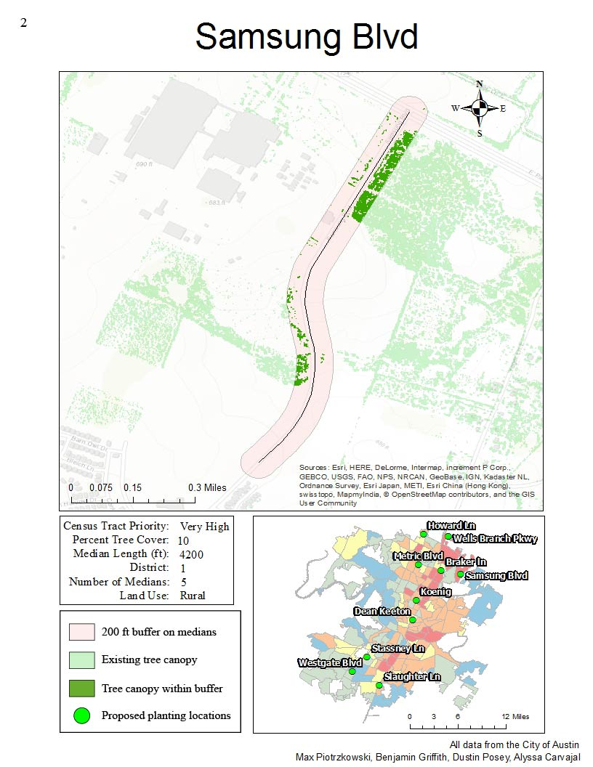

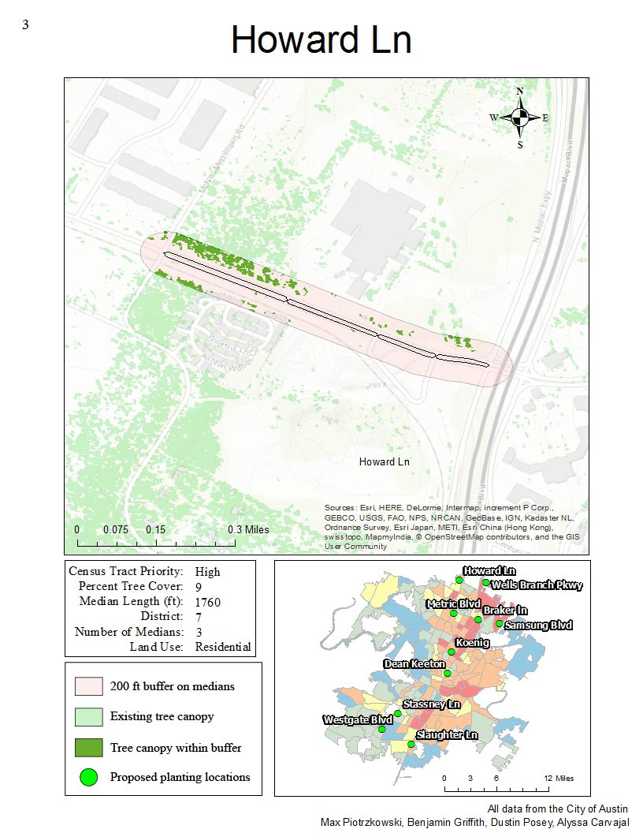

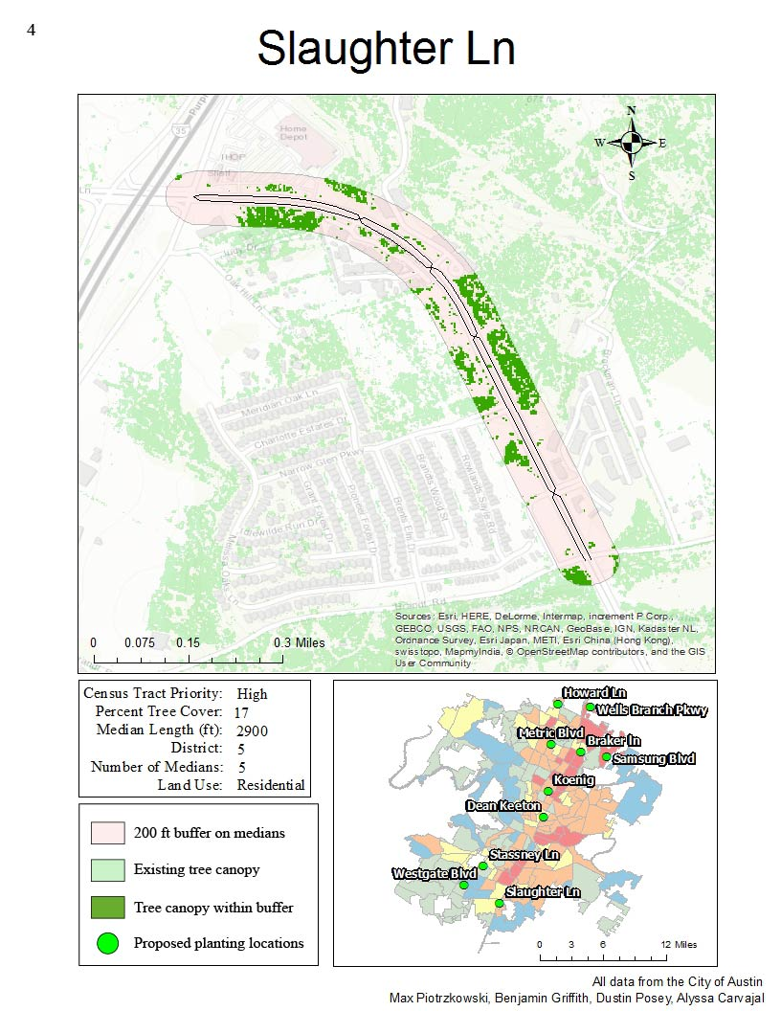

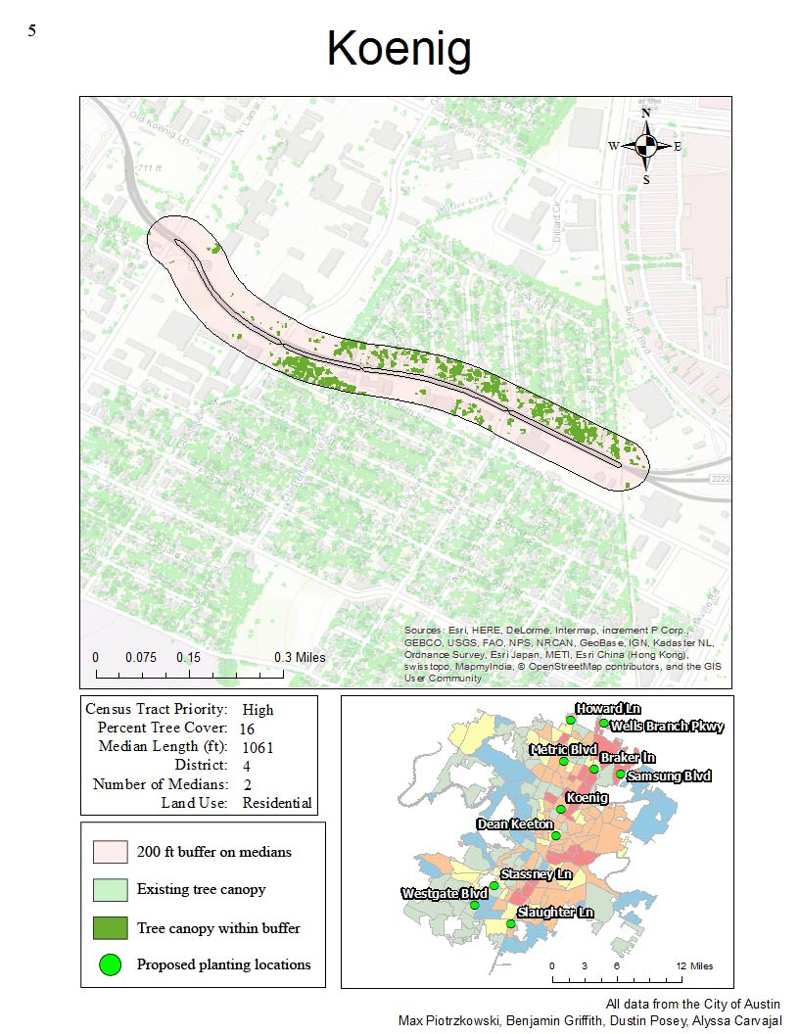

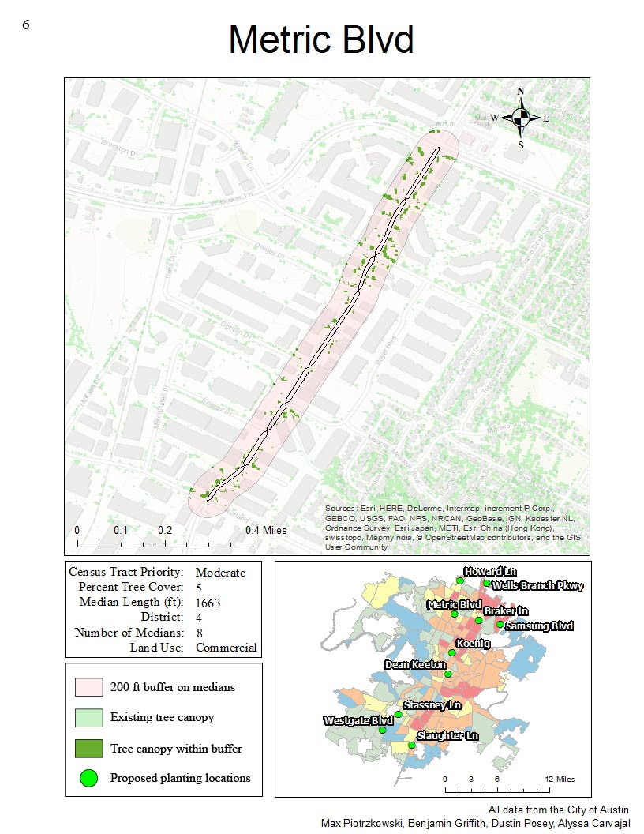
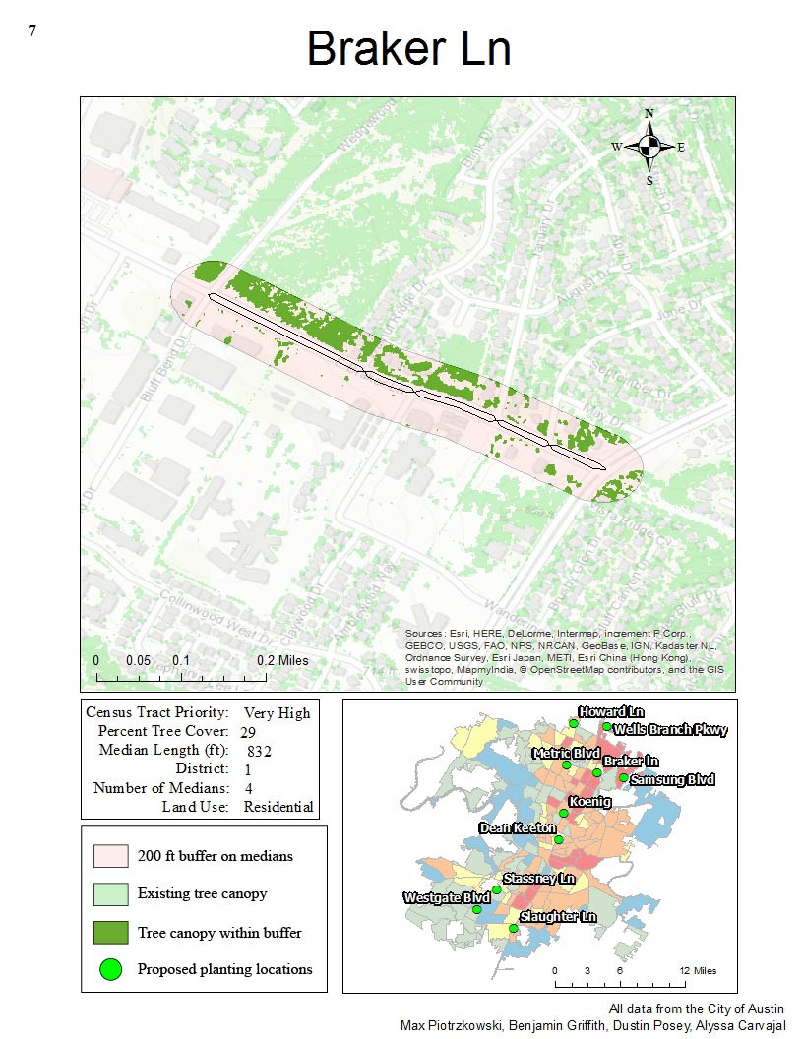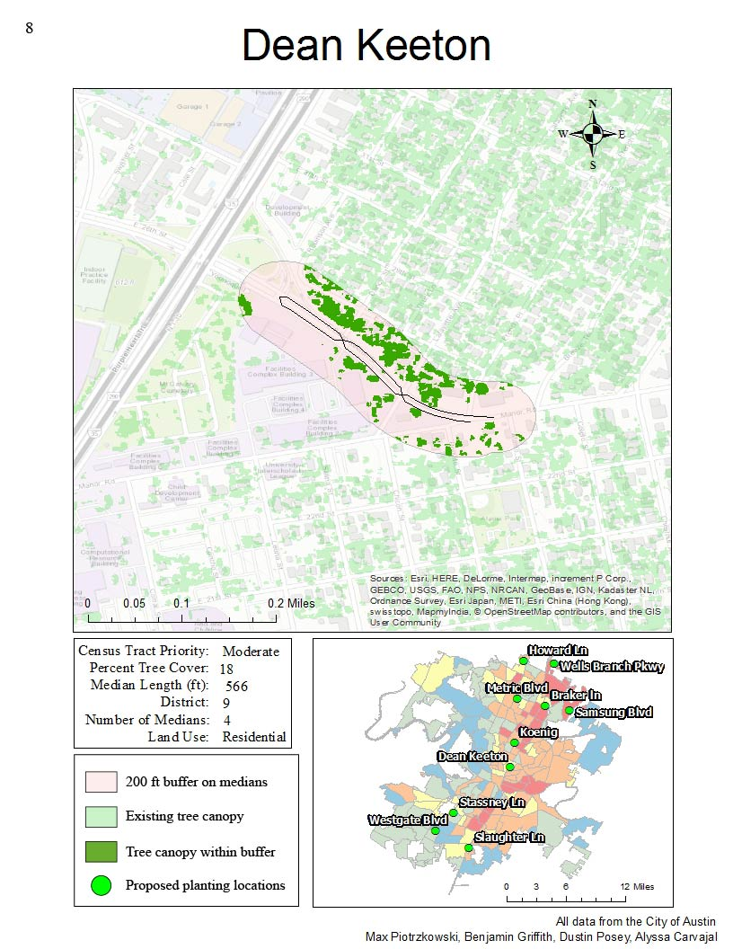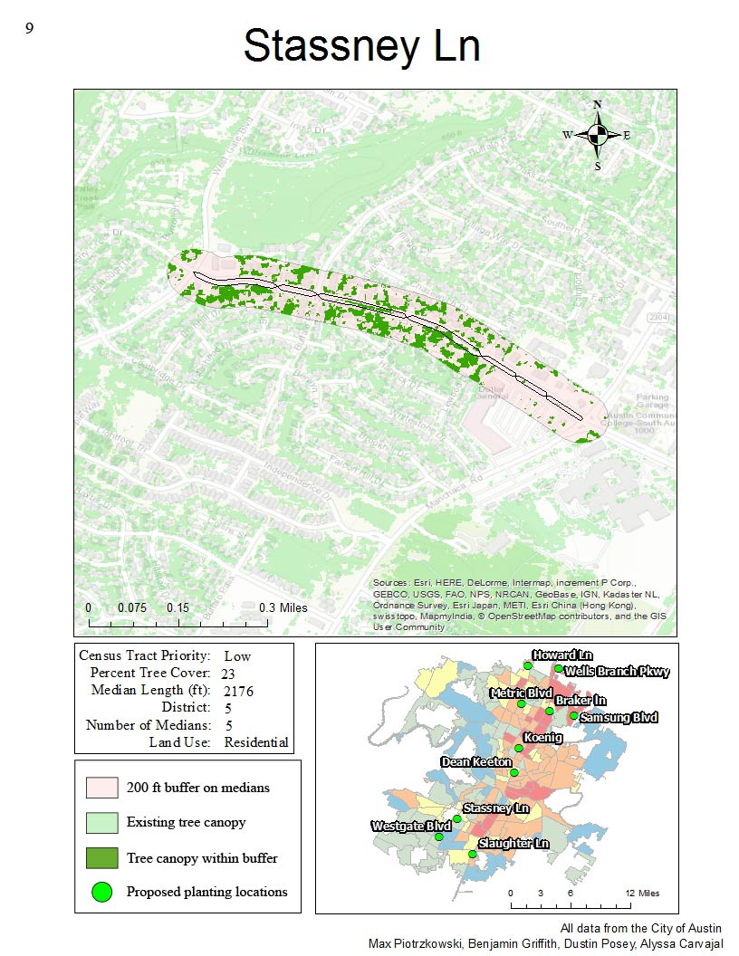

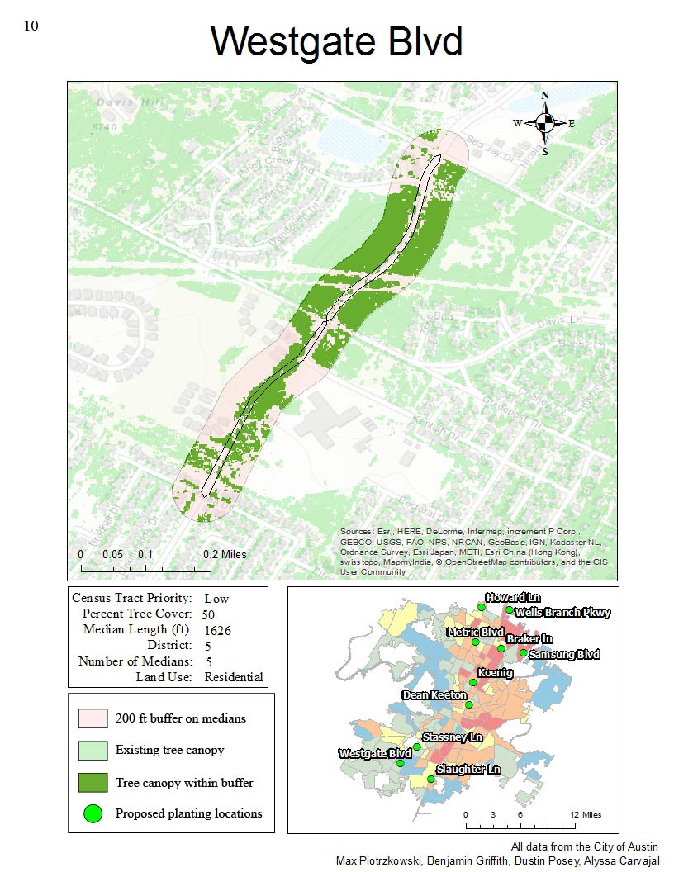

Appendix V: METADATA

Dean_Keeton_calc
File Geodatabase Raster Dataset
Thumbnail Not Available
Tags
There are no tags for this item.

Summary
This was created to calculate the number of existing trees within the 200' buffer we created around the roads.
Description
There is no description for this item.
Credits
There are no credits for this item.
Use limitations
There are no access and use limitations for this item.
Extent
West | -97.724325 | East | -97.719762
North | 30.286474 | South | 30.283465
Scale Range
Maximum (zoomed in) | 1:5,000
Minimum (zoomed out) | 1:150,000,000

ArcGIS Metadata ►

Topics and Keywords ►
* Content type Downloadable Data
Hide Topics and Keywords ▲

Citation ►
* Title Dean_Keeton_calc
Presentation formats * digital table
Hide Citation ▲

Resource Details ►
Dataset languages * English (UNITED STATES)
Spatial representation type * grid
* Processing environment Version 6.2 (Build 9200) ; Esri ArcGIS 10.4.0.5524
ArcGIS item properties
* Name Dean_Keeton_calc
* Location file://\\GEO-209590\E\GIS Design\AustinTree\Project_Databases\Austin_trees\Default.gdb
* Access protocol Local Area Network

Hide Resource Details ▲

Extents ►
Extent
Geographic extent
Bounding rectangle
Extent type Extent used for searching
* West longitude -97.724325
* East longitude -97.719762
* North latitude 30.286474
* South latitude 30.283465
* Extent contains the resource Yes

Extent in the item's coordinate system
* West longitude -97.724325
* East longitude -97.719762
* South latitude 30.283465
* North latitude 30.286474
* Extent contains the resource Yes

Hide Extents ▲

Spatial Reference ►
ArcGIS coordinate system
* Type Geographic
* Geographic coordinate reference WGS84(DD)
* Coordinate reference details
Geographic coordinate system
X origin -400
Y origin -400
XY scale 11258999068426.238
Z origin -100000
Z scale 10000
M origin -100000
M scale 10000
XY tolerance 8.983152841195215e-009
Z tolerance 0.001
M tolerance 0.001
High precision true
Left longitude -180
Well-known text GEOGCS["WGS84(DD)",DATUM["WGS84",SPHEROID["WGS84",6378137.0,298.257223563]],PRIMEM["Greenwich",0.0],UNIT["degree",0.0174532925199433]]

Reference system identifier
* Value 0
Hide Spatial Reference ▲

Distribution ►
Distribution format
* Name File Geodatabase Raster Dataset
Hide Distribution ▲

Fields ►

Details for object VAT_Dean_Keeton_calc ►
* Type Table
* Row count 2
Field OBJECTID ►
* Alias OBJECTID
* Data type OID
* Width 4
* Precision 0
* Scale 0
* Field description
Internal feature number.

* Description source
Esri

* Description of values
Sequential unique whole numbers that are automatically generated.

Hide Field OBJECTID ▲

Field Value ►
* Alias Value
* Data type Integer
* Width 4
* Precision 0
* Scale 0
Hide Field Value ▲

Field Count ►
* Alias Count
* Data type Double
* Width 8
* Precision 0
* Scale 0
Hide Field Count ▲

Hide Details for object VAT_Dean_Keeton_calc ▲

Hide Fields ▲

Metadata Details ►
* Metadata language English (UNITED STATES)
* Metadata character set utf8 - 8 bit UCS Transfer Format
Scope of the data described by the metadata * dataset
Scope name * dataset
* Last update 2016-12-01
ArcGIS metadata properties
Metadata format ArcGIS 1.0
Metadata style FGDC CSDGM Metadata
Standard or profile used to edit metadata FGDC
Created in ArcGIS for the item 2016-11-30 12:16:45
Last modified in ArcGIS for the item 2016-12-01 11:58:38
Automatic updates
Have been performed Yes
Last update 2016-12-01 11:58:38

Hide Metadata Details ▲

FGDC Metadata (read-only) ►

Spatial Data Organization ►
Raster Object Information
Raster Object Type Pixel
Row Count 250
Column Count 379
Vertical Count 1

Hide Spatial Data Organization ▲

Spatial Reference ►
Horizontal Coordinate System Definition
Planar
Planar Coordinate Information
Planar Coordinate Encoding Method row and column
Coordinate Representation
Abscissa Resolution 0.000012
Ordinate Resolution 0.000012

Hide Spatial Reference ▲

Entities and Attributes ►
Detailed Description
Entity Type
Entity Type Label VAT_Dean_Keeton_calc

Attribute
Attribute Label OBJECTID
Attribute Definition
Internal feature number.
Attribute Definition Source Esri
Attribute Domain Values
Unrepresentable Domain
Sequential unique whole numbers that are automatically generated.

Attribute
Attribute Label Value

Attribute
Attribute Label Count

Hide Entities and Attributes ▲

Dean_Keeton_Buffer_Dissolve2
File Geodatabase Feature Class
Thumbnail Not Available
Tags
There are no tags for this item.

Summary
Dissolve multiple buffers into a singular 200' buffer around the road.
Description
There is no description for this item.
Credits
There are no credits for this item.
Use limitations
There are no access and use limitations for this item.
Extent
West | -97.724325 | East | -97.719761
North | 30.286474 | South | 30.283465
Scale Range
Maximum (zoomed in) | 1:5,000
Minimum (zoomed out) | 1:150,000,000

ArcGIS Metadata ►

Topics and Keywords ►
* Content type Downloadable Data
Hide Topics and Keywords ▲

Citation ►
* Title Dean_Keeton_Buffer_Dissolve2
Presentation formats * digital map
Hide Citation ▲

Resource Details ►
Dataset languages * English (UNITED STATES)
Spatial representation type * vector
* Processing environment Version 6.2 (Build 9200) ; Esri ArcGIS 10.4.0.5524
ArcGIS item properties
* Name Dean_Keeton_Buffer_Dissolve2
* Location file://\\GEO-209590\E\GIS Design\AustinTree\Project_Databases\Austin_trees\Default.gdb
* Access protocol Local Area Network

Hide Resource Details ▲

Extents ►
Extent
Geographic extent
Bounding rectangle
Extent type Extent used for searching
* West longitude -97.724325
* East longitude -97.719761
* North latitude 30.286474
* South latitude 30.283465
* Extent contains the resource Yes

Extent in the item's coordinate system
* West longitude -97.724325
* East longitude -97.719761
* South latitude 30.283465
* North latitude 30.286474
* Extent contains the resource Yes

Hide Extents ▲

Spatial Reference ►
ArcGIS coordinate system
* Type Geographic
* Geographic coordinate reference WGS84(DD)
* Coordinate reference details
Geographic coordinate system
X origin -400
Y origin -400
XY scale 1111948722.2222221
Z origin -100000
Z scale 10000
M origin -100000
M scale 10000
XY tolerance 8.983152841195215e-009
Z tolerance 0.001
M tolerance 0.001
High precision true
Left longitude -180
Well-known text GEOGCS["WGS84(DD)",DATUM["WGS84",SPHEROID["WGS84",6378137.0,298.257223563]],PRIMEM["Greenwich",0.0],UNIT["degree",0.0174532925199433]]

Reference system identifier
* Value 0
Hide Spatial Reference ▲

Spatial Data Properties ►

Vector ►
* Level of topology for this dataset geometry only
Geometric objects
Feature class name Dean_Keeton_Buffer_Dissolve2
* Object type composite
* Object count 1

Hide Vector ▲

ArcGIS Feature Class Properties ►
Feature class name Dean_Keeton_Buffer_Dissolve2
* Feature type Simple
* Geometry type Polygon
* Has topology FALSE
* Feature count 1
* Spatial index TRUE
* Linear referencing FALSE

Hide ArcGIS Feature Class Properties ▲

Hide Spatial Data Properties ▲

Geoprocessing history ►
Process
Process name Buffer (2)
Date 2016-11-16 13:45:51
Tool location c:\program files (x86)\arcgis\desktop10.4\ArcToolbox\Toolboxes\Analysis Tools.tbx\Buffer
Command issued
Buffer U:\Tree_database.gdb\Dean_Keeton C:\Users\mjp100\Documents\ArcGIS\Default.gdb\Dean_Keeton_Buffer2 "200 Feet" FULL ROUND NONE # PLANAR
Include in lineage when exporting metadata No
Process
Process name Dissolve (10)
Date 2016-11-16 13:45:52
Tool location c:\program files (x86)\arcgis\desktop10.4\ArcToolbox\Toolboxes\Data Management Tools.tbx\Dissolve
Command issued
Dissolve C:\Users\mjp100\Documents\ArcGIS\Default.gdb\Dean_Keeton_Buffer2 C:\Users\mjp100\Documents\ArcGIS\Default.gdb\Dean_Keeton_Buffer_Dissolve2 # # MULTI_PART DISSOLVE_LINES
Include in lineage when exporting metadata No
Hide Geoprocessing history ▲

Distribution ►
Distribution format
* Name File Geodatabase Feature Class
Hide Distribution ▲

Fields ►

Details for object Dean_Keeton_Buffer_Dissolve2 ►
* Type Feature Class
* Row count 1
Field OBJECTID ►
* Alias FID
* Data type OID
* Width 4
* Precision 0
* Scale 0
* Field description
Internal feature number.

* Description source
Esri

* Description of values
Sequential unique whole numbers that are automatically generated.

Hide Field OBJECTID ▲

Field Shape ►
* Alias Shape
* Data type Geometry
* Width 0
* Precision 0
* Scale 0
* Field description
Feature geometry.

* Description source
Esri

* Description of values
Coordinates defining the features.

Hide Field Shape ▲

Field Shape_Length ►
* Alias Shape_Length
* Data type Double
* Width 8
* Precision 0
* Scale 0
* Field description
Length of feature in internal units.

* Description source
Esri

* Description of values
Positive real numbers that are automatically generated.

Hide Field Shape_Length ▲

Field Shape_Area ►
* Alias Shape_Area
* Data type Double
* Width 8
* Precision 0
* Scale 0
* Field description
Area of feature in internal units squared.

* Description source
Esri

* Description of values
Positive real numbers that are automatically generated.

Hide Field Shape_Area ▲

Hide Details for object Dean_Keeton_Buffer_Dissolve2 ▲

Hide Fields ▲

Metadata Details ►
Metadata language English (UNITED STATES)
Metadata character set utf8 - 8 bit UCS Transfer Format
Scope of the data described by the metadata dataset
Scope name * dataset
* Last update 2016-12-01
ArcGIS metadata properties
Metadata format ArcGIS 1.0
Standard or profile used to edit metadata FGDC
Created in ArcGIS for the item 2016-11-16 12:59:35
Last modified in ArcGIS for the item 2016-12-01 11:59:45
Automatic updates
Have been performed Yes
Last update 2016-12-01 11:59:45

Hide Metadata Details ▲

FGDC Metadata (read-only) ►

Entities and Attributes ►
Detailed Description
Entity Type
Entity Type Label Dean_Keeton_Buffer_Dissolve2

Attribute
Attribute Label OBJECTID
Attribute Definition
Internal feature number.
Attribute Definition Source Esri
Attribute Domain Values
Unrepresentable Domain
Sequential unique whole numbers that are automatically generated.

Attribute
Attribute Label Shape
Attribute Definition
Feature geometry.
Attribute Definition Source Esri
Attribute Domain Values
Unrepresentable Domain
Coordinates defining the features.

Attribute
Attribute Label Shape_Length
Attribute Definition
Length of feature in internal units.
Attribute Definition Source Esri
Attribute Domain Values
Unrepresentable Domain
Positive real numbers that are automatically generated.

Attribute
Attribute Label Shape_Area
Attribute Definition
Area of feature in internal units squared.
Attribute Definition Source Esri
Attribute Domain Values
Unrepresentable Domain
Positive real numbers that are automatically generated.

Hide Entities and Attributes ▲

Howard_calc
File Geodatabase Raster Dataset
Thumbnail Not Available
Tags
There are no tags for this item.

Summary
This was created to calculate the number of existing trees within the 200' buffer we created around the roads.
Description
There is no description for this item.
Credits
There are no credits for this item.
Use limitations
There are no access and use limitations for this item.
Extent
West | -97.708414 | East | -97.698158
North | 30.444132 | South | 30.439866
Scale Range
Maximum (zoomed in) | 1:5,000
Minimum (zoomed out) | 1:150,000,000

ArcGIS Metadata ►

Topics and Keywords ►
* Content type Downloadable Data
Hide Topics and Keywords ▲

Citation ►
Title Howard_calc
Presentation formats * digital table
Hide Citation ▲

Resource Details ►
Dataset languages * English (UNITED STATES)
Spatial representation type * grid
* Processing environment Version 6.2 (Build 9200) ; Esri ArcGIS 10.4.0.5524
ArcGIS item properties
* Name Howard_calc
* Location file://\\GEO-209590\E\GIS Design\AustinTree\Project_Databases\Austin_trees\Default.gdb
* Access protocol Local Area Network

Hide Resource Details ▲

Extents ►
Extent
Geographic extent
Bounding rectangle
Extent type Extent used for searching
* West longitude -97.708414
* East longitude -97.698158
* North latitude 30.444132
* South latitude 30.439866
* Extent contains the resource Yes

Extent in the item's coordinate system
* West longitude -97.708414
* East longitude -97.698158
* South latitude 30.439866
* North latitude 30.444132
* Extent contains the resource Yes

Hide Extents ▲

Spatial Reference ►
ArcGIS coordinate system
* Type Geographic
* Geographic coordinate reference WGS84(DD)
* Coordinate reference details
Geographic coordinate system
X origin -400
Y origin -400
XY scale 11258999068426.238
Z origin -100000
Z scale 10000
M origin -100000
M scale 10000
XY tolerance 8.983152841195215e-009
Z tolerance 0.001
M tolerance 0.001
High precision true
Left longitude -180
Well-known text GEOGCS["WGS84(DD)",DATUM["WGS84",SPHEROID["WGS84",6378137.0,298.257223563]],PRIMEM["Greenwich",0.0],UNIT["degree",0.0174532925199433]]

Reference system identifier
* Value 0
Hide Spatial Reference ▲

Distribution ►
Distribution format
* Name File Geodatabase Raster Dataset
Hide Distribution ▲

Fields ►

Details for object VAT_Howard_calc ►
* Type Table
* Row count 2
Field OBJECTID ►
* Alias OBJECTID
* Data type OID
* Width 4
* Precision 0
* Scale 0
* Field description
Internal feature number.

* Description source
Esri

* Description of values
Sequential unique whole numbers that are automatically generated.

Hide Field OBJECTID ▲

Field Value ►
* Alias Value
* Data type Integer
* Width 4
* Precision 0
* Scale 0
Hide Field Value ▲

Field Count ►
* Alias Count
* Data type Double
* Width 8
* Precision 0
* Scale 0
Hide Field Count ▲

Hide Details for object VAT_Howard_calc ▲

Hide Fields ▲

Metadata Details ►
* Metadata language English (UNITED STATES)
* Metadata character set utf8 - 8 bit UCS Transfer Format
Scope of the data described by the metadata * dataset
Scope name * dataset
* Last update 2016-12-01
ArcGIS metadata properties
Metadata format ArcGIS 1.0
Metadata style FGDC CSDGM Metadata
Standard or profile used to edit metadata FGDC
Created in ArcGIS for the item 2016-11-30 12:16:01
Last modified in ArcGIS for the item 2016-12-01 12:00:09
Automatic updates
Have been performed Yes
Last update 2016-12-01 12:00:09

Hide Metadata Details ▲

FGDC Metadata (read-only) ►

Spatial Data Organization ►
Raster Object Information
Raster Object Type Pixel
Row Count 250
Column Count 601
Vertical Count 1

Hide Spatial Data Organization ▲

Spatial Reference ►
Horizontal Coordinate System Definition
Planar
Planar Coordinate Information
Planar Coordinate Encoding Method row and column
Coordinate Representation
Abscissa Resolution 0.000017
Ordinate Resolution 0.000017

Hide Spatial Reference ▲

Entities and Attributes ►
Detailed Description
Entity Type
Entity Type Label VAT_Howard_calc

Attribute
Attribute Label OBJECTID
Attribute Definition
Internal feature number.
Attribute Definition Source Esri
Attribute Domain Values
Unrepresentable Domain
Sequential unique whole numbers that are automatically generated.

Attribute
Attribute Label Value

Attribute
Attribute Label Count

Hide Entities and Attributes ▲

Howard_Buffer_Dissolve2
File Geodatabase Feature Class
Thumbnail Not Available
Tags
There are no tags for this item.

Summary
Dissolve multiple buffers into a singular 200' buffer around the road.
Description
There is no description for this item.
Credits
There are no credits for this item.
Use limitations
There are no access and use limitations for this item.
Extent
West | -97.708414 | East | -97.698166
North | 30.444132 | South | 30.439866
Scale Range
Maximum (zoomed in) | 1:5,000
Minimum (zoomed out) | 1:150,000,000

ArcGIS Metadata ►

Topics and Keywords ►
* Content type Downloadable Data
Hide Topics and Keywords ▲

Citation ►
* Title Howard_Buffer_Dissolve2
Presentation formats * digital map
Hide Citation ▲

Resource Details ►
Dataset languages * English (UNITED STATES)
Spatial representation type * vector
* Processing environment Version 6.2 (Build 9200) ; Esri ArcGIS 10.4.0.5524
ArcGIS item properties
* Name Howard_Buffer_Dissolve2
* Location file://\\GEO-209590\E\GIS Design\AustinTree\Project_Databases\Austin_trees\Default.gdb
* Access protocol Local Area Network

Hide Resource Details ▲

Extents ►
Extent
Geographic extent
Bounding rectangle
Extent type Extent used for searching
* West longitude -97.708414
* East longitude -97.698166
* North latitude 30.444132
* South latitude 30.439866
* Extent contains the resource Yes

Extent in the item's coordinate system
* West longitude -97.708414
* East longitude -97.698166
* South latitude 30.439866
* North latitude 30.444132
* Extent contains the resource Yes

Hide Extents ▲

Spatial Reference ►
ArcGIS coordinate system
* Type Geographic
* Geographic coordinate reference WGS84(DD)
* Coordinate reference details
Geographic coordinate system
X origin -400
Y origin -400
XY scale 1111948722.2222221
Z origin -100000
Z scale 10000
M origin -100000
M scale 10000
XY tolerance 8.983152841195215e-009
Z tolerance 0.001
M tolerance 0.001
High precision true
Left longitude -180
Well-known text GEOGCS["WGS84(DD)",DATUM["WGS84",SPHEROID["WGS84",6378137.0,298.257223563]],PRIMEM["Greenwich",0.0],UNIT["degree",0.0174532925199433]]

Reference system identifier
* Value 0
Hide Spatial Reference ▲

Spatial Data Properties ►

Vector ►
* Level of topology for this dataset geometry only
Geometric objects
Feature class name Howard_Buffer_Dissolve2
* Object type composite
* Object count 1

Hide Vector ▲

ArcGIS Feature Class Properties ►
Feature class name Howard_Buffer_Dissolve2
* Feature type Simple
* Geometry type Polygon
* Has topology FALSE
* Feature count 1
* Spatial index TRUE
* Linear referencing FALSE

Hide ArcGIS Feature Class Properties ▲

Hide Spatial Data Properties ▲

Geoprocessing history ►
Process
Process name Buffer (3)
Date 2016-11-16 13:45:50
Tool location c:\program files (x86)\arcgis\desktop10.4\ArcToolbox\Toolboxes\Analysis Tools.tbx\Buffer
Command issued
Buffer U:\Tree_database.gdb\Howard C:\Users\mjp100\Documents\ArcGIS\Default.gdb\Howard_Buffer2 "200 Feet" FULL ROUND NONE # PLANAR
Include in lineage when exporting metadata No
Process
Process name Dissolve (9)
Date 2016-11-16 13:45:51
Tool location c:\program files (x86)\arcgis\desktop10.4\ArcToolbox\Toolboxes\Data Management Tools.tbx\Dissolve
Command issued
Dissolve C:\Users\mjp100\Documents\ArcGIS\Default.gdb\Howard_Buffer2 C:\Users\mjp100\Documents\ArcGIS\Default.gdb\Howard_Buffer_Dissolve2 # # MULTI_PART DISSOLVE_LINES
Include in lineage when exporting metadata No
Hide Geoprocessing history ▲

Distribution ►
Distribution format
* Name File Geodatabase Feature Class
Hide Distribution ▲

Fields ►

Details for object Howard_Buffer_Dissolve2 ►
* Type Feature Class
* Row count 1
Field OBJECTID ►
* Alias FID
* Data type OID
* Width 4
* Precision 0
* Scale 0
* Field description
Internal feature number.

* Description source
Esri

* Description of values
Sequential unique whole numbers that are automatically generated.

Hide Field OBJECTID ▲

Field Shape ►
* Alias Shape
* Data type Geometry
* Width 0
* Precision 0
* Scale 0
* Field description
Feature geometry.

* Description source
Esri

* Description of values
Coordinates defining the features.

Hide Field Shape ▲

Field Shape_Length ►
* Alias Shape_Length
* Data type Double
* Width 8
* Precision 0
* Scale 0
* Field description
Length of feature in internal units.

* Description source
Esri

* Description of values
Positive real numbers that are automatically generated.

Hide Field Shape_Length ▲

Field Shape_Area ►
* Alias Shape_Area
* Data type Double
* Width 8
* Precision 0
* Scale 0
* Field description
Area of feature in internal units squared.

* Description source
Esri

* Description of values
Positive real numbers that are automatically generated.

Hide Field Shape_Area ▲

Hide Details for object Howard_Buffer_Dissolve2 ▲

Hide Fields ▲

Metadata Details ►
* Metadata language English (UNITED STATES)
Scope of the data described by the metadata * dataset
Scope name * dataset
* Last update 2016-12-01
ArcGIS metadata properties
Metadata format ArcGIS 1.0
Standard or profile used to edit metadata FGDC
Created in ArcGIS for the item 2016-11-16 13:01:14
Last modified in ArcGIS for the item 2016-12-01 12:00:36
Automatic updates
Have been performed Yes
Last update 2016-12-01 12:00:36

Hide Metadata Details ▲

FGDC Metadata (read-only) ►

Entities and Attributes ►
Detailed Description
Entity Type
Entity Type Label Howard_Buffer_Dissolve2

Attribute
Attribute Label OBJECTID
Attribute Definition
Internal feature number.
Attribute Definition Source Esri
Attribute Domain Values
Unrepresentable Domain
Sequential unique whole numbers that are automatically generated.

Attribute
Attribute Label Shape
Attribute Definition
Feature geometry.
Attribute Definition Source Esri
Attribute Domain Values
Unrepresentable Domain
Coordinates defining the features.

Attribute
Attribute Label Shape_Length
Attribute Definition
Length of feature in internal units.
Attribute Definition Source Esri
Attribute Domain Values
Unrepresentable Domain
Positive real numbers that are automatically generated.

Attribute
Attribute Label Shape_Area
Attribute Definition
Area of feature in internal units squared.
Attribute Definition Source Esri
Attribute Domain Values
Unrepresentable Domain
Positive real numbers that are automatically generated.

Hide Entities and Attributes ▲

Koenig_Buffer_Dissolve2
File Geodatabase Feature Class
Thumbnail Not Available
Tags
There are no tags for this item.

Summary
Dissolve multiple buffers into a singular 200' buffer around the road.
Description
There is no description for this item.
Credits
There are no credits for this item.
Use limitations
There are no access and use limitations for this item.
Extent
West | -97.726970 | East | -97.715310
North | 30.326493 | South | 30.320095
Scale Range
Maximum (zoomed in) | 1:5,000
Minimum (zoomed out) | 1:150,000,000

ArcGIS Metadata ►

Topics and Keywords ►
* Content type Downloadable Data
Hide Topics and Keywords ▲

Citation ►
* Title Koenig_Buffer_Dissolve2
Presentation formats * digital map
Hide Citation ▲

Resource Details ►
Dataset languages * English (UNITED STATES)
Spatial representation type * vector
* Processing environment Version 6.2 (Build 9200) ; Esri ArcGIS 10.4.0.5524
ArcGIS item properties
* Name Koenig_Buffer_Dissolve2
* Location file://\\GEO-209590\E\GIS Design\AustinTree\Project_Databases\Austin_trees\Default.gdb
* Access protocol Local Area Network

Hide Resource Details ▲

Extents ►
Extent
Geographic extent
Bounding rectangle
Extent type Extent used for searching
* West longitude -97.726970
* East longitude -97.715310
* North latitude 30.326493
* South latitude 30.320095
* Extent contains the resource Yes

Extent in the item's coordinate system
* West longitude -97.726970
* East longitude -97.715310
* South latitude 30.320095
* North latitude 30.326493
* Extent contains the resource Yes

Hide Extents ▲

Spatial Reference ►
ArcGIS coordinate system
* Type Geographic
* Geographic coordinate reference WGS84(DD)
* Coordinate reference details
Geographic coordinate system
X origin -400
Y origin -400
XY scale 1111948722.2222221
Z origin -100000
Z scale 10000
M origin -100000
M scale 10000
XY tolerance 8.983152841195215e-009
Z tolerance 0.001
M tolerance 0.001
High precision true
Left longitude -180
Well-known text GEOGCS["WGS84(DD)",DATUM["WGS84",SPHEROID["WGS84",6378137.0,298.257223563]],PRIMEM["Greenwich",0.0],UNIT["degree",0.0174532925199433]]

Reference system identifier
* Value 0
Hide Spatial Reference ▲

Spatial Data Properties ►

Vector ►
* Level of topology for this dataset geometry only
Geometric objects
Feature class name Koenig_Buffer_Dissolve2
* Object type composite
* Object count 1

Hide Vector ▲

ArcGIS Feature Class Properties ►
Feature class name Koenig_Buffer_Dissolve2
* Feature type Simple
* Geometry type Polygon
* Has topology FALSE
* Feature count 1
* Spatial index TRUE
* Linear referencing FALSE

Hide ArcGIS Feature Class Properties ▲

Hide Spatial Data Properties ▲

Geoprocessing history ►
Process
Process name Buffer (4)
Date 2016-11-16 13:45:49
Tool location c:\program files (x86)\arcgis\desktop10.4\ArcToolbox\Toolboxes\Analysis Tools.tbx\Buffer
Command issued
Buffer U:\Tree_database.gdb\Koenig C:\Users\mjp100\Documents\ArcGIS\Default.gdb\Koenig_Buffer2 "200 Feet" FULL ROUND NONE # PLANAR
Include in lineage when exporting metadata No
Process
Process name Dissolve (8)
Date 2016-11-16 13:45:50
Tool location c:\program files (x86)\arcgis\desktop10.4\ArcToolbox\Toolboxes\Data Management Tools.tbx\Dissolve
Command issued
Dissolve C:\Users\mjp100\Documents\ArcGIS\Default.gdb\Koenig_Buffer2 C:\Users\mjp100\Documents\ArcGIS\Default.gdb\Koenig_Buffer_Dissolve2 # # MULTI_PART DISSOLVE_LINES
Include in lineage when exporting metadata No
Hide Geoprocessing history ▲

Distribution ►
Distribution format
* Name File Geodatabase Feature Class
Hide Distribution ▲

Fields ►

Details for object Koenig_Buffer_Dissolve2 ►
* Type Feature Class
* Row count 1
Field OBJECTID ►
* Alias FID
* Data type OID
* Width 4
* Precision 0
* Scale 0
* Field description
Internal feature number.

* Description source
Esri

* Description of values
Sequential unique whole numbers that are automatically generated.

Hide Field OBJECTID ▲

Field Shape ►
* Alias Shape
* Data type Geometry
* Width 0
* Precision 0
* Scale 0
* Field description
Feature geometry.

* Description source
Esri

* Description of values
Coordinates defining the features.

Hide Field Shape ▲

Field Shape_Length ►
* Alias Shape_Length
* Data type Double
* Width 8
* Precision 0
* Scale 0
* Field description
Length of feature in internal units.

* Description source
Esri

* Description of values
Positive real numbers that are automatically generated.

Hide Field Shape_Length ▲

Field Shape_Area ►
* Alias Shape_Area
* Data type Double
* Width 8
* Precision 0
* Scale 0
* Field description
Area of feature in internal units squared.

* Description source
Esri

* Description of values
Positive real numbers that are automatically generated.

Hide Field Shape_Area ▲

Hide Details for object Koenig_Buffer_Dissolve2 ▲

Hide Fields ▲

Metadata Details ►
* Metadata language English (UNITED STATES)
Scope of the data described by the metadata * dataset
Scope name * dataset
* Last update 2016-12-01
ArcGIS metadata properties
Metadata format ArcGIS 1.0
Standard or profile used to edit metadata FGDC
Created in ArcGIS for the item 2016-11-16 12:59:57
Last modified in ArcGIS for the item 2016-12-01 12:01:13
Automatic updates
Have been performed Yes
Last update 2016-12-01 12:01:13

Hide Metadata Details ▲

FGDC Metadata (read-only) ►

Entities and Attributes ►
Detailed Description
Entity Type
Entity Type Label Koenig_Buffer_Dissolve2

Attribute
Attribute Label OBJECTID
Attribute Definition
Internal feature number.
Attribute Definition Source Esri
Attribute Domain Values
Unrepresentable Domain
Sequential unique whole numbers that are automatically generated.

Attribute
Attribute Label Shape
Attribute Definition
Feature geometry.
Attribute Definition Source Esri
Attribute Domain Values
Unrepresentable Domain
Coordinates defining the features.

Attribute
Attribute Label Shape_Length
Attribute Definition
Length of feature in internal units.
Attribute Definition Source Esri
Attribute Domain Values
Unrepresentable Domain
Positive real numbers that are automatically generated.

Attribute
Attribute Label Shape_Area
Attribute Definition
Area of feature in internal units squared.
Attribute Definition Source Esri
Attribute Domain Values
Unrepresentable Domain
Positive real numbers that are automatically generated.

Hide Entities and Attributes ▲

Koenig_calc
File Geodatabase Raster Dataset
Thumbnail Not Available
Tags
There are no tags for this item.

Summary
This was created to calculate the number of existing trees within the 200' buffer we created around the roads.
Description
There is no description for this item.
Credits
There are no credits for this item.
Use limitations
There are no access and use limitations for this item.
Extent
West | -97.726970 | East | -97.715301
North | 30.326493 | South | 30.320095
Scale Range
Maximum (zoomed in) | 1:5,000
Minimum (zoomed out) | 1:150,000,000

ArcGIS Metadata ►

Topics and Keywords ►
* Content type Downloadable Data
Hide Topics and Keywords ▲

Citation ►
Title Koenig_calc
Presentation formats * digital table
Hide Citation ▲

Resource Details ►
Dataset languages * English (UNITED STATES)
Spatial representation type * grid
* Processing environment Version 6.2 (Build 9200) ; Esri ArcGIS 10.4.0.5524
ArcGIS item properties
* Name Koenig_calc
* Location file://\\GEO-209590\E\GIS Design\AustinTree\Project_Databases\Austin_trees\Default.gdb
* Access protocol Local Area Network

Hide Resource Details ▲

Extents ►
Extent
Geographic extent
Bounding rectangle
Extent type Extent used for searching
* West longitude -97.726970
* East longitude -97.715301
* North latitude 30.326493
* South latitude 30.320095
* Extent contains the resource Yes

Extent in the item's coordinate system
* West longitude -97.726970
* East longitude -97.715301
* South latitude 30.320095
* North latitude 30.326493
* Extent contains the resource Yes

Hide Extents ▲

Spatial Reference ►
ArcGIS coordinate system
* Type Geographic
* Geographic coordinate reference WGS84(DD)
* Coordinate reference details
Geographic coordinate system
X origin -400
Y origin -400
XY scale 11258999068426.238
Z origin -100000
Z scale 10000
M origin -100000
M scale 10000
XY tolerance 8.983152841195215e-009
Z tolerance 0.001
M tolerance 0.001
High precision true
Left longitude -180
Well-known text GEOGCS["WGS84(DD)",DATUM["WGS84",SPHEROID["WGS84",6378137.0,298.257223563]],PRIMEM["Greenwich",0.0],UNIT["degree",0.0174532925199433]]

Reference system identifier
* Value 0
Hide Spatial Reference ▲

Distribution ►
Distribution format
* Name File Geodatabase Raster Dataset
Hide Distribution ▲

Fields ►

Details for object VAT_Koenig_calc ►
* Type Table
* Row count 2
Field OBJECTID ►
* Alias OBJECTID
* Data type OID
* Width 4
* Precision 0
* Scale 0
* Field description
Internal feature number.

* Description source
Esri

* Description of values
Sequential unique whole numbers that are automatically generated.

Hide Field OBJECTID ▲

Field Value ►
* Alias Value
* Data type Integer
* Width 4
* Precision 0
* Scale 0
Hide Field Value ▲

Field Count ►
* Alias Count
* Data type Double
* Width 8
* Precision 0
* Scale 0
Hide Field Count ▲

Hide Details for object VAT_Koenig_calc ▲

Hide Fields ▲

Metadata Details ►
* Metadata language English (UNITED STATES)
* Metadata character set utf8 - 8 bit UCS Transfer Format
Scope of the data described by the metadata * dataset
Scope name * dataset
* Last update 2016-12-01
ArcGIS metadata properties
Metadata format ArcGIS 1.0
Metadata style FGDC CSDGM Metadata
Standard or profile used to edit metadata FGDC
Created in ArcGIS for the item 2016-11-30 12:15:12
Last modified in ArcGIS for the item 2016-12-01 12:01:42
Automatic updates
Have been performed Yes
Last update 2016-12-01 12:01:42

Hide Metadata Details ▲

FGDC Metadata (read-only) ►

Spatial Data Organization ►
Raster Object Information
Raster Object Type Pixel
Row Count 250
Column Count 456
Vertical Count 1

Hide Spatial Data Organization ▲

Spatial Reference ►
Horizontal Coordinate System Definition
Planar
Planar Coordinate Information
Planar Coordinate Encoding Method row and column
Coordinate Representation
Abscissa Resolution 0.000026
Ordinate Resolution 0.000026

Hide Spatial Reference ▲

Entities and Attributes ►
Detailed Description
Entity Type
Entity Type Label VAT_Koenig_calc

Attribute
Attribute Label OBJECTID
Attribute Definition
Internal feature number.
Attribute Definition Source Esri
Attribute Domain Values
Unrepresentable Domain
Sequential unique whole numbers that are automatically generated.

Attribute
Attribute Label Value

Attribute
Attribute Label Count

Hide Entities and Attributes ▲

Westgate_Buffer_Dissolve2
File Geodatabase Feature Class
Thumbnail Not Available
Tags
There are no tags for this item.

Summary
Dissolve multiple buffers into a singular 200' buffer around the road.
Description
There is no description for this item.
Credits
There are no credits for this item.
Use limitations
There are no access and use limitations for this item.
Extent
West | -97.836860 | East | -97.830258
North | 30.195224 | South | 30.186489
Scale Range
Maximum (zoomed in) | 1:5,000
Minimum (zoomed out) | 1:150,000,000

ArcGIS Metadata ►

Topics and Keywords ►
* Content type Downloadable Data
Hide Topics and Keywords ▲

Citation ►
* Title Westgate_Buffer_Dissolve2
Presentation formats * digital map
Hide Citation ▲

Resource Details ►
Dataset languages * English (UNITED STATES)
Spatial representation type * vector
* Processing environment Version 6.2 (Build 9200) ; Esri ArcGIS 10.4.0.5524
ArcGIS item properties
* Name Westgate_Buffer_Dissolve2
* Location file://\\GEO-209590\E\GIS Design\AustinTree\Project_Databases\Austin_trees\Default.gdb
* Access protocol Local Area Network

Hide Resource Details ▲

Extents ►
Extent
Geographic extent
Bounding rectangle
Extent type Extent used for searching
* West longitude -97.836860
* East longitude -97.830258
* North latitude 30.195224
* South latitude 30.186489
* Extent contains the resource Yes

Extent in the item's coordinate system
* West longitude -97.836860
* East longitude -97.830258
* South latitude 30.186489
* North latitude 30.195224
* Extent contains the resource Yes

Hide Extents ▲

Spatial Reference ►
ArcGIS coordinate system
* Type Geographic
* Geographic coordinate reference WGS84(DD)
* Coordinate reference details
Geographic coordinate system
X origin -400
Y origin -400
XY scale 1111948722.2222221
Z origin -100000
Z scale 10000
M origin -100000
M scale 10000
XY tolerance 8.983152841195215e-009
Z tolerance 0.001
M tolerance 0.001
High precision true
Left longitude -180
Well-known text GEOGCS["WGS84(DD)",DATUM["WGS84",SPHEROID["WGS84",6378137.0,298.257223563]],PRIMEM["Greenwich",0.0],UNIT["degree",0.0174532925199433]]

Reference system identifier
* Value 0
Hide Spatial Reference ▲

Spatial Data Properties ►

Vector ►
* Level of topology for this dataset geometry only
Geometric objects
Feature class name Westgate_Buffer_Dissolve2
* Object type composite
* Object count 1

Hide Vector ▲

ArcGIS Feature Class Properties ►
Feature class name Westgate_Buffer_Dissolve2
* Feature type Simple
* Geometry type Polygon
* Has topology FALSE
* Feature count 1
* Spatial index TRUE
* Linear referencing FALSE

Hide ArcGIS Feature Class Properties ▲

Hide Spatial Data Properties ▲

Geoprocessing history ►
Process
Process name Buffer (10)
Date 2016-11-16 13:45:44
Tool location c:\program files (x86)\arcgis\desktop10.4\ArcToolbox\Toolboxes\Analysis Tools.tbx\Buffer
Command issued
Buffer U:\Tree_database.gdb\Westgate C:\Users\mjp100\Documents\ArcGIS\Default.gdb\Westgate_Buffer2 "200 Feet" FULL ROUND NONE # PLANAR
Include in lineage when exporting metadata No
Process
Process name Dissolve (2)
Date 2016-11-16 13:45:44
Tool location c:\program files (x86)\arcgis\desktop10.4\ArcToolbox\Toolboxes\Data Management Tools.tbx\Dissolve
Command issued
Dissolve C:\Users\mjp100\Documents\ArcGIS\Default.gdb\Westgate_Buffer2 C:\Users\mjp100\Documents\ArcGIS\Default.gdb\Westgate_Buffer_Dissolve2 # # MULTI_PART DISSOLVE_LINES
Include in lineage when exporting metadata No
Hide Geoprocessing history ▲

Distribution ►
Distribution format
* Name File Geodatabase Feature Class
Hide Distribution ▲

Fields ►

Details for object Westgate_Buffer_Dissolve2 ►
* Type Feature Class
* Row count 1
Field OBJECTID ►
* Alias FID
* Data type OID
* Width 4
* Precision 0
* Scale 0
* Field description
Internal feature number.

* Description source
Esri

* Description of values
Sequential unique whole numbers that are automatically generated.

Hide Field OBJECTID ▲

Field Shape ►
* Alias Shape
* Data type Geometry
* Width 0
* Precision 0
* Scale 0
* Field description
Feature geometry.

* Description source
Esri

* Description of values
Coordinates defining the features.

Hide Field Shape ▲

Field Shape_Length ►
* Alias Shape_Length
* Data type Double
* Width 8
* Precision 0
* Scale 0
* Field description
Length of feature in internal units.

* Description source
Esri

* Description of values
Positive real numbers that are automatically generated.

Hide Field Shape_Length ▲

Field Shape_Area ►
* Alias Shape_Area
* Data type Double
* Width 8
* Precision 0
* Scale 0
* Field description
Area of feature in internal units squared.

* Description source
Esri

* Description of values
Positive real numbers that are automatically generated.

Hide Field Shape_Area ▲

Hide Details for object Westgate_Buffer_Dissolve2 ▲

Hide Fields ▲

Metadata Details ►
* Metadata language English (UNITED STATES)
Scope of the data described by the metadata * dataset
Scope name * dataset
* Last update 2016-12-01
ArcGIS metadata properties
Metadata format ArcGIS 1.0
Standard or profile used to edit metadata FGDC
Created in ArcGIS for the item 2016-11-16 12:58:46
Last modified in ArcGIS for the item 2016-12-01 12:02:13
Automatic updates
Have been performed Yes
Last update 2016-12-01 12:02:13

Hide Metadata Details ▲

FGDC Metadata (read-only) ►

Entities and Attributes ►
Detailed Description
Entity Type
Entity Type Label Westgate_Buffer_Dissolve2

Attribute
Attribute Label OBJECTID
Attribute Definition
Internal feature number.
Attribute Definition Source Esri
Attribute Domain Values
Unrepresentable Domain
Sequential unique whole numbers that are automatically generated.

Attribute
Attribute Label Shape
Attribute Definition
Feature geometry.
Attribute Definition Source Esri
Attribute Domain Values
Unrepresentable Domain
Coordinates defining the features.

Attribute
Attribute Label Shape_Length
Attribute Definition
Length of feature in internal units.
Attribute Definition Source Esri
Attribute Domain Values
Unrepresentable Domain
Positive real numbers that are automatically generated.

Attribute
Attribute Label Shape_Area
Attribute Definition
Area of feature in internal units squared.
Attribute Definition Source Esri
Attribute Domain Values
Unrepresentable Domain
Positive real numbers that are automatically generated.

Hide Entities and Attributes ▲

Westgate_calc
File Geodatabase Raster Dataset
Thumbnail Not Available
Tags
There are no tags for this item.

Summary
This was created to calculate the number of existing trees within the 200' buffer we created around the roads.
Description
There is no description for this item.
Credits
There are no credits for this item.
Use limitations
There are no access and use limitations for this item.
Extent
West | -97.836860 | East | -97.830258
North | 30.195230 | South | 30.186489
Scale Range
Maximum (zoomed in) | 1:5,000
Minimum (zoomed out) | 1:150,000,000

ArcGIS Metadata ►

Topics and Keywords ►
* Content type Downloadable Data
Hide Topics and Keywords ▲

Citation ►
Title Westgate_calc
Presentation formats * digital table
Hide Citation ▲

Resource Details ►
Dataset languages * English (UNITED STATES)
Spatial representation type * grid
* Processing environment Version 6.2 (Build 9200) ; Esri ArcGIS 10.4.0.5524
ArcGIS item properties
* Name Westgate_calc
* Location file://\\GEO-209590\E\GIS Design\AustinTree\Project_Databases\Austin_trees\Default.gdb
* Access protocol Local Area Network

Hide Resource Details ▲

Extents ►
Extent
Geographic extent
Bounding rectangle
Extent type Extent used for searching
* West longitude -97.836860
* East longitude -97.830258
* North latitude 30.195230
* South latitude 30.186489
* Extent contains the resource Yes

Extent in the item's coordinate system
* West longitude -97.836860
* East longitude -97.830258
* South latitude 30.186489
* North latitude 30.195230
* Extent contains the resource Yes

Hide Extents ▲

Spatial Reference ►
ArcGIS coordinate system
* Type Geographic
* Geographic coordinate reference WGS84(DD)
* Coordinate reference details
Geographic coordinate system
X origin -400
Y origin -400
XY scale 11258999068426.238
Z origin -100000
Z scale 10000
M origin -100000
M scale 10000
XY tolerance 8.983152841195215e-009
Z tolerance 0.001
M tolerance 0.001
High precision true
Left longitude -180
Well-known text GEOGCS["WGS84(DD)",DATUM["WGS84",SPHEROID["WGS84",6378137.0,298.257223563]],PRIMEM["Greenwich",0.0],UNIT["degree",0.0174532925199433]]

Reference system identifier
* Value 0
Hide Spatial Reference ▲

Distribution ►
Distribution format
* Name File Geodatabase Raster Dataset
Hide Distribution ▲

Fields ►

Details for object VAT_Westgate_calc ►
* Type Table
* Row count 2
Field OBJECTID ►
* Alias OBJECTID
* Data type OID
* Width 4
* Precision 0
* Scale 0
* Field description
Internal feature number.

* Description source
Esri

* Description of values
Sequential unique whole numbers that are automatically generated.

Hide Field OBJECTID ▲

Field Value ►
* Alias Value
* Data type Integer
* Width 4
* Precision 0
* Scale 0
Hide Field Value ▲

Field Count ►
* Alias Count
* Data type Double
* Width 8
* Precision 0
* Scale 0
Hide Field Count ▲

Hide Details for object VAT_Westgate_calc ▲

Hide Fields ▲

Metadata Details ►
* Metadata language English (UNITED STATES)
* Metadata character set utf8 - 8 bit UCS Transfer Format
Scope of the data described by the metadata * dataset
Scope name * dataset
* Last update 2016-12-01
ArcGIS metadata properties
Metadata format ArcGIS 1.0
Metadata style FGDC CSDGM Metadata
Standard or profile used to edit metadata FGDC
Created in ArcGIS for the item 2016-11-30 12:14:12
Last modified in ArcGIS for the item 2016-12-01 12:02:38
Automatic updates
Have been performed Yes
Last update 2016-12-01 12:02:38

Hide Metadata Details ▲

FGDC Metadata (read-only) ►

Spatial Data Organization ►
Raster Object Information
Raster Object Type Pixel
Row Count 331
Column Count 250
Vertical Count 1

Hide Spatial Data Organization ▲

Spatial Reference ►
Horizontal Coordinate System Definition
Planar
Planar Coordinate Information
Planar Coordinate Encoding Method row and column
Coordinate Representation
Abscissa Resolution 0.000026
Ordinate Resolution 0.000026

Hide Spatial Reference ▲

Entities and Attributes ►
Detailed Description
Entity Type
Entity Type Label VAT_Westgate_calc

Attribute
Attribute Label OBJECTID
Attribute Definition
Internal feature number.
Attribute Definition Source Esri
Attribute Domain Values
Unrepresentable Domain
Sequential unique whole numbers that are automatically generated.

Attribute
Attribute Label Value

Attribute
Attribute Label Count

Hide Entities and Attributes ▲

Metric_Buffer_Dissolve2
File Geodatabase Feature Class
Thumbnail Not Available
Tags
There are no tags for this item.

Summary
Dissolve multiple buffers into a singular 200' buffer around the road.
Description
There is no description for this item.
Credits
There are no credits for this item.
Use limitations
There are no access and use limitations for this item.
Extent
West | -97.716586 | East | -97.707648
North | 30.392892 | South | 30.380100
Scale Range
Maximum (zoomed in) | 1:5,000
Minimum (zoomed out) | 1:150,000,000

ArcGIS Metadata ►

Topics and Keywords ►
* Content type Downloadable Data
Hide Topics and Keywords ▲

Citation ►
* Title Metric_Buffer_Dissolve2
Presentation formats * digital map
Hide Citation ▲

Resource Details ►
Dataset languages * English (UNITED STATES)
Spatial representation type * vector
* Processing environment Version 6.2 (Build 9200) ; Esri ArcGIS 10.4.0.5524
ArcGIS item properties
* Name Metric_Buffer_Dissolve2
* Location file://\\GEO-209590\E\GIS Design\AustinTree\Project_Databases\Austin_trees\Default.gdb
* Access protocol Local Area Network

Hide Resource Details ▲

Extents ►
Extent
Geographic extent
Bounding rectangle
Extent type Extent used for searching
* West longitude -97.716586
* East longitude -97.707648
* North latitude 30.392892
* South latitude 30.380100
* Extent contains the resource Yes

Extent in the item's coordinate system
* West longitude -97.716586
* East longitude -97.707648
* South latitude 30.380100
* North latitude 30.392892
* Extent contains the resource Yes

Hide Extents ▲

Spatial Reference ►
ArcGIS coordinate system
* Type Geographic
* Geographic coordinate reference WGS84(DD)
* Coordinate reference details
Geographic coordinate system
X origin -400
Y origin -400
XY scale 1111948722.2222221
Z origin -100000
Z scale 10000
M origin -100000
M scale 10000
XY tolerance 8.983152841195215e-009
Z tolerance 0.001
M tolerance 0.001
High precision true
Left longitude -180
Well-known text GEOGCS["WGS84(DD)",DATUM["WGS84",SPHEROID["WGS84",6378137.0,298.257223563]],PRIMEM["Greenwich",0.0],UNIT["degree",0.0174532925199433]]

Reference system identifier
* Value 0
Hide Spatial Reference ▲

Spatial Data Properties ►

Vector ►
* Level of topology for this dataset geometry only
Geometric objects
Feature class name Metric_Buffer_Dissolve2
* Object type composite
* Object count 1

Hide Vector ▲

ArcGIS Feature Class Properties ►
Feature class name Metric_Buffer_Dissolve2
* Feature type Simple
* Geometry type Polygon
* Has topology FALSE
* Feature count 1
* Spatial index TRUE
* Linear referencing FALSE

Hide ArcGIS Feature Class Properties ▲

Hide Spatial Data Properties ▲

Geoprocessing history ►
Process
Process name Buffer (5)
Date 2016-11-16 13:45:49
Tool location c:\program files (x86)\arcgis\desktop10.4\ArcToolbox\Toolboxes\Analysis Tools.tbx\Buffer
Command issued
Buffer U:\Tree_database.gdb\Metric C:\Users\mjp100\Documents\ArcGIS\Default.gdb\Metric_Buffer2 "200 Feet" FULL ROUND NONE # PLANAR
Include in lineage when exporting metadata No
Process
Process name Dissolve (7)
Date 2016-11-16 13:45:49
Tool location c:\program files (x86)\arcgis\desktop10.4\ArcToolbox\Toolboxes\Data Management Tools.tbx\Dissolve
Command issued
Dissolve C:\Users\mjp100\Documents\ArcGIS\Default.gdb\Metric_Buffer2 C:\Users\mjp100\Documents\ArcGIS\Default.gdb\Metric_Buffer_Dissolve2 # # MULTI_PART DISSOLVE_LINES
Include in lineage when exporting metadata No
Hide Geoprocessing history ▲

Distribution ►
Distribution format
* Name File Geodatabase Feature Class
Hide Distribution ▲

Fields ►

Details for object Metric_Buffer_Dissolve2 ►
* Type Feature Class
* Row count 1
Field OBJECTID ►
* Alias FID
* Data type OID
* Width 4
* Precision 0
* Scale 0
* Field description
Internal feature number.

* Description source
Esri

* Description of values
Sequential unique whole numbers that are automatically generated.

Hide Field OBJECTID ▲

Field Shape ►
* Alias Shape
* Data type Geometry
* Width 0
* Precision 0
* Scale 0
* Field description
Feature geometry.

* Description source
Esri

* Description of values
Coordinates defining the features.

Hide Field Shape ▲

Field Shape_Length ►
* Alias Shape_Length
* Data type Double
* Width 8
* Precision 0
* Scale 0
* Field description
Length of feature in internal units.

* Description source
Esri

* Description of values
Positive real numbers that are automatically generated.

Hide Field Shape_Length ▲

Field Shape_Area ►
* Alias Shape_Area
* Data type Double
* Width 8
* Precision 0
* Scale 0
* Field description
Area of feature in internal units squared.

* Description source
Esri

* Description of values
Positive real numbers that are automatically generated.

Hide Field Shape_Area ▲

Hide Details for object Metric_Buffer_Dissolve2 ▲

Hide Fields ▲

Metadata Details ►
* Metadata language English (UNITED STATES)
Scope of the data described by the metadata * dataset
Scope name * dataset
* Last update 2016-12-01
ArcGIS metadata properties
Metadata format ArcGIS 1.0
Standard or profile used to edit metadata FGDC
Created in ArcGIS for the item 2016-11-16 13:00:57
Last modified in ArcGIS for the item 2016-12-01 12:03:00
Automatic updates
Have been performed Yes
Last update 2016-12-01 12:03:00

Hide Metadata Details ▲

FGDC Metadata (read-only) ►

Entities and Attributes ►
Detailed Description
Entity Type
Entity Type Label Metric_Buffer_Dissolve2

Attribute
Attribute Label OBJECTID
Attribute Definition
Internal feature number.
Attribute Definition Source Esri
Attribute Domain Values
Unrepresentable Domain
Sequential unique whole numbers that are automatically generated.

Attribute
Attribute Label Shape
Attribute Definition
Feature geometry.
Attribute Definition Source Esri
Attribute Domain Values
Unrepresentable Domain
Coordinates defining the features.

Attribute
Attribute Label Shape_Length
Attribute Definition
Length of feature in internal units.
Attribute Definition Source Esri
Attribute Domain Values
Unrepresentable Domain
Positive real numbers that are automatically generated.

Attribute
Attribute Label Shape_Area
Attribute Definition
Area of feature in internal units squared.
Attribute Definition Source Esri
Attribute Domain Values
Unrepresentable Domain
Positive real numbers that are automatically generated.

Hide Entities and Attributes ▲

Metric_calc
File Geodatabase Raster Dataset
Thumbnail Not Available
Tags
There are no tags for this item.

Summary
This was created to calculate the number of existing trees within the 200' buffer we created around the roads.
Description
There is no description for this item.
Credits
There are no credits for this item.
Use limitations
There are no access and use limitations for this item.
Extent
West | -97.716586 | East | -97.707648
North | 30.392899 | South | 30.380100
Scale Range
Maximum (zoomed in) | 1:5,000
Minimum (zoomed out) | 1:150,000,000

ArcGIS Metadata ►

Topics and Keywords ►
* Content type Downloadable Data
Hide Topics and Keywords ▲

Citation ►
Title Metric_calc
Presentation formats * digital table
Hide Citation ▲

Resource Details ►
Dataset languages * English (UNITED STATES)
Spatial representation type * grid
* Processing environment Version 6.2 (Build 9200) ; Esri ArcGIS 10.4.0.5524
ArcGIS item properties
* Name Metric_calc
* Location file://\\GEO-209590\E\GIS Design\AustinTree\Project_Databases\Austin_trees\Default.gdb
* Access protocol Local Area Network

Hide Resource Details ▲

Extents ►
Extent
Geographic extent
Bounding rectangle
Extent type Extent used for searching
* West longitude -97.716586
* East longitude -97.707648
* North latitude 30.392899
* South latitude 30.380100
* Extent contains the resource Yes

Extent in the item's coordinate system
* West longitude -97.716586
* East longitude -97.707648
* South latitude 30.380100
* North latitude 30.392899
* Extent contains the resource Yes

Hide Extents ▲

Spatial Reference ►
ArcGIS coordinate system
* Type Geographic
* Geographic coordinate reference WGS84(DD)
* Coordinate reference details
Geographic coordinate system
X origin -400
Y origin -400
XY scale 11258999068426.238
Z origin -100000
Z scale 10000
M origin -100000
M scale 10000
XY tolerance 8.983152841195215e-009
Z tolerance 0.001
M tolerance 0.001
High precision true
Left longitude -180
Well-known text GEOGCS["WGS84(DD)",DATUM["WGS84",SPHEROID["WGS84",6378137.0,298.257223563]],PRIMEM["Greenwich",0.0],UNIT["degree",0.0174532925199433]]

Reference system identifier
* Value 0
Hide Spatial Reference ▲

Distribution ►
Distribution format
* Name File Geodatabase Raster Dataset
Hide Distribution ▲

Fields ►

Details for object VAT_Metric_calc ►
* Type Table
* Row count 2
Field OBJECTID ►
* Alias OBJECTID
* Data type OID
* Width 4
* Precision 0
* Scale 0
* Field description
Internal feature number.

* Description source
Esri

* Description of values
Sequential unique whole numbers that are automatically generated.

Hide Field OBJECTID ▲

Field Value ►
* Alias Value
* Data type Integer
* Width 4
* Precision 0
* Scale 0
Hide Field Value ▲

Field Count ►
* Alias Count
* Data type Double
* Width 8
* Precision 0
* Scale 0
Hide Field Count ▲

Hide Details for object VAT_Metric_calc ▲

Hide Fields ▲

Metadata Details ►
* Metadata language English (UNITED STATES)
* Metadata character set utf8 - 8 bit UCS Transfer Format
Scope of the data described by the metadata * dataset
Scope name * dataset
* Last update 2016-12-01
ArcGIS metadata properties
Metadata format ArcGIS 1.0
Metadata style FGDC CSDGM Metadata
Standard or profile used to edit metadata FGDC
Created in ArcGIS for the item 2016-11-30 12:13:11
Last modified in ArcGIS for the item 2016-12-01 12:03:20
Automatic updates
Have been performed Yes
Last update 2016-12-01 12:03:20

Hide Metadata Details ▲

FGDC Metadata (read-only) ►

Spatial Data Organization ►
Raster Object Information
Raster Object Type Pixel
Row Count 358
Column Count 250
Vertical Count 1

Hide Spatial Data Organization ▲

Spatial Reference ►
Horizontal Coordinate System Definition
Planar
Planar Coordinate Information
Planar Coordinate Encoding Method row and column
Coordinate Representation
Abscissa Resolution 0.000036
Ordinate Resolution 0.000036

Hide Spatial Reference ▲

Entities and Attributes ►
Detailed Description
Entity Type
Entity Type Label VAT_Metric_calc

Attribute
Attribute Label OBJECTID
Attribute Definition
Internal feature number.
Attribute Definition Source Esri
Attribute Domain Values
Unrepresentable Domain
Sequential unique whole numbers that are automatically generated.

Attribute
Attribute Label Value

Attribute
Attribute Label Count

Hide Entities and Attributes ▲

Wells_Branch_Buffer_Dissolve2
File Geodatabase Feature Class
Thumbnail Not Available
Tags
There are no tags for this item.

Summary
Dissolve multiple buffers into a singular 200' buffer around the road.
Description
There is no description for this item.
Credits
There are no credits for this item.
Use limitations
There are no access and use limitations for this item.
Extent
West | -97.666810 | East | -97.652334
North | 30.441849 | South | 30.432098
Scale Range
Maximum (zoomed in) | 1:5,000
Minimum (zoomed out) | 1:150,000,000

ArcGIS Metadata ►

Topics and Keywords ►
* Content type Downloadable Data
Hide Topics and Keywords ▲

Citation ►
* Title Wells_Branch_Buffer_Dissolve2
Presentation formats * digital map
Hide Citation ▲

Resource Details ►
Dataset languages * English (UNITED STATES)
Spatial representation type * vector
* Processing environment Version 6.2 (Build 9200) ; Esri ArcGIS 10.4.0.5524
ArcGIS item properties
* Name Wells_Branch_Buffer_Dissolve2
* Location file://\\GEO-209590\E\GIS Design\AustinTree\Project_Databases\Austin_trees\Default.gdb
* Access protocol Local Area Network

Hide Resource Details ▲

Extents ►
Extent
Geographic extent
Bounding rectangle
Extent type Extent used for searching
* West longitude -97.666810
* East longitude -97.652334
* North latitude 30.441849
* South latitude 30.432098
* Extent contains the resource Yes

Extent in the item's coordinate system
* West longitude -97.666810
* East longitude -97.652334
* South latitude 30.432098
* North latitude 30.441849
* Extent contains the resource Yes

Hide Extents ▲

Spatial Reference ►
ArcGIS coordinate system
* Type Geographic
* Geographic coordinate reference WGS84(DD)
* Coordinate reference details
Geographic coordinate system
X origin -400
Y origin -400
XY scale 1111948722.2222221
Z origin -100000
Z scale 10000
M origin -100000
M scale 10000
XY tolerance 8.983152841195215e-009
Z tolerance 0.001
M tolerance 0.001
High precision true
Left longitude -180
Well-known text GEOGCS["WGS84(DD)",DATUM["WGS84",SPHEROID["WGS84",6378137.0,298.257223563]],PRIMEM["Greenwich",0.0],UNIT["degree",0.0174532925199433]]

Reference system identifier
* Value 0
Hide Spatial Reference ▲

Spatial Data Properties ►

Vector ►
* Level of topology for this dataset geometry only
Geometric objects
Feature class name Wells_Branch_Buffer_Dissolve2
* Object type composite
* Object count 1

Hide Vector ▲

ArcGIS Feature Class Properties ►
Feature class name Wells_Branch_Buffer_Dissolve2
* Feature type Simple
* Geometry type Polygon
* Has topology FALSE
* Feature count 1
* Spatial index TRUE
* Linear referencing FALSE

Hide ArcGIS Feature Class Properties ▲

Hide Spatial Data Properties ▲

Geoprocessing history ►
Process
Process name Buffer (9)
Date 2016-11-16 13:45:45
Tool location c:\program files (x86)\arcgis\desktop10.4\ArcToolbox\Toolboxes\Analysis Tools.tbx\Buffer
Command issued
Buffer U:\Tree_database.gdb\Wells_Branch C:\Users\mjp100\Documents\ArcGIS\Default.gdb\Wells_Branch_Buffer2 "200 Feet" FULL ROUND NONE # PLANAR
Include in lineage when exporting metadata No
Process
Process name Dissolve (3)
Date 2016-11-16 13:45:45
Tool location c:\program files (x86)\arcgis\desktop10.4\ArcToolbox\Toolboxes\Data Management Tools.tbx\Dissolve
Command issued
Dissolve C:\Users\mjp100\Documents\ArcGIS\Default.gdb\Wells_Branch_Buffer2 C:\Users\mjp100\Documents\ArcGIS\Default.gdb\Wells_Branch_Buffer_Dissolve2 # # MULTI_PART DISSOLVE_LINES
Include in lineage when exporting metadata No
Hide Geoprocessing history ▲

Distribution ►
Distribution format
* Name File Geodatabase Feature Class
Hide Distribution ▲

Fields ►

Details for object Wells_Branch_Buffer_Dissolve2 ►
* Type Feature Class
* Row count 1
Field OBJECTID ►
* Alias FID
* Data type OID
* Width 4
* Precision 0
* Scale 0
* Field description
Internal feature number.

* Description source
Esri

* Description of values
Sequential unique whole numbers that are automatically generated.

Hide Field OBJECTID ▲

Field Shape ►
* Alias Shape
* Data type Geometry
* Width 0
* Precision 0
* Scale 0
* Field description
Feature geometry.

* Description source
Esri

* Description of values
Coordinates defining the features.

Hide Field Shape ▲

Field Shape_Length ►
* Alias Shape_Length
* Data type Double
* Width 8
* Precision 0
* Scale 0
* Field description
Length of feature in internal units.

* Description source
Esri

* Description of values
Positive real numbers that are automatically generated.

Hide Field Shape_Length ▲

Field Shape_Area ►
* Alias Shape_Area
* Data type Double
* Width 8
* Precision 0
* Scale 0
* Field description
Area of feature in internal units squared.

* Description source
Esri

* Description of values
Positive real numbers that are automatically generated.

Hide Field Shape_Area ▲

Hide Details for object Wells_Branch_Buffer_Dissolve2 ▲

Hide Fields ▲

Metadata Details ►
* Metadata language English (UNITED STATES)
Scope of the data described by the metadata * dataset
Scope name * dataset
* Last update 2016-12-01
ArcGIS metadata properties
Metadata format ArcGIS 1.0
Standard or profile used to edit metadata FGDC
Created in ArcGIS for the item 2016-11-16 13:01:35
Last modified in ArcGIS for the item 2016-12-01 12:03:46
Automatic updates
Have been performed Yes
Last update 2016-12-01 12:03:46

Hide Metadata Details ▲

FGDC Metadata (read-only) ►

Entities and Attributes ►
Detailed Description
Entity Type
Entity Type Label Wells_Branch_Buffer_Dissolve2

Attribute
Attribute Label OBJECTID
Attribute Definition
Internal feature number.
Attribute Definition Source Esri
Attribute Domain Values
Unrepresentable Domain
Sequential unique whole numbers that are automatically generated.

Attribute
Attribute Label Shape
Attribute Definition
Feature geometry.
Attribute Definition Source Esri
Attribute Domain Values
Unrepresentable Domain
Coordinates defining the features.

Attribute
Attribute Label Shape_Length
Attribute Definition
Length of feature in internal units.
Attribute Definition Source Esri
Attribute Domain Values
Unrepresentable Domain
Positive real numbers that are automatically generated.

Attribute
Attribute Label Shape_Area
Attribute Definition
Area of feature in internal units squared.
Attribute Definition Source Esri
Attribute Domain Values
Unrepresentable Domain
Positive real numbers that are automatically generated.

Hide Entities and Attributes ▲

Wells_Branch_calc
File Geodatabase Raster Dataset
Thumbnail Not Available
Tags
There are no tags for this item.

Summary
This was created to calculate the number of existing trees within the 200' buffer we created around the roads.
Description
There is no description for this item.
Credits
There are no credits for this item.
Use limitations
There are no access and use limitations for this item.
Extent
West | -97.666810 | East | -97.652339
North | 30.441849 | South | 30.432098
Scale Range
Maximum (zoomed in) | 1:5,000
Minimum (zoomed out) | 1:150,000,000

ArcGIS Metadata ►

Topics and Keywords ►
* Content type Downloadable Data
Hide Topics and Keywords ▲

Citation ►
* Title Wells_Branch_calc
Presentation formats * digital table
Hide Citation ▲

Resource Details ►
Dataset languages * English (UNITED STATES)
Spatial representation type * grid
* Processing environment Version 6.2 (Build 9200) ; Esri ArcGIS 10.4.0.5524
ArcGIS item properties
* Name Wells_Branch_calc
* Location file://\\GEO-209590\E\GIS Design\AustinTree\Project_Databases\Austin_trees\Default.gdb
* Access protocol Local Area Network

Hide Resource Details ▲

Extents ►
Extent
Geographic extent
Bounding rectangle
Extent type Extent used for searching
* West longitude -97.666810
* East longitude -97.652339
* North latitude 30.441849
* South latitude 30.432098
* Extent contains the resource Yes

Extent in the item's coordinate system
* West longitude -97.666810
* East longitude -97.652339
* South latitude 30.432098
* North latitude 30.441849
* Extent contains the resource Yes

Hide Extents ▲

Spatial Reference ►
ArcGIS coordinate system
* Type Geographic
* Geographic coordinate reference WGS84(DD)
* Coordinate reference details
Geographic coordinate system
X origin -400
Y origin -400
XY scale 11258999068426.238
Z origin -100000
Z scale 10000
M origin -100000
M scale 10000
XY tolerance 8.983152841195215e-009
Z tolerance 0.001
M tolerance 0.001
High precision true
Left longitude -180
Well-known text GEOGCS["WGS84(DD)",DATUM["WGS84",SPHEROID["WGS84",6378137.0,298.257223563]],PRIMEM["Greenwich",0.0],UNIT["degree",0.0174532925199433]]

Reference system identifier
* Value 0
Hide Spatial Reference ▲

Distribution ►
Distribution format
* Name File Geodatabase Raster Dataset
Hide Distribution ▲

Fields ►

Details for object VAT_rastercalc41 ►
* Type Table
* Row count 2
Field OBJECTID ►
* Alias OBJECTID
* Data type OID
* Width 4
* Precision 0
* Scale 0
* Field description
Internal feature number.

* Description source
Esri

* Description of values
Sequential unique whole numbers that are automatically generated.

Hide Field OBJECTID ▲

Field Value ►
* Alias Value
* Data type Integer
* Width 4
* Precision 0
* Scale 0
Hide Field Value ▲

Field Count ►
* Alias Count
* Data type Double
* Width 8
* Precision 0
* Scale 0
Hide Field Count ▲

Hide Details for object VAT_rastercalc41 ▲

Hide Fields ▲

Metadata Details ►
* Metadata language English (UNITED STATES)
* Metadata character set utf8 - 8 bit UCS Transfer Format
Scope of the data described by the metadata * dataset
Scope name * dataset
* Last update 2016-12-01
ArcGIS metadata properties
Metadata format ArcGIS 1.0
Metadata style FGDC CSDGM Metadata
Standard or profile used to edit metadata FGDC
Created in ArcGIS for the item 2016-12-01 11:47:53
Last modified in ArcGIS for the item 2016-12-01 12:04:08
Automatic updates
Have been performed Yes
Last update 2016-12-01 12:04:08

Hide Metadata Details ▲

FGDC Metadata (read-only) ►

Spatial Data Organization ►
Raster Object Information
Raster Object Type Pixel
Row Count 250
Column Count 371
Vertical Count 1

Hide Spatial Data Organization ▲

Spatial Reference ►
Horizontal Coordinate System Definition
Planar
Planar Coordinate Information
Planar Coordinate Encoding Method row and column
Coordinate Representation
Abscissa Resolution 0.000039
Ordinate Resolution 0.000039

Hide Spatial Reference ▲

Entities and Attributes ►
Detailed Description
Entity Type
Entity Type Label VAT_rastercalc41

Attribute
Attribute Label OBJECTID
Attribute Definition
Internal feature number.
Attribute Definition Source Esri
Attribute Domain Values
Unrepresentable Domain
Sequential unique whole numbers that are automatically generated.

Attribute
Attribute Label Value

Attribute
Attribute Label Count

Hide Entities and Attributes ▲

Braker_calc
File Geodatabase Raster Dataset
Thumbnail Not Available
Tags
There are no tags for this item.

Summary
This was created to calculate the number of existing trees within the 200' buffer we created around the roads.
Description
There is no description for this item.
Credits
There are no credits for this item.
Use limitations
There are no access and use limitations for this item.
Extent
West | -97.673169 | East | -97.665101
North | 30.376004 | South | 30.371888
Scale Range
Maximum (zoomed in) | 1:5,000
Minimum (zoomed out) | 1:150,000,000

ArcGIS Metadata ►

Topics and Keywords ►
* Content type Downloadable Data
Hide Topics and Keywords ▲

Citation ►
Title Braker_calc
Presentation formats * digital table
Hide Citation ▲

Resource Details ►
Dataset languages * English (UNITED STATES)
Spatial representation type * grid
* Processing environment Version 6.2 (Build 9200) ; Esri ArcGIS 10.4.0.5524
ArcGIS item properties
* Name Braker_calc
* Location file://\\GEO-209590\E\GIS Design\AustinTree\Project_Databases\Austin_trees\Default.gdb
* Access protocol Local Area Network

Hide Resource Details ▲

Extents ►
Extent
Geographic extent
Bounding rectangle
Extent type Extent used for searching
* West longitude -97.673169
* East longitude -97.665101
* North latitude 30.376004
* South latitude 30.371888
* Extent contains the resource Yes

Extent in the item's coordinate system
* West longitude -97.673169
* East longitude -97.665101
* South latitude 30.371888
* North latitude 30.376004
* Extent contains the resource Yes

Hide Extents ▲

Spatial Reference ►
ArcGIS coordinate system
* Type Geographic
* Geographic coordinate reference WGS84(DD)
* Coordinate reference details
Geographic coordinate system
X origin -400
Y origin -400
XY scale 11258999068426.238
Z origin -100000
Z scale 10000
M origin -100000
M scale 10000
XY tolerance 8.983152841195215e-009
Z tolerance 0.001
M tolerance 0.001
High precision true
Left longitude -180
Well-known text GEOGCS["WGS84(DD)",DATUM["WGS84",SPHEROID["WGS84",6378137.0,298.257223563]],PRIMEM["Greenwich",0.0],UNIT["degree",0.0174532925199433]]

Reference system identifier
* Value 0
Hide Spatial Reference ▲

Distribution ►
Distribution format
* Name File Geodatabase Raster Dataset
Hide Distribution ▲

Fields ►

Details for object VAT_Braker_calc ►
* Type Table
* Row count 2
Field OBJECTID ►
* Alias OBJECTID
* Data type OID
* Width 4
* Precision 0
* Scale 0
* Field description
Internal feature number.

* Description source
Esri

* Description of values
Sequential unique whole numbers that are automatically generated.

Hide Field OBJECTID ▲

Field Value ►
* Alias Value
* Data type Integer
* Width 4
* Precision 0
* Scale 0
Hide Field Value ▲

Field Count ►
* Alias Count
* Data type Double
* Width 8
* Precision 0
* Scale 0
Hide Field Count ▲

Hide Details for object VAT_Braker_calc ▲

Hide Fields ▲

Metadata Details ►
* Metadata language English (UNITED STATES)
* Metadata character set utf8 - 8 bit UCS Transfer Format
Scope of the data described by the metadata * dataset
Scope name * dataset
* Last update 2016-12-01
ArcGIS metadata properties
Metadata format ArcGIS 1.0
Metadata style FGDC CSDGM Metadata
Standard or profile used to edit metadata FGDC
Created in ArcGIS for the item 2016-11-30 12:08:10
Last modified in ArcGIS for the item 2016-12-01 12:04:29
Automatic updates
Have been performed Yes
Last update 2016-12-01 12:04:29

Hide Metadata Details ▲

FGDC Metadata (read-only) ►

Spatial Data Organization ►
Raster Object Information
Raster Object Type Pixel
Row Count 250
Column Count 490
Vertical Count 1

Hide Spatial Data Organization ▲

Spatial Reference ►
Horizontal Coordinate System Definition
Planar
Planar Coordinate Information
Planar Coordinate Encoding Method row and column
Coordinate Representation
Abscissa Resolution 0.000016
Ordinate Resolution 0.000016

Hide Spatial Reference ▲

Entities and Attributes ►
Detailed Description
Entity Type
Entity Type Label VAT_Braker_calc

Attribute
Attribute Label OBJECTID
Attribute Definition
Internal feature number.
Attribute Definition Source Esri
Attribute Domain Values
Unrepresentable Domain
Sequential unique whole numbers that are automatically generated.

Attribute
Attribute Label Value

Attribute
Attribute Label Count

Hide Entities and Attributes ▲

Braker_Buffer_Dissolve2
File Geodatabase Feature Class
Thumbnail Not Available
Tags
There are no tags for this item.

Summary
This dissolve was created to combine multiple 200' buffers of several different medians into a singular 200' buffer.
Description
There is no description for this item.
Credits
There are no credits for this item.
Use limitations
There are no access and use limitations for this item.
Extent
West | -97.673169 | East | -97.665102
North | 30.376004 | South | 30.371888
Scale Range
Maximum (zoomed in) | 1:5,000
Minimum (zoomed out) | 1:150,000,000

ArcGIS Metadata ►

Topics and Keywords ►
* Content type Downloadable Data
Hide Topics and Keywords ▲

Citation ►
* Title Braker_Buffer_Dissolve2
Presentation formats * digital map
Hide Citation ▲

Resource Details ►
Dataset languages * English (UNITED STATES)
Spatial representation type * vector
* Processing environment Version 6.2 (Build 9200) ; Esri ArcGIS 10.4.0.5524
ArcGIS item properties
* Name Braker_Buffer_Dissolve2
* Location file://\\GEO-209590\E\GIS Design\AustinTree\Project_Databases\Austin_trees\Default.gdb
* Access protocol Local Area Network

Hide Resource Details ▲

Extents ►
Extent
Geographic extent
Bounding rectangle
Extent type Extent used for searching
* West longitude -97.673169
* East longitude -97.665102
* North latitude 30.376004
* South latitude 30.371888
* Extent contains the resource Yes

Extent in the item's coordinate system
* West longitude -97.673169
* East longitude -97.665102
* South latitude 30.371888
* North latitude 30.376004
* Extent contains the resource Yes

Hide Extents ▲

Spatial Reference ►
ArcGIS coordinate system
* Type Geographic
* Geographic coordinate reference WGS84(DD)
* Coordinate reference details
Geographic coordinate system
X origin -400
Y origin -400
XY scale 1111948722.2222221
Z origin -100000
Z scale 10000
M origin -100000
M scale 10000
XY tolerance 8.983152841195215e-009
Z tolerance 0.001
M tolerance 0.001
High precision true
Left longitude -180
Well-known text GEOGCS["WGS84(DD)",DATUM["WGS84",SPHEROID["WGS84",6378137.0,298.257223563]],PRIMEM["Greenwich",0.0],UNIT["degree",0.0174532925199433]]

Reference system identifier
* Value 0
Hide Spatial Reference ▲

Spatial Data Properties ►

Vector ►
* Level of topology for this dataset geometry only
Geometric objects
Feature class name Braker_Buffer_Dissolve2
* Object type composite
* Object count 1

Hide Vector ▲

ArcGIS Feature Class Properties ►
Feature class name Braker_Buffer_Dissolve2
* Feature type Simple
* Geometry type Polygon
* Has topology FALSE
* Feature count 1
* Spatial index TRUE
* Linear referencing FALSE

Hide ArcGIS Feature Class Properties ▲

Hide Spatial Data Properties ▲

Geoprocessing history ►
Process
Process name Buffer
Date 2016-11-16 13:45:43
Tool location c:\program files (x86)\arcgis\desktop10.4\ArcToolbox\Toolboxes\Analysis Tools.tbx\Buffer
Command issued
Buffer U:\Tree_database.gdb\Braker C:\Users\mjp100\Documents\ArcGIS\Default.gdb\Braker_Buffer2 "200 Feet" FULL ROUND NONE # PLANAR
Include in lineage when exporting metadata No
Process
Process name Dissolve
Date 2016-11-16 13:45:44
Tool location c:\program files (x86)\arcgis\desktop10.4\ArcToolbox\Toolboxes\Data Management Tools.tbx\Dissolve
Command issued
Dissolve C:\Users\mjp100\Documents\ArcGIS\Default.gdb\Braker_Buffer2 C:\Users\mjp100\Documents\ArcGIS\Default.gdb\Braker_Buffer_Dissolve2 # # MULTI_PART DISSOLVE_LINES
Include in lineage when exporting metadata No
Hide Geoprocessing history ▲

Distribution ►
Distribution format
* Name File Geodatabase Feature Class
Hide Distribution ▲

Fields ►

Details for object Braker_Buffer_Dissolve2 ►
* Type Feature Class
* Row count 1
Field OBJECTID ►
* Alias FID
* Data type OID
* Width 4
* Precision 0
* Scale 0
* Field description
Internal feature number.

* Description source
Esri

* Description of values
Sequential unique whole numbers that are automatically generated.

Hide Field OBJECTID ▲

Field Shape ►
* Alias Shape
* Data type Geometry
* Width 0
* Precision 0
* Scale 0
* Field description
Feature geometry.

* Description source
Esri

* Description of values
Coordinates defining the features.

Hide Field Shape ▲

Field Shape_Length ►
* Alias Shape_Length
* Data type Double
* Width 8
* Precision 0
* Scale 0
* Field description
Length of feature in internal units.

* Description source
Esri

* Description of values
Positive real numbers that are automatically generated.

Hide Field Shape_Length ▲

Field Shape_Area ►
* Alias Shape_Area
* Data type Double
* Width 8
* Precision 0
* Scale 0
* Field description
Area of feature in internal units squared.

* Description source
Esri

* Description of values
Positive real numbers that are automatically generated.

Hide Field Shape_Area ▲

Hide Details for object Braker_Buffer_Dissolve2 ▲

Hide Fields ▲

Metadata Details ►
Metadata language English (UNITED STATES)
Metadata character set utf8 - 8 bit UCS Transfer Format
Scope of the data described by the metadata dataset
Scope name * dataset
* Last update 2016-12-01
ArcGIS metadata properties
Metadata format ArcGIS 1.0
Standard or profile used to edit metadata FGDC
Created in ArcGIS for the item 2016-11-16 13:00:37
Last modified in ArcGIS for the item 2016-12-01 12:04:54
Automatic updates
Have been performed Yes
Last update 2016-12-01 12:04:54

Hide Metadata Details ▲

FGDC Metadata (read-only) ►

Entities and Attributes ►
Detailed Description
Entity Type
Entity Type Label Braker_Buffer_Dissolve2

Attribute
Attribute Label OBJECTID
Attribute Definition
Internal feature number.
Attribute Definition Source Esri
Attribute Domain Values
Unrepresentable Domain
Sequential unique whole numbers that are automatically generated.

Attribute
Attribute Label Shape
Attribute Definition
Feature geometry.
Attribute Definition Source Esri
Attribute Domain Values
Unrepresentable Domain
Coordinates defining the features.

Attribute
Attribute Label Shape_Length
Attribute Definition
Length of feature in internal units.
Attribute Definition Source Esri
Attribute Domain Values
Unrepresentable Domain
Positive real numbers that are automatically generated.

Attribute
Attribute Label Shape_Area
Attribute Definition
Area of feature in internal units squared.
Attribute Definition Source Esri
Attribute Domain Values
Unrepresentable Domain
Positive real numbers that are automatically generated.

Hide Entities and Attributes ▲

Samsung_calc
File Geodatabase Raster Dataset
Thumbnail Not Available
Tags
There are no tags for this item.

Summary
This was created to calculate the number of existing trees within the 200' buffer we created around the roads.
Description
There is no description for this item.
Credits
There are no credits for this item.
Use limitations
There are no access and use limitations for this item.
Extent
West | -97.637625 | East | -97.631080
North | 30.376557 | South | 30.363151
Scale Range
Maximum (zoomed in) | 1:5,000
Minimum (zoomed out) | 1:150,000,000

ArcGIS Metadata ►

Topics and Keywords ►
* Content type Downloadable Data
Hide Topics and Keywords ▲

Citation ►
Title Samsung_calc
Presentation formats * digital table
Hide Citation ▲

Resource Details ►
Dataset languages * English (UNITED STATES)
Spatial representation type * grid
* Processing environment Version 6.2 (Build 9200) ; Esri ArcGIS 10.4.0.5524
ArcGIS item properties
* Name Samsung_calc
* Location file://\\GEO-209590\E\GIS Design\AustinTree\Project_Databases\Austin_trees\Default.gdb
* Access protocol Local Area Network

Hide Resource Details ▲

Extents ►
Extent
Geographic extent
Bounding rectangle
Extent type Extent used for searching
* West longitude -97.637625
* East longitude -97.631080
* North latitude 30.376557
* South latitude 30.363151
* Extent contains the resource Yes

Extent in the item's coordinate system
* West longitude -97.637625
* East longitude -97.631080
* South latitude 30.363151
* North latitude 30.376557
* Extent contains the resource Yes

Hide Extents ▲

Spatial Reference ►
ArcGIS coordinate system
* Type Geographic
* Geographic coordinate reference WGS84(DD)
* Coordinate reference details
Geographic coordinate system
X origin -400
Y origin -400
XY scale 11258999068426.238
Z origin -100000
Z scale 10000
M origin -100000
M scale 10000
XY tolerance 8.983152841195215e-009
Z tolerance 0.001
M tolerance 0.001
High precision true
Left longitude -180
Well-known text GEOGCS["WGS84(DD)",DATUM["WGS84",SPHEROID["WGS84",6378137.0,298.257223563]],PRIMEM["Greenwich",0.0],UNIT["degree",0.0174532925199433]]

Reference system identifier
* Value 0
Hide Spatial Reference ▲

Distribution ►
Distribution format
* Name File Geodatabase Raster Dataset
Hide Distribution ▲

Fields ►

Details for object VAT_rastercalc35 ►
* Type Table
* Row count 2
Field OBJECTID ►
* Alias OBJECTID
* Data type OID
* Width 4
* Precision 0
* Scale 0
* Field description
Internal feature number.

* Description source
Esri

* Description of values
Sequential unique whole numbers that are automatically generated.

Hide Field OBJECTID ▲

Field Value ►
* Alias Value
* Data type Integer
* Width 4
* Precision 0
* Scale 0
Hide Field Value ▲

Field Count ►
* Alias Count
* Data type Double
* Width 8
* Precision 0
* Scale 0
Hide Field Count ▲

Hide Details for object VAT_rastercalc35 ▲

Hide Fields ▲

Metadata Details ►
* Metadata language English (UNITED STATES)
* Metadata character set utf8 - 8 bit UCS Transfer Format
Scope of the data described by the metadata * dataset
Scope name * dataset
* Last update 2016-12-01
ArcGIS metadata properties
Metadata format ArcGIS 1.0
Metadata style FGDC CSDGM Metadata
Standard or profile used to edit metadata FGDC
Created in ArcGIS for the item 2016-11-30 12:06:26
Last modified in ArcGIS for the item 2016-12-01 12:05:20
Automatic updates
Have been performed Yes
Last update 2016-12-01 12:05:20

Hide Metadata Details ▲

FGDC Metadata (read-only) ►

Spatial Data Organization ►
Raster Object Information
Raster Object Type Pixel
Row Count 512
Column Count 250
Vertical Count 1

Hide Spatial Data Organization ▲

Spatial Reference ►
Horizontal Coordinate System Definition
Planar
Planar Coordinate Information
Planar Coordinate Encoding Method row and column
Coordinate Representation
Abscissa Resolution 0.000026
Ordinate Resolution 0.000026

Hide Spatial Reference ▲

Entities and Attributes ►
Detailed Description
Entity Type
Entity Type Label VAT_rastercalc35

Attribute
Attribute Label OBJECTID
Attribute Definition
Internal feature number.
Attribute Definition Source Esri
Attribute Domain Values
Unrepresentable Domain
Sequential unique whole numbers that are automatically generated.

Attribute
Attribute Label Value

Attribute
Attribute Label Count

Samsung_Buffer_Dissolve2
File Geodatabase Feature Class
Thumbnail Not Available
Tags
There are no tags for this item.

Summary
Dissolve multiple buffers into a singular 200' buffer around the road.
Description
There is no description for this item.
Credits
There are no credits for this item.
Use limitations
There are no access and use limitations for this item.
Extent
West | -97.637625 | East | -97.631080
North | 30.376551 | South | 30.363151
Scale Range
Maximum (zoomed in) | 1:5,000
Minimum (zoomed out) | 1:150,000,000

ArcGIS Metadata ►

Topics and Keywords ►
* Content type Downloadable Data
Hide Topics and Keywords ▲

Citation ►
* Title Samsung_Buffer_Dissolve2
Presentation formats * digital map
Hide Citation ▲

Resource Details ►
Dataset languages * English (UNITED STATES)
Spatial representation type * vector
* Processing environment Version 6.2 (Build 9200) ; Esri ArcGIS 10.4.0.5524
ArcGIS item properties
* Name Samsung_Buffer_Dissolve2
* Location file://\\GEO-209590\E\GIS Design\AustinTree\Project_Databases\Austin_trees\Default.gdb
* Access protocol Local Area Network

Hide Resource Details ▲

Extents ►
Extent
Geographic extent
Bounding rectangle
Extent type Extent used for searching
* West longitude -97.637625
* East longitude -97.631080
* North latitude 30.376551
* South latitude 30.363151
* Extent contains the resource Yes

Extent in the item's coordinate system
* West longitude -97.637625
* East longitude -97.631080
* South latitude 30.363151
* North latitude 30.376551
* Extent contains the resource Yes

Hide Extents ▲

Spatial Reference ►
ArcGIS coordinate system
* Type Geographic
* Geographic coordinate reference WGS84(DD)
* Coordinate reference details
Geographic coordinate system
X origin -400
Y origin -400
XY scale 1111948722.2222221
Z origin -100000
Z scale 10000
M origin -100000
M scale 10000
XY tolerance 8.983152841195215e-009
Z tolerance 0.001
M tolerance 0.001
High precision true
Left longitude -180
Well-known text GEOGCS["WGS84(DD)",DATUM["WGS84",SPHEROID["WGS84",6378137.0,298.257223563]],PRIMEM["Greenwich",0.0],UNIT["degree",0.0174532925199433]]

Reference system identifier
* Value 0
Hide Spatial Reference ▲

Spatial Data Properties ►

Vector ►
* Level of topology for this dataset geometry only
Geometric objects
Feature class name Samsung_Buffer_Dissolve2
* Object type composite
* Object count 1

Hide Vector ▲

ArcGIS Feature Class Properties ►
Feature class name Samsung_Buffer_Dissolve2
* Feature type Simple
* Geometry type Polygon
* Has topology FALSE
* Feature count 1
* Spatial index TRUE
* Linear referencing FALSE

Hide ArcGIS Feature Class Properties ▲

Hide Spatial Data Properties ▲

Geoprocessing history ►
Process
Process name Buffer (6)
Date 2016-11-16 13:45:48
Tool location c:\program files (x86)\arcgis\desktop10.4\ArcToolbox\Toolboxes\Analysis Tools.tbx\Buffer
Command issued
Buffer U:\Tree_database.gdb\Samsung C:\Users\mjp100\Documents\ArcGIS\Default.gdb\Samsung_Buffer2 "200 Feet" FULL ROUND NONE # PLANAR
Include in lineage when exporting metadata No
Process
Process name Dissolve (6)
Date 2016-11-16 13:45:48
Tool location c:\program files (x86)\arcgis\desktop10.4\ArcToolbox\Toolboxes\Data Management Tools.tbx\Dissolve
Command issued
Dissolve C:\Users\mjp100\Documents\ArcGIS\Default.gdb\Samsung_Buffer2 C:\Users\mjp100\Documents\ArcGIS\Default.gdb\Samsung_Buffer_Dissolve2 # # MULTI_PART DISSOLVE_LINES
Include in lineage when exporting metadata No
Hide Geoprocessing history ▲

Distribution ►
Distribution format
* Name File Geodatabase Feature Class
Hide Distribution ▲

Fields ►

Details for object Samsung_Buffer_Dissolve2 ►
* Type Feature Class
* Row count 1
Field OBJECTID ►
* Alias FID
* Data type OID
* Width 4
* Precision 0
* Scale 0
* Field description
Internal feature number.

* Description source
Esri

* Description of values
Sequential unique whole numbers that are automatically generated.

Hide Field OBJECTID ▲

Field Shape ►
* Alias Shape
* Data type Geometry
* Width 0
* Precision 0
* Scale 0
* Field description
Feature geometry.

* Description source
Esri

* Description of values
Coordinates defining the features.

Hide Field Shape ▲

Field Shape_Length ►
* Alias Shape_Length
* Data type Double
* Width 8
* Precision 0
* Scale 0
* Field description
Length of feature in internal units.

* Description source
Esri

* Description of values
Positive real numbers that are automatically generated.

Hide Field Shape_Length ▲

Field Shape_Area ►
* Alias Shape_Area
* Data type Double
* Width 8
* Precision 0
* Scale 0
* Field description
Area of feature in internal units squared.

* Description source
Esri

* Description of values
Positive real numbers that are automatically generated.

Hide Field Shape_Area ▲

Hide Details for object Samsung_Buffer_Dissolve2 ▲

Hide Fields ▲

Metadata Details ►
* Metadata language English (UNITED STATES)
Scope of the data described by the metadata * dataset
Scope name * dataset
* Last update 2016-12-01
ArcGIS metadata properties
Metadata format ArcGIS 1.0
Standard or profile used to edit metadata FGDC
Created in ArcGIS for the item 2016-11-16 13:00:17
Last modified in ArcGIS for the item 2016-12-01 12:05:38
Automatic updates
Have been performed Yes
Last update 2016-12-01 12:05:38

Hide Metadata Details ▲

FGDC Metadata (read-only) ►

Entities and Attributes ►
Detailed Description
Entity Type
Entity Type Label Samsung_Buffer_Dissolve2

Attribute
Attribute Label OBJECTID
Attribute Definition
Internal feature number.
Attribute Definition Source Esri
Attribute Domain Values
Unrepresentable Domain
Sequential unique whole numbers that are automatically generated.

Attribute
Attribute Label Shape
Attribute Definition
Feature geometry.
Attribute Definition Source Esri
Attribute Domain Values
Unrepresentable Domain
Coordinates defining the features.

Attribute
Attribute Label Shape_Length
Attribute Definition
Length of feature in internal units.
Attribute Definition Source Esri
Attribute Domain Values
Unrepresentable Domain
Positive real numbers that are automatically generated.

Attribute
Attribute Label Shape_Area
Attribute Definition
Area of feature in internal units squared.
Attribute Definition Source Esri
Attribute Domain Values
Unrepresentable Domain
Positive real numbers that are automatically generated.

Hide Entities and Attributes ▲

Stassney_calc
File Geodatabase Raster Dataset
Thumbnail Not Available
Tags
There are no tags for this item.

Summary
This was created to calculate the number of existing trees within the 200' buffer we created around the roads.
Description
There is no description for this item.
Credits
There are no credits for this item.
Use limitations
There are no access and use limitations for this item.
Extent
West | -97.807762 | East | -97.797067
North | 30.219561 | South | 30.214878
Scale Range
Maximum (zoomed in) | 1:5,000
Minimum (zoomed out) | 1:150,000,000

ArcGIS Metadata ►

Topics and Keywords ►
* Content type Downloadable Data
Hide Topics and Keywords ▲

Citation ►
* Title Stassney_calc
Presentation formats * digital table
Hide Citation ▲

Resource Details ►
Dataset languages * English (UNITED STATES)
Spatial representation type * grid
* Processing environment Version 6.2 (Build 9200) ; Esri ArcGIS 10.4.0.5524
ArcGIS item properties
* Name Stassney_calc
* Location file://\\GEO-209590\E\GIS Design\AustinTree\Project_Databases\Austin_trees\Default.gdb
* Access protocol Local Area Network

Hide Resource Details ▲

Extents ►
Extent
Geographic extent
Bounding rectangle
Extent type Extent used for searching
* West longitude -97.807762
* East longitude -97.797067
* North latitude 30.219561
* South latitude 30.214878
* Extent contains the resource Yes

Extent in the item's coordinate system
* West longitude -97.807762
* East longitude -97.797067
* South latitude 30.214878
* North latitude 30.219561
* Extent contains the resource Yes

Hide Extents ▲

Spatial Reference ►
ArcGIS coordinate system
* Type Geographic
* Geographic coordinate reference WGS84(DD)
* Coordinate reference details
Geographic coordinate system
X origin -400
Y origin -400
XY scale 11258999068426.238
Z origin -100000
Z scale 10000
M origin -100000
M scale 10000
XY tolerance 8.983152841195215e-009
Z tolerance 0.001
M tolerance 0.001
High precision true
Left longitude -180
Well-known text GEOGCS["WGS84(DD)",DATUM["WGS84",SPHEROID["WGS84",6378137.0,298.257223563]],PRIMEM["Greenwich",0.0],UNIT["degree",0.0174532925199433]]

Reference system identifier
* Value 0
Hide Spatial Reference ▲

Distribution ►
Distribution format
* Name File Geodatabase Raster Dataset
Hide Distribution ▲

Fields ►

Details for object VAT_Stassney_calc ►
* Type Table
* Row count 2
Field OBJECTID ►
* Alias OBJECTID
* Data type OID
* Width 4
* Precision 0
* Scale 0
* Field description
Internal feature number.

* Description source
Esri

* Description of values
Sequential unique whole numbers that are automatically generated.

Hide Field OBJECTID ▲

Field Value ►
* Alias Value
* Data type Integer
* Width 4
* Precision 0
* Scale 0
Hide Field Value ▲

Field Count ►
* Alias Count
* Data type Double
* Width 8
* Precision 0
* Scale 0
Hide Field Count ▲

Hide Details for object VAT_Stassney_calc ▲

Hide Fields ▲

Metadata Details ►
* Metadata language English (UNITED STATES)
* Metadata character set utf8 - 8 bit UCS Transfer Format
Scope of the data described by the metadata * dataset
Scope name * dataset
* Last update 2016-12-01
ArcGIS metadata properties
Metadata format ArcGIS 1.0
Metadata style FGDC CSDGM Metadata
Standard or profile used to edit metadata FGDC
Created in ArcGIS for the item 2016-11-30 12:11:56
Last modified in ArcGIS for the item 2016-12-01 12:06:10
Automatic updates
Have been performed Yes
Last update 2016-12-01 12:06:10

Hide Metadata Details ▲

FGDC Metadata (read-only) ►

Spatial Data Organization ►
Raster Object Information
Raster Object Type Pixel
Row Count 250
Column Count 571
Vertical Count 1

Hide Spatial Data Organization ▲

Spatial Reference ►
Horizontal Coordinate System Definition
Planar
Planar Coordinate Information
Planar Coordinate Encoding Method row and column
Coordinate Representation
Abscissa Resolution 0.000019
Ordinate Resolution 0.000019

Hide Spatial Reference ▲

Entities and Attributes ►
Detailed Description
Entity Type
Entity Type Label VAT_Stassney_calc

Attribute
Attribute Label OBJECTID
Attribute Definition
Internal feature number.
Attribute Definition Source Esri
Attribute Domain Values
Unrepresentable Domain
Sequential unique whole numbers that are automatically generated.

Attribute
Attribute Label Value

Attribute
Attribute Label Count

Hide Entities and Attributes ▲

Stassney_Buffer_Dissolve2
File Geodatabase Feature Class
Thumbnail Not Available
Tags
There are no tags for this item.

Summary
Dissolve multiple buffers into a singular 200' buffer around the road.
Description
There is no description for this item.
Credits
There are no credits for this item.
Use limitations
There are no access and use limitations for this item.
Extent
West | -97.807762 | East | -97.797072
North | 30.219561 | South | 30.214878
Scale Range
Maximum (zoomed in) | 1:5,000
Minimum (zoomed out) | 1:150,000,000

ArcGIS Metadata ►

Topics and Keywords ►
* Content type Downloadable Data
Hide Topics and Keywords ▲

Citation ►
* Title Stassney_Buffer_Dissolve2
Presentation formats * digital map
Hide Citation ▲

Resource Details ►
Dataset languages * English (UNITED STATES)
Spatial representation type * vector
* Processing environment Version 6.2 (Build 9200) ; Esri ArcGIS 10.4.0.5524
ArcGIS item properties
* Name Stassney_Buffer_Dissolve2
* Location file://\\GEO-209590\E\GIS Design\AustinTree\Project_Databases\Austin_trees\Default.gdb
* Access protocol Local Area Network

Hide Resource Details ▲

Extents ►
Extent
Geographic extent
Bounding rectangle
Extent type Extent used for searching
* West longitude -97.807762
* East longitude -97.797072
* North latitude 30.219561
* South latitude 30.214878
* Extent contains the resource Yes

Extent in the item's coordinate system
* West longitude -97.807762
* East longitude -97.797072
* South latitude 30.214878
* North latitude 30.219561
* Extent contains the resource Yes

Hide Extents ▲

Spatial Reference ►
ArcGIS coordinate system
* Type Geographic
* Geographic coordinate reference WGS84(DD)
* Coordinate reference details
Geographic coordinate system
X origin -400
Y origin -400
XY scale 1111948722.2222221
Z origin -100000
Z scale 10000
M origin -100000
M scale 10000
XY tolerance 8.983152841195215e-009
Z tolerance 0.001
M tolerance 0.001
High precision true
Left longitude -180
Well-known text GEOGCS["WGS84(DD)",DATUM["WGS84",SPHEROID["WGS84",6378137.0,298.257223563]],PRIMEM["Greenwich",0.0],UNIT["degree",0.0174532925199433]]

Reference system identifier
* Value 0
Hide Spatial Reference ▲

Spatial Data Properties ►

Vector ►
* Level of topology for this dataset geometry only
Geometric objects
Feature class name Stassney_Buffer_Dissolve2
* Object type composite
* Object count 1

Hide Vector ▲

ArcGIS Feature Class Properties ►
Feature class name Stassney_Buffer_Dissolve2
* Feature type Simple
* Geometry type Polygon
* Has topology FALSE
* Feature count 1
* Spatial index TRUE
* Linear referencing FALSE

Hide ArcGIS Feature Class Properties ▲

Hide Spatial Data Properties ▲

Geoprocessing history ►
Process
Process name Buffer (8)
Date 2016-11-16 13:45:46
Tool location c:\program files (x86)\arcgis\desktop10.4\ArcToolbox\Toolboxes\Analysis Tools.tbx\Buffer
Command issued
Buffer U:\Tree_database.gdb\Stassney C:\Users\mjp100\Documents\ArcGIS\Default.gdb\Stassney_Buffer2 "200 Feet" FULL ROUND NONE # PLANAR
Include in lineage when exporting metadata No
Process
Process name Dissolve (4)
Date 2016-11-16 13:45:46
Tool location c:\program files (x86)\arcgis\desktop10.4\ArcToolbox\Toolboxes\Data Management Tools.tbx\Dissolve
Command issued
Dissolve C:\Users\mjp100\Documents\ArcGIS\Default.gdb\Stassney_Buffer2 C:\Users\mjp100\Documents\ArcGIS\Default.gdb\Stassney_Buffer_Dissolve2 # # MULTI_PART DISSOLVE_LINES
Include in lineage when exporting metadata No
Hide Geoprocessing history ▲

Distribution ►
Distribution format
* Name File Geodatabase Feature Class
Hide Distribution ▲

Fields ►

Details for object Stassney_Buffer_Dissolve2 ►
* Type Feature Class
* Row count 1
Field OBJECTID ►
* Alias FID
* Data type OID
* Width 4
* Precision 0
* Scale 0
* Field description
Internal feature number.

* Description source
Esri

* Description of values
Sequential unique whole numbers that are automatically generated.

Hide Field OBJECTID ▲

Field Shape ►
* Alias Shape
* Data type Geometry
* Width 0
* Precision 0
* Scale 0
* Field description
Feature geometry.

* Description source
Esri

* Description of values
Coordinates defining the features.

Hide Field Shape ▲

Field Shape_Length ►
* Alias Shape_Length
* Data type Double
* Width 8
* Precision 0
* Scale 0
* Field description
Length of feature in internal units.

* Description source
Esri

* Description of values
Positive real numbers that are automatically generated.

Hide Field Shape_Length ▲

Field Shape_Area ►
* Alias Shape_Area
* Data type Double
* Width 8
* Precision 0
* Scale 0
* Field description
Area of feature in internal units squared.

* Description source
Esri

* Description of values
Positive real numbers that are automatically generated.

Hide Field Shape_Area ▲

Hide Details for object Stassney_Buffer_Dissolve2 ▲

Hide Fields ▲

Metadata Details ►
* Metadata language English (UNITED STATES)
Scope of the data described by the metadata * dataset
Scope name * dataset
* Last update 2016-12-01
ArcGIS metadata properties
Metadata format ArcGIS 1.0
Standard or profile used to edit metadata FGDC
Created in ArcGIS for the item 2016-11-16 12:59:11
Last modified in ArcGIS for the item 2016-12-01 12:06:35
Automatic updates
Have been performed Yes
Last update 2016-12-01 12:06:35

Hide Metadata Details ▲

FGDC Metadata (read-only) ►

Entities and Attributes ►
Detailed Description
Entity Type
Entity Type Label Stassney_Buffer_Dissolve2

Attribute
Attribute Label OBJECTID
Attribute Definition
Internal feature number.
Attribute Definition Source Esri
Attribute Domain Values
Unrepresentable Domain
Sequential unique whole numbers that are automatically generated.

Attribute
Attribute Label Shape
Attribute Definition
Feature geometry.
Attribute Definition Source Esri
Attribute Domain Values
Unrepresentable Domain
Coordinates defining the features.

Attribute
Attribute Label Shape_Length
Attribute Definition
Length of feature in internal units.
Attribute Definition Source Esri
Attribute Domain Values
Unrepresentable Domain
Positive real numbers that are automatically generated.

Attribute
Attribute Label Shape_Area
Attribute Definition
Area of feature in internal units squared.
Attribute Definition Source Esri
Attribute Domain Values
Unrepresentable Domain
Positive real numbers that are automatically generated.

Hide Entities and Attributes ▲

Slaughter_calc
File Geodatabase Raster Dataset
Thumbnail Not Available
Tags
There are no tags for this item.

Summary
This was created to calculate the number of existing trees within the 200' buffer we created around the roads.
Description
There is no description for this item.
Credits
There are no credits for this item.
Use limitations
There are no access and use limitations for this item.
Extent
West | -97.785617 | East | -97.775229
North | 30.167621 | South | 30.158108
Scale Range
Maximum (zoomed in) | 1:5,000
Minimum (zoomed out) | 1:150,000,000

ArcGIS Metadata ►

Topics and Keywords ►
* Content type Downloadable Data
Hide Topics and Keywords ▲

Citation ►
Title Slaughter_calc
Presentation formats * digital table
Hide Citation ▲

Resource Details ►
Dataset languages * English (UNITED STATES)
Spatial representation type * grid
* Processing environment Version 6.2 (Build 9200) ; Esri ArcGIS 10.4.0.5524
ArcGIS item properties
* Name Slaughter_calc
* Location file://\\GEO-209590\E\GIS Design\AustinTree\Project_Databases\Austin_trees\Default.gdb
* Access protocol Local Area Network

Hide Resource Details ▲

Extents ►
Extent
Geographic extent
Bounding rectangle
Extent type Extent used for searching
* West longitude -97.785617
* East longitude -97.775229
* North latitude 30.167621
* South latitude 30.158108
* Extent contains the resource Yes

Extent in the item's coordinate system
* West longitude -97.785617
* East longitude -97.775229
* South latitude 30.158108
* North latitude 30.167621
* Extent contains the resource Yes

Hide Extents ▲

Spatial Reference ►
ArcGIS coordinate system
* Type Geographic
* Geographic coordinate reference WGS84(DD)
* Coordinate reference details
Geographic coordinate system
X origin -400
Y origin -400
XY scale 11258999068426.238
Z origin -100000
Z scale 10000
M origin -100000
M scale 10000
XY tolerance 8.983152841195215e-009
Z tolerance 0.001
M tolerance 0.001
High precision true
Left longitude -180
Well-known text GEOGCS["WGS84(DD)",DATUM["WGS84",SPHEROID["WGS84",6378137.0,298.257223563]],PRIMEM["Greenwich",0.0],UNIT["degree",0.0174532925199433]]

Reference system identifier
* Value 0
Hide Spatial Reference ▲

Distribution ►
Distribution format
* Name File Geodatabase Raster Dataset
Hide Distribution ▲

Fields ►

Details for object VAT_Slaughter_calc ►
* Type Table
* Row count 2
Field OBJECTID ►
* Alias OBJECTID
* Data type OID
* Width 4
* Precision 0
* Scale 0
* Field description
Internal feature number.

* Description source
Esri

* Description of values
Sequential unique whole numbers that are automatically generated.

Hide Field OBJECTID ▲

Field Value ►
* Alias Value
* Data type Integer
* Width 4
* Precision 0
* Scale 0
Hide Field Value ▲

Field Count ►
* Alias Count
* Data type Double
* Width 8
* Precision 0
* Scale 0
Hide Field Count ▲

Hide Details for object VAT_Slaughter_calc ▲

Hide Fields ▲

Metadata Details ►
* Metadata language English (UNITED STATES)
* Metadata character set utf8 - 8 bit UCS Transfer Format
Scope of the data described by the metadata * dataset
Scope name * dataset
* Last update 2016-12-01
ArcGIS metadata properties
Metadata format ArcGIS 1.0
Metadata style FGDC CSDGM Metadata
Standard or profile used to edit metadata FGDC
Created in ArcGIS for the item 2016-11-30 12:09:55
Last modified in ArcGIS for the item 2016-12-01 12:06:59
Automatic updates
Have been performed Yes
Last update 2016-12-01 12:06:59

Hide Metadata Details ▲

FGDC Metadata (read-only) ►

Spatial Data Organization ►
Raster Object Information
Raster Object Type Pixel
Row Count 250
Column Count 273
Vertical Count 1

Hide Spatial Data Organization ▲

Spatial Reference ►
Horizontal Coordinate System Definition
Planar
Planar Coordinate Information
Planar Coordinate Encoding Method row and column
Coordinate Representation
Abscissa Resolution 0.000038
Ordinate Resolution 0.000038

Hide Spatial Reference ▲

Entities and Attributes ►
Detailed Description
Entity Type
Entity Type Label VAT_Slaughter_calc

Attribute
Attribute Label OBJECTID
Attribute Definition
Internal feature number.
Attribute Definition Source Esri
Attribute Domain Values
Unrepresentable Domain
Sequential unique whole numbers that are automatically generated.

Attribute
Attribute Label Value

Attribute
Attribute Label Count

Hide Entities and Attributes ▲

Slaughter_Buffer_Dissolve3
File Geodatabase Feature Class
Thumbnail Not Available
Tags
There are no tags for this item.

Summary
Dissolve multiple buffers into a singular 200' buffer around the road.
Description
There is no description for this item.
Credits
There are no credits for this item.
Use limitations
There are no access and use limitations for this item.
Extent
West | -97.785617 | East | -97.775219
North | 30.167621 | South | 30.158108
Scale Range
Maximum (zoomed in) | 1:5,000
Minimum (zoomed out) | 1:150,000,000

ArcGIS Metadata ►

Topics and Keywords ►
* Content type Downloadable Data
Hide Topics and Keywords ▲

Citation ►
* Title Slaughter_Buffer_Dissolve3
Presentation formats * digital map
Hide Citation ▲

Resource Details ►
Dataset languages * English (UNITED STATES)
Spatial representation type * vector
* Processing environment Version 6.2 (Build 9200) ; Esri ArcGIS 10.4.0.5524
ArcGIS item properties
* Name Slaughter_Buffer_Dissolve3
* Location file://\\GEO-209590\E\GIS Design\AustinTree\Project_Databases\Austin_trees\Default.gdb
* Access protocol Local Area Network

Hide Resource Details ▲

Extents ►
Extent
Geographic extent
Bounding rectangle
Extent type Extent used for searching
* West longitude -97.785617
* East longitude -97.775219
* North latitude 30.167621
* South latitude 30.158108
* Extent contains the resource Yes

Extent in the item's coordinate system
* West longitude -97.785617
* East longitude -97.775219
* South latitude 30.158108
* North latitude 30.167621
* Extent contains the resource Yes

Hide Extents ▲

Spatial Reference ►
ArcGIS coordinate system
* Type Geographic
* Geographic coordinate reference WGS84(DD)
* Coordinate reference details
Geographic coordinate system
X origin -400
Y origin -400
XY scale 1111948722.2222221
Z origin -100000
Z scale 10000
M origin -100000
M scale 10000
XY tolerance 8.983152841195215e-009
Z tolerance 0.001
M tolerance 0.001
High precision true
Left longitude -180
Well-known text GEOGCS["WGS84(DD)",DATUM["WGS84",SPHEROID["WGS84",6378137.0,298.257223563]],PRIMEM["Greenwich",0.0],UNIT["degree",0.0174532925199433]]

Reference system identifier
* Value 0
Hide Spatial Reference ▲

Spatial Data Properties ►

Vector ►
* Level of topology for this dataset geometry only
Geometric objects
Feature class name Slaughter_Buffer_Dissolve3
* Object type composite
* Object count 1

Hide Vector ▲

ArcGIS Feature Class Properties ►
Feature class name Slaughter_Buffer_Dissolve3
* Feature type Simple
* Geometry type Polygon
* Has topology FALSE
* Feature count 1
* Spatial index TRUE
* Linear referencing FALSE

Hide ArcGIS Feature Class Properties ▲

Hide Spatial Data Properties ▲

Distribution ►
Distribution format
* Name File Geodatabase Feature Class
Hide Distribution ▲

Fields ►

Details for object Slaughter_Buffer_Dissolve3 ►
* Type Feature Class
* Row count 1
Field OBJECTID ►
* Alias FID
* Data type OID
* Width 4
* Precision 0
* Scale 0
* Field description
Internal feature number.

* Description source
Esri

* Description of values
Sequential unique whole numbers that are automatically generated.

Hide Field OBJECTID ▲

Field Shape ►
* Alias Shape
* Data type Geometry
* Width 0
* Precision 0
* Scale 0
* Field description
Feature geometry.

* Description source
Esri

* Description of values
Coordinates defining the features.

Hide Field Shape ▲

Field Shape_Length ►
* Alias Shape_Length
* Data type Double
* Width 8
* Precision 0
* Scale 0
* Field description
Length of feature in internal units.

* Description source
Esri

* Description of values
Positive real numbers that are automatically generated.

Hide Field Shape_Length ▲

Field Shape_Area ►
* Alias Shape_Area
* Data type Double
* Width 8
* Precision 0
* Scale 0
* Field description
Area of feature in internal units squared.

* Description source
Esri

* Description of values
Positive real numbers that are automatically generated.

Hide Field Shape_Area ▲

Hide Details for object Slaughter_Buffer_Dissolve3 ▲

Hide Fields ▲

Metadata Details ►
* Metadata language English (UNITED STATES)
Scope of the data described by the metadata * dataset
Scope name * dataset
* Last update 2016-12-01
ArcGIS metadata properties
Metadata format ArcGIS 1.0
Standard or profile used to edit metadata FGDC
Created in ArcGIS for the item 2016-11-16 12:57:14
Last modified in ArcGIS for the item 2016-12-01 12:07:22
Automatic updates
Have been performed Yes
Last update 2016-12-01 12:07:22

Hide Metadata Details ▲

FGDC Metadata (read-only) ►

Entities and Attributes ►
Detailed Description
Entity Type
Entity Type Label Slaughter_Buffer_Dissolve3

Attribute
Attribute Label OBJECTID
Attribute Definition
Internal feature number.
Attribute Definition Source Esri
Attribute Domain Values
Unrepresentable Domain
Sequential unique whole numbers that are automatically generated.

Attribute
Attribute Label Shape
Attribute Definition
Feature geometry.
Attribute Definition Source Esri
Attribute Domain Values
Unrepresentable Domain
Coordinates defining the features.

Attribute
Attribute Label Shape_Length
Attribute Definition
Length of feature in internal units.
Attribute Definition Source Esri
Attribute Domain Values
Unrepresentable Domain
Positive real numbers that are automatically generated.

Attribute
Attribute Label Shape_Area
Attribute Definition
Area of feature in internal units squared.
Attribute Definition Source Esri
Attribute Domain Values
Unrepresentable Domain
Positive real numbers that are automatically generated.

Hide Entities and Attributes ▲

tree_canopy_2010.tif
Raster Dataset
Thumbnail Not Available
Tags
There are no tags for this item.

Summary
This layer displays the locations of all trees in Austin prior to 2010.
Description
There is no description for this item.
Credits
There are no credits for this item.
Use limitations
There are no access and use limitations for this item.
Extent
West | -98.301779 | East | -97.350839
North | 30.634182 | South | 29.916916
Scale Range
Maximum (zoomed in) | 1:5,000
Minimum (zoomed out) | 1:150,000,000

ArcGIS Metadata ►

Topics and Keywords ►
* Content type Downloadable Data
Hide Topics and Keywords ▲

Citation ►
* Title tree_canopy_2010.tif
Presentation formats * digital map
Hide Citation ▲

Resource Details ►
Dataset languages * English (UNITED STATES)
Spatial representation type * grid
* Processing environment Version 6.2 (Build 9200) ; Esri ArcGIS 10.4.0.5524
ArcGIS item properties
* Name tree_canopy_2010.tif
* Location file://E:\GIS Design\AustinTree\Project_Databases\Austin_trees\Tree_canopy\tree_canopy_2010.tif
* Access protocol Local Area Network

Hide Resource Details ▲

Extents ►
Extent
Geographic extent
Bounding rectangle
Extent type Extent used for searching
* West longitude -98.301779
* East longitude -97.350839
* North latitude 30.634182
* South latitude 29.916916
* Extent contains the resource Yes

Extent in the item's coordinate system
* West longitude 2940099.607371
* East longitude 3234621.607371
* South latitude 9946004.171134
* North latitude 10200302.171134
* Extent contains the resource Yes

Hide Extents ▲

Spatial Reference ►
ArcGIS coordinate system
* Type Projected
* Geographic coordinate reference GCS_North_American_1983
* Projection NAD_1983_StatePlane_Texas_Central_FIPS_4203_Feet
* Coordinate reference details
Projected coordinate system
Well-known identifier 102739
X origin -124805500
Y origin -81923100
XY scale 35432942.484959878
Z origin -100000
Z scale 10000
M origin -100000
M scale 10000
XY tolerance 0.0032808333333333331
Z tolerance 0.001
M tolerance 0.001
High precision true
Latest well-known identifier 2277
Well-known text PROJCS["NAD_1983_StatePlane_Texas_Central_FIPS_4203_Feet",GEOGCS["GCS_North_American_1983",DATUM["D_North_American_1983",SPHEROID["GRS_1980",6378137.0,298.257222101]],PRIMEM["Greenwich",0.0],UNIT["Degree",0.0174532925199433]],PROJECTION["Lambert_Conformal_Conic"],PARAMETER["False_Easting",2296583.333333333],PARAMETER["False_Northing",9842500.0],PARAMETER["Central_Meridian",-100.3333333333333],PARAMETER["Standard_Parallel_1",30.11666666666667],PARAMETER["Standard_Parallel_2",31.88333333333333],PARAMETER["Latitude_Of_Origin",29.66666666666667],UNIT["Foot_US",0.3048006096012192],AUTHORITY["EPSG",2277]]

Reference system identifier
* Value 2277
* Codespace EPSG
* Version 5.3(9.0.0)
Hide Spatial Reference ▲

Spatial Data Properties ►

Georectified Grid ►
* Number of dimensions 2
Axis dimensions properties
Dimension type column (x-axis)
* Dimension size 98174
* Resolution 3.000000 ftUS

Axis dimensions properties
Dimension type row (y-axis)
* Dimension size 84766
* Resolution 3.000000 ftUS

* Cell geometry area
* Point in pixel center
* Transformation parameters are available Yes
* Check points are available No
Corner points
* Point 2940099.607371 9946004.171134
* Point 2940099.607371 10200302.171134
* Point 3234621.607371 10200302.171134
* Point 3234621.607371 9946004.171134

* Center point 3087360.607371 10073153.171134
Hide Georectified Grid ▲

ArcGIS Raster Properties ►
General Information
* Pixel depth 8
* Compression type LZW
* Number of bands 1
* Raster format TIFF
* Source type discrete
* Pixel type unsigned integer
* Has colormap Yes
* Has pyramids Yes
Hide ArcGIS Raster Properties ▲

Hide Spatial Data Properties ▲

Spatial Data Content ►
Image Description
* Type of information thematic classification
Band information
* Description Band_1
* Maximum value 1.000000
* Minimum value 0.000000
* Number of bits per value 8
Hide Spatial Data Content ▲

Distribution ►
Distribution format
* Name Raster Dataset
Hide Distribution ▲

Fields ►

Details for object tree_canopy_2010.tif.vat ►
* Type Table
* Row count 2
Field OID ►
* Alias OID
* Data type OID
* Width 4
* Precision 0
* Scale 0
* Field description
Internal feature number.

* Description source
Esri

* Description of values
Sequential unique whole numbers that are automatically generated.

Hide Field OID ▲

Field Value ►
* Alias Value
* Data type Integer
* Width 9
* Precision 9
* Scale 0
Hide Field Value ▲

Field Count ►
* Alias Count
* Data type Double
* Width 19
* Precision 0
* Scale 0
Hide Field Count ▲

Hide Details for object tree_canopy_2010.tif.vat ▲

Hide Fields ▲

Metadata Details ►
* Metadata language English (UNITED STATES)
* Metadata character set utf8 - 8 bit UCS Transfer Format
Scope of the data described by the metadata * dataset
Scope name * dataset
* Last update 2016-12-01
ArcGIS metadata properties
Metadata format ArcGIS 1.0
Metadata style ISO 19139 Metadata Implementation Specification
Standard or profile used to edit metadata FGDC
Created in ArcGIS for the item 2014-03-28 14:58:32
Last modified in ArcGIS for the item 2016-12-01 12:09:34
Automatic updates
Have been performed Yes
Last update 2016-12-01 12:07:54

Hide Metadata Details ▲

FGDC Metadata (read-only) ►

Entities and Attributes ►
Detailed Description
Entity Type
Entity Type Label tree_canopy_2010.tif.vat

Attribute
Attribute Label OID
Attribute Definition
Internal feature number.
Attribute Definition Source Esri
Attribute Domain Values
Unrepresentable Domain
Sequential unique whole numbers that are automatically generated.

Attribute
Attribute Label Value

Attribute
Attribute Label Count

Hide Entities and Attributes ▲

road_clip
File Geodatabase Feature Class
Thumbnail Not Available
Tags
There are no tags for this item.

Summary
This layer displays all locally managed roadways (city/county roads).
Description
There is no description for this item.
Credits
There are no credits for this item.
Use limitations
There are no access and use limitations for this item.
Extent
West | -97.930740 | East | -97.569659
North | 30.515516 | South | 30.098578
Scale Range
Maximum (zoomed in) | 1:5,000
Minimum (zoomed out) | 1:150,000,000

ArcGIS Metadata ►

Topics and Keywords ►
* Content type Downloadable Data
Hide Topics and Keywords ▲

Citation ►
* Title road_clip
Presentation formats * digital map
Hide Citation ▲

Resource Details ►
Dataset languages * English (UNITED STATES)
Spatial representation type * vector
* Processing environment Version 6.2 (Build 9200) ; Esri ArcGIS 10.4.0.5524
ArcGIS item properties
* Name road_clip
* Location file://\\GEO-209590\E\GIS Design\AustinTree\Project_Databases\Austin_trees\Tree_database.gdb
* Access protocol Local Area Network

Hide Resource Details ▲

Extents ►
Extent
Geographic extent
Bounding rectangle
Extent type Extent used for searching
* West longitude -97.930740
* East longitude -97.569659
* North latitude 30.515516
* South latitude 30.098578
* Extent contains the resource Yes

Extent in the item's coordinate system
* West longitude -97.930740
* East longitude -97.569659
* South latitude 30.098578
* North latitude 30.515516
* Extent contains the resource Yes

Hide Extents ▲

Spatial Reference ►
ArcGIS coordinate system
* Type Geographic
* Geographic coordinate reference WGS84(DD)
* Coordinate reference details
Geographic coordinate system
X origin -400
Y origin -400
XY scale 1111948722.2222221
Z origin -100000
Z scale 10000
M origin -100000
M scale 10000
XY tolerance 8.983152841195215e-009
Z tolerance 0.001
M tolerance 0.001
High precision true
Left longitude -180
Well-known text GEOGCS["WGS84(DD)",DATUM["WGS84",SPHEROID["WGS84",6378137.0,298.257223563]],PRIMEM["Greenwich",0.0],UNIT["degree",0.0174532925199433]]

Reference system identifier
* Value 0
Hide Spatial Reference ▲

Spatial Data Properties ►

Vector ►
* Level of topology for this dataset geometry only
Geometric objects
Feature class name road_clip
* Object type composite
* Object count 32697

Hide Vector ▲

ArcGIS Feature Class Properties ►
Feature class name road_clip
* Feature type Simple
* Geometry type Polyline
* Has topology FALSE
* Feature count 32697
* Spatial index TRUE
* Linear referencing FALSE

Hide ArcGIS Feature Class Properties ▲

Hide Spatial Data Properties ▲

Distribution ►
Distribution format
* Name File Geodatabase Feature Class
Hide Distribution ▲

Fields ►

Details for object road_clip ►
* Type Feature Class
* Row count 32697
Field OBJECTID ►
* Alias FID
* Data type OID
* Width 4
* Precision 0
* Scale 0
* Field description
Internal feature number.

* Description source
Esri

* Description of values
Sequential unique whole numbers that are automatically generated.

Hide Field OBJECTID ▲

Field Shape ►
* Alias Shape
* Data type Geometry
* Width 0
* Precision 0
* Scale 0
* Field description
Feature geometry.

* Description source
Esri

* Description of values
Coordinates defining the features.

Hide Field Shape ▲

Field street_typ ►
* Alias street_typ
* Data type String
* Width 254
* Precision 0
* Scale 0
Hide Field street_typ ▲

Field street_pla ►
* Alias street_pla
* Data type Double
* Width 8
* Precision 0
* Scale 0
Hide Field street_pla ▲

Field built_stat ►
* Alias built_stat
* Data type Double
* Width 8
* Precision 0
* Scale 0
Hide Field built_stat ▲

Field left_to_ad ►
* Alias left_to_ad
* Data type Double
* Width 8
* Precision 0
* Scale 0
Hide Field left_to_ad ▲

Field miles ►
* Alias miles
* Data type Double
* Width 8
* Precision 0
* Scale 0
Hide Field miles ▲

Field created_by ►
* Alias created_by
* Data type String
* Width 254
* Precision 0
* Scale 0
Hide Field created_by ▲

Field left_from ►
* Alias left_from
* Data type Double
* Width 8
* Precision 0
* Scale 0
Hide Field left_from ▲

Field left_blo_1 ►
* Alias left_blo_1
* Data type Double
* Width 8
* Precision 0
* Scale 0
Hide Field left_blo_1 ▲

Field right_bl_1 ►
* Alias right_bl_1
* Data type Double
* Width 8
* Precision 0
* Scale 0
Hide Field right_bl_1 ▲

Field elevation1 ►
* Alias elevation1
* Data type Double
* Width 8
* Precision 0
* Scale 0
Hide Field elevation1 ▲

Field modified_b ►
* Alias modified_b
* Data type String
* Width 254
* Precision 0
* Scale 0
Hide Field modified_b ▲

Field prefix_typ ►
* Alias prefix_typ
* Data type String
* Width 254
* Precision 0
* Scale 0
Hide Field prefix_typ ▲

Field elevation ►
* Alias elevation
* Data type Double
* Width 8
* Precision 0
* Scale 0
Hide Field elevation ▲

Field full_stree ►
* Alias full_stree
* Data type String
* Width 254
* Precision 0
* Scale 0
Hide Field full_stree ▲

Field suffix_dir ►
* Alias suffix_dir
* Data type String
* Width 254
* Precision 0
* Scale 0
Hide Field suffix_dir ▲

Field street_nam ►
* Alias street_nam
* Data type String
* Width 254
* Precision 0
* Scale 0
Hide Field street_nam ▲

Field segment_id ►
* Alias segment_id
* Data type Double
* Width 8
* Precision 0
* Scale 0
Hide Field segment_id ▲

Field speed_limi ►
* Alias speed_limi
* Data type Double
* Width 8
* Precision 0
* Scale 0
Hide Field speed_limi ▲

Field left_block ►
* Alias left_block
* Data type Double
* Width 8
* Precision 0
* Scale 0
Hide Field left_block ▲

Field right_to_a ►
* Alias right_to_a
* Data type Double
* Width 8
* Precision 0
* Scale 0
Hide Field right_to_a ▲

Field right_from ►
* Alias right_from
* Data type Double
* Width 8
* Precision 0
* Scale 0
Hide Field right_from ▲

Field road_class ►
* Alias road_class
* Data type Double
* Width 8
* Precision 0
* Scale 0
Hide Field road_class ▲

Field date_creat ►
* Alias date_creat
* Data type Date
* Width 8
* Precision 0
* Scale 0
Hide Field date_creat ▲

Field time_creat ►
* Alias time_creat
* Data type String
* Width 254
* Precision 0
* Scale 0
Hide Field time_creat ▲

Field date_modif ►
* Alias date_modif
* Data type Date
* Width 8
* Precision 0
* Scale 0
Hide Field date_modif ▲

Field time_modif ►
* Alias time_modif
* Data type String
* Width 254
* Precision 0
* Scale 0
Hide Field time_modif ▲

Field seconds ►
* Alias seconds
* Data type Double
* Width 8
* Precision 0
* Scale 0
Hide Field seconds ▲

Field cad_id ►
* Alias cad_id
* Data type Double
* Width 8
* Precision 0
* Scale 0
Hide Field cad_id ▲

Field one_way ►
* Alias one_way
* Data type String
* Width 254
* Precision 0
* Scale 0
Hide Field one_way ▲

Field right_bloc ►
* Alias right_bloc
* Data type Double
* Width 8
* Precision 0
* Scale 0
Hide Field right_bloc ▲

Field prefix_dir ►
* Alias prefix_dir
* Data type String
* Width 254
* Precision 0
* Scale 0
Hide Field prefix_dir ▲

Field Shape_Length ►
* Alias Shape_Length
* Data type Double
* Width 8
* Precision 0
* Scale 0
* Field description
Length of feature in internal units.

* Description source
Esri

* Description of values
Positive real numbers that are automatically generated.

Hide Field Shape_Length ▲

Hide Details for object road_clip ▲

Hide Fields ▲

Metadata Details ►
* Metadata language English (UNITED STATES)
Scope of the data described by the metadata * dataset
Scope name * dataset
* Last update 2016-12-01
ArcGIS metadata properties
Metadata format ArcGIS 1.0
Standard or profile used to edit metadata FGDC
Created in ArcGIS for the item 2016-09-12 12:10:29
Last modified in ArcGIS for the item 2016-12-01 12:11:16
Automatic updates
Have been performed Yes
Last update 2016-12-01 12:10:09

Hide Metadata Details ▲

FGDC Metadata (read-only) ►

Entities and Attributes ►
Detailed Description
Entity Type
Entity Type Label road_clip

Attribute
Attribute Label OBJECTID
Attribute Definition
Internal feature number.
Attribute Definition Source Esri
Attribute Domain Values
Unrepresentable Domain
Sequential unique whole numbers that are automatically generated.

Attribute
Attribute Label Shape
Attribute Definition
Feature geometry.
Attribute Definition Source Esri
Attribute Domain Values
Unrepresentable Domain
Coordinates defining the features.

Attribute
Attribute Label street_typ

Attribute
Attribute Label street_pla

Attribute
Attribute Label built_stat

Attribute
Attribute Label left_to_ad

Attribute
Attribute Label miles

Attribute
Attribute Label created_by

Attribute
Attribute Label left_from

Attribute
Attribute Label left_blo_1

Attribute
Attribute Label right_bl_1

Attribute
Attribute Label elevation1

Attribute
Attribute Label modified_b

Attribute
Attribute Label prefix_typ

Attribute
Attribute Label elevation

Attribute
Attribute Label full_stree

Attribute
Attribute Label suffix_dir

Attribute
Attribute Label street_nam

Attribute
Attribute Label segment_id

Attribute
Attribute Label speed_limi

Attribute
Attribute Label left_block

Attribute
Attribute Label right_to_a

Attribute
Attribute Label right_from

Attribute
Attribute Label road_class

Attribute
Attribute Label date_creat

Attribute
Attribute Label time_creat

Attribute
Attribute Label date_modif

Attribute
Attribute Label time_modif

Attribute
Attribute Label seconds

Attribute
Attribute Label cad_id

Attribute
Attribute Label one_way

Attribute
Attribute Label right_bloc

Attribute
Attribute Label prefix_dir

Attribute
Attribute Label Shape_Length
Attribute Definition
Length of feature in internal units.
Attribute Definition Source Esri
Attribute Domain Values
Unrepresentable Domain
Positive real numbers that are automatically generated.

Hide Entities and Attributes ▲

priority_clip
File Geodatabase Feature Class
Thumbnail Not Available
Tags
There are no tags for this item.

Summary
This is Allen Halter's 2014 tree planting prioritization. It was simply clipped to the full purpose area to limit the extent.
Description
There is no description for this item.
Credits
There are no credits for this item.
Use limitations
There are no access and use limitations for this item.
Extent
West | -97.936770 | East | -97.560396
North | 30.456244 | South | 30.098416
Scale Range
Maximum (zoomed in) | 1:5,000
Minimum (zoomed out) | 1:150,000,000

ArcGIS Metadata ►

Topics and Keywords ►
* Content type Downloadable Data
Hide Topics and Keywords ▲

Citation ►
* Title priority_clip
Presentation formats * digital map
Hide Citation ▲

Resource Details ►
Dataset languages * English (UNITED STATES)
Spatial representation type * vector
* Processing environment Version 6.2 (Build 9200) ; Esri ArcGIS 10.4.0.5524
ArcGIS item properties
* Name priority_clip
* Location file://\\GEO-209590\E\GIS Design\AustinTree\Project_Databases\Austin_trees\Tree_database.gdb
* Access protocol Local Area Network

Hide Resource Details ▲

Extents ►
Extent
Geographic extent
Bounding rectangle
Extent type Extent used for searching
* West longitude -97.936770
* East longitude -97.560396
* North latitude 30.456244
* South latitude 30.098416
* Extent contains the resource Yes

Extent in the item's coordinate system
* West longitude -97.936770
* East longitude -97.560396
* South latitude 30.098416
* North latitude 30.456244
* Extent contains the resource Yes

Hide Extents ▲

Spatial Reference ►
ArcGIS coordinate system
* Type Geographic
* Geographic coordinate reference WGS84(DD)
* Coordinate reference details
Geographic coordinate system
X origin -400
Y origin -400
XY scale 1111948722.2222221
Z origin -100000
Z scale 10000
M origin -100000
M scale 10000
XY tolerance 8.983152841195215e-009
Z tolerance 0.001
M tolerance 0.001
High precision true
Left longitude -180
Well-known text GEOGCS["WGS84(DD)",DATUM["WGS84",SPHEROID["WGS84",6378137.0,298.257223563]],PRIMEM["Greenwich",0.0],UNIT["degree",0.0174532925199433]]

Reference system identifier
* Value 0
Hide Spatial Reference ▲

Spatial Data Properties ►

Vector ►
* Level of topology for this dataset geometry only
Geometric objects
Feature class name priority_clip
* Object type composite
* Object count 200

Hide Vector ▲

ArcGIS Feature Class Properties ►
Feature class name priority_clip
* Feature type Simple
* Geometry type Polygon
* Has topology FALSE
* Feature count 200
* Spatial index TRUE
* Linear referencing FALSE

Hide ArcGIS Feature Class Properties ▲

Hide Spatial Data Properties ▲

Distribution ►
Distribution format
* Name File Geodatabase Feature Class
Hide Distribution ▲

Fields ►

Details for object priority_clip ►
* Type Feature Class
* Row count 200
Field OBJECTID ►
* Alias FID
* Data type OID
* Width 4
* Precision 0
* Scale 0
* Field description
Internal feature number.

* Description source
Esri

* Description of values
Sequential unique whole numbers that are automatically generated.

Hide Field OBJECTID ▲

Field Shape ►
* Alias Shape
* Data type Geometry
* Width 0
* Precision 0
* Scale 0
* Field description
Feature geometry.

* Description source
Esri

* Description of values
Coordinates defining the features.

Hide Field Shape ▲

Field district ►
* Alias district
* Data type String
* Width 254
* Precision 0
* Scale 0
Hide Field district ▲

Field score ►
* Alias score
* Data type Double
* Width 8
* Precision 0
* Scale 0
Hide Field score ▲

Field water_qual ►
* Alias water_qual
* Data type Double
* Width 8
* Precision 0
* Scale 0
Hide Field water_qual ▲

Field ej ►
* Alias ej
* Data type Double
* Width 8
* Precision 0
* Scale 0
Hide Field ej ▲

Field air_qual ►
* Alias air_qual
* Data type Double
* Width 8
* Precision 0
* Scale 0
Hide Field air_qual ▲

Field shape_leng ►
* Alias shape_leng
* Data type Double
* Width 8
* Precision 0
* Scale 0
Hide Field shape_leng ▲

Field preserve ►
* Alias preserve
* Data type Double
* Width 8
* Precision 0
* Scale 0
Hide Field preserve ▲

Field uhi ►
* Alias uhi
* Data type Double
* Width 8
* Precision 0
* Scale 0
Hide Field uhi ▲

Field geoid10 ►
* Alias geoid10
* Data type String
* Width 254
* Precision 0
* Scale 0
Hide Field geoid10 ▲

Field critical_p ►
* Alias critical_p
* Data type Double
* Width 8
* Precision 0
* Scale 0
Hide Field critical_p ▲

Field replenish ►
* Alias replenish
* Data type Double
* Width 8
* Precision 0
* Scale 0
Hide Field replenish ▲

Field health ►
* Alias health
* Data type Double
* Width 8
* Precision 0
* Scale 0
Hide Field health ▲

Field Shape_Length ►
* Alias Shape_Length
* Data type Double
* Width 8
* Precision 0
* Scale 0
* Field description
Length of feature in internal units.

* Description source
Esri

* Description of values
Positive real numbers that are automatically generated.

Hide Field Shape_Length ▲

Field Shape_Area ►
* Alias Shape_Area
* Data type Double
* Width 8
* Precision 0
* Scale 0
* Field description
Area of feature in internal units squared.

* Description source
Esri

* Description of values
Positive real numbers that are automatically generated.

Hide Field Shape_Area ▲

Hide Details for object priority_clip ▲

Hide Fields ▲

Metadata Details ►
* Metadata language English (UNITED STATES)
Scope of the data described by the metadata * dataset
Scope name * dataset
* Last update 2016-12-01
ArcGIS metadata properties
Metadata format ArcGIS 1.0
Standard or profile used to edit metadata FGDC
Created in ArcGIS for the item 2016-09-12 12:12:04
Last modified in ArcGIS for the item 2016-12-01 12:12:06
Automatic updates
Have been performed Yes
Last update 2016-12-01 12:12:06

Hide Metadata Details ▲

FGDC Metadata (read-only) ►

Entities and Attributes ►
Detailed Description
Entity Type
Entity Type Label priority_clip

Attribute
Attribute Label OBJECTID
Attribute Definition
Internal feature number.
Attribute Definition Source Esri
Attribute Domain Values
Unrepresentable Domain
Sequential unique whole numbers that are automatically generated.

Attribute
Attribute Label Shape
Attribute Definition
Feature geometry.
Attribute Definition Source Esri
Attribute Domain Values
Unrepresentable Domain
Coordinates defining the features.

Attribute
Attribute Label district

Attribute
Attribute Label score

Attribute
Attribute Label water_qual

Attribute
Attribute Label ej

Attribute
Attribute Label air_qual

Attribute
Attribute Label shape_leng

Attribute
Attribute Label preserve

Attribute
Attribute Label uhi

Attribute
Attribute Label geoid10

Attribute
Attribute Label critical_p

Attribute
Attribute Label replenish

Attribute
Attribute Label health

Attribute
Attribute Label Shape_Length
Attribute Definition
Length of feature in internal units.
Attribute Definition Source Esri
Attribute Domain Values
Unrepresentable Domain
Positive real numbers that are automatically generated.

Attribute
Attribute Label Shape_Area
Attribute Definition
Area of feature in internal units squared.
Attribute Definition Source Esri
Attribute Domain Values
Unrepresentable Domain
Positive real numbers that are automatically generated.

Hide Entities and Attributes ▲

Medians
File Geodatabase Feature Class
Thumbnail Not Available
Tags
There are no tags for this item.

Summary
These are simple point locations of all the medians we have selected as viable planting space.
Description
There is no description for this item.
Credits
There are no credits for this item.
Use limitations
There are no access and use limitations for this item.
Extent
West | -97.832670 | East | -97.635387
North | 30.455853 | South | 30.166945
Scale Range
Maximum (zoomed in) | 1:5,000
Minimum (zoomed out) | 1:150,000,000

ArcGIS Metadata ►

Topics and Keywords ►
* Content type Downloadable Data
Hide Topics and Keywords ▲

Citation ►
Title Medians
Presentation formats * digital map
Hide Citation ▲

Resource Details ►
Dataset languages * English (UNITED STATES)
Spatial representation type * vector
* Processing environment Version 6.2 (Build 9200) ; Esri ArcGIS 10.4.0.5524
ArcGIS item properties
* Name Points
* Location file://\\GEO-209590\E\GIS Design\AustinTree\Project_Databases\Austin_trees\medians\medians.gdb
* Access protocol Local Area Network

Hide Resource Details ▲

Extents ►
Extent
Vertical extent
* Minimum value 0.000000
* Maximum value 0.000000
Extent
Geographic extent
Bounding rectangle
Extent type Extent used for searching
* West longitude -97.832670
* East longitude -97.635387
* North latitude 30.455853
* South latitude 30.166945
* Extent contains the resource Yes

Extent in the item's coordinate system
* West longitude -97.832670
* East longitude -97.635387
* South latitude 30.166945
* North latitude 30.455853
* Extent contains the resource Yes

Hide Extents ▲

Spatial Reference ►
ArcGIS coordinate system
* Type Geographic
* Geographic coordinate reference GCS_WGS_1984
* Coordinate reference details
Geographic coordinate system
Well-known identifier 4326
X origin -400
Y origin -400
XY scale 999999999.99999988
Z origin -100000
Z scale 10000
M origin -100000
M scale 10000
XY tolerance 8.983152841195215e-009
Z tolerance 0.001
M tolerance 0.001
High precision true
Left longitude -180
Latest well-known identifier 4326
Well-known text GEOGCS["GCS_WGS_1984",DATUM["D_WGS_1984",SPHEROID["WGS_1984",6378137.0,298.257223563]],PRIMEM["Greenwich",0.0],UNIT["Degree",0.0174532925199433],AUTHORITY["EPSG",4326]]

Reference system identifier
* Value 4326
* Codespace EPSG
* Version 6.14(3.0.1)
Hide Spatial Reference ▲

Spatial Data Properties ►

Vector ►
* Level of topology for this dataset geometry only
Geometric objects
Feature class name Points
* Object type point
* Object count 10

Hide Vector ▲

ArcGIS Feature Class Properties ►
Feature class name Points
* Feature type Simple
* Geometry type Point
* Has topology FALSE
* Feature count 10
* Spatial index TRUE
* Linear referencing FALSE

Hide ArcGIS Feature Class Properties ▲

Hide Spatial Data Properties ▲

Distribution ►
Distribution format
* Name File Geodatabase Feature Class
Hide Distribution ▲

Fields ►

Details for object Points ►
* Type Feature Class
* Row count 10
Field OID ►
* Alias OID
* Data type OID
* Width 4
* Precision 0
* Scale 0
* Field description
Internal feature number.

* Description source
Esri

* Description of values
Sequential unique whole numbers that are automatically generated.

Hide Field OID ▲

Field Shape ►
* Alias Shape
* Data type Geometry
* Width 0
* Precision 0
* Scale 0
* Field description
Feature geometry.

* Description source
Esri

* Description of values
Coordinates defining the features.

Hide Field Shape ▲

Field Name ►
* Alias Name
* Data type String
* Width 255
* Precision 0
* Scale 0
Hide Field Name ▲

Field FolderPath ►
* Alias FolderPath
* Data type String
* Width 255
* Precision 0
* Scale 0
Hide Field FolderPath ▲

Field SymbolID ►
* Alias SymbolID
* Data type Integer
* Width 4
* Precision 0
* Scale 0
Hide Field SymbolID ▲

Field AltMode ►
* Alias AltMode
* Data type SmallInteger
* Width 2
* Precision 0
* Scale 0
Hide Field AltMode ▲

Field Base ►
* Alias Base
* Data type Double
* Width 8
* Precision 0
* Scale 0
Hide Field Base ▲

Field Snippet ►
* Alias Snippet
* Data type String
* Width 268435455
* Precision 0
* Scale 0
Hide Field Snippet ▲

Field PopupInfo ►
* Alias PopupInfo
* Data type String
* Width 268435455
* Precision 0
* Scale 0
Hide Field PopupInfo ▲

Field HasLabel ►
* Alias HasLabel
* Data type SmallInteger
* Width 2
* Precision 0
* Scale 0
Hide Field HasLabel ▲

Field LabelID ►
* Alias LabelID
* Data type Integer
* Width 4
* Precision 0
* Scale 0
Hide Field LabelID ▲

Field Priority_Zone ►
* Alias Priority Zone
* Data type String
* Width 50
* Precision 0
* Scale 0
Hide Field Priority_Zone ▲

Field Percent_Tree_Canopy ►
* Alias Percent Tree Cover
* Data type SmallInteger
* Width 2
* Precision 0
* Scale 0
Hide Field Percent_Tree_Canopy ▲

Field Total_Median_Length ►
* Alias Median Length (ft)
* Data type SmallInteger
* Width 2
* Precision 0
* Scale 0
Hide Field Total_Median_Length ▲

Field District_Number ►
* Alias District Number
* Data type SmallInteger
* Width 2
* Precision 0
* Scale 0
Hide Field District_Number ▲

Field Nmbr_of_Medians ►
* Alias Number of Medians
* Data type SmallInteger
* Width 2
* Precision 0
* Scale 0
Hide Field Nmbr_of_Medians ▲

Field LandUse ►
* Alias Land Use
* Data type String
* Width 50
* Precision 0
* Scale 0
Hide Field LandUse ▲

Hide Details for object Points ▲

Hide Fields ▲

Metadata Details ►
* Metadata language English (UNITED STATES)
* Metadata character set utf8 - 8 bit UCS Transfer Format
Scope of the data described by the metadata * dataset
Scope name * dataset
* Last update 2016-12-01
ArcGIS metadata properties
Metadata format ArcGIS 1.0
Metadata style FGDC CSDGM Metadata
Standard or profile used to edit metadata FGDC
Created in ArcGIS for the item 2016-11-30 12:18:12
Last modified in ArcGIS for the item 2016-12-01 12:13:55
Automatic updates
Have been performed Yes
Last update 2016-12-01 12:13:55

Hide Metadata Details ▲

FGDC Metadata (read-only) ►

Entities and Attributes ►
Detailed Description
Entity Type
Entity Type Label Points

Attribute
Attribute Label OID
Attribute Definition
Internal feature number.
Attribute Definition Source Esri
Attribute Domain Values
Unrepresentable Domain
Sequential unique whole numbers that are automatically generated.

Attribute
Attribute Label Shape
Attribute Definition
Feature geometry.
Attribute Definition Source Esri
Attribute Domain Values
Unrepresentable Domain
Coordinates defining the features.

Attribute
Attribute Label Name

Attribute
Attribute Label FolderPath

Attribute
Attribute Label SymbolID

Attribute
Attribute Label AltMode

Attribute
Attribute Label Base

Attribute
Attribute Label Snippet

Attribute
Attribute Label PopupInfo

Attribute
Attribute Label HasLabel

Attribute
Attribute Label LabelID

Attribute
Attribute Label Priority_Zone

Attribute
Attribute Label Percent_Tree_Canopy

Attribute
Attribute Label Total_Median_Length

Attribute
Attribute Label District_Number

Attribute
Attribute Label Nmbr_of_Medians

Attribute
Attribute Label LandUse

Hide Entities and Attributes ▲

