Green Leaf Consulting
Texas State University 10/19/2016

Maxwell Piotrzkowski: Project Manager
Alyssa Carvajal: GIS Analyst & Design
Dustin Posey: GIS Analyst & Design
Benjamin Griiffith: GIS Analyst & Research
Table of Contents

Introduction……………………………………………………………………………………2-3
Summary…………………………………………………………….…………………….2
Background…………………………………………………………………….............….2
Scope……………………………………………………………………...……………….3

Tasks……………………………………………………………………………………………3-4
Completed Work……………………………………………………………….………….3
Work in Progress ………………………………………………………………………….3
Work Scheduled………………………………………………………………...…………4

Conclusion……………………………………………………………………….….……………4

Appendix……………………………………………………………………………….………5-7
Appendix I……………………………………………………………………….….…….5
Appendix II……………………………………………………………………………..…..6-7
- INTRODUCTION
1.1 SUMMARY
After our proposal was approved by the City of Austin (COA), a great deal of progress has been made. This progress report’s purpose is to reassure the COA that the original goals of the project will be met and that they will be receiving their desired product, which is ideal locations to plant trees as well as our methodology we used to select these locations.
1.2 BACKGROUND
As addressed in the project proposal, this project’s goal is to design a scoring system that will determine ideal locations that the Public Works Department of the COA can plant trees. This study will examine planting factors determined by Alan Halter, a former employee of the COA Urban Forestry Department, from his Tree Planting Prioritization Report. These categories Halter designated significant included public health and safety, air quality, environmental justice, water quality, critical places, forest replenishment needs, tree preservation and development impacts, and urban heat islands. Each of these have multiple factors within them that determined their overall priority score. Other factors determining these locations will be utility interference as well as locations with enough area to plant fifty or more trees, as this is more cost efficient for the city. A new request presented by the COA after the proposal was presented added that these areas will be focused around residential areas and ideally on medians. The areas of focus will be divided among the ten political districts within Austin. This study will identify the areas within Austin City Limits that will be the most beneficial as well as the most cost effective to plant trees.
Task 1: Determine criteria for ideal locations to plant trees by taking Halter’s research into consideration as well as creating our own criteria.
Task 2: Using aerial imagery, identify possible locations based on determined criteria.
Task 3: Verify suitability of these locations to ensure that they meet criteria by getting utility records for these areas.
Task 4: Digitize ideal locations and create final deliverables that the COA can use to see not only suggested locations, but the criteria that these locations meet.

1.3 Scope
This study will be based within the full purpose Austin City Limits in locations with high priority for tree planting. These areas will be divided between the ten political districts, with a focus on residential areas. A visual representation of not only the scope of the project, but the specific locations that will be examined is presented in Appendix I.
- TASKS
2.1 COMPLETED WORK
The criteria have been determined. Looking within the areas prioritized in Alan Halter’s research, locations will be chosen based on it having no utility interference, the area will ideally be in a residential area, and also an area, preferably a median, large enough to plant fifty or more trees. The most significant factors are that the location is in a high propriety area and the area being void of utilities.
Based on this criteria, using aerial imagery possible locations have been determined. First, the areas that were highly prioritized in Halter’s report were examined. Within these areas, medians in residential areas were measured to assure they are large enough to plant at least fifty trees, which requires thirty feet between two large trees and one medium tree being planted between them. At this time, twenty-one locations have been chosen.
2.2 WORK IN PROGRESS
Currently, the twenty-one locations that have been chosen are being closely examined. The Green Leaf Consulting team has called the COA utilities and is waiting on records on utilities in these areas to ensure that these are feasible planting locations. The team is also checking each location again and making note of the criteria each location meets and how well they meet the criteria. More locations will continue to be searched for as the project progresses.
2.3 WORK SCHEDULED
Once all of the locations have been verified, Green Leaf Consulting will begin digitizing these locations. With the data produced through this process, a map book will be created that has a page for each location that will include a map of the location, the criteria it met, and the statistics for these locations. The statistics will involve the size of the location, how many trees can be expected to fit on this location, and where in the city this location is. Pages that give detailed explanation on why these locations were chosen will also be included to allow the COA to continue this project in the future.
3. CONCLUSION
Progress on the project is slightly ahead of schedule at this point. This may leave extra time to either search for more locations, or to work more thoroughly on the final deliverables. The revised timeline is shown in Appendix II. The only change made since the project proposal was presented is that the client requested a narrowed scope for the project. This changed the scope from all available locations in Austin to mostly residential areas.
The project is still expected to be completed by December 5, 2016 and presented on December 7, 2016 to the client. The final result will be a developed scoring system to determine tree planting locations, actual selected locations to plant trees, as well as a detailed mapbook. This product will aid in the City of Austin reaching its goal of planting one thousand trees each year.

- APPENDIX

APPENDIX I. Study Area
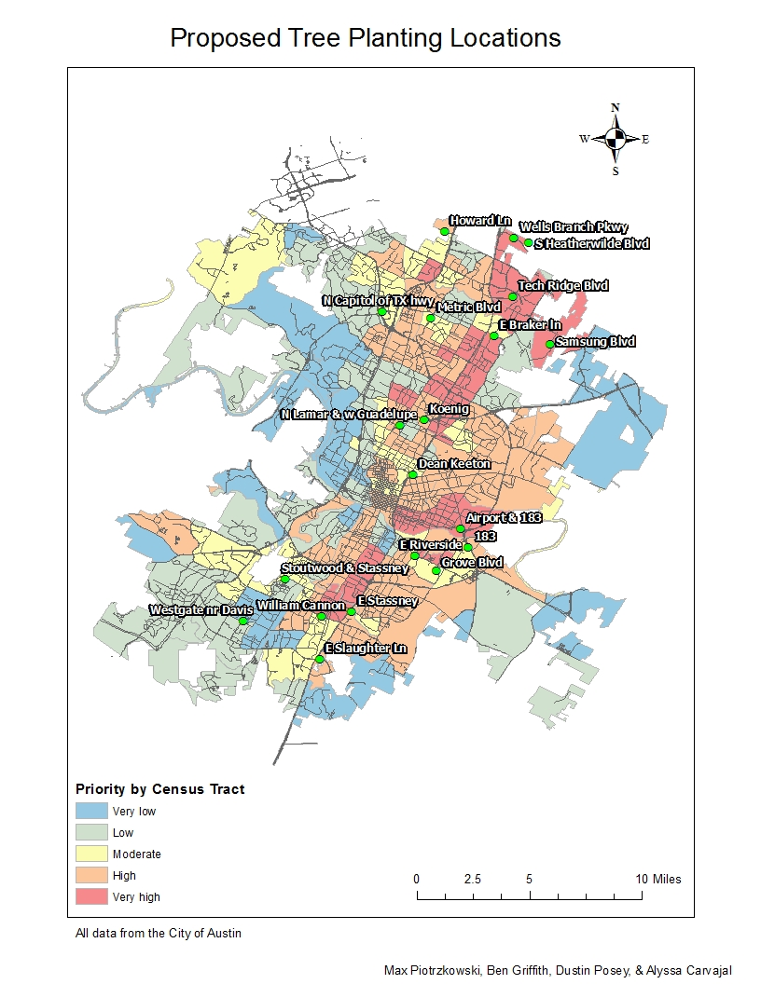 This figure is a visual representation of not only the scope of the project, but the specific locations that will be examined
APPENDIX II. Revised Timeline

Data Collection & Client Discussion
Data Analysis & Geodatabase Creation
Map Design & Create Final Product
September
Sun |  | Mon |  | Tue |  | Wed |  | Thu |  | Fri |  | Sat
 |  |  |  |  |  |  |  | 1 |  | 2 |  | 3
4 |  | 5 |  | 6 |  | 7 |  | 8 |  | 9 |  | 10
11 |  | 12 |  | 13 |  | 14 |  | 15 |  | 16 |  | 17
18 |  | 19 |  | 20 |  | 21 |  | 22 |  | 23 |  | 24
25 |  | 26 |  | 27 |  | 28 |  | 29 |  | 30

October
Sun |  | Mon |  | Tue |  | Wed |  | Thu |  | Fri |  | Sat
 |  |  |  |  |  |  |  |  |  |  |  | 1
2 |  | 3 |  | 4 |  | 5 |  | 6 |  | 7 |  | 8
9 |  | 10 |  | 11 |  | 12 |  | 13 |  | 14 |  | 15
16 |  | 17 |  | 18 |  | 19 |  | 20 |  | 21 |  | 22
23 |  | 24 |  | 25 |  | 26 |  | 27 |  | 28 |  | 29
30 |  | 31

November
Sun |  | Mon |  | Tue |  | Wed |  | Thu |  | Fri |  | Sat
 |  |  |  | 1 |  | 2 |  | 3 |  | 4 |  | 5
6 |  | 7 |  | 8 |  | 9 |  | 10 |  | 11 |  | 12
13 |  | 14 |  | 15 |  | 16 |  | 17 |  | 18 |  | 19
20 |  | 21 |  | 22 |  | 23 |  | 24 |  | 25 |  | 26
27 |  | 28 |  | 29 |  | 30 |  | 31

December
Sun |  | Mon |  | Tue |  | Wed |  | Thu |  | Fri |  | Sat
 |  |  |  |  |  |  |  |  |  |  |  | 1
2 |  | 3 |  | 4 |  | 5 |  | 6 |  | 7 |  | 8
9 |  | 10 |  | 11 |  | 12 |  | 13 |  | 14 |  | 15
16 |  | 17 |  | 18 |  | 19 |  | 20 |  | 21 |  | 22
23 |  | 24 |  | 25 |  | 26 |  | 27 |  | 28 |  | 29
30 |  | 31

