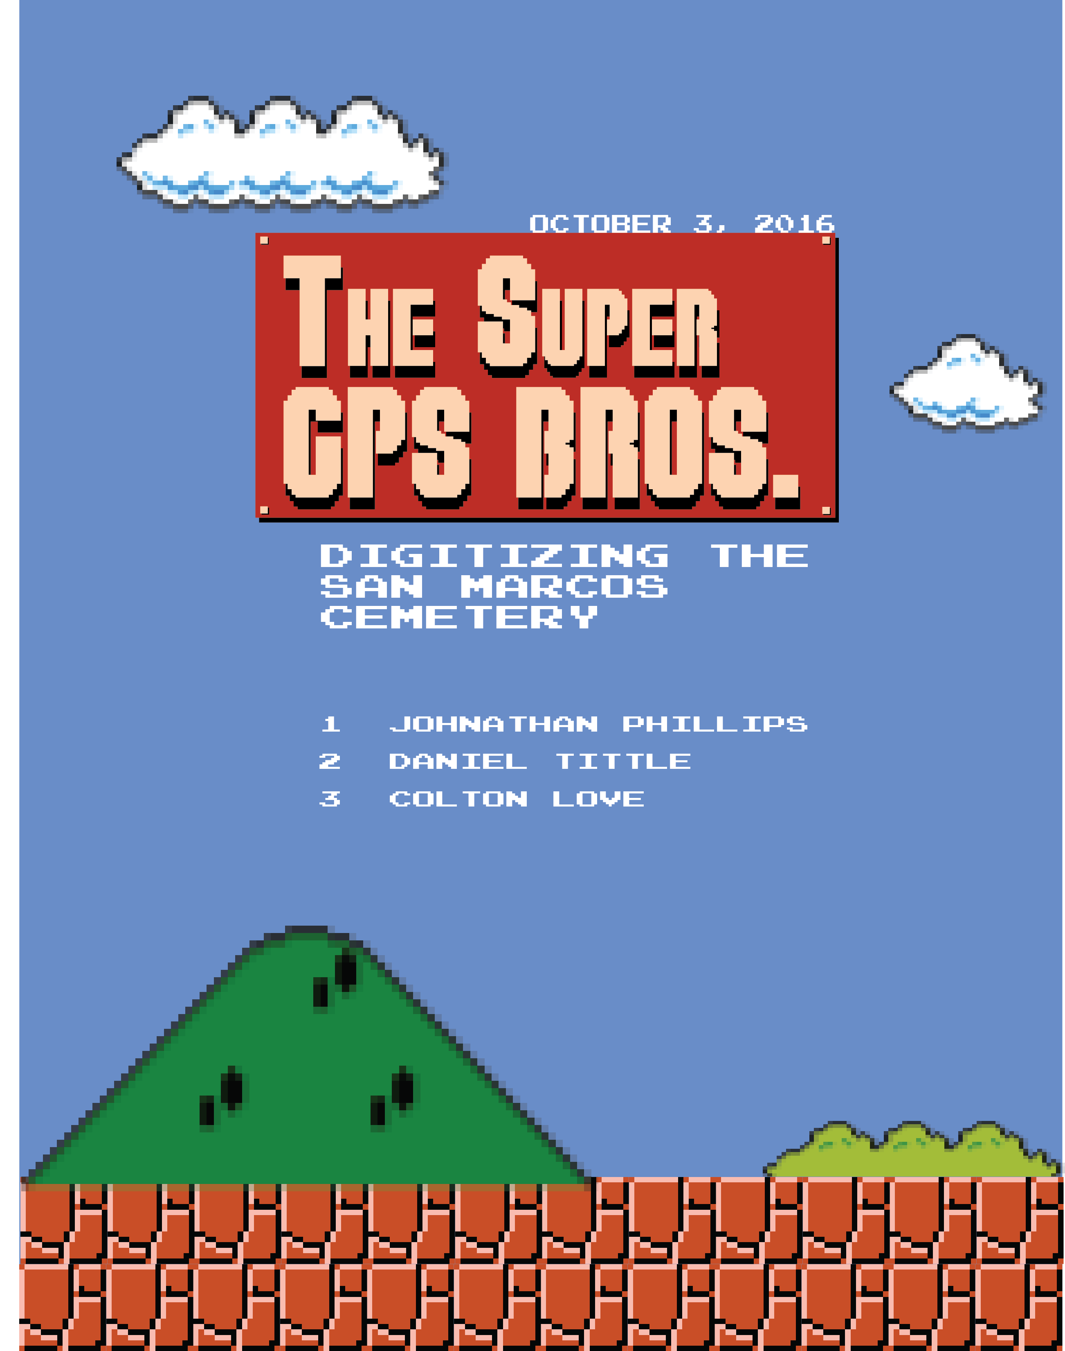

Digitizing the San Marcos Cemetery

Prepared by: The Super GPS Bros.

Table of Contents

Introduction……………………………………………………………………………………1
Background…………………………………………………………………………….1
Purpose…………………………………………………………………………………1
Scope……………………………………………………………………………………2
Literature Review……………………………………………………………………………...2
Abstract………………………………………………………………………………....2
History of Land acquisition …………………………………………………………...2
Laws……………………………………………………………………………………..3
Project Design……………...…………………………………………………………………...3
Data……………………………………………………………………………………...3
Methodology…………………………………………………………………………….3
Implications……………………………………………………………………………..4
Budget…………………………………………………………………………………...7
Timetable………………………………………………………………………….....8-10
Deliverables…………………………………………………………………………….11
Conclusion ……………………………………………………………………………………..12
References……………………………………………………………………………………...12
Participation……………………………………………………………………………………13

1. Introduction
1.1 Background
The San Marcos Cemetery commonly referred to as the city cemetery, consists of a 45-acre plot located on 1001 Ranch Road 12. Founded in 1876 as an expansion of the town’s original cemetery, The San Marcos City Cemetery has burials dating back to 1846 making this cemetery a historic site for the people of San Marcos. The property is owned by the city of San Marcos, and managed by the Texas Parks and Recreation Department [1]. The San Marcos City Cemetery is designated as a historic perpetual care cemetery by the TAC [2]. The goal of this project is to use GIS to create an inventory of the San Marcos City Cemetery, which will help the city better manage this site.
1.2 Purpose
The purpose of this project is to collect data on the cemetery layout and make a methodology, which will be used in constructing a comprehensive digital map of the cemetery. We are responsible for block A1 through A4 of the Ramsey edition. The methodology we use will be the standard for digitizing the rest of the cemetery. The final product must be compatible with Pontem software, which is what the city will be using to manage the data. The map which will be titled San Marcuse Cemetery: Ramsey Edison, will show: cemetery outline, addition, block, individual grave space, and any large obstructions occupying grave space. The map will be used by the city to help with inventory, record keeping, maintenance, and future expansion projects. The map will also be used by residents of San Marcos and others to help navigate the cemetery.

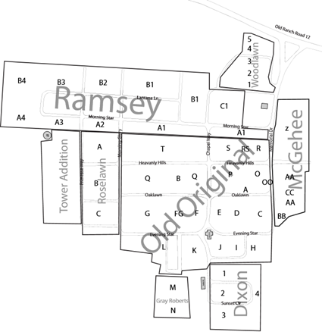
Figure 1.0
1.3 Scope
The map will focus on section A1 through A4 of the Ramsey Edison, located at the southeast side of the cemetery, along Morning Stare and Lantana Ln roads. The map will also feature the cemetery outline, and roads.
2. Literature Review
The purpose of this research is to understand factors that influenced the layout the San Marcos City Cemetery and the methodology required to map its current layout. The factors that we will be looking at include: history as it pertains to land acquisition and cemetery layout, laws and regulations, and technology and methodology used in making a digital map and database.
2.1 History of Land acquisition
The land for the San Marcos City Cemetery was purchased in 1876 by the San Marcos Cemetery Association, which was founded earlier that same year [3]. The original purchase consisted of 10 acres. This portion – called the Old Original - is the oldest, and has graves that were moved from the previous cemetery. The first recorded burial in the old Original is that of Major C. Rogers, although it is likely there are other unmarked graves from the same time, which belong to slaves ³. The cemetery has had three other additions, which account for the remainder of its present day 45 acres. The San Marcos Cemetery Association sold the cemetery to the city of San Marcos in 1924 [4]. Cemetery layouts started at the beginning of the 1900’s, prior to this there were no set parameters for how cemeteries were to be laid out. This information is important to note when mapping a historic site such as this.
2.2 Laws
The Texas Administrative Code (TAC) is a compilation of all state agency rules in Texas (About The Texas Register Section, 2015). Effective January 1, 2015 the TAC enacted more stringent regulations, that perpetual care cemetery are required to follow. These changes fall under administrative code chapter 10 ⁵, and require that perpetual care cemetery maintain the following records in a general file that is readily accessible to the department:
- All maps, plats, and property dedications, and a list of these that reflects the dates
- Current sales maps showing the sold and unsold spaces in all gardens, mausoleums, crematories, and columbaria in the cemetery
- All documents relating to the offer and sale of undeveloped mausoleum spaces
- Maintain monthly records of all conveyance of interment rights issued since the date of their last examination, and the amount of ground area, number of crypts, or number of inches conveyed under the purchase agreement, and the corresponding sales price for each.

3. Proposal

3.1 Data
Data Type | Source
Orthophoto (2015) – San Marcos Cemetery | City of San Marcos
Cemetery Boundary file | City of San Marcos
GPS points for boundaries | To be collected
GPS points for obstructions | To be collected
Ramsey Addition Boundary | To be created
Section A1-A4 Boundaries | To be created
Blocks inside each Section Boundaries | To be created
Individual Gravesite Boundary | To be created
Geodatabase on Ramsey Addition | To be created

3.1.1 Software
For this project we will be using TerraSync Centimeter Edition software for the GPS unit, ArcMap, and GPS Pathfinder Office.
3.2 Methodology
The Super G.P.S. Bros. will gather GPS data on the Ramsay Addition of the San Marcos Cemetery for the purpose of creating a geodatabase to be integrated with Pontem cemetery management software. To gather the data needed to create boundaries for the geodatabase we will need to develop a consistent method of capturing data. We will use our GPS unit to collect areas by the vertex averaging method. Going to each corner of the boundary in question and capturing it as a vertex, then we will take these data to the computer and process the vertexes into polygons. This will happen for each boundary we need to create for the geodatabase. Once the feature classes have been created we will fill out the attribute table for each polygon so the geodatabase can be seamlessly integrated with Pontem cemetery management software. The Pontem software is being used in other cities to create an interactive web-map of cemeteries. These maps have each gravesite as individual polygons, that is the goal of this project, and have all the attribute data accessible through a popup hyperlink. The city of San Marcos has a database with all the attribute data for each grave already, it is not our job to collect these data. For the geodatabase we create to integrate with Pontems’ software we need to fill out the attribute data for the feature classes in the correct way. The feature classes need to have ‘nested’ attribute data, which means each gravesite polygon will have attribute data from the outer feature classes. For example a gravesite will have these attribute data: FID, Shape, Space, Block, Section, Addition, and Cemetery. Shape will be polygon, Space is the grave number (1-8), Block is the block number that the grave is in (1-64), Section is the section the grave is in (A1-A4), Addition will be Ramsay, and Cemetery will be San Marcos. The methods of how we collect the GPS data will be recorded and put in our final report for future use with other groups who will be mapping other parts of the cemetery.
3.2.1 Implications
The data collected from the cemetery has many different uses. The information that each of these plots hold consists of who owns the land, when it was purchased, and who is buried there. Once the cemetery is accurately mapped these attributes will be added to the metadata. With this information, combined with geospatial data, the cemetery will be better suited to locate burials with more ease and precision. With genealogy becoming a growing interest in individuals looking to find out more about their family history, this will help set a standard in cemetery database management for the San Marcos Cemetery. The data will be readily available to the public anytime they would like to access it. The data and results will be used to structure the rest of the mapping for the San Marcos City Cemetery. Seeing as each of these plots is a bought & owned piece of land, it is necessary this data is tangible to those who need it, and is as accurate as possible.
3.2.2 Equipment
The Geography department at Texas State has provided a handheld GPS unit to use for this project. The Unit has an accuracy of within 1 centimeter. The data will be processed using Arc Map.
- Trimble GeoXT 2005 Series
3.2.3 Data Collection
Before collecting data the GPS unit needs roughly forty-five minutes to acquire satellites locating, the more satellites it can acquire the more accurate the data will be. We will collect points into areas as we move though the cemetery, using vector averaging. First we will collect the Ramsay addition boundary, then each section (A1-A4) boundaries, then blocks of graves in each section. As mentioned previously we also collect data on any obstructions in grave space. Metadata will include the measurements of individual grave space. These measurements will be used when dividing blocks and individual grave spaces.
3.2.3 Data Processing
Once the GPS data has been collected for the whole Ramsay Addition we will upload it to ArcMap and process it by removing extra or incorrect points. After post processing the data we will create the feature classes and add the required attribute data. Then, once the geodatabase is ready to go, we will use the feature classes to produce a map of the Ramsay Addition of the San Marcos Cemetery. Figure 2 shows a general outline of our methodology and the flow of the project.

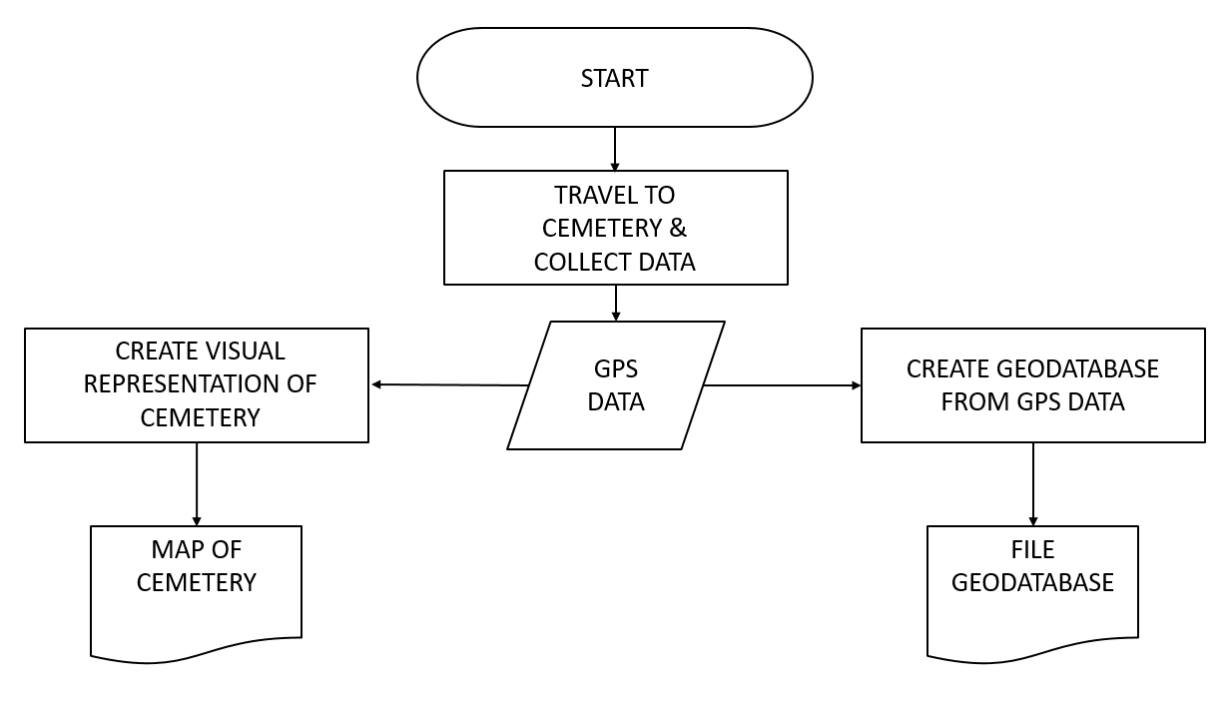
Figure 2. Work flowchart

3.3 Budget

Table 1
Service | Hours | Cost per hour | Total
Data Collection & Preprocessing | 20 per week (3 weeks) | $20/hour | $1,200
Data Analysis | 15 per week (3 weeks) | $30/hour | $1,350
Interpretation & Conclusion | 15 per week (3 weeks) | $25/hour | $1,125
Total represents 1 employee |  |  | $3,675
3 Employees |  |  | X 3
Service Subtotal |  |  | $11,025

Supplies & Misc. | Cost | Total
Trimble GPS Unit cost/hour (1 unit) | $20/hour (60 in-field hours) | $1,200
Transportation (30 miles)
Gasoline | $0.50 per mile | $15
Vehicle wear | $0.10 per mile | $3
Workstations + Software (3) | $1,000 | $3,000
Supplies & Misc. Total |  | $4,218

 | Totals
Services Total for 3 Employees | $11,025
Supplies & Misc. Total | $4,218
Super GPS Bros. Subtotal | $15,243

3.4 Timetable
Table 2
◄ Sep 2016 | October 2016 |  |  |  |  | Nov 2016 ►
Sun | Mon | Tue | Wed | Thu | Fri | Sat
 |  |  |  |  |  | 1
2 | 3  Proposal presentations to client | 4 | 5 | 6 | 7 | 8
9 | 10 | 11 | 12 | 13 | 14 | 15
16 | 17 | 18 | 19 | 20 | 21 | 22
23 | 24 | 25 | 26 | 27 | 28 | 29
30 | 31  Progress report due and presentation | Notes:

◄ Oct 2016 | November 2016 |  |  |  |  | Dec 2016 ►
Sun | Mon | Tue | Wed | Thu | Fri | Sat
 |  | 1 | 2 | 3 | 4 | 5
6 | 7 | 8 | 9 | 10 | 11 | 12
13 | 14 | 15 | 16 | 17 | 18 | 19
20 | 21 | 22 | 23  Thanksgiving Break | 24  Thanksgiving Break | 25  Thanksgiving Break | 26  Thanksgiving Break
27  Thanksgiving Break | 28 | 29 | 30 | Notes:

◄ Nov 2016 | December 2016 |  |  |  |  | Jan 2017 ►
Sun | Mon | Tue | Wed | Thu | Fri | Sat
 |  |  |  | 1 | 2 | 3
4 | 5  All Final Deliverables to clients are due to the instructor by 4:00pm | 6 | 7  Final presentations on the last day on class | 8 | 9 | 10
11 | 12 | 13 | 14 | 15 | 16 | 17
18 | 19 | 20 | 21 | 22 | 23 | 24
25 | 26 | 27 | 28 | 29 | 30 | 31

Data Collection & Preprocessing

- These first 3 weeks will consist of collecting accurate point, line, and area data in field at the San Marcos Cemetery

- This will be done on one GPS unit to ensure reliability of data when collection conditions are optimal

- As data is collected each day super GPS Bros. will upload it and begin pocessing to ensure that quality is the upmost priority

Data Analysis

- During these next few weeks the Bros. will we overlay data collected on a number of shape files, satalite DEM file for elevation terrain, and other point files collected infield and provide attriebute data to correspond with the Pontem Software

- First priority is making sure the data is accurate can be easily steamlined for following Additions in the cemetery

- At this time a decision will be made to see if we can collect data and process more Blocks or Additions for the cemetery

Interpretation & Conclusion

- A simple-to-use geodatabase will be created so that the city & public may easily access records to loved ones burried at San Marcos Cemetery

- This geodatabase will coincide with Pontem Software to easily access further records and attribute data that may be present and included

- The Super GPS Bros. will provide our methodology to the client so that our steps are transparent and easy to follow for the next engineer to take the reins on

3.5 Final Deliverables
At the end of the semester, and this project, The Super G.P.S. Bros. will provide our client with the following:
- Two copies of the final report
- Professional report for display in the Geography Department
- Two CD’s containing
  - Report
  - Project proposal
  - Poster
  - PowerPoint Presentation
  - Raw GPS data (.cor file)
  - San Marcos Cemetery file geodatabase
  - Map of San Marcos Cemetery
  - Instructions on how to use the CD
    - Readme file
4. Conclusion
In this Request for Proposal, the Super GPS Bros. have laid out a plan for what we believe will result in the best-finished product for our clients. Our methodology explains how we plan to obtain and process the utmost accurate data in order to digitize the San Marcos Cemetery. A timeline and budget have been included to provide clear structure and scope for the project. This Proposal should answer any questions the client may have on how we will orchestrate and execute this project. If any questions arise along the way, please feel free to contact us anytime for a speedy response.
5. References
1) City of San Marcos. (n.d.). City Cemetery. Retrieved September 26, 2016, from: http://www.ci.san-marcos.tx.us/index.aspx?page=222
2) Texas Historic Commission. (n.d.). Texas Historic Commission Atlas. Retrieved September 26, 2016, from: http://atlas.thc.texas.gov/
3) Friends of the San Marcos Cemetery. (n.d.). Cemetery History. Retrieved September 26, 2016, from: http://sanmarcoscemetery.org/
4) Hays County Historical commission. (n.d.). San Marcos Cemetery 4764 Inscriptions. . Retrieved September 26, 2016, from: http://www.hayshistoricalcommission.com/cemeteries/sanmarcos/SM-Intro.pdf
5) Texas Cemeteries Association. (1/1/2015).CHANGES TO TEXAS ADMINISTRATIVE CODE. Retrieved September 26, 2016, from: http://www.txca.us/Resources/Documents/TAC%20Rules%20Changes%20Effective%201-1-15.pdf

Other sources
U.S. Department of the Interior, National Park Service. (n.d.). Guidelines For Evaluating And Registering Cemeteries And Burial Places: BURIAL CUSTOMS AND CEMETERIES IN AMERICAN HISTORY. Retrieved September 26, 2016, from: https://www.nps.gov/nr/publications/bulletins/nrb41/nrb41_4.htm
Pontem Software. (n.d.). Retrieved September 26, 2016, from: http://www.pontem.com/
Figure 1.0: San Marcos Cemetery. Digital image. City Of San Marcos. (n.d.). Retrieved September 26, 2016, from: http://www.ci.san-marcos.tx.us/index.aspx?page=222
6. Participation
Johnathan Phillips
- Cover Page
- Title Page
- Table of Contents
- Data
- Methodology
- Logo
Daniel Tittle
- Intro
- Purpose
- Scope
- Literature Review
- Sources
Colton Love
- Budget
- Timetable
- Conclusion
- Implications

