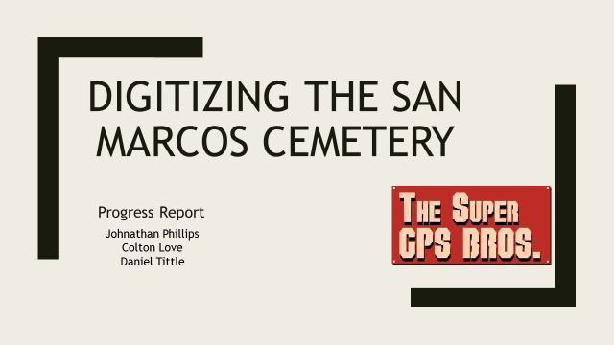

Table of contents:
Cover page………………………………………………………………………………………..1
Table of contents…………………………………………………………………………………2
Introduction………………………………………………………………………………………3
Background………………………………………………………………………………………3
Timescale……………………………………………………………………………………...3 - 4
Methodology…………………………………………………………………………………......5
Work flowchart…………………………………………………………………………………....5
Work completed……………………………………………………………………………….....6
Present work………………………………………………………………………………….......6
Conclusion………………………………………………………………………………………..6

Introduction
The purpose of this report is to summarize the work that The Super GPS Brose have accomplished in digitizing the San Marcos Cemetery. Since the presentation on 10/3/16, we have been collecting data and have refined the project methodology. The changes to the methodology will help to streamline the digitization proses and improve data accuracy. The changes to the project methodology will be addressed in detail in the methodology section of this report. The final product will include: GPS data for the San Marcus Cemetery, a file geodatabase, and map of the cemetery.

Background
As previously stated in the outline the purpose of this project is to collect GPS data on the layout of the Cemetery, and use that data to make a working methodology for creating a digital map of Ramsey addition of the San Marcos Cemetery. The San Marcus Cemetery is divided into eight parts, which are called additions. The additions are divided into sections, and sections are further divided into blocks. Blocks are made of grave spaces, where individuals are buried. Each block has 4 Individual grave spaces. We are responsible for mapping sections A1 - A3 and B1 - B4, block space for those section, and the Ramsey addition boundary.

Time Scale
10/5/16: Start collecting GPS data for cemetery
10/24/16: Collecting meta data, and measurements of boundary areas
10/27/16: Projected completion of data collection
10/28/16 Start Map Assembly
10/29 - 12/3 Map Assembly
10/31/16: Progress report due
12/5/16: Final deliverables dew
◄ Sep 2016 | October 2016 | Nov 2016 ►

 | 3  Proposal presentations to client | 4 Data collection Starts | 5 | 6 | 7 | 8
9 | 10 | 11 | 12 | 13 | 14 | 15
16 | 17 | 18 | 19 | 20 | 21 | 22
23 | 24  meta data collection | 25 | 26 | 27  completion of data collection | 28  Start Map assembly | 29
30 | 31  Progress report due | Notes:

◄ Oct 2016 | November 2016 |  |  |  |  |  |  |  |  |  |  |  | Dec 2016 ►
Sun |  |  | Mon |  | Tue |  | Wed |  | Thu | Fri |  | Sat
 |  |  |  |  | 1 |  | 2 |  | 3 | 4 |  | 5
6 |  |  | 7 |  | 8 |  | 9 |  | 10 | 11 |  | 12
13 |  |  | 14 |  | 15 |  | 16 |  | 17 | 18 |  | 19
20 |  |  | 21 |  | 22 |  | 23  Thanksgiving Break |  | 24  Thanksgiving Break | 25  Thanksgiving Break |  | 26  Thanksgiving Break
27  Thanksgiving Break |  |  | 28 |  | 29 |  | 30 |  | Notes:
◄ Nov 2016 |  | December 2016
Sun |  | Mon |  | Tue |  | Wed
4 |  | 5  All Final Deliverables to clients are due to the instructor by 4:00pm |  | 6 |  | 7  Final presentations on the last day on class

Methodology
GPS points were acquired for the 4 corners of the Ramsay addition boundary, boundary offsets, and one grave block. Offset GPS points were used to represents boundary GPS points that could not be acquired accurately because of obstructions that reduced GPS accuracy. The grave block GPS points were used as a template for digitizing the other grave blocks. GPS points where acquired in WGS84 (World Geodetic System), which is the default projection for the GPS unit. This was done to speed up the collection proses. During data processing the points were reprojected using a 420 South Central State plane projection, complying with are clients GPS specifications. During Data processing GPS points were edited into polygons. Grave blocks are uniformly (6.8m by 7.6m), so we were able to copy and paste the templet into the other grave blocks. Using a grave block template we were able to streamline the digitization process, and populate the layer quickly and accurately. Overall the steps in the methodology will remain the same, the primary change being the number of GPS points.
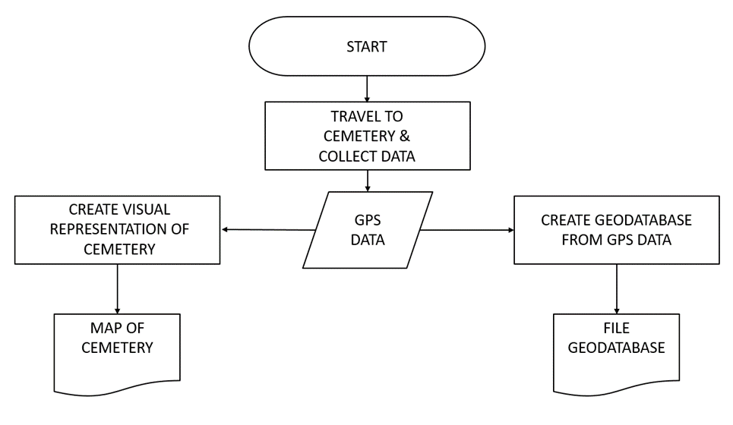Figure1. Work flowchart

Work Completed
Data collection on the Ramsay addition began 10/5/16, and is expected to be finished by 10/ 27/16. While collecting data we decided to change a methodology. Originally we had planned on collecting GPS points for the 4 corners of the Ramsay addition boundary, section (A1-A3, B1-B3) boundaries, and block and grave spaces bounders. Then use the 4 corner points for each boundary to create a vertex. Then take the vertexes and process them into polygon layers. However, as we started collecting data we found the GPS unit (Tremble GEO XT 2005) was not accurate enough to make reliable vertexes. During Data collection accuracy would vary between 30cm and 19m, averaging about 1m accuracy overall. As of 10/26/16 we have made 6 trips to the cemetery to collect data. The other reason we decided to change the data collection process is because we felt it was unnecessary to use so many GPS points to create polygon layers. It was much simpler to create polygon layers during the editing process and use fewer GPS control points. This method offers better quality polygon layers, while still meeting are clients criteria of using GPS control points.

Present work
Currently we are working on putting the cemetery map together. Right now we are making the grave block and grave space layers. Next we will make the section and then addition, working from the smallest layers to the largest.

Conclusion
In conclusion the project is going smoothly. Although the methodology of the project has changed the final product will not be altered drastically. The only change to the final product will be a reduced number of GPS control points, which we feel will improve the maps overall aesthetics without reducing its accuracy. The Super GPS Brose will present the final deliverables on 12/7/16.

