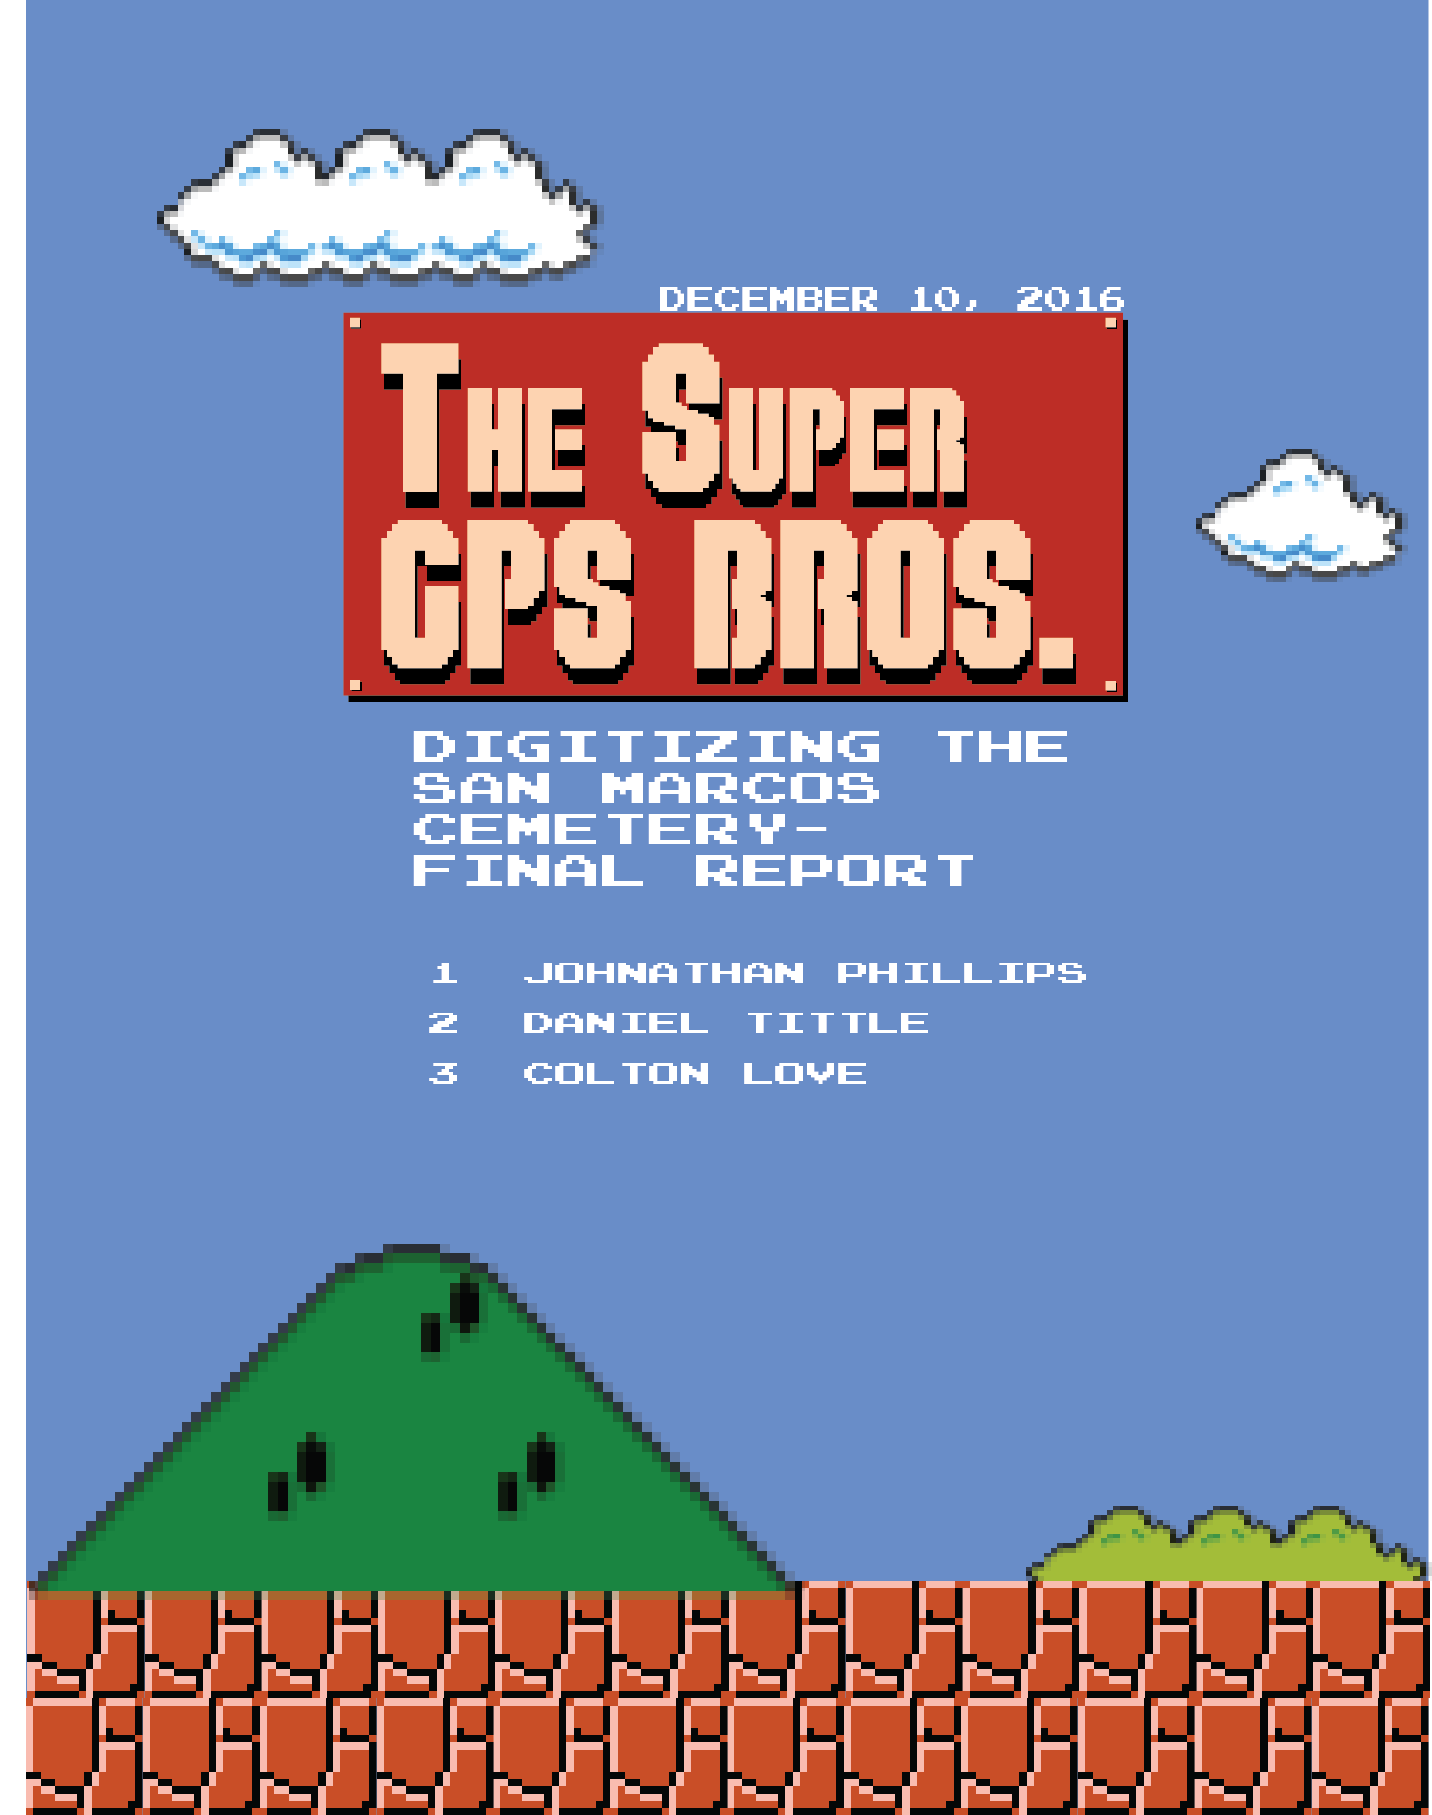

Digitizing the San Marcos Cemetery

Prepared by: The Super GPS Bros.

Cover Page ………………………………………………………………………………………..1
Tittle Page ………………………………………………………………………………………...2
Table of Contents………………………………………………………………………………….3
Introduction………………………………………………………………………………………..4
Background………………………………………………………………………………..4
Problem Statement………………………………………………………………………...4
Scope …………………………………………………………………………………….5
Data………………………………………………………………………………………………..5
Required Data……………………………………………………………………..………5
Acquired Data…………………………………………………………………………..…6
Methods……………………………………………………………………………………………6
Selecting the GPS device………………………………………………………………….6
Data Dictionary……………………………………………………………………………7
Data Collection.………………………………………………………………...…………7
Figure 1……………………………………………………………………………………8
Figure 2……………………………………………………………………………………9
Figure 3…………………………………………………………………………………..10
Data Summary.………………………………………………………………...………...11
Table 1. Summary of Data……………………………………………………...………..11
Table 2. Timeline of Project……………………………………………………...…...…11
Results and Discussion………………………………………………………………………..…11
Project Issues……………………………………………………………………………13
Final Methodology…………………………………………………………………...13-14
Discussion………………………………………………………………………………..15
Conclusion…………………………………………………...…………………………………..15
Appendix 1……………………………………………………………………………………….16
Appendix 2…………………………………………………………………………………...16-26

- Introduction

  - Background

The City of San Marcos approached the Super GPS Bros to assist in their project of creating an inventory of the San Marcos Cemetery. The City of San Marcos is in the process of creating a GIS inventory to help reduce maintenance costs, create a model of the cemetery, and eventually integrating attribute data for graves into a cemetery management software. The City of San Marcos requested that the Super GPS Bros utilize a GPS data collection device to capture the data required for the project.
The San Marcos Cemetery is so old it is considered a historic site. It was founded in 1876 with some gravesites being as old as 1846. The cemetery has serval additions, the oldest being called the ‘Old Original’, the addition The City of San Marcos is starting on in the Ramsay addition. In the end the City of San Marcos will create a web-map of the San Marcos Cemetery using Pontem cemetery management software.

  - Problem Statement

This project was created because The City of San Marcos did not have a GIS system in place for the San Marcos Cemetery. Currently there is no way of searching who is buried in the cemetery and where they are located. Aside from finding the groundskeeper and asking him, since he has worked there for many decades, he knows who is where. The City of San Marcos required the use of GPS and GIS to gather and generate data for their inventory of the San Marcos Cemetery. The benefit of using GPS is that whatever data is gathered is known to be just about what is actually on the ground. The City of San Marcos could have used GIS and digitized the boundaries and polygons they needed; the problem with that is the created data has no reference, it is not tied to anything actually on the Earth. For example; when a GPS polygon is created that polygons’ vertices are, depending on the accuracy of the recording instrument, exactly on the points they were collected on. That polygon is already ground-truthed.
The City of San Marcos required that we use GPS to collect data to create a geospatial inventory of a certain portion of the San Marcos cemetery. Using GPS is a much quicker method than traditional techniques. Using standard surveying requires more people and much more expensive equipment, a typical survey team is two to three people and two or more pieces of equipment. While a GPS device can be operated by one person and can fit in one hand.
The other part of this project that the City of San Marcos requested us to complete is developing a methodology of data collection that can be utilized by future groups. What this means is that we will have to determine the best way of collecting GPS data for the purpose of creating polygons. The methodology that we create will likely be utilized by other groups, maybe even other GEO 4427 groups, to collect other data to complete the spatial inventory of the San Marcos cemetery.

  - Scope

The scope of this project is the San Marcos cemetery. Located just west of the intersection of Ranch Road 12 and Holland Street.
- Data

  - Required Data

The City of San Marcos requested that we gather to start a spatial inventory of the San Marcos Cemetery. More specifically, the City of San Marcos requested we gather GPS data for the creation of boundary polygons within a specific section of the cemetery. The Ramsay Addition. Our original proposal stated we would gather GPS points to create these data:
- Boundary of the Ramsay Addition
- Section A3 boundary
- Section A2 boundary
- Section A1 boundary
- In each section, the blocks of graves boundaries
- Centers of objects that would obstruct graves
- If possible, the individual graves within each block
At the time of the proposal we were unsure how accurate out GPS device was, and unsure of the best method of data collection. Any data we create for the City of San Marcos must be in the Texas South Central 4204 Feet system.
  - Acquired Data

When we started the project the City of San Marcos gave us some data to start with. These data were:
- Orthophoto of the cemetery area shot in 2015
- File geodatabase of the current geospatial data in the San Marcos Cemetery. Such as road centerlines, total cemetery boundary, and water outlets.
- Digital copies of cemetery maps produced by BEC-LIN
These data were provided for us to use as reference when creating out own data. The 2015 orthophoto is what we used as our base map when creating other data for this project. The City of San Marcos contracted BEC-LIN, a surveying company in San Marcos, to perform a survey of the cemetery. The control points BEC-LIN used were also given to us and will be used in our data as reference points. These control points will be used in the future continuation of this project as the City of San Marcos will be continuing their spatial inventory of the cemetery in future semesters.

- Methods

  - Selecting the GPS device

At Texas State we have access to three different GPS devices that range in price from a few hundred dollars to over one thousand dollars. With the increase of price comes an increase in accuracy and precision, so we chose the best of the best to use in this project as creating accurate data is one of the City of San Marcos’ top priority. The GPS device we used to collect all the data for this project is a Trimble GeoXT 2005 series. The Trimble unit boasted one centimeter accuracy, after forty-five minutes of satellite tracking, however the best accuracy we achieved in the field was forty-four centimeters. Inside the device we used TerraSync Centimeter Edition to gather data, before we gathered data we had to construct a data dictionary that would facilitate the gathering process.

  - Data Dictionary

Before any data can be collected in the GPS device a data dictionary needs to be created. This data dictionary is a file that is imported into the GPS device to facilitate the collection of specific features, points lines or polygons. This file is created beforehand and is designed to collect any and all features needed for the project. In our case we needed to collect polygons and points. The data dictionary we created is broken down into categories of points, lines, and polygons. Our Point category is divided into the sub categories of Trees, Obstructions, and Other. This means that when we collect a point we choose the category of Point then whichever sub category is necessary. The second category we created was Polygons, the sub categories for it are: Addition, Section, Block, and Grave. This category was by far the most utilized in this project as the majority of the data required were polygons. The final category we created was a Line category, this was used only once to test a data collection method. We created a Horizontal and Vertical Line subcategory to test the grid method of collection.
Within each category and subcategory one can predefine a number of attributes that must be filled in at the moment of data collection. For our data dictionary we used only a few of these attribute fields as we were still developing our collection method. The attribute fields we used were simple ones to denote which section of the cemetery that piece of data was collected in. The vast majority of data attribution was done post collection in ArcMap.

  - Data Collection

Data collection began almost as soon as we received the GPS device, we started collecting data on the blocks of graves by creating a polygon with each corner being a vertex. We used the vertex averaging method when collecting these points, at the start we took anywhere from thirty to ninety points for each vertex. This was done because we were still learning how to use the GPS device and we were concerned that any fewer points per vertex would lead to inaccurate polygons. In the first few sessions we tested a few collection methods; the first was collecting thirty to ninety points per vertex per grave block, for sixty-four grave blocks. This method is quite precise and accurate, but takes far too long. Each grave block took around four minutes to collect and just in the A3 section we were working in there are sixty-four grave blocks, that’s over four hours of collecting.
Our second method of collection actually shortened the collection time by fifty percent. This was accomplished by taking half as many vertices. In fact, we didn’t collect any polygons in this method, only lines. Out idea was to create a grid across the A3 section that would outline each grave block, the intersection of the lines would be the locations of the grave block vertices. During this method we collected sixty to ninety points per end of the lines. The time it took to complete this method was still over two hours. This method was promising but inconsistent, if one endpoint was collected in an area of bad accuracy, under a tree, the whole line was off and unusable. Another issue with this method of collection was greater human error. This being collecting the line endpoints exactly in line with each other and parallel to the other gridlines. Being off by as low as half a foot skews the whole line. Figure 1, below, shows just how much human error can effect GPS data.

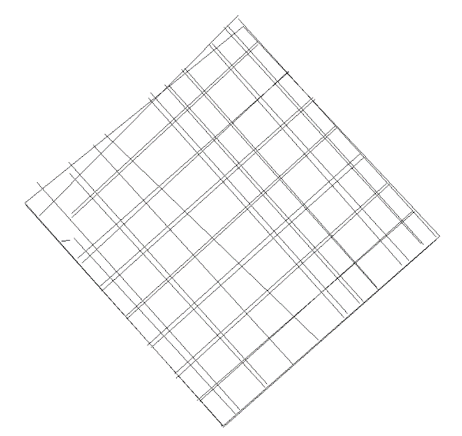

Figure 1. Grid method of GPS collection
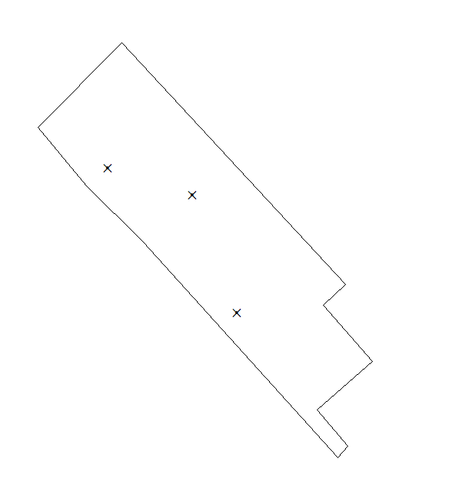
The final method we used for collection came after meeting with Ron, a tech specialist who works at for the City of San Marcos, who with his many years of GPS and GIS experience suggested that we only collect one point per vertex when creating polygons. If the overall accuracy at the position of collection is good enough, then the single point will be great. Once we acquired this knowledge it was a simple matter of applying it to the first method of collection. At this meeting we discussed with our contact from the City of San Marcos just how much of the data needed to be GPS collected and how much could be digitized. Having a handful of really accurate GPS collected polygons and creating the rest of the polygons from those GPS collected ones is perfectly acceptable. This is the method we used for collecting the grave block boundaries. An example of this method and how excellent it turns out is below, in Figure 2.

Figure 2. GPS collected control points and Ramsay Addition Boundary
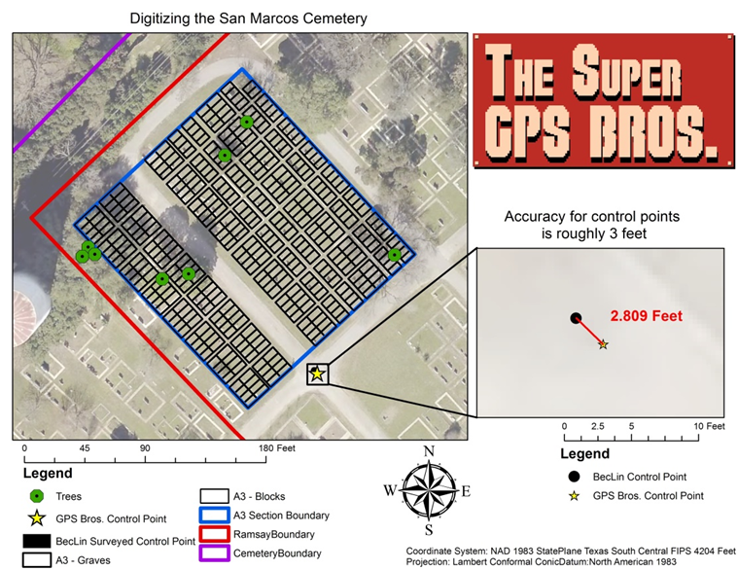
To collect the Ramsay addition boundary, we collected one point per vertex and created a polygon from them. The same method was used to collect the A3 section boundary polygon. Collecting GPS points for the obstructions required another method. Since all the obstructions we captured were trees the GPS accuracy under them was terrible. Any points collected under a tree aren’t good enough to use so we collected the locations another way, using the distance-bearing method. This method is widely used to collect points in inaccurate locations as it uses a location of high accuracy as a base point. This is how the distance-bearing method works; the GPS device is near the point that needs collecting but in an area where it has great accuracy. The data collector measures the direct distance to the center of the tree, from the GPS device, and inputs that into the GPS device, then they measure the bearing or the azimuthal angle to the center of the tree and inputs that into the GPS device. The GPS device will put a point along the inputted bearing at the inputted distance. This is the method we utilized to collect all the tree locations in the A3 section. The result of this methodology is shown below in Figure 3.
Figure 3. Final Map of San Marcos Cemetery, Section A3
  - Data Summary

Table 1 (below) outlines and describes all the data used in this project whether it was given, gathered, generated, or otherwise acquired.

Table 1. Summary of Data
Name | Data Type | Method of Acquisition | Data Creator
2015 Orthophoto | Tiff | Given | City of San Marcos
Cemetery Boundary | Shapefile | Given | City of San Marcos
Graves | Shapefile | Generated | Super GPS Bros.
Blocks | Shapefile | Gathered/Generated | Super GPS Bros.
Section A3 Boundary | Shapefile | Gathered/Generated | Super GPS Bros.
Ramsay Boundary | Shapefile | Gathered/Generated | Super GPS Bros.
Trees | Shapefile | Gathered/Generated | Super GPS Bros.
GPS Control Pts. | Shapefile | Gathered | Super GPS Bros.
Survey Control Pts. | Shapefile | Given | BEC-LIN
Cemetery Map | Reference Map | Given | BEC-LIN
Section A3 Map | Reference Map | Given | BEC-LIN

  - Time Table
Table 2. Timeline of Project
◄ Sep 2016 | October 2016 |  |  |  |  | Nov 2016 ►
Sun | Mon | Tue | Wed | Thu | Fri | Sat
 |  |  |  |  |  | 1
2 | 3  Proposal presentations to client | 4 | 5 | 6 | 7 | 8
9 | 10 | 11 | 12 | 13 | 14 | 15
16 | 17 | 18 | 19 | 20 | 21 | 22
23 | 24 | 25 | 26 | 27 | 28 | 29
30 | 31  Progress report due and presentation | Notes:

◄ Oct 2016 | November 2016 |  |  |  |  | Dec 2016 ►
Sun | Mon | Tue | Wed | Thu | Fri | Sat
 |  | 1 | 2 | 3 | 4 | 5
6 | 7 | 8 | 9 | 10 | 11 | 12
13 | 14 | 15 | 16 | 17 | 18 | 19
20 | 21 | 22 | 23  Thanksgiving Break | 24  Thanksgiving Break | 25  Thanksgiving Break | 26  Thanksgiving Break
27  Thanksgiving Break | 28 | 29 | 30 | Notes:

◄ Nov 2016 | December 2016 |  |  |  |  | Jan 2017 ►
Sun | Mon | Tue | Wed | Thu | Fri | Sat
 |  |  |  | 1 | 2 | 3
4 | 5  Final Deliverables due | 6 | 7  Final presentations on the last day on class | 8 | 9 | 10

This table outlines the final timeline for this project, it has changed since our initial proposal. Initially we proposed to stop data collection on the twenty-third of October, however, due to the extended learning period and weather conditions we extended the data collection period to the nineteenth of November. The remainder of our time on this project was spent compiling the data and generating the shapefiles we needed to complete the project. The important dates, in red, are presentation days for our project.

- Results and Discussion

  - Project Issues

One of the greatest challenges we faced while working on this project was learning how to utilize the GPS device. When we received the RFP (request for proposal) from the City of San Marcos none of the team members had any real experience with using the chosen GPS device. As we developed new methodologies for collecting data we were also improving our knowledge with the device itself. As the weeks went on we grew more and more comfortable in the devices operation as well as the post processing software. This learning period severely impacted how much data we were able to gather in the field. The RFP stated that the project required data collection for sections A1 through A3, however, due to the learning period and other factors, such as bad weather, we were only able to complete data collection for the A3 section.
Any project that requires field collection of data, of any description, will run into the same problem. The weather. In regards to this specific project the weather hindered us in a few ways. The most direct way the weather negatively impacted our project was by completely stopping data collection, by raining. Rain, of course, is not compatible with most electronic devices and as such we could not risk the University’s equipment by taking it out. Rain cut our collection time by a whole week. The second way weather interfered with the project was by being cloudy and overcast. The heavy cloud cover reduces the connectivity of the GPS device to satellites and the fewer satellites that it’s connected to, the less accuracy the points will be. This problem of few satellites due to cloud cover happened on a fairly regular basis, luckily the accuracy was still good enough to collect data, most of the time.

  - Final Methodology

The final data collection method that we developed and utilized are these steps:
- Develop data dictionary to be exhaustive for collecting data, collect all data in WGS84. The Trimble GPS collects in WGS84 by default so it is easier to collect in the default and reproject the data later.
- Collect data for largest polygons first, then collect smaller and smaller polygons
- Collect one GPS point for each vertex of the polygons being captured. For the smaller more numerous polygons, collect one or two extremely accurate polygons then copy paste to fill in the needed data.
- For collecting obstructions, such as trees, stand in a location with great accuracy and use the distance bearing method to capture the center of them.
- For polygons or polygon vertices that are in areas of low accuracy use a method similar to capturing trees, except the point you are measuring to is the center of the polygon you are trying to capture. This way you collect a point where the center of the polygon will be, then when you export your data into ArcMap you can copy paste the accurate polygon to that location and snap the center to the point.
- When data collection is finished for the day, take it back to the computer and apply differential correction to the data. Then export it as an ESRI shapefile, select the inbuilt attribute data you require (such as average horizontal position), use a WGS84 projection file, then once the files are in ArcMap reproject them into the desired coordinate system.
- Once the raw data has been corrected and exported into ArcMap then it’s up to the specific needs of the project to dictate what needs editing. The attribute data required for our data to be integrated into Pontems cemetery management software needed to be implemented.
- Each grave polygon needs certain attribution: A Cemetery attribute: for denoting which cemetery the polygon falls into. An Addition attribute: for denoting which addition of the cemetery the polygon falls into. A Section attribute: for denoting which section the polygon falls into. A Block attribute: for denoting which block the polygon falls into. As well as a Grave attribute.
- The polygons that aren’t graves just need all the attribution up until the Grave attribute.

  - Discussion

Using GIS and GPS to gather and create a spatial inventory of a cemetery is this essence of this project. The pros of utilizing a handheld GPS to collect spatial data are these: simple operation, a handheld GPS is a much simpler device to operate than a full scale surveying set up. The data processing is a quick process. The biggest con of using a GPS device for this project is accuracy. The accuracy of the gathered data is only as good as the hardware that’s being used. In this case the hardware is fairly good and our accuracy was about fifty centimeters.
Our project was limited by the weather and our GPS device. The weather hindered us only by preventing data collection in certain conditions. Our GPS limited us in that the original request from the City of San Marcos wanted us to capture the individual grave spaces with the GPS. When we wrote the proposal we indicated that it might be possible to collect individual grave spaces. However, during our learning period of this project we determined that the accuracy was not good enough for individual graves. A single grave is only a few feet wide and an accuracy of about fifty centimeters per vertex is not good enough for polygons of that size.

- Conclusion
  - Thoughts on the Project

In the future I suggest more analysis be added to this project, or have this project move to the GIS and GPS course in the department. This project had zero analysis and I feel that negatively impacted our groups learning potential. The Capstone course of a degree plan should test the students over all that they have learned, not force the group members to learn as they go.

Appendix 1: Group Members Contribution

Colton Love:
- GPS data collection
- Budget
- Timetable
- Poster creation
Daniel Tittle:
- Adobe Illustrator map creation
- Proof read reports
- GPS collection assistance
Johnathan Phillips:
- Logo
- Cover pages
- GPS data collection
- GPS data collection assistance
- ArcMap GPS data editing
- ArcMap data attribution
- Final Report
- Final Power Point

Appendix 2: Metadata
<?xml version="1.0"?>
<metadata><idinfo><citation><citeinfo><origin>The Super GPS Bros</origin><pubdate>20161121</pubdate><geoform>vector digital data</geoform></citeinfo></citation> <descript><abstract>Blocks of graves created from GPS collected data. Created for the CIty of San Marcos for the purpose of mapping the San Marcos Cemetery.</abstract><purpose>Blocks of graves created from GPS collected data.</purpose></descript> <timeperd><timeinfo><rngdates><begdate>20160919</begdate><enddate>20161118</enddate></rngdates></timeinfo><current>Period of time we collected and editied the data.</current></timeperd> <status><progress>In work</progress><update>None planned</update></status> <spdom><bounding><westbc>-97.958313</westbc><eastbc>-97.957506</eastbc><northbc>29.889963</northbc><southbc>29.889285</southbc></bounding></spdom> <keywords><theme><themekt>None</themekt><themekey>GPS</themekey><themekey>Created</themekey><themekey>Polygons</themekey></theme> </keywords> <accconst>None</accconst> <useconst>None</useconst> <datacred>The Super GPS Bros: Colton Love Daniel Tittle Johnathan Phillips</datacred> <native> Version 6.2 (Build 9200) ; Esri ArcGIS 10.4.0.5524</native> </idinfo><spdoinfo><direct>Vector</direct><ptvctinf><sdtsterm><sdtstype>GT-polygon composed of chains</sdtstype><ptvctcnt>64</ptvctcnt></sdtsterm></ptvctinf></spdoinfo><spref><horizsys><planar><mapproj><mapprojn>NAD 1983 StatePlane Texas South Central FIPS 4204 Feet</mapprojn><lambertc><stdparll>28.38333333333333</stdparll><stdparll>30.28333333333334</stdparll><longcm>-99.0</longcm><latprjo>27.83333333333333</latprjo><feast>1968500.0</feast><fnorth>13123333.33333333</fnorth></lambertc></mapproj><planci><plance>coordinate pair</plance><coordrep><absres>0.0003280833333333333</absres><ordres>0.0003280833333333333</ordres></coordrep><plandu>foot_us</plandu></planci></planar><geodetic><horizdn>D North American 1983</horizdn><ellips>GRS 1980</ellips><semiaxis>6378137.0</semiaxis><denflat>298.257222101</denflat></geodetic></horizsys></spref><eainfo><detailed><enttyp><enttypl>A3Blocks</enttypl><enttypd>Feature Class of the grave blocks in the A3 section of the Ramsay addition in the San Marcos cemetery,</enttypd><enttypds>The Super GPS Bros</enttypds></enttyp><attr><attrlabl>OBJECTID</attrlabl><attrdef>Internal feature number.</attrdef><attrdefs>Esri</attrdefs><attrdomv><udom>Sequential unique whole numbers that are automatically generated.</udom></attrdomv></attr><attr><attrlabl>Shape</attrlabl><attrdef>Feature geometry.</attrdef><attrdefs>Esri</attrdefs><attrdomv><udom>Coordinates defining the features.</udom></attrdomv></attr><attr><attrlabl>Type</attrlabl><attrdef>Type of polygon collected, from list in GPS data dictionary.</attrdef><attrdefs>The Super GPS Bros</attrdefs></attr><attr><attrlabl>ID</attrlabl><attrdef>Numerical ID</attrdef><attrdefs>The Super GPS Bros</attrdefs></attr><attr><attrlabl>GPS_Date</attrlabl><attrdef>Date of GPS</attrdef><attrdefs>The Super GPS Bros</attrdefs></attr><attr><attrlabl>GNSS_Area</attrlabl><attrdef>Area by GPS</attrdef><attrdefs>The Super GPS Bros</attrdefs></attr><attr><attrlabl>GNSS_Perim</attrlabl><attrdef>Perimeter by GPS</attrdef><attrdefs>The Super GPS Bros</attrdefs></attr><attr><attrlabl>Area_ID</attrlabl><attrdef>Area ID</attrdef><attrdefs>The Super GPS Bros</attrdefs></attr><attr><attrlabl>Cemetery</attrlabl><attrdef>Field for noting which cemetery the data is in.</attrdef><attrdefs>The Super GPS Bros</attrdefs></attr><attr><attrlabl>Addition</attrlabl><attrdef>Field for noting which addition the data is in.</attrdef><attrdefs>The Super GPS Bros</attrdefs></attr><attr><attrlabl>Section_</attrlabl><attrdef>Field for noting which section the data is in.</attrdef><attrdefs>The Super GPS Bros</attrdefs></attr><attr><attrlabl>Block</attrlabl><attrdef>Field for noting which block the data is </attrdef><attrdefs>The Super GPS Bros</attrdefs></attr><attr><attrlabl>Shape_Length</attrlabl><attrdef>Length of feature in internal units.</attrdef><attrdefs>Esri</attrdefs><attrdomv><udom>Positive real numbers that are automatically generated.</udom></attrdomv></attr><attr><attrlabl>Shape_Area</attrlabl><attrdef>Area of feature in internal units squared.</attrdef><attrdefs>Esri</attrdefs><attrdomv><udom>Positive real numbers that are automatically generated.</udom></attrdomv></attr></detailed></eainfo><metainfo><metd>20161205</metd><metc><cntinfo><cntperp><cntper>The Super GPS Bros</cntper></cntperp><cntaddr><addrtype>mailing and physical</addrtype>
<address>601 University Drive</address>
<city>San Marcos</city><state>TX</state><postal>78666</postal><country>US</country></cntaddr><cntvoice>5122452111</cntvoice><cntemail>j_p267@txstate.edu</cntemail></cntinfo></metc><metstdn>FGDC Content Standard for Digital Geospatial Metadata</metstdn><metstdv>FGDC-STD-001-1998</metstdv><mettc>local time</mettc></metainfo></metadata>

<?xml version="1.0"?>
<metadata><idinfo><citation><citeinfo><origin>The Super GPS Bros</origin><pubdate>20161121</pubdate><geoform>vector digital data</geoform></citeinfo></citation><descript><abstract>Created from GPS collected data. Polygon of the A3 section in the Ramsay addition of the San Marcos Cemetery.</abstract><purpose>Created for the CIty of San Marcos to aid in the development of a map of the entire San Marcos cemetery.</purpose></descript><timeperd><timeinfo><rngdates><begdate>20160919</begdate><enddate>20161118</enddate></rngdates></timeinfo><current>Temporal Extent</current></timeperd><status><progress>Complete</progress><update>None planned</update></status><spdom><bounding><westbc>-97.958313</westbc><eastbc>-97.957506</eastbc><northbc>29.889986</northbc><southbc>29.889285</southbc></bounding></spdom><keywords><theme><themekt>None</themekt><themekey>Polygon</themekey><themekey>Created</themekey><themekey>GPS</themekey></theme></keywords><accconst>None</accconst><useconst>None</useconst><datacred>The Super GPS Bros. Colton Love Daniel Tittle Johnathan Phillips</datacred><native> Version 6.2 (Build 9200) ; Esri ArcGIS 10.4.0.5524</native></idinfo><spdoinfo><direct>Vector</direct><ptvctinf><sdtsterm><sdtstype>GT-polygon composed of chains</sdtstype><ptvctcnt>1</ptvctcnt></sdtsterm></ptvctinf></spdoinfo><spref><horizsys><planar><mapproj><mapprojn>NAD 1983 StatePlane Texas South Central FIPS 4204 Feet</mapprojn><lambertc><stdparll>28.38333333333333</stdparll><stdparll>30.28333333333334</stdparll><longcm>-99.0</longcm><latprjo>27.83333333333333</latprjo><feast>1968500.0</feast><fnorth>13123333.33333333</fnorth></lambertc></mapproj><planci><plance>coordinate pair</plance><coordrep><absres>0.0003280833333333333</absres><ordres>0.0003280833333333333</ordres></coordrep><plandu>foot_us</plandu></planci></planar><geodetic><horizdn>D North American 1983</horizdn><ellips>GRS 1980</ellips><semiaxis>6378137.0</semiaxis><denflat>298.257222101</denflat></geodetic></horizsys></spref><eainfo><detailed><enttyp><enttypl>A3Boundary</enttypl><enttypd>The polygon representing the boundary of the A3 section of the Ramsay addition in the San Marcos cemetery.</enttypd><enttypds>The Super GPS Bros</enttypds></enttyp><attr><attrlabl>OBJECTID</attrlabl><attrdef>Internal feature number.</attrdef><attrdefs>Esri</attrdefs><attrdomv><udom>Sequential unique whole numbers that are automatically generated.</udom></attrdomv></attr><attr><attrlabl>Shape</attrlabl><attrdef>Feature geometry.</attrdef><attrdefs>Esri</attrdefs><attrdomv><udom>Coordinates defining the features.</udom></attrdomv></attr><attr><attrlabl>Type</attrlabl><attrdef>The type of polygon from a list in the GPS data dictionary.</attrdef><attrdefs>The Super GPS Bros</attrdefs></attr><attr><attrlabl>ID</attrlabl><attrdef>ID</attrdef><attrdefs>The Super GPS Bros</attrdefs></attr><attr><attrlabl>Max_PDOP</attrlabl><attrdef>Max PDOP</attrdef><attrdefs>The Super GPS Bros</attrdefs></attr><attr><attrlabl>Max_HDOP</attrlabl><attrdef>Max HDOP</attrdef><attrdefs>The Super GPS Bros</attrdefs></attr><attr><attrlabl>GPS_Date</attrlabl><attrdef>Date of GPS collection</attrdef><attrdefs>The Super GPS Bros</attrdefs></attr><attr><attrlabl>GNSS_Area</attrlabl><attrdef>Area by GPS</attrdef><attrdefs>The Super GPS Bros</attrdefs></attr><attr><attrlabl>GNSS_Perim</attrlabl><attrdef>Perimeter by GPS</attrdef><attrdefs>The Super GPS Bros</attrdefs></attr><attr><attrlabl>Avg_Horz_P</attrlabl><attrdef>Average Horizontal Precision</attrdef><attrdefs>The Super GPS Bros</attrdefs></attr><attr><attrlabl>Cemetery</attrlabl><attrdef>Field noting the cemetery the data is in.</attrdef><attrdefs>The Super GPS Bros</attrdefs></attr><attr><attrlabl>Addition</attrlabl><attrdef>Field noting the addition the cemetery is in.</attrdef><attrdefs>The Super GPS Bros</attrdefs></attr><attr><attrlabl>Section_</attrlabl><attrdef>Field noting the section the data is in.</attrdef><attrdefs>The Super GPS Bros</attrdefs></attr><attr><attrlabl>Shape_Length</attrlabl><attrdef>Length of feature in internal units.</attrdef><attrdefs>Esri</attrdefs><attrdomv><udom>Positive real numbers that are automatically generated.</udom></attrdomv></attr><attr><attrlabl>Shape_Area</attrlabl><attrdef>Area of feature in internal units squared.</attrdef><attrdefs>Esri</attrdefs><attrdomv><udom>Positive real numbers that are automatically generated.</udom></attrdomv></attr></detailed></eainfo><metainfo><metd>20161205</metd><metc><cntinfo><cntperp><cntper>The Super GPS Bros</cntper></cntperp><cntaddr><addrtype>mailing and physical</addrtype>
<address>601 University Drive</address>
<city>San Marcos</city><state>TX</state><postal>78666</postal></cntaddr><cntvoice>5122452111</cntvoice></cntinfo></metc><metstdn>FGDC Content Standard for Digital Geospatial Metadata</metstdn><metstdv>FGDC-STD-001-1998</metstdv><mettc>local time</mettc></metainfo></metadata>

<?xml version="1.0"?>
<metadata><idinfo><citation><citeinfo><geoform>vector digital data</geoform></citeinfo></citation><descript><abstract>All property parcels in San Marcos ETJ. Updated frequently per plats</abstract><purpose>Parcels</purpose></descript><spdom><bounding><westbc>-97.959776</westbc><eastbc>-97.954323</eastbc><northbc>29.890471</northbc><southbc>29.885206</southbc></bounding></spdom><keywords><theme><themekt>None</themekt><themekey>Parcels</themekey></theme></keywords><accconst>None</accconst><useconst>Parcels sometime do not match up with aerials. Edit as needed.</useconst><native> Version 6.2 (Build 9200) ; Esri ArcGIS 10.4.0.5524</native></idinfo><spdoinfo><direct>Vector</direct><ptvctinf><sdtsterm><sdtstype>GT-polygon composed of chains</sdtstype><ptvctcnt>1</ptvctcnt></sdtsterm></ptvctinf></spdoinfo><spref><horizsys><planar><mapproj><mapprojn>NAD 1983 StatePlane Texas South Central FIPS 4204 Feet</mapprojn><lambertc><stdparll>28.38333333333333</stdparll><stdparll>30.28333333333334</stdparll><longcm>-99.0</longcm><latprjo>27.83333333333333</latprjo><feast>1968500.0</feast><fnorth>13123333.33333333</fnorth></lambertc></mapproj><planci><plance>coordinate pair</plance><coordrep><absres>0.0003280833333333333</absres><ordres>0.0003280833333333333</ordres></coordrep><plandu>foot_us</plandu></planci></planar><geodetic><horizdn>D North American 1983</horizdn><ellips>GRS 1980</ellips><semiaxis>6378137.0</semiaxis><denflat>298.257222101</denflat></geodetic></horizsys></spref><eainfo><detailed><enttyp><enttypl>CemeteryBoundary</enttypl></enttyp><attr><attrlabl>OBJECTID</attrlabl><attrdef>Internal feature number.</attrdef><attrdefs>Esri</attrdefs><attrdomv><udom>Sequential unique whole numbers that are automatically generated.</udom></attrdomv></attr><attr><attrlabl>SHAPE</attrlabl><attrdef>Feature geometry.</attrdef><attrdefs>Esri</attrdefs><attrdomv><udom>Coordinates defining the features.</udom></attrdomv></attr><attr><attrlabl>ACREAGE</attrlabl><attrdef>ACREAGE</attrdef></attr><attr><attrlabl>ADDTAXID</attrlabl><attrdef>ADDTAXID</attrdef></attr><attr><attrlabl>CITYLIMIT</attrlabl><attrdef>CITYLIMIT</attrdef></attr><attr><attrlabl>CREATEDATE</attrlabl><attrdef>CREATEDATE</attrdef></attr><attr><attrlabl>DAY_POP</attrlabl><attrdef>DAY_POP</attrdef></attr><attr><attrlabl>FULLADDR</attrlabl><attrdef>FULLADDR</attrdef></attr><attr><attrlabl>MAXIMOID</attrlabl><attrdef>MAXIMOID</attrdef></attr><attr><attrlabl>MAXIMOPFX</attrlabl><attrdef>MAXIMOID WITH PREFIX</attrdef></attr><attr><attrlabl>MODIFIEDBY</attrlabl><attrdef>MODIFIEDBY</attrdef></attr><attr><attrlabl>MODIFIEDDATE</attrlabl><attrdef>MODIFIEDDATE</attrdef></attr><attr><attrlabl>MULTIPLIER</attrlabl><attrdef>MULTIPLIER</attrdef></attr><attr><attrlabl>NUMROOMS</attrlabl><attrdef>NUMROOMS</attrdef></attr><attr><attrlabl>NUMUNITS</attrlabl><attrdef>NUMUNITS</attrdef></attr><attr><attrlabl>PARCEL_ID</attrlabl><attrdef>PARCEL_ID</attrdef></attr><attr><attrlabl>POPULATION</attrlabl><attrdef>POPULATION</attrdef></attr><attr><attrlabl>PRD</attrlabl><attrdef>PRD</attrdef></attr><attr><attrlabl>RESIDENTIAL</attrlabl><attrdef>RESIDENTIAL</attrdef></attr><attr><attrlabl>SAN</attrlabl><attrdef>SAN</attrdef></attr><attr><attrlabl>SF</attrlabl><attrdef>SF</attrdef></attr><attr><attrlabl>SITEPLAN</attrlabl><attrdef>SITEPLAN</attrdef></attr><attr><attrlabl>STN</attrlabl><attrdef>STN</attrdef></attr><attr><attrlabl>STS</attrlabl><attrdef>STS</attrdef></attr><attr><attrlabl>TAXEXEMPT</attrlabl><attrdef>TAXEXEMPT</attrdef></attr><attr><attrlabl>TAXID</attrlabl><attrdef>TAXID</attrdef></attr><attr><attrlabl>VACANT</attrlabl><attrdef>VACANT</attrdef></attr><attr><attrlabl>YEARBUILT</attrlabl><attrdef>YEARBUILT</attrdef></attr><attr><attrlabl>CREATEDBY</attrlabl></attr><attr><attrlabl>GlobalID</attrlabl></attr><attr><attrlabl>LOT_NUM</attrlabl></attr><attr><attrlabl>BLOCK_NUM</attrlabl></attr><attr><attrlabl>SHAPE_Length</attrlabl><attrdef>Length of feature in internal units.</attrdef><attrdefs>Esri</attrdefs><attrdomv><udom>Positive real numbers that are automatically generated.</udom></attrdomv></attr><attr><attrlabl>SHAPE_Area</attrlabl><attrdef>Area of feature in internal units squared.</attrdef><attrdefs>Esri</attrdefs><attrdomv><udom>Positive real numbers that are automatically generated.</udom></attrdomv></attr></detailed></eainfo><metainfo><metd>20161205</metd><metstdn>FGDC Content Standard for Digital Geospatial Metadata</metstdn><metstdv>FGDC-STD-001-1998</metstdv><mettc>local time</mettc></metainfo></metadata>

<?xml version="1.0"?>
<metadata><idinfo><citation><citeinfo><origin>The Super GPS Bros</origin><pubdate>20161118</pubdate><geoform>vector digital data</geoform></citeinfo></citation><descript><abstract>Points gathered by GPS to allow all our gathered data to line up with future data and surveyed data.</abstract><purpose>Points collected on Survey Markers in the field to match with other data gathered by the survey company.</purpose></descript><timeperd><timeinfo><rngdates><begdate>20161118</begdate><enddate>20161118</enddate></rngdates></timeinfo><current>Temporal Extent</current></timeperd><status><progress>Complete</progress><update>None planned</update></status><spdom><bounding><westbc>-97.957753</westbc><eastbc>-97.956612</eastbc><northbc>29.889358</northbc><southbc>29.888268</southbc></bounding></spdom><keywords><theme><themekt>None</themekt><themekey>GPS</themekey><themekey>Control Point</themekey><themekey>Point</themekey></theme></keywords><accconst>None</accconst><useconst>None</useconst><datacred>The Super GPS Bros Colton Love Daniel Tittle Johnathan Phillips</datacred><native> Version 6.2 (Build 9200) ; Esri ArcGIS 10.4.0.5524</native></idinfo><spdoinfo><direct>Vector</direct><ptvctinf><sdtsterm><sdtstype>Entity point</sdtstype><ptvctcnt>3</ptvctcnt></sdtsterm></ptvctinf></spdoinfo><spref><horizsys><planar><mapproj><mapprojn>NAD 1983 StatePlane Texas South Central FIPS 4204 Feet</mapprojn><lambertc><stdparll>28.38333333333333</stdparll><stdparll>30.28333333333334</stdparll><longcm>-99.0</longcm><latprjo>27.83333333333333</latprjo><feast>1968500.0</feast><fnorth>13123333.33333333</fnorth></lambertc></mapproj><planci><plance>coordinate pair</plance><coordrep><absres>0.0003280833333333333</absres><ordres>0.0003280833333333333</ordres></coordrep><plandu>foot_us</plandu></planci></planar><geodetic><horizdn>D North American 1983</horizdn><ellips>GRS 1980</ellips><semiaxis>6378137.0</semiaxis><denflat>298.257222101</denflat></geodetic></horizsys></spref><eainfo><detailed><enttyp><enttypl>GPSCTRLPoints</enttypl><enttypd>GPS collection points to compare with the surveyed control points.</enttypd><enttypds>The Super GPS Bros</enttypds></enttyp><attr><attrlabl>OBJECTID</attrlabl><attrdef>Internal feature number.</attrdef><attrdefs>Esri</attrdefs><attrdomv><udom>Sequential unique whole numbers that are automatically generated.</udom></attrdomv></attr><attr><attrlabl>Shape</attrlabl><attrdef>Feature geometry.</attrdef><attrdefs>Esri</attrdefs><attrdomv><udom>Coordinates defining the features.</udom></attrdomv></attr><attr><attrlabl>Type</attrlabl><attrdef>Other type field.</attrdef><attrdefs>The Super GPS Bros</attrdefs></attr><attr><attrlabl>Type2</attrlabl><attrdef>ID field for what type of point this is.</attrdef><attrdefs>The Super GPS Bros</attrdefs></attr><attr><attrlabl>Max_HDOP</attrlabl><attrdef>MAX HDOP</attrdef><attrdefs>The Super GPS Bros</attrdefs></attr><attr><attrlabl>GPS_Date</attrlabl><attrdef>Date of GPS collection</attrdef><attrdefs>The Super GPS Bros</attrdefs></attr><attr><attrlabl>GPS_Time</attrlabl><attrdef>Time of GPS collection</attrdef><attrdefs>The Super GPS Bros</attrdefs></attr><attr><attrlabl>Feat_Name</attrlabl><attrdef>Feature Name</attrdef><attrdefs>The Super GPS Bros</attrdefs></attr><attr><attrlabl>GNSS_Heigh</attrlabl></attr><attr><attrlabl>Vert_Prec</attrlabl><attrdef>Vertical Precision</attrdef><attrdefs>The Super GPS Bros</attrdefs></attr><attr><attrlabl>Horz_Prec</attrlabl><attrdef>Horizontal Precision</attrdef><attrdefs>The Super GPS Bros</attrdefs></attr><attr><attrlabl>Latitude</attrlabl><attrdef>Latitude</attrdef><attrdefs>The Super GPS Bros</attrdefs></attr><attr><attrlabl>Longitude</attrlabl><attrdef>Longitude</attrdef><attrdefs>The Super GPS Bros</attrdefs></attr><attr><attrlabl>Point_ID</attrlabl><attrdef>Point ID</attrdef><attrdefs>The Super GPS Bros</attrdefs></attr></detailed></eainfo><metainfo><metd>20161205</metd><metc><cntinfo><cntperp><cntper>The Super GPS Bros</cntper></cntperp><cntaddr><addrtype>mailing and physical</addrtype>
<address>601 University Drive</address>
<city>San Marcos</city><state>TX</state><postal>78666</postal></cntaddr><cntvoice>5122452111</cntvoice></cntinfo></metc><metstdn>FGDC Content Standard for Digital Geospatial Metadata</metstdn><metstdv>FGDC-STD-001-1998</metstdv><mettc>local time</mettc></metainfo></metadata>

<?xml version="1.0"?>
<metadata><idinfo><citation><citeinfo><origin>The Super GPS Bros</origin><pubdate>20161118</pubdate><geoform>vector digital data</geoform></citeinfo></citation><descript><abstract>GPS collected data the makes up the boundary of the Ramsay addition in the San Marcos cemetery.</abstract><purpose>GPS collected boundary of the Ramsay addition for the City of San Marcos.</purpose></descript><timeperd><timeinfo><rngdates><begdate>20161118</begdate><enddate>20161118</enddate></rngdates></timeinfo><current>Temporal Extent</current></timeperd><status><progress>Complete</progress><update>None planned</update></status><spdom><bounding><westbc>-97.958436</westbc><eastbc>-97.955423</eastbc><northbc>29.890342</northbc><southbc>29.887180</southbc></bounding></spdom><keywords><theme><themekt>None</themekt><themekey>Polygon</themekey><themekey>GPS</themekey><themekey>Created</themekey></theme></keywords><accconst>None</accconst><useconst>None</useconst><datacred>The Super GPS Bros Colton Love Daniel Tittle Johnathan Phillips</datacred><native> Version 6.2 (Build 9200) ; Esri ArcGIS 10.4.0.5524</native></idinfo><spdoinfo><direct>Vector</direct><ptvctinf><sdtsterm><sdtstype>GT-polygon composed of chains</sdtstype><ptvctcnt>1</ptvctcnt></sdtsterm></ptvctinf></spdoinfo><spref><horizsys><planar><mapproj><mapprojn>NAD 1983 StatePlane Texas South Central FIPS 4204 Feet</mapprojn><lambertc><stdparll>28.38333333333333</stdparll><stdparll>30.28333333333334</stdparll><longcm>-99.0</longcm><latprjo>27.83333333333333</latprjo><feast>1968500.0</feast><fnorth>13123333.33333333</fnorth></lambertc></mapproj><planci><plance>coordinate pair</plance><coordrep><absres>0.0003280833333333333</absres><ordres>0.0003280833333333333</ordres></coordrep><plandu>foot_us</plandu></planci></planar><geodetic><horizdn>D North American 1983</horizdn><ellips>GRS 1980</ellips><semiaxis>6378137.0</semiaxis><denflat>298.257222101</denflat></geodetic></horizsys></spref><eainfo><detailed><enttyp><enttypl>RamsayBoundary</enttypl><enttypd>Data collected for the CIty of San Marcos</enttypd><enttypds>The Super GPS Bros</enttypds></enttyp><attr><attrlabl>OBJECTID</attrlabl><attrdef>Internal feature number.</attrdef><attrdefs>Esri</attrdefs><attrdomv><udom>Sequential unique whole numbers that are automatically generated.</udom></attrdomv></attr><attr><attrlabl>Shape</attrlabl><attrdef>Feature geometry.</attrdef><attrdefs>Esri</attrdefs><attrdomv><udom>Coordinates defining the features.</udom></attrdomv></attr><attr><attrlabl>Type</attrlabl><attrdef>Field noting the type of polygon being created form the GPS data dictionary.</attrdef><attrdefs>The Super GPS Bros</attrdefs></attr><attr><attrlabl>ID</attrlabl><attrdef>Name given to polygon vertexes when collecting.</attrdef><attrdefs>The Super GPS Bros</attrdefs></attr><attr><attrlabl>Max_HDOP</attrlabl></attr><attr><attrlabl>GPS_Date</attrlabl><attrdef>Date of GPS collection</attrdef><attrdefs>The Super GPS Bros</attrdefs></attr><attr><attrlabl>GPS_Time</attrlabl><attrdef>Time of GPS collection</attrdef><attrdefs>The Super GPS Bros</attrdefs></attr><attr><attrlabl>Feat_Name</attrlabl><attrdef>Feature Name</attrdef><attrdefs>The Super GPS Bros</attrdefs></attr><attr><attrlabl>GNSS_Area</attrlabl><attrdef>GNSS Area</attrdef><attrdefs>The Super GPS Bros</attrdefs></attr><attr><attrlabl>GNSS_Perim</attrlabl><attrdef>GNSS Perimeter</attrdef><attrdefs>The Super GPS Bros</attrdefs></attr><attr><attrlabl>Avg_Vert_P</attrlabl></attr><attr><attrlabl>Avg_Horz_P</attrlabl></attr><attr><attrlabl>Area_ID</attrlabl></attr><attr><attrlabl>Cemetery</attrlabl><attrdef>Field noting which cemetery the data is in.</attrdef><attrdefs>The Super GPS Bros</attrdefs></attr><attr><attrlabl>Shape_Length</attrlabl><attrdef>Length of feature in internal units.</attrdef><attrdefs>Esri</attrdefs><attrdomv><udom>Positive real numbers that are automatically generated.</udom></attrdomv></attr><attr><attrlabl>Shape_Area</attrlabl><attrdef>Area of feature in internal units squared.</attrdef><attrdefs>Esri</attrdefs><attrdomv><udom>Positive real numbers that are automatically generated.</udom></attrdomv></attr></detailed></eainfo><metainfo><metd>20161205</metd><metc><cntinfo><cntperp><cntper>The Super GPS Bros</cntper></cntperp><cntaddr><addrtype>mailing and physical</addrtype>
<address>601 University Drvie</address>
<city>San Marcos</city><state>TX</state><postal>78666</postal></cntaddr><cntvoice>5122452111</cntvoice></cntinfo></metc><metstdn>FGDC Content Standard for Digital Geospatial Metadata</metstdn><metstdv>FGDC-STD-001-1998</metstdv><mettc>local time</mettc></metainfo></metadata>

<?xml version="1.0"?>
<metadata><idinfo><citation><citeinfo><origin>BEC-LIN Engineering, LP</origin><pubdate>20161118</pubdate><geoform>vector digital data</geoform></citeinfo></citation><descript><abstract>Control points set by BEC-LIN to survey the San Marcos Cemetery</abstract><purpose>Control points set by BEC-LIN to survey the San Marcos Cemetery</purpose></descript><status><progress>Complete</progress><update>None planned</update></status><spdom><bounding><westbc>-97.958671</westbc><eastbc>-97.955572</eastbc><northbc>29.889377</northbc><southbc>29.886024</southbc></bounding></spdom><keywords><theme><themekt>None</themekt><themekey>Control Point</themekey><themekey>Survey Grade</themekey></theme></keywords><accconst>None</accconst><useconst>None</useconst><datacred>BEC-LIN Engineering, LP</datacred><native> Version 6.2 (Build 9200) ; Esri ArcGIS 10.4.0.5524</native></idinfo><spdoinfo><direct>Vector</direct><ptvctinf><sdtsterm><sdtstype>GT-polygon composed of chains</sdtstype><ptvctcnt>10</ptvctcnt></sdtsterm></ptvctinf></spdoinfo><spref><horizsys><planar><mapproj><mapprojn>NAD 1983 StatePlane Texas South Central FIPS 4204 Feet</mapprojn><lambertc><stdparll>28.38333333333333</stdparll><stdparll>30.28333333333333</stdparll><longcm>-99.0</longcm><latprjo>27.83333333333333</latprjo><feast>1968500.0</feast><fnorth>13123333.333</fnorth></lambertc></mapproj><planci><plance>coordinate pair</plance><coordrep><absres>0.00000002857585279514297</absres><ordres>0.00000002857585279514297</ordres></coordrep><plandu>foot_us</plandu></planci></planar><geodetic><horizdn>D North American 1983</horizdn><ellips>GRS 1980</ellips><semiaxis>6378137.0</semiaxis><denflat>298.257222101</denflat></geodetic></horizsys></spref><eainfo><detailed><enttyp><enttypl>SurveyedCTRLPoints</enttypl></enttyp><attr><attrlabl>OBJECTID</attrlabl><attrdef>Internal feature number.</attrdef><attrdefs>Esri</attrdefs><attrdomv><udom>Sequential unique whole numbers that are automatically generated.</udom></attrdomv></attr><attr><attrlabl>Shape</attrlabl><attrdef>Feature geometry.</attrdef><attrdefs>Esri</attrdefs><attrdomv><udom>Coordinates defining the features.</udom></attrdomv></attr><attr><attrlabl>LAYER</attrlabl></attr><attr><attrlabl>Shape_Length</attrlabl><attrdef>Length of feature in internal units.</attrdef><attrdefs>Esri</attrdefs><attrdomv><udom>Positive real numbers that are automatically generated.</udom></attrdomv></attr><attr><attrlabl>Shape_Area</attrlabl><attrdef>Area of feature in internal units squared.</attrdef><attrdefs>Esri</attrdefs><attrdomv><udom>Positive real numbers that are automatically generated.</udom></attrdomv></attr></detailed></eainfo><metainfo><metd>20161205</metd><metc><cntinfo><cntperp><cntper>BEC-LIN Engineering, LP</cntper></cntperp><cntaddr><addrtype>mailing and physical</addrtype>
<address>100 E San Antonio St #100</address>
<city>San Marcos</city><state>TX</state><postal>78666</postal></cntaddr><cntvoice>5125353335</cntvoice></cntinfo></metc><metstdn>FGDC Content Standard for Digital Geospatial Metadata</metstdn><metstdv>FGDC-STD-001-1998</metstdv><mettc>local time</mettc></metainfo></metadata>

<?xml version="1.0"?>
<metadata><idinfo><citation><citeinfo><origin>The Super GPS Bros</origin><pubdate>20161118</pubdate><geoform>vector digital data</geoform></citeinfo></citation><descript><abstract>Points that are the GPS collected location of trees that obscure graves in the A3 section of the Ramay addition on the San Marcos cemetery.</abstract><purpose>Points collected for the City of San Marcos to locate obstructions that obscure graves from an above point of view.</purpose></descript><timeperd><timeinfo><rngdates><begdate>20161118</begdate><enddate>20161118</enddate></rngdates></timeinfo><current>Temporal Extent</current></timeperd><status><progress>Complete</progress><update>None planned</update></status><spdom><bounding><westbc>-97.958292</westbc><eastbc>-97.957554</eastbc><northbc>29.889877</northbc><southbc>29.889549</southbc></bounding></spdom><keywords><theme><themekt>None</themekt><themekey>GPS</themekey><themekey>Point</themekey></theme></keywords><accconst>None</accconst><useconst>None</useconst><datacred>The Super GPS Bros Colton Love Daniel Tittle Johnathan Phillips</datacred><native> Version 6.2 (Build 9200) ; Esri ArcGIS 10.4.0.5524</native></idinfo><spdoinfo><direct>Vector</direct><ptvctinf><sdtsterm><sdtstype>Entity point</sdtstype><ptvctcnt>8</ptvctcnt></sdtsterm></ptvctinf></spdoinfo><spref><horizsys><planar><mapproj><mapprojn>NAD 1983 StatePlane Texas South Central FIPS 4204 Feet</mapprojn><lambertc><stdparll>28.38333333333333</stdparll><stdparll>30.28333333333334</stdparll><longcm>-99.0</longcm><latprjo>27.83333333333333</latprjo><feast>1968500.0</feast><fnorth>13123333.33333333</fnorth></lambertc></mapproj><planci><plance>coordinate pair</plance><coordrep><absres>0.0003280833333333333</absres><ordres>0.0003280833333333333</ordres></coordrep><plandu>foot_us</plandu></planci></planar><geodetic><horizdn>D North American 1983</horizdn><ellips>GRS 1980</ellips><semiaxis>6378137.0</semiaxis><denflat>298.257222101</denflat></geodetic></horizsys></spref><eainfo><detailed><enttyp><enttypl>Trees</enttypl><enttypd>Points that are trees that obscure graves</enttypd><enttypds>The Super GPS Bros</enttypds></enttyp><attr><attrlabl>OBJECTID</attrlabl><attrdef>Internal feature number.</attrdef><attrdefs>Esri</attrdefs><attrdomv><udom>Sequential unique whole numbers that are automatically generated.</udom></attrdomv></attr><attr><attrlabl>Shape</attrlabl><attrdef>Feature geometry.</attrdef><attrdefs>Esri</attrdefs><attrdomv><udom>Coordinates defining the features.</udom></attrdomv></attr><attr><attrlabl>Type</attrlabl><attrdef>Type of point collected</attrdef><attrdefs>The Super GPS Bros</attrdefs></attr><attr><attrlabl>Type2</attrlabl></attr><attr><attrlabl>Max_PDOP</attrlabl></attr><attr><attrlabl>Max_HDOP</attrlabl></attr><attr><attrlabl>GPS_Date</attrlabl><attrdef>Date of GPS collection</attrdef><attrdefs>The Super GPS Bros</attrdefs></attr><attr><attrlabl>Horz_Prec</attrlabl><attrdef>Horizontal precision</attrdef><attrdefs>The Super GPS Bros</attrdefs></attr></detailed></eainfo><metainfo><metd>20161205</metd><metc><cntinfo><cntperp><cntper>The Super GPS Bros</cntper></cntperp><cntaddr><addrtype>mailing and physical</addrtype>
<address>601 University Drive</address>
<city>San Marcos</city><state>TX</state><postal>78666</postal></cntaddr><cntvoice>5122452111</cntvoice></cntinfo></metc><metstdn>FGDC Content Standard for Digital Geospatial Metadata</metstdn><metstdv>FGDC-STD-001-1998</metstdv><mettc>local time</mettc></metainfo></metadata>

