POLLUTION SOLUTIONS

Aspen Navarro, Project Manager, GIS Analyst
Michael Jones, Assistant Project Manager, GIS Analyst
William Perry, Project Designer, GIS Analyst

30 September 2016

Analyzing Inlets, Outfalls, and Land Cover Using Spatial and Network Analysis Within the San Antonio Sewershed

Prepared for:

Prepared by:
Pollution Solutions

30 September 2016

Table of Contents
Table of Contents III
1. Introduction 1
1.1 Summary 1
1.2 Purpose 1
1.3 Scope 1
2. Literature Review 3
2.1 GIS Applications 3
2.2 GIS and Water Resources 3
3. Proposal 5
3.1 Data 5
3.2 Methodology 6
3.3 Implications 7
3.4 Budget 8
3.5 Timetable 9
3.6 Final Deliverables 10
4. Conclusion 11
5. Participation 11
6. References 12

Introduction

Summary
San Antonio is a major city in Texas, drawing in many new residents, visitors, and development plans each year. With the cities rapid growth, it is essential to ensure that the health of rivers and other waterways are maintained. This is where The San Antonio River Authority (SARA) plays a vital role in San Antonio. The SARA manages over 3,600 square miles of waterways, spanning over a total of four counties. Overall, the goal of The SARA is to maintain the health of waterways through education, outreach, and protection.
This fall semester, The SARA has reached out to Pollution Solutions to implement a GIS to locate areas of high pollution production along Westside Creeks, located in Bexar county. Identifying areas that are contributing pollution can help reduce the amount of waste spilling into San Antonio waterways, as well as identify where the main sources of pollution are coming from.

Purpose
Pollution Solutions will analyze inlet and outfalls present throughout Westside Creeks using a network analysis to determine where pollution is occurring. Additional analysis of land use and land cover data will identify if pollution is coming from more urbanized or less developed regions in Bexar county. These methods will track down areas in San Antonio that are in need of more pollution management, as well as identify areas that might be illegally contributing to pollution.

Scope
San Antonio River Authority contains inlet and outfall data along creeks in San Antonio, Texas. The Western part of Bexar county will be the region of focus for this project, specifically Westside Creeks. Figure 1 below highlights the Westside Creeks being analyzed for this study. Further analysis and GIS processes will be conducted throughout the Fall 2016 semester, August 2016 – December 2016. Final project submission including all deliverables and recommendations will be submitted by Wednesday, December 7th, 2016.
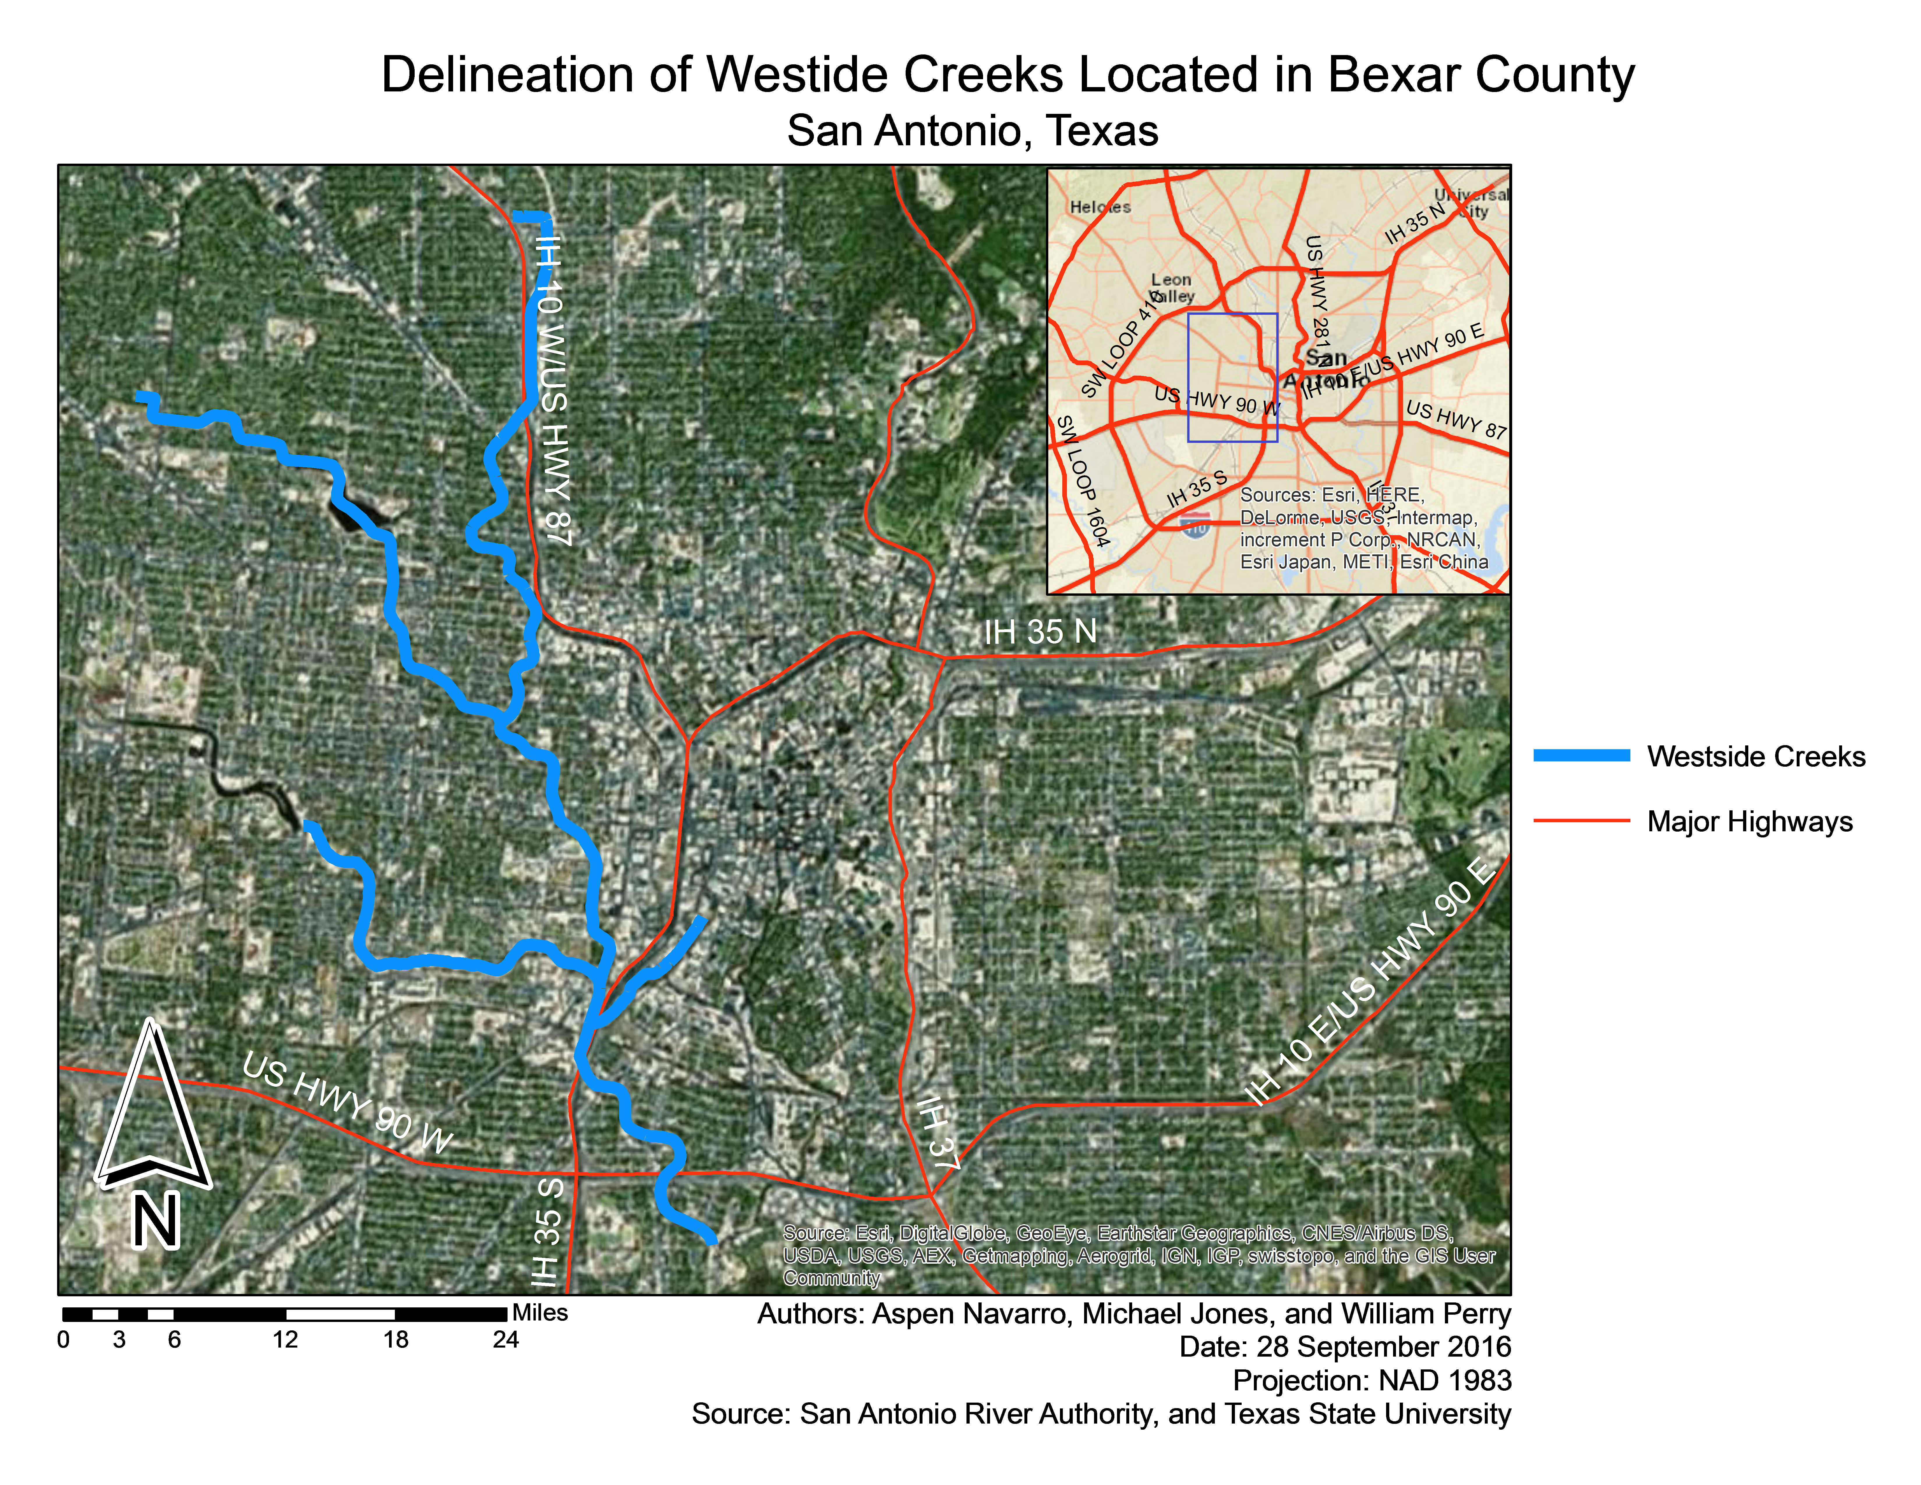
Figure 1: Map showing the extent of the study area.

Literature Review

2.1 GIS Applications
The reviewed literature emphasizes the contemporary use of spatial analysis when dealing with wastewater infrastructure. The American Water Resources Association (AWRA) has held conferences which concentrated on GIS applications and the modeling of urban stormwater. Scientist have explored various ways in accessing non-point source pollution, such as combining flow estimations (GIS) and nutrient concentrations (Soil and Water Assessment Tool) to access the impacts of animal feeding operations (Rosenthal and Hoffman 1996). This is another way to analyze the impacts of the assets humans desire. Environmental Systems Research Institute (ESRI) has also been a leading contributor to GIS applications and software, providing an abundant amount of information to users about wastewater applications. A textbook worth mentioning that has been helpful to this project is GIS Applications for Water, Wastewater and Stormwater Systems, by U.M. Shamsi (Shamsi 2005).

2.2 GIS and Water Resources
Trying to locate sources of pollution can be a difficult task, especially in waterways surrounded by Urban development. In the field of water resources, there are an abundant amount of publications that have focused on using geographic information systems to manage nonpoint source pollution. Although not specific to sewersheds, the proceedings from conferences discussing urban stormwater are helpful for this project as the analyses are fairly similar (Seiker and Verworn 1996). Experts believe that GIS is a necessary tool for investigating threats to urban water quality. Publications by the International Association of Hydrological Sciences have covered many topics about the integration of GIS in the management of water sources (Kovar and Nachtnebel, 1996). There is a growing need of geographically referenced data in watersheds. According to the American Water Works Association, more water utilities in the United States are starting to rely on GIS technology (Shamsi, 2005). GIS has revolutionized the water resources field by simplifying ways in which watersheds are delineated (Lanfear, 2000). Modeling parameters and managing spatial data have become easier than ever before (Miller et al., 2004). Reading journal articles that deal with GIS applications in different water systems, a GIS analyst can become familiar with the different ways GIS can improve pollution management.

Proposal

3.1 Data
Table 1. Data list consisting of layers, components, and purpose.
Source: United States Geological Survey
Layer |  | Contents/Attributes | Purpose
Channels |  | Names, adjacent streams, length type | Allows all Westside Creeks to be delineated, ensuring proper boundaries of the study area so further analyses and GIS processes can take place.
Roads |  | Names, types, directions, adjacent, length | Assists in boundary delineation, and will also be beneficial when adding land use/land cover data for visual analysis.
Boundary |  | Boundary shapefile of the study area | Further assistants for boundary delineation, also adds to map visuals.
Source: San Antonio River Authority
Layer | Contents/Attributes |  | Purpose
Inlets | Point data counting all inlets in the SA sewershed |  | Focusing in on inlets in Bexar County will allow further assessment as to the path in which waterways travel as they connect with other channels. Inlets will be essential for the network analysis part of this project.
Outfalls | Point data counting all outfalls in the SA sewershed |  | Outfalls in Bexar county will indicate where a waterway empties into another water source. Outfalls will need to be connected to their inlets when running a network analysis, in order to better determine the path of waterways. Thus, confirming where a pollution source is located.
DEM | 1-m Resolution DEM of Westside Creeks |  | Allows elevation to be analyzed in order to determine flow direction of waterways. This is essential for indicating waterways path of travel.
Land Use/Land Cover | Polygon data containing land use of plots |  | Analyzing Land use/Land cover layers will allow an assessment to be made, as to whether or not areas with more development contribute to pollution more than areas with little development. This data is also good to have visually when depicting pollution sources.

3.2 Methodology
Pollution Solutions will construct a basic geometric network from the inlet and outfall points. The next step would be to vectorize the stream channels with the sewershed grids. Ground slope can be obtained by extracting DEM values at junctions of the sewer network. The 1-meter DEM will then be used to compute the flow direction and flow accumulation to the nearest downslope outlet. The assumption is that the surface slope will be similar to the slope of the underground sewer system.
Topological relationships can help model hydrological processes. A network with hydrologic attributes will allow the GIS analysis to delineate the sewershed. A network analysis of the West Side Creek sewershed can answer many different questions. If a network analysis of the study area is made, then the San Antonio River Authority can trace sources of pollution and find out who is breaking laws that protect water quality.
A spatial analysis will be necessary to understand where pollution might come from. For Pollution Solutions to identify potential areas of non-point source pollution, the team must look at the land cover of the West Side Creek area. The final step would be to assemble different land cover polygons together to create a complete data layer. This will develop a visual representation of land types where inlets exist.
The West Side Creek study region is highly developed and urbanized. Determining the physical characteristics within urban landscape will be important, because there is a much faster reaction time for pollution to run off impervious areas than vegetated land. Adding land cover types to the GIS would be helpful to the San Antonio River Authority, because it will allow them to study the spatial arrangements of inlet points where pollution may have originated. Figure 2 shows a flow chart briefly describing the order of steps for the analysis of this project.
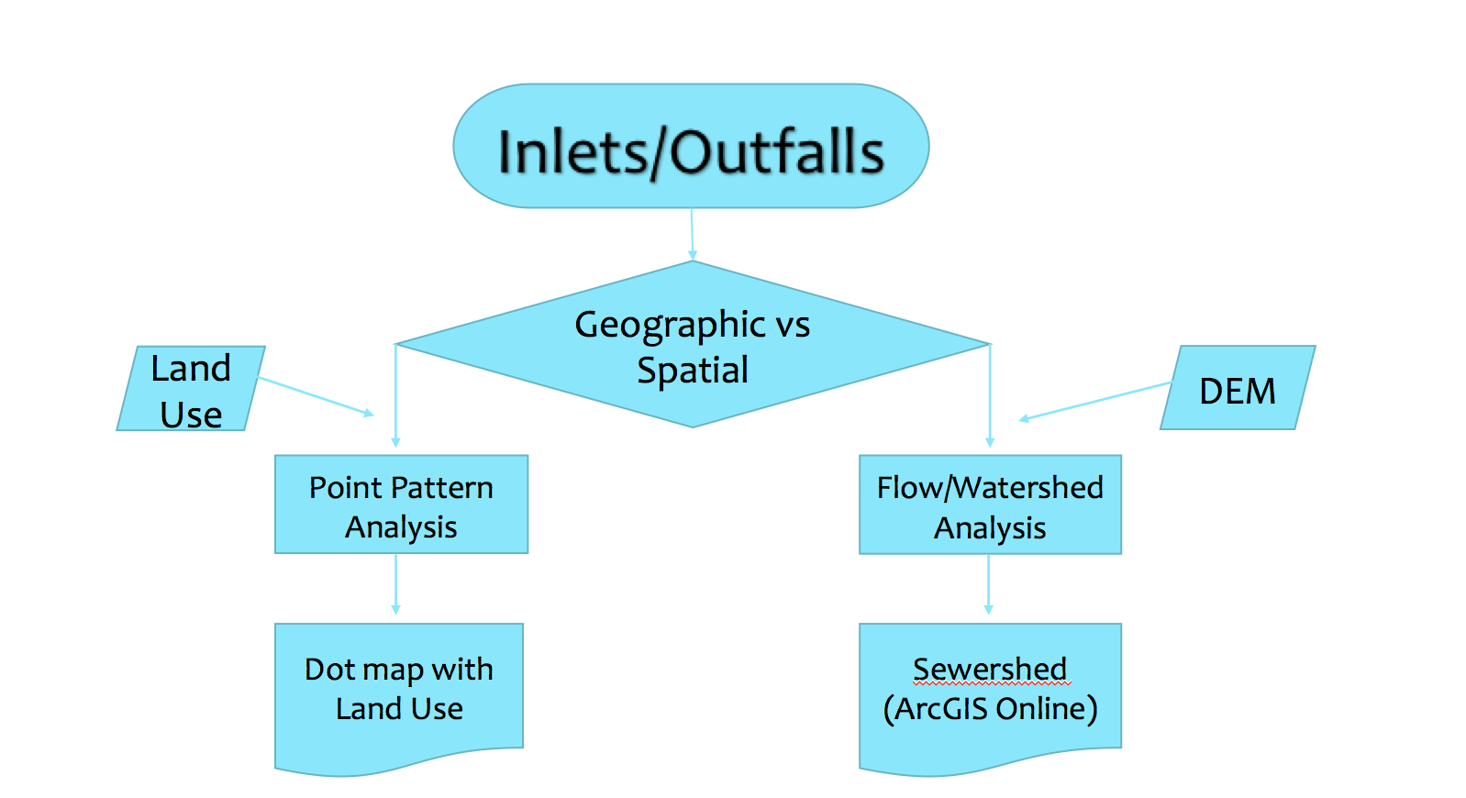
Figure 2. Flow chart showing the analysis and components essential to this project.

3.3 Implications
Final results of this project will be useful for The San Antonio River Authority, as well as the overall city of San Antonio. The boundary of this project is a small region out of the entire area SARA is managing. Therefore, the final geodatabase of this project will give SARA a framework for how to compute this analyses for other regions in Bexar County. The San Antonio River Authority will have a better way to track down where pollution originates, which will be especially beneficial as the city of San Antonio continues to grow and develop. The city of San Antonio will also benefit, as this analysis will ensure the health of rivers and creeks, making them available for recreational activities. Other cities can adopt this analysis as well to limit the amount of pollution that ends up in their waterways.

3.4 Budget
Table 2. Budget needed to fulfill project task.
Services:
Position | Hourly Rate | Hours (30 days) | Sub-Total
Project Manager | $36.00 | 130 | $4,680.00
Assistant Manager | $26.00 | 130 | $3,380.00
GIS Analysts/Design | $24.00 | 130 | $3,120.00
Services Sub-Total: $11,180.00
Supplies and Software:
Equipment | Amount Per | Quantity | Sub-Total
Computers | $200.00/station | 3 | $600.00
Workstations | $100.00/station | 3 | $300.00
ArcGIS Subscription | $2,500.00/year | 1 | $2,500.00
Supplies and Software Sub-Total: $3,400.00
Overall Total: $14,580.00

3.5 Timetable

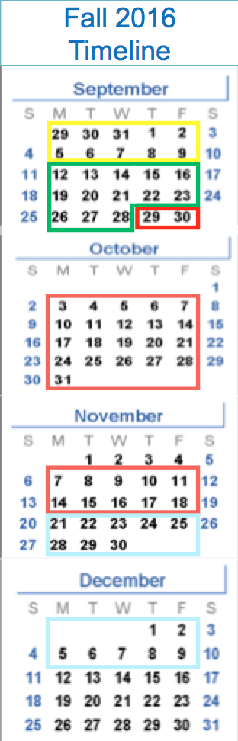

Data Collection and Intro stage
Weeks 1 – 2: The first two weeks after meeting with SARA, data aspects of the project will be collected and compiled to efficiently use, and to check for possible data quality issues. The project plan will also be organized.
Pre- Processing
Weeks 3 – 5: Data will be put into a GIS, creating geodatabases to easily lead into other timetables. Also, running preprocessing techniques on the DEM and Point pattern analysis.
Data Analysis
Weeks 5 – 12: Perform analysis over the entire sewershed and create deliverables in the form of shapefiles.
Data Interpolation
Weeks 13 –15: Create a report based on findings from the data and study area. Additional deliverables will also be made, checking for errors along the way before presenting our project on December 7th.

Figure 3. Timeline of project.

3.6 Final Deliverables
- Final Report
- Introduction
-Purpose
-Problem Statement
-Scope
- Literature Review
-GIS and Water Resources
-GIS Applications
- Data
- Methods
-Process Overview
-Building a Geometric Network
-Network Analysis
-Land Classification
-Spatial Analysis
-Visualization
- Results
-Network Analysis Results
-Spatial Analysis Results
- Discussion
-Data Quality
-Data Processing
-Design and Implementation
-Final Conclusion

- Final Poster
- Maps
- Methodology
- Flow Chart
- Results

- CD
1. Instructions
2. Poster File
3. Data
4. Maps
5. PowerPoint Presentation

- Website
1. Purpose
2. Results
3. Documents
4. Contact Information
Final deliverables given to The SARA will consist of a final map, showing all connections between inlets and outfalls, as well as land use/land cover surrounding Westside Creeks. Each layer and feature class file will also be given to the SARA, along with descriptions the contents in the attribute table. In order for the SARA to recreate this project, all powerpoint slides, proposals, and CDs containing workflow information will be submitted as well.

Conclusion
Identifying regions that are contributing to pollution in Bexar county will help The San Antonio River Authority continue to track down areas that are contributing to pollution in San Antonio waterways, especially as the city continues to expand. Pollution Solutions predicts that areas with more development will contribute to pollution more than areas with less development. Minimizing the amount of pollution that ends up in San Antonio waterways will improve the rivers overall accessibility, ensuring waterways are healthy for the natural ecology present, as well as river users.

Participation
Analyst | Position | Task
Aspen Navarro | Project Manager, GIS Analyst | Cover and Title Page, Table of Contents, Introduction, Map of Project Site, Implications, Conclusion, Participation
Michael Jones | Assistant Project Manager, GIS Analyst | Literature Review, Methodology, Deliverables, Reference
William Perry | GIS Analyst, Project Designer | Data, Budget, Timeline, Logo design

References

Kovar, K. and Nachtnebel, H.P., Eds. 1996. Application of Geographic Information Systems in
Hydrology and Water Resources Management, Proceedings of the HydroGIS’96 Conference, April 16-19, 1996, Vienna, Austria, IAHS Publication No. 235, Intern’l Assoc. Hyrol. Sci., Oxfordshire, U.K.

Lanfear, K. J. 2000. The Future of GIS and Water Resources. Water Resources Impact.
American Water Resources Association, Vol. 2, Number 5, September 2000, 9-11.

Miller et al. 2002. Integrating landscape assessment and hydrologic modeling for land cover
change analysis. JAWRA 38(4): 915-929.

Rosenthal, W. D. and Hoffman, D. W. 1996. Hydrologic Modeling to aid in Locating Monitoring Sites. American Water Resources Association. Ft. Lauderdale, FL.

Shamsi, U. 2005. GIS Applications for Water, Wastewater and Stormwater Systems. New
York: Taylor and Frances.

