San Marcos Trail Mappers
Alexandra Hughes- Project Manager
Griffin Price- GIS Analyst
Kevin Garcia- GIS Analyst

September 28th, 2016

Creation and Design of GIS of the Austin Ridge Riders Mountain Bike Trails

Prepared by San Marcos Trail Mappers

Table of Contents
Introduction
Summary ………………………………………..4
Purpose …………………………………………4
Scope …………………………………………...5
Literature Review……………………………………….6
Proposal
Data……………………………………………...7
Methodology………………………………….…8
Budget…………………………………………...10
Timetable………………………………………..12
Final Deliverables……………………………….13
Conclusion………………….……………………….......13
Participation……………………………………………..14
References……………………………………………….14

1. Introduction
1.1 Summary
Austin Ridge Riders is a non-profit mountain biking club located in Austin, Texas. Activities managed by the group include developing and maintaining bike trails, education and community outreach on bike safety, and monthly club, women’s, and youth rides. Recently, Austin Ridge Riders has been awarded a grant from REI to improve signage along the off-road bike trails.
San Marcos Trail Mappers will create a GIS for Reimer’s Ranch to enable Austin Ridge Riders to better document the biking trails, multi-use trails, and other important features in those areas. These maps can then be used to create simple maps for use by bike riders as well as to create more complete maps to be used by Austin Ridge Riders to plan and maintain the trails.
1.2 Purpose
This study will result in a GIS of an area where there is none to improve recreational safety and maintenance of the area. Open source GIS such as Google Earth and QGIS will be used in conjunction with existing maps to make shapefiles of the features in the study area. From that data, simple maps will be created in a manner that is easy use as reference maps by bikers riding the trails, and complete maps will be given to the club for trail planning and maintenance. We will provide PDF maps and QGIS maps of the areas for use by Austin Ridge Riders, who do not have access to ArcGIS, as well as shapefiles for use in the future if the club does obtain access to ArcGIS software.

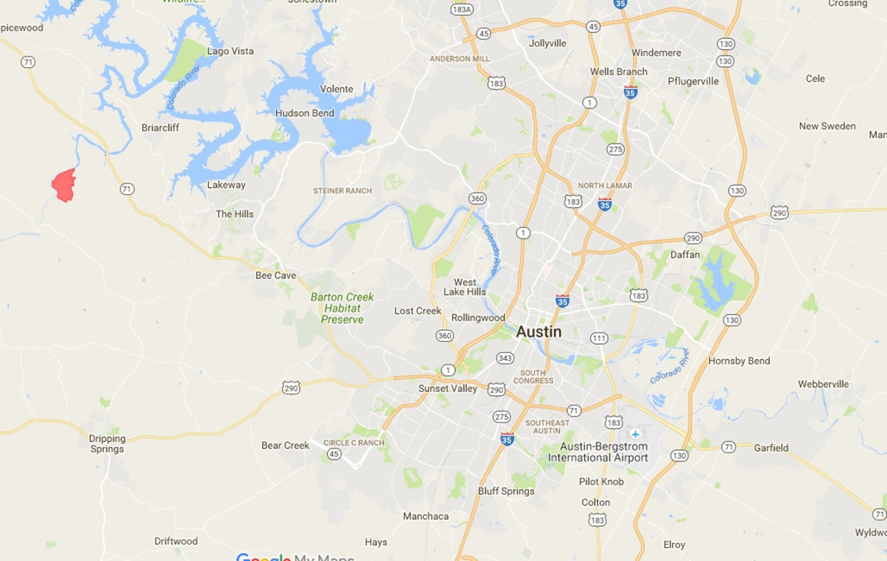
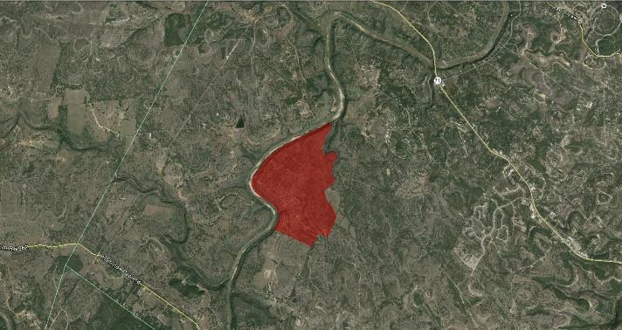
1.3 Scope
Figure 1. An aerial photo of Riemer’s Ranch and a map showing the location of the park in relation to the city of Austin

Reimer’s Ranch is located west of downtown Austin, in the southwest corner of Travis County. It is in a less developed area near other popular places of recreation such as Pedernales Falls States Park and Hamilton pool.

2. Literature Review
In this study, we will be focused on creating maps of areas that are used for recreation. We will be focusing on biking trails within two areas, Reimer’s Ranch. This will require us to examine the ways map use can affect the utilization of recreational spaces. More specifically, how map availability and design can affect the use of recreational spaces and the user’s ability to find their way around the area.
Careen Yarnal and Michael Coulson conducted an experiment to examine the correlation between map utilization and design and recreational trail use (Yarnal & Coulson, 2013). Trail use was compared between subject who were able to use a map of the trails as a reference and those without maps. The study also compared the trails use of subjects who had a colorful map versus a monochromatic map. It was found that trail use increased significantly with map availability, and subjects had a preference of colored maps over monochromatic maps (Yarnal & Coulson, 2013). This is relevant to our project in that it shows that map availability and design has a profound influence on the utilization of recreational trails. An interesting and user friendly map could potentially increase trail use in Reimer’s Ranch.
Another important factor in the map design of these areas is the map’s ability to improve wayfinding. Boon Soh and Tonya Smith-Jackson examined the way differences in map design, user differences, and area markings effected the time it took for map users to make wayfinding decisions and the accuracy of those decisions (Soh & Smith-Jackson, 2004). The experiment found that signage along the trails as well as map design improved the accuracy of the users’ decision making. Subjects preferred contour maps over shaded relief or schematic maps (Soh & Smith-Jackson, 2004). It is important that our study produces maps that improves wayfinding abilities of trail users, so the findings of this study need to be taken into consideration so that people do not get lost on the trails.

3. Proposal
3.1 Dataset
  - Publicly accessible GIS data
    - Google Earth/Maps
    - Open Street Map
    - QGIS
    - TNRIS aerial quad imagery and elevation data
      - Contour data, along with trail data, will be used to determine areas along the trail that do not meet sustainable trail guidelines
      - Findings will result in recommendations on where to change the trail to make it sustainable
  - GPX data of Reimer’s Ranch mountain biking trails provided by Austin Ridge Riders.
  - Additional data will be collected and provided by Austin Ridge Riders as needed.
  - International Mountain Biking Association (IMBA) Trail Solutions Book for guidance on sustainable trails
    - Email client to get applicable chapter in book to help with determination of unsustainable areas of trail
  - Existing Maps on Travis County Parks website to aid in building GIS of Reimer’s Ranch and Muleshoe Bend
  - Reimer’s Ranch property lines from the consulting company that did their maps
  - Software to be used: ArcGIS, QGIS, ERDAS Imagine, Adobe Illustrator, Google Earth, Open Street Map

  - Methodology
  - Create base map of Reimer’s Ranch using aerial imagery, existing park maps, and trail data provided by client
    - Quads obtained through TNRIS
    - Overlay with existing park map image to map park boundaries
    - Create point, line, and polygon features based on aerial imagery and existing park map
    - trails
  - Implementing the half rule of trail sustainability, the trails layer and contour lines will be used in determining sections of the trail that are not sustainable and should be altered by Austin Ridge Riders members to improve trail sustainability
    - The half rule means that a trail’s slope should not exceed half the grade of the side slope.
Creating a GIS Database of Reimer’s Ranch and Muleshoe Bend
TNRIS Aerial Imagery/Google Earth
Existing Park Map (Travis County Parks)
Multiple layers (shapefiles) depicting these features
Create Features
Points, Lines, Polygons of Trails, Buildings, Roads, etc.
Overlay

Trail grade analysis for trail sustainability
Line features of mountain biking trails
Contour shapefiles overlaying each park (5ft contour interval)

Identify unsustainable points/sections of trail
½ Rule of Trail Sustainability
Make recommendations on where to improve trail to make it more sustainable
  - Budget
Data Processing
Project Manager | 10 hours/week * 1 week
GIS Analyst | 10 hours/week * 2 analysts *1 weeks
Total Hours | 30
Hourly Pay | $20
Subtotal | $600

Data Analysis
Project Manager | 10 hours/week * 2 weeks
GIS Analyst | 10 hours/week * 2 analysts *2 weeks
Total Hours | 60
Hourly Pay | $20
Subtotal | $1,200

Web and Map Development
Project Manager | 8 hours/week * 6 weeks
GIS Analyst | 8 hours/ week * 2 analysts * 6 weeks
Total Hours | 144
Hourly Pay | $20
Subtotal | $2,280

Data Interpretation
Project Manager | 5 hours/week * 2 weeks
GIS Analyst | 5 hours/week * 2 analysts *2 weeks
Total Hours | 30
Hourly Pay | $20
Subtotal | $600

Software
ArcGIS | $1,750 ($7,000 annual subscription)
ERDAS Imagine | $220
Adobe Illustrator | $599
Subtotal | $2,569

Total Cost
Data Processing Subtotal | $600
Data Analysis Subtotal | $1,200
Web and Map Development Subtotal | $2,280
Data Interpretation Subtotal | $600
Software Subtotal | $2,569
Total Cost | $7,649

3.4 Timetable
The data processing phase will amount to exactly one week. Typically, this process would 2 to 3 weeks, however, most of the necessary data was already supplied. During this time, the given data will be collected, viewed, and processed to ensure accuracy and validity.
The data analysis phase will consist of three weeks of map integration, base map analysis, and surface interpolation of the given data set.
The web and map development phase will require 4 weeks of map generating to benefit the trail user. This will include a slope based interpolation of the terrain, flood zone mapping, natural landmark water feature mapping, emergency location analysis, and a map of each trail labeled by difficulty.
The data interpretation phase will only require a week of time to further assess the results from the analysis. The final deliverables will be collected during this time.

Project Phase | Starting | Ending
Data Processing | 9/12/16 | 9/19/16
Data Analysis | 9/20/16 | 10/4/16
Web and Map Development | 10/5/16 | 11/9/16
Data Interpretation | 11/10/16 | 11/17/16
Presentation | 12/7/16 | 12/7/16

September | October | November | December | January | February
M T W T F S S  1 2 3 4  5 6 7 8 9 10 11  12 13 14 15 16 17 18  19 20 21 22 23 24 25  26 27 28 29 30 | M T W T F S S  1 2  3 4 5 6 7 8 9  10 11 12 13 14 15 16  17 18 19 20 21 22 23  24 25 26 27 28 29 30  31 | M T W T F S S  1 2 3 4 5 6  7 8 9 10 11 12 13  14 15 16 17 18 19 20  21 22 23 24 25 26 27  28 29 30 | M T W T F S S  1 2 3 4  5 6 7 8 9 10 11  12 13 14 15 16 17 18  19 20 21 22 23 24 25  26 27 28 29 30 31 | M T W T F S S  1  2 3 4 5 6 7 8  9 10 11 12 13 14 15  16 17 18 19 20 21 22  23 24 25 26 27 28 29  30 31 | M T W T F S S  1 2 3 4 5  6 7 8 9 10 11 12  13 14 15 16 17 18 19  20 21 22 23 24 25 26  27 28

3.5 Final Deliverables
- Final Report
- Proposal
- GIS trail database and PDF file
- Website
- PowerPoint Presentation
- Map of based on trail names, difficultly, elevation, flood zones, and areas of emergency access.

The final deliverables will include a digital map specifying levels of existing trails provided by the Austin Ridge Riders. These trails must contain levels of information including trail names, trail difficulty, elevation, and location of natural water features. Other additional information needed in the final deliverables are flood zones and areas of emergency access for trail users. The information must be available to all trail users, and be made to show areas of potential trail building for the city of Austin. All of the information stated is to be delivered to promote the sustainability of the Austin Ridge Rider trails for the city of Austin. The preventions needed to ensure safety of the trails are based on erosion and ground cover. The final map will show trails that meet such criteria.
4. Conclusion
San Marcos Trail Mappers will use the data provided by the Austin Rider Riders to ensure proper trial sustainability through the analysis of spatial data. The GIS functionality of the project will focus on hazard mitigation of ground cover and erosional properties of the trails. The maps created will help Austin Ridge Riders in regards to their commitment to the development of public bike trails, safe forms of recreation, transportation, and aid its goal to overall public bike use and safety. When the project is completed, Austin Ridge Riders will provide the city of Austin the access of physical maps to aid in recreation and athletic performance of mountain bikers as well as the general public.

5. Participation
Kevin Garcia (Graphic Designer/Planner)
- Logo designer, team name designer, in charge of planning through creating the projected timetable
Alexandra Hughes (Project Manager)
- Wrote the summary, purpose, scope, and literature review sections, complied and formatted project proposal.
Griffin Price (GIS Analyst)
- Compiled list of data sources, developed methodology for executing project, created budget showing cost of project.

6.1 References
Boon Kee Soh and Tonya L. Smith-Jackson. 2004. Influence of Map Design, Individual Differences, and Environmental Cues on Wayfinding Performance , Spatial Cognition & Computation, 4(2): 15-26.
Careen M. Mackay Yarnal and Michael R. C. Coulson. 2013. Recreational Map Design and Map Use: An Experiment, The Cartographic Journal, 19(1): 16-27.

