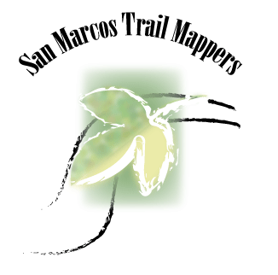

San Marcos Trail Mappers
Texas State University
October 31st, 2016
Alex Hughes- Project Manager
Griffin Price- GIS analyst
Kevin Garcia- GIS Analyst

Progress Report

The Digitalization and Cartography of the Austin Ridge Riders Mountain Bike Trails

Prepared by the San Marcos Trail Mappers

Table of Contents

Introduction ……………………………………………………………...………………………..4
Summary………………………………………………...…………………………….…..4
Background………………………………………………………………………………..4
Tasks……………………………………………………………………………………………....4
Work Completed………………………………………………………………………..…4
Present Work………………………………………………………………………...…….4
Work Scheduled…………………………………………………………………………...5
Problems…………………………………………………………………………………..5
Time Table…………………………………………………………………………..…….5
Conclusion………………………………………………………………………………………...6

1. Introduction
1.1 Summary
I am reviewing to you a report based on the progress the San Marcos Trail Mappers have made in regards to a satisfactory work promise. Progress for mapping bike trials for Austin Ridge Riders is going very well. The map of Reimer’s Ranch is almost complete per the requested guidelines and progress on the Muleshoe Bend map is already underway. In the following sections of this progress report, a list of work will be shown of what has been accomplished up to this point within the scope of the project.
1.2 Background
All areas of the project include overlooking the creation of detailed maps given to the club for trail planning, maintenance, and development, and simple maps to be used by bikers. Specific features of these maps include trail names, trail difficulty, elevation, and location of natural features. Other additional information needed in the final deliverables are flood zones and areas of emergency access for trail users. While only one map was requested by the end of the semester, we are confident that we will be able to deliver both maps to the Austin Ridge Riders by the December 7th.
2. TASKS
2.1 Work Completed
Since our project proposal on October 3rd, a lot of progress has been made on the Reimer’s Ranch map. First, features such as trails, roads, bike trails, parking lots, etc. were digitized in Google Earth Pro using existing Reimer’s Ranch maps as reference. The KML files from this step were then converted to layer files in ArcMap. Contour data from that area was found online and clipped to the shape of the park. From this data, a simple map was created in Adobe Illustrator that included other information such as trail difficulty, and trail names.
2.2 Present Work
As the final details are added to the Reimer’s Ranch map, we have also started digitizing the Muleshoe Bend map in the same way as before. Boundary lines of the park and some roads have been digitized. Flood zone data is being located for the Reimer’s Ranch area, and trail sustainability is being analyzed, which includes identifying areas where the slope of the trail is more than half the slope of the ground it traverses
2.3 Work Scheduled
Over the next month and a half, we expect to complete the map for Muleshoe Bend Park in the same way we accomplished the map for Reimer’s Ranch. We will continue to digitize the features using an existing map as reference, convert these files to layer files, and create a simple map in Adobe Illustrator.
2.4 Problems
The biggest challenge with this project was converting KML files to files that could be used in ArcMap. Originally, we planned on converting the KML files to shapefiles using a tool on ArcToolbox. However, this resulted in many more files than needed. After trying many solutions, we solved this problem by using the KML to Layer tool to convert the files to a layer file and a geodatabase.
Project Phase | Start Date | End Date
Digitalization | 11/1/16 | 11/12/16
Data Analysis | 11/13/16 | 11/19/16
Web and Map Development | 11/20/16 | 11/26/16
Final Edits | 11/27/16 | 12/6/16
Final Presentation | 12/7/16 | 12/7/16
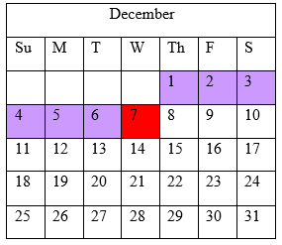
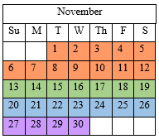

3. Conclusion
As we move into the second half of the semester, the digitization and cartography of Reimer’s Ranch is nearing completion. While there have been some unexpected challenges, problem solving has been quick and effective. As the finishing touches have been added to the Reimer’s Ranch map, we have already started digitizing Muleshoe Bend. Now that we are aware of the problems that can arise in this type of project and have found effective solutions, the process of creating the Muleshoe Bend map should be much more streamlined and any edits to the maps of either park should be quick and easy. We expect to be able to produce maps of both Reimer’s Ranch and Muleshoe Bend by the end of the semester.

