San Marcos Trail Mappers
Texas State University
December 5th, 2016
Alex Hughes- Project Manager
Griffin Price- GIS analyst
Kevin Garcia- GIS Analyst

Final Report

The Digitalization and Cartography of the Austin Ridge Riders Mountain Bike Trails

Prepared by the San Marcos Trail Mappers

Table of Contents
Abstract……………………………………………………………………………………………4
Introduction ……………………………………………………………...………………………..4
Problem Statement………….…………………………...…………………………….…..4
Summary…………………………………………………………………………………..5
Background………………………………………………………………………………..5
Scope……………………………………………………………………………………....6
Data………………………………………………………………………………………………..7
Methods…………………………………………………………………………………………....7
Map Digitization and Cartography…………………………………………………..……7
Trail Sustainability Analysis………………………………………………………………8
Results and Discussion……………………………………………………………………………9
Conclusion………………………………………………………………………………..……...13
References………………………………………………………………………………………..14
Appendix I……………………………………………………………………………………….14
Appendix II………………………………………………………………………………………15
Abstract
The Austin Ridge Riders, a non-profit mountain bike club, has been awarded a grant to improve signage along the off-road bike trails. Our project included creating simple maps for this purpose, and to create digitized features to aid the Austin Ridge Riders with future planning and maintenance. Using the data given to us by Austin Ridge Riders and other data collected online, we digitized bike trails, roads, and other features of the parks. To determine whether the trail met the half rule of trail sustainability, we compared the slopes of the parks with that of the trails to identify areas where the trail slope was greater than half the slope of the ground it traversed. This revealed the parts of the trails that The Austin Ridge Riders will have to fix. The completion of this project will result in better overall safety of the trails for bikers of all skill levels.
1.Introduction
1.1 Problem Statement
Despite the rapid urbanization of the city, many of the residents of Austin enjoy outdoor recreational activities. One increasingly popular hobby is mountain biking. With more and more people taking to the trails, trail development, maintenance and mapping is more important than ever to ensure the safety of all the bikers. This is a job that the Austin Ridge Riders have taken on.
Austin Ridge Riders is a non-profit mountain biking club located in Austin, Texas. Activities managed by the group include developing and maintaining bike trails, education and community outreach on bike safety, and monthly club, women’s, and youth rides. Recently, Austin Ridge Riders has been awarded a grant to improve signage along the off-road bike trails. Part of our project includes creating simple maps for this purpose, the other is to create digitized features to aid the Austin Ridge Riders with future planning and maintenance.
GIS is needed for this project so that people from Austin Ridge Riders can use GPS data collected in the field in a comprehensive map that accurately depicts the trails in the parks as one big picture. This will allow them to accurately edit the map as changes are made to the trails and analyze the trails to make sure they are safe to ride and are resistant to weathering.

1.2 Summary
San Marcos Trail Mappers will create digitized features for Reimer’s Ranch and Muleshoe Bend to enable Austin Ridge Riders to better document the biking trails, multi-use trails, and other important features in those areas. These maps can then be used to create simple maps for use by bike riders as well as to create more complete maps to be used by Austin Ridge Riders to plan and maintain the trails.
To do this, open source GIS such as Google Earth and QGIS were used in conjunction with existing maps to make shapefiles of the features in the study area. From that data, simple maps were created in a manner that are easy use as reference maps by bikers riding the trails, and complete maps will be given to the club for trail planning and maintenance. We will provide PDF maps and QGIS maps of the areas for use by Austin Ridge Riders, who do not have access to ArcGIS, as well as shapefiles for use in the future if the club does obtain access to ArcGIS software.
1.3 Background
In order to create simple maps to be used along the trails, we must take into consideration a map’s role in wayfinding and trail use. Careen Yarnal and Michael Coulson conducted an experiment which concluded that trail use increased significantly with map availability, and subjects had a preference of colored maps over monochromatic maps (Yarnal & Coulson, 2013). This is relevant to our project in that it shows that map availability and design has a profound influence on the utilization of recreational trails. An interesting and user friendly map could potentially increase trail use in Reimer’s Ranch and Muleshoe Bend.
The main reason for Austin Ridge Riders to improve signage along the trails is to improve wayfinding in the area. It is important for us to take into consideration how a map can affect wayfinding. Boon Soh and Tonya Smith-Jackson examined this in a study and found that signage along the trails as well as map design improved the accuracy of the users’ decision making. Subjects preferred contour maps over shaded relief or schematic maps (Soh & Smith-Jackson, 2004).

1.4 Scope
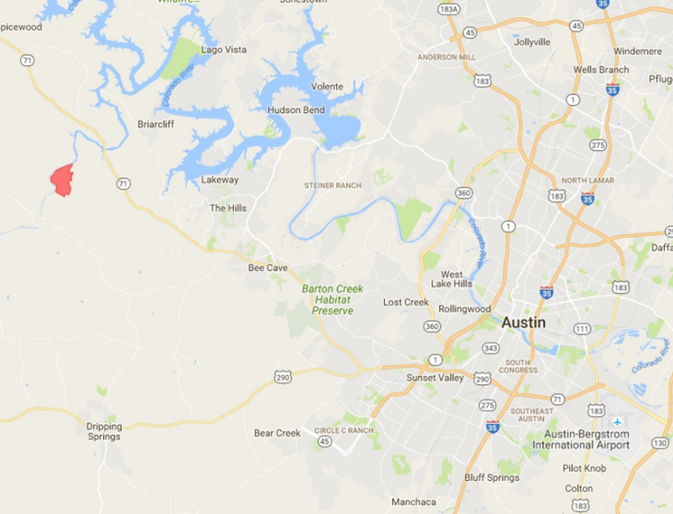
See Figures 1 and 2 for the relative size of Reimer’s Ranch and Muleshoe Bend and their locations in relation to the city of Austin.

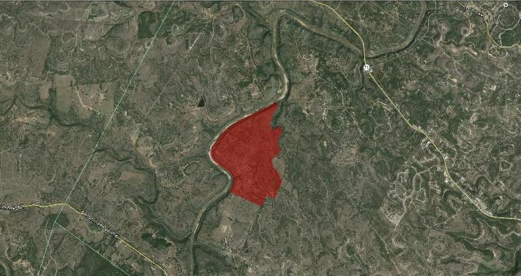
Figure 1. An aerial photo of Riemer’s Ranch and a map showing the location of the park in relation to the city of Austin

Figure 2. An aerial photo of Muleshoe Bend and a map showing the location of the park in relation to the city of Austin
2. Data
While a majority of the files were created by us, some of it was given to us by the Austin Ridge Riders and some was found using online databases to produce the final deliverables. Point data of the mountain bike trails was given to us by the Austin Ridge Riders in the form of GPX files. These files were converted into line files to show accurate GPS coordinates of the trails. The Austin Ridge Riders also provided us with old maps that helped us with determining usage to different pathways and roads as well as assign difficulty levels to the bike trails.
Data that was found online included the contour data and the flood zone data. The contour data was found using Texas Natural Resources Information System. The data containing the flood zones was found on the Federal Emergency Management Agency website. Both of these layers had to be clipped to the study area and the projection of these files had to be converted to GCS WGS 1984 to match the data created in Google Earth.
3. Methods
3.1 Map Digitization and Cartography
Using the data given to us by Austin Ridge Riders and other data collected online, we began the process of digitizing Milton Reimer’s Ranch and Muleshoe Bend Recreation Area, as depicted in Figure 3. 50cm aerial imagery obtained from the Texas Natural Resource Information System (TNRIS) website provided a georeferenced backdrop that we then overlaid with an existing map image of the parks found online. The map image was referenced with the georeferencing toolbar using easily recognizable control points, such as road intersections, evenly distributed across the map image to stretch the image so that it matched the aerial image beneath. Transparency of the park map image was adjusted so both the existing map image and the aerial imagery could be seen at the same time. From there, we digitized feature classes in to the ArcMap document starting with the Park Outline followed by a Roads layer. Then we imported the trail data provided to us by Austin Ridge Riders. The trail data given to us was a point feature class in the GPX format. The file was changed from the GPX format into a shapefile with the GPX To Features conversion tool so it could then be opened, viewed, and manipulated in ArcMap. The point feature class was turned into a line feature using the Points To Line tool. Then we split up the single line features with the split line tool in the editor toolbar into the different trails and classified them by trail name and difficulty. Five-foot contour line data was downloaded from the TNRIS website, opened in ArcMap and clipped using the park outline as a mask. Other features were created including: bathrooms (flushing, non-flushing), mile markers, flood zone, river channel, trailhead, and alternative/emergency access points to the trail. The alternative/emergency access points are located at points where the trail intersects with the park roads totaling four alternative access points. Some of the shapefiles had to be projected so that all the features shared the same coordinate system. The methods for digitizing Reimer’s Ranch and Muleshoe Bend were practically identical except for a few minor edits. The maps were exported as a PNG and brought into Adobe Illustrator where they were further edited for aesthetics and to make them more user friendly. Information such as title, legend, scale bar, and north arrow were among the elements added to the maps.
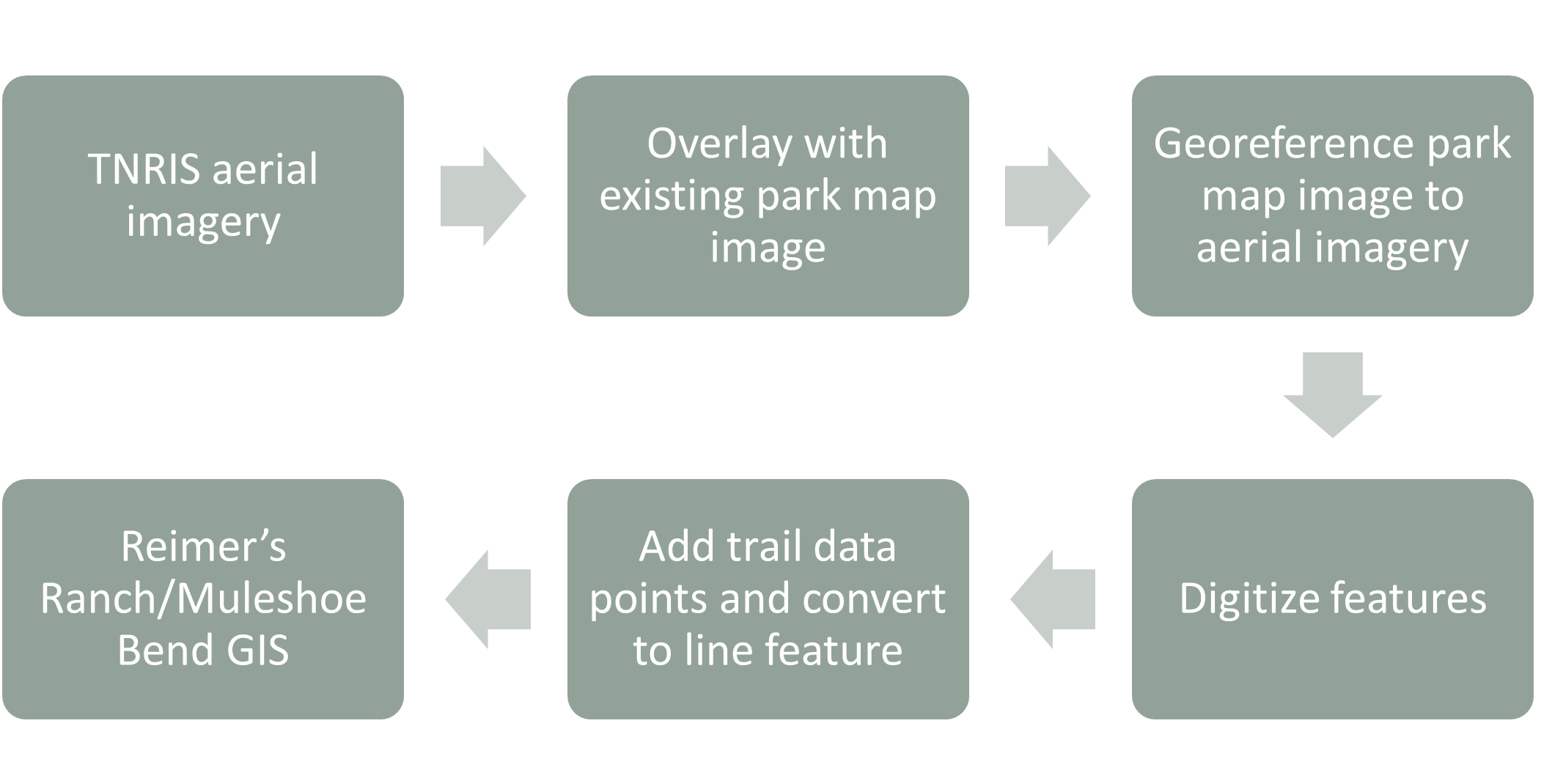
Figure 3. Flowchart depicting the process of digitizing Reimer’s Ranch and Muleshoe Bend.
3.2 Trail Sustainability Analysis
The second component of this project was an analysis of trail sustainability using the “half rule” element of trail sustainability established by the International Mountain Bicycling Association, as depicted in Figure 4. The half rule states that “a trail’s grade shouldn’t exceed half the grade of the hillside or sideslope that the trail traverses.” If the trail grade is greater than half the hillside grade, it is considered a fall-line trail where water will flow down the trail instead of across it. During rain events, trails that do not meet the half rule will wash out making it difficult and unsafe for hikers and bikers to travel it. It also results in trail closures and increased trail maintenance.
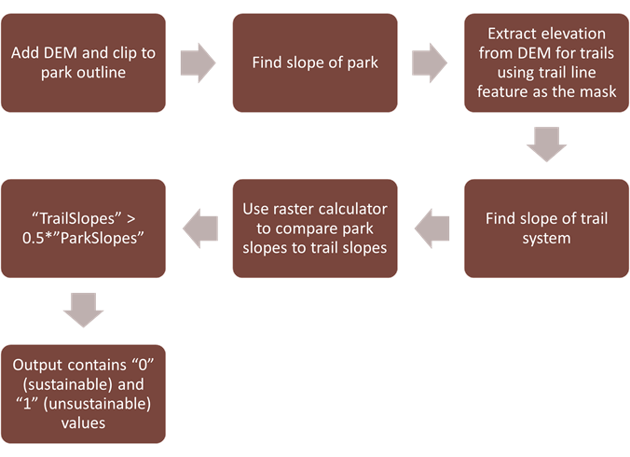
To determine whether the trail met the half rule, we compared the slopes of the parks with that of the trails to identify areas where the trail slope was greater than half the slope of the ground it traversed. Using a Digital Elevation Model (DEM) obtained from the TNRIS website, we clipped it to the shape of the park outline then ran the Slope tool. Then we took the line feature of the trail created from the point data given to us by the client and rasterized it. The rasterized line feature enabled us to extract elevation data using the Extract By Mask tool with the DEM as the layer from which the data was extracted and the rasterized line feature as the mask. The new output was the rasterized line feature containing elevation data extracted from the DEM. We ran the slope tool for this output which resulted in an output with the trail slopes. Next, the Raster Calculator was used with the equation “trailslopes” > 0.5*”sideslope” which output values of “0” (meets half rule) and “1” (does not meet half rule) showing areas along the trail that did not meet the half rule. This method was used for both Reimer’s Ranch and Muleshoe Bend.
Figure 4. Flowchart depicting the process of analyzing trail sustainability.
4. Results and Discussion
The results acquired by the analysis of both Reimers Ranch and Muleshoe bend proved significant to the projects initial goals and purpose. The maps designed by the San Marcos Trial Mappers were shown to promote trail signage, user friendly maps for the public, and provide sustainably trail options for further development by the nonprofit organization. More importantly, the maps provided by the San Marcos Trail Mappers will hopefully aid in the organizations main purpose of providing an educational outreach to trail goers in respects of safe and proper usage of bicycles. In the scope of the projects timeline, most if not all materials were carried out in the timely manner first described in the proposal, and were delivered in the form of a GIS database (not yet acquired for the organization) and a PDF file.
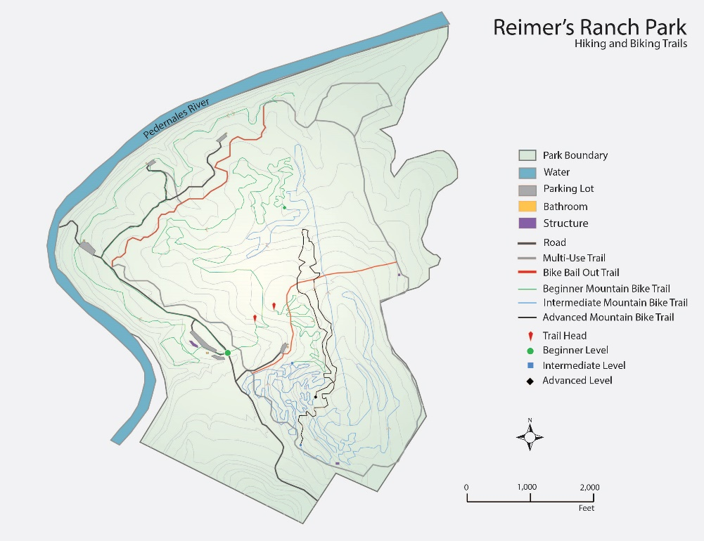
Figure 5. The completed map of Reimer’s Ranch, created using Adobe Illustrator.
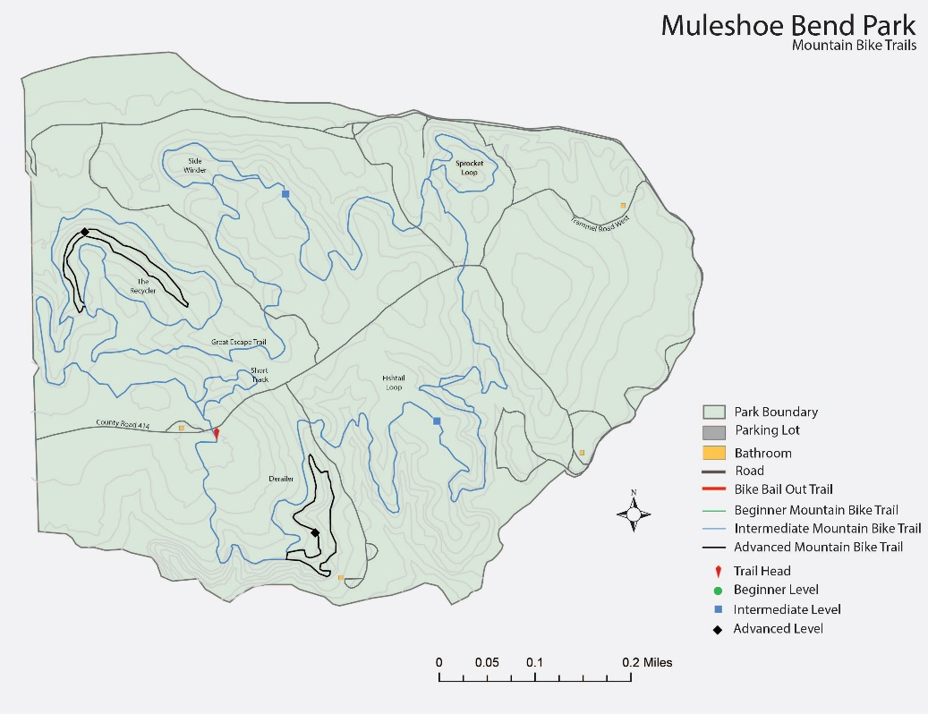
Figure 6. The completed map of Muleshoe Bend, created using Adobe Illustrator.
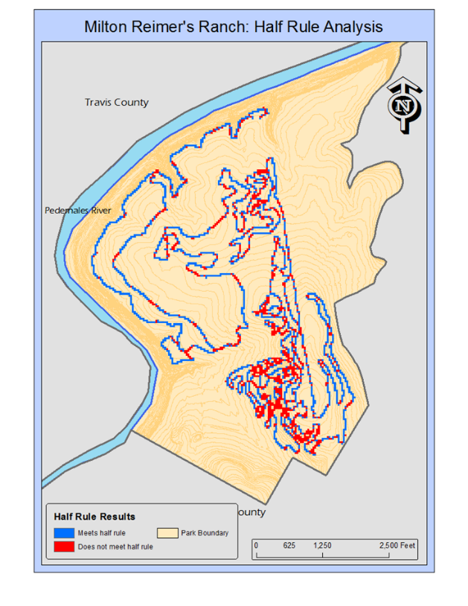
The trails that were assigned to us, in the form of GPX files, were precisely mapped out and digitized to fit Austin Ridge Riders request for providing bike trail maps with all the intended purposes of signage, outreach, and sustainability. Each layer that was rendered with the use of QGIS contained the features that were first outlined in the proposal. These features included the trails, difficulty, and emergency access locations. The park boundary for both Reimers Ranch and Muleshoe Bend were obtained with the use of TNRIS and Google Earth. The satellite imagery obtained from these sites were then traced to obtain the boundary points for the area of analysis. After overlaying both the area of the park and the trail files, the results can clearly be seen in figures 5 and 6. Note that the trails are divided into beginner, intermediate, and advance levels of trial difficulty. The trails are organized in such this way as to promote safer uses of mountain bike mobilization between avid bike users and maybe those just starting out. Bike safety, being one of the big concerns for the Austin Ridge Riders, can be better allocated with this in mind. The trails listed in figures 5 and 6 also give a detailed look into what the exact uses are for each given trail. The trails outlined in yellow, for example, are those that represent trails designated for mountain bikers. The maroon colored trials are those that for multi-use purposes and red is designated as a bike bail out trail. Sustainable trail development can be seen in detail when looking at Muleshoe Bend. This sustainable development was achieved through the application of the ½-inch rule. This rule in particular defines a truly sustainable trail by looking at its slope in relation to a DEM of the surrounding area. Muleshoe bend, for example, offered a lot of sustainable opportunity for further trail development by the Austin Ridge Riders. When looking at figure 7 and 8 it can be clear where the unsustainable trails lie and where the developable ones persist. The areas highlighted in green have a slope that falls over half of the total slope of the DEM for the Muleshoe Bend area, while the areas in black contain the slopes that did not meet these criteria. A trail that meets this ½ rule is crucial when looking for areas better suited to combat high amounts of rain or floodwater. The purpose of this rule is to find areas alongside the trails that both do not have a “fall line,” and a large flat surface area. Areas that have either of these elements are those that will retain water more easily. A trail that holds water is one that holds stronger erosional properties that does not provide true sustainability for its users, as the sediment from the trail can gradually deteriorate or wash away over time. This was one of the most important issues raised by the project by far.

Figure 7. Results from the trail sustainability analysis for Reimer’s Ranch. This shows areas of the trail that cannot be sustained based on the half rule.
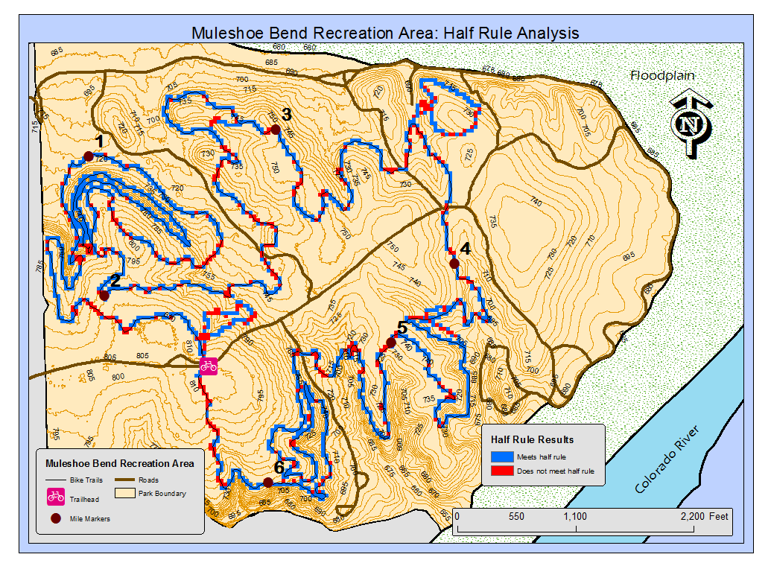
Figure 8. Results from the trail sustainability analysis for Muleshoe Bend. This shows areas of the trail that cannot be sustained based on the half rule.
The results aquired from the analysis of both Reimers Ranch and Muleshoe Bend were laid out exactly as predicted from the start of the project. Aquiring the GPX files at the beginning of the project proved to yield limitations to the overall scope of the project. Theses limitations include specifically the lack of data collection, variables, and spatial patterns for observation within the group. If the proect were to be repeated, the problem woud first be better defined from the initial start of the proposal.
5. Conclusion
The Austin Ridge Riders project taken on by the San Marcos Trail mappers will help the club plan and maintain trails in the Reimer’s Ranch and Muleshoe Bend areas, as well as help bikers navigate through the trails. This will result in better overall safety of the trails for bikers of all skill levels.
When creating data of an area where there is none, it is important that the data be as accurate as possible. The data that we deliver to our client will be used quite a bit before new data is created. It may also be used by anyone else that needs data for this area. This was the biggest obstacle in our project; that digitizing features accurately without being able to go out and collect GPS data points is very difficult. Digitizing the features of these areas required a great deal of patience to get accurate results.
Now that the base maps have been created for these parks, there are many possibilities for future projects. One that may be of best benefit to the Austin Ridge Riders specifically would be to use GPS to pinpoint potential hazards, endangered plants, and other points of interest along the trails to help with trail planning. This way, much of the planning can be done before the group goes out into the field to make changes to the trails, as well as allowing the users to see the potential hazards as a part of the big picture of the trails.
Refernces:
Boon Kee Soh and Tonya L. Smith-Jackson. 2004. Influence of Map Design, Individual Differences, and Environmental Cues on Wayfinding Performance , Spatial Cognition & Computation, 4(2): 15-26.
Careen M. Mackay Yarnal and Michael R. C. Coulson. 2013. Recreational Map Design and Map Use: An Experiment, The Cartographic Journal, 19(1): 16-27.
Appendix I
Alex Hughes- Project Manager
Digitization: Digitized all features of Reimer’s Ranch.
Cartography: Created maps in Illustrator of Reimer’s Ranch and Muleshoe Bend
Analysis: N/A
Proposal: Summary, Purpose, and Scope as well as editing and formatting the paper. Created the PowerPoint for the presentation.
Progress Report: Conclusion, editing and formatting the paper. Created the PowerPoint for the presentation.
Final Project: Introduction, Data, Conclusion, and Metadata, editing and formatting the paper. Created the PowerPoint for the Presentation.
Griffin Price- GIS Analyst
Digitization: Digitized all features of Muleshoe Bend
Cartography: N/A
Analysis: Performed the trail sustainability analysis for Muleshoe Bend and Reimer’s Ranch.
Proposal: Data, Methodology and Budget
Progress Report: Entire Tasks section of the paper.
Final Report: Methods section of the paper. Created the Poster.
Kevin Garcia- GIS Analyst
Digitization: Found contour and floodzone data for Reimer’s Ranch and Muleshoe Bend
Cartography: N/A
Analysis: N/A
Misc: Created Logo, sent in website data.
Proposal: Timetable, conclusion, and final deliverables.
Progress Report: Introduction section of the paper.
Final Report: Results and Discussion section of the paper.

Appendix II

Bike_Trails
Shapefile
Tags
There are no tags for this item.

Summary
The purpose of the Bike Trails shapefile and database is to document mountain bike trails in Reimer’s Ranch and their associated spatial and non-spatial attributes.
Description
The Bike Trails shapefile and the geodatabase includes bike trails and difficulty level.
Credits
Kent Browning, Alex Hughes, Griffin Price, Kevin Garcia.
Use limitations
There are no access and use limitations for this item.
Extent
West | -98.129939 | East | -98.114249
North | 30.376396 | South | 30.358363
Scale Range
There is no scale range for this item.
Scale Range
There is no scale range for this item.

ArcGIS Metadata ►

Topics and Keywords ►
* Content type Downloadable Data

Citation ►
* Title Bike_Trails
Presentation formats * digital map

Resource Details ►
Dataset languages * English (UNITED STATES)
Spatial representation type * vector
* Processing environment Version 6.2 (Build 9200) ; Esri ArcGIS 10.4.0.5524
ArcGIS item properties
* Name Bike_Trails
* Size 0.065
* Location file://\\files.txstate.edu\udrive\4427\Reimer's Ranch\Bike Trails\Bike_Trails.shp
* Access protocol Local Area Network

Extents ►
Extent
Vertical extent
* Minimum value 236.621700
* Maximum value 284.687600
Extent
Geographic extent
Bounding rectangle
Extent type Extent used for searching
* West longitude -98.129939
* East longitude -98.114249
* North latitude 30.376396
* South latitude 30.358363
* Extent contains the resource Yes

Extent in the item's coordinate system
* West longitude -98.129939
* East longitude -98.114249
* South latitude 30.358363
* North latitude 30.376396
* Extent contains the resource Yes

Spatial Reference ►
ArcGIS coordinate system
* Type Geographic
* Geographic coordinate reference GCS_WGS_1984
* Coordinate reference details
Geographic coordinate system
Well-known identifier 4326
X origin -400
Y origin -400
XY scale 11258999068426.238
Z origin -813.08717349999597
Z scale 4194304001953.124
M origin -100000
M scale 10000
XY tolerance 8.983152841195215e-009
Z tolerance 0.001
M tolerance 0.001
High precision true
Left longitude -180
Latest well-known identifier 4326
Well-known text GEOGCS["GCS_WGS_1984",DATUM["D_WGS_1984",SPHEROID["WGS_1984",6378137.0,298.257223563]],PRIMEM["Greenwich",0.0],UNIT["Degree",0.0174532925199433],AUTHORITY["EPSG",4326]]

Reference system identifier
* Value 4326
* Codespace EPSG
* Version 6.14(3.0.1)

Spatial Data Properties ►

Vector ►
* Level of topology for this dataset geometry only
Geometric objects
Feature class name Bike_Trails
* Object type composite
* Object count 5

ArcGIS Feature Class Properties ►
Feature class name Bike_Trails
* Feature type Simple
* Geometry type Polyline
* Has topology FALSE
* Feature count 5
* Spatial index TRUE
* Linear referencing TRUE

Distribution ►
Distribution format
* Name Shapefile
Transfer options
* Transfer size 0.065

Fields ►

Details for object Bike_Trails ►
* Type Feature Class
* Row count 5
Field FID ►
* Alias FID
* Data type OID
* Width 4
* Precision 0
* Scale 0
* Field description
Internal feature number.

* Description source
Esri

* Description of values
Sequential unique whole numbers that are automatically generated.

Field Shape ►
* Alias Shape
* Data type Geometry
* Width 0
* Precision 0
* Scale 0
* Field description
Feature geometry.

* Description source
Esri

* Description of values
Coordinates defining the features.

Field OID_ ►
* Alias OID_
* Data type Integer
* Width 10
* Precision 10
* Scale 0
Field Name ►
* Alias Name
* Data type String
* Width 254
* Precision 0
* Scale 0
Field FolderPath ►
* Alias FolderPath
* Data type String
* Width 254
* Precision 0
* Scale 0
Field SymbolID ►
* Alias SymbolID
* Data type Integer
* Width 10
* Precision 10
* Scale 0
Field AltMode ►
* Alias AltMode
* Data type Integer
* Width 5
* Precision 5
* Scale 0
Field Base ►
* Alias Base
* Data type Double
* Width 19
* Precision 0
* Scale 0
Field Clamped ►
* Alias Clamped
* Data type Integer
* Width 5
* Precision 5
* Scale 0
Field Extruded ►
* Alias Extruded
* Data type Integer
* Width 5
* Precision 5
* Scale 0
Field Snippet ►
* Alias Snippet
* Data type String
* Width 254
* Precision 0
* Scale 0
Hide Field Snippet ▲

Field PopupInfo ►
* Alias PopupInfo
* Data type String
* Width 254
* Precision 0
* Scale 0
Hide Field PopupInfo ▲

Field Shape_Leng ►
* Alias Shape_Leng
* Data type Double
* Width 19
* Precision 0
* Scale 0
Hide Field Shape_Leng ▲

Field Difficulty ►
* Alias Difficulty
* Data type String
* Width 50
* Precision 0
* Scale 0

Metadata Details ►
* Metadata language English (UNITED STATES)
* Metadata character set utf8 - 8 bit UCS Transfer Format
Scope of the data described by the metadata * dataset
Scope name * dataset
* Last update 2016-11-16
ArcGIS metadata properties
Metadata format ArcGIS 1.0
Created in ArcGIS for the item 2016-11-14 09:11:33
Last modified in ArcGIS for the item 2016-11-16 11:31:13
Automatic updates
Have been performed Yes
Last update 2016-11-16 11:31:13

Contours
Shapefile
Thumbnail Not Available
Tags
There are no tags for this item.

Summary
The purpose of the Countours shapefile and database is to document contour lines as the fall on Reimer’s Ranch
Description
The Contours shapefile and the geodatabase includes contour lines.

Credits
Alex Hughes, Griffin Price, Kevin Garcia.

Use limitations
There are no access and use limitations for this item.
Extent
West | -98.131269 | East | -98.111274
North | 30.379372 | South | 30.355461
Scale Range
There is no scale range for this item.

ArcGIS Metadata ►

Topics and Keywords ►
* Content type Downloadable Data

Citation ►
* Title Contours
Presentation formats * digital map

Resource Details ►
Dataset languages * English (UNITED STATES)
Spatial representation type * vector
* Processing environment Version 6.2 (Build 9200) ; Esri ArcGIS 10.4.0.5524
ArcGIS item properties
* Name Contours
* Size 6.018
* Location file://\\files.txstate.edu\udrive\4427\Reimer's Ranch\Contours\Contours.shp
* Access protocol Local Area Network

Hide Resource Details ▲

Extents ►
Extent
Geographic extent
Bounding rectangle
Extent type Extent used for searching
* West longitude -98.131269
* East longitude -98.111274
* North latitude 30.379372
* South latitude 30.355461
* Extent contains the resource Yes

Extent in the item's coordinate system
* West longitude 2991074.903863
* East longitude 2997211.321341
* South latitude 10100012.073784
* North latitude 10108587.713769
* Extent contains the resource Yes

Spatial Reference ►
ArcGIS coordinate system
* Type Projected
* Geographic coordinate reference GCS_North_American_1983
* Projection NAD83_Texas_Central_ft
* Coordinate reference details
Projected coordinate system
X origin -124805500
Y origin -81923100
XY scale 35432942.484959878
Z origin -100000
Z scale 10000
M origin -100000
M scale 10000
XY tolerance 0.0032808333333333331
Z tolerance 0.001
M tolerance 0.001
High precision true
Well-known text PROJCS["NAD83_Texas_Central_ft",GEOGCS["GCS_North_American_1983",DATUM["D_NORTH_AMERICAN_1983",SPHEROID["GRS_1980",6378137.0,298.257222101]],PRIMEM["Greenwich",0.0],UNIT["Degree",0.0174532925199433]],PROJECTION["Lambert_Conformal_Conic"],PARAMETER["false_easting",2296583.333333334],PARAMETER["false_northing",9842500.0],PARAMETER["central_meridian",-100.3333333333333],PARAMETER["standard_parallel_1",30.11666666666667],PARAMETER["standard_parallel_2",31.88333333333333],PARAMETER["scale_factor",1.0],PARAMETER["latitude_of_origin",29.66666666666667],UNIT["Foot_US",0.3048006096012192]]

Reference system identifier
* Value 0

Spatial Data Properties ►

Vector ►
* Level of topology for this dataset geometry only
Geometric objects
Feature class name Contours
* Object type composite
* Object count 433

ArcGIS Feature Class Properties ►
Feature class name Contours
* Feature type Simple
* Geometry type Polyline
* Has topology FALSE
* Feature count 433
* Spatial index TRUE
* Linear referencing TRUE

Distribution ►
Distribution format
* Name Shapefile
Transfer options
* Transfer size 6.018

Fields ►

Details for object Contours ►
* Type Feature Class
* Row count 433
Field FID ►
* Alias FID
* Data type OID
* Width 4
* Precision 0
* Scale 0
* Field description
Internal feature number.

* Description source
Esri

* Description of values
Sequential unique whole numbers that are automatically generated.

Hide Field FID ▲

Field Shape ►
* Alias Shape
* Data type Geometry
* Width 0
* Precision 0
* Scale 0
* Field description
Feature geometry.

* Description source
Esri

* Description of values
Coordinates defining the features.

Field NAME ►
* Alias NAME
* Data type String
* Width 4
* Precision 0
* Scale 0
Field LAYER ►
* Alias LAYER
* Data type String
* Width 26
* Precision 0
* Scale 0
Field ELEVATION ►
* Alias ELEVATION
* Data type Integer
* Width 10
* Precision 10
* Scale 0
Field CLOSED_CON ►
* Alias CLOSED_CON
* Data type String
* Width 3
* Precision 0
* Scale 0

Metadata Details ►
* Metadata language English (UNITED STATES)
* Metadata character set utf8 - 8 bit UCS Transfer Format
Scope of the data described by the metadata * dataset
Scope name * dataset
* Last update 2016-11-16
ArcGIS metadata properties
Metadata format ArcGIS 1.0
Created in ArcGIS for the item 2016-11-07 12:02:43
Last modified in ArcGIS for the item 2016-11-16 11:38:33
Automatic updates
Have been performed Yes
Last update 2016-11-16 11:38:33

Flood Zones
Shapefile
Tags
There are no tags for this item.

Summary
The purpose of the Flood zones shapefile and database is to document flood zones in Reimer’s Ranch and their associated spatial attributes.
Description
The Flood Zones shapefile and the geodatabase includes flood zones.

Credits
Alex Hughes, Griffin Price, Kevin Garcia

Use limitations
There are no access and use limitations for this item.
Extent
West | -98.130988 | East | -98.111915
North | 30.379592 | South | 30.362062
Scale Range
There is no scale range for this item.

ArcGIS Metadata ►

Topics and Keywords ►
* Content type Downloadable Data
* Title Flood Zones
Presentation formats * digital map

Resource Details ►
Dataset languages * English (UNITED STATES)
Spatial representation type * vector
* Processing environment Version 6.2 (Build 9200) ; Esri ArcGIS 10.4.0.5524
ArcGIS item properties
* Name Flood Zones
* Size 0.004
* Location file://\\files.txstate.edu\udrive\4427\Reimer's Ranch\Floodzones\Flood Zones.shp
* Access protocol Local Area Network

Extents ►
Extent
Geographic extent
Bounding rectangle
Extent type Extent used for searching
* West longitude -98.130988
* East longitude -98.111915
* North latitude 30.379592
* South latitude 30.362062
* Extent contains the resource Yes

Extent in the item's coordinate system
* West longitude -98.130988
* East longitude -98.111915
* South latitude 30.362062
* North latitude 30.379592
* Extent contains the resource Yes

Spatial Reference ►
ArcGIS coordinate system
* Type Geographic
* Geographic coordinate reference GCS_WGS_1984
* Coordinate reference details
Geographic coordinate system
Well-known identifier 4326
X origin -400
Y origin -400
XY scale 11258999068426.238
Z origin -100000
Z scale 10000
M origin -100000
M scale 10000
XY tolerance 8.983152841195215e-009
Z tolerance 0.001
M tolerance 0.001
High precision true
Left longitude -180
Latest well-known identifier 4326
Well-known text GEOGCS["GCS_WGS_1984",DATUM["D_WGS_1984",SPHEROID["WGS_1984",6378137.0,298.257223563]],PRIMEM["Greenwich",0.0],UNIT["Degree",0.0174532925199433],AUTHORITY["EPSG",4326]]

Reference system identifier
* Value 4326
* Codespace EPSG
* Version 6.14(3.0.1)

Spatial Data Properties ►

Vector ►
* Level of topology for this dataset geometry only
Geometric objects
Feature class name Flood Zones
* Object type composite
* Object count 1

ArcGIS Feature Class Properties ►
Feature class name Flood Zones
* Feature type Simple
* Geometry type Polygon
* Has topology FALSE
* Feature count 1
* Spatial index TRUE
* Linear referencing FALSE

Distribution ►
Distribution format
* Name Shapefile
Transfer options
* Transfer size 0.004

Fields ►

Details for object Flood Zones ►
* Type Feature Class
* Row count 1
Field FID ►
* Alias FID
* Data type OID
* Width 4
* Precision 0
* Scale 0
* Field description
Internal feature number.

* Description source
Esri

* Description of values
Sequential unique whole numbers that are automatically generated.

Field Shape ►
* Alias Shape
* Data type Geometry
* Width 0
* Precision 0
* Scale 0
* Field description
Feature geometry.

* Description source
Esri

* Description of values
Coordinates defining the features.

Field Id ►
* Alias Id
* Data type Integer
* Width 6
* Precision 6
* Scale 0

Metadata Details ►
* Metadata language English (UNITED STATES)
* Metadata character set utf8 - 8 bit UCS Transfer Format
Scope of the data described by the metadata * dataset
Scope name * dataset
* Last update 2016-11-16
ArcGIS metadata properties
Metadata format ArcGIS 1.0
Metadata style FGDC CSDGM Metadata
Created in ArcGIS for the item 2016-11-16 11:41:45
Last modified in ArcGIS for the item 2016-11-16 11:41:45
Automatic updates
Have been performed Yes
Last update 2016-11-16 11:41:45

Multi-use_Trails
Shapefile
Tags
There are no tags for this item.

Summary
The purpose of the Multi-Use Trail shapefile and database is to document multi-use trails in Reimer’s Ranch and their associated spatial attributes.
Description
The Multi-Use Trails shapefile and the geodatabase includes multi-use trails.

Credits
Alex Hughes, Griffin Price, Kevin Garcia

Use limitations
There are no access and use limitations for this item.
Extent
West | -98.128255 | East | -98.113106
North | 30.376815 | South | 30.357783
Scale Range
There is no scale range for this item.

ArcGIS Metadata ►

Topics and Keywords ►
* Content type Downloadable Data
Hide Topics and Keywords ▲

Citation ►
* Title Multi-use_Trails
Presentation formats * digital map
Hide Citation ▲

Resource Details ►
Dataset languages * English (UNITED STATES)
Spatial representation type * vector
* Processing environment Version 6.2 (Build 9200) ; Esri ArcGIS 10.4.0.5524
ArcGIS item properties
* Name Multi-use_Trails
* Size 0.008
* Location file://\\files.txstate.edu\udrive\4427\Reimer's Ranch\Multi-Use Trails\Multi-use_Trails.shp
* Access protocol Local Area Network

Hide Resource Details ▲

Extents ►
Extent
Geographic extent
Bounding rectangle
Extent type Extent used for searching
* West longitude -98.128255
* East longitude -98.113106
* North latitude 30.376815
* South latitude 30.357783
* Extent contains the resource Yes

Extent in the item's coordinate system
* West longitude -98.128255
* East longitude -98.113106
* South latitude 30.357783
* North latitude 30.376815
* Extent contains the resource Yes

Spatial Reference ►
ArcGIS coordinate system
* Type Geographic
* Geographic coordinate reference GCS_WGS_1984
* Coordinate reference details
Geographic coordinate system
Well-known identifier 4326
X origin -400
Y origin -400
XY scale 11258999068426.238
Z origin -100000
Z scale 10000
M origin -100000
M scale 10000
XY tolerance 8.983152841195215e-009
Z tolerance 0.001
M tolerance 0.001
High precision true
Left longitude -180
Latest well-known identifier 4326
Well-known text GEOGCS["GCS_WGS_1984",DATUM["D_WGS_1984",SPHEROID["WGS_1984",6378137.0,298.257223563]],PRIMEM["Greenwich",0.0],UNIT["Degree",0.0174532925199433],AUTHORITY["EPSG",4326]]

Reference system identifier
* Value 4326
* Codespace EPSG
* Version 6.14(3.0.1)

Spatial Data Properties ►

Vector ►
* Level of topology for this dataset geometry only
Geometric objects
Feature class name Multi-use_Trails
* Object type composite
* Object count 3

ArcGIS Feature Class Properties ►
Feature class name Multi-use_Trails
* Feature type Simple
* Geometry type Polyline
* Has topology FALSE
* Feature count 3
* Spatial index TRUE
* Linear referencing TRUE

Distribution ►
Distribution format
* Name Shapefile
Transfer options
* Transfer size 0.008

Fields ►

Details for object Multi-use_Trails ►
* Type Feature Class
* Row count 3
Field FID ►
* Alias FID
* Data type OID
* Width 4
* Precision 0
* Scale 0
* Field description
Internal feature number.

* Description source
Esri

* Description of values
Sequential unique whole numbers that are automatically generated.

Field Shape ►
* Alias Shape
* Data type Geometry
* Width 0
* Precision 0
* Scale 0
* Field description
Feature geometry.

* Description source
Esri

* Description of values
Coordinates defining the features.

Field OID_ ►
* Alias OID_
* Data type Integer
* Width 10
* Precision 10
* Scale 0
Field Name ►
* Alias Name
* Data type String
* Width 254
* Precision 0
* Scale 0
Field FolderPath ►
* Alias FolderPath
* Data type String
* Width 254
* Precision 0
* Scale 0
Field SymbolID ►
* Alias SymbolID
* Data type Integer
* Width 10
* Precision 10
* Scale 0
Field AltMode ►
* Alias AltMode
* Data type Integer
* Width 5
* Precision 5
* Scale 0
Field Base ►
* Alias Base
* Data type Double
* Width 19
* Precision 0
* Scale 0
Field Clamped ►
* Alias Clamped
* Data type Integer
* Width 5
* Precision 5
* Scale 0
Field Extruded ►
* Alias Extruded
* Data type Integer
* Width 5
* Precision 5
* Scale 0
Field Snippet ►
* Alias Snippet
* Data type String
* Width 254
* Precision 0
* Scale 0
Field PopupInfo ►
* Alias PopupInfo
* Data type String
* Width 254
* Precision 0
* Scale 0
Field Shape_Leng ►
* Alias Shape_Leng
* Data type Double
* Width 19
* Precision 0
* Scale 0

Metadata Details ►
* Metadata language English (UNITED STATES)
* Metadata character set utf8 - 8 bit UCS Transfer Format
Scope of the data described by the metadata * dataset
Scope name * dataset
* Last update 2016-11-16
ArcGIS metadata properties
Metadata format ArcGIS 1.0
Metadata style FGDC CSDGM Metadata
Created in ArcGIS for the item 2016-11-16 11:43:30
Last modified in ArcGIS for the item 2016-11-16 11:43:30
Automatic updates
Have been performed Yes
Last update 2016-11-16 11:43:30

Park_Boundaries
Shapefile
Thumbnail Not Available
Tags
There are no tags for this item.

Summary
The purpose of the Park Boundaries shapefile and database is to document the boundaries of Reimer’s Ranch.
Description
The Park Boundaries shapefile and the geodatabase includes park boundaries.

Credits
Alex Hughes, Griffin Price, Kevin Garcia

Use limitations
There are no access and use limitations for this item.
Extent
West | -98.130988 | East | -98.111420
North | 30.379592 | South | 30.355572
Scale Range
There is no scale range for this item.

ArcGIS Metadata ►

Topics and Keywords ►
* Content type Downloadable Data
Hide Topics and Keywords ▲

Citation ►
* Title Park_Boundaries
Presentation formats * digital map
Hide Citation ▲

Resource Details ►
Dataset languages * English (UNITED STATES)
Spatial representation type * vector
* Processing environment Version 6.2 (Build 9200) ; Esri ArcGIS 10.4.0.5524
ArcGIS item properties
* Name Park_Boundaries
* Size 0.003
* Location file://\\files.txstate.edu\udrive\4427\Reimer's Ranch\Park Boundaries\Park_Boundaries.shp
* Access protocol Local Area Network

Hide Resource Details ▲

Extents ►
Extent
Geographic extent
Bounding rectangle
Extent type Extent used for searching
* West longitude -98.130988
* East longitude -98.111420
* North latitude 30.379592
* South latitude 30.355572
* Extent contains the resource Yes

Extent in the item's coordinate system
* West longitude -98.130988
* East longitude -98.111420
* South latitude 30.355572
* North latitude 30.379592
* Extent contains the resource Yes

Hide Extents ▲

Spatial Reference ►
ArcGIS coordinate system
* Type Geographic
* Geographic coordinate reference GCS_WGS_1984
* Coordinate reference details
Geographic coordinate system
Well-known identifier 4326
X origin -400
Y origin -400
XY scale 11258999068426.238
Z origin -100000
Z scale 10000
M origin -100000
M scale 10000
XY tolerance 8.983152841195215e-009
Z tolerance 0.001
M tolerance 0.001
High precision true
Left longitude -180
Latest well-known identifier 4326
Well-known text GEOGCS["GCS_WGS_1984",DATUM["D_WGS_1984",SPHEROID["WGS_1984",6378137.0,298.257223563]],PRIMEM["Greenwich",0.0],UNIT["Degree",0.0174532925199433],AUTHORITY["EPSG",4326]]

Reference system identifier
* Value 4326
* Codespace EPSG
* Version 6.14(3.0.1)
Hide Spatial Reference ▲

Spatial Data Properties ►

Vector ►
* Level of topology for this dataset geometry only
Geometric objects
Feature class name Park_Boundaries
* Object type composite
* Object count 1

Hide Vector ▲

ArcGIS Feature Class Properties ►
Feature class name Park_Boundaries
* Feature type Simple
* Geometry type Polygon
* Has topology FALSE
* Feature count 1
* Spatial index TRUE
* Linear referencing TRUE

Hide ArcGIS Feature Class Properties ▲

Hide Spatial Data Properties ▲

Distribution ►
Distribution format
* Name Shapefile
Transfer options
* Transfer size 0.003
Hide Distribution ▲

Fields ►

Details for object Park_Boundaries ►
* Type Feature Class
* Row count 1
Field FID ►
* Alias FID
* Data type OID
* Width 4
* Precision 0
* Scale 0
* Field description
Internal feature number.

* Description source
Esri

* Description of values
Sequential unique whole numbers that are automatically generated.

Hide Field FID ▲

Field Shape ►
* Alias Shape
* Data type Geometry
* Width 0
* Precision 0
* Scale 0
* Field description
Feature geometry.

* Description source
Esri

* Description of values
Coordinates defining the features.

Hide Field Shape ▲

Field OID_ ►
* Alias OID_
* Data type Integer
* Width 10
* Precision 10
* Scale 0
Hide Field OID_ ▲

Field Name ►
* Alias Name
* Data type String
* Width 254
* Precision 0
* Scale 0
Hide Field Name ▲

Field FolderPath ►
* Alias FolderPath
* Data type String
* Width 254
* Precision 0
* Scale 0
Hide Field FolderPath ▲

Field SymbolID ►
* Alias SymbolID
* Data type Integer
* Width 10
* Precision 10
* Scale 0
Hide Field SymbolID ▲

Field AltMode ►
* Alias AltMode
* Data type Integer
* Width 5
* Precision 5
* Scale 0
Hide Field AltMode ▲

Field Base ►
* Alias Base
* Data type Double
* Width 19
* Precision 0
* Scale 0
Hide Field Base ▲

Field Clamped ►
* Alias Clamped
* Data type Integer
* Width 5
* Precision 5
* Scale 0
Hide Field Clamped ▲

Field Extruded ►
* Alias Extruded
* Data type Integer
* Width 5
* Precision 5
* Scale 0
Hide Field Extruded ▲

Field Snippet ►
* Alias Snippet
* Data type String
* Width 254
* Precision 0
* Scale 0
Hide Field Snippet ▲

Field PopupInfo ►
* Alias PopupInfo
* Data type String
* Width 254
* Precision 0
* Scale 0
Hide Field PopupInfo ▲

Field Shape_Leng ►
* Alias Shape_Leng
* Data type Double
* Width 19
* Precision 0
* Scale 0
Hide Field Shape_Leng ▲

Field Shape_Area ►
* Alias Shape_Area
* Data type Double
* Width 19
* Precision 0
* Scale 0
* Field description
Area of feature in internal units squared.

* Description source
Esri

* Description of values
Positive real numbers that are automatically generated.

Metadata Details ►
* Metadata language English (UNITED STATES)
* Metadata character set utf8 - 8 bit UCS Transfer Format
Scope of the data described by the metadata * dataset
Scope name * dataset
* Last update 2016-11-16
ArcGIS metadata properties
Metadata format ArcGIS 1.0
Metadata style FGDC CSDGM Metadata
Created in ArcGIS for the item 2016-11-16 11:46:07
Last modified in ArcGIS for the item 2016-11-16 11:46:07
Automatic updates
Have been performed Yes
Last update 2016-11-16 11:46:07

Parking_Lots
Shapefile
Tags
There are no tags for this item.

Summary
The purpose of the Parking Lots shapefile and database is to document Parking Lots in Reimer’s Ranch and their associated spatial and non-spatial attributes.
Description
The Parking Lots shapefile and the geodatabase includes parking lots and difficulty level.

Credits
Alex Hughes, Griffin Price, Kevin Garcia

Use limitations
There are no access and use limitations for this item.
Extent
West | -98.129765 | East | -98.119674
North | 30.374398 | South | 30.363408
Scale Range
There is no scale range for this item.

ArcGIS Metadata ►

Topics and Keywords ►
* Content type Downloadable Data
Hide Topics and Keywords ▲

Citation ►
* Title Parking_Lots
Presentation formats * digital map
Hide Citation ▲

Resource Details ►
Dataset languages * English (UNITED STATES)
Spatial representation type * vector
* Processing environment Version 6.2 (Build 9200) ; Esri ArcGIS 10.4.0.5524
ArcGIS item properties
* Name Parking_Lots
* Size 0.002
* Location file://\\files.txstate.edu\udrive\4427\Reimer's Ranch\Parking Lots\Parking_Lots.shp
* Access protocol Local Area Network

Hide Resource Details ▲

Extents ►
Extent
Geographic extent
Bounding rectangle
Extent type Extent used for searching
* West longitude -98.129765
* East longitude -98.119674
* North latitude 30.374398
* South latitude 30.363408
* Extent contains the resource Yes

Extent in the item's coordinate system
* West longitude -98.129765
* East longitude -98.119674
* South latitude 30.363408
* North latitude 30.374398
* Extent contains the resource Yes

Hide Extents ▲

Spatial Reference ►
ArcGIS coordinate system
* Type Geographic
* Geographic coordinate reference GCS_WGS_1984
* Coordinate reference details
Geographic coordinate system
Well-known identifier 4326
X origin -400
Y origin -400
XY scale 11258999068426.238
Z origin -100000
Z scale 10000
M origin -100000
M scale 10000
XY tolerance 8.983152841195215e-009
Z tolerance 0.001
M tolerance 0.001
High precision true
Left longitude -180
Latest well-known identifier 4326
Well-known text GEOGCS["GCS_WGS_1984",DATUM["D_WGS_1984",SPHEROID["WGS_1984",6378137.0,298.257223563]],PRIMEM["Greenwich",0.0],UNIT["Degree",0.0174532925199433],AUTHORITY["EPSG",4326]]

Reference system identifier
* Value 4326
* Codespace EPSG
* Version 6.14(3.0.1)
Hide Spatial Reference ▲

Spatial Data Properties ►

Vector ►
* Level of topology for this dataset geometry only
Geometric objects
Feature class name Parking_Lots
* Object type composite
* Object count 6

Hide Vector ▲

ArcGIS Feature Class Properties ►
Feature class name Parking_Lots
* Feature type Simple
* Geometry type Polygon
* Has topology FALSE
* Feature count 6
* Spatial index TRUE
* Linear referencing TRUE

Hide ArcGIS Feature Class Properties ▲

Hide Spatial Data Properties ▲

Distribution ►
Distribution format
* Name Shapefile
Transfer options
* Transfer size 0.002
Hide Distribution ▲

Fields ►

Details for object Parking_Lots ►
* Type Feature Class
* Row count 6
Field FID ►
* Alias FID
* Data type OID
* Width 4
* Precision 0
* Scale 0
* Field description
Internal feature number.

* Description source
Esri

* Description of values
Sequential unique whole numbers that are automatically generated.

Hide Field FID ▲

Field Shape ►
* Alias Shape
* Data type Geometry
* Width 0
* Precision 0
* Scale 0
* Field description
Feature geometry.

* Description source
Esri

* Description of values
Coordinates defining the features.

Hide Field Shape ▲

Field OID_ ►
* Alias OID_
* Data type Integer
* Width 10
* Precision 10
* Scale 0
Hide Field OID_ ▲

Field Name ►
* Alias Name
* Data type String
* Width 254
* Precision 0
* Scale 0
Hide Field Name ▲

Field FolderPath ►
* Alias FolderPath
* Data type String
* Width 254
* Precision 0
* Scale 0
Hide Field FolderPath ▲

Field SymbolID ►
* Alias SymbolID
* Data type Integer
* Width 10
* Precision 10
* Scale 0
Hide Field SymbolID ▲

Field AltMode ►
* Alias AltMode
* Data type Integer
* Width 5
* Precision 5
* Scale 0
Hide Field AltMode ▲

Field Base ►
* Alias Base
* Data type Double
* Width 19
* Precision 0
* Scale 0
Hide Field Base ▲

Field Clamped ►
* Alias Clamped
* Data type Integer
* Width 5
* Precision 5
* Scale 0
Hide Field Clamped ▲

Field Extruded ►
* Alias Extruded
* Data type Integer
* Width 5
* Precision 5
* Scale 0
Hide Field Extruded ▲

Field Snippet ►
* Alias Snippet
* Data type String
* Width 254
* Precision 0
* Scale 0
Hide Field Snippet ▲

Field PopupInfo ►
* Alias PopupInfo
* Data type String
* Width 254
* Precision 0
* Scale 0
Hide Field PopupInfo ▲

Field Shape_Leng ►
* Alias Shape_Leng
* Data type Double
* Width 19
* Precision 0
* Scale 0
Hide Field Shape_Leng ▲

Field Shape_Area ►
* Alias Shape_Area
* Data type Double
* Width 19
* Precision 0
* Scale 0
* Field description
Area of feature in internal units squared.

* Description source
Esri

* Description of values
Positive real numbers that are automatically generated.

Hide Field Shape_Area ▲

Hide Details for object Parking_Lots ▲

Hide Fields ▲

Metadata Details ►
* Metadata language English (UNITED STATES)
* Metadata character set utf8 - 8 bit UCS Transfer Format
Scope of the data described by the metadata * dataset
Scope name * dataset
* Last update 2016-11-21
ArcGIS metadata properties
Metadata format ArcGIS 1.0
Metadata style FGDC CSDGM Metadata
Created in ArcGIS for the item 2016-11-21 11:37:53
Last modified in ArcGIS for the item 2016-11-21 11:38:13
Automatic updates
Have been performed Yes
Last update 2016-11-21 11:38:13

Pedernales
Shapefile
Thumbnail Not Available
Tags
There are no tags for this item.

Summary
The purpose of the Pedernales shapefile and database is to document the Pedernales River in proximity to Reimer’s Ranch and its associated spatial and non-spatial attributes.
Description
The Pedernales shapefile and the geodatabase includes the Pedernales River.
Credits
Alex Hughes, Griffin Price, Kevin Garcia

Use limitations
There are no access and use limitations for this item.
Extent
West | -98.131834 | East | -98.109937
North | 30.381082 | South | 30.357474
Scale Range
There is no scale range for this item.

ArcGIS Metadata ►

Topics and Keywords ►
* Content type Downloadable Data
Hide Topics and Keywords ▲

Citation ►
* Title Pedernales
Presentation formats * digital map
Hide Citation ▲

Resource Details ►
Dataset languages * English (UNITED STATES)
Spatial representation type * vector
* Processing environment Version 6.2 (Build 9200) ; Esri ArcGIS 10.4.0.5524
ArcGIS item properties
* Name Pedernales
* Size 0.001
* Location file://\\files.txstate.edu\udrive\4427\Reimer's Ranch\Pedernales\Pedernales.shp
* Access protocol Local Area Network

Hide Resource Details ▲

Extents ►
Extent
Geographic extent
Bounding rectangle
Extent type Extent used for searching
* West longitude -98.131834
* East longitude -98.109937
* North latitude 30.381082
* South latitude 30.357474
* Extent contains the resource Yes

Extent in the item's coordinate system
* West longitude -98.131834
* East longitude -98.109937
* South latitude 30.357474
* North latitude 30.381082
* Extent contains the resource Yes

Hide Extents ▲

Spatial Reference ►
ArcGIS coordinate system
* Type Geographic
* Geographic coordinate reference GCS_WGS_1984
* Coordinate reference details
Geographic coordinate system
Well-known identifier 4326
X origin -400
Y origin -400
XY scale 11258999068426.238
Z origin -100000
Z scale 10000
M origin -100000
M scale 10000
XY tolerance 8.983152841195215e-009
Z tolerance 0.001
M tolerance 0.001
High precision true
Left longitude -180
Latest well-known identifier 4326
Well-known text GEOGCS["GCS_WGS_1984",DATUM["D_WGS_1984",SPHEROID["WGS_1984",6378137.0,298.257223563]],PRIMEM["Greenwich",0.0],UNIT["Degree",0.0174532925199433],AUTHORITY["EPSG",4326]]

Reference system identifier
* Value 4326
* Codespace EPSG
* Version 6.14(3.0.1)
Hide Spatial Reference ▲

Spatial Data Properties ►

Vector ►
* Level of topology for this dataset geometry only
Geometric objects
Feature class name Pedernales
* Object type composite
* Object count 1

Hide Vector ▲

ArcGIS Feature Class Properties ►
Feature class name Pedernales
* Feature type Simple
* Geometry type Polyline
* Has topology FALSE
* Feature count 1
* Spatial index TRUE
* Linear referencing TRUE

Hide ArcGIS Feature Class Properties ▲

Hide Spatial Data Properties ▲

Distribution ►
Distribution format
* Name Shapefile
Transfer options
* Transfer size 0.001
Hide Distribution ▲

Fields ►

Details for object Pedernales ►
* Type Feature Class
* Row count 1
Field FID ►
* Alias FID
* Data type OID
* Width 4
* Precision 0
* Scale 0
* Field description
Internal feature number.

* Description source
Esri

* Description of values
Sequential unique whole numbers that are automatically generated.

Hide Field FID ▲

Field Shape ►
* Alias Shape
* Data type Geometry
* Width 0
* Precision 0
* Scale 0
* Field description
Feature geometry.

* Description source
Esri

* Description of values
Coordinates defining the features.

Hide Field Shape ▲

Field OID_ ►
* Alias OID_
* Data type Integer
* Width 10
* Precision 10
* Scale 0
Hide Field OID_ ▲

Field Name ►
* Alias Name
* Data type String
* Width 254
* Precision 0
* Scale 0
Hide Field Name ▲

Field FolderPath ►
* Alias FolderPath
* Data type String
* Width 254
* Precision 0
* Scale 0
Hide Field FolderPath ▲

Field SymbolID ►
* Alias SymbolID
* Data type Integer
* Width 10
* Precision 10
* Scale 0
Hide Field SymbolID ▲

Field AltMode ►
* Alias AltMode
* Data type Integer
* Width 5
* Precision 5
* Scale 0
Hide Field AltMode ▲

Field Base ►
* Alias Base
* Data type Double
* Width 19
* Precision 0
* Scale 0
Hide Field Base ▲

Field Clamped ►
* Alias Clamped
* Data type Integer
* Width 5
* Precision 5
* Scale 0
Hide Field Clamped ▲

Field Extruded ►
* Alias Extruded
* Data type Integer
* Width 5
* Precision 5
* Scale 0
Hide Field Extruded ▲

Field Snippet ►
* Alias Snippet
* Data type String
* Width 254
* Precision 0
* Scale 0
Hide Field Snippet ▲

Field PopupInfo ►
* Alias PopupInfo
* Data type String
* Width 254
* Precision 0
* Scale 0
Hide Field PopupInfo ▲

Field Shape_Leng ►
* Alias Shape_Leng
* Data type Double
* Width 19
* Precision 0
* Scale 0
Hide Field Shape_Leng ▲

Hide Details for object Pedernales ▲

Hide Fields ▲

Metadata Details ►
* Metadata language English (UNITED STATES)
* Metadata character set utf8 - 8 bit UCS Transfer Format
Scope of the data described by the metadata * dataset
Scope name * dataset
* Last update 2016-11-21
ArcGIS metadata properties
Metadata format ArcGIS 1.0
Created in ArcGIS for the item 2016-11-07 12:03:43
Last modified in ArcGIS for the item 2016-11-21 11:38:56
Automatic updates
Have been performed Yes
Last update 2016-11-21 11:38:56

Item location history
Item copied or moved 2016-11-07 12:03:43
From U:\4427\SHP\Pedernales
To \\files.txstate.edu\udrive\4427\SHP\Pedernales\Pedernales

Roads
Shapefile
Tags
There are no tags for this item.

Summary
The purpose of the Roads shapefile and database is to document roads in Reimer’s Ranch and their associated spatial and non-spatial attributes.
Description
The Roads shapefile and the geodatabase includes roads.

Credits
Alex Hughes, Griffin Price, Kevin Garcia

Use limitations
There are no access and use limitations for this item.
Extent
West | -98.130825 | East | -98.118218
North | 30.373975 | South | 30.356616
Scale Range
There is no scale range for this item.

ArcGIS Metadata ►

Topics and Keywords ►
* Content type Downloadable Data
Hide Topics and Keywords ▲

Citation ►
* Title Roads
Presentation formats * digital map
Hide Citation ▲

Resource Details ►
Dataset languages * English (UNITED STATES)
Spatial representation type * vector
* Processing environment Version 6.2 (Build 9200) ; Esri ArcGIS 10.4.0.5524
ArcGIS item properties
* Name Roads
* Size 0.005
* Location file://\\files.txstate.edu\udrive\4427\Reimer's Ranch\Roads\Roads.shp
* Access protocol Local Area Network

Hide Resource Details ▲

Extents ►
Extent
Vertical extent
* Minimum value 0.000000
* Maximum value 0.000000
Extent
Geographic extent
Bounding rectangle
Extent type Extent used for searching
* West longitude -98.130825
* East longitude -98.118218
* North latitude 30.373975
* South latitude 30.356616
* Extent contains the resource Yes

Extent in the item's coordinate system
* West longitude -98.130825
* East longitude -98.118218
* South latitude 30.356616
* North latitude 30.373975
* Extent contains the resource Yes

Hide Extents ▲

Spatial Reference ►
ArcGIS coordinate system
* Type Geographic
* Geographic coordinate reference GCS_WGS_1984
* Coordinate reference details
Geographic coordinate system
Well-known identifier 4326
X origin -400
Y origin -400
XY scale 11258999068426.238
Z origin -100000
Z scale 10000
M origin -100000
M scale 10000
XY tolerance 8.983152841195215e-009
Z tolerance 0.001
M tolerance 0.001
High precision true
Left longitude -180
Latest well-known identifier 4326
Well-known text GEOGCS["GCS_WGS_1984",DATUM["D_WGS_1984",SPHEROID["WGS_1984",6378137.0,298.257223563]],PRIMEM["Greenwich",0.0],UNIT["Degree",0.0174532925199433],AUTHORITY["EPSG",4326]]

Reference system identifier
* Value 4326
* Codespace EPSG
* Version 6.14(3.0.1)
Hide Spatial Reference ▲

Spatial Data Properties ►

Vector ►
* Level of topology for this dataset geometry only
Geometric objects
Feature class name Roads
* Object type composite
* Object count 5

Hide Vector ▲

ArcGIS Feature Class Properties ►
Feature class name Roads
* Feature type Simple
* Geometry type Polyline
* Has topology FALSE
* Feature count 5
* Spatial index TRUE
* Linear referencing TRUE

Hide ArcGIS Feature Class Properties ▲

Hide Spatial Data Properties ▲

Distribution ►
Distribution format
* Name Shapefile
Transfer options
* Transfer size 0.005
Hide Distribution ▲

Fields ►

Details for object Roads ►
* Type Feature Class
* Row count 5
Field FID ►
* Alias FID
* Data type OID
* Width 4
* Precision 0
* Scale 0
* Field description
Internal feature number.

* Description source
Esri

* Description of values
Sequential unique whole numbers that are automatically generated.

Hide Field FID ▲

Field Shape ►
* Alias Shape
* Data type Geometry
* Width 0
* Precision 0
* Scale 0
* Field description
Feature geometry.

* Description source
Esri

* Description of values
Coordinates defining the features.

Hide Field Shape ▲

Field OID_ ►
* Alias OID_
* Data type Integer
* Width 10
* Precision 10
* Scale 0
Hide Field OID_ ▲

Field Name ►
* Alias Name
* Data type String
* Width 254
* Precision 0
* Scale 0
Hide Field Name ▲

Field FolderPath ►
* Alias FolderPath
* Data type String
* Width 254
* Precision 0
* Scale 0
Hide Field FolderPath ▲

Field SymbolID ►
* Alias SymbolID
* Data type Integer
* Width 10
* Precision 10
* Scale 0
Hide Field SymbolID ▲

Field AltMode ►
* Alias AltMode
* Data type Integer
* Width 5
* Precision 5
* Scale 0
Hide Field AltMode ▲

Field Base ►
* Alias Base
* Data type Double
* Width 19
* Precision 0
* Scale 0
Hide Field Base ▲

Field Clamped ►
* Alias Clamped
* Data type Integer
* Width 5
* Precision 5
* Scale 0
Hide Field Clamped ▲

Field Extruded ►
* Alias Extruded
* Data type Integer
* Width 5
* Precision 5
* Scale 0
Hide Field Extruded ▲

Field Snippet ►
* Alias Snippet
* Data type String
* Width 254
* Precision 0
* Scale 0
Hide Field Snippet ▲

Field PopupInfo ►
* Alias PopupInfo
* Data type String
* Width 254
* Precision 0
* Scale 0
Hide Field PopupInfo ▲

Field Shape_Leng ►
* Alias Shape_Leng
* Data type Double
* Width 19
* Precision 0
* Scale 0
Hide Field Shape_Leng ▲

Hide Details for object Roads ▲

Hide Fields ▲

Metadata Details ►
* Metadata language English (UNITED STATES)
* Metadata character set utf8 - 8 bit UCS Transfer Format
Scope of the data described by the metadata * dataset
Scope name * dataset
* Last update 2016-11-21
ArcGIS metadata properties
Metadata format ArcGIS 1.0
Metadata style FGDC CSDGM Metadata
Created in ArcGIS for the item 2016-11-21 11:39:31
Last modified in ArcGIS for the item 2016-11-21 11:39:31
Automatic updates
Have been performed Yes
Last update 2016-11-21 11:39:31

Buildings
Shapefile
Tags
There are no tags for this item.

Summary
The purpose of the Buildings shapefile and database is to document buildings in Reimer’s Ranch and their associated spatial and non-spatial attributes.
Description
The Buildings shapefile and the geodatabase includes buildings and their purpose.

Credits
Alex Hughes, Griffin Price, Kevin Garcia

Use limitations
There are no access and use limitations for this item.
Extent
West | -98.129604 | East | -98.114251
North | 30.374410 | South | 30.358865
Scale Range
There is no scale range for this item.

ArcGIS Metadata ►

Topics and Keywords ►
* Content type Downloadable Data
Hide Topics and Keywords ▲

Citation ►
* Title Buildings
Presentation formats * digital map
Hide Citation ▲

Resource Details ►
Dataset languages * English (UNITED STATES)
Spatial representation type * vector
* Processing environment Version 6.2 (Build 9200) ; Esri ArcGIS 10.4.0.5524
ArcGIS item properties
* Name Buildings
* Size 0.002
* Location file://\\files.txstate.edu\udrive\4427\Reimer's Ranch\Buildings\Buildings.shp
* Access protocol Local Area Network

Hide Resource Details ▲

Extents ►
Extent
Geographic extent
Bounding rectangle
Extent type Extent used for searching
* West longitude -98.129604
* East longitude -98.114251
* North latitude 30.374410
* South latitude 30.358865
* Extent contains the resource Yes

Extent in the item's coordinate system
* West longitude -98.129604
* East longitude -98.114251
* South latitude 30.358865
* North latitude 30.374410
* Extent contains the resource Yes

Hide Extents ▲

Spatial Reference ►
ArcGIS coordinate system
* Type Geographic
* Geographic coordinate reference GCS_WGS_1984
* Coordinate reference details
Geographic coordinate system
Well-known identifier 4326
X origin -400
Y origin -400
XY scale 11258999068426.238
Z origin -100000
Z scale 10000
M origin -100000
M scale 10000
XY tolerance 8.983152841195215e-009
Z tolerance 0.001
M tolerance 0.001
High precision true
Left longitude -180
Latest well-known identifier 4326
Well-known text GEOGCS["GCS_WGS_1984",DATUM["D_WGS_1984",SPHEROID["WGS_1984",6378137.0,298.257223563]],PRIMEM["Greenwich",0.0],UNIT["Degree",0.0174532925199433],AUTHORITY["EPSG",4326]]

Reference system identifier
* Value 4326
* Codespace EPSG
* Version 6.14(3.0.1)
Hide Spatial Reference ▲

Spatial Data Properties ►

Vector ►
* Level of topology for this dataset geometry only
Geometric objects
Feature class name Buildings
* Object type composite
* Object count 10

Hide Vector ▲

ArcGIS Feature Class Properties ►
Feature class name Buildings
* Feature type Simple
* Geometry type Polygon
* Has topology FALSE
* Feature count 10
* Spatial index TRUE
* Linear referencing FALSE

Hide ArcGIS Feature Class Properties ▲

Hide Spatial Data Properties ▲

Distribution ►
Distribution format
* Name Shapefile
Transfer options
* Transfer size 0.002
Hide Distribution ▲

Fields ►

Details for object Buildings ►
* Type Feature Class
* Row count 10
Field FID ►
* Alias FID
* Data type OID
* Width 4
* Precision 0
* Scale 0
* Field description
Internal feature number.

* Description source
Esri

* Description of values
Sequential unique whole numbers that are automatically generated.

Hide Field FID ▲

Field Shape ►
* Alias Shape
* Data type Geometry
* Width 0
* Precision 0
* Scale 0
* Field description
Feature geometry.

* Description source
Esri

* Description of values
Coordinates defining the features.

Hide Field Shape ▲

Field Id ►
* Alias Id
* Data type Integer
* Width 6
* Precision 6
* Scale 0
Hide Field Id ▲

Field Purpose ►
* Alias Purpose
* Data type String
* Width 50
* Precision 0
* Scale 0
Hide Field Purpose ▲

Hide Details for object Buildings ▲

Hide Fields ▲

Metadata Details ►
* Metadata language English (UNITED STATES)
* Metadata character set utf8 - 8 bit UCS Transfer Format
Scope of the data described by the metadata * dataset
Scope name * dataset
* Last update 2016-11-21
ArcGIS metadata properties
Metadata format ArcGIS 1.0
Metadata style FGDC CSDGM Metadata
Created in ArcGIS for the item 2016-11-21 11:46:59
Last modified in ArcGIS for the item 2016-11-21 11:46:59
Automatic updates
Have been performed Yes
Last update 2016-11-21 11:46:59

Trails1
Shapefile
Thumbnail Not Available
Tags
There are no tags for this item.

Summary
The purpose of the Trails 1 shapefile and database is to document mountain bike trails in Muleshoe Bend and their associated spatial and non-spatial attributes.
Description
The Trails 1 shapefile and the geodatabase includes trails, their names and difficulty.

Credits
Kent Browning, Alex Hughes, Griffin Price, Kevin Garcia.
Use limitations
There are no access and use limitations for this item.
Extent
West | -98.102531 | East | -98.089351
North | 30.494297 | South | 30.483504
Scale Range
There is no scale range for this item.

ArcGIS Metadata ►

Topics and Keywords ►
* Content type Downloadable Data
Hide Topics and Keywords ▲

Citation ►
* Title Trails1
Presentation formats * digital map
Hide Citation ▲

Resource Details ►
Dataset languages * English (UNITED STATES)
Spatial representation type * vector
* Processing environment Version 6.2 (Build 9200) ; Esri ArcGIS 10.4.1.5686
ArcGIS item properties
* Name Trails1
* Size 0.255
* Location file://\\files.txstate.edu\udrive\4427\MuleshoeBend\Trails1.shp
* Access protocol Local Area Network

Hide Resource Details ▲

Extents ►
Extent
Vertical extent
* Minimum value 0.000000
* Maximum value 0.000000
Extent
Geographic extent
Bounding rectangle
Extent type Extent used for searching
* West longitude -98.102531
* East longitude -98.089351
* North latitude 30.494297
* South latitude 30.483504
* Extent contains the resource Yes

Extent in the item's coordinate system
* West longitude 586137.750344
* East longitude 587393.312392
* South latitude 3372715.743892
* North latitude 3373901.875194
* Extent contains the resource Yes

Hide Extents ▲

Spatial Reference ►
ArcGIS coordinate system
* Type Projected
* Geographic coordinate reference GCS_North_American_1983
* Projection NAD_1983_UTM_Zone_14N
* Coordinate reference details
Projected coordinate system
Well-known identifier 26914
X origin -5120900
Y origin -9998100
XY scale 450445547.3910538
Z origin -100000
Z scale 10000
M origin -100000
M scale 10000
XY tolerance 0.001
Z tolerance 0.001
M tolerance 0.001
High precision true
Latest well-known identifier 26914
Well-known text PROJCS["NAD_1983_UTM_Zone_14N",GEOGCS["GCS_North_American_1983",DATUM["D_North_American_1983",SPHEROID["GRS_1980",6378137.0,298.257222101]],PRIMEM["Greenwich",0.0],UNIT["Degree",0.0174532925199433]],PROJECTION["Transverse_Mercator"],PARAMETER["False_Easting",500000.0],PARAMETER["False_Northing",0.0],PARAMETER["Central_Meridian",-99.0],PARAMETER["Scale_Factor",0.9996],PARAMETER["Latitude_Of_Origin",0.0],UNIT["Meter",1.0],AUTHORITY["EPSG",26914]]

Reference system identifier
* Value 26914
* Codespace EPSG
* Version 6.13(3.0.1)
Hide Spatial Reference ▲

Spatial Data Properties ►

Vector ►
* Level of topology for this dataset geometry only
Geometric objects
Feature class name Trails1
* Object type composite
* Object count 7

Hide Vector ▲

ArcGIS Feature Class Properties ►
Feature class name Trails1
* Feature type Simple
* Geometry type Polyline
* Has topology FALSE
* Feature count 7
* Spatial index TRUE
* Linear referencing TRUE

Hide ArcGIS Feature Class Properties ▲

Hide Spatial Data Properties ▲

Distribution ►
Distribution format
* Name Shapefile
Transfer options
* Transfer size 0.255
Hide Distribution ▲

Fields ►

Details for object Trails1 ►
* Type Feature Class
* Row count 7
Field FID ►
* Alias FID
* Data type OID
* Width 4
* Precision 0
* Scale 0
* Field description
Internal feature number.

* Description source
Esri

* Description of values
Sequential unique whole numbers that are automatically generated.

Hide Field FID ▲

Field Shape ►
* Alias Shape
* Data type Geometry
* Width 0
* Precision 0
* Scale 0
* Field description
Feature geometry.

* Description source
Esri

* Description of values
Coordinates defining the features.

Hide Field Shape ▲

Field Difficulty ►
* Alias Difficulty
* Data type String
* Width 50
* Precision 0
* Scale 0
Hide Field Difficulty ▲

Field Type ►
* Alias Type
* Data type String
* Width 50
* Precision 0
* Scale 0
Hide Field Type ▲

Field Name ►
* Alias Name
* Data type String
* Width 50
* Precision 0
* Scale 0
Hide Field Name ▲

Hide Details for object Trails1 ▲

Hide Fields ▲

Metadata Details ►
* Metadata language English (UNITED STATES)
* Metadata character set utf8 - 8 bit UCS Transfer Format
Scope of the data described by the metadata * dataset
Scope name * dataset
* Last update 2016-12-03
ArcGIS metadata properties
Metadata format ArcGIS 1.0
Created in ArcGIS for the item 2016-11-30 11:55:05
Last modified in ArcGIS for the item 2016-12-03 17:20:12
Automatic updates
Have been performed Yes
Last update 2016-12-03 17:20:12

BathroomFlush
Shapefile
Thumbnail Not Available
Tags
There are no tags for this item.

Summary
The purpose of the BathroomFlush shapefile and database is to document flush bathrooms in Muleshoe Bend and their associated spatial and non-spatial attributes.
Description
The BathroomFlush shapefile and the geodatabase includes flush bathrooms.

Credits
Alex Hughes, Griffin Price, Kevin Garcia.
Use limitations
There are no access and use limitations for this item.
Extent
West | -98.098478 | East | -98.098478
North | 30.487036 | South | 30.487036
Scale Range
There is no scale range for this item.

ArcGIS Metadata ►

Topics and Keywords ►
* Content type Downloadable Data
Hide Topics and Keywords ▲

Citation ►
* Title BathroomFlush
Presentation formats * digital map
Hide Citation ▲

Resource Details ►
Dataset languages * English (UNITED STATES)
Spatial representation type * vector
* Processing environment Version 6.2 (Build 9200) ; Esri ArcGIS 10.4.1.5686
ArcGIS item properties
* Name BathroomFlush
* Size 0.000
* Location file://\\files.txstate.edu\udrive\4427\MuleshoeBend\BathroomFlush.shp
* Access protocol Local Area Network

Hide Resource Details ▲

Extents ►
Extent
Geographic extent
Bounding rectangle
Extent type Extent used for searching
* West longitude -98.098478
* East longitude -98.098478
* North latitude 30.487036
* South latitude 30.487036
* Extent contains the resource Yes

Extent in the item's coordinate system
* West longitude 586523.784882
* East longitude 586523.784882
* South latitude 3373100.219605
* North latitude 3373100.219605
* Extent contains the resource Yes

Hide Extents ▲

Spatial Reference ►
ArcGIS coordinate system
* Type Projected
* Geographic coordinate reference GCS_North_American_1983
* Projection NAD_1983_UTM_Zone_14N
* Coordinate reference details
Projected coordinate system
Well-known identifier 26914
X origin -5120900
Y origin -9998100
XY scale 450445547.3910538
Z origin -100000
Z scale 10000
M origin -100000
M scale 10000
XY tolerance 0.001
Z tolerance 0.001
M tolerance 0.001
High precision true
Latest well-known identifier 26914
Well-known text PROJCS["NAD_1983_UTM_Zone_14N",GEOGCS["GCS_North_American_1983",DATUM["D_North_American_1983",SPHEROID["GRS_1980",6378137.0,298.257222101]],PRIMEM["Greenwich",0.0],UNIT["Degree",0.0174532925199433]],PROJECTION["Transverse_Mercator"],PARAMETER["False_Easting",500000.0],PARAMETER["False_Northing",0.0],PARAMETER["Central_Meridian",-99.0],PARAMETER["Scale_Factor",0.9996],PARAMETER["Latitude_Of_Origin",0.0],UNIT["Meter",1.0],AUTHORITY["EPSG",26914]]

Reference system identifier
* Value 26914
* Codespace EPSG
* Version 6.13(3.0.1)
Hide Spatial Reference ▲

Spatial Data Properties ►

Vector ►
* Level of topology for this dataset geometry only
Geometric objects
Feature class name BathroomFlush
* Object type point
* Object count 1

Hide Vector ▲

ArcGIS Feature Class Properties ►
Feature class name BathroomFlush
* Feature type Simple
* Geometry type Point
* Has topology FALSE
* Feature count 1
* Spatial index TRUE
* Linear referencing FALSE

Hide ArcGIS Feature Class Properties ▲

Hide Spatial Data Properties ▲

Geoprocessing history ►
Process
Date 2016-12-01 13:19:05
Tool location c:\program files (x86)\arcgis\desktop10.4\ArcToolbox\Toolboxes\Data Management Tools.tbx\CreateFeatureclass
Command issued
CreateFeatureclass E:\aRidgeRidersProject\Muleshoe\MuleshoeBend BathroomFlush POINT # DISABLED DISABLED "PROJCS['NAD_1983_UTM_Zone_14N',GEOGCS['GCS_North_American_1983',DATUM['D_North_American_1983',SPHEROID['GRS_1980',6378137.0,298.257222101]],PRIMEM['Greenwich',0.0],UNIT['Degree',0.0174532925199433]],PROJECTION['Transverse_Mercator'],PARAMETER['False_Easting',500000.0],PARAMETER['False_Northing',0.0],PARAMETER['Central_Meridian',-99.0],PARAMETER['Scale_Factor',0.9996],PARAMETER['Latitude_Of_Origin',0.0],UNIT['Meter',1.0]];-5120900 -9998100 10000;-100000 10000;-100000 10000;0.001;0.001;0.001;IsHighPrecision" # 0 0 0
Include in lineage when exporting metadata No
Hide Geoprocessing history ▲

Distribution ►
Distribution format
* Name Shapefile
Transfer options
* Transfer size 0.000
Hide Distribution ▲

Fields ►

Details for object BathroomFlush ►
* Type Feature Class
* Row count 1
Field FID ►
* Alias FID
* Data type OID
* Width 4
* Precision 0
* Scale 0
* Field description
Internal feature number.

* Description source
Esri

* Description of values
Sequential unique whole numbers that are automatically generated.

Hide Field FID ▲

Field Shape ►
* Alias Shape
* Data type Geometry
* Width 0
* Precision 0
* Scale 0
* Field description
Feature geometry.

* Description source
Esri

* Description of values
Coordinates defining the features.

Hide Field Shape ▲

Field Id ►
* Alias Id
* Data type Integer
* Width 6
* Precision 6
* Scale 0
Hide Field Id ▲

Hide Details for object BathroomFlush ▲

Hide Fields ▲

Metadata Details ►
* Metadata language English (UNITED STATES)
* Metadata character set utf8 - 8 bit UCS Transfer Format
Scope of the data described by the metadata * dataset
Scope name * dataset
* Last update 2016-12-03
ArcGIS metadata properties
Metadata format ArcGIS 1.0
Created in ArcGIS for the item 2016-12-01 13:19:05
Last modified in ArcGIS for the item 2016-12-03 17:23:41
Automatic updates
Have been performed Yes
Last update 2016-12-03 17:23:41

BathroomNoFlush
Shapefile
Thumbnail Not Available
Tags
There are no tags for this item.

Summary
The purpose of the BathroomNoFlush shapefile and database is to document bathrooms without flush in Muleshoe Bend and their associated spatial and non-spatial attributes.
Description
The BathroomNoFlush shapefile and the geodatabase includes non-flush bathrooms.

Credits
Alex Hughes, Griffin Price, Kevin Garcia.
Use limitations
There are no access and use limitations for this item.
Extent
West | -98.094013 | East | -98.086052
North | 30.492722 | South | 30.483283
Scale Range
There is no scale range for this item.

ArcGIS Metadata ►

Topics and Keywords ►
* Content type Downloadable Data
Hide Topics and Keywords ▲

Citation ►
* Title BathroomNoFlush
Presentation formats * digital map
Hide Citation ▲

Resource Details ►
Dataset languages * English (UNITED STATES)
Spatial representation type * vector
* Processing environment Version 6.2 (Build 9200) ; Esri ArcGIS 10.4.1.5686
ArcGIS item properties
* Name BathroomNoFlush
* Size 0.000
* Location file://\\files.txstate.edu\udrive\4427\MuleshoeBend\BathroomNoFlush.shp
* Access protocol Local Area Network

Hide Resource Details ▲

Extents ►
Extent
Geographic extent
Bounding rectangle
Extent type Extent used for searching
* West longitude -98.094013
* East longitude -98.086052
* North latitude 30.492722
* South latitude 30.483283
* Extent contains the resource Yes

Extent in the item's coordinate system
* West longitude 586955.585746
* East longitude 587711.364257
* South latitude 3372693.818792
* North latitude 3373733.950872
* Extent contains the resource Yes

Hide Extents ▲

Spatial Reference ►
ArcGIS coordinate system
* Type Projected
* Geographic coordinate reference GCS_North_American_1983
* Projection NAD_1983_UTM_Zone_14N
* Coordinate reference details
Projected coordinate system
Well-known identifier 26914
X origin -5120900
Y origin -9998100
XY scale 450445547.3910538
Z origin -100000
Z scale 10000
M origin -100000
M scale 10000
XY tolerance 0.001
Z tolerance 0.001
M tolerance 0.001
High precision true
Latest well-known identifier 26914
Well-known text PROJCS["NAD_1983_UTM_Zone_14N",GEOGCS["GCS_North_American_1983",DATUM["D_North_American_1983",SPHEROID["GRS_1980",6378137.0,298.257222101]],PRIMEM["Greenwich",0.0],UNIT["Degree",0.0174532925199433]],PROJECTION["Transverse_Mercator"],PARAMETER["False_Easting",500000.0],PARAMETER["False_Northing",0.0],PARAMETER["Central_Meridian",-99.0],PARAMETER["Scale_Factor",0.9996],PARAMETER["Latitude_Of_Origin",0.0],UNIT["Meter",1.0],AUTHORITY["EPSG",26914]]

Reference system identifier
* Value 26914
* Codespace EPSG
* Version 6.13(3.0.1)
Hide Spatial Reference ▲

Spatial Data Properties ►

Vector ►
* Level of topology for this dataset geometry only
Geometric objects
Feature class name BathroomNoFlush
* Object type point
* Object count 3

Hide Vector ▲

ArcGIS Feature Class Properties ►
Feature class name BathroomNoFlush
* Feature type Simple
* Geometry type Point
* Has topology FALSE
* Feature count 3
* Spatial index TRUE
* Linear referencing FALSE

Hide ArcGIS Feature Class Properties ▲

Hide Spatial Data Properties ▲

Geoprocessing history ►
Process
Date 2016-12-01 13:21:21
Tool location c:\program files (x86)\arcgis\desktop10.4\ArcToolbox\Toolboxes\Data Management Tools.tbx\CreateFeatureclass
Command issued
CreateFeatureclass E:\aRidgeRidersProject\Muleshoe\MuleshoeBend BathroomNoFlush POINT # DISABLED DISABLED "PROJCS['NAD_1983_UTM_Zone_14N',GEOGCS['GCS_North_American_1983',DATUM['D_North_American_1983',SPHEROID['GRS_1980',6378137.0,298.257222101]],PRIMEM['Greenwich',0.0],UNIT['Degree',0.0174532925199433]],PROJECTION['Transverse_Mercator'],PARAMETER['False_Easting',500000.0],PARAMETER['False_Northing',0.0],PARAMETER['Central_Meridian',-99.0],PARAMETER['Scale_Factor',0.9996],PARAMETER['Latitude_Of_Origin',0.0],UNIT['Meter',1.0]];-5120900 -9998100 10000;-100000 10000;-100000 10000;0.001;0.001;0.001;IsHighPrecision" # 0 0 0
Include in lineage when exporting metadata No
Hide Geoprocessing history ▲

Distribution ►
Distribution format
* Name Shapefile
Transfer options
* Transfer size 0.000
Hide Distribution ▲

Fields ►

Details for object BathroomNoFlush ►
* Type Feature Class
* Row count 3
Field FID ►
* Alias FID
* Data type OID
* Width 4
* Precision 0
* Scale 0
* Field description
Internal feature number.

* Description source
Esri

* Description of values
Sequential unique whole numbers that are automatically generated.

Hide Field FID ▲

Field Shape ►
* Alias Shape
* Data type Geometry
* Width 0
* Precision 0
* Scale 0
* Field description
Feature geometry.

* Description source
Esri

* Description of values
Coordinates defining the features.

Hide Field Shape ▲

Field Id ►
* Alias Id
* Data type Integer
* Width 6
* Precision 6
* Scale 0
Hide Field Id ▲

Hide Details for object BathroomNoFlush ▲

Hide Fields ▲

Metadata Details ►
* Metadata language English (UNITED STATES)
* Metadata character set utf8 - 8 bit UCS Transfer Format
Scope of the data described by the metadata * dataset
Scope name * dataset
* Last update 2016-12-03
ArcGIS metadata properties
Metadata format ArcGIS 1.0
Created in ArcGIS for the item 2016-12-01 13:21:21
Last modified in ArcGIS for the item 2016-12-03 17:24:04
Automatic updates
Have been performed Yes
Last update 2016-12-03 17:24:04

MileMarkers
Shapefile
Thumbnail Not Available
Tags
There are no tags for this item.

Summary
The purpose of the MileMarkers shapefile and database is to document mile markers along the mountain bike trails in Muleshoe Bend and their associated spatial and non-spatial attributes.
Description
The MileMarkers shapefile and the geodatabase includes mile markers.

Credits
Alex Hughes, Griffin Price, Kevin Garcia.
Use limitations
There are no access and use limitations for this item.
Extent
West | -98.101297 | East | -98.090393
North | 30.493044 | South | 30.483915
Scale Range
There is no scale range for this item.

ArcGIS Metadata ►

Topics and Keywords ►
* Content type Downloadable Data
Hide Topics and Keywords ▲

Citation ►
* Title MileMarkers
Presentation formats * digital map
Hide Citation ▲

Resource Details ►
Dataset languages * English (UNITED STATES)
Spatial representation type * vector
* Processing environment Version 6.2 (Build 9200) ; Esri ArcGIS 10.4.1.5686
ArcGIS item properties
* Name MileMarkers
* Size 0.000
* Location file://\\files.txstate.edu\udrive\4427\MuleshoeBend\MileMarkers.shp
* Access protocol Local Area Network

Hide Resource Details ▲

Extents ►
Extent
Geographic extent
Bounding rectangle
Extent type Extent used for searching
* West longitude -98.101297
* East longitude -98.090393
* North latitude 30.493044
* South latitude 30.483915
* Extent contains the resource Yes

Extent in the item's coordinate system
* West longitude 586255.874043
* East longitude 587294.417113
* South latitude 3372760.578299
* North latitude 3373764.016760
* Extent contains the resource Yes

Hide Extents ▲

Spatial Reference ►
ArcGIS coordinate system
* Type Projected
* Geographic coordinate reference GCS_North_American_1983
* Projection NAD_1983_UTM_Zone_14N
* Coordinate reference details
Projected coordinate system
Well-known identifier 26914
X origin -5120900
Y origin -9998100
XY scale 450445547.3910538
Z origin -100000
Z scale 10000
M origin -100000
M scale 10000
XY tolerance 0.001
Z tolerance 0.001
M tolerance 0.001
High precision true
Latest well-known identifier 26914
Well-known text PROJCS["NAD_1983_UTM_Zone_14N",GEOGCS["GCS_North_American_1983",DATUM["D_North_American_1983",SPHEROID["GRS_1980",6378137.0,298.257222101]],PRIMEM["Greenwich",0.0],UNIT["Degree",0.0174532925199433]],PROJECTION["Transverse_Mercator"],PARAMETER["False_Easting",500000.0],PARAMETER["False_Northing",0.0],PARAMETER["Central_Meridian",-99.0],PARAMETER["Scale_Factor",0.9996],PARAMETER["Latitude_Of_Origin",0.0],UNIT["Meter",1.0],AUTHORITY["EPSG",26914]]

Reference system identifier
* Value 26914
* Codespace EPSG
* Version 6.13(3.0.1)
Hide Spatial Reference ▲

Spatial Data Properties ►

Vector ►
* Level of topology for this dataset geometry only
Geometric objects
Feature class name MileMarkers
* Object type point
* Object count 6

Hide Vector ▲

ArcGIS Feature Class Properties ►
Feature class name MileMarkers
* Feature type Simple
* Geometry type Point
* Has topology FALSE
* Feature count 6
* Spatial index TRUE
* Linear referencing FALSE

Hide ArcGIS Feature Class Properties ▲

Hide Spatial Data Properties ▲

Geoprocessing history ►
Process
Date 2016-12-01 13:22:03
Tool location c:\program files (x86)\arcgis\desktop10.4\ArcToolbox\Toolboxes\Data Management Tools.tbx\CreateFeatureclass
Command issued
CreateFeatureclass E:\aRidgeRidersProject\Muleshoe\MuleshoeBend MileMarkers POINT # DISABLED DISABLED "PROJCS['NAD_1983_UTM_Zone_14N',GEOGCS['GCS_North_American_1983',DATUM['D_North_American_1983',SPHEROID['GRS_1980',6378137.0,298.257222101]],PRIMEM['Greenwich',0.0],UNIT['Degree',0.0174532925199433]],PROJECTION['Transverse_Mercator'],PARAMETER['False_Easting',500000.0],PARAMETER['False_Northing',0.0],PARAMETER['Central_Meridian',-99.0],PARAMETER['Scale_Factor',0.9996],PARAMETER['Latitude_Of_Origin',0.0],UNIT['Meter',1.0]];-5120900 -9998100 10000;-100000 10000;-100000 10000;0.001;0.001;0.001;IsHighPrecision" # 0 0 0
Include in lineage when exporting metadata No
Process
Date 2016-12-02 13:36:08
Tool location c:\program files (x86)\arcgis\desktop10.4\ArcToolbox\Toolboxes\Data Management Tools.tbx\DefineProjection
Command issued
DefineProjection MileMarkers GEOGCS['GCS_WGS_1984',DATUM['D_WGS_1984',SPHEROID['WGS_1984',6378137.0,298.257223563]],PRIMEM['Greenwich',0.0],UNIT['Degree',0.0174532925199433]]
Include in lineage when exporting metadata No
Process
Date 2016-12-02 13:36:49
Tool location c:\program files (x86)\arcgis\desktop10.4\ArcToolbox\Toolboxes\Data Management Tools.tbx\DefineProjection
Command issued
DefineProjection MileMarkers PROJCS['NAD_1983_UTM_Zone_14N',GEOGCS['GCS_North_American_1983',DATUM['D_North_American_1983',SPHEROID['GRS_1980',6378137.0,298.257222101]],PRIMEM['Greenwich',0.0],UNIT['Degree',0.0174532925199433]],PROJECTION['Transverse_Mercator'],PARAMETER['False_Easting',500000.0],PARAMETER['False_Northing',0.0],PARAMETER['Central_Meridian',-99.0],PARAMETER['Scale_Factor',0.9996],PARAMETER['Latitude_Of_Origin',0.0],UNIT['Meter',1.0]]
Include in lineage when exporting metadata No
Hide Geoprocessing history ▲

Distribution ►
Distribution format
* Name Shapefile
Transfer options
* Transfer size 0.000
Hide Distribution ▲

Fields ►

Details for object MileMarkers ►
* Type Feature Class
* Row count 6
Field FID ►
* Alias FID
* Data type OID
* Width 4
* Precision 0
* Scale 0
* Field description
Internal feature number.

* Description source
Esri

* Description of values
Sequential unique whole numbers that are automatically generated.

Hide Field FID ▲

Field Shape ►
* Alias Shape
* Data type Geometry
* Width 0
* Precision 0
* Scale 0
* Field description
Feature geometry.

* Description source
Esri

* Description of values
Coordinates defining the features.

Hide Field Shape ▲

Field Id ►
* Alias Id
* Data type Integer
* Width 6
* Precision 6
* Scale 0
Hide Field Id ▲

Field Miles ►
* Alias Miles
* Data type Integer
* Width 5
* Precision 5
* Scale 0
Hide Field Miles ▲

Hide Details for object MileMarkers ▲

Hide Fields ▲

Metadata Details ►
* Metadata language English (UNITED STATES)
* Metadata character set utf8 - 8 bit UCS Transfer Format
Scope of the data described by the metadata * dataset
Scope name * dataset
* Last update 2016-12-03
ArcGIS metadata properties
Metadata format ArcGIS 1.0
Created in ArcGIS for the item 2016-12-01 13:22:03
Last modified in ArcGIS for the item 2016-12-03 17:24:40
Automatic updates
Have been performed Yes
Last update 2016-12-03 17:24:40

Trailhead
Shapefile
Thumbnail Not Available
Tags
There are no tags for this item.

Summary
The purpose of the Trailhead shapefile and database is to document trail head of the mountain bike trails in Muleshoe Bend and their associated spatial and non-spatial attributes.
Description
The trailhead shapefile and geodatabase includes the trailhead.
Credits
Alex Hughes, Griffin Price, Kevin Garcia.
Use limitations
There are no access and use limitations for this item.
Extent
West | -98.097739 | East | -98.097739
North | 30.486964 | South | 30.486964
Scale Range
There is no scale range for this item.

ArcGIS Metadata ►

Topics and Keywords ►
* Content type Downloadable Data
Hide Topics and Keywords ▲

Citation ►
* Title Trailhead
Presentation formats * digital map
Hide Citation ▲

Resource Details ►
Dataset languages * English (UNITED STATES)
Spatial representation type * vector
* Processing environment Version 6.2 (Build 9200) ; Esri ArcGIS 10.4.1.5686
ArcGIS item properties
* Name Trailhead
* Size 0.000
* Location file://\\files.txstate.edu\udrive\4427\MuleshoeBend\Trailhead.shp
* Access protocol Local Area Network

Hide Resource Details ▲

Extents ►
Extent
Geographic extent
Bounding rectangle
Extent type Extent used for searching
* West longitude -98.097739
* East longitude -98.097739
* North latitude 30.486964
* South latitude 30.486964
* Extent contains the resource Yes

Extent in the item's coordinate system
* West longitude 586594.727494
* East longitude 586594.727494
* South latitude 3373092.867508
* North latitude 3373092.867508
* Extent contains the resource Yes

Hide Extents ▲

Spatial Reference ►
ArcGIS coordinate system
* Type Projected
* Geographic coordinate reference GCS_North_American_1983
* Projection NAD_1983_UTM_Zone_14N
* Coordinate reference details
Projected coordinate system
Well-known identifier 26914
X origin -5120900
Y origin -9998100
XY scale 450445547.3910538
Z origin -100000
Z scale 10000
M origin -100000
M scale 10000
XY tolerance 0.001
Z tolerance 0.001
M tolerance 0.001
High precision true
Latest well-known identifier 26914
Well-known text PROJCS["NAD_1983_UTM_Zone_14N",GEOGCS["GCS_North_American_1983",DATUM["D_North_American_1983",SPHEROID["GRS_1980",6378137.0,298.257222101]],PRIMEM["Greenwich",0.0],UNIT["Degree",0.0174532925199433]],PROJECTION["Transverse_Mercator"],PARAMETER["False_Easting",500000.0],PARAMETER["False_Northing",0.0],PARAMETER["Central_Meridian",-99.0],PARAMETER["Scale_Factor",0.9996],PARAMETER["Latitude_Of_Origin",0.0],UNIT["Meter",1.0],AUTHORITY["EPSG",26914]]

Reference system identifier
* Value 26914
* Codespace EPSG
* Version 6.13(3.0.1)
Hide Spatial Reference ▲

Spatial Data Properties ►

Vector ►
* Level of topology for this dataset geometry only
Geometric objects
Feature class name Trailhead
* Object type point
* Object count 1

Hide Vector ▲

ArcGIS Feature Class Properties ►
Feature class name Trailhead
* Feature type Simple
* Geometry type Point
* Has topology FALSE
* Feature count 1
* Spatial index TRUE
* Linear referencing FALSE

Hide ArcGIS Feature Class Properties ▲

Hide Spatial Data Properties ▲

Geoprocessing history ►
Process
Date 2016-12-02 14:52:16
Tool location c:\program files (x86)\arcgis\desktop10.4\ArcToolbox\Toolboxes\Data Management Tools.tbx\CreateFeatureclass
Command issued
CreateFeatureclass E:\aRidgeRidersProject\Muleshoe\MuleshoeBend Trailhead POINT # DISABLED DISABLED "PROJCS['NAD_1983_UTM_Zone_14N',GEOGCS['GCS_North_American_1983',DATUM['D_North_American_1983',SPHEROID['GRS_1980',6378137.0,298.257222101]],PRIMEM['Greenwich',0.0],UNIT['Degree',0.0174532925199433]],PROJECTION['Transverse_Mercator'],PARAMETER['False_Easting',500000.0],PARAMETER['False_Northing',0.0],PARAMETER['Central_Meridian',-99.0],PARAMETER['Scale_Factor',0.9996],PARAMETER['Latitude_Of_Origin',0.0],UNIT['Meter',1.0]];-5120900 -9998100 10000;-100000 10000;-100000 10000;0.001;0.001;0.001;IsHighPrecision" # 0 0 0
Include in lineage when exporting metadata No
Hide Geoprocessing history ▲

Distribution ►
Distribution format
* Name Shapefile
Transfer options
* Transfer size 0.000
Hide Distribution ▲

Fields ►

Details for object Trailhead ►
* Type Feature Class
* Row count 1
Field FID ►
* Alias FID
* Data type OID
* Width 4
* Precision 0
* Scale 0
* Field description
Internal feature number.

* Description source
Esri

* Description of values
Sequential unique whole numbers that are automatically generated.

Hide Field FID ▲

Field Shape ►
* Alias Shape
* Data type Geometry
* Width 0
* Precision 0
* Scale 0
* Field description
Feature geometry.

* Description source
Esri

* Description of values
Coordinates defining the features.

Hide Field Shape ▲

Field Id ►
* Alias Id
* Data type Integer
* Width 6
* Precision 6
* Scale 0
Hide Field Id ▲

Hide Details for object Trailhead ▲

Hide Fields ▲

Metadata Details ►
* Metadata language English (UNITED STATES)
* Metadata character set utf8 - 8 bit UCS Transfer Format
Scope of the data described by the metadata * dataset
Scope name * dataset
* Last update 2016-12-03
ArcGIS metadata properties
Metadata format ArcGIS 1.0
Created in ArcGIS for the item 2016-12-02 14:52:16
Last modified in ArcGIS for the item 2016-12-03 17:25:05
Automatic updates
Have been performed Yes
Last update 2016-12-03 17:25:05

Roads
Shapefile
Thumbnail Not Available
Tags
There are no tags for this item.

Summary
The purpose of the Roads shapefile and database is to document roads in Muleshoe Bend and their associated spatial and non-spatial attributes.
Description
The Roads shapefile and the geodatabase includes roads.
Credits
Alex Hughes, Griffin Price, Kevin Garcia.
Use limitations
There are no access and use limitations for this item.
Extent
West | -98.106357 | East | -98.083769
North | 30.494942 | South | 30.483048
Scale Range
There is no scale range for this item.

ArcGIS Metadata ►

Topics and Keywords ►
* Content type Downloadable Data
Hide Topics and Keywords ▲

Citation ►
* Title Roads
Presentation formats * digital map
Hide Citation ▲

Resource Details ►
Dataset languages * English (UNITED STATES)
Spatial representation type * vector
* Processing environment Version 6.2 (Build 9200) ; Esri ArcGIS 10.4.1.5686
ArcGIS item properties
* Name Roads
* Size 0.018
* Location file://\\files.txstate.edu\udrive\4427\MuleshoeBend\Roads.shp
* Access protocol Local Area Network

Hide Resource Details ▲

Extents ►
Extent
Geographic extent
Bounding rectangle
Extent type Extent used for searching
* West longitude -98.106357
* East longitude -98.083769
* North latitude 30.494942
* South latitude 30.483048
* Extent contains the resource Yes

Extent in the item's coordinate system
* West longitude 585770.852539
* East longitude 587928.540649
* South latitude 3372669.600403
* North latitude 3373970.509243
* Extent contains the resource Yes

Hide Extents ▲

Spatial Reference ►
ArcGIS coordinate system
* Type Projected
* Geographic coordinate reference GCS_North_American_1983
* Projection NAD_1983_UTM_Zone_14N
* Coordinate reference details
Projected coordinate system
Well-known identifier 26914
X origin -5120900
Y origin -9998100
XY scale 450445547.3910538
Z origin -100000
Z scale 10000
M origin -100000
M scale 10000
XY tolerance 0.001
Z tolerance 0.001
M tolerance 0.001
High precision true
Latest well-known identifier 26914
Well-known text PROJCS["NAD_1983_UTM_Zone_14N",GEOGCS["GCS_North_American_1983",DATUM["D_North_American_1983",SPHEROID["GRS_1980",6378137.0,298.257222101]],PRIMEM["Greenwich",0.0],UNIT["Degree",0.0174532925199433]],PROJECTION["Transverse_Mercator"],PARAMETER["False_Easting",500000.0],PARAMETER["False_Northing",0.0],PARAMETER["Central_Meridian",-99.0],PARAMETER["Scale_Factor",0.9996],PARAMETER["Latitude_Of_Origin",0.0],UNIT["Meter",1.0],AUTHORITY["EPSG",26914]]

Reference system identifier
* Value 26914
* Codespace EPSG
* Version 6.13(3.0.1)
Hide Spatial Reference ▲

Spatial Data Properties ►

Vector ►
* Level of topology for this dataset geometry only
Geometric objects
Feature class name Roads
* Object type composite
* Object count 17

Hide Vector ▲

ArcGIS Feature Class Properties ►
Feature class name Roads
* Feature type Simple
* Geometry type Polyline
* Has topology FALSE
* Feature count 17
* Spatial index TRUE
* Linear referencing FALSE

Hide ArcGIS Feature Class Properties ▲

Hide Spatial Data Properties ▲

Distribution ►
Distribution format
* Name Shapefile
Transfer options
* Transfer size 0.018
Hide Distribution ▲

Fields ►

Details for object Roads ►
* Type Feature Class
* Row count 17
Field FID ►
* Alias FID
* Data type OID
* Width 4
* Precision 0
* Scale 0
* Field description
Internal feature number.

* Description source
Esri

* Description of values
Sequential unique whole numbers that are automatically generated.

Hide Field FID ▲

Field Shape ►
* Alias Shape
* Data type Geometry
* Width 0
* Precision 0
* Scale 0
* Field description
Feature geometry.

* Description source
Esri

* Description of values
Coordinates defining the features.

Hide Field Shape ▲

Field Id ►
* Alias Id
* Data type Integer
* Width 6
* Precision 6
* Scale 0
Hide Field Id ▲

Hide Details for object Roads ▲

Hide Fields ▲

Metadata Details ►
* Metadata language English (UNITED STATES)
* Metadata character set utf8 - 8 bit UCS Transfer Format
Scope of the data described by the metadata * dataset
Scope name * dataset
* Last update 2016-12-03
ArcGIS metadata properties
Metadata format ArcGIS 1.0
Metadata style FGDC CSDGM Metadata
Created in ArcGIS for the item 2016-12-03 17:25:38
Last modified in ArcGIS for the item 2016-12-03 17:25:39
Automatic updates
Have been performed Yes
Last update 2016-12-03 17:25:39

ParkContours
Shapefile
Thumbnail Not Available
Tags
There are no tags for this item.

Summary
The purpose of the Park Contours shapefile and database is to document contour lines in Muleshoe Bend and their associated spatial and non-spatial attributes.
Description
The ParkContours shapefile and the geodatabase includes contour lines for the park.
Credits
Alex Hughes, Griffin Price, Kevin Garcia.
Use limitations
There are no access and use limitations for this item.
Extent
West | -98.102968 | East | -98.083891
North | 30.496101 | South | 30.482654
Scale Range
There is no scale range for this item.

ArcGIS Metadata ►

Topics and Keywords ►
* Content type Downloadable Data
Hide Topics and Keywords ▲

Citation ►
* Title ParkContours
Presentation formats * digital map
Hide Citation ▲

Resource Details ►
Dataset languages * English (UNITED STATES)
Spatial representation type * vector
* Processing environment Version 6.2 (Build 9200) ; Esri ArcGIS 10.4.1.5686
ArcGIS item properties
* Name ParkContours
* Size 3.513
* Location file://\\files.txstate.edu\udrive\4427\MuleshoeBend\ParkContours.shp
* Access protocol Local Area Network

Hide Resource Details ▲

Extents ►
Extent
Geographic extent
Bounding rectangle
Extent type Extent used for searching
* West longitude -98.102968
* East longitude -98.083891
* North latitude 30.496101
* South latitude 30.482654
* Extent contains the resource Yes

Extent in the item's coordinate system
* West longitude 586096.536044
* East longitude 587915.751927
* South latitude 3372625.788839
* North latitude 3374101.500000
* Extent contains the resource Yes

Hide Extents ▲

Spatial Reference ►
ArcGIS coordinate system
* Type Projected
* Geographic coordinate reference GCS_North_American_1983
* Projection NAD_1983_UTM_Zone_14N
* Coordinate reference details
Projected coordinate system
Well-known identifier 26914
X origin -5120900
Y origin -9998100
XY scale 450445547.3910538
Z origin -100000
Z scale 10000
M origin -100000
M scale 10000
XY tolerance 0.001
Z tolerance 0.001
M tolerance 0.001
High precision true
Latest well-known identifier 26914
Well-known text PROJCS["NAD_1983_UTM_Zone_14N",GEOGCS["GCS_North_American_1983",DATUM["D_North_American_1983",SPHEROID["GRS_1980",6378137.0,298.257222101]],PRIMEM["Greenwich",0.0],UNIT["Degree",0.0174532925199433]],PROJECTION["Transverse_Mercator"],PARAMETER["False_Easting",500000.0],PARAMETER["False_Northing",0.0],PARAMETER["Central_Meridian",-99.0],PARAMETER["Scale_Factor",0.9996],PARAMETER["Latitude_Of_Origin",0.0],UNIT["Meter",1.0],AUTHORITY["EPSG",26914]]

Reference system identifier
* Value 26914
* Codespace EPSG
* Version 6.13(3.0.1)
Hide Spatial Reference ▲

Spatial Data Properties ►

Vector ►
* Level of topology for this dataset geometry only
Geometric objects
Feature class name ParkContours
* Object type composite
* Object count 362

Hide Vector ▲

ArcGIS Feature Class Properties ►
Feature class name ParkContours
* Feature type Simple
* Geometry type Polyline
* Has topology FALSE
* Feature count 362
* Spatial index TRUE
* Linear referencing FALSE

Hide ArcGIS Feature Class Properties ▲

Hide Spatial Data Properties ▲

Distribution ►
Distribution format
* Name Shapefile
Transfer options
* Transfer size 3.513
Hide Distribution ▲

Fields ►

Details for object ParkContours ►
* Type Feature Class
* Row count 362
Field FID ►
* Alias FID
* Data type OID
* Width 4
* Precision 0
* Scale 0
* Field description
Internal feature number.

* Description source
Esri

* Description of values
Sequential unique whole numbers that are automatically generated.

Hide Field FID ▲

Field Shape ►
* Alias Shape
* Data type Geometry
* Width 0
* Precision 0
* Scale 0
* Field description
Feature geometry.

* Description source
Esri

* Description of values
Coordinates defining the features.

Hide Field Shape ▲

Field NAME ►
* Alias NAME
* Data type String
* Width 4
* Precision 0
* Scale 0
Hide Field NAME ▲

Field LAYER ►
* Alias LAYER
* Data type String
* Width 26
* Precision 0
* Scale 0
Hide Field LAYER ▲

Field ELEVATION ►
* Alias ELEVATION
* Data type Integer
* Width 10
* Precision 10
* Scale 0
Hide Field ELEVATION ▲

Field CLOSED_CON ►
* Alias CLOSED_CON
* Data type String
* Width 3
* Precision 0
* Scale 0
Hide Field CLOSED_CON ▲

Hide Details for object ParkContours ▲

Hide Fields ▲

Metadata Details ►
* Metadata language English (UNITED STATES)
* Metadata character set utf8 - 8 bit UCS Transfer Format
Scope of the data described by the metadata * dataset
Scope name * dataset
* Last update 2016-12-03
ArcGIS metadata properties
Metadata format ArcGIS 1.0
Created in ArcGIS for the item 2016-11-30 11:59:43
Last modified in ArcGIS for the item 2016-12-03 17:26:15
Automatic updates
Have been performed Yes
Last update 2016-12-03 17:26:15

channel
Shapefile
Thumbnail Not Available
Tags
There are no tags for this item.

Summary
The purpose of the channel shapefile and database is to document Lake Travis around Muleshoe Bend and it’s associated spatial and non-spatial attributes.
Description
The channel shapefile and the geodatabase includes Lake Travis
Credits
Alex Hughes, Griffin Price, Kevin Garcia.
Use limitations
There are no access and use limitations for this item.
Extent
West | -98.103322 | East | -98.078672
North | 30.501577 | South | 30.479603
Scale Range
There is no scale range for this item.

ArcGIS Metadata ►

Topics and Keywords ►
* Content type Downloadable Data
Hide Topics and Keywords ▲

Citation ►
* Title channel
Presentation formats * digital map
Hide Citation ▲

Resource Details ►
Dataset languages * English (UNITED STATES)
Spatial representation type * vector
* Processing environment Version 6.2 (Build 9200) ; Esri ArcGIS 10.4.1.5686
ArcGIS item properties
* Name channel
* Size 0.003
* Location file://\\files.txstate.edu\udrive\4427\MuleshoeBend\channel.shp
* Access protocol Local Area Network

Hide Resource Details ▲

Extents ►
Extent
Geographic extent
Bounding rectangle
Extent type Extent used for searching
* West longitude -98.103322
* East longitude -98.078672
* North latitude 30.501577
* South latitude 30.479603
* Extent contains the resource Yes

Extent in the item's coordinate system
* West longitude 586065.247088
* East longitude 588411.703781
* South latitude 3372291.646185
* North latitude 3374708.178795
* Extent contains the resource Yes

Hide Extents ▲

Spatial Reference ►
ArcGIS coordinate system
* Type Projected
* Geographic coordinate reference GCS_North_American_1983
* Projection NAD_1983_UTM_Zone_14N
* Coordinate reference details
Projected coordinate system
Well-known identifier 26914
X origin -5120900
Y origin -9998100
XY scale 450445547.3910538
Z origin -100000
Z scale 10000
M origin -100000
M scale 10000
XY tolerance 0.001
Z tolerance 0.001
M tolerance 0.001
High precision true
Latest well-known identifier 26914
Well-known text PROJCS["NAD_1983_UTM_Zone_14N",GEOGCS["GCS_North_American_1983",DATUM["D_North_American_1983",SPHEROID["GRS_1980",6378137.0,298.257222101]],PRIMEM["Greenwich",0.0],UNIT["Degree",0.0174532925199433]],PROJECTION["Transverse_Mercator"],PARAMETER["False_Easting",500000.0],PARAMETER["False_Northing",0.0],PARAMETER["Central_Meridian",-99.0],PARAMETER["Scale_Factor",0.9996],PARAMETER["Latitude_Of_Origin",0.0],UNIT["Meter",1.0],AUTHORITY["EPSG",26914]]

Reference system identifier
* Value 26914
* Codespace EPSG
* Version 6.13(3.0.1)
Hide Spatial Reference ▲

Spatial Data Properties ►

Vector ►
* Level of topology for this dataset geometry only
Geometric objects
Feature class name channel
* Object type composite
* Object count 1

Hide Vector ▲

ArcGIS Feature Class Properties ►
Feature class name channel
* Feature type Simple
* Geometry type Polygon
* Has topology FALSE
* Feature count 1
* Spatial index TRUE
* Linear referencing FALSE

Hide ArcGIS Feature Class Properties ▲

Hide Spatial Data Properties ▲

Geoprocessing history ►
Process
Date 2016-12-01 12:22:17
Tool location c:\program files (x86)\arcgis\desktop10.4\ArcToolbox\Toolboxes\Data Management Tools.tbx\CreateFeatureclass
Command issued
CreateFeatureclass E:\aRidgeRidersProject\Muleshoe\MuleshoeBend channel POLYGON # DISABLED DISABLED "PROJCS['NAD_1983_UTM_Zone_14N',GEOGCS['GCS_North_American_1983',DATUM['D_North_American_1983',SPHEROID['GRS_1980',6378137.0,298.257222101]],PRIMEM['Greenwich',0.0],UNIT['Degree',0.0174532925199433]],PROJECTION['Transverse_Mercator'],PARAMETER['False_Easting',500000.0],PARAMETER['False_Northing',0.0],PARAMETER['Central_Meridian',-99.0],PARAMETER['Scale_Factor',0.9996],PARAMETER['Latitude_Of_Origin',0.0],UNIT['Meter',1.0]];-5120900 -9998100 10000;-100000 10000;-100000 10000;0.001;0.001;0.001;IsHighPrecision" # 0 0 0
Include in lineage when exporting metadata No
Hide Geoprocessing history ▲

Distribution ►
Distribution format
* Name Shapefile
Transfer options
* Transfer size 0.003
Hide Distribution ▲

Fields ►

Details for object channel ►
* Type Feature Class
* Row count 1
Field FID ►
* Alias FID
* Data type OID
* Width 4
* Precision 0
* Scale 0
* Field description
Internal feature number.

* Description source
Esri

* Description of values
Sequential unique whole numbers that are automatically generated.

Hide Field FID ▲

Field Shape ►
* Alias Shape
* Data type Geometry
* Width 0
* Precision 0
* Scale 0
* Field description
Feature geometry.

* Description source
Esri

* Description of values
Coordinates defining the features.

Hide Field Shape ▲

Field Id ►
* Alias Id
* Data type Integer
* Width 6
* Precision 6
* Scale 0
Hide Field Id ▲

Hide Details for object channel ▲

Hide Fields ▲

Metadata Details ►
* Metadata language English (UNITED STATES)
* Metadata character set utf8 - 8 bit UCS Transfer Format
Scope of the data described by the metadata * dataset
Scope name * dataset
* Last update 2016-12-03
ArcGIS metadata properties
Metadata format ArcGIS 1.0
Created in ArcGIS for the item 2016-12-01 12:22:17
Last modified in ArcGIS for the item 2016-12-03 17:26:49
Automatic updates
Have been performed Yes
Last update 2016-12-03 17:26:49

ParkOutline
Shapefile
Thumbnail Not Available
Tags
There are no tags for this item.

Summary
The purpose of the Park Outline shapefile and database is to document park dimensions of Muleshoe Bend and their associated spatial and non-spatial attributes.
Description
The ParkOutline shapefile and the geodatabase includes the boundaries of the park.

Credits
Alex Hughes, Griffin Price, Kevin Garcia.
Use limitations
There are no access and use limitations for this item.
Extent
West | -98.102968 | East | -98.083718
North | 30.496292 | South | 30.482643
Scale Range
There is no scale range for this item.

ArcGIS Metadata ►

Topics and Keywords ►
* Content type Downloadable Data
Hide Topics and Keywords ▲

Citation ►
* Title ParkOutline
Presentation formats * digital map
Hide Citation ▲

Resource Details ►
Dataset languages * English (UNITED STATES)
Spatial representation type * vector
* Processing environment Version 6.2 (Build 9200) ; Esri ArcGIS 10.4.1.5686
ArcGIS item properties
* Name ParkOutline
* Size 0.004
* Location file://\\files.txstate.edu\udrive\4427\MuleshoeBend\ParkOutline.shp
* Access protocol Local Area Network

Hide Resource Details ▲

Extents ►
Extent
Geographic extent
Bounding rectangle
Extent type Extent used for searching
* West longitude -98.102968
* East longitude -98.083718
* North latitude 30.496292
* South latitude 30.482643
* Extent contains the resource Yes

Extent in the item's coordinate system
* West longitude 586096.502747
* East longitude 587932.231995
* South latitude 3372624.772949
* North latitude 3374122.675537
* Extent contains the resource Yes

Hide Extents ▲

Spatial Reference ►
ArcGIS coordinate system
* Type Projected
* Geographic coordinate reference GCS_North_American_1983
* Projection NAD_1983_UTM_Zone_14N
* Coordinate reference details
Projected coordinate system
Well-known identifier 26914
X origin -5120900
Y origin -9998100
XY scale 450445547.3910538
Z origin -100000
Z scale 10000
M origin -100000
M scale 10000
XY tolerance 0.001
Z tolerance 0.001
M tolerance 0.001
High precision true
Latest well-known identifier 26914
Well-known text PROJCS["NAD_1983_UTM_Zone_14N",GEOGCS["GCS_North_American_1983",DATUM["D_North_American_1983",SPHEROID["GRS_1980",6378137.0,298.257222101]],PRIMEM["Greenwich",0.0],UNIT["Degree",0.0174532925199433]],PROJECTION["Transverse_Mercator"],PARAMETER["False_Easting",500000.0],PARAMETER["False_Northing",0.0],PARAMETER["Central_Meridian",-99.0],PARAMETER["Scale_Factor",0.9996],PARAMETER["Latitude_Of_Origin",0.0],UNIT["Meter",1.0],AUTHORITY["EPSG",26914]]

Reference system identifier
* Value 26914
* Codespace EPSG
* Version 6.13(3.0.1)
Hide Spatial Reference ▲

Spatial Data Properties ►

Vector ►
* Level of topology for this dataset geometry only
Geometric objects
Feature class name ParkOutline
* Object type composite
* Object count 1

Hide Vector ▲

ArcGIS Feature Class Properties ►
Feature class name ParkOutline
* Feature type Simple
* Geometry type Polygon
* Has topology FALSE
* Feature count 1
* Spatial index TRUE
* Linear referencing FALSE

Hide ArcGIS Feature Class Properties ▲

Hide Spatial Data Properties ▲

Geoprocessing history ►
Process
Date 2016-11-16 18:48:47
Tool location c:\program files (x86)\arcgis\desktop10.4\ArcToolbox\Toolboxes\Data Management Tools.tbx\CreateFeatureclass
Command issued
CreateFeatureclass E:\aRidgeRidersProject\Reimers ParkOutline POLYGON # DISABLED DISABLED # # 0 0 0
Include in lineage when exporting metadata No
Hide Geoprocessing history ▲

Distribution ►
Distribution format
* Name Shapefile
Transfer options
* Transfer size 0.004
Hide Distribution ▲

Fields ►

Details for object ParkOutline ►
* Type Feature Class
* Row count 1
Field FID ►
* Alias FID
* Data type OID
* Width 4
* Precision 0
* Scale 0
* Field description
Internal feature number.

* Description source
Esri

* Description of values
Sequential unique whole numbers that are automatically generated.

Hide Field FID ▲

Field Shape ►
* Alias Shape
* Data type Geometry
* Width 0
* Precision 0
* Scale 0
* Field description
Feature geometry.

* Description source
Esri

* Description of values
Coordinates defining the features.

Hide Field Shape ▲

Field Id ►
* Alias Id
* Data type Integer
* Width 6
* Precision 6
* Scale 0
Hide Field Id ▲

Hide Details for object ParkOutline ▲

Hide Fields ▲

Metadata Details ►
* Metadata language English (UNITED STATES)
* Metadata character set utf8 - 8 bit UCS Transfer Format
Scope of the data described by the metadata * dataset
Scope name * dataset
* Last update 2016-12-03
ArcGIS metadata properties
Metadata format ArcGIS 1.0
Created in ArcGIS for the item 2016-11-16 18:48:47
Last modified in ArcGIS for the item 2016-12-03 17:27:22
Automatic updates
Have been performed Yes
Last update 2016-12-03 17:27:22

shoreline
Shapefile
Thumbnail Not Available
Tags
There are no tags for this item.

Summary
The purpose of the Shoreline shapefile and database is to document shoreline around Muleshoe Bend and their associated spatial and non-spatial attributes.
Description
The shoreline shapefile and the geodatabase includes the shoreline.

Credits
Alex Hughes, Griffin Price, Kevin Garcia.
Use limitations
There are no access and use limitations for this item.
Extent
West | -98.103222 | East | -98.079983
North | 30.500383 | South | 30.480987
Scale Range
There is no scale range for this item.

ArcGIS Metadata ►

Topics and Keywords ►
* Content type Downloadable Data
Hide Topics and Keywords ▲

Citation ►
* Title shoreline
Presentation formats * digital map
Hide Citation ▲

Resource Details ►
Dataset languages * English (UNITED STATES)
Spatial representation type * vector
* Processing environment Version 6.2 (Build 9200) ; Esri ArcGIS 10.4.1.5686
ArcGIS item properties
* Name shoreline
* Size 0.006
* Location file://\\files.txstate.edu\udrive\4427\MuleshoeBend\shoreline.shp
* Access protocol Local Area Network

Hide Resource Details ▲

Extents ►
Extent
Geographic extent
Bounding rectangle
Extent type Extent used for searching
* West longitude -98.103222
* East longitude -98.079983
* North latitude 30.500383
* South latitude 30.480987
* Extent contains the resource Yes

Extent in the item's coordinate system
* West longitude 586073.563136
* East longitude 588286.976479
* South latitude 3372444.117045
* North latitude 3374575.955656
* Extent contains the resource Yes

Hide Extents ▲

Spatial Reference ►
ArcGIS coordinate system
* Type Projected
* Geographic coordinate reference GCS_North_American_1983
* Projection NAD_1983_UTM_Zone_14N
* Coordinate reference details
Projected coordinate system
Well-known identifier 26914
X origin -5120900
Y origin -9998100
XY scale 450445547.3910538
Z origin -100000
Z scale 10000
M origin -100000
M scale 10000
XY tolerance 0.001
Z tolerance 0.001
M tolerance 0.001
High precision true
Latest well-known identifier 26914
Well-known text PROJCS["NAD_1983_UTM_Zone_14N",GEOGCS["GCS_North_American_1983",DATUM["D_North_American_1983",SPHEROID["GRS_1980",6378137.0,298.257222101]],PRIMEM["Greenwich",0.0],UNIT["Degree",0.0174532925199433]],PROJECTION["Transverse_Mercator"],PARAMETER["False_Easting",500000.0],PARAMETER["False_Northing",0.0],PARAMETER["Central_Meridian",-99.0],PARAMETER["Scale_Factor",0.9996],PARAMETER["Latitude_Of_Origin",0.0],UNIT["Meter",1.0],AUTHORITY["EPSG",26914]]

Reference system identifier
* Value 26914
* Codespace EPSG
* Version 6.13(3.0.1)
Hide Spatial Reference ▲

Spatial Data Properties ►

Vector ►
* Level of topology for this dataset geometry only
Geometric objects
Feature class name shoreline
* Object type composite
* Object count 1

Hide Vector ▲

ArcGIS Feature Class Properties ►
Feature class name shoreline
* Feature type Simple
* Geometry type Polygon
* Has topology FALSE
* Feature count 1
* Spatial index TRUE
* Linear referencing FALSE

Hide ArcGIS Feature Class Properties ▲

Hide Spatial Data Properties ▲

Geoprocessing history ►
Process
Date 2016-12-01 11:55:57
Tool location c:\program files (x86)\arcgis\desktop10.4\ArcToolbox\Toolboxes\Data Management Tools.tbx\CreateFeatureclass
Command issued
CreateFeatureclass E:\aRidgeRidersProject\Muleshoe\MuleshoeBend shoreline POLYGON # DISABLED DISABLED "PROJCS['NAD_1983_UTM_Zone_14N',GEOGCS['GCS_North_American_1983',DATUM['D_North_American_1983',SPHEROID['GRS_1980',6378137.0,298.257222101]],PRIMEM['Greenwich',0.0],UNIT['Degree',0.0174532925199433]],PROJECTION['Transverse_Mercator'],PARAMETER['False_Easting',500000.0],PARAMETER['False_Northing',0.0],PARAMETER['Central_Meridian',-99.0],PARAMETER['Scale_Factor',0.9996],PARAMETER['Latitude_Of_Origin',0.0],UNIT['Meter',1.0]];-5120900 -9998100 10000;-100000 10000;-100000 10000;0.001;0.001;0.001;IsHighPrecision" # 0 0 0
Include in lineage when exporting metadata No
Hide Geoprocessing history ▲

Distribution ►
Distribution format
* Name Shapefile
Transfer options
* Transfer size 0.006
Hide Distribution ▲

Fields ►

Details for object shoreline ►
* Type Feature Class
* Row count 1
Field FID ►
* Alias FID
* Data type OID
* Width 4
* Precision 0
* Scale 0
* Field description
Internal feature number.

* Description source
Esri

* Description of values
Sequential unique whole numbers that are automatically generated.

Hide Field FID ▲

Field Shape ►
* Alias Shape
* Data type Geometry
* Width 0
* Precision 0
* Scale 0
* Field description
Feature geometry.

* Description source
Esri

* Description of values
Coordinates defining the features.

Hide Field Shape ▲

Field Id ►
* Alias Id
* Data type Integer
* Width 6
* Precision 6
* Scale 0
Hide Field Id ▲

Hide Details for object shoreline ▲

Hide Fields ▲

Metadata Details ►
* Metadata language English (UNITED STATES)
* Metadata character set utf8 - 8 bit UCS Transfer Format
Scope of the data described by the metadata * dataset
Scope name * dataset
* Last update 2016-12-03
ArcGIS metadata properties
Metadata format ArcGIS 1.0
Created in ArcGIS for the item 2016-12-01 11:55:57
Last modified in ArcGIS for the item 2016-12-03 17:27:47
Automatic updates
Have been performed Yes
Last update 2016-12-03 17:27:47

