Carlos A. Soto, Project Manager, GIS Analyst
Curtis D. Klinge, Assistant Manager, GIS Analyst
Bradly D. McDonald, GIS Analyst
Omar A. Rivera Guzman, GIS Analyst

September 2015

GPS Inventory & Impervious Cover Mitigation
Ramon Lucio Park and Baseball Fields
San Marcos, Tx

Prepared for:

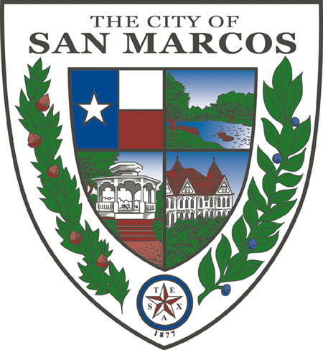

Prepared by: KMRS Geospatial Consultants
Table of Contents
1. Introduction 4

1.1 Summary 4
1.2 Purpose 4
1.3 Scope 5
2. Literature Review 6

3. Data 7

3.1 Software 7
4. Methodology 8

5. Implications 9

6. Budget 10

7. Timetable 11

8. Final Deliverables 13

9. Conclusion 14

10. Participation 15

11. References 16

1. Introduction

1.1 Summary

The natural beauty and clear water of the San Marcos River headwaters dazzle the eyes of most who cast their gaze on its flowing currents. Ramon Lucio Park and Baseball Fields, encompassing an area of 22 acres, is located approximately 1.5 miles from the headwaters of the river in the City of San Marcos, Texas. The City of San Marcos, which has topped the list of fastest-growing cities in the nation for the 3rd consecutive year (Janzen and Beausoleil 2015), is in the process of creating GIS inventories of city parks and green spaces, and proactively managing the sensitive ecosystem of the Upper San Marcos River, in an effort to grow the city in harmony with the nature in and around it.

KMRS Geospatial Consultants, in collaboration with the Community Services division of the City Of San Marcos, will inventory over 30 different types of features at the property and create a geodatabase that will be used to reduce park maintenance cost, disseminate information to the public, and provide scientific analytics for sound ecological range management. In addition, our consultants will evaluate the existing impervious cover within the property boundaries and propose a course of action to mitigate imperious cover within park boundaries.

1.2 Purpose

This project will determine the spatial and attribute data of park amenities, such as grills, gazebos, and parking, and field layout, such as base plugs, dugouts, and illumination. This data will be used to create a geodatabase to model Ramon Lucio Park and Baseball Fields features. Additionally, previous data collection and file geodatabase architecture for Rio Vista Park will be evaluated and changed if needed. This will help the city make more efficient and informed decisions about future parks and recreation projects. KMRS Geospatial Consultants will then use data collected to evaluate existing impervious cover and propose a course of action to mitigate it.

1.3 Scope

This project will be carried out on the parcel of land containing Ramon Lucio Park and Baseball Fields. This parcel s bounded by Cheatham Street on the North, C. M. Allen Parkway on the West, and the South Interstate 35 Frontage Road on the South East side, and the Upper San Marcos River on the North East side. All processes will be carried out in the Fall 2015 semester, and all deliverables will be submitted by Monday, November 30 2015.

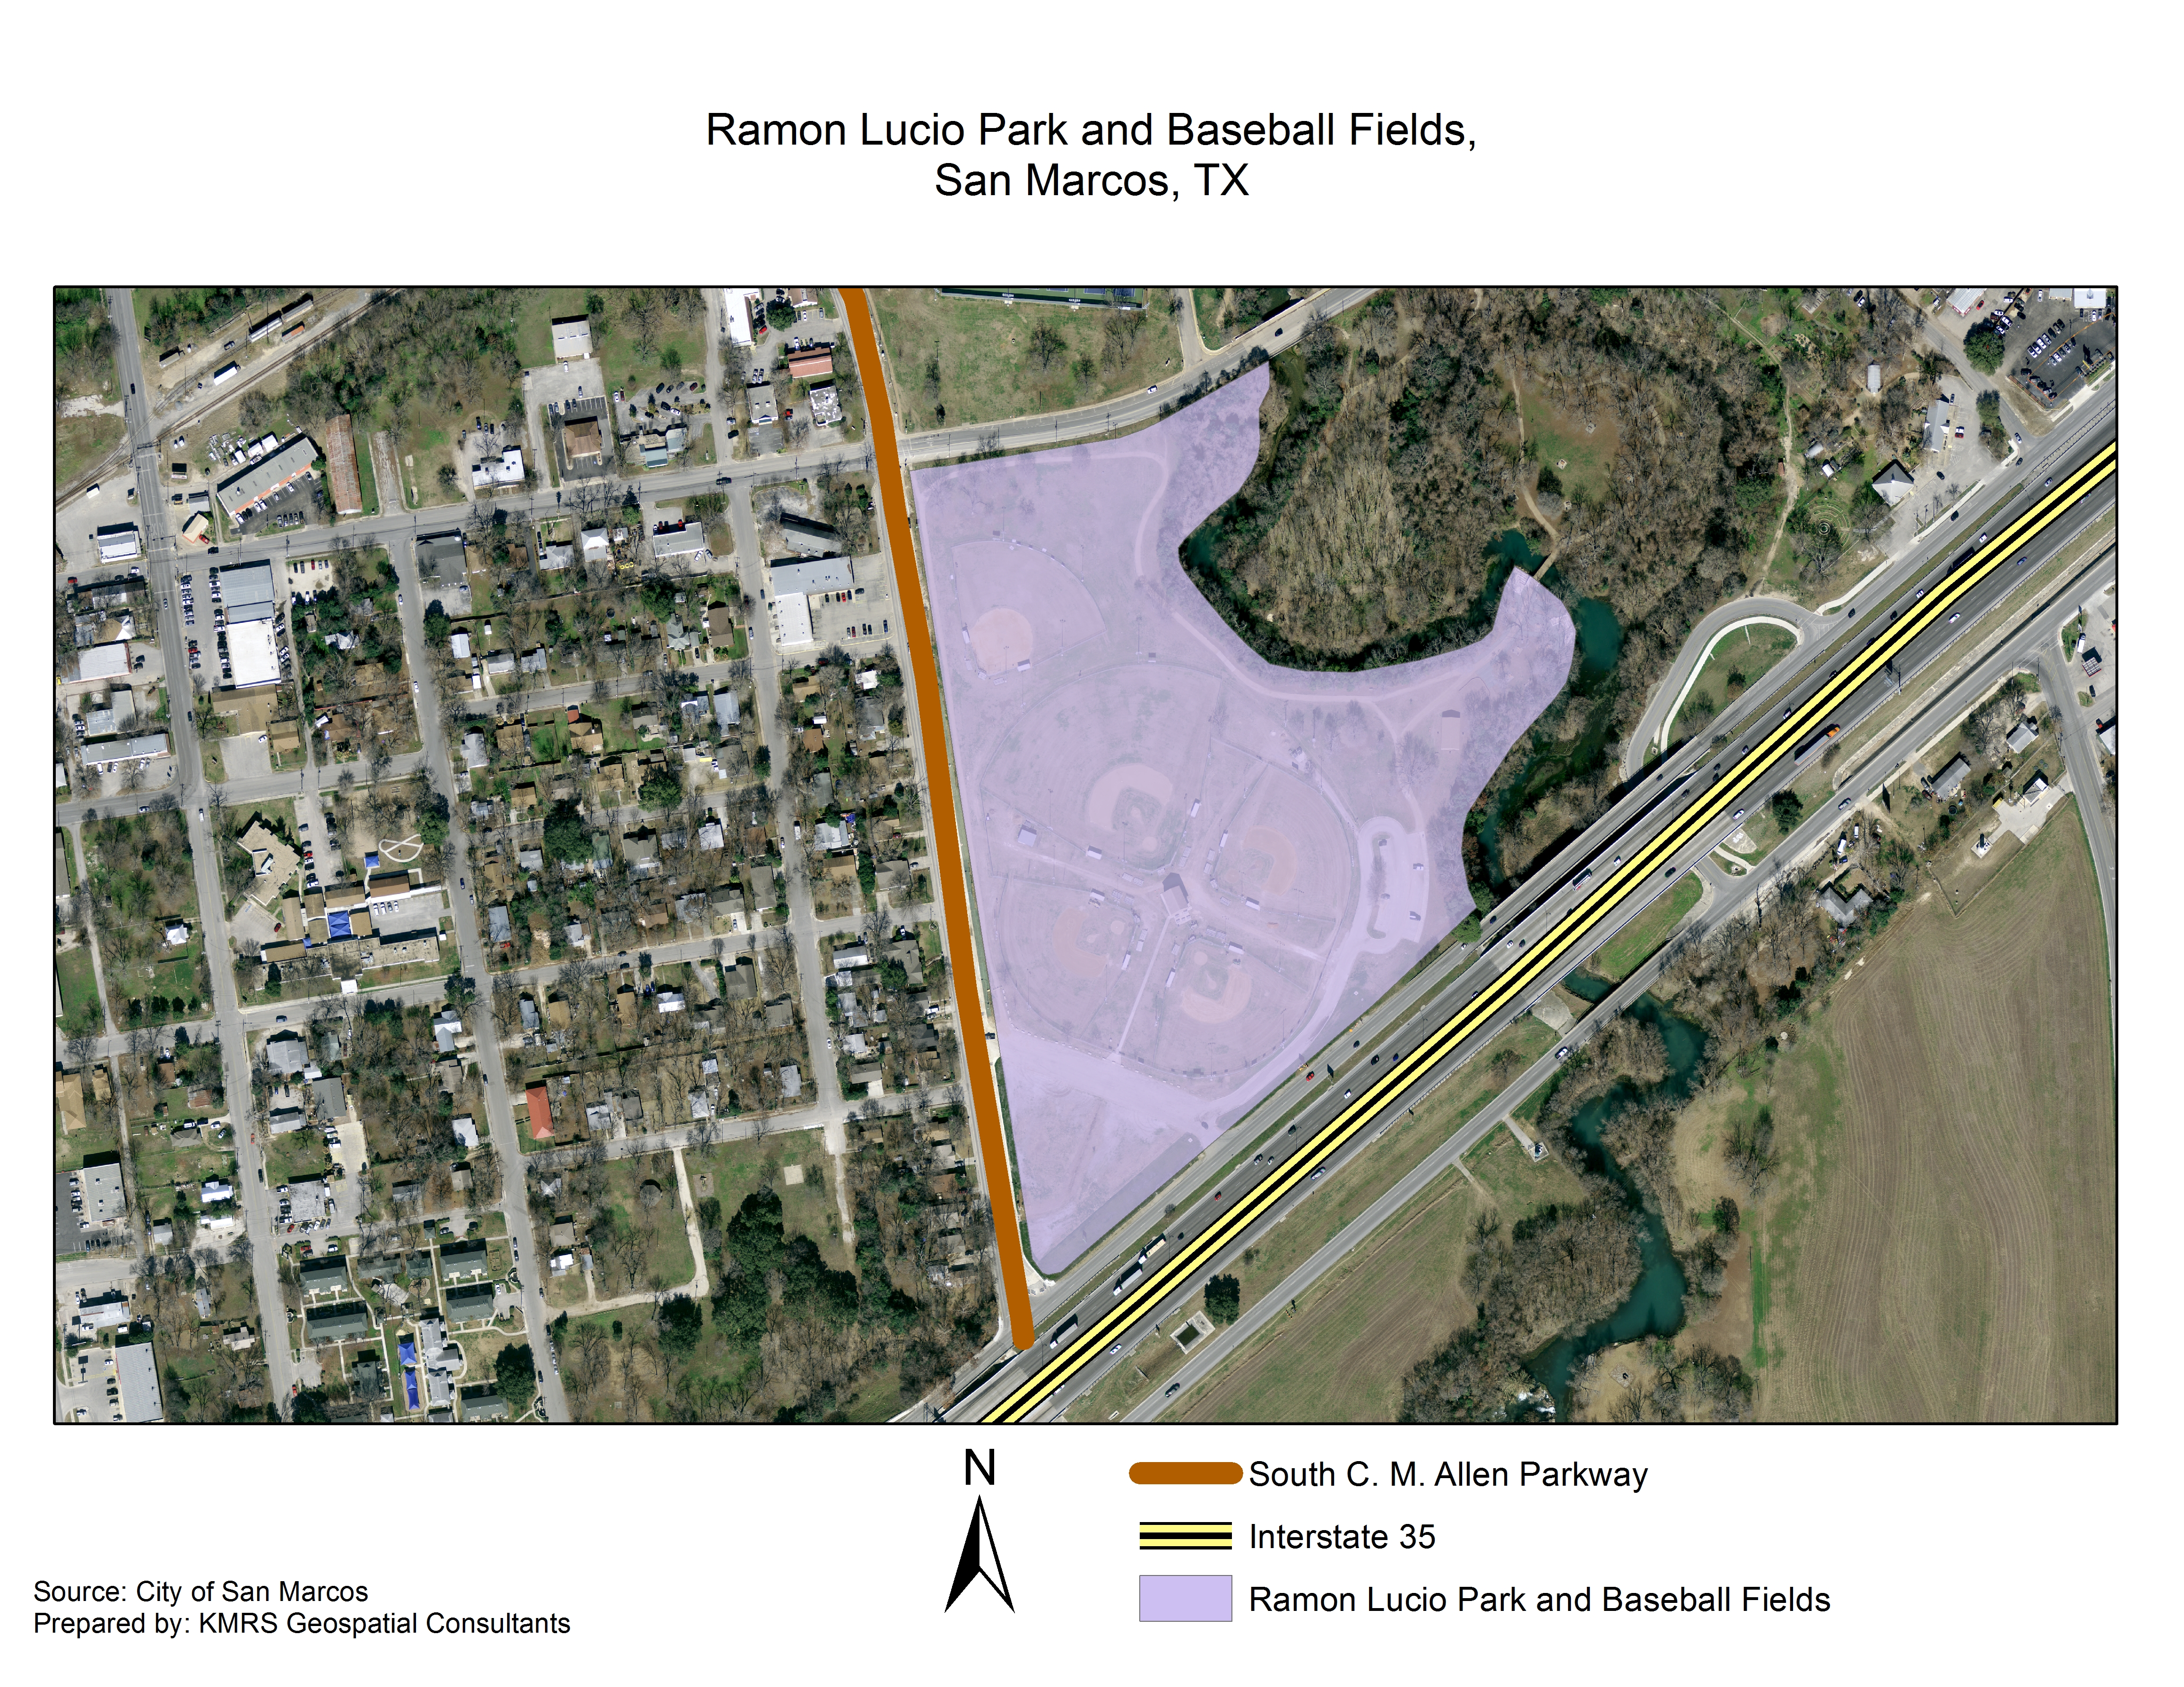
Figure 1. Project extent.

2. Literature Review

The dramatic growth in population the city has seen in recent years has resulted in increased pressure on parks and recreational facilities, and on the San Marcos River watershed. The first 3.8 miles of the river are an incredibly diverse biologic ecosystem home to several threatened and endangered species, some of which are found nowhere else in the world (Godfrey and Guerra 2010). In 2012, growing out of the larger Edwards Aquifer Recovery Implementation Program, a portion of the San Marcos River including its headwaters was designated a State Scientific Area by the Texas Parks and Wildlife department for the purpose of education, scientific research, and preservation of flora and fauna of scientific or educational value (TPWD 2012).

Scientific research has shown that the stormwater runoff created by impervious cover such as rooftops, roadways or parking lots carries with it contaminants including oil and grease, organic matter, pesticides, and fertilizer, which can have a negative impact on the water quality of the bodies of water where these pollutants drain into (Flinker 2008). Due to the impact impervious cover has on water quality and runoff quantity, and the accuracy with which impervious cover can be quantified, analyzed, managed, and mitigated, city and environmental planners use impervious cover, along with other metrics, to determine policies and legislation (Schuler, Fraley_McNeal, and Cappiella 2009).

In San Marcos, the Municipal Land Development Code § 5.1.1.5 sets limitations on impervious cover, with special stipulations for areas within the Edwards Aquifer and for buffer zones surrounding rivers, streams and waterways. Since this parcel contains portions within those specifications, and since the facilities were built before such regulations were in place, the City of San Marcos is consulting with KMRS Geospatial Consultants to prepare a mitigation plan in accordance with all applicable codes.
3. Data
Table 1. Datasets
Data | Source
Ramon Lucio Park Base Map:  - Buildings  - Streets  - Park boundaries  - GPS monuments  - San Marcos River  Ramon Lucio Park Aerial Image | Bert Stratemann,  Parks Operations Manager,  City of San Marcos, Texas
Ramon Lucio Park Features:  - Parking Spaces  - Signage  - Amenities  - Illumination  - ADA  - Impervious Cover  - Trash  - Youth Baseball and Softball Fields  - Irrigation  - Fences | To be collected in the field

3.1 Software

- ArcMap
- Trimble GPS Pathfinder Office
- Adobe Creative Cloud

4. Methodology

The main goal of this project is to create a geodatabase that will help the City of San Marcos make data-driven management decisions regarding parks and green spaces, such as the mitigation of impervious cover at Ramon Lucio Park. Initial tasks will include the evaluation of the geodatabase structure for a similar project previously carried out at Rio Vista Park. At this point, we will decide whether the GDB merits modification, and apply any necessary changes. Next, our team will define the data dictionary required for field data collection. The major features to be mapped are: parking lots (polygons), trails (lines), dugouts (polygons), illumination poles (points), sprinklers (points) sewer (points), breaker boxes (polygons), maintenance equipment storage (polygons), sidewalks (lines), San Marcos River (polygon), and administration offices (polygon). We will add any other features as necessary. All the features will have attribute tables that will define each unique feature. These attribute tables will include geographic coordinates and any other required attributes.

For field data collection will be using Trimble GeoXT handheld GPS devices checked out from Texas State University's Geography Department. These units are capable of submeter accuracy. While most of the work we will perform will focus on performing inventory of facilities and amenities at the park, in order to help mitigate impervious cover we will also conduct analysis of slope of the area of study so we can more accurately model stormwater runoff drainage patterns.

Once we have gathered our own GPS data and conducted all necessary analysis, we will compare it to the Rio Vista Park data that has been provided to us by the City of San Marcos officials. This will give us an idea of what has been previously done at this adjacent park and will help us fulfill the needs of the analysis that should be conducted in order to mitigate the impervious cover at the Ramon Lucio Park.

5. Implications

This project will meet the City of San Marcos request for the creation of a geodatabase for the parks adjacent to the San Marcos River. The city’s goals with this project include reduction of park maintenance costs, dissemination of information to the public, and providing data-driven sound ecological range management. In this particular case, the mitigation of impervious cover at Ramon Lucio Park is an important outcome that will help improve the water quality of the environmentally sensitive San Marcos River corridor. In addition to providing existing residents with up-to-date information about city parks and green spaces facilities, web applications containing recreational, economic, demographic and environmental data are already being used by local governments in other states to also attract new residents and businesses to their area.

6. Budget

Services/ Salaries | Supplies, Equipment, and Overhead
Project Manager | ArcGIS subscription: $600
$4500 for 20 days work | Trimble GPS rental: $3750
Web Master/ Researcher | Workstation rental: $7500
$4300 for 20 days work | Office supplies: $500
GIS Technician | Insurance: $5000
$4300 for 20 days work | Transportation: $1000
Researcher/ Editor
$4300 for 20 days work
Salaries Subtotal: $17,400 | Equipment Subtotal: $17,850

7. Timetable

- Wed, September 2nd – Discuss project guidelines and needs with the City of San Marcos’ client and begin planning accordingly.

- Mon, September 7th – Identify the main objective and assign members of KMRS Consultants® duties specific to the tasks while keeping our available resources in mind.

- Wed, September 9th – Review the previous projects and data given to us by our client, specifically with ESRI’s Arcmap. Also look for guidelines and laws involving impervious cover for recreational areas near water sources.

- Mon, Sep 14th / Wed, Sept 16th – Begin a rough look at the destination of interest (Ramon Lucio Park) while noting any important features or issues that may affect our inventory count such as unusual structures or impervious cover.

- Mon, Sept 21st / Mon, Sept 23rd – Plan and conduct a proposal for the City of San Marcos.

- Wed, September 28th – Present Proposal to our client .

- Wed, Sept 30th / Mon, Oct 26th -- Begin using TRIMBLE GPS units to mark objects, structures, and other locations that were specifically asked for by our client and or follow the data structure of the previous projects that we are using as a guide. Then transfer this data into spatially recognized shapefiles that can be manipulated in ESRI’s Arcmap.

- Wed, October 28th – Report progress with our client .

- Mon, Nov 2nd / Wed, Nov 18th – Continue taking an inventory of Ramon Lucio Park and organizing the spatial data through Arcmap.

- Mon, Nov 23rd / Mon, Nov 30th – Compile the Data we collected and organize it an attractive manner while coming up with conclusions regarding the park’s orientation and degree of impervious cover and preparing our final presentation to our client.

- Wed, December 2nd – Present our final results.

Figure 2. Project timeline.

8. Final Deliverables

- Final Report

- Detailed Poster
- Visual representation of Ramon Lucio Park and Baseball features
- Map showing amenities and impervious cover spatial locations

- CD containing:
- All data
- Raw GPS data
- Metadata
- Report
- Digital Poster
- Power Point Presentation
- Instructions on how to use the CD

- Final report containing the amenities of Ramon Lucio Park and Baseball Fields, the methods used to collect GPS data, an estimation of the accuracy and precision of the data, and a scientific methodology for the GDB design process that may be repeated for future park projects

- Plans for mitigating impervious cover

- Merged geodatabase between Ramon Lucio Park, and Rio Vista Park.

These deliverables will include a map of GPS data obtained to show the spatial locations of the current impervious cover features and amenities. There will also be a visual representation that includes future plans for the most effective way to implement mitigation of the impervious cover to provide a more ecological sound environment.

9. Conclusion

The dramatic increase in the population of San Marcos and other regional cities, combined with changes in legislation affecting land adjacent to the San Marcos River, have prompted the city to re-evaluate its parks and green spaces. After analyzing data from Rio Vista Park, provided by the city of San Marcos, and processing the data that KMRS will collect in the field at Ramon Lucio Park, our company will provide the City of San Marcos with a geodatabase containing features from both Rio Vista and Ramon Lucio Parks, a report listing the results of our assessment of existing impervious cover on the parcel, and a series of recommendations for the mitigation of impervious cover at Ramon Lucio Park.

10. Participation

Analyst | Position | Duties
Carlos A. Soto | Project Manager, GIS Analyst | Table of Contents, Introduction, Literature Review, Data, References, Editing
Curtis D. Klinge | Assistant Project Manager, GIS Analyst | Budget, Timeline, Editing
Bradly McDonald | GIS Analyst | Cover and Title Page, Implications, Final Deliverables
Omar A. Rivera Guzman | GIS Analyst | Methodology, Conclusion, Implications

11. References

Janzen, Eric; and Beausoleil, Sofia; 2015. San Marcos is nation’s fastest-growing city. KXAN-TV Austin. Austin, Texas May 20 2015. http://kxan.com/2015/05/20/san-marcos-is-nations-fastest-growing-city/ Last accessed 24 Sep 2015
Gofrey, Andria N.; and Guerra, Jonathan; 2010. Endangered Species – San Marcos Prepared as part of a National Park Service Trails and Rails project in partnership between Amtrak, Inc, and the Department of Recreation, Park and Tourism Sciences at Texas A & M University, 2010.
Texas Parks & Wildlife (2012). San Marcos River State Scientific Area Information Sheet. San Marcos, TX
Flinker, Peter; 2008. The Need To Reduce Impervious Cover to Prevent Flooding and Protect Water Quality. Rhode Island Department of Environmental Management, 2008, revised 2010.
Schueler, Thomas R.; Fraley-McNeal, Lisa; and Cappiella, Karen; 2009. Is Impervious Cover Still Important? Review Of Recent Research Journal of Hydrologic Engineering, ASCE, April 2009.
UNCC Press Release, 2015. University partners with city, county on Web-based Quality of Life Explorer University of North Carolina – Charlotte http://inside.uncc.edu/news-features/2015-06-15/university-partners-city-county-web-based-quality-life-explorer#sthash.1Jnjppz5.dpuf Last accessed 24 Sep 2015.

