Carlos A. Soto, Project Manager, GIS Analyst
Curtis D. Klinge, Assistant Manager, GIS Analyst
Bradly D. McDonald, GIS Analyst
Omar A. Rivera Guzman, GIS Analyst

October 2015

GPS Inventory & Impervious Cover Mitigation
Ramon Lucio Park and Baseball Fields
San Marcos, Tx

Prepared for:

Prepared by: KMRS Geospatial Consultants
Table of Contents
1. Introduction 4
1.1 Summary 4
1.2 Purpose 4
1.3 Scope 4
2. Tasks 6
2.1 Progress 6
2.1.1 Task 1: Rio Vista Park Data and GDB Structure Evaluation 6
2.1.2 Task 2: Ramon Lucio Park Facilities Inventory Data Collection 6
2.1.3 Task 3: Mitigation of Impervious Cover within Park Boundaries 6
2.1.4 Revised Timeline 7
2.1.5 Challenges and concerns 8
3. Conclusion 8

1. Introduction

1.1 Summary
This report was prepared by KMRS Geospatial Consultants to update the Community Services division of the City of San Marcos (CSM) on the advances our group has accomplished in our facilities inventory project at Ramon Lucio Park and Baseball Fields. Following our presentation on September 28, we commenced with the field data collection phase of the project. This report will provide information on our tasks accomplished and developments in this project, including an updated timetable.

1.2 Purpose
This project will determine the spatial and attribute data of park amenities, such as grills, gazebos, and parking, as well as field layout, such as base plugs, dugouts, and illumination. This data will be merged with a different dataset consisting of Rio Vista Park features, creating a geo database (GDB) that will be used to reduce park maintenance cost, disseminate information to the public, and provide scientific analytics for sound ecological range management. This data can also help the city make more efficient and informed decisions about future parks and recreation projects. KMRS Geospatial Consultants will then use data collected to evaluate existing impervious cover within park boundaries and propose a course of action to mitigate said impervious cover.

1.3 Scope
This project will be carried out on the parcel of land containing Ramon Lucio Park and Baseball Fields, located at 601 S CM Allen Parkway, in San Marcos, TX. This parcel is bounded by Cheatham Street on the North, C. M. Allen Parkway on the West, South Interstate 35 Frontage Road on the South East side, and the Upper San Marcos River on the North East side. Figure 1 shows a map of the project extent.
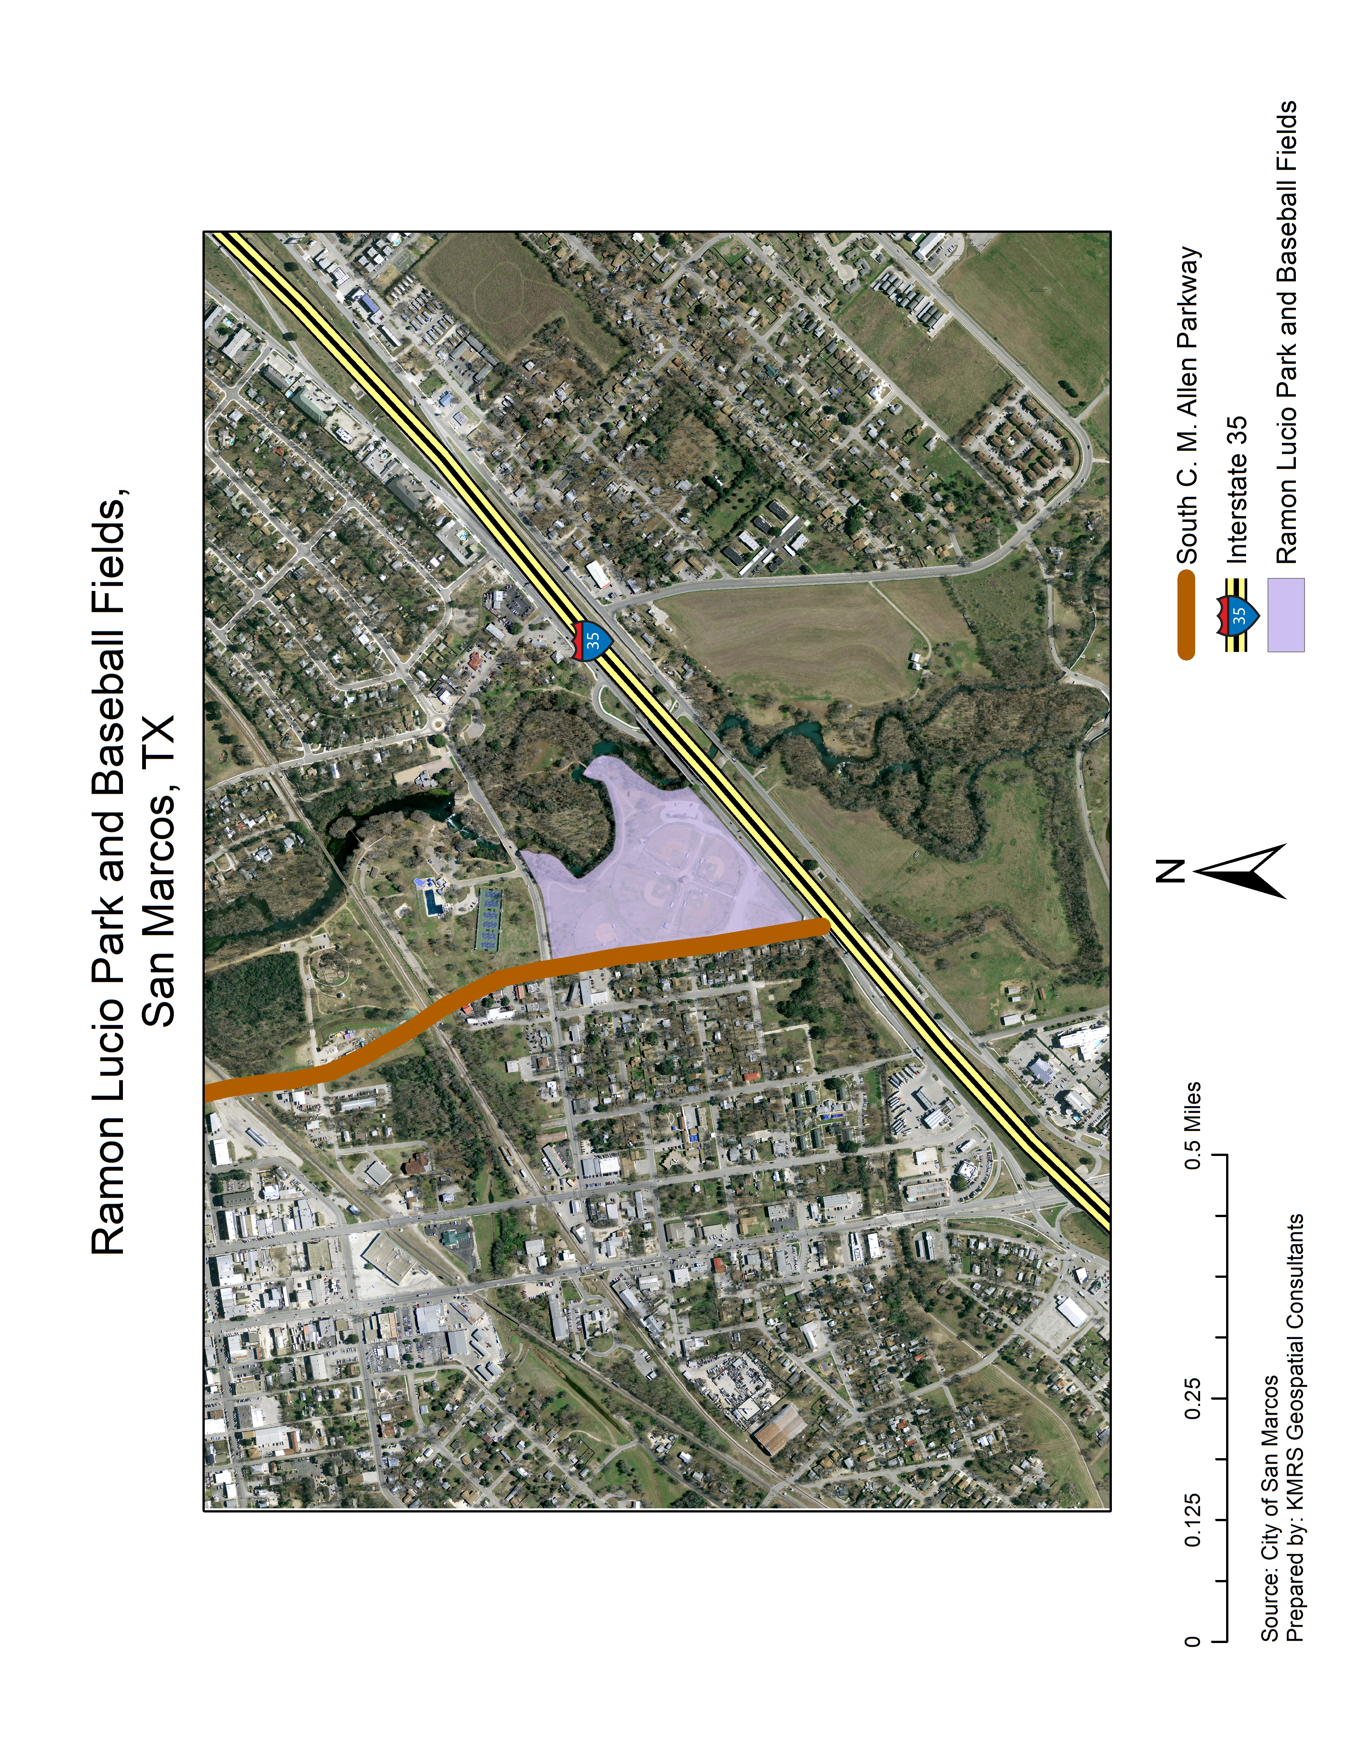
Figure 1. Project extent.

2. Tasks

2.1 Progress
In general, the project has progressed without any serious issues or problems to hamper progress. Our tasks were to evaluate the collected data and Geo Data Base (GDB) structure of a similar project previously carried out at Rio Vista Park, collect inventory data at Ramon Lucio Park, and propose a plan for the mitigation of impervious cover within park boundaries.

2.1.1 Task 1: Rio Vista Park Data and GDB Structure Evaluation
- Close examination of the Rio Vista Park GDB revealed that the group who prepared the data only recorded 1 position per point feature. Our group also found that two of the individual feature classes appearing in the Rio Vista Park GDB could be combined into a single layer, resulting in a more efficient GDB structure.

2.1.2 Task 2: Ramon Lucio Park Facilities Inventory Data Collection
- The favorable weather in this region during the months of September and October, and the excellent collaborative efforts from the CSM, combined to allow us to complete data collection over a week ahead of schedule. Data has been differentially corrected resulting in accuracies of 1.5ft, in most cases.
- Currently, our team is in the process of rectifying the shapefiles collected in the field.
- Once shapefiles are rectified, the final GDB will be assembled and used to produce all necessary maps, to quantify impervious cover within park boundaries, and to inform the suggestions we will make in our mitigation plan proposal.

2.1.3 Task 3: Mitigation of Impervious Cover within Park Boundaries
- Field collection of necessary data has been completed, and the data has been differential corrected. While collecting field data for the park inventory, we examined the extent of existing impervious cover at the site. Best practices and legislation regulating the mitigation of impervious cover have been also been determined.
- Currently we are busy rectifying the polygons that constitute the impervious cover within park boundaries.
- Once polygon rectification is complete we will determine the amount of impervious cover within park boundaries, examine the location of impervious cover and its proximity to the San Marcos River, and evaluate cost-effective interventions to help ensure the Ramon Lucio Park complies with all legislation and impervious cover mitigation best practices are implemented at the site.

2.1.4 Revised Timeline
Table 1 shows a revised timeline, reflecting the time we saved during data collection tasks. Consequently, we were able to get an early start on post-processing and shapefile rectification.
Table 1. Revised timeline
Activity | Week Date
 | Aug  31 | Sep7 | Sep14 |  | Sep21 |  | Sep28 | Oct  5 | Oct 12 | Oct  19 |  | Oct  26 | Nov  2 | Nov  9 | Nov  16 |  | Nov  23 | Nov  30
 | Week No.
 | 0 | 1 |  | 2 | 3 | 4 |  | 5 | 6 | 7 | 8 |  | 9 | 10 | 11 | 12 |  | 13
Client meeting; research | *
Research; data collection |  |  |  |  |  | *
Post-processing, correction
Edit; finalize park shapefiles |  |  |  |  |  |  |  |  |  |  | *
Prepare impervious cover mitigation plan
Merge data
Final report preparation
Final presentation |  |  |  |  |  |  |  |  |  |  |  |  |  |  |  |  |  | *

2.1.5 Challenges and concerns
Some challenges our group encountered were:
- Securing access to the site required synchronizing multiple calendars, but Mr. Strateman installed a combination lock that solved this issue.
- The location of the sprinkler heads was difficult to find. Once Jim arrived and activated the system, we were able to locate the remaining heads.
- The sprinkler head in the left field corner of the practice field was broken and spewing a vertical stream of water over 10 feet tall.

3. Conclusion
KMRS Geospatial Consultants is completing a facilities inventory for Ramon Lucio Park and Baseball Fields and proposing an impervious cover mitigation plan for the site. We are currently ahead of schedule and are optimistic about the possibility of completing the project sooner than anticipated. After analyzing data from Rio Vista Park, provided by the city of San Marcos, and collecting field data at Ramon Lucio Park, we are currently in the process of rectifying feature polygons and creating a merged GDB consisting of Rio Vista Park and Ramon Lucio Park feature data, drafting a report listing the results of our assessment of existing impervious cover on the parcel, and proposing a list of recommendations for the mitigation of impervious cover at Ramon Lucio Park.

