Texas State (San Marcos) Map Visulaization
c. 1900 to 2015 Project
Proposal Submission to the Texas State University Archives
Submitted by:

Project Manager:
Christian T. Hartnett MSc, RPA, GISP
GIS Analysts:
Corby Schaub
Dylan Epley
Johnnie German
Filed: September 25, 2015

Table of Contents
1.1 Introduction 2
1.2 Summary 2
1.3 Purpose 2
1.4 Scope 2
2.1 Literature Review 2
3.1 Proposal 4
3.2 Data 4
3.2.1 Primary Data Sources: 4
3.2.2 Supplementary Data Sources: 5
3.3 Methodology 5
3.4 Implications 7
3.5 Budget 8
3.6 Timetable 9
3.7 Final Deliverables 10
3.8 Conclusion 10
4.1 Participation 10
4.0 Works Cited 11

1.1 Introduction

1.2 Summary

Texas State University was founded as the Southwest Texas Normal School in San Marcos, Texas in 1899. Over the last 116 years, the university has steadily grown from a small school aimed at teaching domestic and agricultural science to Hays County residents to a major research university attracting students and faculty from across the world. This project will document the changes to Texas State’s campus and buildings through the use of historic maps, photographs, and other archival documents.

1.3 Purpose

The main goal of this project is to document how the campus of Texas State University has changed since its inception in 1899. To date, there has been no formal attempt by the university to present the history of the university through the use of spatial data. Ultimately, the results of this project will be used by researchers at the Texas State University Archives as well as an introduction to the history of the university to students. The data will be presented, in part, through the use of online web mapping tools.

1.4 Scope

The project will focus on the area immediately surrounding Texas State University in the City of San Marcos, Hays County, Texas. The temporal data of the project will be presented in 10-year increments starting in 1900 and ending in 2015.

2.1 Literature Review

The use of historic maps and data help visualize changes to a location throughout time. By visualizing these changes it’s easier to show the development and growth of any given location. Historic maps and spatial data “capture the attitudes of those who made them and represent worldviews of their time” (Rumsey and Williams 2002).
One of the basic uses of historic maps is a visual aide, designed to show a location at a particular point in time. Rumsey and Williams (2002) provides several examples of this use of historic maps as well as how maps are converted from analog paper form to digital format. They go on to demonstrate how overlaying maps from different periods of time can be used to discern the accuracy and reliability of a map drawing, but more importantly how overlaying two or more maps along with attribute information will tell the story of a location.
One of the challenges of using historic maps is finding a sufficient repository of data that can be used to demonstrate the various uses of maps outlines by Rumsey and Williams (2002). One such repository is the Texas Department of Transportation’s (TxDOT) Texas Historic Overlay (THO) (Foster, Summerville and Brown 2006). The THO was developed for TxDOT by the engineering firm PBS&J in the mid-2000s as the main source of historic background information for cultural resource management projects in Texas (Summerville 2009).
The THO contains over 3,000 historic maps dating from 1722 to 1988, mainly from the eastern half of Texas on a series of eight DVDs. Summerville (2009) says that the main purpose of the THO is to provide archaeologists and architectural historians with background information on potential historic-age resources in a project area prior to the commencement of fieldwork. This method has been used effectively in a number of recent cultural resource projects (Hartnett 2010, Gallindo 2012).
In addition to the DVD based resources of the THC, there are now online repositories of historic maps and spatial data readily available to researchers. One major source of this data is the newly launched United States Geological Survey (USGS) topoView website (www. http://ngmdb.usgs.gov/maps/TopoView/), which is an archive of 178,000 scanned and georeferenced historic USGS maps dating from the 1880s to 2010 (Soller, et al. 2015).
With the advent of both repositories of historic maps and the ability to distribute map data across the Internet, the next logical step in historic mapping has been to use the Internet to explore the historic a specific location through historic maps and web mapping. ESRI, the manufacturers of the GIS program ArcGIS, have developed a web platform called “Story Maps” (http://storymaps.arcgis.com/) which allows people to easily create a dynamic mapping environment aimed at telling a story through spatial data. One such map on the website outlines the events surrounding the assassination of Abraham Lincoln (ESRI n.d.).
More specifically related to this project is the Texas A&M “Mapping Historic Aggieland” project (http://arcgis.library.tamu.edu/mgl/mha/), which is online web mapping aimed at telling “the story of the A&M campus by linking [its] heritage to the present day” (Texas A&M n.d.). The website was developed by the Texas A&M University Library. The interactive web map shows how buildings were added to campus through time and provides attribute information regarding the date of construction, current status, and a photograph. Additionally, a variety of historic maps can be used as a base.
As noted above, Texas State University was founded in 1899 as the Southwest Texas Normal School teaching domestic and agricultural science. Scholarship on the history of the university has focused documenting the overall history of the university, as outlined by Brown (1979) and Brown (1999). Additional focus has been given to specific aspects of university life, including the African American experience at Texas State (Joni, Holt and Mayo 1989), fraternity history (Willbern 1989), and student dance organizations (Fite 1999). To date, no research has been made regarding the development of the university using maps or other spatial data.

3.1 Proposal

3.2 Data

Data for the project will come from a variety of sources. The Texas State University Archives and the Texas State University Facilities department are providing the main bulk of the dataset. Data will generally be comprised of historic-age maps, images, and aerials. Supplementary data will be collected on an “as needed” basis to support analysis or the production of deliverables.

3.2.1 Primary Data Sources:

- Texas State University Facilities Office and University Archives
  - 20 gigabytes of maps, aerial imagery, and spatial data (already collected)
  - Online data http://guides.library.txstate.edu/univhistory/GEOG (already collected)
  - Spatial data regarding the changes in campus boundaries and building information (already collected)

3.2.2 Supplementary Data Sources:

- Texas Department of Transportation Historic Overlay (Foster et al. 2006)
- USGS topoView Website (http://ngmdb.usgs.gov/maps/topoview/)
- Texas Natural Resource Information System (TNRIS) Website (https://tnris.org/)

3.3 Methodology

Nmotion GIS will prepare twelve interactive published maps. These maps will represent each decade from 1900-2015. The maps will feature pop-up windows with information about the building progress of each time period. In addition, these maps will be used to create a time slider video showing the campus changes. A geo-database will also be created for all data and maps for future use. A brief and thorough analysis of campus land use will document the changes of the Texas State University campus.
Twelve interactive web maps will feature pop-up windows with historic photos and interesting events from 1900-2015. These maps will be produced using ESRI ArcMap and the data set provided by the Texas State University Facilities Office and University Archives. Nmotion GIS will compile the spatial data with photos into a geodatabase for future use by Texas State University and interested public institutions and individuals. These maps will be published on ArcGIS Online. A presentation will also be created for public demonstration and informational purposes.
These twelve maps will be used to create a time slider video. This video will illustrate the changes in campus land use from 1900-2015 in ten year increments. Video will be produced using ESRI ArcMap. To achieve this, Nmotion GIS will create time-enabled shapefiles. Campus shapefiles will have time parameters added to create time attributes for video creation.
A brief detailed analysis of land use change and building construction will be produced. The output produced by Nmotion GIS will demonstrate the decades with the most change. This analysis will define how campus land use has changed in the past 115 years. Moreover, this project will compare growth rates by decade and land use associated with that growth (Figure 1).
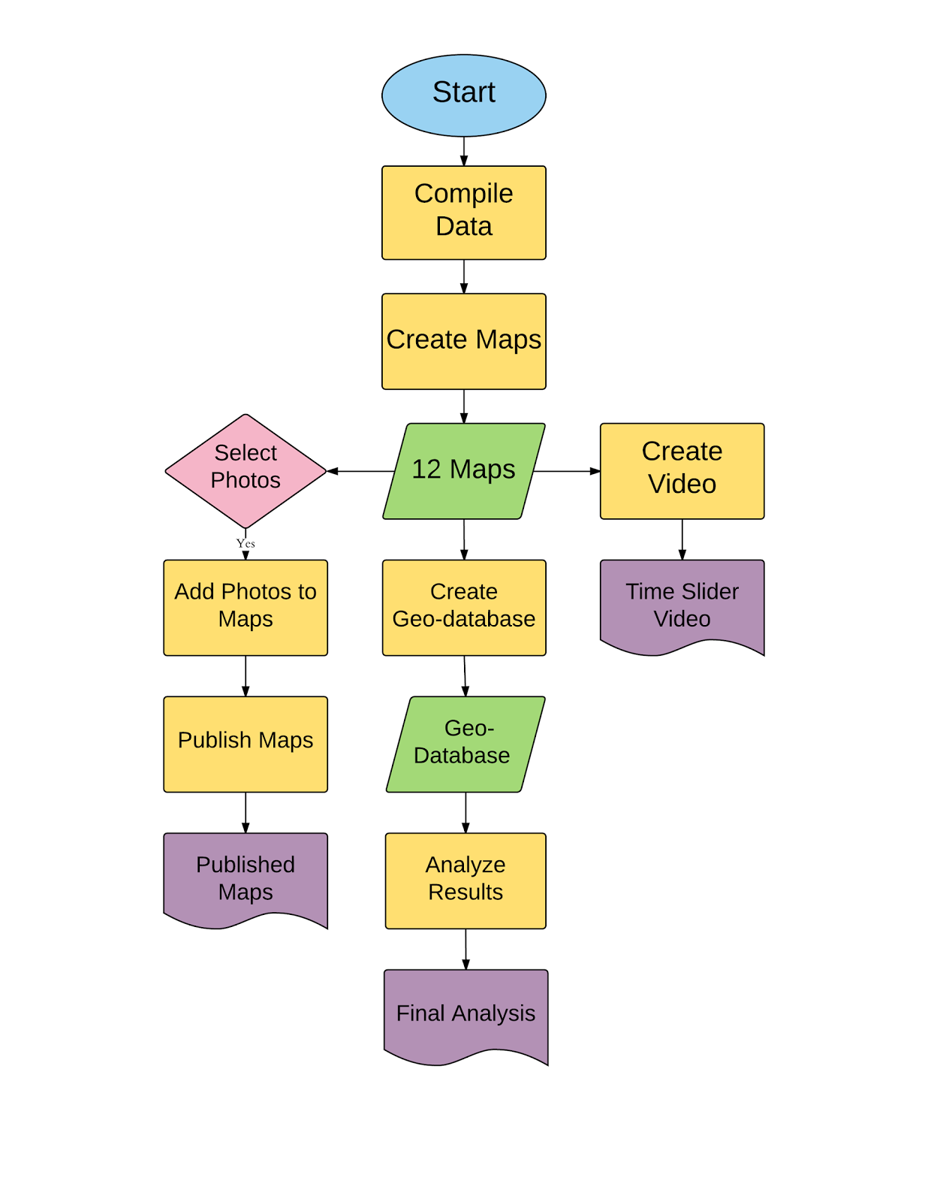
Figure 1. General flow chart outline major project processes and outputs

3.4 Implications

The results of this project will create valuable resources for the Texas State University Archives, assist in research and development, and serve as a teaching tool for students and the public. Researchers will be able to access the geodatabase for mapping resources. Students and the public will be able to access the video of the published maps for an educational historic journey of the Texas State University campus. The land use analysis will define the relationship between land acquisition and allocation against the growth rate of student population.

3.5 Budget

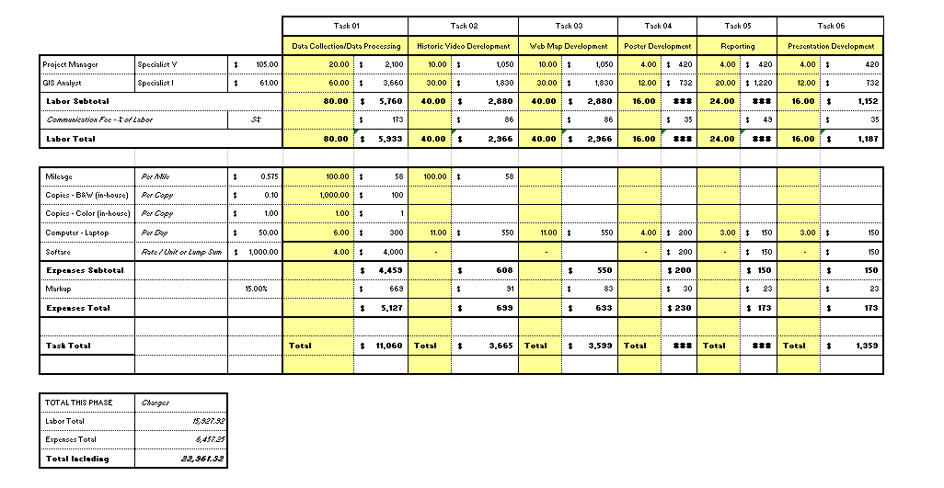

3.6 Timetable

The project can generally be broken down into five phases: data collection, map production, web map/video production, analysis/reporting, and final poster/presentation preparation. The calendars below present the general timeline proposed to complete each task and major milestones. The final deliverables will be provided to the client no later than December 2nd, 2015.
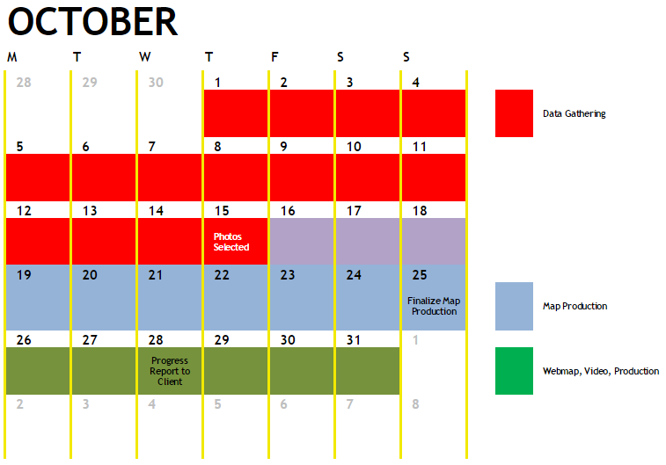

3.7 Final Deliverables

- Geodatabase of all spatial data used in the project
- Video showing growth and interesting historical facts.
- Web map that allows users to choose different eras of Texas State University’s spatial development including interactive pop ups of pictures and historical facts.
- Written Final Report outlining the project.
- Poster that shows final maps and showcases Texas State University’s expansion.
- Final Presentation to be given in class by Nmotion GIS

3.8 Conclusion

This project will focus on telling the story of Texas State University through historic spatial data and photographs. Data will be collected from existing data sets provided by the Texas State University Archives and the Texas State Facilities Department. Nmotion GIS will provide our client with three basic deliverables: a video showing the growth and change of Texas State University’s campus, an interactive web map that highlights photos and historic facts about the university, and a final report that will include a poster outlining the projects results.

4.1 Participation

Christian T. Hartnett – Project Manager
- Introduction, Literature Review, Timetable, Budget, and Conclusion
Johnnie German – GIS Analyst
- Methodology, Implications, Flow Chart, Company Name and Logo
Dylan Epley – GIS Analyst
- Data Sources, Final Deliverables
Corby Schuab – GIS Analyst
- Literature Review, Timetable, and Budget

4.0 Works Cited

Brown, Ronald. 1999. Up the hill, down the years: A Century in the life of the college in San Marcos, Southwest Texas State University, 1899-1999. Virginia Beach: Donning Co.
ESRI. n.d. Death of a President. ESRI. Accessed 9 15, 2015. http://story.maps.arcgis.com/apps/MapTour/?appid=c50be5615f024cc482ccb88222a8719d.
Fite, Kathleen. 1999. Strutters: An introduction and history of Texas’ legendary dance team. San Marcos: Southwest Texas State University Press.
Foster, T, Ty Summerville, and T Brown. 2006. The Texas Historic Overlay: A Geographic Information System of Historic Map Images for Planning Transportation Projects in Texas. Austin, Texas.
Gallindo, Mary Jo. 2012. Cultural Resources Background Review of the NuStar Presa Street Refinery Expansion Project, Bexar County, Texas. Austin: SWCA Environmental Consultants.
Hartnett, Christian. 2010. Survey of the 0.728-Acre Moonlight Way Development Project, San Antonio, Bexar County, Texas. Austin: SWCA Environmental Consultants.
Joni, Charles, Elvin Holt, and Sandra Mayo. 1989. The African-American presence at SWT: Celebrating forty years, 1963-2003. San Marcos: Southwest Texas State University Press.
Rumsey, David, and Meredith Williams. 2002. Historical Maps in GIS. In Past Time, Past Pace: GIS for History. Redlands: ESRI.
Soller, David, Chris Garrity, Rob Dollison, and Mark Newell. 2015. "USGS.gov." A New Way to Find Old Maps. 7 7. Accessed 9 19, 2015. http://www.usgs.gov/blogs/features/usgs_top_story/a-new-way-to-find-old-maps/.
Summerville, Ty. 2009. "Texas Historic Overlay Project Helps TxDOT Build For the Future." Right of Way, March/April.
n.d. Texas A&M. Accessed 9 19, 2015. https://library.tamu.edu/about/collections/map-gis-collections-services/historic-aggieland.html.
Willbern, Roy. 1989. The White Star story: A history of Alpha & Omega Fraternity, Southwest Texas State University, 1929-1989. San Marcos: Southwest Texas State University Press.

