Brietta Perez, Project Manager, GIS Analyst
Mujahid Hussein, Assistant Project Manager, GIS Analyst
Jeffrey Cuevas, GIS Analyst
Nick Waters, GIS Analyst

Tree Planting in Austin, Texas:
An Analysis of the Austin Community Tree Program

Prepared by:
Green City GeoTech

TABLE OF CONTENTS
1. Introduction….………………………………..……………………………………………….1
1.1 Summary….…………………………………………………………………………..1
1.2 Purpose….…………………………………………………………………………….1
1.3 Scope….………………………………………………………………………………2
2. Project Tasks….…………………………………..…………………………………………...2
2.1 Task 1: Tree Canopy Growth and Significance Testing.……………………………..2
2.2 Task 2: CO₂ Sequestration and Energy Conservation………………………………..3
2.3 Task 3: Canopy Growth Extrapolation………………….……………………………5
3. Timetable…...………………………………………………………………………………….6
4. Conclusion…………………………………………………………………………………......7
5. Participation….………………………………………………………………………………..7
Appendix I….………………………………………………………………...…………………..8
Appendix II……………...………………………………………………………………………..9

1. INTRODUCTION

1.1 SUMMARY

The goal of this report is to demonstrate to the City of Austin Forestry Division the progress that we, Green City GeoTech, have made in evaluating the efficacy of the Austin Community Tree Program, to explain any changes to our work plans that have come about since submission of the proposal, and to outline the future work that will complete before we submit the final deliverables to the client.

1.2 PURPOSE

Green City GeoTech was assigned to evaluate the effectiveness of the Austin Community Tree program for the City of Austin. Our objectives consist of three analytical tasks and the design and composition of a map book.
- Task 1: To create an overlay that compares the locations where ACT Program trees were delivered and canopy growth by neighborhood and overall; to express the total growth as a percentage; to determine through significance testing whether there is significant canopy growth between 2006 and 2010
- Task 2: To calculate the total electrical energy conserved and total CO₂ sequestered by ACT trees from 2006 to 2015 using the National Tree Benefit Calculator and express sequestration in pounds (lbs.) and energy conserved kilowatt hours (kWh)
- Task 3: To extrapolate tree canopy growth to 2015 and 2025 and express the total canopy gain in square feet (ft²)
- All Tasks: To create a map book that shows canopy growth, total CO₂ sequestration, and total energy conserved per neighborhood

1.3 SCOPE

The study area of this project is the limited to the 14 neighborhoods where ACT Program delivered trees. We confirmed with the City of Austin Forestry Division that multi-family residences that received up to 48 trees are to be included in our calculations of benefits, and they have been accounted for in our analyses.

2. PROJECT TASKS

2.1 TASK 1: TREE CANOPY GROWTH AND SIGNIFICANCE TESTING

2.1.1 Work Completed

Task 1 of the methodology has been completed. Using tree canopy cover data from 2006 and 2010, we found the total growth and reduction in the individual neighborhood planning areas and overall. Total reduction was subtracted from total growth to account for canopy cover that disappeared between 2006 and 2010, possibly from tree trimming or removal. The analysis showed 16.5% overall tree canopy growth from 2006 to 2010. The sample map of the Old West neighborhood (Appendix I) overlays tree canopy growth and tree delivery locations for comparison.

2.1.2 Current Work

We are nearing completion of our significance testing. We will determine whether there is a significant positive change in tree canopy area for each neighborhood between 2006 and 2010. Because we are we are working with paired datasets and our data distribution is not normal, we are conducting a Wilcoxon Signed Rank test. The two datasets are the total square footage of tree canopy cover for each neighborhood in 2006 and 2010. The determining critical value is 0.05.
Otherwise, we are transitioning from data analysis to creating visual representations of analysis results. How the data is to be displayed—an overlay of delivery locations and canopy growth—has been predetermined, so we are in the process of planning and experimenting with map aesthetics. The greatest challenge we face here is achieving balance between very small growth polygons and large neighborhood planning areas.

2.1.3 Future Work

Once we have completed significance testing and resolved the aesthetics issues, we will finalize a layout for individual map pages of the map book. Map pages will include individual neighborhood overlays, locator maps showing neighborhoods within the wider planning area context, and neighbor labels to further contextualize the individual neighborhood.

2.2 TASK 2: CO₂ SEQUESTRATION AND ENERGY CONSERVATION

2.2.1 Work Completed

Task 2 of the methodology has been completed. To calculate total CO² sequestration and total electrical energy conserved from 2006 to 2015, we used the National Tree Benefit Calculator (NTBC) to find benefits based on an assumed 1 inch tree trunk diameter and multiplied the resulting CO₂ pounds and energy kWh’s by the number of each tree type (e.g. large broadleaf deciduous, large conifer evergreen) delivered and planted at each address. We then multiplied the resulting values by the number of years planted (years in ground) to find the total pounds of carbon and kWh’s of energy conserved for each address. Finally, we added the carbon and energy totals to find the overall total and totals by neighborhood (Table 1). The values given in the table show the total benefits of all ACT Program trees within the geographic scope of our study from 2006 to 2015. The neighborhoods with larger total benefits are those that were selected during the earlier years of the ACT Program and therefore whose trees have been in the ground longer; as the number of years in ground increases, so generally do the total benefits. Included in the calculations are multi-family residential addresses that received more than ten trees from the ACT Program, which also affect the benefit totals.
In our proposal, we anticipated performing significance testing on CO₂ sequestration and energy conservation. However, because the number of trees present before the ACT Program is not available, we are unable to perform such a test.

Table 1. Total CO₂ Sequestration and Electrical Energy Conservation
Planning Area | Total CO₂ in Pounds | Total Energy in kWh’s
Coronado Hills | 8,696 | 3,532
Crestview | 27,540 | 10,800
East Cesar Chavez | 7,580 | 3,400
East Congress | 14,130 | 5,306
Franklin Park | 10,890 | 4,524
McKinney | 5,034 | 2,079
Montopolis | 25,152 | 10,590
N. Austin Civic Association | 10,620 | 4,244
Old West Austin | 10,152 | 4,293
Rosewood | 14,448 | 5,008
St. John | 2,016 | 880
Sweetbriar | 9,982 | 3,724
West Congress | 16,842 | 6,650
Wooten | 9,020 | 3,270
Totals | 173,034 | 68,657

2.2.2 Current Work

We are assessing the best possible method for visually displaying benefit totals for each neighborhood planning area in the map book. We will display delivery location point features in graduated colors to show into which range of total CO₂ lbs. and kWh’s each location falls. The ranges will be delineated by natural breaks: there are no distinctive natural breaks in the data, but this classification is the only one to yield usable results whereas outliers make equal interval and quantile classifications impractical. Because of spatial overlap of points depicting total pounds of CO₂ sequestered and electrical energy conserved, we have concluded that two individual series of map pages—one for each benefit—will be necessary. A simple ArcMap created example of CO₂ sequestration totals is given in Appendix II.

2.2.3 Future Work

We will finalize a consistent layout for the CO₂ and energy benefits section of the map book that includes the numbers of ACT trees delivered within each planning area and their overall total pounds and kWh’s as of 2015. The layout for each of the series of map pages will include a locator map, the total count of ACT trees delivered, the total benefits of each neighborhood as of 2015, and neighbor labels.

2.3 TASK 3: CANOPY GROWTH EXTRAPOLATION

2.3.1 Work Completed

Task 3 of the methodology has been completed. Over the course of data processing and analysis, we considered two methods for extrapolating canopy growth. The first was to base growth on the increase in leaf surface area (LSA) calculated by the NTBC. The LSA increase of one tree would be multiplied by the number of trees by species and then by the number of years they would have been in ground by 2015 and 2025. The second was to base growth on the assumption that the canopy of a single tree, regardless of species, grows one foot each year. We opted to conduct our analysis on the basis of assumed canopy growth by year. We performed the analysis on each of the individual neighborhood planning areas. We multiplied the 1 ft² of growth by the total number of trees in each neighborhood and by the years in ground. The total canopy extent provided by ACT trees in 2014 was 20,405 ft². We extrapolated growth by multiplying the total number of trees by the number of years they would have been in the ground in a particular year. For 2015, this meant simply adding one year to the 2014 data and recalculating. The current canopy extent of 2015, based on our method, is 24,908 ft². For 2025, we added 11 the number of years in ground and recalculated. The total predicted canopy extent provided by ACT trees in 2025 is 69,938 ft².

2.3.1 Current Work

Canopy growth extrapolation analysis outcomes will not be represented visually. Not only does the client not require it, but there is no way to accurately predict the absolute location of tree canopy growth in 2015 and 2025. Therefore, outcomes will be represented only in numbers (Table 2).

Table 2. Tree Canopy Extrapolation
Planning Area | Total Trees | Canopy Extent (2014) | Canopy Extent (2015) | Canopy Extent (2025)
N. Austin Civic Assn. | 749 | 749 ft² | 1,498 ft² | 8,988 ft²
Wooten | 134 | 1,206 | 1,340 | 2,680
Crestview | 408 | 3,672 | 4,080 | 8,160
St. John | 68 | 204 | 272 | 952
Coronado Hills | 307 | 921 | 1,228 | 4,298
Old West Austin | 175 | 1,400 | 1,575 | 3,325
Rosewood | 253 | 1,771 | 2,024 | 4,554
East Cesar Chavez | 231 | 924 | 1,155 | 3,465
Montopolis | 598 | 2,990 | 3,588 | 9,568
McKinney | 231 | 462 | 693 | 3,003
Franklin Park | 497 | 994 | 1,491 | 6,461
East Congress | 295 | 1,770 | 2,065 | 5,015
West Congress | 347 | 2,082 | 2,429 | 5,899
Sweetbriar | 210 | 1,260 | 1,470 | 3,570
Totals | 4503 | 20,405 ft² | 24,908 ft² | 69,938 ft²

2.3.3 Future Work

As the table has been produced, the only work necessary for Task 3 is to integrate it into the map book. It will follow the canopy growth overlays and the tree benefits series.

3. TIMETABLE

At the time we submitted the proposal, we overestimated the amount of data processing necessary and the time needed to complete it; instead, we completed data processing soon after delivery of the proposal. Data analysis, on the other hand, took one week longer than we anticipated because of revisions to the Task 3 methodology discussed in section 2.3.1 and the recalculation of results based on those revisions. Ultimately, we are currently one week ahead of our initial schedule, leaving us with five weeks to design and compile the map book and other deliverables.

Table 3. Revised Timetable
Week | 1 | 2 | 3 | 4 | 5 | 6 | 7 | 8 | 9 | 10 | 11 | 12 | 13 | 14
Starting Date | 8/  24 | 8/  31 | 9/  7 | 9/  14 | 9/  21 | 9/  28 | 10/5 | 10/12 | 10/19 | 10/26 | 11/2 | 11/9 | 11/16 | 11/ 23
Data Collection
Data Preprocessing
Data Analysis
Interpretation and Deliverables

4. CONCLUSION

We expect that we will be able to submit all deliverables by November 30, 2015. Over the course of planning and conducting our analysis, we faced the most difficulty deciding what method of tree canopy growth extrapolation would result in acceptably accurate estimates while remaining feasible within given time constraints. We considered basing our extrapolation on LSA but ultimately decided to extrapolate based on assumed annual canopy growth. As shown above, this particular phase of the ACT Program evaluation has been completed. We also found that conducting significance testing on CO₂ sequestration and energy conservation is not possible because necessary data is not available. At the time of this progress report, we are transitioning from analysis to visual representation of results. We have still to conduct significance testing on canopy growth, but otherwise our main objective is to compile a map book in three parts: canopy growth, CO₂ sequestration, and electrical energy conserved.

5. PARTICIPATION

Team Member | Title | Tasks
Brietta Perez | Project Member, GIS Analyst | Task 2, Timeline, Conclusion, Appendix II, editing and proofreading, quality assurance, compilation, and submission
Mujahid Hussein | Assistance Project Manager, GIS Analyst | Summary, Purpose, Scope, significance testing for Task 1, Task 2
Jeffrey Cuevas | GIS Analyst | Task 1, Task 3, Appendix I
Nick Waters | GIS Analyst | Timeline
APPENDIX I. Sample Canopy Growth Overlay
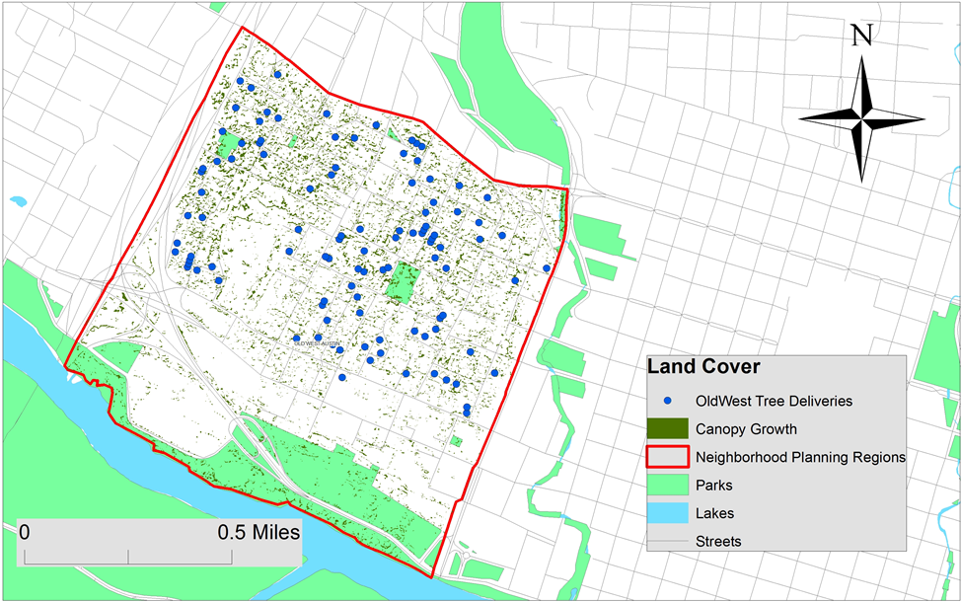
Figure 1. The sample map of the Old West neighborhood shows ACT tree delivery locations overlain with positive change in tree canopy. Here, map aesthetics are purely functional as we are still developing and refining them. Source: City of Austin GIS Data Downloads.

APPENDIX II. Sample Total CO₂ Sequestration Map
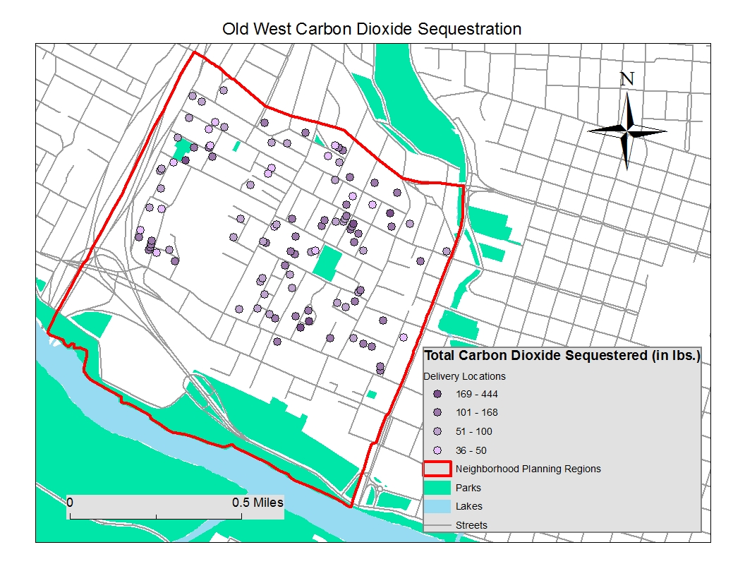
Figure 2. The sample map of the Old West neighborhood shows delivery location point data in graduated color to indicate the range into which total tree benefits (as of 2015) fall. Here, map aesthetics are purely functional as we are still developing and refining them. Source: City of Austin GIS Data Downloads.

