Memorandum
To: Daniel Benson
CC: Dr. Yongmei Lu
From: Lone Star Geospatial
Date: 10/27/2013
Re: Progress Report
The document you will find below explains our progress concerning the San Marcos Municipal Airport Planning project. In the report, we discuss our original tasks, what we have completed, what we are currently working on, and what we will be working on in the future. We expect to have the work completed as scheduled. If you have any questions, do not hesitate to contact our point of contact, Jason Ford. He can be reached by email at jf1150@txstate.edu.

Lone Star Geospatial
  - Jason Ford: Project Manager / GIS Analyst
Patricia Michel: GIS Analyst
Grayson Jones: GIS Analyst
Casey Carpenter: GIS Analyst

San Marcos Municipal Airport
Airspace Planning Project
Prepared by: Lone Star Geospatial
Table of Contents
Introduction 5
Purpose: 5
Task 1: 5
Task 2: 5
Task 3: 5
Scope: 5
Project Tasks 6
Task 1: 6
Work Completed: 6
Work in Progress: 6
Task 2: Create specialized GIS Layers and 3D visualization 6
Work in Progress: 6
Work Scheduled: 6
Task 3: 3D Interactive Tool 7
Work Planned: 7
Issues 7
Revised Timeline 8
Phase 2: Data Analysis 8
Phase 3: Web and Map Development 8
Phase 4: Data Interpretation 8
Phase 5: Contingency 8
Conclusion 9
Participation 10
Appendix: Figures 11-15

Introduction
Following the presentation, and acceptance, of our proposal on Monday, September 30, 2013, our team at Lone Star Geospatial began work immediately on this project. We are submitting this progress report as a reminder of the purpose and scope of our project, and to inform you of our current progress. In this report we will include what is completed, in progress, and planned for each project task.

Purpose:
As identified in the proposal accepted by Texas Department of Transportation (TxDOT) on September 30, 2013, the overall ongoing goal is to provide the city of San Marcos with the tools and information required to enact zoning regulations that will protect and preserve the air space surrounding the San Marcos Municipal Airport. Our revised tasks to accomplish this goal now include:
Task 1: To create an updated hazard-zone map for the San Marcos Municipal Airport.
Task 2: Create specialized GIS layers and 3D visualization reference imagery. This includes the maximum allowable height raster, penetrating obstacles, non-penetrating obstacles, and reference imagery of volumes created from the imaginary surfaces.
Task 3: Develop a user-friendly interactive screening tool using Manifold that will identify maximum allowable height and current structural and surface penetrations through the airport hazard-zones.

Scope:
The geographic extent of this study remains the same as previously established in our proposal. It will center on the San Marcos Municipal Airport (reference point is 29° 53′ 34″ N and 97° 51′ 47″ W) and its three operational runways: 8/26, 13/31, and 17/35. The scope of this study encompasses both the air and ground space surrounding the airport and will be established by dimensions set forth under Federal Aviation Administration 14 Code of Federal Regulation Part 77 (14 CFR 77). Cities that may be affected or fall into the scope of this project include San Marcos, Martindale, Kyle, Wimberley, and Lockhart.

Project Tasks

Task 1:

Work Completed:
- Obtained all data required to create a new hazard-zone map. This data includes county boundaries, city boundaries, streets, digital elevation models, National Flight Data Survey, and GIS survey data (provided by TxDOT).
- Created accurate imaginary surfaces using ArcMap and ArcScene (viewable in both 2D and 3D) by referencing the AutoCAD line data provided by TxDOT and 14 CFR 77.

Work in Progress:
- Decide the layout of the final deliverable hazard zone map and create it utilizing all obtained data and imaginary surfaces.

Task 2: Create specialized GIS Layers and 3D visualization

Work in Progress:
- Create allowable height raster file encompassing all imaginary surfaces. Each 10 meter cell of the raster identifies the maximum allowable height in that area based on the lowest surface.
- Develop volumes for imaginary surfaces for 3D visualization purposes.

Work Scheduled:
- Create point feature class identifying elevation of current penetrations within imaginary surfaces.
- Create point feature class identifying those obstructions in and around the airport hazard zones not penetrating imaginary surfaces.

Task 3: 3D Interactive Tool

Work Planned:
- Decide the layout of the interactive screening tool. This will include design decisions regarding cartographic properties like color schemes, legend, scale, and labeling.
- Determine which layers will be included in the interactive screening tool. Layers will be included based on their significance to the overall goal.
- Determine overall tool functionality. This will include deciding how queries are made, zoom extent and functionality, layer transparency, and how layers will be toggled on and off.
- Determine the method of displaying user queried information and error messages for invalid queries.

Issues
We originally chose to use the United States Geological Survey (USGS) as our resource for National Elevation Dataset (NED) data; however, the site was down when we were in our data collection phase. We were able to collect 10m Digital Elevation Models (DEMs) from Texas Natural Resource Information System (TNRIS) instead.
We had issues with the conical surface displaying properly in 3-D. The surface had two noticeable vertical walls and plateaus instead of a consistent slope throughout the surface. To fix this issue, we converted the polygon to a TIN and the surface displays properly in 3-D now (See Figure 7.)
Second, because we are creating imaginary surfaces for three runways, we have run into an issue visualizing the transitional surfaces in 3-D because they are intersecting and passing through each other. Keep in mind this is only an issue with visualization and not when calculating maximum allowable height because we will only use the lowest surfaces for our calculations. To correct this, we have performed a merge and union of the transitional surfaces to create a 3-D volume (See Figure 8.)

Revised Timeline
We are revising our timeline as we have found ourselves ahead of schedule based on our initial plans. Our initial phase of data collection and processing went quicker than we expected. We were able to obtain all major layers of data before the start date of the next phase of work. This meant that we were able to begin the Data Analysis phase early and have already accomplished a considerable amount of work to this point.
In light of the fact that we are ahead of schedule, we have decided we will use the extra time as a contingency. We have moved all remaining phase deadlines up one week. The addition of this contingency will ensure that these phases will be completed prior to the project deadline.

October/November
S | M | T | W | H | F | S
27 | 28 | 29 | 30 | 31 | 1 | 2
3 | 4 | 5 | 6 | 7 | 8 | 9
10 | 11 | 12 | 13 | 14 | 15 | 16
17 | 18 | 19 | 20 | 21 | 22 | 23
24 | 25 | 26 | 27 | 28 | 29 | 30

December
S | M | T | W | H | F | S
1 | 2 | 3 | 4 | 5 | 6 | 7
8 | 9 | 10 | 11 | 12 | 13 | 14
15 | 16 | 17 | 18 | 19 | 20 | 21
22 | 23 | 24 | 25 | 26 | 27 | 28
29 | 30 | 31
December 9: Final Product Delivered

Phase 2: Data Analysis

Phase 3: Web and Map Development

Phase 4: Data Interpretation

Phase 5: Contingency

Conclusion
In Conclusion, Lone Star Geospatial is extremely satisfied with the progress we have made and are ahead of schedule. We feel that each of our tasks is moving closer to completion. So far, we have only encountered minimal issues and were able to overcome them with little difficulty. The following weeks will be spent on creating our specialized GIS layers, configuring our 3-D visualization, and developing our interactive map tool. With our first task soon to be finished, our team sees no problem completing this project right on schedule. Lone Star Geospatial is confident we will issue our final deliverables on December 9, 2013.

Participation
Casey Carpenter: Creation of imaginary surface polygons, TINs, rasters, and multipatch volumes. Also drafted the purpose, scope, introduction, and task 1 sections of the progress report and presentation. Assisted in generating figures for the presentation.
Jason Ford: Creation of imaginary surface polygons, TINs, rasters, and multipatch volumes. Also drafted the issues section of the progress report and presentation. Generated figures for the progress report and presentation.
Greyson Jones: Assisted with creation of imaginary surface TINs, rasters. Also drafted the task 3 and conclusion sections of the progress report and presentation.
Patricia Michel: Creation of imaginary surface polygons, and rasters. Organized the layout and design of the progress report memorandum, document, and presentation. Also drafted the task 2 and timeline sections of the progress report and presentation.

Appendix: Figures
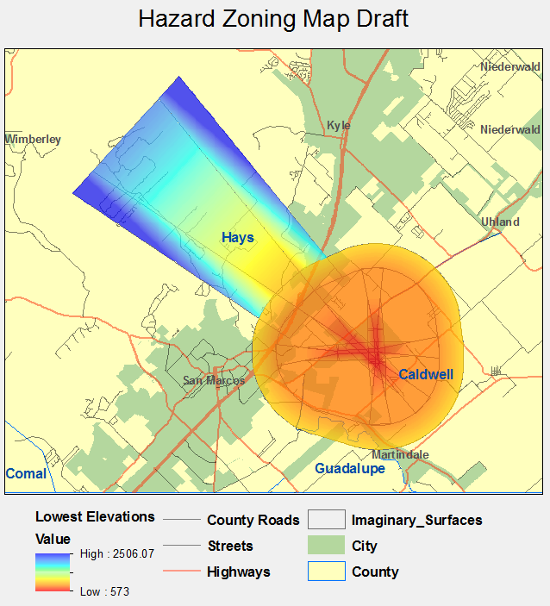
Figure 1: This is a draft of our hazard zoning map which includes a County, City, Roads, and Imaginary Surfaces layers. The imaginary surfaces layer is colored based on elevation.
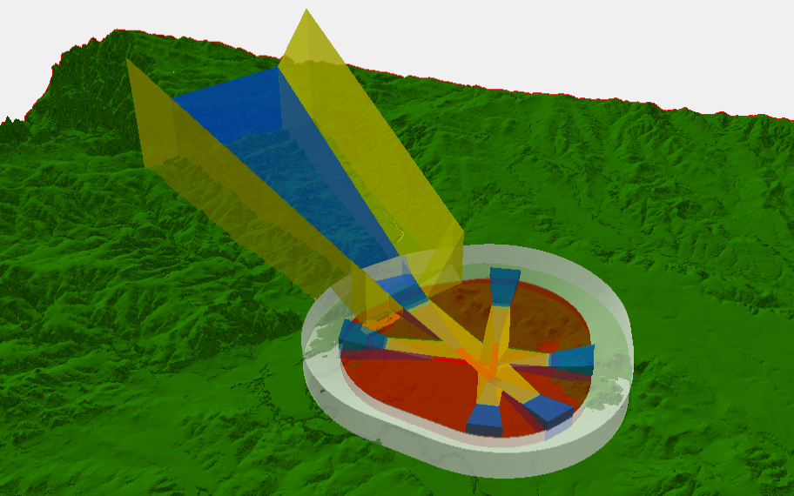
Figure 2: This is a3D visualization of the imaginary surfaces.
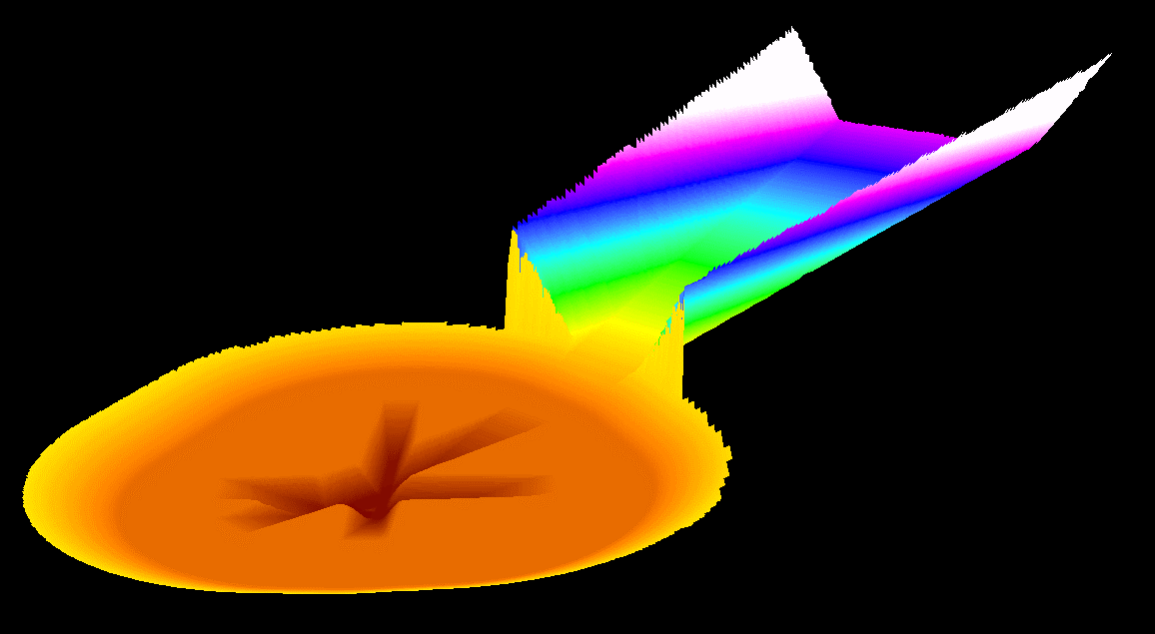
Figure 3: This is a 3D visualization raster of the lowest elevations of the imaginary surfaces.
Figure 4: This is a 3D visualization of the primary and transitional surfaces.
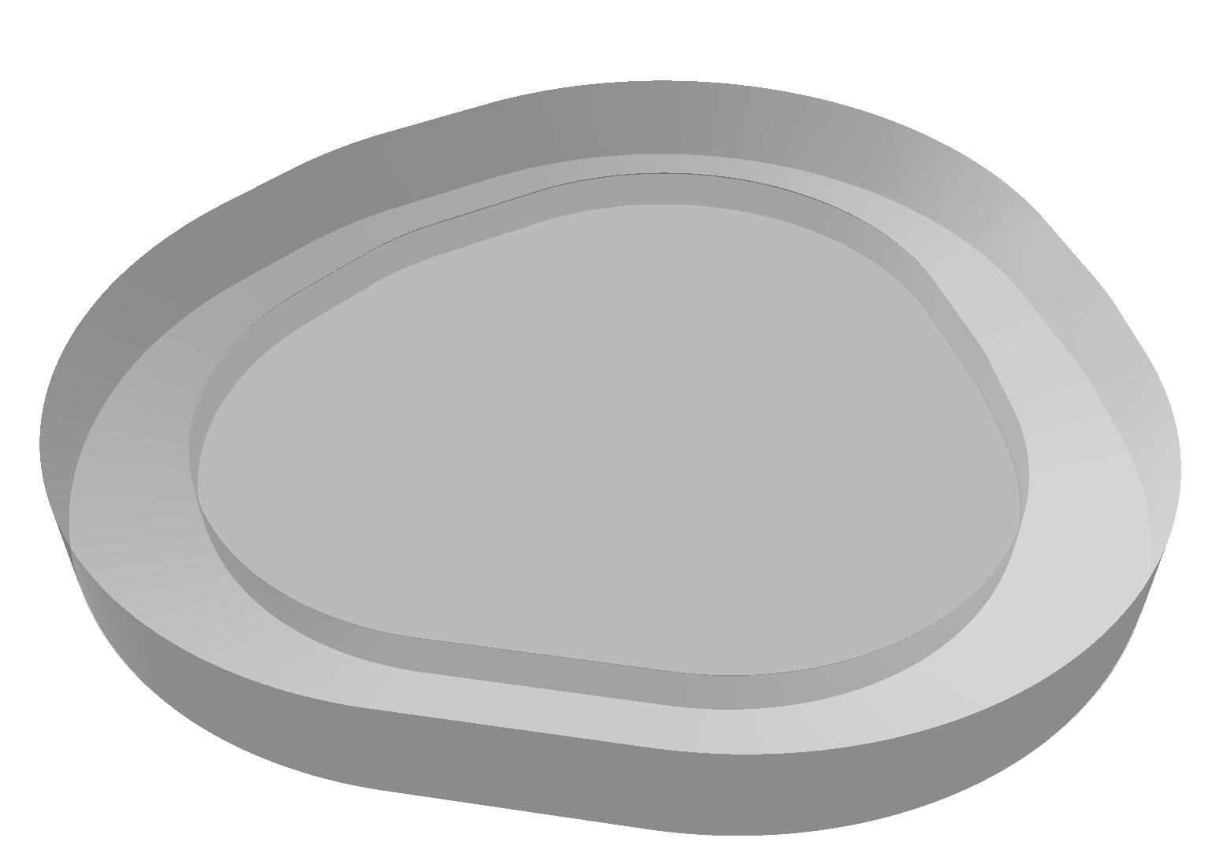
Figure 5: This is a 3D visualization of the horizontal and conical surfaces.
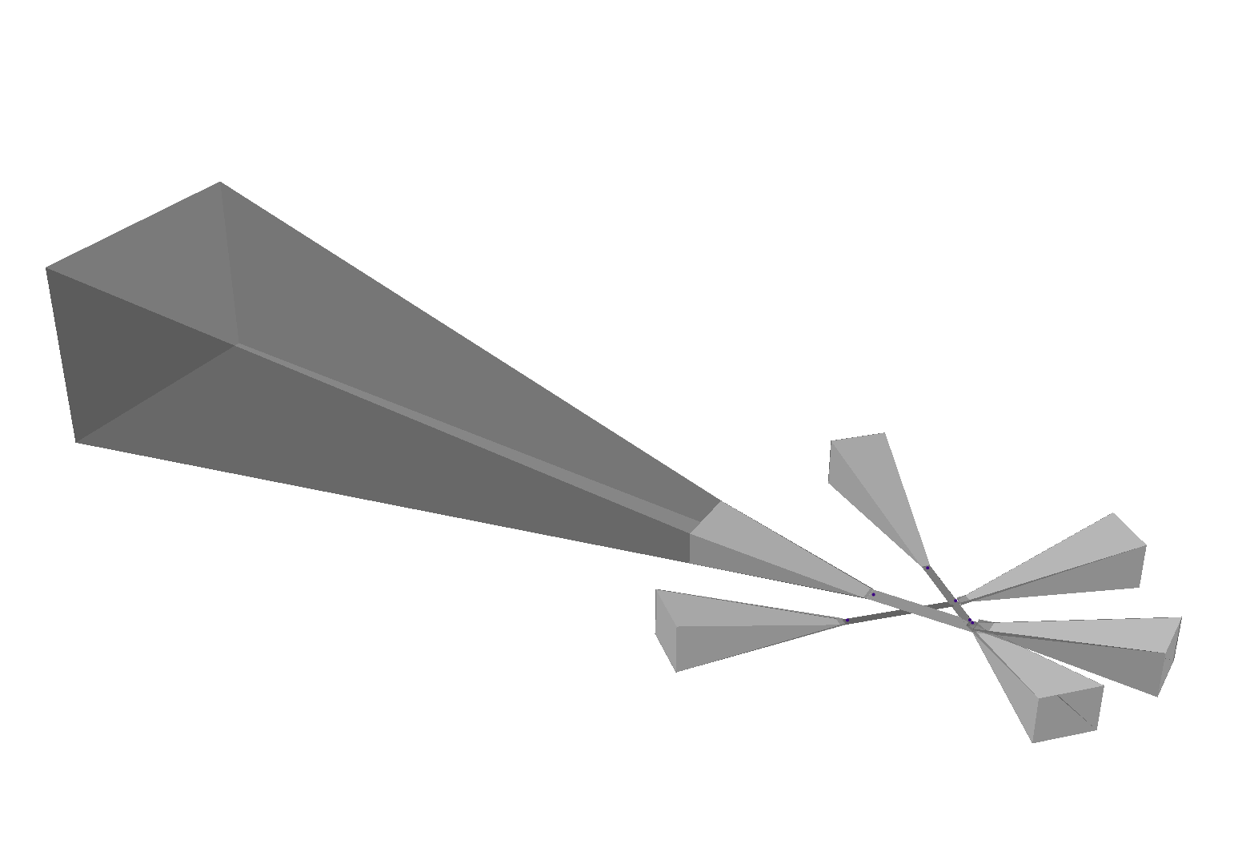
Figure 6: This is a 3D visualization of the approach surfaces.
Figure 7: The example on the left shows the lower transitional surfaces clipping through each other. The example on the right shows the proper shape of the lower transitional surfaces as a result of Merge, Union and conversion to Multipatch tools.
Incorrect Slope
Correct Slope
Figure 8: The example on top has noticeable walls and plateaus instead of a constant slope. The lower example shows the proper slop as a result of converting the polygon surface to a Triangulated Irregular Network (TIN).

