

Lone Star Geospatial

Jason Ford: Project Manager / GIS Analyst  
 Patricia Michel: GIS Analyst  
 Grayson Jones: GIS Analyst  
 Casey Carpenter: GIS Analyst

San Marcos Municipal Airport  
Airspace Planning Project

Prepared by: Lone Star Geospatial

# Abstract

As the cities and counties surround the San Marcos Municipal Airport continue to grow, regulations governing and protecting the airspace and air traffic related to the airport become more important. While there exist regulations for the design of airspace zones in the form of Federal Aviation Administration code of federal regulations title 14 part 77, there are no local laws that strictly protect the air space surrounding airports.

It is therefore the purpose of this planning study to provide the city of San Marcos with the tools and information necessary to adopt regulations that will protect and preserve the airspace surrounding San Marcos Municipal Airport. These tools assist planning officials and the general public in ensuring the continued prosperity of their regional airport and will facilitate growth. The following document is a comprehensive report outlining a planning study conducted by Lone Star Geospatial for the protection and preservation of the San Marcos Municipal Airport. The contents of which will describe the data sources, methods, and results of our work.

Table of Contents

[Abstract 3](#_Toc374288524)

[Introduction 6](#_Toc374288525)

[1.1 Background 6](#_Toc374288526)

[1.2 Purpose 6](#_Toc374288527)

[1.3 Objective 6](#_Toc374288528)

[1.4 Scope 7](#_Toc374288529)

[Literature Review 8](#_Toc374288530)

[2.1 Regulations 8](#_Toc374288531)

[2.2 Prior Projects 9](#_Toc374288532)

[2.3 Interactive Tool Usability 9](#_Toc374288533)

[Data 10](#_Toc374288534)

[3.1 Hazard Zoning Map: 10](#_Toc374288535)

[3.2 Specialized GIS Layers: 10](#_Toc374288536)

[3.3 Interactive Mapping Tool: 11](#_Toc374288537)

[Methodology 12](#_Toc374288538)

[4.1 Hazard Zoning Map 12](#_Toc374288539)

[4.2 Maximum Allowable Height Analysis 12](#_Toc374288540)

[4.3 Penetrations 14](#_Toc374288541)

[4.4 Interact Mapping Tool 15](#_Toc374288542)

[Results 15](#_Toc374288543)

[5.1 Hazard Zone Map 15](#_Toc374288544)

[5.2 Specialized GIS Layers 15](#_Toc374288545)

[5.3 Interactive Mapping Tool 16](#_Toc374288546)

[Discussions 16](#_Toc374288547)

[6.1 Capabilities and Limitations 16](#_Toc374288548)

[6.2 Similar Studies 17](#_Toc374288549)

[6.3 Future Projects 18](#_Toc374288550)

[Conclusions 18](#_Toc374288551)

[References 18](#_Toc374288552)

[Appendix I: Metadata 18](#_Toc374288553)

[Appendix II: Penetrations List 19](#_Toc374288554)

[Appendix III: Reference Imagery 20](#_Toc374288555)

[Appendix VI: Team Member Contribution 22](#_Toc374288556)

# 1. Introduction

## Background

An airport is a valuable asset to a local economy. Among the many great benefits of an airport, the areas surrounding them often experience increases in business productivity, tourism, and enthusiasm for aviation. In order for airports to operate efficiently, protect their traffic, and plan for future growth, it is essential that local and regional planning officials have access to detailed aviation planning information and tools. The Federal Aviation Administration (FAA) sets forth regulations that establish, among many other things, strict guidelines for creating civil airport imaginary surfaces. These surfaces create zones in which the height of objects within them must not penetrate the surfaces. Utilizing those regulations it is possible for aviation planning services to assist planning officials in their goals of regulating airport air space.

## Purpose

The purpose of this aviation planning study is to provide the city of San Marcos with a newly adoptable airport hazard zoning map, and the tools and information that will help them protect and preserve the air space surrounding the San Marcos Municipal Airport. To create these products our team utilized Geographic Information Systems (GIS) and cartographic design techniques to design and plan our deliverables. The result of our work is an updated airport hazard zoning map and an interactive mapping tool useable by planning officials and, at the discretion of Texas Department of Transportation (TxDOT), the public.

## 1.3 Objective

As established in our project proposal and later expanded upon in our progress report, we identified three major tasks required to complete our goal:

Task 1: Create an updated airport hazard zoning map for the San Marcos Municipal Airport

Task 2: Create specialized GIS layers. This includes the three-dimensional imaginary surface polygons, a maximum allowable height analysis layer, a penetrations layer, and a parcels layer showing the range of maximum allowable heights per parcel.

Task 3: Develop an interactive mapping tool in which users can identify maximum allowable height, current penetrations through the imaginary surfaces in the airport hazard zones, and parcels.

## ScopeMap_112713.jpg1.4 Scope

Figure 1. Planning Study Extent

The geographic extent of this study is centered on the San Marcos Municipal Airport (reference point is 29° 53′ 34″ N and 97° 51′ 47″ W) and its three operation runways: 8/26, 13/31, and 17/35. The scope of this study encompasses both the air and ground space surrounding the airport in the hazard zones and the area just beyond them. The hazard zones are established by dimensions set forth under FAA Code of Federal Regulations 14 Part 77 (14 CFR 77). Cities that fall into the scope of this project (or may be affected by this project) include San Marcos, Martindale, Kyle, Wimberley, and Lockhart (see figure 1 above).

# 2. Literature Review

In preparation for this planning study, we made sure to research different types of airport planning and regulation information. This research included (FAA) documentation regarding the regulations for establishing civil airport imaginary surfaces. It also included two prior projects conducted by other Texas State University GIS Design and Implementation groups on the New Braunfels Regional Airport and San Marcos Municipal Airport. Lastly, we studied the uses of interactive web mapping tools from the cities of Houston and New Braunfels (via Geo Solutions, Inc) that focused on airport hazard zoning and air space planning.

## 2.1 Regulations

During our research, we started by consulting the FAA regulations to note the parameters required to establish civil airport imaginary surfaces. These regulations, 14 CFR 77, provide exact details on the dimensions that each imaginary surface should have. In addition to federal regulations, we also consulted statutes from the Texas State Legislature regarding the general provisions of airport zoning. From this statute (Title 7, Subtitle C, Chapter 241) we were able to understand the importance that accurate hazard zoning has on the public and to the city (or regulating officials).

## 2.2 Prior Projects

The first project we referenced focused on the New Braunfels airport and conducted by Geo Solutions, Inc. From their project, we studied their methods of creating imaginary surfaces for airport zones, and we noted the software and techniques they used to develop and distribute their results. We also researched the web based map tool that they created as an example of an interactive tool for identifying airport hazard zones. We were able to glean many pros and cons of their design such as the use of google earth to visualize and create surfaces. However, we ultimately decided to create surfaces in ArcGIS and use ArcScene to manipulate and display visual information regarding surfaces. The second project that we researched covered the San Marcos Municipal Airport and was conducted by Geo-Air Consulting. From this project we were able to observe the methods they used to record obstructions, map imaginary surfaces, and identify penetrations. However, because that project also focused on planning for runway extensions we chose to only use their data and results for reference purposes.

## 2.3 Interactive Tool Usability

Finally, we studied examples of interactive mapping tools from both the city of Houston and city of New Braunfels regarding airport systems. These examples provided us with a great working example of the capabilities of interactive mapping tools that we could use to identify maximum allowable building heights and parcel information. While much of the functionality in the city of Houston tool is beyond the scope of this project, we found that many of its features fit with our goals and our timeline such as being able to query maximum allowable heights by clicking on the map. From the New Braunfels map, created by Geo Solutions, Inc., we learned that Manifold could create user friendly maps if designed with usability in mind.

# 3. Data

Our company looked through all sources of available data and narrowed it down to what we needed based on quality and accuracy. Data was collected or created for the San Marcos Municipal Hazard Zoning Map, the specialized GIS layers, and the interactive mapping tool. We projected all data used or created in this project using the North American Datum 83 (NAD 83) and in the State Plane Texas South Central (ft.) coordinate system. Some data had to be transformed from its original projection to adhere to the desired projection.

Due to the government shutdown of 2013, we did encounter some issues obtaining digital elevation models (DEM), of 10 meter resolution, from the United States Geological Survey (USGS). However, we were able to overcome this issue by locating the data we required via the Texas Natural Resource information System (TNRIS).

## 3.1 Hazard Zoning Map:

All necessary data for the hazard zoning map was obtained from TNRIS, TxDOT, and ESRI (Environmental Systems Research Institute). From TNRIS we were able to gather the county boundaries, cities boundaries, roads stratmap, and digital elevation models (DEM). The county, city, and roads stratmap data were all necessary in order to create the base map. The DEM (10 meter resolution) was used to provide accurate contour intervals and display changes in elevation. From TxDOT we received CAD (Computer Assisted Drafting) files representing the imaginary surfaces for the San Marcos Municipal Airport. These files were used to create runway polygons and contours representing the imaginary surface overlaying the airport.

## 3.2 Specialized GIS Layers:

All imaginary surface polygons were designed by members of Lone Star Geospatial by referencing the CAD files provided by TxDOT and the guidelines established in 14 CFR 77. The penetrations analysis layer was created using GIS survey and National Flight Data Center data from 2012 that were provided by our client, Mr. Daniel Benson at TxDOT. The accuracy of the penetrations layer is slightly affected by its date of acquisition, 2012. The affected parcels layer, which shows the range of maximum allowable heights per parcel within imaginary surfaces, was created using parcel data retrieved from City of San Marcos and Geo-Air Consulting. The maximum allowable height analysis layer, which provides interactive map tool users the ability to query allowable heights, was created using the imaginary surface polygons that we created in this project and the DEM that we obtained. The accuracy of this layer matches that of the DEM, which is 10 meters, in order to ensure exact overlap of data for calculations.

## 3.3 Interactive Mapping Tool:

Sources like TxDOT, TNRIS, the city of San Marcos, and Geo Air Consulting provided base data necessary for the Interactive Mapping Tool. All specialized GIS layers we created in task two were also used in the interactive mapping tool. We also used data gathered for the airport hazard zoning map in order to create our geographic reference overlays. The maximum allowable height analysis layer was included to allow users the ability find maximum allowable heights. The penetrations layer is included to provide users with information on 127 penetrations that exist within the airport hazard zones. The affected parcels layer is included so that users may query their parcel or property ID should they have that information. They will then receive information regarding the parcel’s range of maximum allowable heights.

# 4. Methodology

## 4.1 Hazard Zoning Map

To update the hazard zone map from 1984, we imported base layers such as hill shade, roads, and city boundaries. We then added a DEM and the CAD contour lines of imaginary surfaces. We generated terrain contours from the DEM, split lines and adjusted symbology to classify colors into a easily readable format. This was then exported to Adobe Illustrator for annotation. In Adobe, a side view of runway 13/31 was drawn to scale and exaggerated. This side view was used as an inset for the final map. The rest of the annotations were placed manually in Adobe, and the final map was produced.

The flowchart below can show these steps.

Start

CAD Lines

Add vertices and split lines

Base Layers

Adjust attributes

Change Symbology

Export to Adobe Illustrator

Map Document

Manually Annotate Map

Draw side view of runway to scale

Exaggerate

15x Vert.

Hazard Zone Map Document

Finish

Generate Terrain Contours

Digital Elevation Model

Flowchart 1. Hazard Zoning Map Flowchart

## 4.2 Maximum Allowable Height Analysis

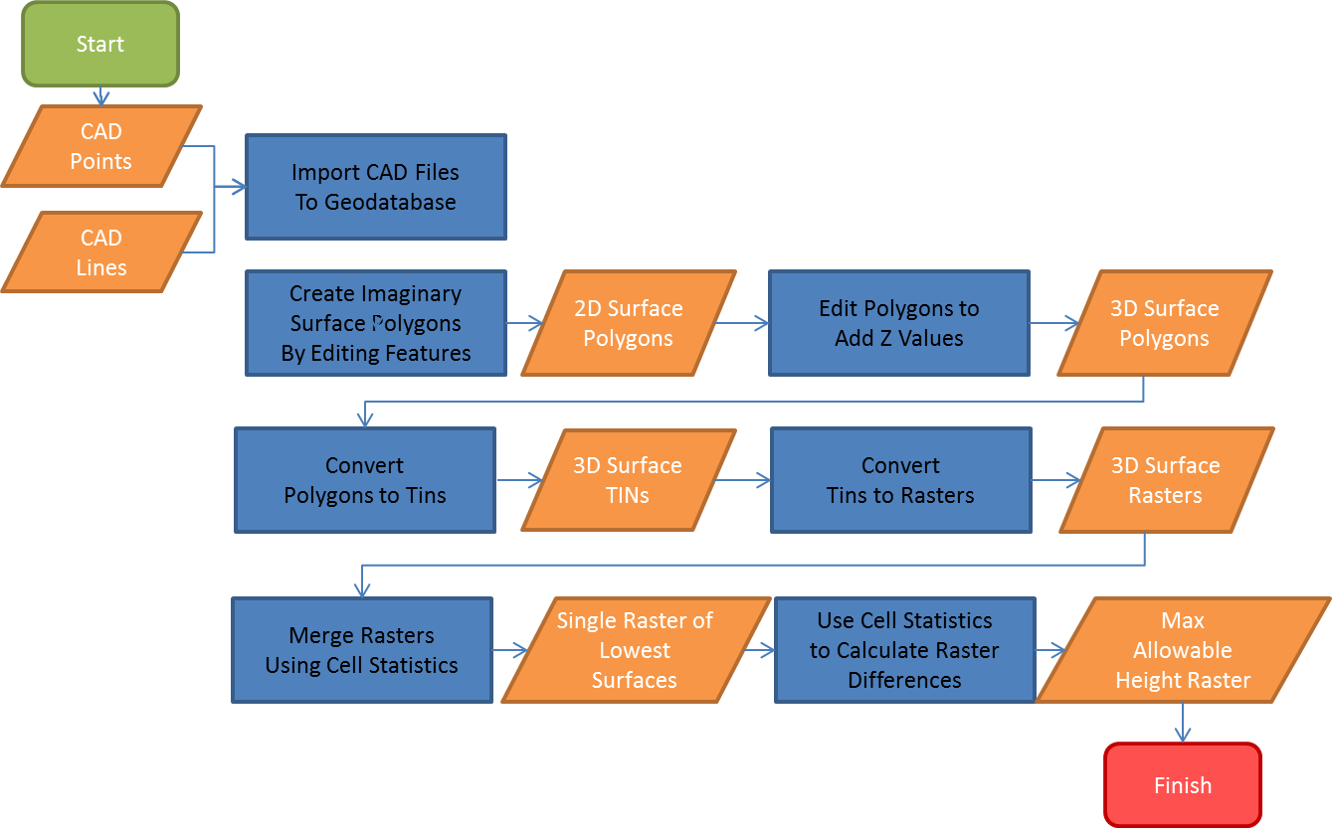

Flowchart 2. Maximum Allowable Height Raster Flowchart

In order for the interactive mapping tool to display the maximum allowable height as we wanted, we had to go through several steps to accomplish this. We first imported the CAD files provided by TxDOT to the geodatabase. We then created polygons of each imaginary surface referencing the CAD files and following the regulations specified on the CFR, which gave us the end product of 2D polygons of the imaginary surfaces. Each imaginary surface has a different elevation, so Z values were added, making them 3D polygons. These polygons were then converted to TINs then to rasters. All the rasters were combined using cell statistics, giving us the result of a raster with the lowest surfaces. The difference was then calculated for the raster of lowest surfaces and our extent DEM. This gave us the maximum allowable height raster.

Maximum allowable height information was a priority for this study, especially for the interactive mapping tool. In order to provide this information in an interactive format, we had to convert the specialized GIS layer to a grid layer of 10m resolution to match the resolution of our surface terrain.

First, we converted the imaginary surface polygons to TINs to generate the proper slopes of all layers. We then converted them to raster so that they could be combined to produce a continuous layer of only the lowest surface elevations.

A constant value raster was also created that covered the extent of our study area, and the values were set above the range of imaginary surface elevations. This new raster was then combined with the raster of lowest imaginary surface elevations to produce a layer that contained all necessary allowable height values, and covered the extent of our study area. The arbitrary high value assigned to the extent raster was then selected and converted to a value of “NA” for “Not Affected”

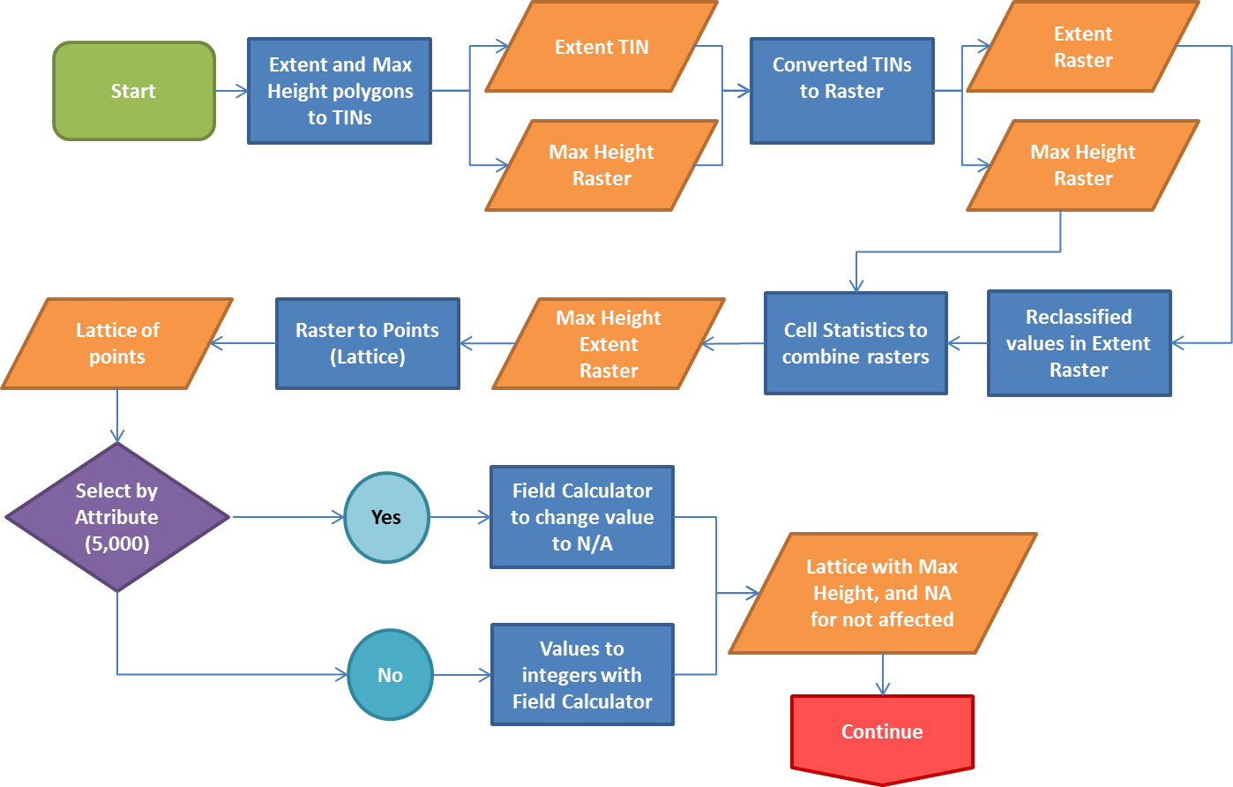

Flowchart 3. Max Height Raster to Points Flowchart

We then created two different fishnets using our extent polygon and our lattice points so they could be added to our interactive mapping tool.

Because raster layers cannot be easily queried in Manifold, we decided to convert the raster layer to a lattice of points 10 meters apart. This however, would not produce any results if the user zoomed in far enough and selected an area between the points. To fix this, we then converted the lattice point layer to a fishnet of 10m polygons via a spatial join tool, and converted the decimal values to intergers for easy comprehension.

Finally, to minimize loading time for the interactive map, we divided all map into nine grid areas.

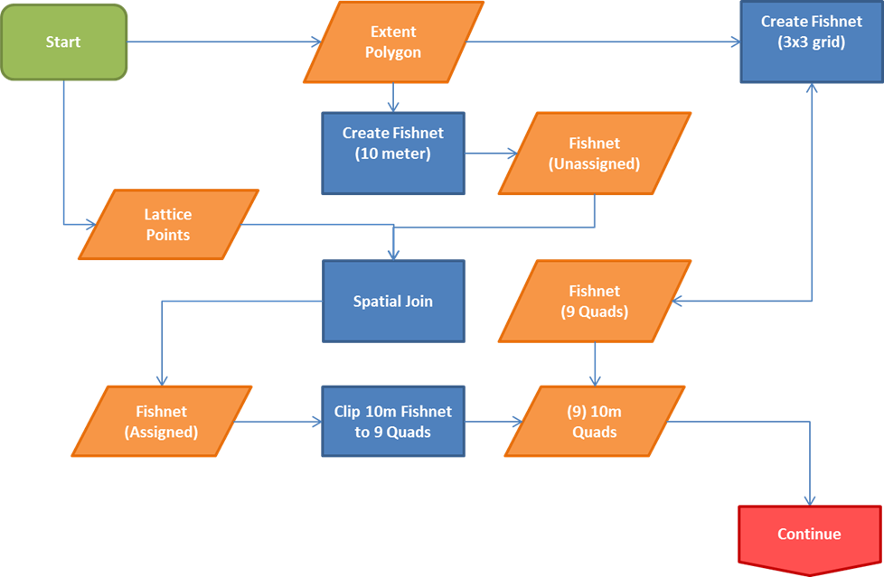

Flowchart 4. Points to Fishnet Flowchart

## 4.3 Penetrations

We created the penetrations layer to be included in the interactive mapping tool and allow users to see the penetrations within the hazard zones (under the imaginary surfaces) of the airport. We started our work with some data from a GIS survey conducted for the San Marcos Municipal Airport and some National Flight Data Center data for the state of Texas from 2012. After clipping those layers to our study area extent, we added information to each point’s attribute table about the ground elevation, the imaginary surface elevation, and each objects highest elevation.

We also converted some points to three-dimensional features by adding elevation geometry to them using their elevation. After calculating the difference between feature elevations and surface elevations we selected all features that penetrated the surface and created a final layer based on those points. Our final layer contained 127 separate penetration features. Each feature has a description, location attributes, and height information. See flowchart 4 for a detailed view of our workflow.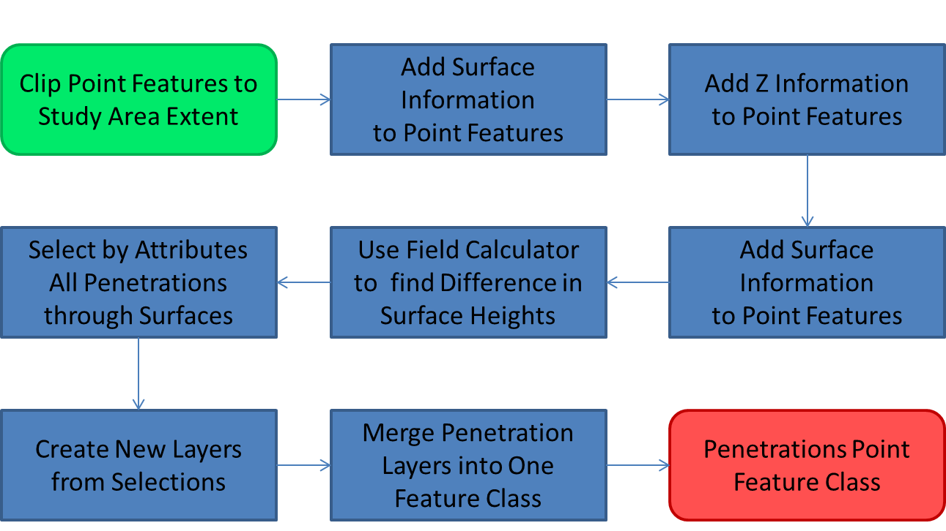

Flowchart 5. Penetrations Flowchart

## 4.4 Interact Mapping Tool

Our interactive mapping tool started out by importing the layers containing the necessary elements desired by our client into Manifold System. The next step in the process was to adjust the symbology to make the map user friendly. This included changing the roads and airspace contours to their respectable colors, by importing their color ramp off of ArcMap. After this was finished, I then went into the affected parcel attribute table and renamed columns to display their proper name. When this was finished, all unnecessary columns were hidden, to allow for a non-cluttered display when using the tool to find the highest/lowest maximum allowable building height. After completing this step, I then added a static reference area of the map in GIF format, that broken into 9 grid sections. Each grid will have a hyperlink that will link to the associated map when clicked. The last step was to export the final map product as a webpage to my local host web page. This will allow users to access the map from the internet and find their highest/lowest maximum allowable building height for their property.

**Flowchart 6: Interactive Map Tool flowchart**

Export Map to local host server

Adjust symbology to make the map user friendly

Hide unnecessary layer attributes

Final Map hosted at http://localhost.ims

Start

Add Map Layers

Finish

# 5. Results

As a result of our work, our team was able to create a new hazard zoning map, specialize GIS layers, and an interactive map tool. We designed all of our deliverables with the general user in mind and ensured that our information would be easily understood while leaving the capability of more technical users to bring out the best in the data.

## 5.1 Hazard Zone Map

The first major task to complete for this project was an updated hazard zoning map. Our main concern was to ensure that the final product resembled the 1984 hazard zoning map and maintained its level of usefulness for planning. However, we also wanted this new map to be more understandable by general map users. As a result, we were able to produce an updated digital version of an airport hazard zoning map which is now flexible enough to be edited and used by engineers, planners, and other city officials alike.

## 5.2 Specialized GIS Layers

The second major task to complete for this project was to complete specialized GIS layers. These layers include three-dimensional imaginary surfaces, maximum allowable height analysis layer, penetrations, and affected parcels. Our results for task were outstanding in all aspects. Our three-dimensional imaginary surfaces were created accurately using CAD files provided by TxDOT and by referencing FAA code of federal regulations title 14 part 77. These surfaces made it possible to create our maximum allowable height analysis layer accurately. This layer is used in our interactive mapping tool to let the user query individual 10 square meter polygons and find out what the maximum allowable height is for objects.

Our penetrations layer is another layer that was created accurately using the imaginary surface polygons. This layer, which is also used in the interactive mapping tool, allows users to look at and display 127 separate penetration features within the imaginary surfaces (hazard zones) surround the airport. They are able to find information regarding the type of object, the amount it penetrates, and its latitude and longitude location. Finally, we were able to create an affected parcels layer which allows users to query their parcels using parcel ID, property ID, or full address, and find out if they fall under the imaginary surfaces. This layer also provides them with information about what the minimum and maximum allowable height is in that specific parcel.

## 5.3 Interactive Mapping Tool

We were also able to create an interactive mapping tool using Manifold Systems that can be hosted via the web and made available to the general public as desired. This tool allows users to query information such as parcel ID’s, property ID’s, or full address. From that query the tool will provide information such as the range of maximum allowable heights for the selected parcel. This tool also allows users to use the info tool on the map to find the maximum allowable height at any point inside the imaginary surfaces at (10 meter resolution). For all other areas they will see a value of NA, which means that it falls outside of the imaginary surfaces and is not affected. Finally, users will be able to identify and find information for 127 penetrations through the imaginary surfaces. This interactive tool is broken down into a grid system which lets users choose the grid they are in and shows only a map for that grid. This reduces the loading time of each map and gives the user an easier extent to work with.

# 6. Discussions

## 6.1 Capabilities and Limitations

Use of ESRI ArcMap and ArcScene 10.1 produced great results for this project. We successfully made accurate GIS produces for the imaginary surfaces and maximum allowable height analysis layer using regulations describing their dimensions and CAD data as references. These layers were vital to our final interactive mapping tool product and we are confident in the results. One of the capabilities of GIS is the ability to edit of any of our layers to reflect future work or changes to the San Marcos Municipal Airport or imaginary surfaces.

One limitation that we encountered during the course of this project was the availability of high-resolution digital elevation models (DEM). Since civil airport imaginary surfaces and airspace regulation and protection are so important, we wanted to obtain data that would show as much detail as possible. Initially, our goal was to obtain 3 meter DEM’s for the planning study extent. However, for our area of study the best available DEM’s were in 10 meter resolution. At any rate, we fully believe that using 10 meter resolution DEM’s we were able to produce very accurate results.

We also encountered a limitation with our maximum allowable height layer. Initially, we planned on allowing users to query cells in a raster. Use of a raster would allow our data to be smaller and load faster. However, our interactive mapping tool could not handle data in this format so we ended up having to create a polygon fishnet for the same raster. These polygons in this fishnet would represent each raster cell. This meant that we ended up with a large vector layer with a good deal of information. The result works flawlessly and still provides users with the information we planned on delivering.

Another limitation we encountered had to do with the size of our data in the Interactive Mapping Tool. We later found out that since the scope of our project was too large for acceptable loading of our tool. We discovered that it took a considerable amount of time for the map to load. In order to make this easier for users, we decided to divide the study area into nine sections so the information could load faster. Besides having a faster loading time, users will not have to worry about whether the parcel they are querying is divided into two grids because the maximum and minimum allowable height will still be the same in both grids.

## 6.2 Similar Studies

We studied two projects from prior Texas State University GEO 4427 class groups. The first project we referenced focused on the New Braunfels airport conducted by Geo Solutions, Inc. From their project, we studied their methods of creating imaginary surfaces for airport zones, and we noted the software and techniques they used to develop and distribute their results. We also researched the web based map tool that they created as an example of an interactive tool for identifying airport hazard zones. We were able to glean many pros and cons of their design. The second project that we researched covered the San Marcos Municipal Airport conducted by Geo-Air Consulting. From this project we were able to observe how the methods they used to record obstructions, map imaginary surfaces, and discover penetrations. However, because that project also focused on planning for runway extensions we chose to use their data and results for reference purposes.

## 6.3 Future Projects

Now that we have constructed a new hazard zoning map, interactive mapping tool, and imaginary surfaces, there are many new options to explore in relation to the San Marcos Municipal Airport. For instance, analysis for the extension of the runways and new penetration analysis would be easy to conduct and entered into our interactive mapping tool. Runway extensions could give the San Marcos Municipal Airport great capacity to help assist cities like Austin and San Antonio with excess air traffic during large events. This would benefit the San Marcos airport greatly in terms of economic benefits. Future projects could also explore the expansion of an airport’s virtual flight school (Red Bird Skyport) in the area of San Marcos. This could also possibly attract more attention to the airport.

# 7. Conclusions

Our study was successful, and can be used for many other projects in the future because the data is all available in electronic format. We were able to create an updated hazard zoning map with the current active runways in electronic format that can be easily updated. The interactive map allows the general public to view their parcel and see if it is affected by regulated airspaces. If they are affected, they can view, at 10 meter resolution, the maximum allowable height at any point selected on the map. This tool will aide the City if San Marcos in drafting zoning regulations to prevent new buildings or other obstructions from penetrating the regulated airspace.

If we were to do a project similar to this in the future, we would include a programmer in the budget to help with extra functionality for the mapping tool. Also, it would have been nice to have better data for the parcels layer from the city and county. Many of the parcels did not have addresses and the parcel polygons themselves overlapped.

We look forward to working with TxDOT again on future projects.

# 8. References

Geo-Air Consulting. 2012. *San Marcos Airport Expansion.* GEO 4427 at Texas State University. Retrieved from http://geosites.evans.txstate.edu/g4427/F12/TXDOT/deliverables.html

Geo Solutions, Inc. 2012. Airport 3-D Visualization Final Report . GEO 4427 at Texas State University. Retrieved from http://geosites.evans.txstate.edu/g4427/S12/NB\_Airport/ Airport%20Project%20Final%20Report.pdf

Geo Solutions, Inc. Interactive Map. (n.d.). Retrieved from http://geosites.evans.txstate.edu/g4427/S12/NB\_Airport/ims/

Houston, City of. Houston Airport System Airspace Map. (n.d.). Retrieved from http://mycity.houstontx.gov/has/#

Safe, Efficient Use, and Preservation of Navigable Airspace. 14 CFR § 77. 2013.

# Appendix I: Metadata

## Metadata for Maximum Height Analysis Layer

**Summary**

Lone Star Geospatial is an up and coming GIS provider for the citizens of Texas. Our goal is to provide affordable geospatial information and raise awareness about the benefits of using GIS. Our maps are accurate and designed to be user/platform friendly. The purpose of this shapefile was to be able to this layer on a interactive map tool and be able to display the maximum allowable height on a location.

**Description**

This layer contains points showing the maximum allowable height based on the Federal; Aviation Administration 14 CFR 77.19. The points are located on Hays County and portions of Caldwell, Comal, and Guadalupe County.

**Credits**

There are no credits associated with this shapefile.

**Use limitations**

There are no access and use limitations for this item.

**Extent**

|  |  |  |  |
| --- | --- | --- | --- |
| **WWest** | -98.087923 | **EEast** | -97.706318 |
| **NNorth** | 30.063750 | **SSouth** | 29.799532 |

**Scale Range**

|  |  |
| --- | --- |
| **Maximum (zoomed in)** | 1:5,000 |
| **Minimum (zoomed out)** | 1:150,000,000 |

[ArcGIS Metadata ▼►](file:///C:\Users\pm1153\AppData\Local\Temp\arcE07C\tmp5F7D.tmp.htm#arcgisMetadata)

**[Topics and Keywords ▼►](file:///C:\\Users\\pm1153\\AppData\\Local\\Temp\\arcE07C\\tmp5F7D.tmp.htm" \l "true)**

Themes or categories of the resource  elevation, location

**\*** Content type  Downloadable Data

Export to FGDC CSDGM XML format as Resource Description No

Place keywords  Hays, Caldwell, Comal, Guadalupe County

[*Hide Topics and Keywords ▲*](file:///C:\Users\pm1153\AppData\Local\Temp\arcE07C\tmp5F7D.tmp.htm#true)

[**Citation ▼►**](file:///C:\Users\pm1153\AppData\Local\Temp\arcE07C\tmp5F7D.tmp.htm#ID0ELRA)

Title Maximum Height Points

Creation date 2013-11-21 00:00:00

Presentation formats  **\*** digital map

[*Hide Citation ▲*](file:///C:\Users\pm1153\AppData\Local\Temp\arcE07C\tmp5F7D.tmp.htm#ID0ELRA)

[**Resource Details ▼►**](file:///C:\Users\pm1153\AppData\Local\Temp\arcE07C\tmp5F7D.tmp.htm#ID0EECGSA)

Dataset languages  **\*** English (UNITED STATES)

Dataset character set  utf8 - 8 bit UCS Transfer Format

Status  completed

Spatial representation type  **\*** vector

**\*** Processing environment Microsoft Windows 7 Version 6.1 (Build 7601) Service Pack 1; Esri ArcGIS 10.1.1.3143

Credits

There are no credits associated with this shapefile.

ArcGIS item properties

**\*** Name max\_ht\_pts

**\*** Size 264.197

**\*** Location file://\\Geoserve\Data\G4427\TxDOT\_SMA\Jason\_Temp\Data\InteractiveMapLayers\max\_ht\_pts.shp

**\*** Access protocol Local Area Network

[*Hide Resource Details ▲*](file:///C:\Users\pm1153\AppData\Local\Temp\arcE07C\tmp5F7D.tmp.htm#ID0EECGSA)

[**Service Details ▼►**](file:///C:\Users\pm1153\AppData\Local\Temp\arcE07C\tmp5F7D.tmp.htm#ID0EACRA)

Service type Maximum Height Points

Codespace

[*Hide Service Details ▲*](file:///C:\Users\pm1153\AppData\Local\Temp\arcE07C\tmp5F7D.tmp.htm#ID0EACRA)

[**Extents ▼►**](file:///C:\Users\pm1153\AppData\Local\Temp\arcE07C\tmp5F7D.tmp.htm#ID0EEBCGSA)

Extent

Geographic extent

Bounding rectangle

Extent type  Extent used for searching

**\*** West longitude -98.087923

**\*** East longitude -97.706318

**\*** North latitude 30.063750

**\*** South latitude 29.799532

**\*** Extent contains the resource Yes

Extent in the item's coordinate system

**\*** West longitude 2257759.550872

**\*** East longitude 2377741.312870

**\*** South latitude 13840513.795455

**\*** North latitude 13935471.176427

**\*** Extent contains the resource Yes

[*Hide Extents ▲*](file:///C:\Users\pm1153\AppData\Local\Temp\arcE07C\tmp5F7D.tmp.htm#ID0EEBCGSA)

[**Spatial Reference ▼►**](file:///C:\Users\pm1153\AppData\Local\Temp\arcE07C\tmp5F7D.tmp.htm#ID0EEAGSA)

ArcGIS coordinate system

**\*** Type Projected

**\*** Geographic coordinate reference GCS\_North\_American\_1983

**\*** Projection NAD\_1983\_StatePlane\_Texas\_South\_Central\_FIPS\_4204\_Feet

**\*** Coordinate reference details

Projected coordinate system

Well-known identifier 102740

X origin -126725700

Y origin -77828800

XY scale 34994581.165044695

Z origin -100000

Z scale 10000

M origin -100000

M scale 10000

XY tolerance 0.0032808333333333331

Z tolerance 0.001

M tolerance 0.001

High precision true

Latest well-known identifier 2278

Well-known text PROJCS["NAD\_1983\_StatePlane\_Texas\_South\_Central\_FIPS\_4204\_Feet",GEOGCS["GCS\_North\_American\_1983",DATUM["D\_North\_American\_1983",SPHEROID["GRS\_1980",6378137.0,298.257222101]],PRIMEM["Greenwich",0.0],UNIT["Degree",0.0174532925199433]],PROJECTION["Lambert\_Conformal\_Conic"],PARAMETER["False\_Easting",1968500.0],PARAMETER["False\_Northing",13123333.33333333],PARAMETER["Central\_Meridian",-99.0],PARAMETER["Standard\_Parallel\_1",28.38333333333333],PARAMETER["Standard\_Parallel\_2",30.28333333333334],PARAMETER["Latitude\_Of\_Origin",27.83333333333333],UNIT["Foot\_US",0.3048006096012192],AUTHORITY["EPSG",2278]]

Reference system identifier

**\*** Value 2278

**\*** Codespace EPSG

**\*** Version 7.11.2

[*Hide Spatial Reference ▲*](file:///C:\Users\pm1153\AppData\Local\Temp\arcE07C\tmp5F7D.tmp.htm#ID0EEAGSA)

[**Spatial Data Properties ▼►**](file:///C:\Users\pm1153\AppData\Local\Temp\arcE07C\tmp5F7D.tmp.htm#ID0EAKA)

[Vector  ▼►](file:///C:\\Users\\pm1153\\AppData\\Local\\Temp\\arcE07C\\tmp5F7D.tmp.htm" \l "ID0EBAKA)

**\*** Level of topology for this dataset  geometry only

Geometric objects

Feature class name max\_ht\_pts

**\*** Object type  point

**\*** Object count 9893947

[*Hide Vector ▲*](file:///C:\Users\pm1153\AppData\Local\Temp\arcE07C\tmp5F7D.tmp.htm#ID0EBAKA)

[Vector  ▼►](file:///C:\\Users\\pm1153\\AppData\\Local\\Temp\\arcE07C\\tmp5F7D.tmp.htm" \l "ID0EBAGA)

**\*** Level of topology for this dataset  geometry only

Geometric objects

Feature class name max\_ht\_pts

**\*** Object type  point

**\*** Object count 9893947

[*Hide Vector ▲*](file:///C:\Users\pm1153\AppData\Local\Temp\arcE07C\tmp5F7D.tmp.htm#ID0EBAGA)

[Grid  ▼►](file:///C:\\Users\\pm1153\\AppData\\Local\\Temp\\arcE07C\\tmp5F7D.tmp.htm" \l "ID0EABGA)

Transformation parameters are available No

[*Hide Grid ▲*](file:///C:\Users\pm1153\AppData\Local\Temp\arcE07C\tmp5F7D.tmp.htm#ID0EABGA)

[ArcGIS Feature Class Properties  ▼►](file:///C:\\Users\\pm1153\\AppData\\Local\\Temp\\arcE07C\\tmp5F7D.tmp.htm" \l "ID0EA)

Feature class name max\_ht\_pts

**\*** Feature type Simple

**\*** Geometry type Point

**\*** Has topology FALSE

**\*** Feature count 9893947

**\*** Spatial index FALSE

**\*** Linear referencing FALSE

[*Hide ArcGIS Feature Class Properties ▲*](file:///C:\Users\pm1153\AppData\Local\Temp\arcE07C\tmp5F7D.tmp.htm#ID0EA)

[*Hide Spatial Data Properties ▲*](file:///C:\Users\pm1153\AppData\Local\Temp\arcE07C\tmp5F7D.tmp.htm#ID0EAKA)

[**Spatial Data Content ▼►**](file:///C:\Users\pm1153\AppData\Local\Temp\arcE07C\tmp5F7D.tmp.htm#ID0EFA)

Image Description

Triangulation has been performed No

Radiometric calibration is available No

Camera calibration is available No

Film distortion information is available No

Lens distortion information is available No

[*Hide Spatial Data Content ▲*](file:///C:\Users\pm1153\AppData\Local\Temp\arcE07C\tmp5F7D.tmp.htm#ID0EFA)

[**Data Quality ▼►**](file:///C:\Users\pm1153\AppData\Local\Temp\arcE07C\tmp5F7D.tmp.htm#ID0EBBEA)

[Scope of quality information  ▼►](file:///C:\\Users\\pm1153\\AppData\\Local\\Temp\\arcE07C\\tmp5F7D.tmp.htm" \l "ID0EBBEA)

Resource level  feature

Scope description

Attributes Elevation

[*Hide Scope of quality information ▲*](file:///C:\Users\pm1153\AppData\Local\Temp\arcE07C\tmp5F7D.tmp.htm#ID0EBBEA)

[*Hide Data Quality ▲*](file:///C:\Users\pm1153\AppData\Local\Temp\arcE07C\tmp5F7D.tmp.htm#ID0EBBEA)

[**Lineage ▼►**](file:///C:\Users\pm1153\AppData\Local\Temp\arcE07C\tmp5F7D.tmp.htm#ID0EAEA)

Lineage statement

This is generates data from data that was downloaded from TNRIS. It was then converted to a TIN, then raster, then points in order to show the elevation on each.

[*Hide Lineage ▲*](file:///C:\Users\pm1153\AppData\Local\Temp\arcE07C\tmp5F7D.tmp.htm#ID0EAEA)

[**Geoprocessing history ▼►**](file:///C:\Users\pm1153\AppData\Local\Temp\arcE07C\tmp5F7D.tmp.htm#ID0EDGSA)

Process

Process name

Date 2013-11-21 12:32:37

Tool location c:\program files (x86)\arcgis\desktop10.1\ArcToolbox\Toolboxes\Conversion Tools.tbx\RasterToPoint

Command issued

RasterToPoint max\_ht\_ext Q:\max\_ht\_pts.shp Value

Include in lineage when exporting metadata No

Process

Process name

Date 2013-11-21 13:33:40

Tool location c:\program files (x86)\arcgis\desktop10.1\ArcToolbox\Toolboxes\Data Management Tools.tbx\CalculateField

Command issued

CalculateField max\_ht\_pts Max\_Ht [GRID\_CODE] VB #

Include in lineage when exporting metadata No

Process

Process name

Date 2013-11-21 13:49:46

Tool location c:\program files (x86)\arcgis\desktop10.1\ArcToolbox\Toolboxes\Data Management Tools.tbx\CalculateField

Command issued

CalculateField max\_ht\_pts Max\_Ht "NA" VB #

Include in lineage when exporting metadata No

Process

Process name

Date 2013-11-25 11:19:51

Tool location c:\program files (x86)\arcgis\desktop10.1\ArcToolbox\Toolboxes\Data Management Tools.tbx\CalculateField

Command issued

CalculateField max\_ht\_pts Max\_Ht "Int ( [GRID\_CODE] )" VB #

Include in lineage when exporting metadata No

[*Hide Geoprocessing history ▲*](file:///C:\Users\pm1153\AppData\Local\Temp\arcE07C\tmp5F7D.tmp.htm#ID0EDGSA)

[**Distribution ▼►**](file:///C:\Users\pm1153\AppData\Local\Temp\arcE07C\tmp5F7D.tmp.htm#ID0EOA)

Distribution format

**\*** Name Shapefile

Transfer options

**\*** Transfer size 264.197

[*Hide Distribution ▲*](file:///C:\Users\pm1153\AppData\Local\Temp\arcE07C\tmp5F7D.tmp.htm#ID0EOA)

[**Fields ▼►**](file:///C:\Users\pm1153\AppData\Local\Temp\arcE07C\tmp5F7D.tmp.htm#ID0EIA)

[Details for object max\_ht\_pts ▼►](file:///C:\\Users\\pm1153\\AppData\\Local\\Temp\\arcE07C\\tmp5F7D.tmp.htm" \l "ID0EAIA)

**\*** Type Feature Class

**\*** Row count 9893947

[Field FID ▼►](file:///C:\\Users\\pm1153\\AppData\\Local\\Temp\\arcE07C\\tmp5F7D.tmp.htm" \l "ID0EFAIA)

**\*** Alias FID

**\*** Data type OID

**\*** Width 4

**\*** Precision 0

**\*** Scale 0

**\*** Field description

Internal feature number.

**\*** Description source

Esri

**\*** Description of values Sequential unique whole numbers that are automatically generated.

[*Hide Field FID ▲*](file:///C:\Users\pm1153\AppData\Local\Temp\arcE07C\tmp5F7D.tmp.htm#ID0EFAIA)

[Field Shape ▼►](file:///C:\\Users\\pm1153\\AppData\\Local\\Temp\\arcE07C\\tmp5F7D.tmp.htm" \l "ID0EEAIA)

**\*** Alias Shape

**\*** Data type Geometry

**\*** Width 0

**\*** Precision 0

**\*** Scale 0

**\*** Field description

Feature geometry.

**\*** Description source

Esri

**\*** Description of values Coordinates defining the features.

[*Hide Field Shape ▲*](file:///C:\Users\pm1153\AppData\Local\Temp\arcE07C\tmp5F7D.tmp.htm#ID0EEAIA)

[Field POINTID ▼►](file:///C:\\Users\\pm1153\\AppData\\Local\\Temp\\arcE07C\\tmp5F7D.tmp.htm" \l "ID0EDAIA)

**\*** Alias POINTID

**\*** Data type Integer

**\*** Width 6

**\*** Precision 6

**\*** Scale 0

[*Hide Field POINTID ▲*](file:///C:\Users\pm1153\AppData\Local\Temp\arcE07C\tmp5F7D.tmp.htm#ID0EDAIA)

[Field GRID\_CODE ▼►](file:///C:\\Users\\pm1153\\AppData\\Local\\Temp\\arcE07C\\tmp5F7D.tmp.htm" \l "ID0ECAIA)

**\*** Alias GRID\_CODE

**\*** Data type Double

**\*** Width 17

**\*** Precision 16

**\*** Scale 8

[*Hide Field GRID\_CODE ▲*](file:///C:\Users\pm1153\AppData\Local\Temp\arcE07C\tmp5F7D.tmp.htm#ID0ECAIA)

[Field Max\_Height ▼►](file:///C:\\Users\\pm1153\\AppData\\Local\\Temp\\arcE07C\\tmp5F7D.tmp.htm" \l "ID0EBAIA)

**\*** Alias Max\_Height

**\*** Data type Single

**\*** Width 13

**\*** Precision 0

**\*** Scale 0

[*Hide Field Max\_Height ▲*](file:///C:\Users\pm1153\AppData\Local\Temp\arcE07C\tmp5F7D.tmp.htm#ID0EBAIA)

[Field Max\_Ht ▼►](file:///C:\\Users\\pm1153\\AppData\\Local\\Temp\\arcE07C\\tmp5F7D.tmp.htm" \l "ID0EAAIA)

**\*** Alias Max\_Ht

**\*** Data type String

**\*** Width 20

**\*** Precision 0

**\*** Scale 0

[*Hide Field Max\_Ht ▲*](file:///C:\Users\pm1153\AppData\Local\Temp\arcE07C\tmp5F7D.tmp.htm#ID0EAAIA)

[*Hide Details for object max\_ht\_pts ▲*](file:///C:\Users\pm1153\AppData\Local\Temp\arcE07C\tmp5F7D.tmp.htm#ID0EAIA)

[*Hide Fields ▲*](file:///C:\Users\pm1153\AppData\Local\Temp\arcE07C\tmp5F7D.tmp.htm#ID0EIA)

[**Metadata Details ▼►**](file:///C:\Users\pm1153\AppData\Local\Temp\arcE07C\tmp5F7D.tmp.htm#ID0TAKSA)

**\*** Metadata language English (UNITED STATES)

**\*** Metadata character set  utf8 - 8 bit UCS Transfer Format

Scope of the data described by the metadata  **\*** dataset

Scope name  **\*** dataset

**\*** Last update 2013-12-09

ArcGIS metadata properties

Metadata format ArcGIS 1.0

Standard or profile used to edit metadata NAP

Created in ArcGIS for the item 2013-11-21 12:56:45

Last modified in ArcGIS for the item 2013-12-09 08:53:14

Automatic updates

Have been performed Yes

Last update 2013-12-09 08:53:14

Item location history

Item copied or moved 2013-11-21 12:56:45

From Q:\max\_ht\_pts

To \\Geoserve\Data\G4427\TxDOT\_SMA\Jason\_Temp\Data\InteractiveMapLayers\max\_ht\_pts

[*Hide Metadata Details ▲*](file:///C:\Users\pm1153\AppData\Local\Temp\arcE07C\tmp5F7D.tmp.htm#ID0TAKSA)

[**Metadata Contacts ▼►**](file:///C:\Users\pm1153\AppData\Local\Temp\arcE07C\tmp5F7D.tmp.htm#ID0EDA)

Metadata contact

Individual's name Patricia Michel

Organization's name Lone Star Geospatial

Contact's role  editor

Metadata contact

Individual's name Jason Ford

Organization's name Lone Star Geospatial

Contact's role  point of contact

Metadata contact

Individual's name Casey Carpenter

Organization's name Lone Star Geospatial

Contact's role  editor

Metadata contact

Individual's name Grayson Jones

Organization's name Lone Star Geospatial

Contact's role  editor

## Metadata for Conical Surface Layer

**Summary**

LoneStar Geospatial is an up and coming GIS provider for the citizens of Texas. Our goal is to provide affordable geospatial information and raise awareness about the benefits of using GIS. Our maps are accurate and designed to be user/platform friendly.

**Description**

This shapefile contains the conical surface for the San Marcos Municipal Airports airspace as defined by the Federal Aviation Administration 14 CFR 77.19. The conical surface is an imaginary surface that is used primarily to prevent existing or proposed manmade objects, objects of natural growth, or objects of terrain from penetrating navigable airspace. The conical surface was developed with a slope of 20:1.

**Credits**

There are no credits associated with this shapefile

**Use limitations**

There are no access and use limitations for this item.

**Extent**

|  |  |  |  |
| --- | --- | --- | --- |
| **West** | -97.922347 | **East** | -97.811738 |
| **North** | 29.941343 | **South** | 29.847375 |

**Scale Range**

|  |  |
| --- | --- |
| **Maximum (zoomed in)** | 1:5,000 |
| **Minimum (zoomed out)** | 1:150,000,000 |

[ArcGIS Metadata ▼►](file:///C:\Users\c_c215\AppData\Local\Temp\arcAC16\tmp22CD.tmp.htm#arcgisMetadata)

[**Topics and Keywords ▼►**](file:///C:\Users\c_c215\AppData\Local\Temp\arcAC16\tmp22CD.tmp.htm#true)

Themes or categories of the resource  boundaries

**\*** Content type  Downloadable Data

Export to FGDC CSDGM XML format as Resource Description No

Place keywords  San Marcos; Hays county; Caldwell county

Theme keywords  Imaginary Surface; Conical Surface

[*Hide Topics and Keywords ▲*](file:///C:\Users\c_c215\AppData\Local\Temp\arcAC16\tmp22CD.tmp.htm#true)

[**Citation ▼►**](file:///C:\Users\c_c215\AppData\Local\Temp\arcAC16\tmp22CD.tmp.htm#ID0ELMA)

**\*** Title Conical\_101113

Presentation formats  **\*** digital map

[*Hide Citation ▲*](file:///C:\Users\c_c215\AppData\Local\Temp\arcAC16\tmp22CD.tmp.htm#ID0ELMA)

[**Resource Details ▼►**](file:///C:\Users\c_c215\AppData\Local\Temp\arcAC16\tmp22CD.tmp.htm#ID0EECGNA)

Dataset languages  **\*** English (UNITED STATES)

Dataset character set  utf8 - 8 bit UCS Transfer Format

Status  completed

Spatial representation type  **\*** vector

**\*** Processing environment Microsoft Windows 7 Version 6.1 (Build 7601) Service Pack 1; Esri ArcGIS 10.1.1.3143

Credits

There are no credits associated with this shapefile

ArcGIS item properties

**\*** Name Conical\_101113

**\*** Size 0.040

**\*** Location file://\\Geoserve\Data\G4427\TxDOT\_SMA\Jason\_Temp\Data\Imaginary\_Surfaces\Polygons\Conical\_101113.shp

**\*** Access protocol Local Area Network

[*Hide Resource Details ▲*](file:///C:\Users\c_c215\AppData\Local\Temp\arcAC16\tmp22CD.tmp.htm#ID0EECGNA)

[**Extents ▼►**](file:///C:\Users\c_c215\AppData\Local\Temp\arcAC16\tmp22CD.tmp.htm#ID0EEBCGNA)

Extent

Vertical extent

**\*** Minimum value 747.000000

**\*** Maximum value 947.000000

Extent

Geographic extent

Bounding rectangle

Extent type  Extent used for searching

**\*** West longitude -97.922347

**\*** East longitude -97.811738

**\*** North latitude 29.941343

**\*** South latitude 29.847375

**\*** Extent contains the resource Yes

Extent in the item's coordinate system

**\*** West longitude 2310116.670361

**\*** East longitude 2344838.355639

**\*** South latitude 13857563.956163

**\*** North latitude 13891400.825797

**\*** Extent contains the resource Yes

[*Hide Extents ▲*](file:///C:\Users\c_c215\AppData\Local\Temp\arcAC16\tmp22CD.tmp.htm#ID0EEBCGNA)

[**Spatial Reference ▼►**](file:///C:\Users\c_c215\AppData\Local\Temp\arcAC16\tmp22CD.tmp.htm#ID0EEAGNA)

ArcGIS coordinate system

**\*** Type Projected

**\*** Geographic coordinate reference GCS\_North\_American\_1983

**\*** Projection NAD\_1983\_StatePlane\_Texas\_South\_Central\_FIPS\_4204\_Feet

**\*** Coordinate reference details

Projected coordinate system

Well-known identifier 102740

X origin -126725700

Y origin -77828800

XY scale 34994581.165044695

Z origin -226.74182350000001

Z scale 4194304001953.124

M origin -100000

M scale 10000

XY tolerance 0.0032808333333333331

Z tolerance 0.001

M tolerance 0.001

High precision true

Latest well-known identifier 2278

Well-known text PROJCS["NAD\_1983\_StatePlane\_Texas\_South\_Central\_FIPS\_4204\_Feet",GEOGCS["GCS\_North\_American\_1983",DATUM["D\_North\_American\_1983",SPHEROID["GRS\_1980",6378137.0,298.257222101]],PRIMEM["Greenwich",0.0],UNIT["Degree",0.0174532925199433]],PROJECTION["Lambert\_Conformal\_Conic"],PARAMETER["False\_Easting",1968500.0],PARAMETER["False\_Northing",13123333.33333333],PARAMETER["Central\_Meridian",-99.0],PARAMETER["Standard\_Parallel\_1",28.38333333333333],PARAMETER["Standard\_Parallel\_2",30.28333333333334],PARAMETER["Latitude\_Of\_Origin",27.83333333333333],UNIT["Foot\_US",0.3048006096012192],AUTHORITY["EPSG",2278]]

Reference system identifier

**\*** Value 2278

**\*** Codespace EPSG

**\*** Version 7.11.2

[*Hide Spatial Reference ▲*](file:///C:\Users\c_c215\AppData\Local\Temp\arcAC16\tmp22CD.tmp.htm#ID0EEAGNA)

[**Spatial Data Properties ▼►**](file:///C:\Users\c_c215\AppData\Local\Temp\arcAC16\tmp22CD.tmp.htm#ID0EAFA)

[Vector  ▼►](file:///C:\\Users\\c_c215\\AppData\\Local\\Temp\\arcAC16\\tmp22CD.tmp.htm" \l "ID0EBAFA)

**\*** Level of topology for this dataset  geometry only

Geometric objects

Feature class name Conical\_101113

**\*** Object type  composite

**\*** Object count 1

[*Hide Vector ▲*](file:///C:\Users\c_c215\AppData\Local\Temp\arcAC16\tmp22CD.tmp.htm#ID0EBAFA)

[ArcGIS Feature Class Properties  ▼►](file:///C:\\Users\\c_c215\\AppData\\Local\\Temp\\arcAC16\\tmp22CD.tmp.htm" \l "ID0EA)

Feature class name Conical\_101113

**\*** Feature type Simple

**\*** Geometry type Polygon

**\*** Has topology FALSE

**\*** Feature count 1

**\*** Spatial index TRUE

**\*** Linear referencing TRUE

[*Hide ArcGIS Feature Class Properties ▲*](file:///C:\Users\c_c215\AppData\Local\Temp\arcAC16\tmp22CD.tmp.htm#ID0EA)

[*Hide Spatial Data Properties ▲*](file:///C:\Users\c_c215\AppData\Local\Temp\arcAC16\tmp22CD.tmp.htm#ID0EAFA)

[**Spatial Data Content ▼►**](file:///C:\Users\c_c215\AppData\Local\Temp\arcAC16\tmp22CD.tmp.htm#ID0EAA)

Coverage Description

Type of information  image

Attribute described by cell values Conical Imaginary Surface

[*Hide Spatial Data Content ▲*](file:///C:\Users\c_c215\AppData\Local\Temp\arcAC16\tmp22CD.tmp.htm#ID0EAA)

[**Data Quality ▼►**](file:///C:\Users\c_c215\AppData\Local\Temp\arcAC16\tmp22CD.tmp.htm#ID0EBBBA)

[Scope of quality information  ▼►](file:///C:\\Users\\c_c215\\AppData\\Local\\Temp\\arcAC16\\tmp22CD.tmp.htm" \l "ID0EBBBA)

Resource level  feature

Scope description

Attributes 20:1 Slope

[*Hide Scope of quality information ▲*](file:///C:\Users\c_c215\AppData\Local\Temp\arcAC16\tmp22CD.tmp.htm#ID0EBBBA)

[*Hide Data Quality ▲*](file:///C:\Users\c_c215\AppData\Local\Temp\arcAC16\tmp22CD.tmp.htm#ID0EBBBA)

[**Lineage ▼►**](file:///C:\Users\c_c215\AppData\Local\Temp\arcAC16\tmp22CD.tmp.htm#ID0EABA)

Lineage statement

The Conical surface was derived from the horizontal surface using a slope of 20:1 according to FAA 14 CFR 77.19. The horizontal surface was based off CAD files we recieved from TxDOT.

[*Hide Lineage ▲*](file:///C:\Users\c_c215\AppData\Local\Temp\arcAC16\tmp22CD.tmp.htm#ID0EABA)

[**Geoprocessing history ▼►**](file:///C:\Users\c_c215\AppData\Local\Temp\arcAC16\tmp22CD.tmp.htm#ID0EDGNA)

Process

Process name

Date 2013-10-10 17:57:15

Tool location c:\program files (x86)\arcgis\desktop10.1\ArcToolbox\Toolboxes\3D Analyst Tools.tbx\FeatureTo3DByAttribute

Command issued

FeatureTo3DByAttribute Con\_Surf101013 W:\G4427\TxDOT\_SMA\Data\Imag\_Surf\_Data\Con\_Surf101013B.shp Id #

Include in lineage when exporting metadata No

[*Hide Geoprocessing history ▲*](file:///C:\Users\c_c215\AppData\Local\Temp\arcAC16\tmp22CD.tmp.htm#ID0EDGNA)

[**Distribution ▼►**](file:///C:\Users\c_c215\AppData\Local\Temp\arcAC16\tmp22CD.tmp.htm#ID0EJA)

Distribution format

**\*** Name Shapefile

Transfer options

**\*** Transfer size 0.040

[*Hide Distribution ▲*](file:///C:\Users\c_c215\AppData\Local\Temp\arcAC16\tmp22CD.tmp.htm#ID0EJA)

[**Fields ▼►**](file:///C:\Users\c_c215\AppData\Local\Temp\arcAC16\tmp22CD.tmp.htm#ID0EDA)

[Details for object Conical\_101113 ▼►](file:///C:\\Users\\c_c215\\AppData\\Local\\Temp\\arcAC16\\tmp22CD.tmp.htm" \l "ID0EADA)

**\*** Type Feature Class

**\*** Row count 1

[Field FID ▼►](file:///C:\\Users\\c_c215\\AppData\\Local\\Temp\\arcAC16\\tmp22CD.tmp.htm" \l "ID0ECADA)

**\*** Alias FID

**\*** Data type OID

**\*** Width 4

**\*** Precision 0

**\*** Scale 0

**\*** Field description

Internal feature number.

**\*** Description source

Esri

**\*** Description of values Sequential unique whole numbers that are automatically generated.

[*Hide Field FID ▲*](file:///C:\Users\c_c215\AppData\Local\Temp\arcAC16\tmp22CD.tmp.htm#ID0ECADA)

[Field Shape ▼►](file:///C:\\Users\\c_c215\\AppData\\Local\\Temp\\arcAC16\\tmp22CD.tmp.htm" \l "ID0EBADA)

**\*** Alias Shape

**\*** Data type Geometry

**\*** Width 0

**\*** Precision 0

**\*** Scale 0

**\*** Field description

Feature geometry.

**\*** Description source

Esri

**\*** Description of values Coordinates defining the features.

[*Hide Field Shape ▲*](file:///C:\Users\c_c215\AppData\Local\Temp\arcAC16\tmp22CD.tmp.htm#ID0EBADA)

[Field Id ▼►](file:///C:\\Users\\c_c215\\AppData\\Local\\Temp\\arcAC16\\tmp22CD.tmp.htm" \l "ID0EAADA)

**\*** Alias Id

**\*** Data type Integer

**\*** Width 6

**\*** Precision 6

**\*** Scale 0

[*Hide Field Id ▲*](file:///C:\Users\c_c215\AppData\Local\Temp\arcAC16\tmp22CD.tmp.htm#ID0EAADA)

[*Hide Details for object Conical\_101113 ▲*](file:///C:\Users\c_c215\AppData\Local\Temp\arcAC16\tmp22CD.tmp.htm#ID0EADA)

[*Hide Fields ▲*](file:///C:\Users\c_c215\AppData\Local\Temp\arcAC16\tmp22CD.tmp.htm#ID0EDA)

[**Metadata Details ▼►**](file:///C:\Users\c_c215\AppData\Local\Temp\arcAC16\tmp22CD.tmp.htm#ID0TAKNA)

**\*** Metadata language English (UNITED STATES)

**\*** Metadata character set  utf8 - 8 bit UCS Transfer Format

Scope of the data described by the metadata  **\*** dataset

Scope name  **\*** dataset

**\*** Last update 2013-12-09

ArcGIS metadata properties

Metadata format ArcGIS 1.0

Standard or profile used to edit metadata NAP

Created in ArcGIS for the item 2013-10-27 17:07:54

Last modified in ArcGIS for the item 2013-12-09 09:00:36

Automatic updates

Have been performed Yes

Last update 2013-12-09 09:00:36

Item location history

Item copied or moved 2013-10-27 17:07:54

From E:\School\4427\Data\Imag\_Surf\_Data\Con\_Surf\_101113

To \\JFO-PC\D$\Users\jfo\Documents\School\4427\Data\Imaginary\_Surfaces\Polygons\Con\_Surf\_101113

[*Hide Metadata Details ▲*](file:///C:\Users\c_c215\AppData\Local\Temp\arcAC16\tmp22CD.tmp.htm#ID0TAKNA)

[FGDC Metadata (read-only) ▼►](file:///C:\Users\c_c215\AppData\Local\Temp\arcAC16\tmp22CD.tmp.htm#fgdcMetadata)

**[Entities and Attributes ▼►](file:///C:\\Users\\c_c215\\AppData\\Local\\Temp\\arcAC16\\tmp22CD.tmp.htm" \l "/metadata/eainfo//text()[1])**

Detailed Description

Entity Type

Entity Type Label Conical\_101113

Attribute

Attribute Label FID

Attribute Definition

Internal feature number.

Attribute Definition Source Esri

Attribute Domain Values

Unrepresentable Domain

Sequential unique whole numbers that are automatically generated.

Attribute

Attribute Label Shape

Attribute Definition

Feature geometry.

Attribute Definition Source Esri

Attribute Domain Values

Unrepresentable Domain

Coordinates defining the features.

Attribute

Attribute Label Id

*[Hide Entities and Attributes ▲](file:///C:\\Users\\c_c215\\AppData\\Local\\Temp\\arcAC16\\tmp22CD.tmp.htm" \l "/metadata/eainfo//text()[1])*

# Appendix II: Penetrations List





# Appendix III: Reference Imagery

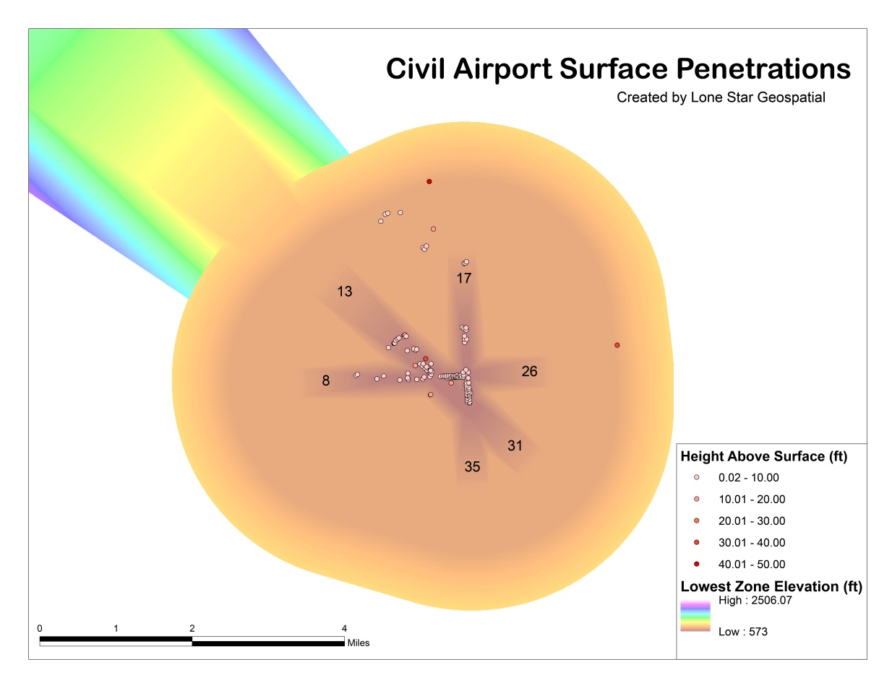  
Figure A1

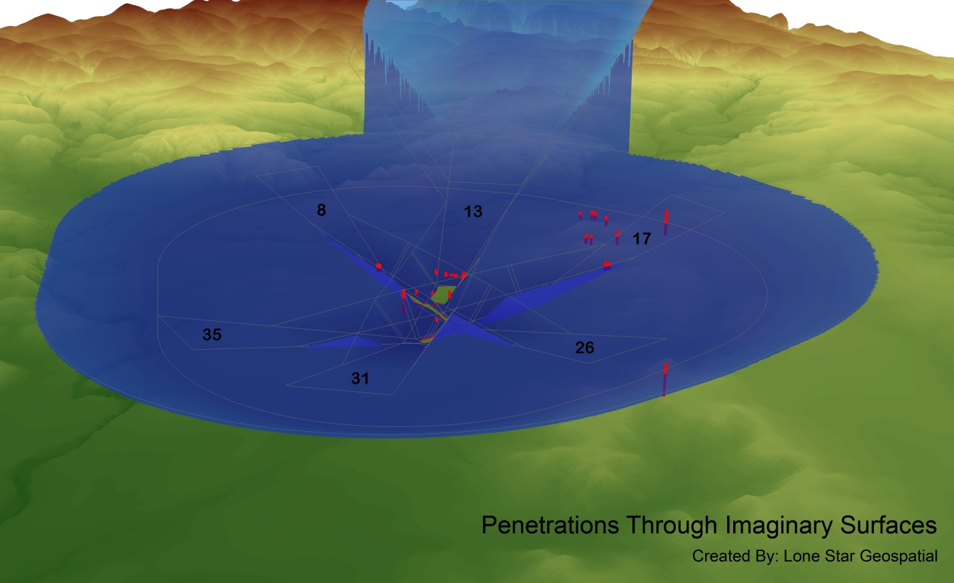Figure A2

Extruded by a factor of 10

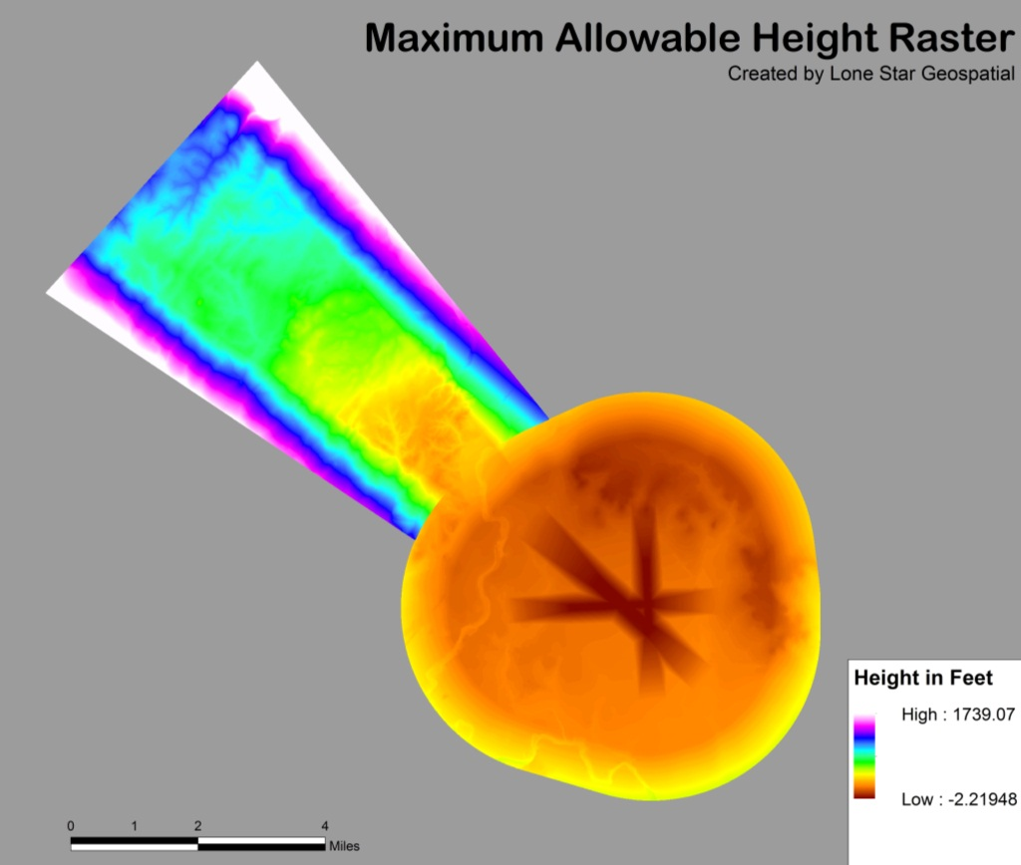  
Figure A3

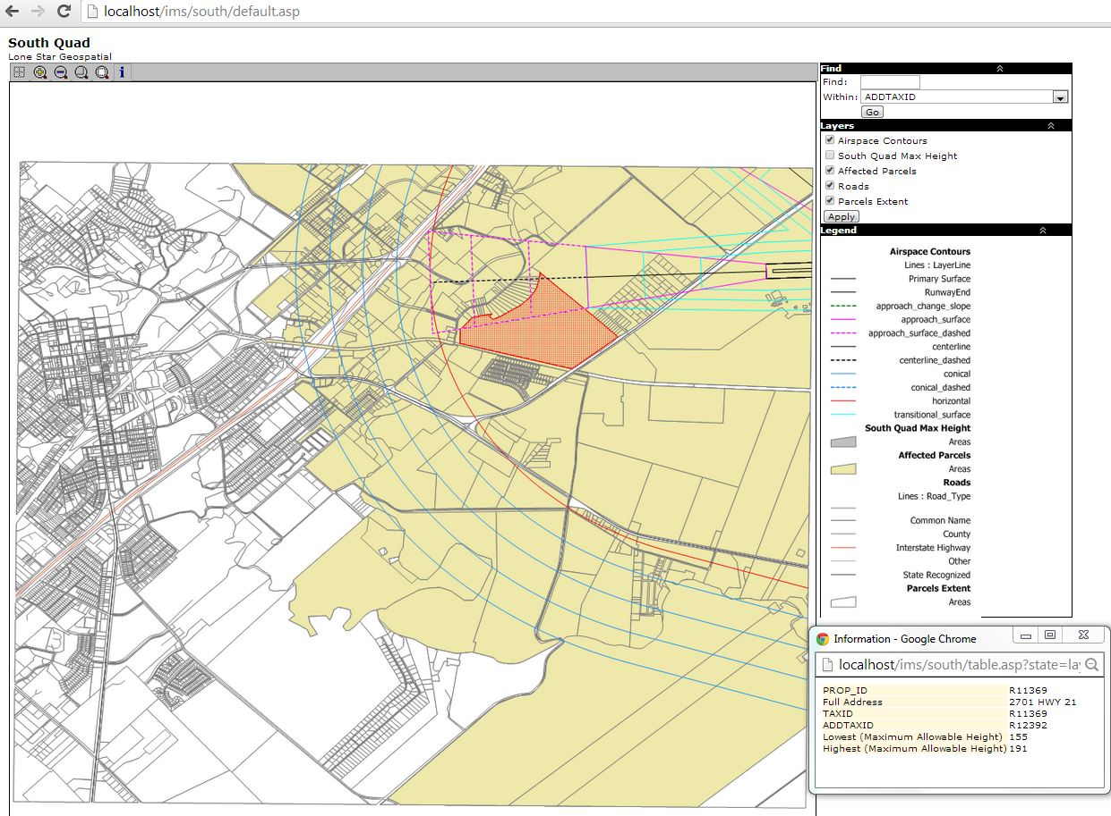Figure A4

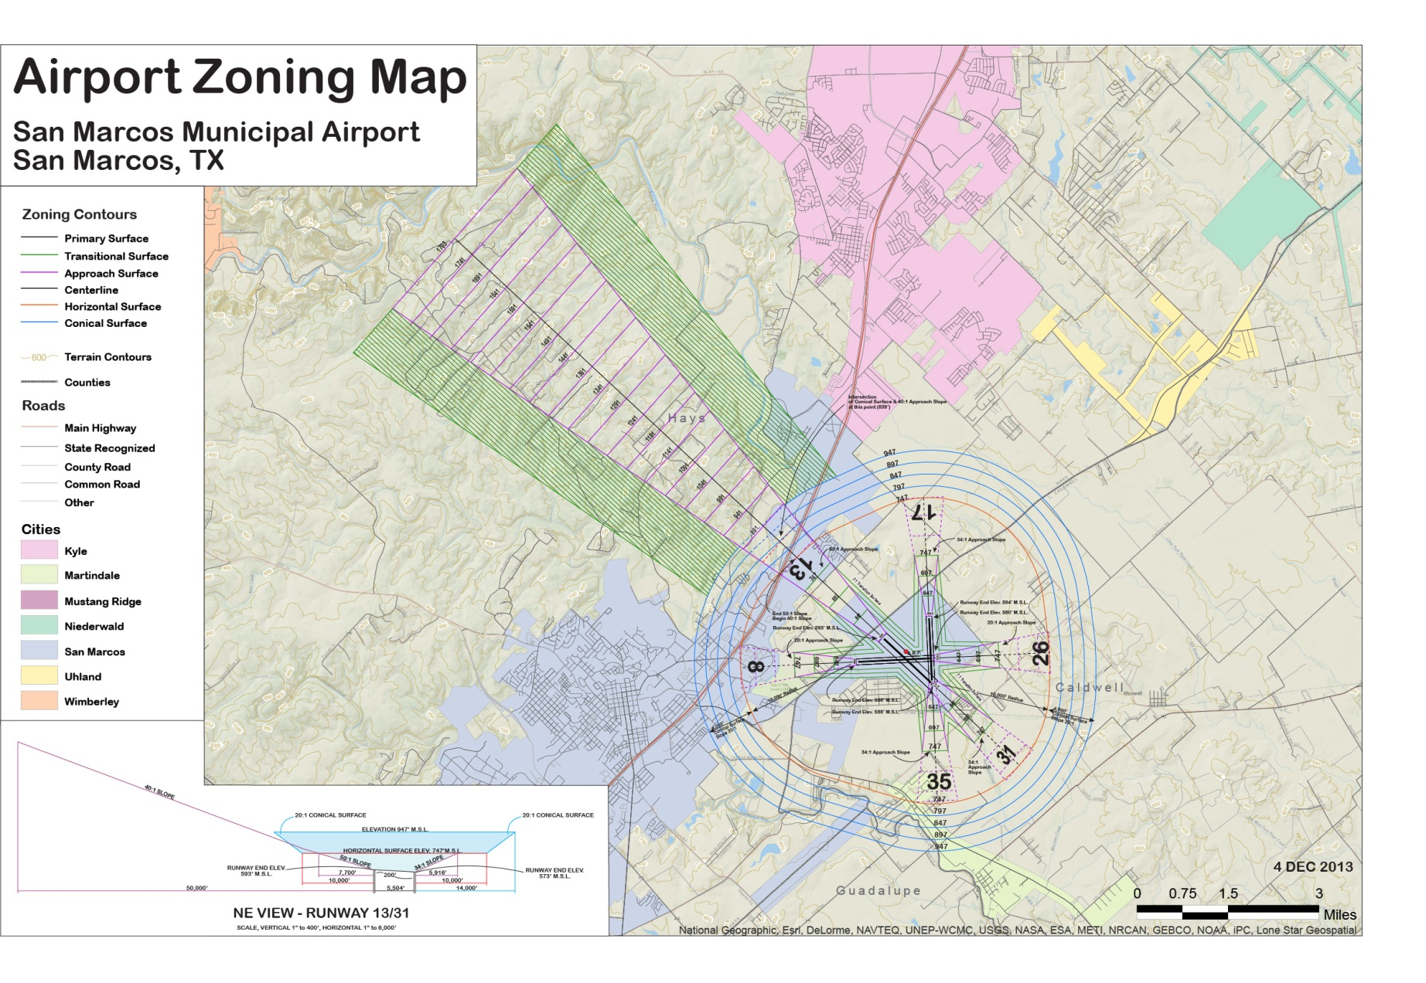Figure A5

Figure A6

# Appendix VI: Team Member Contribution

## Jason Ford

### Logo Design

Hazard Zone Map: Generate terrain contours from DEM, calculated centerline distances for change in slope from 40:1 to 50:1 and for approach surface intersection with conical surface for the precision approach runway. Added vertices to contour lines and changed symbology into classifications. Used Adobe Illustrator to add annotations for all contour lines and surface label annotation placements, added hill-shade base layer, generated scale drawing of side view of runway 13/31 for inset map.

Specialized GIS layers: Generated polygon shapes and assigned Z values with calculated elevations based on federal regulations. Converted Max Height lattice layer to fishnet polygons and clipped to 9 grid sections for use in interactive tool. Jason generated the model tool for clipping all layers into 9 grid sections for use in interactive map.

Final Report Contributions: report templates, conclusion, 4.1 hazard zone map methodology, flowchart 1, flowchart 2, flowchart 3, flowchart 4, 4.2 maximum allowable height analysis methodology in cooperation with Patricia,, grammar and content editing, figure labeling, figure layout, Appendix III Hazard Zoning Map (Figure A5)

## Grayson Jones

Specialized GIS Layers: Helped convert imaginary surface layers to Surface Tins and Rasters. Clipped and cleaned parcel layer data for use in interactive map.

Interactive Mapping Tool: Imported all layers, saved color templates for each layer, ordered layers for each map, edited attribute table field headings. Created folder structure for all Manifold maps.

Final Report: data (hazard zoning map, specialized GIS layers, interactive map tool), 4.4 interactive mapping tool methodology, 5.3 interactive mapping tool results, flowchart 6, 6.3 future projects discussion, Metadata – conical surface (Appendix I), Appendix III manifold figure (Figure A4)

## Patricia Michel

Hazard Zone Map: Clipped and edited colors and symbology for base layers

Specialized GIS layers: Generated polygon shapes for primary surfaces and assigned Z values with calculated elevations based on federal regulations. Helped convert imaginary surface layers to Surface Tins and Rasters. Assisted with conversion of Max Height Raster into lattice points.

Final Report: 4.2 maximum allowable height analysis methodology in cooperation with Jason, 5.1 hazard zone map results, 6.1 capabilities and limitations discussion, Metadata – maximum height point layer (Appendix I),

## Casey Carpenter

Specialized GIS layers: Generated polygon shapes and assigned Z values with calculated elevations based on federal regulations. Helped convert imaginary surface layers to Surface Tins and Rasters. Casey completed all penetrations layer analysis, see Flowchart 5. Contributed significantly to literature review, and research for most of the methodology and techniques we used in this study to accomplish our goals.

Final Report: introduction section (abstract, background, purpose, objective, scope), literature review (regulations, prior projects, interactive tool usability), 4.3 penetrations methodology, flowchart 5, 5.2 specialized GIS layers results, 6.2 similar studies discussion, Appendix III penetrations figures (figure A1, A2, A3), Penetrations methodology, Penetrations results, Penetrations list (Appendix II)