CARE

Capital Area Research for the Environment

Kyle Fuchshuber (Project Manager)

Jerad Laxson (Assistant Project Manager)

Eric Tijerina (Graphic Designer & Researcher)

Megan Thomas (Editor & Researcher)

Zachary Dye (GIS Specialist & Researcher)

Socio-Economic Benefits of Austin’s Tree Canopy

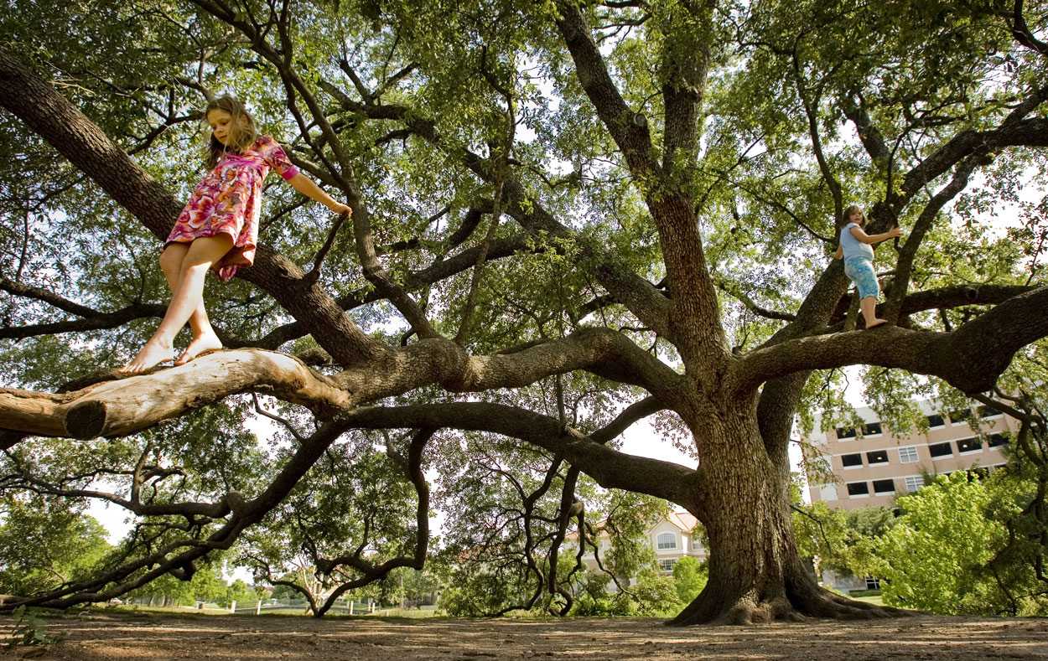
http://clarkrichardson.files.wordpress.com/2011/12/austin-tree.jpg

Presented by CARE – Capital Area Research for the Environment

Table of Contents

Introduction

Summary……………………………………………………………4

Purpose……………………………………………………………...4

Scope…………………………………………………………………5

Proposal

Literature Cited…………………………………………………..6

Data…………..……………………………………………………….8

Methodology………………………………………………………9
- Objective 1 – Pavement Costs…………………….9
- Objective 2 – Crime Rates………………………..10
- Objective 3 – Property Values...........................11
- Field Analysis…………………………………………12

Budget……………………………………………………………..13

Timeline...………………………………………………………...14

Final Deliverables……………………………………………..15

Conclusion………………………………………………………..15

Sources…………………………………………………………….16

Participation…………………………………………………….18

Introduction

Summary
Trees provide many benefits, environmentally and economically. Trees can sequester carbon from the atmosphere, lower greenhouse gases, and reduce storm water runoff. Trees also help to reduce energy use by keeping surrounding buildings cooler ("Reducing urban heat," 2008). The City of Austin Urban Forestry Program has a need to explore the benefits of tree canopy, particularly in the socio-economic sphere. Capital Area Research for the Environment (CARE) will utilize GIS to help explore the relationship between tree canopy and property values, crime rates, and pavement condition. CARE’s research will prove to be beneficial for the city of Austin’s legislative decisions regarding urban forestry.

Purpose
The main goal of CARE’s research will be to determine the socio-economic benefits that tree canopy can provide. Using a 2010 tree canopy layer provided by the City of Austin, CARE will examine the relationship between urban tree shade and:
- Pavement Condition- The less maintenance and rehabilitation that needs to be done to a pavement, the less costly it is for the city.
- Crime Rates- Lower crime rates translate not only to more contented citizens, but economic benefits as well. Incarceration costs, medical care for victims of assault, and policing are just a few of the costs borne of violent crimes (Shapiro & Hassett, 2012).
- Property Values- Higher property values equal higher property taxes for the city. Property taxes for the city of Austin are used to build roads, fund education, fund hospitals, and manage the criminal justice system (Toohey, 2012).

Scope

CARE will observe the entirety of Austin city limits with focus given primarily to individual areas with the following characteristics:
- Heavy tree cover
- Broad tree cover
- Average tree cover
- Limited tree cover
- No tree cover
A suitability model will be applied to find areas that fit these characteristics. COA Urban Forestry program may be asked for advise in what areas to specifically focus on.

Proposal

Literature Cited
Pavement deteriorates due to a number of factors such as: the material used, its age, high surface temperatures, and the amount/type of traffic (Gupta, Kumar & Rastogi, 2011). The cost of pavement maintenance or rehabilitation can escalate quickly, depending on the type of work that needs to be done. The City of Austin alone spent $37,186,628 for preventative maintenance and rehabilitation for the fiscal year 2012 (Wilson, 2012). Tree shade might help to reduce these costs. One study, done in Modesto California, looked at the relationship between tree canopy and pavement deterioration. One street was planted with small-stature crape myrtle trees, spaced equally at 25-foot intervals. The other street was planted with six large-stature Chinese hackberry trees, spaced equally at 50-foot intervals. The study found that the more shade the streets had, the less damage there was to the pavement. The large-stature trees provided more benefit, as the hackberry trees were projected to save nearly 60% in paving costs over a 30-year period. The small-stature trees provided less protection, but were still estimated to save about 17% in pavement costs (McPherson & Muchnick, 2005).
Other research on tree cover has found a positive correlation between tree shade and property values. One study in Rochester, New York claimed that lots with trees sold for an average of $9500 more than un-treed lots (Morales, Micha & Weber, 1983). A more comprehensive study considered the effects of trees on property value to determine the aesthetic value of urban forests. The analysis considered the value of each tree to a city and concluded that Berkeley trees each have a $67 benefit to the city, Fort Collins $52 per tree, and Bismarck $21 per tree (McPherson, 2005). This study only considered tree coverage and property price as their variables, so it is safe to assume that the difference in tree prices between each city is due to other environmental, structural, or community factors within each area. A study of tree cover and property value in the Twin Cities of Minnesota was the most conclusive analysis researched, and was the aspiration for the methodology that will be executed in our study. Using the Hedonic property price model, the research was able to include many characteristics (environmental, structural, and neighborhood) as variables within their conclusions. Their model concluded that increasing tree cover within 250 meters is related to increasing home sale prices up to 60% (Sander, Polasky & Haight, 2010).
There has been considerable research on the subject with a general consensus that old growth tree cover has a negative relationship to crime rates. Two such studies were completed in Portland, Oregon and Baltimore, Maryland and provide the bulk of our research material. The first of these studies, which covered the Portland metropolitan area, showed a modest inverse relationship between old growth trees and crime (Donovan, Prestemon, 2010). In contrast, the Baltimore, Maryland study revealed a strong negative relationship (Troy, Grove, O’Neil-Dunne, 2012). By using existing literature in conjunction with our own GIS analysis, we are confident we can determine the extent, if any, to which trees correlate to crime.

Data
CARE will be using a GIS based program, ArcGIS 10, to address the needs and demands of the project. The following is the data that will be utilized by CARE in order to fulfill the demands of the project:
City of Austin website
  - TCAD parcels
  - Tree Canopy 2006 and 2010
  - Land Use 2006 and 2010
  - City of Austin parcels
  - City of Austin parks
  - Other jurisdiction parkland
  - Appraised value of property
  - Geolocated Crime data
  - % shade by street segment

COA Urban Forestry Program
  - COA lists of crimes
  - Street and pavement repair

Methodology
CARE plans to use a mixture of literature research and GIS to determine the socioeconomic benefits of tree cover. The project consists of three objectives: correlations between tree cover and pavement costs, tree cover and amount of crime, and tree cover and property value. The nature of this analysis is very multi-dimensional therefore many external variables will be included. These variables will be analyzed in a similar method within each objective.

Objective 1 – Pavement Costs
We plan to perform GIS analysis to determine the effect tree cover has on pavement lifecycles. In order to do this we will compare the instances of pavement resurfacing between streets within each focus area. Many factors contribute to pavement deterioration including age, amount of traffic, environment, material, and strength of pavement (Gupta, Kumar, Rastogi, 1997). These factors may individually have a negative or positive impact upon the pavement.
A model will be built that expresses the correlation between tree cover and pavement deterioration. Each external variable in the model will be analyzed to appropriately reflect the natural effect each has upon the pavement. This analysis helps to understand the degree of how these external variables impact the pavement so that better conclusions can be drawn for the impact of tree cover. Percent tree cover data will be applied, and then a comparative analysis between tree cover amounts will be conducted. We expect to see a positive correlation between the health of the pavement and tree cover.

Objective 2 – Crime Rates
There are many factors that contribute to crime rate including median income, age of the neighborhood, prevalence of alarm systems, sidewalk traffic, and whether a home is considered a single family residence (Troy, Grove, O’Neil-Dunne. 2012). In order to determine if trees have a negative relationship to crime, it will be important to include in our analysis as many of these contributing variables as realistically possible. Some discretion will be used when determining what crimes to consider. For the purpose of this study we will focus primarily on home invasion, burglary, auto theft, and vandalism. It is highly unlikely that other crimes, such as traffic violations, have any correlation to tree cover.
Crime rates will be fit into a model that can best analyze their relationship to tree cover. Each crime will be analyzed individually. The external variables previously mentioned will be independently analyzed for each crime to determine the natural influence they have upon the crimes. This analysis helps to understand the degree of how these external variables impact each crime rate so that better conclusions can be drawn for the impact of tree cover. Percent tree cover data will be applied, and then a comparative analysis between tree cover amounts will be conducted. We expect to see a negative correlation between crime rates and amount of tree cover (i.e. high tree cover negatively affects crime rates).

Objective 3 – Property Value
Each focus area will be analyzed to determine a relationship between tree cover and property values. A model will be constructed that estimates the contribution of the many aspects that affect property value. These variables include environmental, structural, and community characteristics as well as amount of tree cover.
Environmental aspects that could be considered are proximity to greenbelts, lakes, city parks and hiking trails, and the view shed a property has. Suggested structural aspects include property tax rates, elevation, age of property, and size/square footage of residence. Characteristics within the community such as proximity to universities, shopping centers, central business districts, and high volume highway traffic, quality of school district, and distance from impervious cover may all be considered as well.
A model will be built that expresses the correlation between tree cover and property price. Each external variable in the model will be analyzed to appropriately reflect the natural effect each has upon property value. This analysis helps to understand the degree of how these external variables impact property value so that better conclusions can be drawn for the impact of tree cover. Percent tree cover data will be applied, and then a comparative analysis between tree cover amounts will be conducted. We expect to see a positive correlation between the price of a property and tree cover.

Field Analysis
An on foot survey of areas studied will be conducted. This will allow our team to better understand the areas and the variables that contribute to each objective. Pictures will be taken to supplement our analysis.

Supplies & Software
Esri ArcGIS
Hours Used: 100 Work hours over 20 days
Hourly Rate for Subscription: $5.71
Sub-Total: $571

(5) Workstations
2.5 Months
Rent per Station: $150
Sub-Total: $750
Assistant Project Manager
Hours: 100 Work hours over 20 days
Hourly Rate: $36
Sub-Total: $3600

(5) Depreciation of
Computers
2.5 Months
Rent per Computer: $138
Sub-Total: $690
Graphic Designer
& Researcher
Hours: 100 Work hours over 20 days
Hourly Rate: $26
Sub-Total: $2600

Transportation
60 Mile Trip
2 Trips
55 cents per Mile: $33
Sub-Total: $66
GIS Specialist
& Researcher
Hours: 100 Work hours over 20 days
Hourly Rate: $29
Sub-Total: $2900

Editor & Researcher
Hours: 100 Work hours over 20 days
Hourly Rate: $30
Sub-Total: $3000

Services Sub-Total: $16,100
Supplies &
Software Sub-Total: $2,077

Total Cost: $18,177
Services
Project Manager
Hours: 100 Work hours over 20 days
Hourly Rate: $40
Sub-Total: $4000
Budget
Week 1 Sep | Initial planning and project development
Week 2 Oct | Crime rate analysis development
Week 3 Oct | Property value analysis development
Week 4 Oct | Pavement cost analysis development
Week 5 Oct | Objective compiling
Week 6 Nov | Progress report and map development
Week 7 Nov | GIS Final Deliverables
Week 8 Nov | Finalize and Edit
Week 9 Nov | Project complete
Week 10 Dec | Final Prep
Week 11 Dec | Final Presentation
Timeline

Week one will consist primarily of preparation and planning. This includes developing a strategy and layout for the three tasks we will be tackling. Week two through four will consist primarily of data collection. By week six we will have had time to work with the data and adjust our strategy if needed. It is at this point that we will produce a progress report for the City of Austin. Weeks seven through nine will find us developing and preparing our final deliverables. We plan to have the project completed by November 27th and ready to present on December 9th.
Final Deliverables
By the end of our analysis, CARE will provide COA Urban Forestry with the following deliverables:
- (2) CDs that cover all aspects of project including:
  - Proposal report and presentation
  - Progress report and presentation
  - Final Report
  - GIS data including metadata
  - Maps for each objective covering all aspects of analysis
- Physical Final Report
- Poster
  - Generalizes methodology of project and findings

Conclusion
CARE will analyze the socio-economic benefits of trees within the city of Austin in response to the Urban Forestry programs request. Our analysis will correlate five different areas within the city that range in tree coverage to three different objectives (i.e. crime rates, property value, pavement damage) to determine how tree cover affects each. Due to the multi-dimensional nature of this analysis, external variables will be considered for each objective. Models will be constructed that consider the natural relationship between each focus area with each external variable including tree coverage. At the end of our analysis, we will present COA Urban Forestry with (2) CDs documenting our results.
Sources
Dwyer, M. C., & Miller, R. W. (1999). Using GIS to assess urban tree canopy benefits
and surrounding greenspace distributions. Journal of Arboriculture 25(2),
102-107. http://cambria.cgu.edu/ccsi/resources/08_USING_GIS_TO_
ASSESS_CANOPY_BENEFITSdwyer.pdf

Gupta, A., Kumar, P., & Rastogi, R. (2011). Pavement deterioration and maintenance for low
volume roads. International Journal of Pavement Research and Technology, 4(4),
Retrieved from http://libproxy.txstate.edu/login?url=http://search.ebscohost.com/
login.aspx?direct=true&db=a9h&AN=63282663&site=eds-live&scope=site

Geiger, J. R., & Gardner, S. L. Center for Urban Forest Research, Pacific Southwest Research
Station , USDA Forest Service. (2006). Why shade streets? the unexpected benefit.
Retrieved from website: http://www.fs.fed.us/psw/programs/uesd/uep/products/
cufr_673_WhyShadeStreets_10-06.pdf

McPherson, E. G., & Muchnick, J. (2005). Effects of street tree shade on asphalt concrete
pavement performance. International Society of Aboriculture, 31(6), Retrieved from http://www.treebenefits.terrasummit.com/Documents/Business/psw_2005_mcpherson001_joa_1105.pdf

McPherson G., Simpson J. R., Peper, P. J., Maco, S. E., & Xiao, Q. (2005). Municipal
forest benefits and costs in five US cities. Journal of Forestry, 411-416.
http://www.fs.fed.us/ccrc/topics/urban-forests/docs/jof_Dec_2005.pdf
Morales, D. J., Micha, F. R., & Weber, R. L. (1983). Two methods of valuating trees on
residential sites. Journal of Arboriculture 9(1), 21-24.

Sander, H., Polasky, S. & Haight, R. G. (2010). The value of urban tree cover: A
hedonic property price model in Ramsey and Dakota Counties, Minnesota, USA. Ecological Economics 69(2010), 1646-1656. http://www.nrs.fs.fed.us/
pubs/jrnl/2010/nrs_2010_sander_001.pdf

Shapiro, R. J., & Hassett, K. A. Center for American Progress, (2012). The economic benefits
of reducing violent crime. Retrieved from website: http://www.americanprogress.org/issues/economy/report/2012/06/19/11755/the-economic-benefits-of-reducing-violent-crime/

Toohey, M. (2012, July 1). Austin property taxes jump 38% over past decade. Austin-
American Statesman. Retrieved from http://www.statesman.com/news/news/local/austin-property-taxes-jump-38-over-past-decade/nRprf/

United States Environmental Protection Agency, (2008).Reducing urban heat islands:
Compendium of strategies (Chapter 2: Trees and Vegetation). Retrieved from website: http://www.epa.gov/heatisland/resources/compendium.htm

Wilson, P. Texas Department of Transportation, (2012).Transportation program
expenditures fiscal year 2012. Retrieved from website: http://ftp.dot.state.tx.us/
pub/txdot-info/library/reports/expenditures/fy2012.pdf

Zhang, Z., & Murphy, M. R. Center for Transportation Research at The University of Texas at
Austin,Texas Department of Transportation. (2012). A web-based performance and maintenance management and gis mapping system for easy access to pavement condition information(FHWA/TX-12/5-9035-01-2 ). Retrieved from website: http://www.utexas.edu/research/ctr/pdf_reports/5_9035_01_2.pdf

Participation
- Eric Tijerina (Graphic Designer & Researcher)
  - Property value objective research, budget, timeline
- Megan Thomas (Editor & Researcher)
  - Pavement endurance objective research and methodology, introduction, sources
- Kyle Fuchshuber (Project Manager)
  - Property value objective research and methodology, final deliverables, conclusion, scope, cover page, title page, table of contents, final collaboration of document
- Zachary Dye (GIS Specialist & Researcher)
  - Crime rate objective research and methodology, data
- Jerad Laxson (Graphic Designer)
  - Crime rate objective research and methodology, logo designer, team name designer

