MEMORANDUM

TO: City of Austin Urban Forestry Program
FROM: C.A.R.E. – Capital Area Research for the Environment
SUBJECT: Progress on analysis for the socio-economic benefits of Austin’s tree
canopy
DATE: October 27, 2013

The following is a progress report developed by C.A.R.E. for the purpose of updating the City of Austin's Urban Forestry Program on our progress for tree shade analysis. This report will be to update COA's Urban Forestry Program on work that has been completed, work that is in progress, and future work, as well as issues that we have encountered.

Project Description

The City of Austin Urban Forestry Program is looking to explore the benefits of tree-canopy. Our focus will be on three main areas; the relationship between tree shade and crime rates, the relationship between tree shade and property values, and the relationship between tree shade and pavement endurance. We hope to provide valuable information for the Urban Forestry Program in their upcoming meet with the city of Austin, regarding legislative decisions on urban forestry.

Project Scope

CARE will observe the entirety of Austin city limits, ultimately focusing on specific study areas for each task. Tree shade will be analyzed according to heavy tree cover, broad tree cover, average tree cover, limited tree cover, and no tree cover, with particular focus on the extremes (heavy tree cover and no tree cover) in order to best establish a relationship between tree canopy and the three focus areas.

Effect of Tree Canopy on Property Value

- Work Completed

Research and data collection is mostly complete. Our team has completed a density analysis to understand the natural distribution of tree canopy within the city of Austin. Another density analysis upon market values of single-family homes shows the concentrations of low value and high value homes. Observational analysis has lead to an understanding of which neighborhoods will serve best for our five focus areas. Images of the density analysis are shown on the page 2.

Density of tree canopies

Density of single family homes with darker values
representing higher market price
- Problems

Upon observational analysis of data, we noticed that some neighborhoods might not be as fitting for analysis on one task relative to other areas for another task. Therefore, we will determine focus areas based on variables for each tasks. This is an amendment to our proposal that suggested using the same focus areas for each task.

- Work Scheduled

We will analyze independent variables besides tree canopy that affect property value in order to gain a better conclusion. These variables include viewshed, distance from businesses and universities, distance from natural areas, and acreage of parcels. Then, a GWR (Geographically Weighted Regression) model will be applied to understand how our dependent variable (i.e. property values) is influenced by tree canopy. The GWR analyzes the influence multiple independent variables have upon a singular dependent variable. This is the best model to use considering the multi-dimensional aspects of this task. Maps will then be created based on our final analysis.

Effect of Tree Canopy on Pavement Costs

- Work Completed

We have the tree canopy data provided us by COA Urban Forestry Program, as well as street centerlines, obtained from Capital Area Council of Governments (CAPCOG). We have started to explore the data, including buffering of 1000 feet around the major urban roads. This buffer will be included with the independent variables that affect pavement costs.

- Problems

We are in need of pavement data, including all or some: pavement maintenance and rehabilitation costs of Austin roads, pavement material used in the building of the road, age of the pavement, and the average traffic that travels on Austin roads. If data is not available, the pavement will be analyzed for ultraviolet damage through viewshed analysis, and condition of roads will be based on whether road is a highway (heavy damage), street (moderate damage), or neighborhood road (least damage).

- Work Scheduled

We will decided what data to include. Then, analysis to find focus areas will be conducted, followed by an analysis of independent variables. Variables will be installed to the GWR model for final analysis.

Effect of Tree Canopy on Crime Rates

- Work Completed

We have collected all the data we will need for our crime rate analysis. This data includes the tree canopy layer, APD incident report, census demographic data, and neighborhood median income data. We have digitized the APD incident report and created a dot map showing the location of various crimes across the city. Using data collected from CAPCOG we were able to manually enter the median income values for several Austin neighborhoods. These neighborhoods will serve as our samples in a comparison analysis. Using the canopy layer, we were able to create a model that calculated the percent tree cover per census block. We also created a model that calculated the number of crimes per census block. The map on page 5 displays a basic relationship between tree canopy and crime rates.

- Problems

Due to the federal government shutdown, access to certain data halted progress. 2010 census data including tracts with income data was not accessible. 2000 census data was found, but fortunately the government was brought back allowing us access to 2010 data.

- Work Scheduled

We believe that with what we’ve accomplished so far we should be able to begin running our analysis. Our focus now is to select specific neighborhoods to compare to one another. Once this is done we should be able to create a series of maps detailing our sample area and our results.
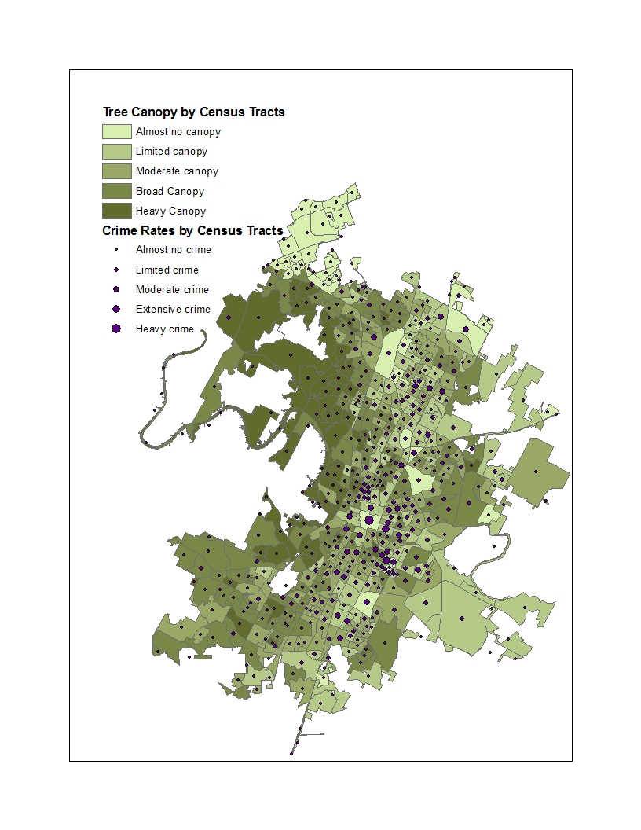

Conclusion

With half of the allotted time behind us now, CARE can easily see what changes must be done to follow this project all the way through. Tree canopy effects on crime rates analysis has progressed the most, so primary focus will now be given to finalizing analysis with the other two objectives. Altogether, the progression we have made is on track and advancing well with very few issues left to resolve.

