CARE

Capital Area Research for the Environment

Kyle Fuchshuber (Project Manager)

Jerad Laxson (Assistant Project Manager)

Eric Tijerina (Graphic Designer & Researcher)

Megan Thomas (Editor & Researcher)

Zachary Dye (GIS Specialist & Researcher)

Socio-Economic Benefits of Austin’s Tree Canopy

Final Report

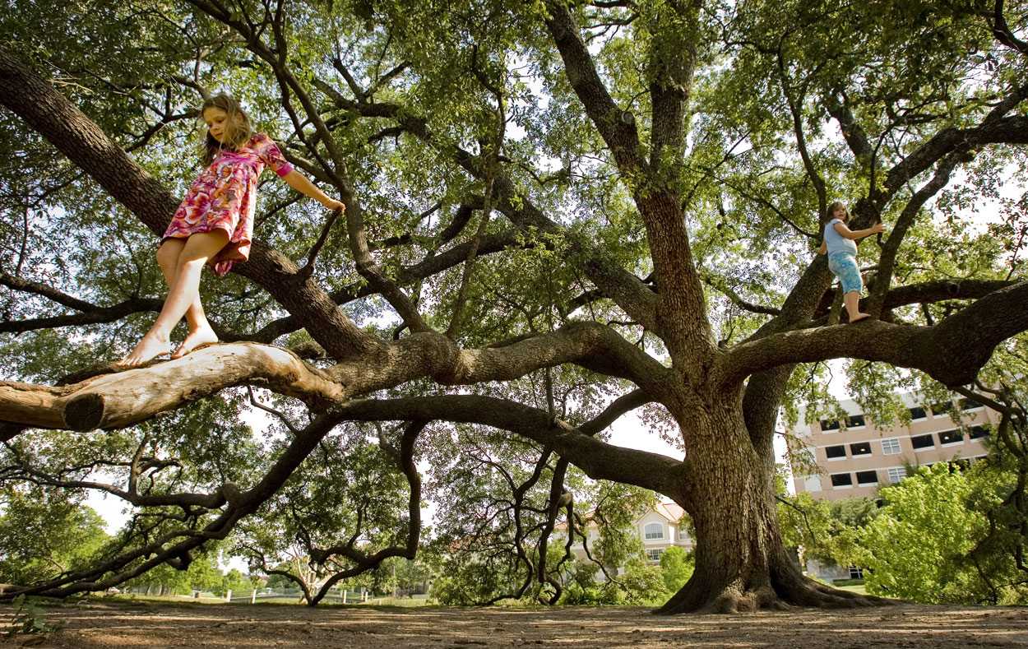
http://clarkrichardson.files.wordpress.com/2011/12/austin-tree.jpg

Prepared For: The City of Austin Urban Forestry Program Presented by CARE – Capital Area Research for the Environment

Table of Contents

Introduction............................................................................................................4
Literature Review...................................................................................................6
Data.......................................................................................................................8
Methodology
- Objective 1..................................................................................................9
  - Methodology……………………………………………………………9
- Results and Maps...........................................................................12
- Discussion & Conclusion................................................................21
- Objective 2................................................................................................23
- Results...........................................................................................33
- Discussion & Conclusion...............................................................35
Sources...............................................................................................................42
Appendix (Metadata)...........................................................................................43

Introduction

Summary
Trees provide many benefits, environmentally and economically. Trees can sequester carbon from the atmosphere, lower greenhouse gases, and reduce storm water runoff. Trees also help to reduce energy use by keeping surrounding buildings cooler ("Reducing urban heat," 2008). The City of Austin Urban Forestry Program approached Capital Area Research for the Environment (CARE) to analyze the effects of tree shade in major socio-economic areas. CARE used Geographic Information Systems (ESRI) to explore the relationship between tree canopy and property values, and tree canopy and crime rates. CARE’s research will help to provide beneficial information for the city of Austin’s upcoming legislative decisions regarding urban forestry.

Purpose
The main goal of CARE’s research was to determine the socio-economic benefits that tree canopy can provide. Using a 2010 tree canopy layer provided by the City of Austin, CARE examined the relationship between urban tree shade and:
- Crime Rates- Lower crime rates translate not only to more contented citizens, but economic benefits as well. Incarceration costs, medical care for victims of assault, and policing are just a few of the costs born of violent crimes (Shapiro & Hassett, 2012).
- Property Values- Higher property values equal higher property taxes for the city. Property taxes for the city of Austin are used to build roads, fund education, fund hospitals, and manage the criminal justice system (Toohey, 2012).
Scope
The City of Austin, delineated by census tracts.
Adjustments
CARE originally intended to analyze the relationship between pavement endurance and tree canopy in addition to the other two areas of study. Due to lack of data, the analysis for pavement endurance and tree shade was dropped. CARE would be very interested in pursuing analysis in the future with the needed data.
An adjustment was also made to the scope CARE covered. Initially, we planned on five neighborhoods that ranged in tree canopy percentages. After the scope of the city was analyzed, it was decided that an analysis of the entire city gave a better generalization for the entirety of Austin. Delineation of focus areas to gain a clearer conclusion of specific parts of the city is a good future initiative that our analysis can help guide.

Literature Review
Other research on tree cover has found a positive correlation between tree shade and property values. One study in Rochester, New York claimed that lots with trees sold for an average of $9500 more than un-treed lots (Morales, Micha & Weber, 1983). A more comprehensive study considered the effects of trees on property value to determine the aesthetic value of urban forests. The analysis considered the value of each tree to a city and concluded that Berkeley trees each have a $67 benefit to the city, Fort Collins $52 per tree, and Bismarck $21 per tree (McPherson, 2005). This study only considered tree coverage and property price as their variables, so it is safe to assume that the difference in tree prices between each city is due to other environmental, structural, or community factors within each area. A study of tree cover and property value in the Twin Cities of Minnesota was the most conclusive analysis researched, and was the aspiration for the methodology that was executed in our study. Using the Hedonic property price model, the research was able to include many characteristics (environmental, structural, and neighborhood) as variables within their conclusions. Their model concluded that increasing tree cover within 250 meters is related to increasing home sale prices up to 60% (Sander, Polasky & Haight, 2010).
There has been considerable research on the subject with a general consensus that old growth tree cover has a negative relationship to crime rates. Two such studies were completed in Portland, Oregon and Baltimore, Maryland and provide the bulk of our research material. The first of these studies, which covered the Portland metropolitan area, showed a modest inverse relationship between old growth trees and crime (Donovan, Prestemon, 2010). In contrast, the Baltimore, Maryland study revealed a strong negative relationship (Troy, Grove, O’Neil-Dunne, 2012). By using existing literature in conjunction with our own GIS analysis, we were confident we could determine the extent, if any, to which trees correlate to crime.

Data
- TCAD Parcels – Percent Tree Canopy and Property Market Prices
- US Census Tracts
- TEA – School Rankings
- CAPCOG – City of Austin Border
- Google Earth – Cultural Attractions
- City of Austin – Parks
- APD Incident report 2010.
- US Census 2010

Objective 1: Methodology – Tree Cover’s Effect upon Crime Rates
In order to determine the effect of tree cover on crime rates, we decided to use a geographically weighted regression (GWR). A GWR is a form of regression modeling that predicts the effect of an explanatory variable(s) on a dependent variable for each feature in the dataset. This method was chosen because it was the most efficient way to visualize the predicted effect of tree cover on crime rates. Using this method, multiple variables could be considered in order to produce a single product that would represent the predicted effect these variables would have on our target variable: crime. In order to run a GWR analysis, the dependent and independent variables would need to be determined.
Our analysis began with literature research. Through this research we were able to determine what variables were most important in determining crime rates. There are many factors that determine crime rates such as income, population density, ethnicity, tree cover, age of neighborhood, etc. With the data we had available, we limited these variables to percent of census block with tree shade, population density and median income.
Our first task was to incorporate crime data supplied by the Austin Police Department (APD) with spatial data provided by the City of Austin. We were supplied with an APD incident report for 2010. This report detailed the type of crime and location for each incident. In total there were 174,318 entries in the report, however only 8.4% of these entries had geographic coordinates. The 8.4% of incidence mapped contained a total 14,738 crimes covering 54 different types. Although the number of crimes actually mapped seems low, we believe it covers a wide spectrum and accurately depicts crime prevalence throughout the city of Austin. A spatial join was used to determine the total number of crimes committed in each census block.
We decided the best way to represent the prevalence of tree shade per census block was by percentage. In order to do this we used a dataset supplied by the City of Austin that provided the percentage of tree shade per parcel. Once again a spatial join was used to determine the percentage of tree shade per census tract. The product of this join was used to create a choropleth map which was then combined with the crime map created shown in figure 1.1A.
It was determined that some crimes such as moving violations were in no way related to tree cover. For this reason we decided to exclude these incidences and focus only on violent crimes, burglaries, and other serious offences. This was done by editing the crime incidence report and repeating the spatial join mentioned earlier. A revised version of the map in figure 1.1A was created; see figure 1.1B.
The next task was to join census data containing the median income for Austin neighborhoods with our tree canopy percentage map. In order to do this a table join was used. Once this was completed we had all the variables we needed to run our GWR analysis. A total of four GWR models were created. The first of these models was used to determine the predicted effect that tree shade alone had on all incidences in the city. The result of this model can be seen in figure 1.2A. Because a GWR is a predictive model there is a certain level of error and uncertainty. Fortunately a GWR can tell us how confident it is in its prediction. A map was created representing this; see figure 1.2B. A second GWR model was created incorporating total population, and median income per census block. The result of this model can be seen in figure 1.3A. A third model was run, this time with violent crime as the dependent variable and tree shade alone as the independent variable; see figure 1.3B. As was the case with the first two models, a map was generated visualizing the models confidence; see figure 1.4A. Finally, a model was run incorporating violent crimes, median income and total population per census block; see figure 1.5A. The model’s confidence was again visualized and can be seen in figure 1.5B.

Objective 1 - Results: Tree Cover’s Effect upon Crime Rates
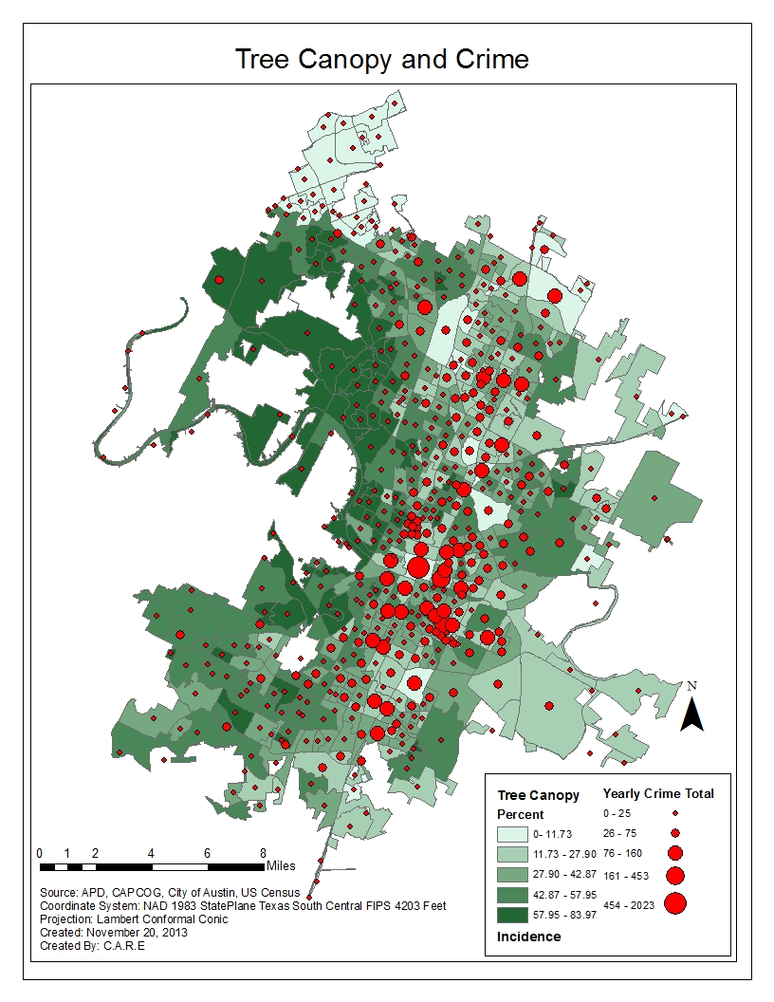
Figure 1.1:. The first map created was a choropleth map depicting the percent area with tree shade per census block and the total number of incidences in each census block for 2010.
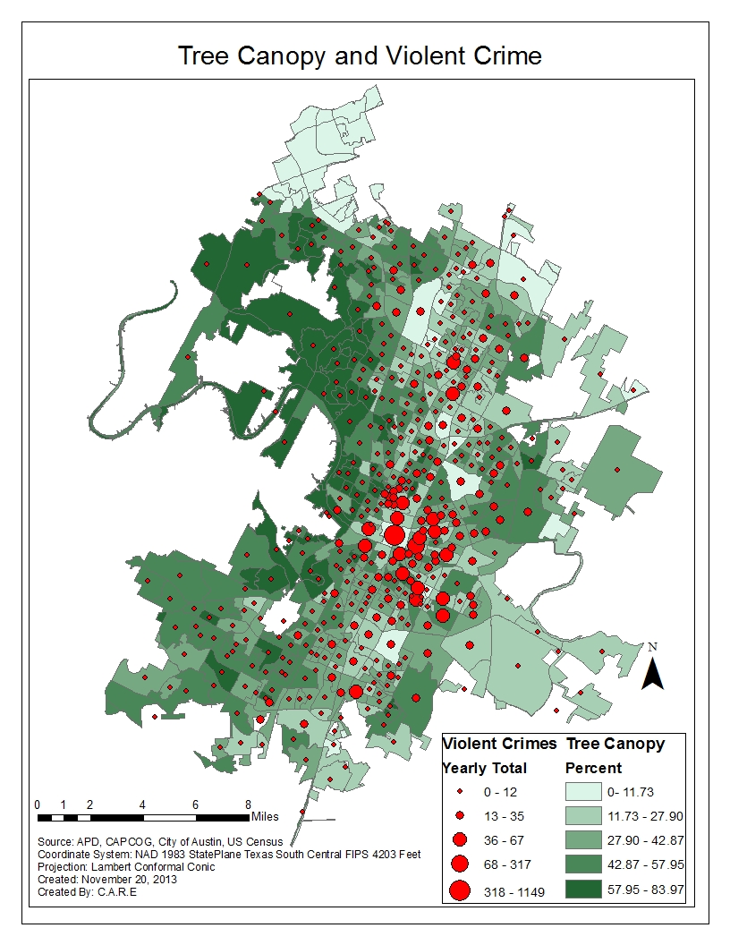
Figure 1.1B: It was decided that some incidences had zero relation to tree cover such as moving violations. For this reason these incidences were removed in order to focus on more serious offenses such as violent crimes.
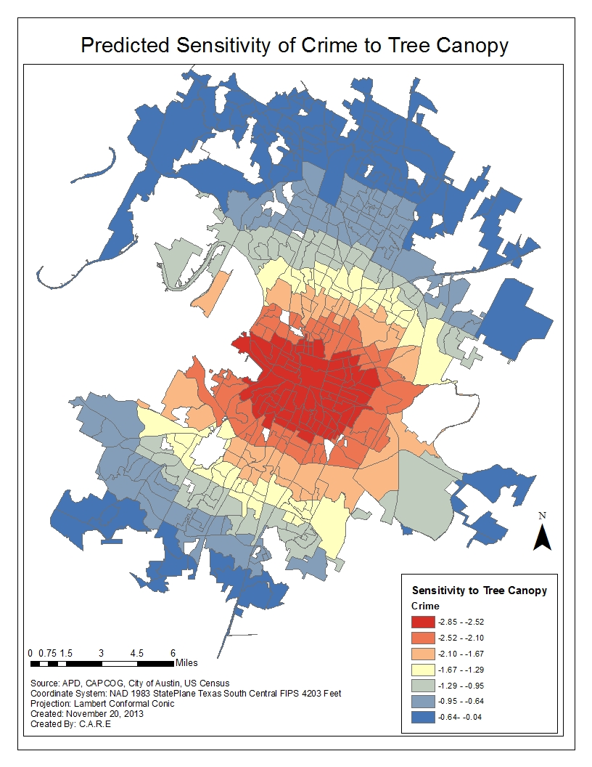
Figure 1.2A: With this data in place we had everything needed in order to run a GWR. For our first model, tree cover alone was used as the independent variable with crime as the dependent variable. By doing this we hope to see how other variables effect our results once they are included.
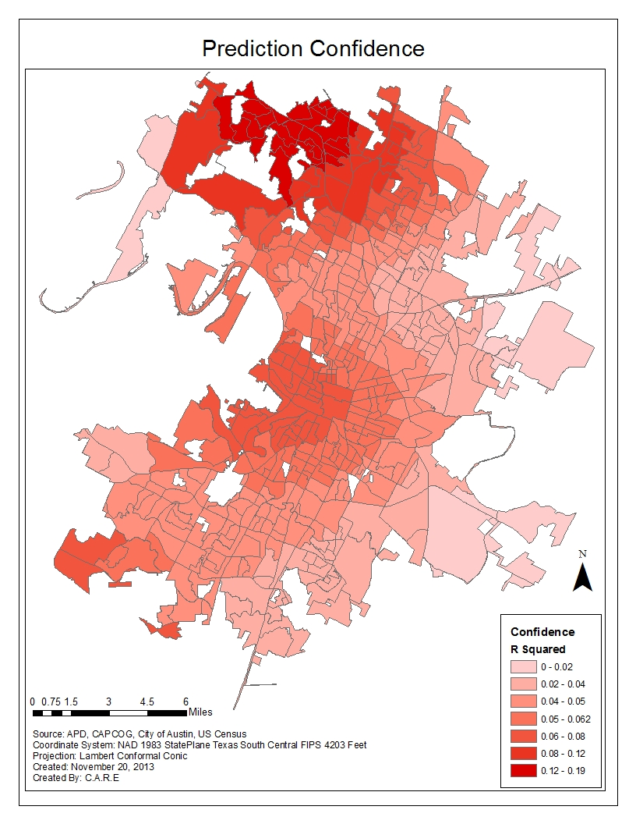
Figure 1.2B: Because a model is predictive in nature, there is some error and uncertainty involved. For this reason a companion map to the one above was created to visually represent the areas the model was more or less confident about.
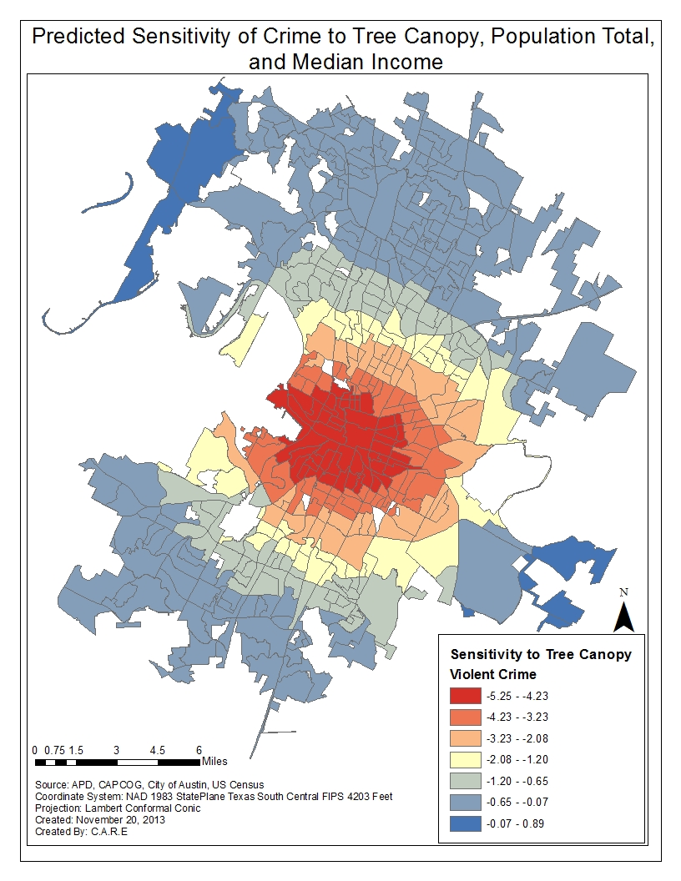
Figure 1.3A: Median income and total population were included and a second GWR was run. The product of this model was the following map.
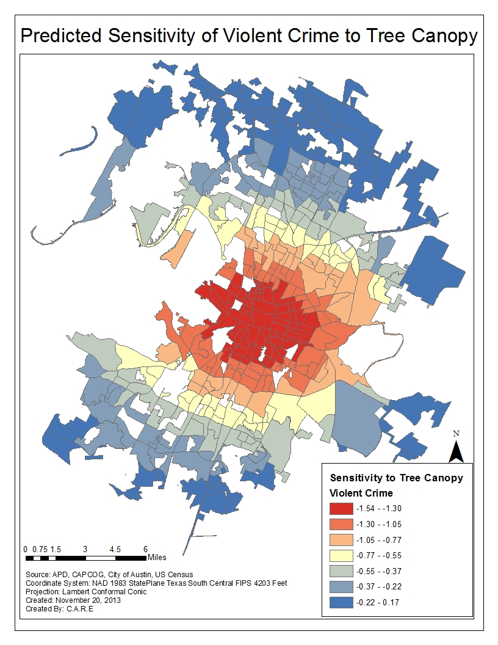
Figure 1.3B: It was decided that some crimes are in no way related to the prevalence of tree cover. Crimes such as moving violations were removed in order to place more emphasis on serious offenses. The GWR was run again and the following map was created.
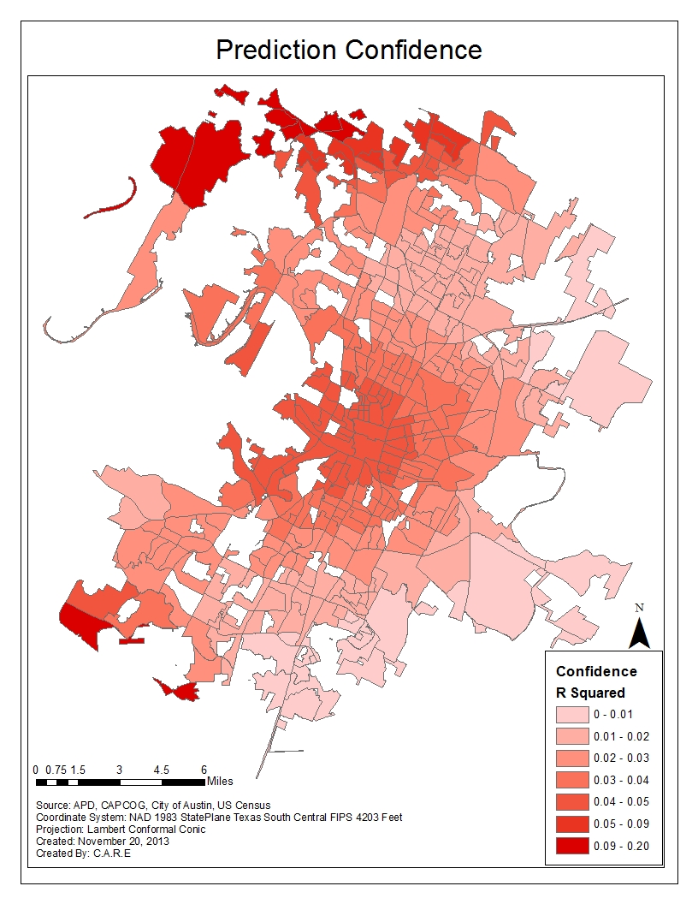
Figure 1.4A: Once again the models confidence was visualized to create the following map.
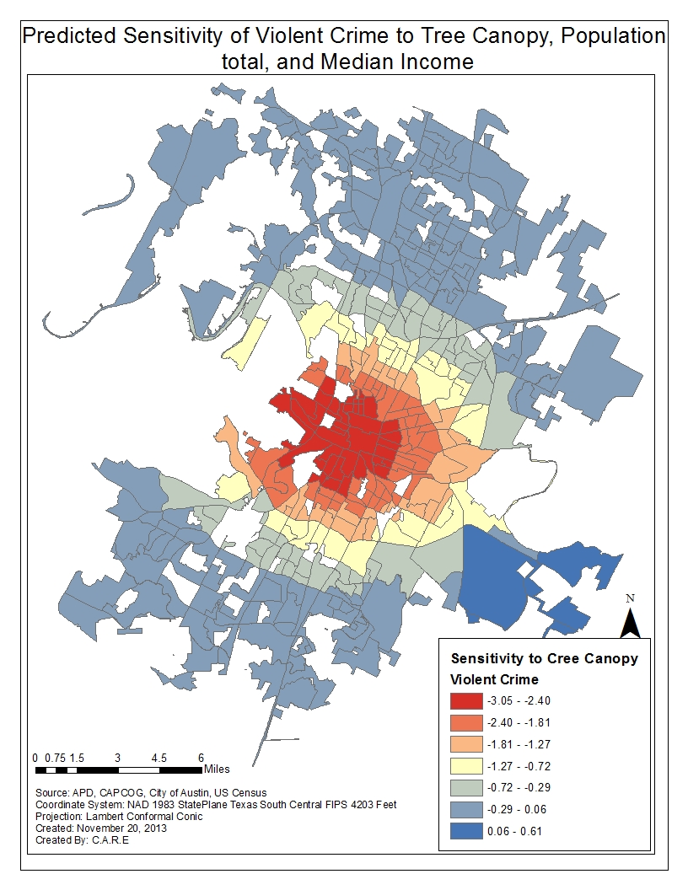
Figure 1.5A: Median income and total population were added as explanatory variables and the model was run again. The result was the following maps, the first of which shows the predicted effect of tree cover on crime and the second representing the models confidence in said prediction.
Figure 1.5B: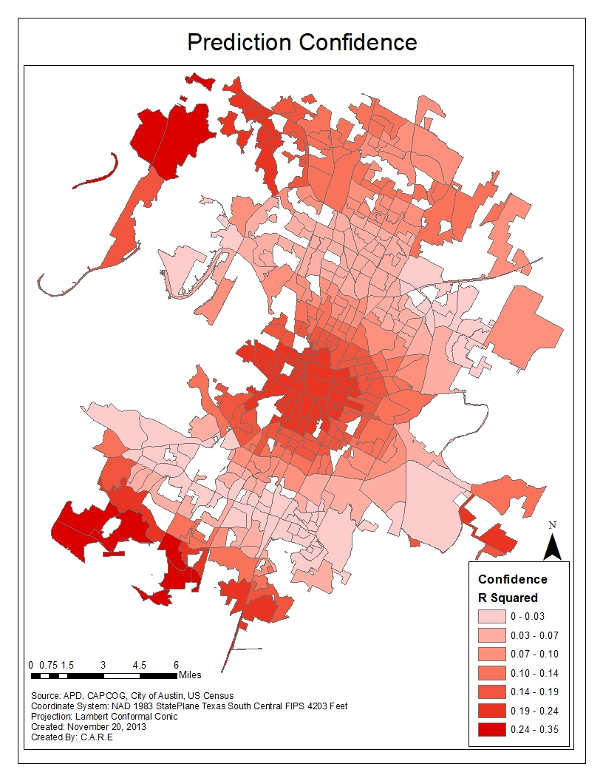
Objective 1 - Discussion: Tree Cover’s Effect upon Crime Rates
During our analysis on the effect of tree canopy on crime, we discovered a recurring trend. The GWR models indicated that areas downtown or near downtown would benefit most from an increase in tree cover. The model predicts that an increase in tree canopy has little effect on crime in areas furthest from downtown. Our results suggest that an increase in tree cover will result in a decrease in crime; however the significance of this relationship isn’t all that high. In order to get a better idea of how tree cover effects crime rates, more external variables would need to be considered.
Objective 1 - Conclusion: Tree Cover’s Effect upon Crime Rates
Our literature research and analysis suggests that there is indeed a negative relationship between an increase in tree cover and crime. The geographically weighted regression predicted that an increase in tree cover will correspond with a decrease in crime across the entire city of Austin. Our analysis indicates that downtown and surrounding areas are more affected by the prevalence of tree canopy. It should be noted that because areas near downtown experience much higher crime rates than other areas, this trend was to be expected. Although the GWR predicted that tree canopy has a negative impact on crime rates across the board, the effect was not particularly significant. Our analysis seems to indicate that with the exception of areas near downtown, there is very little relationship between crime and tree cover. It should be noted that only the median income and total population of each census unit was used as external variables. Although these variables do have an effect on crime rates there are many other variables that also have an impact. These variables could not be considered due to data limitations. In order to more accurately depict the effect of tree cover on crime, more variables need be considered. The models confidence should also be considered when formulating a conclusion. The R squared value is generally used to represent how confident the model is in its prediction. The closer this value is to 1 the more confident the model is. The closest our model got to 1 was .47. In order to get a value closer to 1, other variables should be considered.

Objective 2: Methodology – Tree Canopy and Property Values
A GWR analysis was used again to determine the impact tree cover has upon property values. Explanatory variables analyzed are percent tree canopy, Texas Education Agency (TEA) school rankings, proximity to cultural attractions, and proximity to natural attractions. Cultural attractions include popular destinations such as theatres, shopping, business districts, and popular nightlife areas. Natural attraction variables include access to greenbelts, city parks, and lakes or other waterways. An overview of the GWR equation is shown below in figure 2:

To begin, parcel data for the City of Austin was analyzed. Parcels included data for properties that were residential and non-residential. The variables we are analyzing mostly correspond to residential properties, so only parcels with single-family residences were included. Multi-family homes were excluded from our study due to the variability multi-family residences have (duplex, condo towers) relative to single-family homes. This exclusion allows for a more defined variable when considering property value. Of the single-family home parcels, 110 were removed from our analysis because they merely shared an edge of the City of Austin’s boundary. In order to account for the size of homes, market prices of the properties were normalized by the property’s square footage.
Next, given the large scope of parcel data within the city, the data needed to be appropriated to a smaller resolution. Single-family parcels were spatially joined to census blocks, and then spatially joined again to census tracts. Averages of percent tree canopy and market prices per square foot within each tract area were assigned to the census tracts. Figure 2.1A below shows the results of these averages. A smaller resolution normalizes the data and allows for broader patterns to emerge within the analysis.

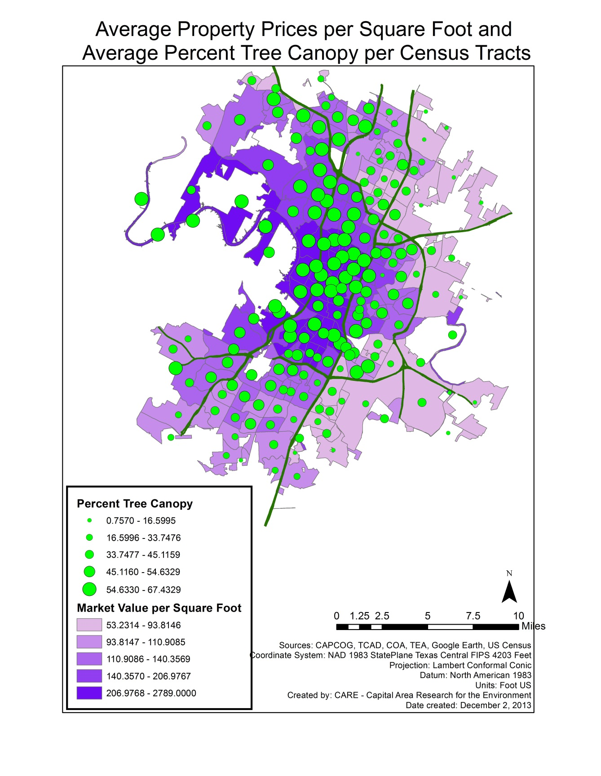
Figure 2.1A:
Explanatory variables – School rankings
Now data for the explanatory variables were mapped. TEA school rankings were added to the map and ranked 1-5:
1: No data or ranking available
2: Academically unacceptable
3: Academically acceptable
4: Recognized
5: Exemplary
School attendance zones would have been ideal shape files to use, yet data was not available. So, rankings were then spatially joined to tract data. Tracts with multiple schools were assigned average rankings. Tracts were now individually ranked 1-5. Rankings were based on average rankings within area, amount of schools within area, and the overall majority of schools with the same ranking within each area. Figure 2.1B below shows ranked census tracts.
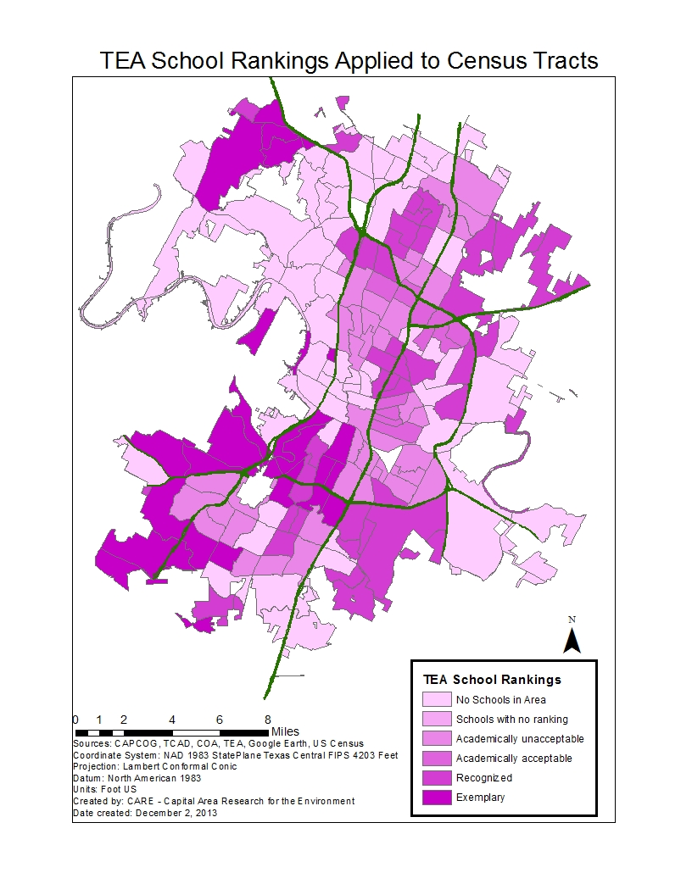
Figure 2.1B:
Explanatory variables – Park/Natural Area Rankings
CARE took the parks layer and clipped it to the city of Austin resulting in 272 parks within COA. We then placed the parks in order from largest to smallest area size, and then split the ordered parks into 5 increments. Each increment was designed a rank or weight that correlated to the relative size of the parks. Once all the parks were quantified, they were joined to the census tracts. The result is a census tract layer with an average of park ranks; see Figure 2.1C.
Figure 2.1C:

Explanatory variables – Cultural Attraction Rankings
First, it was necessary to define which areas of entertainment to document. The most important areas we decided to focus on were theaters (including performing arts in addition to cinemas), shopping areas and malls, and nightlife areas. Using google maps, we searched for each type of entertainment venues or areas and found addresses for each. Confirmation that the venues still existed were found through these websites:
- http://www.fandango.com
- http://www.nowplayingaustin.com
- http://texasperformingarts.org
General knowledge of the area was also used, with caution. Areas or venues we were unsure of were verified to still exist by doing web searches for web sites for the venues, or through yellow pages for businesses.
In ArcMap, a new table was created for the venues. Addresses were put into the table, and geocoded. Fields were also created for the name of each venue/area and type of each venue/area.
Each venue/area was then weighted according to the following:
- For tracts with no venues, a value of 0 was given.
- For each theater, performing arts center, or cinema, a value of 1 was given.
- For each nightlife area, a value of 1 was given.
- For each regular shopping center, a value of 1 was given.
- For each major shopping center or mall, a value of 2 was given.
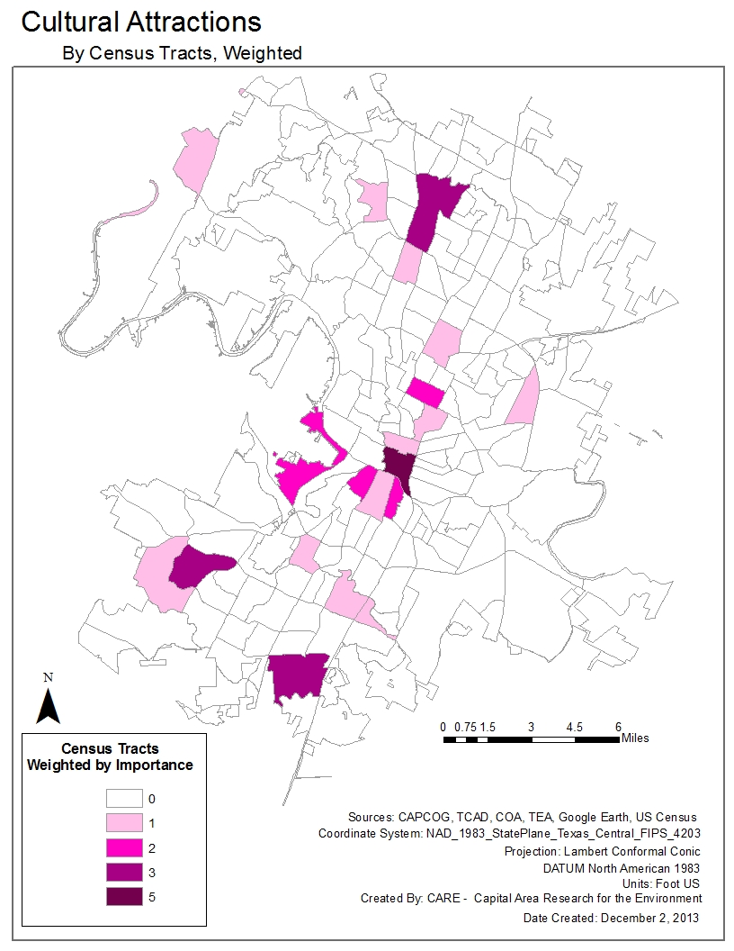
If more than one venue exists in a census tract, the values are added up, for a total of up to 5. Values ranged from 0 to 5. Figure 2.1D below shows census tracts and their corresponding ranking.

Geographically Weighted Regression (GWR)
Now that rankings have been assigned, the GWR can be applied. First, a model based on the direct correlation between percentage of tree cover and property value per square foot was conducted with no explanatory variables considered. Three maps were created based on this analysis. The first was a map showing areas that were predicted to be correlated (figure 2.2A), secondly a map showing areas sensitive to adjustments of tree canopy (figure 2.2B), and lastly a map showing the level of confidence each tract has of actually representing reality (figure 2.2C). Three more maps of the same nature were created with explanatory variables included. Figure 2.3A shows predictions, figure 2.3B shows tree canopy sensitivity analysis, and figure 2.3C shows the level of confidence for the regression.

Objective 2 – Results: Tree Cover’s Effects upon Property Values
Predictions
The predictions from the direct correlation between tree cover and property values (figure 2.2A) portray the conceptual hypothesis of tree canopy’s positive correlation to property values. Properties in central to west Austin showed the highest predicted correlation. The trend follows similar trends portrayed in figure 2.1A.
Predictions of tree canopy’s sensitivity upon property values that include explanatory variables (figure 2.3A) gives a closer look to the reality of Austin’s tree canopy and property values relationship. Areas that are not as positively correlated show that proximity to cultural attractions, parks/natural areas, and school rankings do have an effect upon property values. This prediction shows the importance of including these variables to gain a more conclusive study.
Tree Cover’s Actual Sensitivity to Property Values
Figure 2.2B shows the direct sensitivity of tree canopy upon property values without any explanatory variables included. Areas with the highest positive correlation are in northern Austin, and south-southeast Austin. In this analysis, a value of 1 represents an exceptionally high positive correlation. Areas close to this value are generally north. There is an assembly of tracts with high positive correlation near Research Boulevard, between I-35 and Mopac.
Figure 2.3B shows the sensitivity of tree canopy upon property values with explanatory variables included. All census tracts within the city portray a positive correlation between tree canopy and property values. Areas with the highest positive correlation are in north and north-central Austin with a trend towards the west. This map shows a more distinct pattern due to the inclusion of the explanatory variables.
R² Confidence
Figure 2.2C shows the R² value (an indicator of the regression’s confidence) for tree canopy’s direct correlation to property values; no explanatory variables were included. The area has a consistent positive value, with very few high R² values. This indicates that more variables should be considered.
Figure 2.3C shows the R² value for tree canopy’s correlation to property values with explanatory variables included. R² values are positive showing a good level of confidence, and the pattern is very consistent. Although, R² values are fairly low, and the pattern may be an indication that more variables need to be included.

Objective 2 – Conclusions: Tree Cover’s Effects upon Property Values
Our overall analysis shows a positive correlation between tree cover and property values. There were areas with negative values in our direct model between tree canopy and property values, but this is due to a lack of explanatory variables. With an addition of explanatory variables, which gives a closer look to the multi-dimension reality that affects property values, there was absolutely no negative correlation. In this analysis, areas with the highest positive correlation to tree cover account for 23% of single family homes in Austin. Our results show that in all areas of Austin, an addition of tree canopy will benefit property values with north, central, and west areas most sensitive.
Objective 2 – Discussion: Tree Cover’s Effects upon Property Values
Our analysis gives light to future initiatives concerning tree canopy within the City of Austin. An analysis that considers more explanatory variables, such as resident’s viewpoint within the property, historical homes, proximity to busy streets, etc. could be considered along with our variables to gain an even more conclusive study. Also, multi-family homes could be considered. The list for the amount of variables that can be included and analyzed is extensive and restricted by the amount of data available. Homes could be compared on an individual basis. This allows for questions like: are certain neighborhoods more valuable due to historical reputation? How much of a radius does tree cover have an effect on individual homes? More coverage of variables will result in a higher level of a confident analysis.
As portrayed in our analysis, homes in the northern part of the city seem to have a more positive correlation to tree cover. Perhaps this is due to the area being relatively new to the rest of the city. Therefore, the addition of mature tree canopies may be needed which results in a higher sensitivity to any addition of canopy. Other areas may already have established canopies, but not very many cultural attractions. Therefore, an addition of cultural attractions will have a greater affect upon property values than tree cover, yet tree canopy is nevertheless positively correlated to property values to a degree.
In conclusion, the analysis of tree cover’s effect upon property values shows that urban forests are a great benefit. The value of Austin’s tree canopy is worth an investment towards further research and legislative decision making.

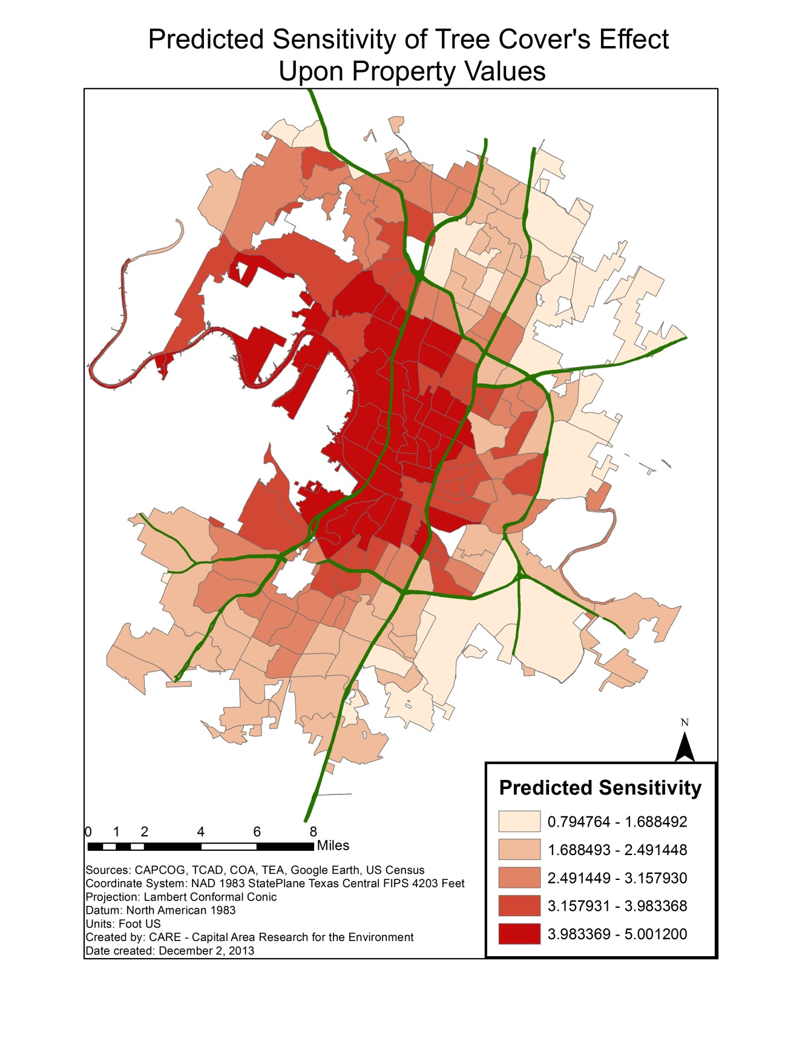
Figure 2.2A:
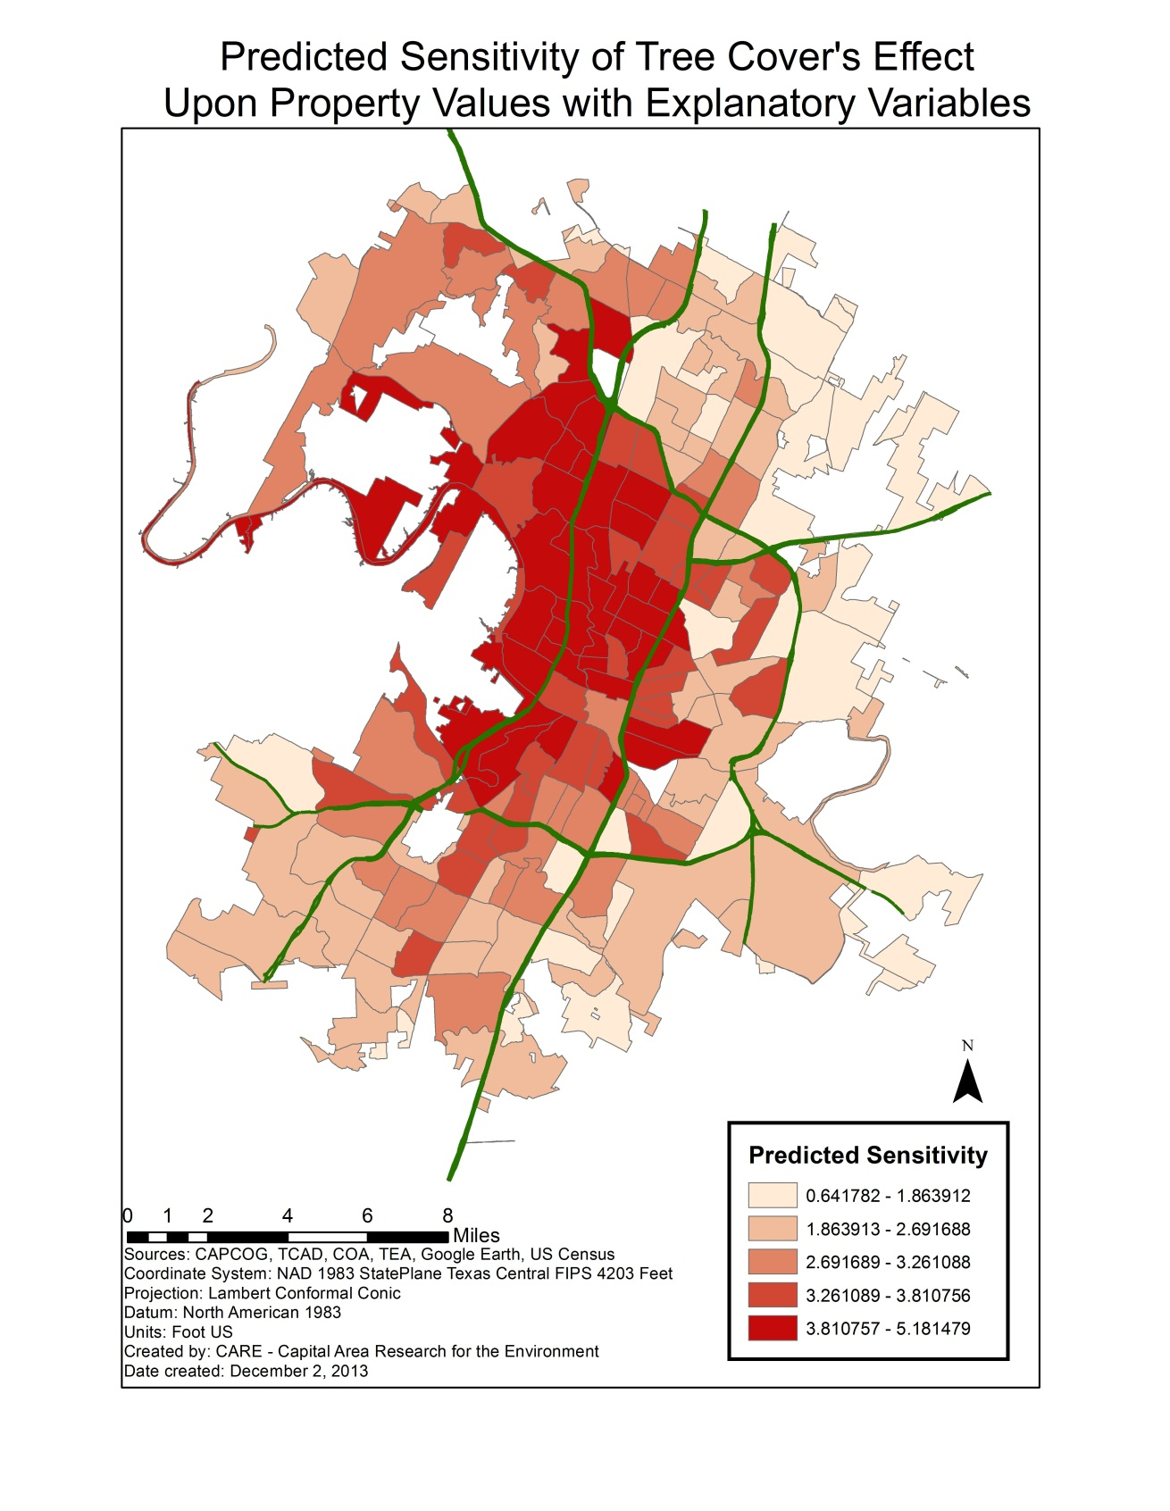
Figure 2.3A:
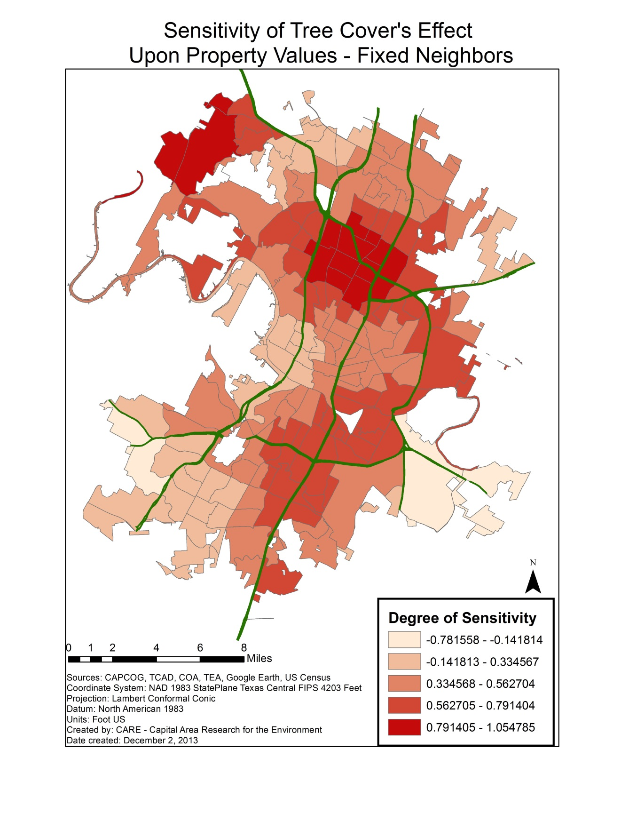
Figure 2.2B:
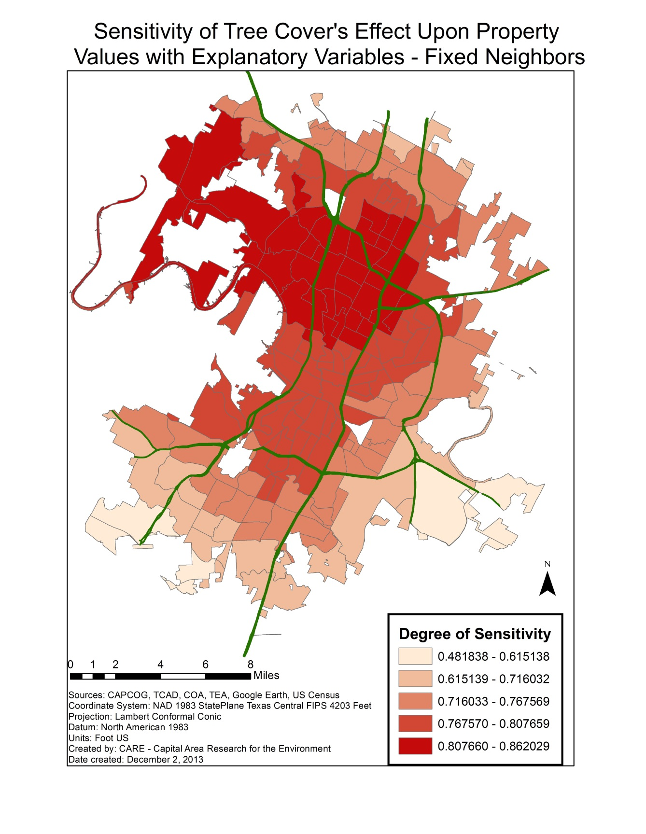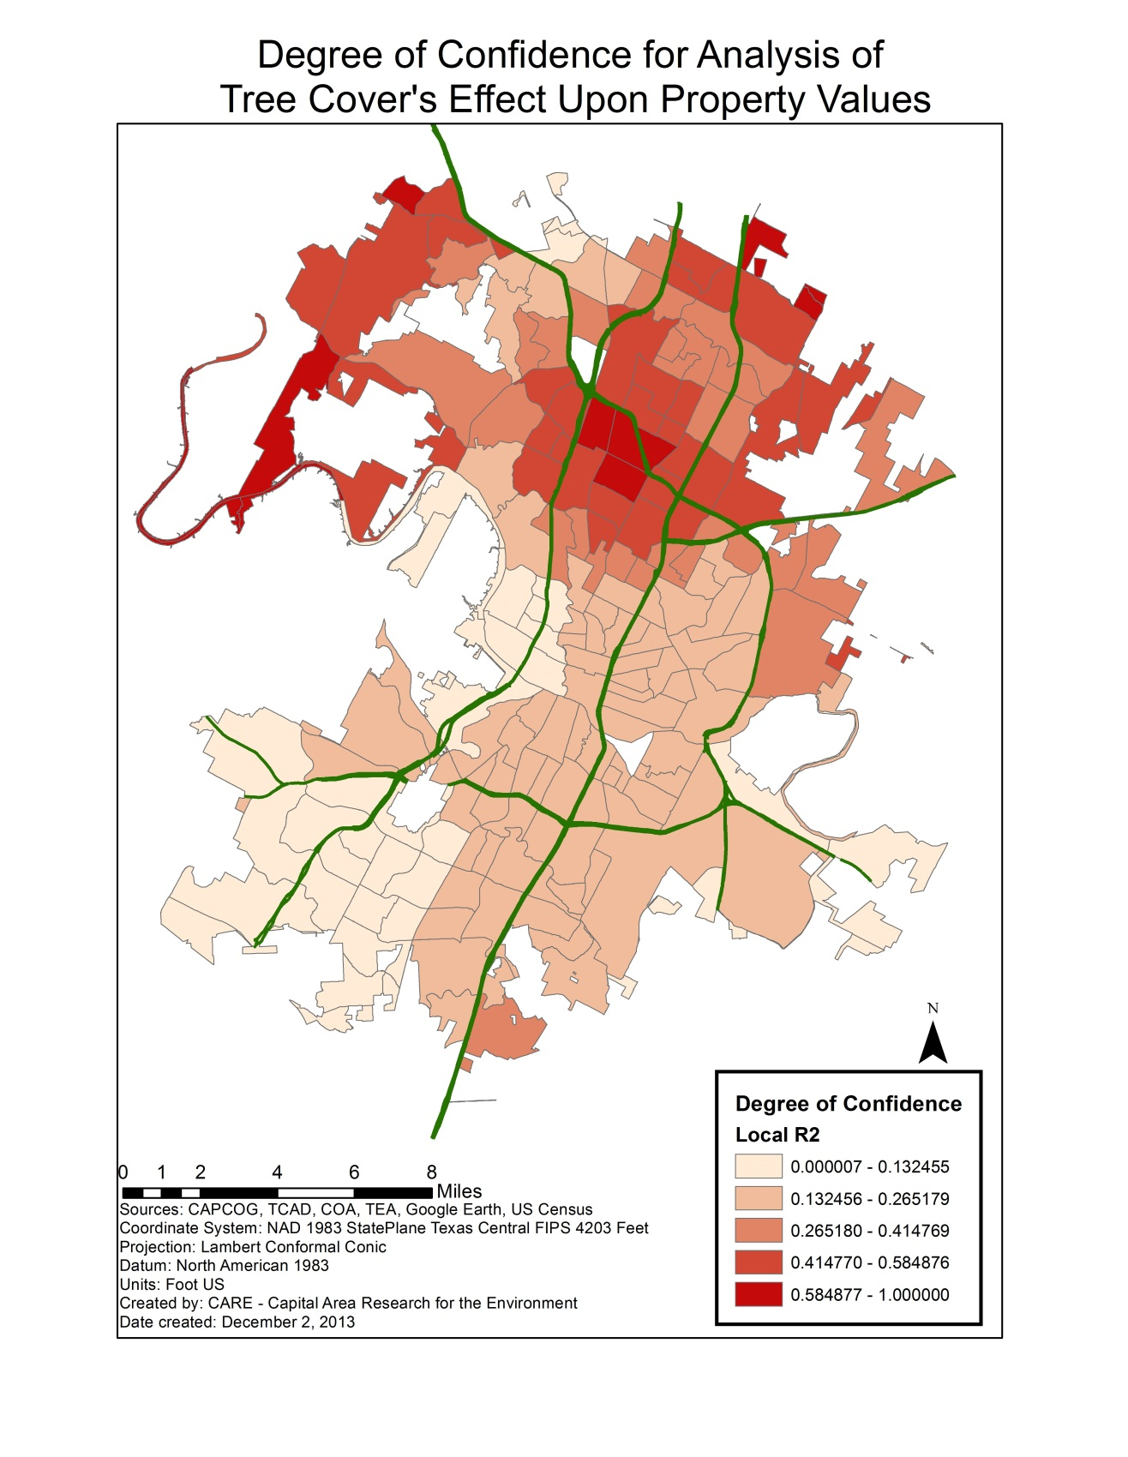
Figure 2.3B:
Figure 2.2C:
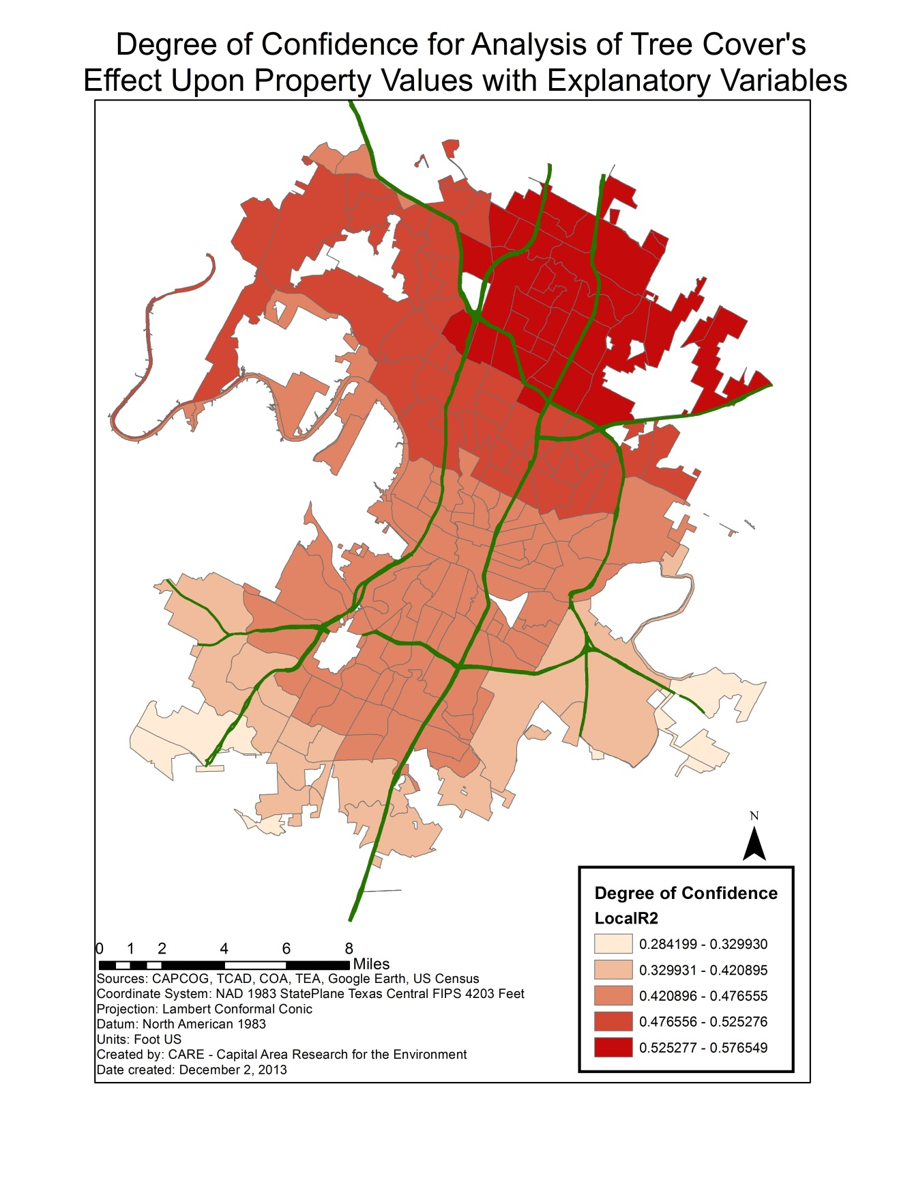
Figure 2.3C:
Sources
Donovan, Geoffrey H., Jeffrey P. Prestemon. (2012)The effect of trees on crime in Portland, Oregon. Environment and Behavior. 44(1): 3-30.
Dwyer, M. C., & Miller, R. W. (1999). Using GIS to assess urban tree canopy benefits
and surrounding green space distributions. Journal of Arboriculture 25(2),
102-107. http://cambria.cgu.edu/ccsi/resources/08_USING_GIS_TO_
ASSESS_CANOPY_BENEFITSdwyer.pdf

McPherson G., Simpson J. R., Peper, P. J., Maco, S. E., & Xiao, Q. (2005). Municipal
forest benefits and costs in five US cities. Journal of Forestry, 411-416.
http://www.fs.fed.us/ccrc/topics/urban-forests/docs/jof_Dec_2005.pdf
Morales, D. J., Micha, F. R., & Weber, R. L. (1983). Two methods of valuating trees on
residential sites. Journal of Arboriculture 9(1), 21-24.

Sander, H., Polasky, S. & Haight, R. G. (2010). The value of urban tree cover: A
hedonic property price model in Ramsey and Dakota Counties, Minnesota, USA. Ecological Economics 69(2010), 1646-1656. http://www.nrs.fs.fed.us/
pubs/jrnl/2010/nrs_2010_sander_001.pdf

Shapiro, R. J., & Hassett, K. A. Center for American Progress, (2012). The economic benefits
of reducing violent crime. Retrieved from website: http://www.americanprogress.org/issues/economy/report/2012/06/19/11755/the-economic-benefits-of-reducing-violent-crime/

Toohey, M. (2012, July 1). Austin property taxes jump 38% over past decade. Austin-
American Statesman. Retrieved from http://www.statesman.com/news/news/local/austin-property-taxes-jump-38-over-past-decade/nRprf/
Troy, A., Grove, J. Morgan., & O'Neil-Dunne, J. The relationship between tree canopy and crime rates across and urban-rural gradient in the greater Baltimore region. (2012). Landscape and Urban Planning.
United States Environmental Protection Agency, (2008).Reducing urban heat islands:
Compendium of strategies (Chapter 2: Trees and Vegetation). Retrieved from website: http://www.epa.gov/heatisland/resources/compendium.htm

Metadata for Canopy_2010
Summary
The data was compiled by CoA to provide public access to Austin tree canopy data for GIS analysis.
Description
This file gives the tree canopy shade cover in the city of Austin which has over 2,000+ entries, shade cover statistics and measurements included as well.
Credits
Credit goes to CoA for providing the field work and data entry to make this possible.
Use limitations
No limitations or restrictions on use.
Extent
West | -98.176283 | East | -97.370610
North | 30.629121 | South | 30.021946

Scale Range
There is no scale range for this item.

Topics and Keywords
* Content type Downloadable Data

Citation
* Title Canopy_2010
Presentation formats * digital map

Resource Details
Dataset languages * English (UNITED STATES)
Spatial representation type * vector
* Processing environment Microsoft Windows 7 Version 6.1 (Build 7601) Service Pack 1; Esri ArcGIS 10.1.1.3143
ArcGIS item properties
* Name Canopy_2010
* Size 0.000
* Location file://\\GEO-311301\E$\Imp&Des\Final Project\MapData_PropMapEric\Canopy_2010.shp
* Access protocol Local Area Network

Spatial Reference
ArcGIS coordinate system
* Type Projected
* Geographic coordinate reference GCS_North_American_1983
* Projection NAD_1983_StatePlane_Texas_Central_FIPS_4203_Feet
* Coordinate reference details
Projected coordinate system
Well-known identifier 102739
X origin -124805500
Y origin -81923100
XY scale 35432942.484959878
Z origin -100000
Z scale 10000
M origin -100000
M scale 10000
XY tolerance 0.0032808333333333331
Z tolerance 0.001
M tolerance 0.001
High precision true
LatestWKID 2277

Reference system identifier
* Value 2277
* Codespace EPSG
* Version 7.11.2

Spatial Data Properties

Vector
* Level of topology for this dataset geometry only
Geometric objects
Feature class name Canopy_2010
* Object type composite
* Object count 0

ArcGIS Feature Class Properties
Feature class name Canopy_2010
* Feature type Simple
* Geometry type Polygon
* Has topology FALSE
* Feature count 0
* Spatial index FALSE
* Linear referencing FALSE

Geoprocessing history
Process
Process name Clip (8)
Date 2013-05-08 18:14:06

Distribution
Distribution format
* Name Shapefile
Transfer options
* Transfer size 0.000

Fields

Details for object Canopy_2010
* Type Feature Class
* Row count 0
Field FID
* Alias FID
* Data type OID
* Width 4
* Precision 0
* Scale 0
* Field description
Internal feature number.
* Description source
Esri
* Description of values Sequential unique whole numbers that are automatically generated.

Field Shape
* Alias Shape
* Data type Geometry
* Width 0
* Precision 0
* Scale 0
* Field description
Feature geometry.
* Description source
ESRI
* Description of values Coordinates defining the features.

Field CLASS_ID
* Alias CLASS_ID
* Data type Integer
* Width 9
* Precision 9
* Scale 0

Field Shape_Leng
* Alias Shape_Leng
* Data type Double
* Width 19
* Precision 0
* Scale 0

Field Shape_Area
* Alias Shape_Area
* Data type Double
* Width 19
* Precision 0
* Scale 0
* Field description
Area of feature in internal units squared.
* Description source
ESRI
* Description of values Positive real numbers that are automatically generated.

Metadata Details
* Metadata language English (UNITED STATES)
Scope of the data described by the metadata * dataset
Scope name * dataset
* Last update 2013-11-13
ArcGIS metadata properties
Metadata format ArcGIS 1.0
Created in ArcGIS for the item 2013-05-08 18:12:02
Last modified in ArcGIS for the item 2013-11-13 11:54:43
Automatic updates
Have been performed Yes
Last update 2013-11-13 11:54:43

Entities and Attributes
Detailed Description
Entity Type
Entity Type Label Canopy_2010

Attribute
Attribute Label FID
Attribute Definition
Internal feature number.
Attribute Definition Source Esri
Attribute Domain Values
Unrepresentable Domain
Sequential unique whole numbers that are automatically generated.

Attribute
Attribute Label Shape
Attribute Definition
Feature geometry.
Attribute Definition Source ESRI
Attribute Domain Values
Unrepresentable Domain
Coordinates defining the features.

Attribute
Attribute Label CLASS_ID

Attribute
Attribute Label Shape_Leng

Attribute
Attribute Label Shape_Area
Attribute Definition
Area of feature in internal units squared.
Attribute Definition Source ESRI
Attribute Domain Values
Unrepresentable Domain
Positive real numbers that are automatically generated.

Metadata for city_tract
Summary
The data was compiled by CAPCOG to provide public access to Census 2010 data for GIS analysis then taken by C.A.R.E for city Parks weighted analysis.
Description
This dataset was compiled from the Census 2010 Redistricting dataset from the Census FTP site and Census 2010 Tigerline files. The geographic unit is the Census Tracts within the CAPCOG service area. The attribute data includes total population and race/ethnic profile and number of housing units. Field Descriptions: Totpop- Census 2010 Population Hispanic- Total Hispanic Population NotHis- Total Not Hispanic Population (all races) NHWhite- Total Not Hispanic White Alone population NHBlack- Total Not Hispanic Black Alone population AIAN- Total Not Hispanic American Indian and Alaskan Native Alone population Asian- Total Non Hispanic Asian Alone population NHOPI- Total Not Hispanic Naive Hawaiin and Other Pacific Islander Alone population Other- Total Not Hispanic Some other race Alone population Twoormore- Total Not Hispanic two or more race population Tot18Plus- Total population 18 and over HIS18- Total Hispanic population 18 and over NHIS18- Total Not Hispanic population 18 and over NHW18- Total Not Hispanic White Alone population 18 and over NHBlack18- Total Not Hispanic Black Alone population 18 and over AIAN18- Total Not Hispanic American Indian and Alaskan Native Alone population 18 and over Asian18- Total Not Hispanic Asian Alone population 18 and over NHOPI18- Total Not Hispanic Naive Hawaiin and Other Pacific Islander Alone population 18 and over Other18- Total Not Hispanic All other races Alone population 18 and over Twomore18- Total Not Hispanic two or more race population 18 and over Units- Total Housing Units OccUnits- Total Occupied Housing Units VacUnits- Total Vacant Housing Units Note: Totpop = Hispanic + NotHis Totpop = Hispanic + NHWhite + NHBlack + AIAN + Asian + NHOPI + Other + Twoormore NotHis = NHWhite + NHBlack + AIAN + Asian + NHOPI + Other + Twoormore Source data: Data from the U.S. Census 2010, Redistricting Dataset. Ranks was added by C.A.R.E to quantify parks in a given census tract.
Credits
Credit goes to CAPCOG, CoA, and C.A.R.E for this updated Census Tract for Parks in Austin, Texas.

Use limitations
The Capital Area Council of Governments provides this data as is and assumes no liability for its accuracy or completeness.
Extent
West | -98.176283 | East | -97.370610
North | 30.629121 | South | 30.021946

Scale Range
There is no scale range for this item.

ArcGIS item properties
* Name city_tract
* Size 0.000
* Location file://\\Geoserve\Data\G4427\CoA_Forestry\Arc\city_tract.shp
* Access protocol Local Area Network

ArcGIS coordinate system
* Type Projected
* Geographic coordinate reference GCS_North_American_1983
* Projection NAD_1983_StatePlane_Texas_Central_FIPS_4203
* Coordinate reference details
Projected coordinate system
Well-known identifier 32139
X origin -38040800
Y origin -24970300
XY scale 116249525.75503074
Z origin -100000
Z scale 10000
M origin -100000
M scale 10000
XY tolerance 0.001
Z tolerance 0.001
M tolerance 0.001
High precision true
LatestWKID 32139

Horizontal Coordinate System Definition
Planar
Planar Coordinate Information
Planar Coordinate Encoding Method coordinate pair
Coordinate Representation
Abscissa Resolution 0.000000
Ordinate Resolution 0.000000
Planar Distance Units meters

Geodetic Model
Horizontal Datum Name North American Datum of 1983
Ellipsoid Name Geodetic Reference System 80
Semi-major Axis 6378137.000000
Denominator of Flattening Ratio 298.257222

Entities and Attributes
Detailed Description
Entity Type
Entity Type Label city_tract

Attribute
Attribute Label FID
Attribute Definition
Internal feature number.
Attribute Definition Source ESRI
Attribute Domain Values
Unrepresentable Domain
Sequential unique whole numbers that are automatically generated.

Attribute
Attribute Label Shape
Attribute Definition
Feature geometry.
Attribute Definition Source ESRI
Attribute Domain Values
Unrepresentable Domain
Coordinates defining the features.

Attribute
Attribute Label STATEFP10

Attribute
Attribute Label COUNTYFP10

Attribute
Attribute Label TRACTCE10

Attribute
Attribute Label GEOID10

Attribute
Attribute Label NAME10

Attribute
Attribute Label NAMELSAD10

Attribute
Attribute Label MTFCC10

Attribute
Attribute Label FUNCSTAT10

Attribute
Attribute Label ALAND10

Attribute
Attribute Label AWATER10

Attribute
Attribute Label INTPTLAT10

Attribute
Attribute Label INTPTLON10

Attribute
Attribute Label Tract

Attribute
Attribute Label Totpop

Attribute
Attribute Label Hispanic

Attribute
Attribute Label NotHis

Attribute
Attribute Label NHWhite

Attribute
Attribute Label NHBlack

Attribute
Attribute Label AIAN

Attribute
Attribute Label Asian

Attribute
Attribute Label NHOPI

Attribute
Attribute Label Other

Attribute
Attribute Label Twoormore

Attribute
Attribute Label Tot18Plus

Attribute
Attribute Label Total18

Attribute
Attribute Label HIS18

Attribute
Attribute Label NHIS18

Attribute
Attribute Label NHW18

Attribute
Attribute Label NHBlack18

Attribute
Attribute Label AIAN18

Attribute
Attribute Label Asian18

Attribute
Attribute Label NHOPI18

Attribute
Attribute Label Other18

Attribute
Attribute Label Twomore18

Attribute
Attribute Label Units

Attribute
Attribute Label OccUnits

Attribute
Attribute Label VacUnits

Distribution Information
Resource Description Downloadable Data
Standard Order Process
Digital Form
Digital Transfer Information
Transfer Size 32.751

Metadata Reference
Metadata Date 2011-03-17
Metadata Contact
Contact Information
Contact Person Primary
Contact Person Chris Ramser
Contact Organization Capital Area Council of Governments
Contact Position Community Planner
Contact Address
Address Type REQUIRED: The mailing and/or physical address for the organization or individual.
City REQUIRED: The city of the address.
State or Province REQUIRED: The state or province of the address.
Postal Code REQUIRED: The ZIP or other postal code of the address.

Contact Voice Telephone 512-916-6184

Metadata Standard Name FGDC Content Standards for Digital Geospatial Metadata
Metadata Standard Version FGDC-STD-001-1998
Metadata Time Convention local time
Metadata Extensions
Online Linkage http://www.esri.com/metadata/esriprof80.html
Profile Name ESRI Metadata Profile
Metadata Extensions
Online Linkage http://www.esri.com/metadata/esriprof80.html
Profile Name ESRI Metadata Profile

