MEMORANDUM

TO: Melanie Snyder, PPLT Executive Director…....melanie.snyder@pplt.org
Tina Fucile, PPLT Board of Directors………..…………tinafucile@msn.com

FROM: Arma-Geo Products, POC: Ryan Henderson…………rh1268@txstate.edu
CC: Dr. Yongmei Lu, Texas State University……………………yl10@txstate.edu
SUBJECT: Progress Report
DATE: October 31, 2012

Purpose

The following memorandum has been developed by Arma-Geo Products in order to update Pines and Prairies Land Trust (PPLT) on our current progress in designing and creating a geodatabase for their use. In this report, the Arma-Geo Products team will discuss project details and describe the work that has been completed, work in progress, and future work to be completed before the December 10 deadline.

Arma-Geo Products will then provide PPLT with an assessment of our progress including problems encountered, and project changes made since our proposal on October 3. This report gives our team a great opportunity to hear valuable feedback on our current progress, and how we have performed so far.

Background

Pines and Prairies Land Trust is a non-profit organization that owns and manages multiple properties in the Central Texas region for conservation purposes. They use these properties and easements to educate local communities on a wide array of topics including forestry, wildfire prevention, and native species. PPLT has identified a lack of geospatial information on these properties. Due to limited resources, PPLT has assigned Arma-Geo Products the task of solving this problem. With our knowledge of geographic information systems, Arma-Geo Products will provide a useful solution for Pines and Prairies Land Trust and their staff.

Project Description

After reviewing the request for proposal submitted by PPLT and meeting with the staff, the Arma-Geo Products team has begun the process of designing a geodatabase that will be used to store important spatial and descriptive data on the Colorado River Refuge. This database will serve as a valuable reference tool for the PPLT staff. After gathering primary and secondary data on the Colorado River Refuge, we will populate the geodatabase accordingly. Shapefiles of various property features will be attached to tables of attribute data. Tables will consist of important information that can be analyzed and reviewed by PPLT staff. This resource will serve as a reference and management tool that will aid PPLT in conducting inventories and project planning. When manipulated in ArcMap, these shapefiles will give PPLT the power to construct useful maps for staff, board members, and visitors of the Colorado River Refuge. Once completed, we believe our geodatabase will provide Pines and Prairies Land Trust with new capabilities that will aid in future projects and improve the beauty of the Colorado River Refuge.

Work Completed

Data Collected

After visiting the Colorado River Refuge back in September, Arma-Geo Products was able to get a better understanding of exactly what primary data features we would need to collect to include in the creating of a geodatabase for the PPLT. In a second visit, Arma-Geo Products used handheld GPS equipment supplied by the client. We collected feature data on benches, marked trees, trails, trail head signs, and focus areas, such as gardens. This data was collected over all trails except Dragonfly trail. In addition, we collected points to use for georeferencing such as road intersections and railroad tracks. For the points we collected we created an Excel spreadsheet, which contained the following fields:

Point no.
Point name
Trail
Maintenance Required
Handicap Accessibility
Point type
Difficulty level
Altitude (ft)
X (Longitude)
Y (Latitude)

As well as primary data, Arma-Geo Products utilized secondary source data. We have downloaded the following data from online source, namely TNRIS.

County boundaries
Roadways
Railroad tracks
Waterways
Satellite imagery
Digital Elevation Models

Data Processed

After the second trip to the Colorado River Refuge, we imported the excel spreadsheet into ArcMap 10, allowing us to visualize the points. Arma-Geo Products created a base map in ArcMap with a set projection of UTM 14 using the NAD 1983 datum. Members of Arma-Geo Products clipped extra data such as irrelevant waterways and roadways from the projected area. The hand drawn map was rectified to a satellite image in ArcMap.
Imported Coordinates From GPS

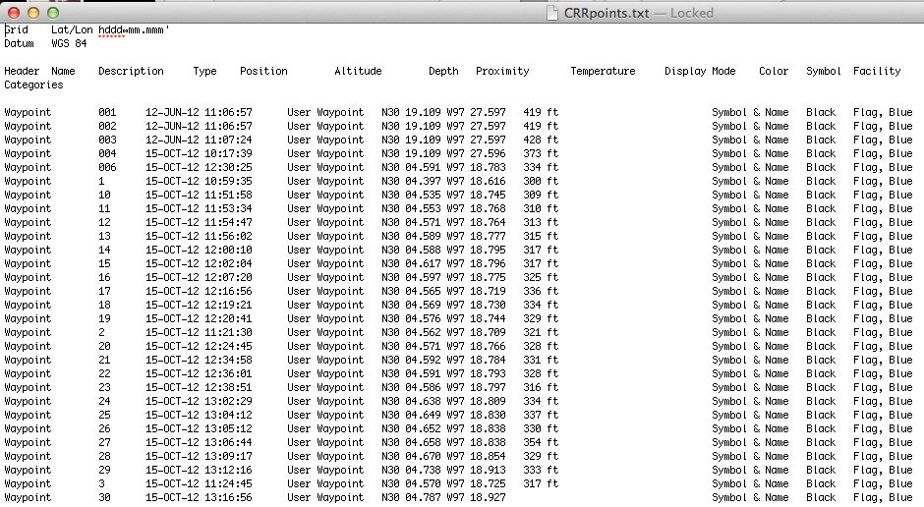

Converted and Processed for ArcMap

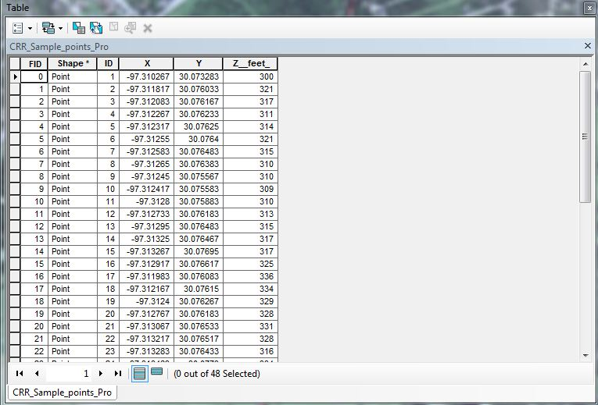

Base Map with GPS Points Plotted

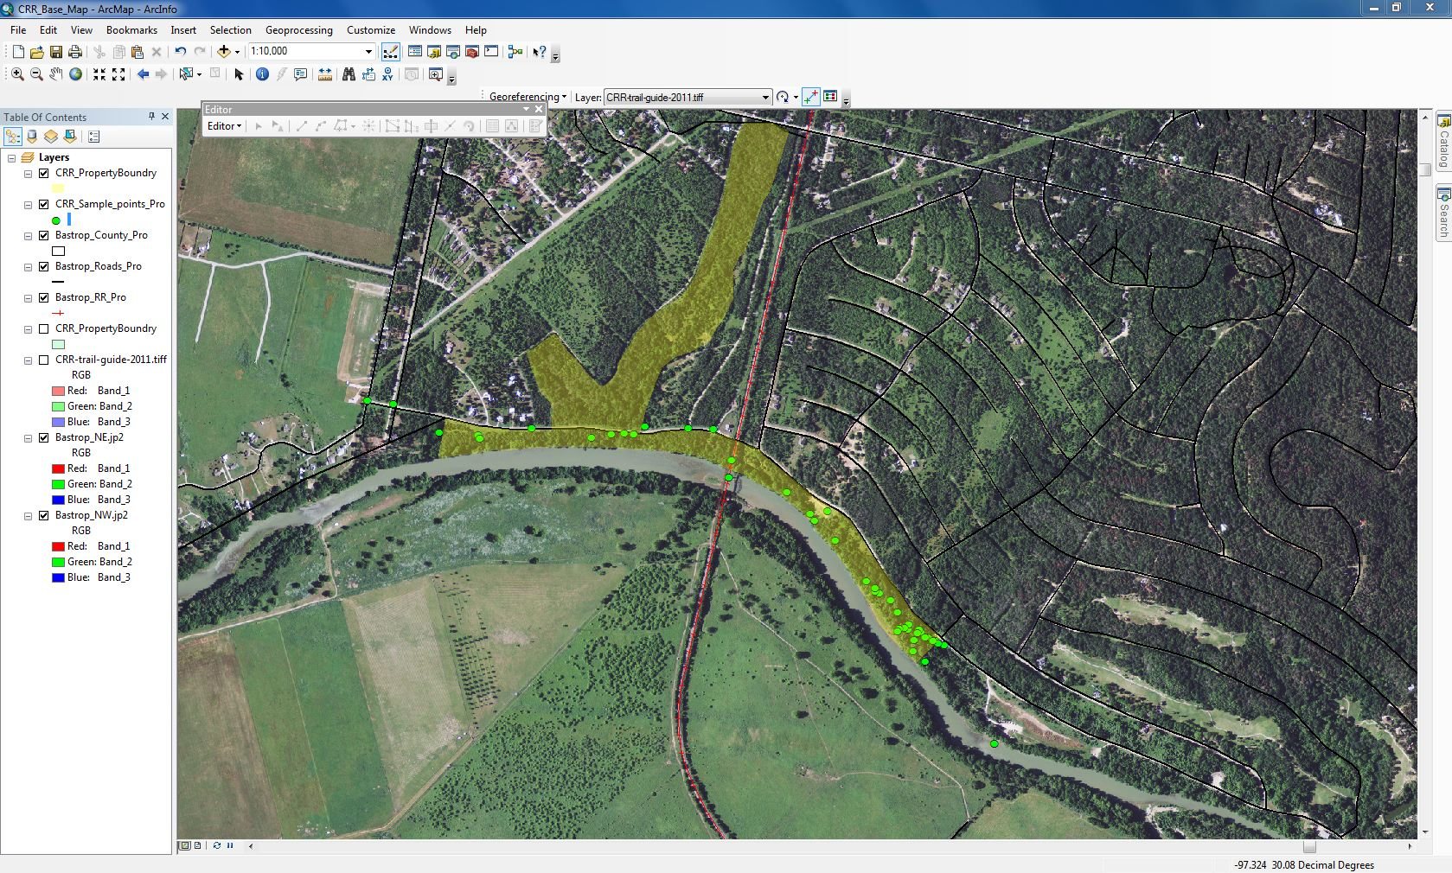

Work In Progress

Data Collection

We are continuing to collect data throughout the rest of the CRR using GPS units that have been supplied by both PPLT and the Texas State University geography department. This GPS data will be the main component that will contribute to our geodatabase. With our second trip to the CRR, the data collection will be plotted with better accuracy and more descriptions that will be used to populate fields for the specific data collected (i.e. Walking Trails) in a data-input form below. This data collection form serves as an inventory and organizational tool for our team, and allows us to see what data we are lacking.

OBJECT ID | POINT ID | LONG | LAT | WALKING_TRAILS | BENCHES | HANDICAP | CONDITION | TYPE | POSINIVY
 | 1 | -98.154953 | 29.7089 | Cottonwood Trail | Yes | yes | GOOD | Beg | yes
 | 2 | -98.124955 | 29.7091 | Dragonfly Trail | No | no | FAIR | Inter | yes
 | 3 | -98.124967 | 29.8001 | Cliffhanger Trail | Yes | no | GOOD | Expt. | yes
 | 4 | -98.125001 | 29.8005 | Cliffhanger Baja | No | no | POOR | Expt | yes

Design Geodatabase

Remaining feature classes are being created for the geodatabase over the course of the next few weeks. Once this is completed, we are going to populate the database with the data collected from the field.

Populate Geodatabase

We will continue to populate the geodatabase manually; using the information stored on the data-input forms and then into the geodatabase. Once the final geodatabase design is completed, we will use the collected data (geodatabase) to test its functionality with ArcCatalog.

Future Work

Things seem to be going right on track up to this point as far as time management goes. We have had to make a few tweaks to the schedule here and there but nothing too significant. There is, however, one part of the process that we felt like we would have completed by this point, which is the data collection. Due to scheduling conflicts among the group and sudden weather changes, we have only managed to dedicate time for one data collection trip thus far. This does not overly worry us though, because we intend to complete the data collection process with our next trip, which should take place within the week. Once the data collection by way of GPS is complete, then all the pieces should start falling together for us and we will quickly begin to knock out the next steps.

When we have all of our data collected the data processing phase should take no more than a few days at the most. Once the data has been processed into a manageable form by Arc GIS, we can begin the process of creating our output maps. At this time, Marcos will also begin the development of our Website. We plan to carry out the website development and the map production during the same time period because we believe these two components of our project are strongly related and will therefore influence the design of each other. Once we deem our final maps as professional and informative, we will incorporate them into the website in a user-friendly way. Our ultimate goal for the website is to provide the user with an online experience that is more informative and easier to navigate than the current Pines and Prairies Land Trust website. We will also display the culmination of our project efforts in a sleek interactive map that not only shows you the trails and features in the park, but tells some attributes about them too.

After the maps and website are out of the way, the only steps left to do are the final round of quality checks, and then the final report write-up. In our schedule we have allotted about three weeks time for this step because we want to allow ourselves ample time to create a professional-grade report for PPLT.

Schedule
C= Complete IP= In Progress
FW= Future Work

- Introduction to Project
- Project Overview C
- Client Introduction C
- Learn clients expectations for final outcome of project C
- Preparation of a Proposal C

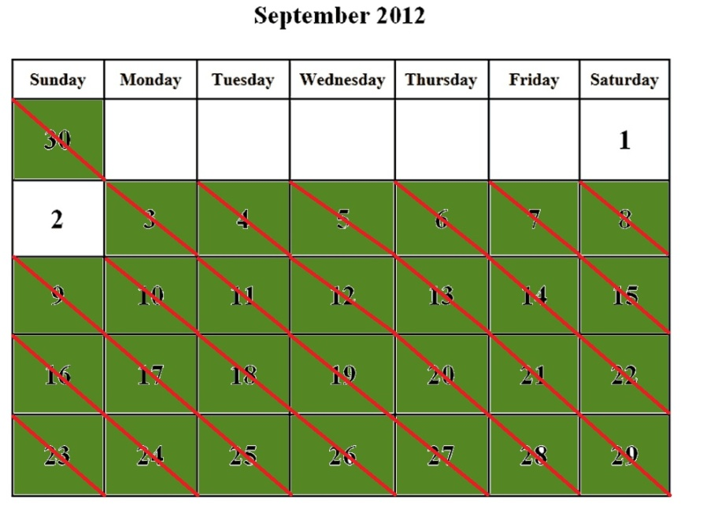

2. GIS Design/ Development
- Create a working geodatabase C
- Ensure it is a user friendly and efficient system for managing our data C

3. Data Collection
- Obtain any previous data from Pines and Prairies C
- GPS data collection fieldwork IP
- Final visit for data quality check FW

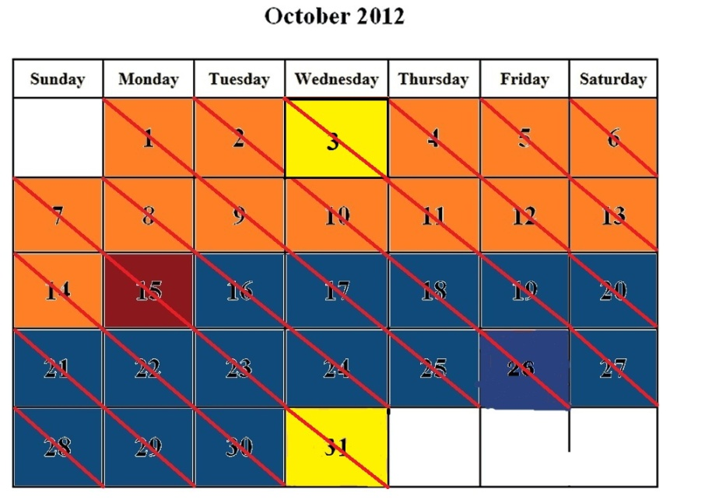

4. Data Processing
- Quality check of GPS data IP
- Prepare the data to be managed in the geodatabase IP
- Ensure all projections and coordinate systems are the same for all layers C

5. Website Development
- Create a professional informative website showcasing our project FW
- Incorporate an interactive map for the use of Pines and Prairies and the general public FW
- Provide a more in depth look at the Colorado River Refuge than Pines and Prairies previously had FW

C= Complete IP= In Progress
FW= Future Work

Schedule cont.
6. Preparation of Final Deliverables
- Creation of maps from data collected FW
- Final report write-up FW
- Incorporate maps into completed website FW
- Poster size map print-out for Colorado River Refuge kiosk FW

7. Presentation Dates
- Project Proposal C
- Progress Report IP
- Final Project Presentation FW

Problems

Overall, we have encountered no major issues in regards to data processing and geodatabase design. Our only issues have been related to the fieldwork trips that are required for the collection of GPS data. The distance to the CRR has created challenges for our group. It requires our group to have at least 4-6 hours of time available for each trip. We have conflicting schedules, which can make that even more difficult. Our last trip was scheduled for Friday, October 26, and we were unable to go due to inclement weather that day. The GPS units have taken some time to learn, but we are now proficient in using them. Some of the other challenges we have faced are attributed to the amount of hiking that is required and our time spent in heavily wooded terrain. We have overcome each of the issues we have encountered in this project.

Conclusion

Up to this point, we believe the project has made appropriate progress towards completion. Data collection has been delayed a few times due to scheduling issues within the group and inclement weather. However, we have collected all of our necessary secondary data, and have the majority of our fieldwork completed. Our next step is to collect the remaining data, populate the geodatabase, verify its functionality, and produce the final deliverables. Much of our time has been used in planning our project and learning from our experiences in the field. Although we have missed a few opportunities to make the trip to Bastrop due to scheduling conflicts and inclement weather, we have made up lost time in the field with systematic planning. Our procedure has streamlined our collection process by improving our organization and reducing our hiking distance on the refuge. With most of our data collected, edited, and checked for quality, we are extremely confident that we will successfully complete our remaining project tasks before the December 10th deadline.

