Aquifer Resource Innovators
(ARI)

Consultants:

Project Manager: Katie Tritsch

Asst. Project Manager: Eric Schroeder

Web Developer/ GIS Analyst: Katie Steele

GIS Analyst/ Graphic Design: Kevin Taylor

[September 26, 2012]

Mapping and Analysis of Wastewater Spills in the Barton Springs and Southern Segments of the Edwards Aquifer

Author: Prepared by Aquifer Resource InnovatorsPrepared For: Greater Edwards Aquifer Alliance (GEAA)
Table of Contents
Introduction
Summary 4
Purpose 5
Scope 6
Proposal
Data 7
Methodology 9
Implications 10
Budget 11
Timetable 12
Final Deliverables 13
Consequences
Conclusion 14
Participation 15

References 16

Summary

The Edwards Aquifer is a unique and special place to Central Texas. The aquifer serves nearly two million people in Central Texas with fresh water, and is used for agricultural, recreational, as well as personal purposes. It consists of four main zones: the contributing zone (CZ), recharge zone (RZ), transition zone, and the artesian zone. As Central Texas grows in population, the Edwards Aquifer is under increasing pressure from over-use and development. With this encroachment in and along the RZ, there is growing cause for concern regarding the future of the aquifer.
‘Water mining,’ or extracting more water than the aquifer can replenish, as well as pollution are a couple of major threats to the aquifer system and its unique inhabitants. Pollution from point and non-point sources can seep into the porous limestone that characterizes the RZ of the aquifer and spoil this great natural resource. Wastewater spills make significant contributions to pollution levels in the groundwater, and can cause irreversible damage to the health of the aquifer and the people that consume its water.
Providing a Geographic Information System (GIS) will give the public and regulating authorities access to, and the ability to interface with, the wastewater spills in the Texas Commission on Environmental Quality (TCEQ) Region 11 of the Edwards Aquifer. Being able to visualize and interact with this information will aid in the understanding of the quantity and spatial distribution of wastewater spills in the different areas of Region 11. The findings for this project will potentially allow for more regulation involving wastewater spills, which would aid in increasing the quality of public health as well as general water resources in the Edwards Aquifer.

Purpose
The purpose of our project is to gather, organize, and analyze wastewater spill data that has occurred in the past five years within TCEQ Region 11. We aim to develop an interactive map as well as static sequential time-lapse maps to effectively display this information to the public and to help educate them on this issue. Our goals include collecting data from pertinent entities within Region 11, mapping the spills in a manner that will communicate the findings effectively, and performing locational and qualitative analyses on the spill data in order to form a conclusion about the density, locations, and or volumes of the spills.

Scope
Our project will be focused on wastewater spill data within the last five years occurring within the RZ and CZ of the Southern and Barton Springs Segments of the Edwards Aquifer Region 11. The total area of Region 11 is comprised of ten counties, which will be mapped and analyzed in this order: Hays, Travis, Blanco, Burnet, Llano, Williamson, Bastrop, Fayette, Caldwell, and Lee.
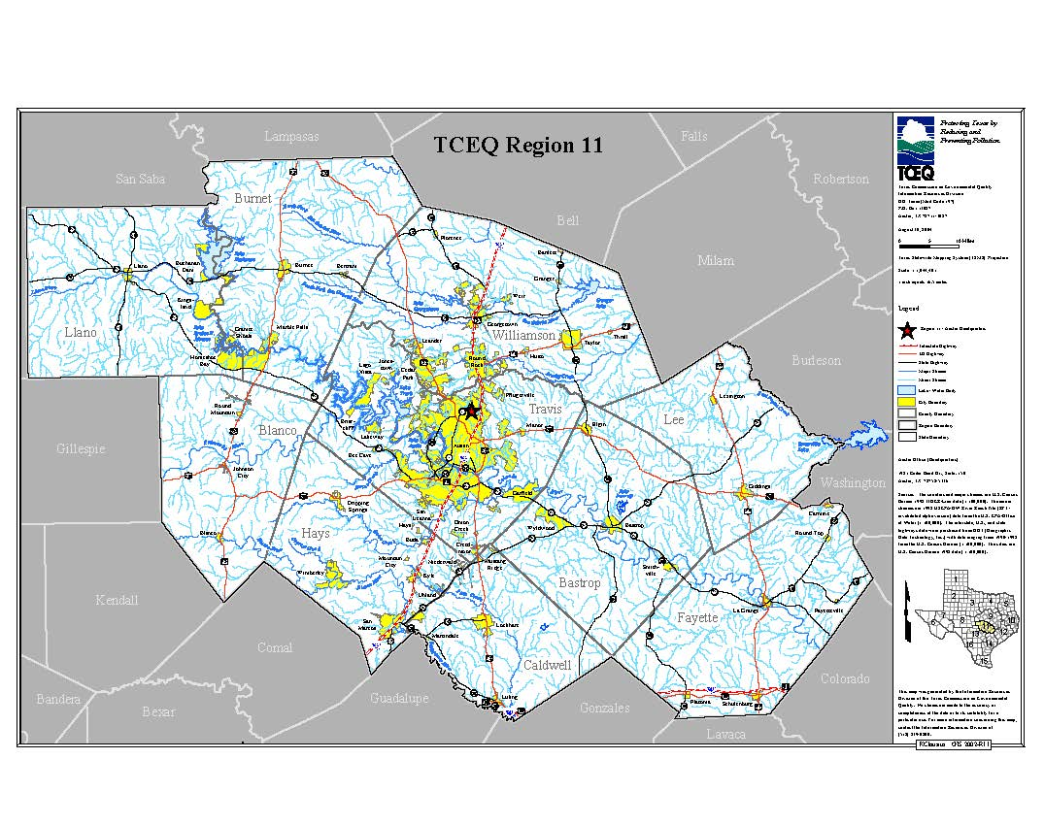Illustrates water features, county and city boundaries, and major roads within Region 11 (TCEQ 2009).

Data
The data needed to complete our analyses are:
o State of Texas and county boundaries
o Major Texas cities – points and boundaries
o TCEQ Region 11 boundaries
o Major streams
o Wastewater service-provider and MUD facilities boundaries
o Major roads
o Edwards Aquifer RZ and CZ boundaries
o Groundwater Conservation Districts boundaries
o Wastewater spill data

Aquifer Resource Innovators (ARI) will need the shapefiles listed above, which can be downloaded free of charge through the internet via the websites of Texas State Data Center (TSDC), Texas Natural Resource Information Systems (TNRIS), Texas Commission on Environmental Quality (TCEQ), Texas Water Development Board (TWDB), Capital Area Council of Governments (CAPCOG), Edwards Aquifer Authority (EAA), and the City of Austin.
Wastewater spill data, however, is not provided in shapefile form. To obtain this data we intend on contacting, through phone calls and e-mails, TCEQ, EAA, and the City of Austin. According to a similar study of wastewater spills in the Edwards Aquifer TCEQ Region 13 done in Spring 2012, data from MUDs was difficult to retrieve due to the districts’ desires to prevent potential damage their reputations (GEOTEX 2012). Furthermore, when data was provided by the MUDs it was often in small amounts and did not produce fruitful results (GEOTEX 2012). For this reason we will not be attempting contact with the MUDs.

Methodology
The first step will be to download shapefiles from TNRIS, TCEQ, CAPCOG, TSDC, EAA, and TWDB. Next, when ARI receives wastewater spill data from TCEQ, EAA, and the City of Austin, we will compare the data from each agency, and put it into a manageable table that can be imported into ArcGIS. The ideal spill data attributes include location (address or lat/long coordinates), volume, date, and duration of spill, as well as additional qualitative information such as cause of spill, responsible parties, and damages.
After this initial processing, ARI plans to geocode these spills on the RZ and CZ of the Edwards Aquifer beginning in Hays and Travis counties. These are the first priority counties of TCEQ Region 11 specified by our clients, GEAA. Next, we will enter this data into Manifold to create an interactive map of the spills capable of public interface. As ARI progresses on the interactive map, we would like to perform a vulnerability analysis for Hays and Travis counties by matching the spills to the MUDs that leaked them, and the Groundwater Conservation Districts (GCDs) that contain these MUDs. We also hope to have time to perform qualitative analysis of development trends based on Census population data. Should there be enough time we will continue geocoding spills and performing analyses in the other counties within TCEQ Region 11.

Implications
The implications for our research include increased public awareness and education about the Edwards Aquifer and the impact that wastewater spills can have on our water resources. It also has the potential to play a part in future dealings between non-profit organizations, regulatory agencies, and the Texas legislature in developing stricter regulations regarding wastewater spills, and helpful in determining the effectiveness of current regulations. Connecting spills to particular MUD leaks in Hays and Travis counties can give GCDs in the area the information they need to seek necessary regulation improvements to decrease the occurrence of spills and preserve the quality of the groundwater in the Edwards Aquifer.

Budget
Data Acquisition and Processing
2 Analysts (10 hrs/wk over 3 weeks) 60
1 Analyst (7 hrs/wk over 3 weeks) 21
1 Analyst (5 hrs/wk over 3 weeks) 15
Hourly Rate $26.00
Subtotal $2,496.00
Data Analysis
2 Analysts (10 hrs/wk over 4 weeks) 80
1 Analyst (7 hrs/wk over 4 weeks) 28
1 Analyst (5 hrs/wk over 4 weeks) 20
Hourly Rate $32.00
Subtotal $4,096.00
Website Development
1 Developer (2 hr/wk over 10 weeks) 20
Hourly Rate $25.00
Subtotal $500.00
Project Management
1 Project Manager (5 hrs/wk over 10 weeks) 50
Hourly Rate $44.00
1 Assistant Project Manager (3 hrs/wk over 10 weeks) 30
Hourly Rate $39.00
Subtotal $3,370.00
Software Costs
ESRI License Fee $5,200.00
Manifold Enterprise Edition $475.00
Subtotal $5,675.00
Equipment Costs
Workstations (4 units * $150/unit) $600.00
Technical Support and Maintenance (4 units * $100/unit) $400.00
Depreciation ($8000/36 * 2.5) $555.56
Subtotal $1555.56

Total Cost $17,692.56

Timetable
ARI Timetable
 | Week 1 | Week 2 | Week 3 | Week 4 | Week 5 | Week 6 | Week 7 | Week 8 | Week 9 | Week 10*
Start date | 1-Oct | 8-Oct | 15-Oct | 22-Oct | 29-Oct | 5-Nov | 12-Nov | 19-Nov | 26-Nov | 12/3-12/10
Data Acquisition & Processing
Data Analysis & Interpretation
Integration with Manifold
Website Publication
Final Deliverables
*Week 10 is lengthened due to Final Deliverables due date

Final Deliverables

- Static maps communicating spill data locations and volumes.
- Sequential static maps showing increase of spills over time along with qualitative analysis of population trends in the area.
- Interactive map created with Manifold software depicting spill data, possibly with time-lapse feature.
- Vulnerability assessment of GCDs, or counties when applicable, based on the amount and volume of spills occurring within their jurisdiction, and of MUDs responsible for wastewater pipeline maintenance.
- Possible oral delivery of findings to press conference with GEAA.
- Detailed report of above findings.
- Professional poster for display in Texas State Geography department.
- CD with all pertinent data regarding the project, the Final Report, the Final Poster, the Final PowerPoint presentation, and a ReadMe file.

Conclusion
The contents of this proposal include our understanding of the project tasked to us by GEAA and BSEACD to convey wastewater spill data within the Edwards Aquifer Region 11 RZ and CZ. This proposal defines our purpose, scope, data origins, methodology of data application, and the implications brought forth by our analyses. We hope that our final deliverables will be instrumental tools in increasing the amount of regulation on wastewater spills in the Edwards Aquifer, and effective in inspiring the citizens of this region to take action in the quality and protection of their groundwater.

Participation

Project Manager, Katie Tritsch: Budget, Timetable, Editing

Asst. Project Manager, Eric Schroeder: Summary, Purpose*, Scope

Web Developer/GIS Analyst, Katie Steele: Data, Methodology*, Implications

GIS Analyst/Graphic Design, Kevin Taylor: Final Deliverables, Conclusion

* Team members were responsible for written component, however content was agreed upon collectively prior to writing

References

GeoTex Environmental Solutions (GEOTEX). 2012. Mapping Wastewater Spill Data Associated with Streams on the Recharge Zone of the Southern (San Antonio) and Barton Springs Segments of the Edwards Aquifer. http://geosites.evans.txstate.edu/g4427/S12/GEAA/ProjectProposal.pdf (last accessed 26 September 2012).

Texas Commission on Environmental Quality (TCEQ). 2009. TCEQ Service Region Maps. http://www.tceq.texas.gov/gis/regionmaps.htm

