Progress Report:

Potential Scenic Sites Analysis for the Hill Country Conservancy and Hill Country Alliance

Prepared by:


Nancy A. Heger Manager
Gene Sipes, Assistant Manager
Matt Broadaway, GIS Analyst
Matt Gray, Web Master

Introduction

Summary

Scenic beauty is an abstract concept and yet each of us has an inherent notion of what scenic beauty is. Not only is scenic beauty important for its aesthetic qualities but it is also associated with natural places and some historical places. Therefore, by conserving places of scenic value, we are also conserving our natural and historical heritage. This concept is in line with the goals of the Hill Country Conservancy (HCC) and Hill Country Alliance as a non-profit organizations seeking to preserve parts of the Texas hill country through conservation easements and legislation. National Environmental Resource Data Solutions (N. E. R. D. S.) is ideally suited to help HCC and HCA reach this goal through our team of geographic experts skilled in the use of Geographic Information Systems (GIS). We will use GIS to help HCC and HCA identify areas for future preservation, deploy its resources more efficiently and aid in the creation of media for use by the organization, legislators, and the public.

Purpose

The objective of this study is to identify potential scenic sites that HCC AND HCA can focus on for future preservation. Areas of the Texas hill country that fit the criteria of “scenic places” will be will be identified by N.E.R.D.S. using factors such as topographical relief, proximity to water bodies, vegetation characteristics and cultural heritage (BLM 2007). Theses factors will be weighted according to importance to produce a suitability model of the area with the most scenic value. The results of this study will provide HCC AND HCA with an inventory of potential scenic sites for further evaluation and future preservation.

Scope
The study region covers a 22 county area located in the Texas hill country primarily west of Interstate 35 (Figure 1). This project will take approximately 3 months to complete (6 September, 2010 to 13 December 2010).

Data
Data sources are shown in Table 1. Data were processed as required to ensure that they were in the same Datum (NAD 83) and projection (UTM 14N).

Table 1. Data Layers and their sources.¹
Layer | Source
30 meter DEM | USGS
Study Region | HCC
Urban Areas (NLCD 2001) | USDA
Water | TTU-CGT
Historic Sites/State Parks | TPWD
Land Use (NLCD 2001) | USDA
Roads | TNRIS

¹Abbreviations: United States Geological Survey (USGS); Hill Country Conservancy (HCC); United States Department of Agriculture (USDA); Texas Tech University Center for Geospatial Technology (TTU-CGT); Texas Parks and Wildlife Department (TPWD). Texas Natural Resource Information System (TNRIS); Texas Department of Transportation (TXDOT).

Methodology

Previous Period.
Originally we had proposed on using a suitability model that incorporated six layers; view from roads, distance from water bodies, distance from state parks and historic sites, slope, and land use. We intended to include areas within a three mile buffer zone around roads and then use additive and weighted suitability models to identify highly scenic areas within the buffer zone.
Current Period
After discussing the model with HCC and HCA there were concerns over the rationale for using a road buffer and also some concerns over other model components. These issues were discussed in detail with Johanna Arendt and a revised model was agreed upon that included only slope and proximity to water, with the omission of urban areas. In addition, it was suggested that stream data be obtained from Texas Tech University. This data was obtained, refined, and prepped for data analysis. The model scoring system for all variables is shown in Table 2.
Other avenues of exploration were also considered, such as viewing results in Google Earth as well as other viewing techniques that could validate that the model was truly identifying scenic areas. In addition, a set of viewshed analyses would be attempted. A pilot study was commenced using only Hays county to validate the model and further refine it before doing the analysis on all 22 counties of the hill country study area.

Table 2. Classification scheme for use in the suitability model.
Layer | Attribute | Classification
Distance From Streams | ≤ 0.5 mile | 9
 | 0.5 mi to 1 mi. | 8
 | 1 mi to 2 mi | 7
 | 2 mi to 3 mi | 6
 | 3 mi to 4 mi | 5
 | 4 mi to 5 mi | 4
 | 5 mi to 10 mi | 3
 | 10 mi to 15 mi | 2
 | > 15 mi | 1
Slope | ≤ 90 > 80 Degrees | 9
 | ≤ 80 > 70 | 8
 | ≤ 70 > 60 | 7
 | ≤ 60 > 50 | 6
 | ≤ 50 > 40 | 5
 | ≤ 40 > 30 | 4
 | ≤ 30 > 20 | 3
 | ≤ 20 > 10 | 2
 | ≤ 10 | 1
Land Use
 | Urban | 0
 | Other | 1
Alternate Land Use (to be considered)
 | Mixed forest, Shrub/scrub, Grassland/herbaceous, or Woody wetland | 8
 | Deciduous forest or evergreen forest | 7
 | Emergent herbaceous wetland | 6
 | Barren land or open water | 5
 | Pasture/Hay | 4
 | Cultivated crops | 2
 | Urban | 0

RESULTS

The simplified model that omitted urban areas and included slope and proximity to water resulted in a pattern that simply mimicked the stream pathways (Figure 1). Given this outcome, we decided to run a model including land use, but the pattern was similar. It was apparent that water was weighted too heavily in these models and so a weighted model would be attempted next that weighted water less heavily.

Next Period

Because water was influencing model results excessively, a weighted model that weights water less heavily will be attempted. In addition, incorporating some of the original variables back into the model will be considered as well as refining the scoring system. Once the model or models are validated and refined, they will be run on the whole 22 county hill country study region.

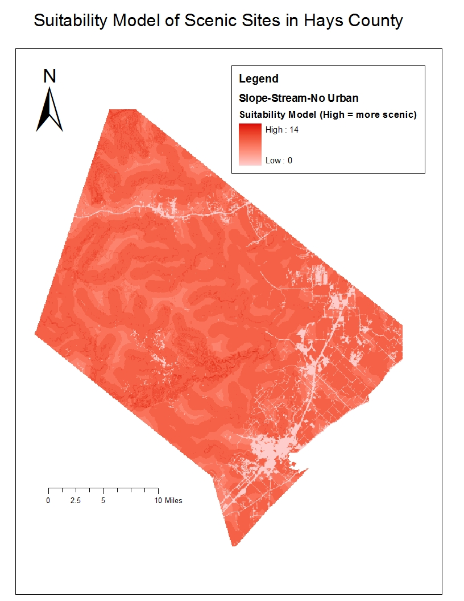

Figure 1. Scenic suitability model for Hays county using higher slope and proximity to water in non-urban areas as the criteria used to score areas in terms of scenic value. Areas scoring high on these scenic criteria are seen as more intensely red in this example.

Data Visualization

Current Period: Creating Visualization Tools within ArcMap
We used visual basic and ARC objects to facilitate quick assessment of model results by creating two tools (Figure 2). The first produced an inset map to show which area of the map you were currently viewing (InsetMap tool). The second worked with Google Earth such that you could zoom into your site within ArcMap and then simultaneously zoom to the same area in Google Earth (synchronized ArcMap-Google Earth) tool.

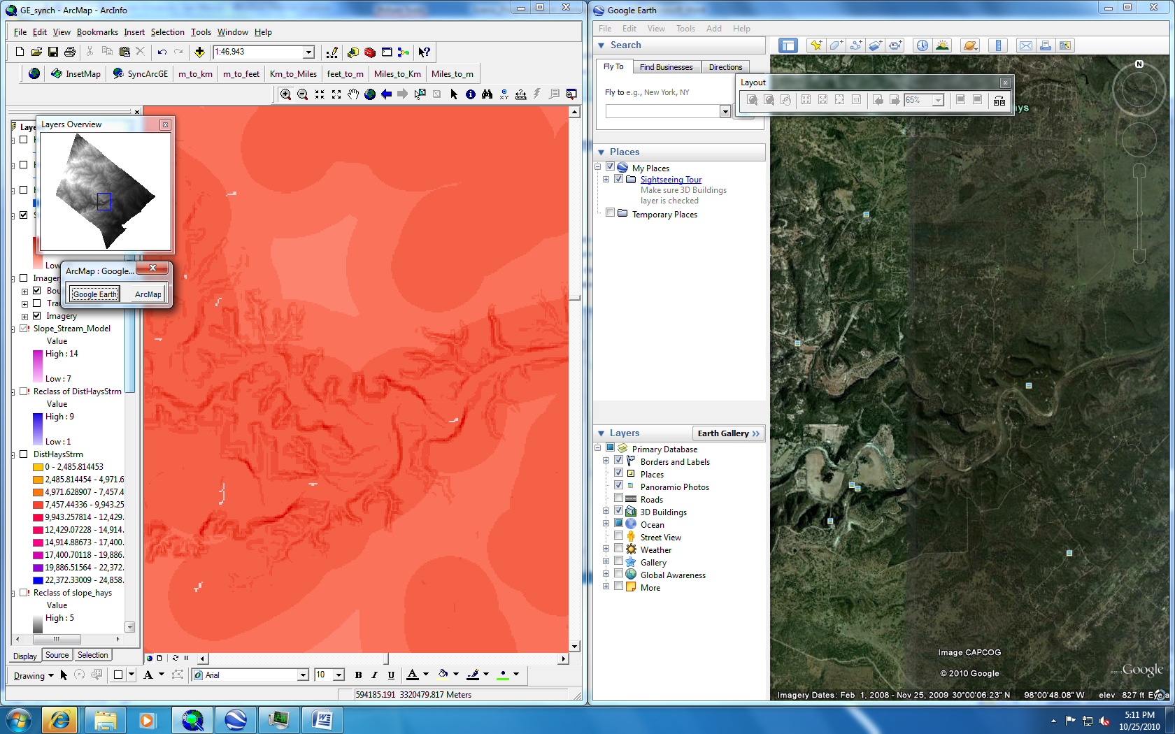
Figure 2. On the left, an area that scored higher in scenic value (dark red) is shown in ArcMap with its relative location in Hays county viewed on the inset map. On the right, the same area is simultaneously viewed in Google Earth by using the SynchArcGE (synchronized ArcMap-Google Earth) tool.

Next Period:
These tools will be utilized to validate that the model is truly identifying scenic areas. We will zoom into sites with higher scenic scores within ArcMap and will use the tool to simultaneously zoom into the same area within Google Earth to view it and assess its scenic attributes.
Arc scene
Arc Scene is an ESRI product that allows for the display of 3-D terrain data. While Arc scene itself will not be used in the actual analysis of the data, we can create a 3-D terrain map that can be manipulated to show what potential locations would look like (Figures 3a and 3b). This software can also be utilized to create short 3-D fly-through movies of the landscape that can be saved and exported into digital movie editing software. This is an option to provide additional media for use by the HCA & HCC to use with the public and legislators.
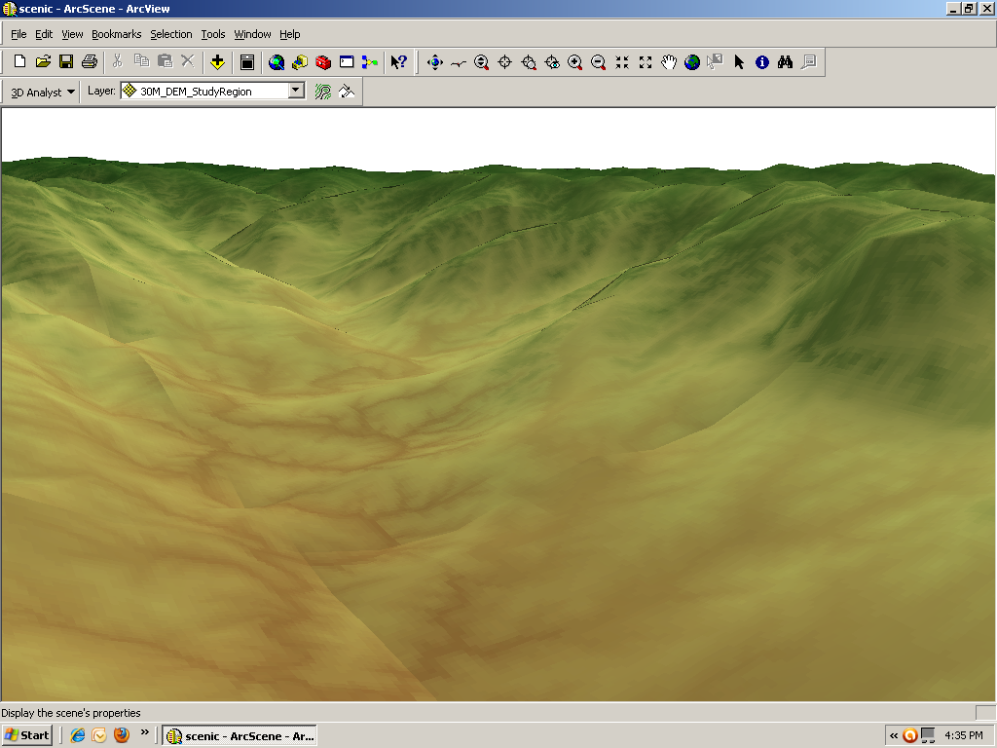

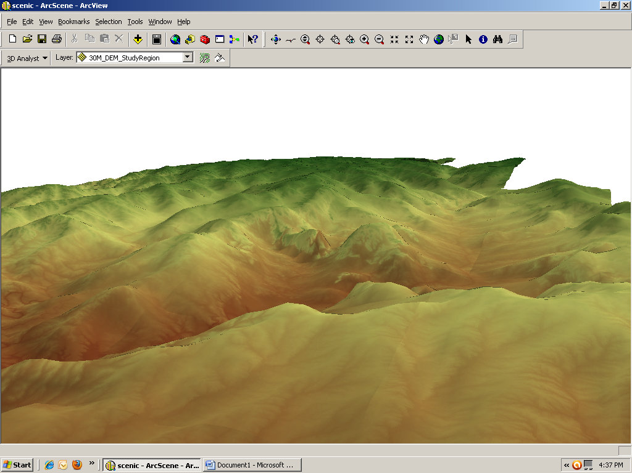

Figure 3a (above) and 3b (below). Views from ArcScene.

Viewshed Analysis Modifications and Strategies
Work was begun on creating a viewshed layer from roads, streams, and State Parks across the entire study region. The following details the challenges and steps taken to accomplish this task.
Previous Period. After two weeks of determining a methodology for viewshed analysis, we decided to attempt to run a separate viewshed from roads, streams, and State Parks because these are public throughways from which areas can be viewed. Running the analysis proved computationally complex and time intensive, and we determined that it was not feasible to run the viewshed from the roads, streams, and State Parks layers as is. In order to successfully run a viewshed analysis, a set of observer points needed to be created and applied to each of the layers i.e. the streams, roads, and State Parks. Random points were positioned along the roads and streams to serve as observation points. However, after running the viewshed across the entire study region, we determined that it was not feasible due to the high amount of processing associated with large DEM’s.
Current Period. Because running the viewshed across the entire study region was not possible, we have decided to attempt to run a viewshed on a county by county basis on the roads layers only (Figures 4). The reasoning behind using roads for the viewshed rests on the fact that HCC will be using these roads when implementing phase II of the project, and also because they are publically traveled areas that are visible to the public. If time permits then there will be consideration of additional viewshed analyses.
Next Period. After a viewshed has been run for each county based on roads, then they will be mosaicked together to form a seamless viewshed map of the entire study region. Next, we will apply scenic quality criteria to these viewable areas for further selection.

Conclusions
This proposal has described the techniques that will be used to determine possible areas of scenic beauty for the 22 county region of interest to the HCC and the HCA. We hope these techniques will provide the desired data for the following phases in the HCC AND HCA’s plan to locate and preserve the beautiful places in the Texas Hill Country. We look forward to your feedback.

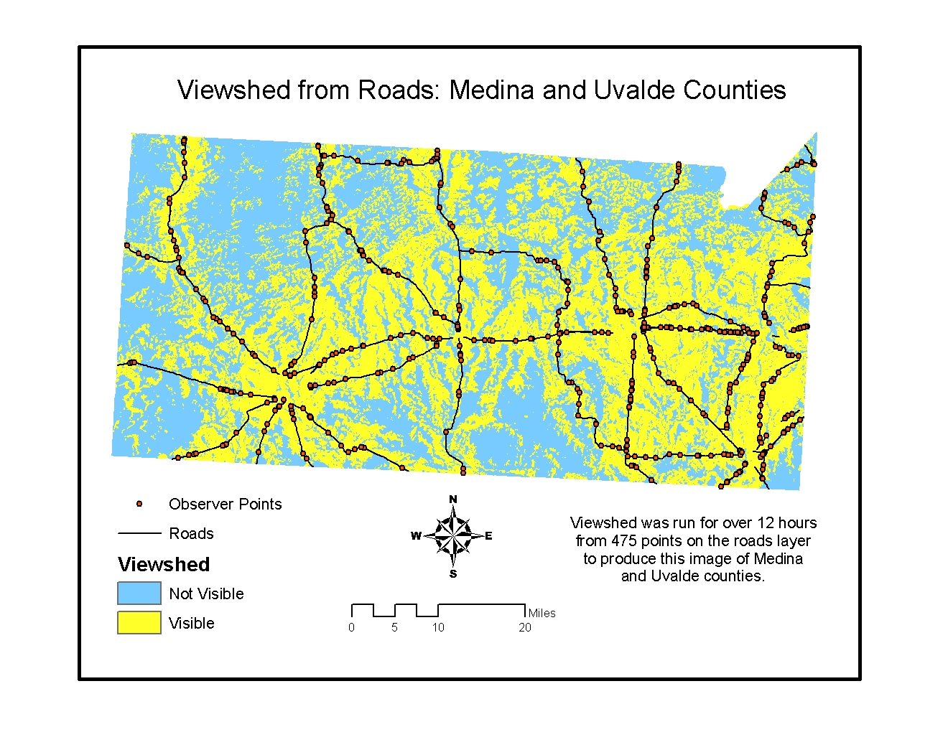Figure 4. Example of viewshed in 2 counties.
Figure 4.

References
ArcGIS 9.3. Environmental Systems Research Institute (ESRI), Redlands, CA, USA.
Bishop, I. D. and D. W. Hulse. 1994. Prediction of scenic beauty using mapped data and geographic information systems. Landscape and Urban Planning 30(1994):59-70.
Bureau of Land Management. 2007. Manual 8410 – Visual Resource Inventory. http://www.blm.gov/nstc/VRM/8410a.html (last accessed 21 September 2010).
Chhetri, P. and C. Arrowsmith. 2003. Mapping the potential of scenic views for the Grampians National Park. Proceedings of the 21st International Cartographic Conference (ICC), Durban, South Africa.
Franco, D. D. Franco, I. Mannino, and G. Zanetto. 2003. The impact of agroforestry networks on scenic beauty estimation - the role of a landscape ecological network on a socio-cultural process. Landscape and Urban Planning 62(2003):119-138.
Grêt-Regamey, A., A. Walz, and P. Bebi. 2008. Valuing ecosystem services for sustainable landscape planning in alpine regions. Mountain Research and Development 28(2):156-165.
Jackson, R. and C. Horyza. 2001. Integrating GIS technologies with the visual resource management inventory process, Technical Note 407. Bureau of Land Management, Denver, Colorado.
Johnston, K. M., R. DeBruyn. 2010. ArcGIS Spatial Analyst Suitability Modeling: San Diego, California. ESRI International User Conference 11-12. http://proceedings.esri.com/dvd/uc/2010/uc-index/uc/workshops/tw_547.pdf. (Last accessed October 3, 2010.)
Palmer, J. F. 2004. Using spatial metrics to predict scenic perception in a changing landscape: Dennis, Massachusetts. Landscape and Urban Planning 69(2004):201-218.
Shafer, E. L., J. F. Hamilton Jr., and E.A. Schmidt. 1969. Natural resources preferences: a predictive model. Journal of Leisure Research 1(1):1-19.

