Capital AreaTracking Services

Cody Clarke- Project Team Leader

Sherry Priddy-Project Assistant Team Leader

Jason Baker- Information Analyst

Les Stewart- Data Collection

Randy Guzman- Graphic Artist & Webmaster

Tracking of Feral Cat Colonies throughout Hays County

Prepared by:

C.A.T.S.

**Table of Contents**

Cover Page i

Title Page ii

Table of Contents iii

1. Introduction 1
   1. Background 1
   2. Project Summary 1
   3. Purpose and Goals 2
   4. Objectives 2
   5. Scope 2
2. Data 3
   1. Data Requisites 3
   2. Data Sources 3
3. Methodology 4
   1. Tools for Analysis 4
   2. Analysis Process 4
4. Final Deliverables 6
5. Conclusions 7
6. Appendix 8
   1. Project Timetable 9
   2. Project Budget 10
   3. Proposal Participation 11
7. **Introduction**

**1.1 Background**

San Marcos TNRM (Trap ~ Neuter ~ Release ~ Maintain) and its mother organization PALS (Pet Prevent A Litter of Central Texas) operates a comprehensive program throughout Hays County, Texas to reduce feral cat populations. *Felis Catus* or feral cat is usually the offspring of a lost or abandoned cat and avoids contact with humans. To reduce feral cat populations, they are safely trapped, neutered, and vaccinated by vets, returned back to their home territory after recovery, and maintained with food and care. San Marcos TNRM has grown extensively over the last several years and is now seeking a way to digitally document existing populations and analyze the source of growth.

**1.2 Project Summary**

Capital Area Tracking Services (C.A.T.S.) will work together with San Marcos TNRM (Trap ~ Neuter ~ Release ~ Maintain) and PALS (Pet Prevent A Litter of Central Texas) in order to create a comprehensive geodatabase and spatial information system that catalogs all feral cat colonies planted and maintained in Hays County by TNRM. Section 1 of this report will cover the purpose, goals, and objectives of this project. Section 2 describes potential data used and the associated sources. Section 3 covers the analysis and methodology to accomplish our project goals. Section 4 is a description of all the results and information the client will receive from this project. Section 5 concludes our project proposal. Section 6 contains the appendix with the associated project budget and timetable.

**1.3 Purpose and Goals**

This project will enable San Marcos TNRM to be more competitive in the search for federal grant money to help support their ongoing project. The project will accomplish two goals; 1) TNRM will meet compliance with City of San Marcos (COSM) ordinance 6.017 Feral Cat Management, which mandates the tracking of feral cat colonies; 2) this project will show where feral cat colonies are in regard to the local habitat and make future predictions of where new feral colonies may occur throughout the county.

In order to reach these goals, we will be using data provided to us by TNRM and various field studies determining exact colony locations. This will allow us to spatially reference the data over other layers of spatial data, including land use, census tracts, city limits, and roads and enable us to examine it from a spatial perspective.

**1.4 Objectives**

Our objectives for the project are to use ESRI’s ArcGIS to reference and plot feral cat colonies across Hays County and show the colony distribution across various types of land use. We will also compare the location of these feral cat colonies to human population density and average income levels based on census tracts. This information, when analyzed, will allow our team to examine the relationships between feral cat distributions and human activities.

**1.5 Scope**

The project area will consist of all municipal and political boundaries within Hays County, Texas. This project will take approximately 10 weeks to complete and all deliverables will be completed by December 7th, 2009 (See *Appendix – Timetable*).

**2.0 Data**

**2.1 Data Requisites**

The data needed to perform and complete the initial analysis will include the following key areas:

* + 1. A complete listing of all feral cats, including vaccinations, whether they are 'ear-tipped' or not, breed and color, sex, micro-chipped, and health.
    2. Where the exact locations of the area the feral cat had been both captured, and released after being spayed or neutered.
    3. The location of 'colonies', the areas where a caregiver visits periodically.
    4. Road networks, municipal and county boundaries, land use, and census data for Hays County will be needed for analysis and visual location purposes.

**2.2 Data Sources**

Data #1-3 will be supplied by Kate Shaw or through field work using GPS devices to mark the locations of feral cat colonies. This data will be in the form of a Microsoft Excel file format, *.xls. Data #4 will be obtained mainly from the Texas State University Geography database, located on the network drive Data on 'Dept of Geography Student File Server(Geo-server) (W: San Marcos/2007/City Files Obtained 15NOV2007). Some of the files that may be used from this particular location are as follows: Centerline (San Marcos Road layer), Counties (Hays county), Historic Neighborhoods, Neighborhoods, and Zoning.

Another area that we may retrieve and use data is the City of San Marcos web site, located at [www.ci.san-marcos.tx.us](http://www.ci.san-marcos.tx.us/). This site has already a few GIS interactive maps, including down-loadable files from the 'map library', which includes City Limit, City Streets, Development, Future Land Use, Historic Districts, and Zoning. Some of the useful information includes Trash Collection layer, which could pin-point areas that may have an infestation of feral cats.

**3.0 Methodology**

**3.1 Tools for Analysis**

The key software that will be used to perform our analysis of data is ESRI’s ArcGIS and Microsoft Excel.

**3.2 Analysis Process**

To complete our objectives of digitally referencing, mapping out, and predicting new feral cat colonies across Hays County, we will begin our analysis by first compiling all feral cat and caretaker information into a single formatted excel document. This will need considerable field work and GPS plotting to determine addresses and coordinates of the exact feral cat colony locations.

With this information, we will create a new point shapefile in ArcGIS of all cat colonies. Points will be plotted based on an 'address locater.’ This will allow for the 'geocoding' of all addresses with attribute information containing caretaker information and the number of cats at that location. The roads layer, census tracts, municipal land use, and political boundaries will then be added to the Arcmap document. All corresponding layers will be clipped to the Hays County boundaries.

1.5 mile buffers will be created around each cat colony. This buffer distance will be up for review by the team and client. It is perceived this buffer will allow for a determination of surrounding habitats which attract the feral cats to this location. After the buffers are created, a “select by location” operation will be performed to create new layers finding municipal land use, population density based on census tracts, and average income based on census tracts within the 1.5 miles buffers. With this data, we will be able to compare trends based on average income, population density, and the majority of municipal land use to determine if these factors are contributing the location of a feral cat colony. Tables and charts will be created displaying the primary land use, average income, and population density surrounding each cat colony. As habitat trends are determined, the original census tract layer and land use layer will then be converted to rasters. The divide tool will be used to place each raster on a common scale with “1” being the determined trend and “0” being all other criteria.

The team will then use Spatial Analyst’s single output map algebra by adding the “1” criteria that attracts feral cats to certain location, whether that be low income or majority residential uses. This will perform a spatial overlay of all layers. After performing the function, a new, trend based layer is created and will predict where feral cat colonies may appear in the future.

After static maps are created with an option to use Adobe Illustrator (To create visually striking maps), the team will then export feral cat colonies, buffers, and prediction trend layer to Google Earth with callout boxes including colony caretaker and number of cats. This will provide all interested parties a user-friendly interface for spatial observation of Hays County feral cat colonies.

**4.0 Final Deliverables**

Upon completion of this project, the client will receive a detailed report of the team’s project summary and purpose, the data used, the analyses and findings, conclusions, and metadata. Maps of the following will be provided:

1. Feral cat colonies in Hays County based on size
2. Feral cat colonies in Hays County based on size with 1.5 mile buffers
3. Feral cat colonies in Hays County and municipal land use
4. Feral cat colonies in Hays County and census tracts with average income
5. Feral cat colonies in Hays County and census tracts with population density
6. Feral cat colonies in Hays County, 1.5 miles buffers and corresponding land use, average income labels, and population density labels in each buffer area
7. Feral cat colonies in Hays County based on size and prediction trend layer

These will be accompanied by a power point presentation to the client summarizing our work and findings. The client will also receive two copies of a CD containing all excel and ArcGIS data, metadata, the report, a wall poster, a power point presentation, and instructions of how to use the CD. A professional poster summarizing our project will be displayed in the Texas State University Evans Liberal Arts building. A “C.A.T.S.” website will also be available containing all data, information on the project, and team members involved. Testing will be performed on all files of this CD and website to ensure that all data is free of corruption and usable for the client and all interested parties.

**5.0 Conclusions**

Our team believes this project is very worthwhile and will be an invaluable resource to TNRM regarding the organization of their cat data. This will be a wonderful tool in applying for grant money in support of TNRM’s project, in addition to helping them meet compliance with the City of San Marcos ordinance 6.017 Feral Cat Management. Finally, this will allow TNRM to make future predictions of where new or unknown feral colonies may occur throughout the county. We are delighted to be working on such a helpful project and look forward to working with TNRM in our completion of these goals in order to better assist them over this fall.

**6.0 Appendix**

**6.1 Project Timetable**

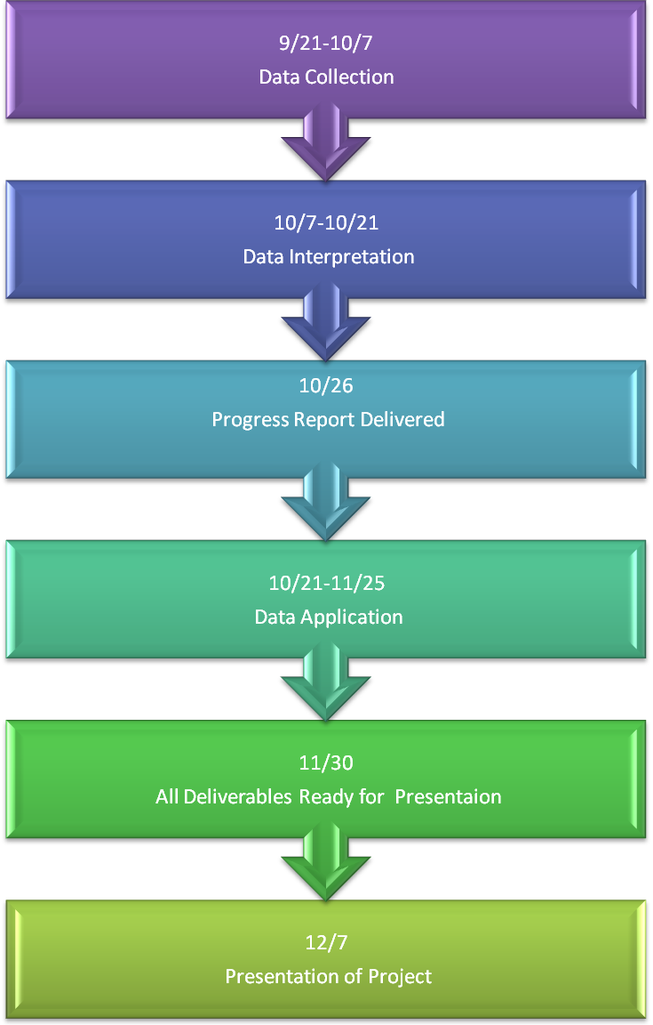

|  |  |
| --- | --- |
| **6.2 Project Budget** |  |

**6.3 Proposal Participation**

Cover Page Sherry Priddy, Project Assistant Team Leader

Randy Guzman, Graphic Artist and Webmaster

Title Page Sherry Priddy, Project Assistant Team Leader

1.0 Introduction Jason Baker, Information Analyst

1.1 Project Summary Jason Baker, Information Analyst

1.2 Purpose and Goals Jason Baker, Information Analyst

1.3 Objectives Jason Baker, Information Analyst

1.4 Scope Jason Baker, Information Analyst

2.0 Data Les Stewart, Data Collection

2.1 Data Requisites Les Stewart, Data Collection

2.3 Data Sources Les Stewart, Data Collection

3.0 Methodology Cody Clarke, Project Team Leader

3.1 Tools for Analysis Cody Clarke, Project Team Leader

3.2 Analysis Process Cody Clarke, Project Team Leader

4.0 Final Deliverables Cody Clarke, Project Team Leader

5.0 Conclusions Jason Baker, Information Analyst

6.0 Appendix

6.1 Project Timetable Sherry Priddy, Project Assistant Team Leader

6.2 Project Budget Randy Guzman, Graphic Artist and Webmaster

6.3 Proposal Participation Cody Clarke, Project Team Leader

*All Editing by Cody Clarke, Project Team Leader, and Sherry Priddy, Project Assistant Team Leader