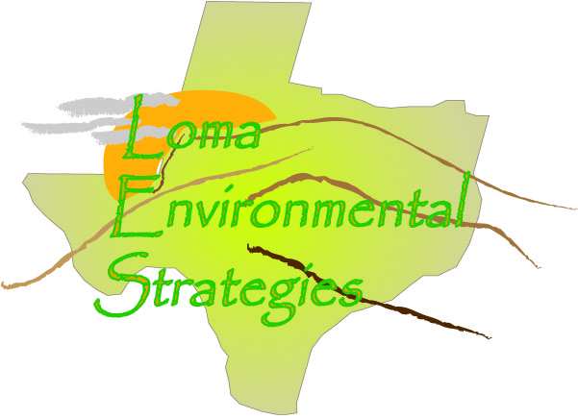
19 November 2008
Contact: Mrs. Kelley V. Shultz (Chief Appraiser)
County: Real
Contact Information: 830-232-6248

COUNTY RECORDS QUESTIONAIRE
- How do you keep track of land use in the county?

As each property sells the land use is updated. The county is divided into thirds and one third is assed each year so that the entire county is reappraised every three years. A survey is sent to 1/3 of the land owners at time and use is determined through the survey. The CAD uses a property classification system that was developed by the State Comptroller’s Office. This guide should be available on-line at www.window.state.tx.us/taxinfo/proptax

- Are the changes recorded in digital format, such as CAD and Shapefiles, or are they recorded on a paper map?
The CAD currently uses software to map the parcels, and records are searchable with True Automation.
- What data is kept about each parcel? Do you have data about what the land is used for?

The county uses the Standard State Property Tax land use codes to identify the use that the property is being appraised at.

- What county departments are interested or could benefit from knowing land use information?

The other taxing entities are more interested in the appraised value, rather than the land use information. That is more of a internal department need

- How many parcels of land are in Real County?
8000
- How often are the parcel records updated?
The records are updated when they are reappraised at least every three years. Ownership and legal description is updated as properties transfer, and as platting occurs.

- How many subdivisions are in this county?
No response
8. Are the records accessible on the internet?
Yes. But there is not a query function to select by land use. The
- Who is the person designated to keep records on individual land parcels in Real County?
The appraiser’s office

- What assistance would help Real County improve its tracking and management of land use and parcel changes?

More budget resources.

Summary
Real County not only is one of the smallest counties with respect to area, it is one of the least populated. Aside from the few towns the county is rural and agricultural in nature. The rugged canyons and arroyos around the county hinder growth somewhat. Real County is only serviced by US 83 and does not have a direct highway to San Antonio. Much of the future growth in the area is likely to be retirees from Austin and San Antonio.

