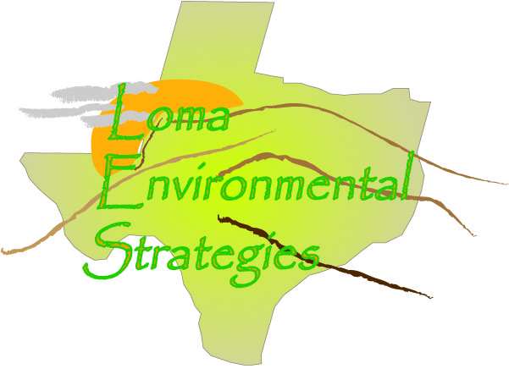
8 October 2008

Mr. Bla Bla
Tax Assessor Collector
Kimble County
Kimble County CAD
1234 Whatever Dr.
Uvalde, TX 78666

Dear Mr. Bla Bla:

I am writing as the representative of a group participating in a GIS (Geographic Information Science) project at Texas State University-San Marcos. We have been assigned to work with the Hill Country Alliance (HCA), a non-profit advocacy group for preservation of the Texas Hill Country, to participate in developing informational resources related to the region. Ultimately the goal of our work with HCA is to facilitate the responsible growth and cost effective expansion of infrastructure and residential and commercial development in the region, while promoting conservation, maintaining the quality of our water resources, and preserving the aesthetics of the Hill Country. Texas is in the unique position of having limited land use planning tools in place which limits the ability of local governments and organizations to monitor zoning of properties. Our project involves the creation of land use information and corresponding maps to provide the tools necessary to promote land use awareness.

To facilitate our research it is necessary for us to evaluate how each county in the Texas Hill Country tracks and disseminates information about land use. Since there is not a standardized means of tracking land use among the counties we would like to assess the practicality of developing a regional standard which would allow the effective assessment of current and projected land use. That is where we need your help. Attached is a questionnaire that will provide us with the initial information we need to develop a primary means of monitoring land use data.

It may prove beneficial after receipt of the questionnaire if I or a colleague contact you by phone, or personally, to discuss the project. My contact information is jb1615@txstate.edu or (512) 554-1948.

Thank you for your time.

Respectfully,

//signed//

Joseph G. Butler
LOMA Data Manager

Loma Environmental Strategies
Manager: Jason Arbogast
Asst. Manager: Staś Moszynski
Analyst: Chris Robertson
Data Management: Garrett Butler

Cc: Jason Arbogast (ja1262@txstate.edu )

Enclosure

County Records Questionnaire

How do you keep track of land use in the county?
Are the changes recorded in a digital format, such as CAD and Shapefiles, or are they recorded on a paper map?
What data is kept about each parcel? Do you have data about what the land is used for, such as whether it is used for agriculture, commercial development, industrial or residential?
What county departments are interested or could benefit from knowing land use information?
How many parcels of land are in this county?
How often are the parcel records updated?
How many subdivisions are in this county?
Are the records accessible on the internet?
Who is the person designated to keep records on individual land parcels in this county? What is their contact information, telephone and email?
What assistance would help your county improve its tracking and management of land use and parcel changes?

