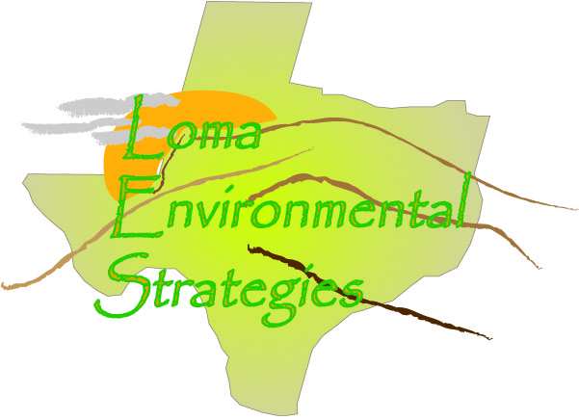
19 November 2008
Contact: Ms Kandy Dick (Chief Appraiser)
County: Kimble
Contact Information: 325-446-3717

COUNTY RECORDS QUESTIONAIRE
- How do you keep track of land use in the county?

As each property sells the land use is updated. The county is divided into thirds and one third is assed each year so that the entire county is reappraised every three years. The CAD uses a property classification system that was developed by the State Comptroller’s Office. This guide should be available on-line at www.window.state.tx.us/taxinfo/proptax

- Are the changes recorded in digital format, such as CAD and Shapefiles, or are they recorded on a paper map?
The CAD currently uses ESRI software to map the parcels; this work is contracted out of house.
- What data is kept about each parcel? Do you have data about what the land is used for?

The county uses the Standard State Property Tax land use codes to identify the use that the property is being appraised at.

- What county departments are interested or could benefit from knowing land use information?

The school district and other special districts are only interested in the appraised value and not that much interested in the current use of the land. There is an Ag board in Kimble County that is interested in the agricultural and wildlife use of the lands in Kimble County

- How many parcels of land are in Kimble County?
9660
- How often are the parcel records updated?
The records are updated when they are reappraised at least every three years. Ownership and legal description is updated as properties transfer, and as platting occurs.

- How many subdivisions are in this county?
Approximately 10 or 12
8. Are the records accessible on the internet?
Yes, at http://co.kimble.tx.us
- Who is the person designated to keep records on individual land parcels in Kimble County?

Kandy Dick, Chief Appraiser: 325-446-3717

- What assistance would help Kimble County improve its tracking and management of land use and parcel changes?

Kimble County has limited budget and mapping is one of the first expenses to be cut

Summary
The county has seen an increase of retirees buying land and there is growing demand for hunting and wildlife lands. The CAD is not involved in regional planning but does work with the TAAD and has quarterly meeting with 13 surrounding counties appraisal districts. The CAD is more reactionary in dealing with growth and does not have policy making authority.
As the land sells the CAD updates the parcel record, also each property is reappraised every three years on a revolving schedule. The CAD uses ESRI to map to parcel and currently contracts the work out of house. Since Kimble County is a small resource deficient and poor there is not much of a budget for mapping but there is an initiative started by the state comptroller to map the lands. The land use is identified according to the Texas state property tax codes. There is an Ag board that is interested in land use and tracking changes from pure agriculture to wildlife and hunting resource use. There are 9,660 parcels and 10-12 subdivisions in the county. Website of property records updated recently and will reflect the 2008 values in about a week or so (November 24).
Overall Kimble County allows easy exchange of public records. The only limiting factor to a GIS professional is the time and distance away from the main population areas. Any participation in a regional land use group or research would have to be provided free of charge to the county.

