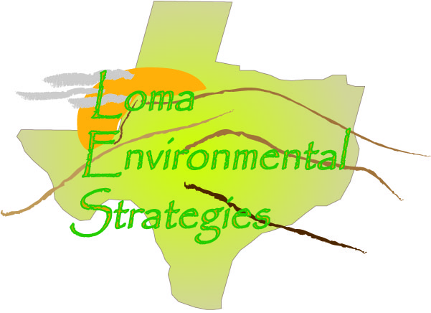
12 November 2008

Mr. David Valle
Chief Appraisal Officer
Hays County
Hays County CAD
P.O. Box 308
San Marcos, TX 78666

Dear Mr. Valle:

I am writing as the representative of a group participating in a GIS (Geographic Information Science) project at Texas State University-San Marcos. We have been assigned to work with the Hill Country Alliance (HCA), a non-profit advocacy group for preservation of the Texas Hill Country, to participate in developing informational resources related to the region. Ultimately the goal of our work with HCA is to facilitate the responsible growth and cost effective expansion of infrastructure and residential and commercial development in the region, while promoting conservation, maintaining the quality of our water resources, and preserving the aesthetics of the Hill Country. Texas is in the unique position of having limited land use planning tools in place which limits the ability of local governments and organizations to monitor zoning of properties. Our project involves the creation of land use information and corresponding maps to provide the tools necessary to promote land use awareness.

To facilitate our research it is necessary for us to evaluate how each county in the Texas Hill Country tracks and disseminates information about land use. Since there is not a standardized means of tracking land use among the counties we would like to assess the practicality of developing a regional standard which would allow the effective assessment of current and projected land use. That is where we need your help. Attached is a questionnaire that will provide us with the initial information we need to develop a primary means of monitoring land use data.

It may prove beneficial after receipt of the questionnaire if I or a colleague contact you by phone, or personally, to discuss the project. My contact information is jr48864@txstate.edu or (512) 296-0100.

Thank you for your time.

Respectfully,

//signed//

Chris Robertson
LOMA Analyst

Loma Environmental Strategies
Manager: Jason Arbogast
Asst. Manager: Staś Moszynski
Analyst: Chris Robertson
Data Management: Garrett Butler

Cc: Jason Arbogast (ja1262@txstate.edu )

Enclosure

County Records Questionnaire

What methods are used to keep track of land use in the county?
Deed Records
Are the changes recorded in a digital format, such as CAD and Shapefiles, or are they recorded on a paper map? Ownership Changes are recorded in digital format.
What data is kept about each parcel? Do you have data about what the land is used for, such as whether it is used for agriculture, commercial development, industrial or residential?
Is not indicated on the map but is kept in the Hays CAD database.
Yes, there should be information on each account that identifies what the property is used for.
What county departments are interested or could benefit from knowing land use information?
All Hays CAD departments could benefit.
How do these departments interact with each other?
In person, phone and E-Mail.
How many parcel of land ownership records are in this county?
Approx. 75,000
How often are parcel records updated?
Daily basis.
How often are the updated records made available to the public?
Quarterly.
How many residential subdivisions are in this county? I will run a report and get this information to you as soon as possible.
There are approx. 2,078 Subdivisions in Hays County. This includes residential and commercial. I could not break it up into residential.
Are the records accessible on the internet?
Yes
Who is the person or department designated to keep records on individual land parcels in this county? What is their contact information, telephone and email?
Gilbert Natal, GIS Coordinator @ 512-268-2522 Ext.234. E-mail is gnatal@hayscad.com

What assistance would help your county improve its tracking and management of land use and parcel changes?
Not sure

SUMMARY:
Deed Records are used to keep track of land use in the county and ownership changes are recorded in digital format. Land use is kept in the Hays CAD database as there is information on each account that identifies what the property is used for. All Hays CAD could benefit from knowing land use information if available. Agencies communicate in person, over the phone and e-mail. Gilbert Natal, GIS Coordinator is responsible for keeping land parcel records. His contact information is @ 512-268-2522 Ext.234 and E-mail is gnatal@hayscad.com. Parcel records are updated on a daily basis and are made available quarterly. There are approx. 2,078 Subdivisions in Hays County (residential and commercial) with approximately 75,000 parcels. Land records are accessible on the internet at www.hayscad.com

