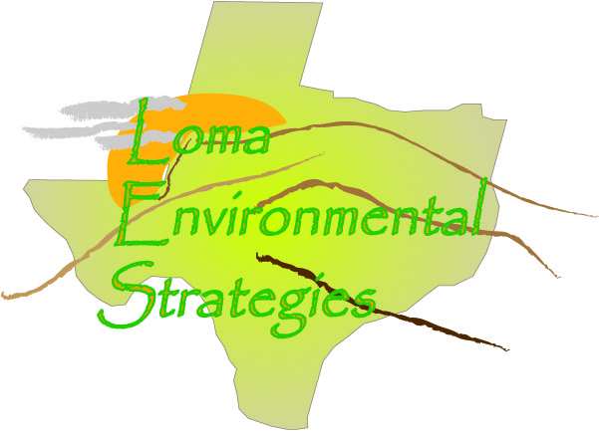
3 November 2008
Contact: Mr. Barnes (Chief Appraiser)
County: Bandera
Contact Information: bancad@indian-creek.net (830) 796-3038

COUNTY RECORDS QUESTIONAIRE
- How do you keep track of land use in the county?

The CAD uses a property classification system that was developed by the State Comptroller’s Office. This guide should be available on-line at www.window.state.tx.us/taxinfo/proptax

- Are the changes recorded in digital format, such as CAD and Shapefiles, or are they recorded on a paper map?
Ownership boundaries, floodplain and soil types are maintained in our GIS system (ESRI software) other information pertaining to land use is maintained in our appraisal software, PACS which is a product of True Automation, Inc..
- What data is kept about each parcel? Do you have data about what the land is used for?

Info that is kept about each parcel include: legal description; size; improvements; use; etc.

- What county departments are interested or could benefit from knowing land use information?

Any department that is directly involved with land use, such as: Road and Bridge, County Engineer; River Authority and Groundwater District.

- How many parcels of land are in Kendall County?
34,271
- How often are the parcel records updated?
The records are updated when they are reappraised at least every three years. Ownership and legal description is updated as properties transfer, and as platting occurs.

- How many subdivisions are in this county?
Approximately 300, this count includes each unit within a subdivision
8. Are the records accessible on the internet?
Yes, at www.banderaproptax.org.
- Who is the person designated to keep records on individual land parcels in Kendall County?

Ed Barnes, Chief Appraiser: 830-796-3039, bancad@indian-creek.net

- What assistance would help Kendall County improve its tracking and management of land use and parcel changes?

Expansion of in-house resources and personnel.

Summary
For Bandera County, land is mapped using a property classification system developed by the State Comptroller’s Office. Data is updated in their GIS system. Data about the parcels are identified by the PID which is unique to whether it is agriculture, industrial, residential, etc. Any department that is directly involved with land use, such as: Road and Bridge, County Engineer; River Authority and Groundwater District, as well as emergency services. Data is updated at least every 3 years or when ownership and legal description is updated and as platting occurs.

