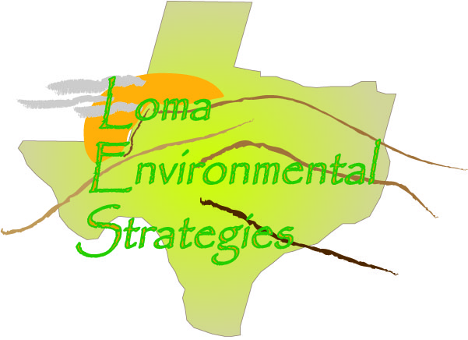
12 November 2008

Mrs. Amy Hulbert
Chief Appraisal Officer
Blanco County
Blanco County CAD
P.O. Box 308
Johnson City, TX 78283

Dear Mrs. Hulbert:

I am writing as the representative of a group participating in a GIS (Geographic Information Science) project at Texas State University-San Marcos. We have been assigned to work with the Hill Country Alliance (HCA), a non-profit advocacy group for preservation of the Texas Hill Country, to participate in developing informational resources related to the region. Ultimately the goal of our work with HCA is to facilitate the responsible growth and cost effective expansion of infrastructure and residential and commercial development in the region, while promoting conservation, maintaining the quality of our water resources, and preserving the aesthetics of the Hill Country. Texas is in the unique position of having limited land use planning tools in place which limits the ability of local governments and organizations to monitor zoning of properties. Our project involves the creation of land use information and corresponding maps to provide the tools necessary to promote land use awareness.

To facilitate our research it is necessary for us to evaluate how each county in the Texas Hill Country tracks and disseminates information about land use. Since there is not a standardized means of tracking land use among the counties we would like to assess the practicality of developing a regional standard which would allow the effective assessment of current and projected land use. That is where we need your help. Attached is a questionnaire that will provide us with the initial information we need to develop a primary means of monitoring land use data.

It may prove beneficial after receipt of the questionnaire if I or a colleague contact you by phone, or personally, to discuss the project. My contact information is jr48864@txstate.edu or (512) 296-0100.

Thank you for your time.

Respectfully,

//signed//

Chris Robertson
LOMA Analyst

Loma Environmental Strategies
Manager: Jason Arbogast
Asst. Manager: Staś Moszynski
Analyst: Chris Robertson
Data Management: Garrett Butler

Cc: Jason Arbogast (ja1262@txstate.edu )

Enclosure

County Records Questionnaire

What methods are used to keep track of land use in the county?
Each parcel is coded with a letter and a number to designate which state property tax code it is.
Examples are:
A1=Single Family Residence in the City,
A2=Single Family Mobile Home in the City
B2=Duplex
C1=Vacant Lot in the City
C3=Vacant Lot out the City
D1=Rural Land
E1=Single Family Residence out of the City
E2=Single Family Mobile Home out of the City.
Are the changes recorded in a digital format, such as CAD and Shapefiles, or are they recorded on a paper map? We have a GIS digital Mapping System
What data is kept about each parcel? Do you have data about what the land is used for, such as whether it is used for agriculture, commercial development, industrial or residential?
Each parcel is on the internet at www.trueautomation.com. The State Property Tax Codes are on the internet.

What county departments are interested or could benefit from knowing land use information?
Not sure any would be.

How do these departments interact with each other?
Only so-so it is a small county
How many parcel of land ownership records are in this county?
15,000 plus
How often are parcel records updated?
Deed changes are done monthly.
How often are the updated records made available to the public?
The public can request a listing of the whole county for $135.00.
How many residential subdivisions are in this county?
Over 100.

Are the records accessible on the internet? Yes at www.trueautomation.com.

Who is the person or department designated to keep records on individual land parcels in this county? What is their contact information, telephone and email?
The mapper is LeeGay McVay. Her office is in the Courthouse Annex. 830-868-7036.

What assistance would help your county improve its tracking and management of land use and parcel changes? Not sure

SUMMARY:
In order to keep track of land use in the country each parcel is coded with a letter and a number to designate which state property tax code it is. Some examples are A1=Single Family Residence in the City, A2=Single Family Mobile Home in the City, B2=Duplex, C1=Vacant Lot in the City, C3=Vacant Lot out the City, D1=Rural Land, E1=Single Family Residence out of the City, E2=Single Family Mobile Home out of the City. GIS mapping maintains records in a digital format using shapefiles. Each parcel record is on the internet at www.trueautomation.com. The State Property Tax Codes are on the internet. It is unknown what other agencies would benefit from land use information. In person, phone, and Email communication is used between agencies in Blanco County. There are over 100 subdivisions with approximately 15,000 plus parcels. Deed changes are updated monthly with the ability for the public to purchase a total listing of records for $135.00. County mapper is LeeGay McVay and she can be contacted at (830) 868-7036.

