- Introduction
1.1 Purpose
The Texas Hill Country is one of the fastest growing regions in the country and is a popular tourist destination. Hays, Comal and Kendall counties are among the 100 fasted growing counties in the nation. Without a comprehensive sustainable development plan the area’s scenic waterways, recreational areas, and vast open lands may be converted into subdivisions, roadways, and retail properties without proper consideration of environmental factors. The creation of a GIS containing current land-use data such as extra territorial jurisdictions, parks, groundwater conservations districts, and most importantly, parcels and subdivisions will allow current and future citizens to take a proactive role in the responsible development of the land. Very often political boundaries do not coincide with environmental boundaries (rivers, streams, watersheds). Usually laws, regulations, and ordinances fall within these political districts so it is difficult to properly implement meaningful environmental guidelines. For example, if a sensitive recharge zone falls within two counties it is necessary for both counties to work together to protect the area or little progress will be made. Terra Corp’s goal is to aid in the process of making political and environmental boundaries more unified. The culmination of this project is the merger between environmental and land-use data to create up-to-date, interactive maps for the preservation of the Texas Hill Country.

1.2 Problem Statement
The objective of this project is to develop an easily updatable and maintainable GIS database of land-use for the seventeen county region that comprises the focus area of the Hill Country Alliance. Upon completion the land-use database will be combined with an environmental vulnerability database created by AquaKESKA. The resulting collective database will provide the backbone for a web-based, interactive interface to be used by citizens, landowners, planners, developers, and public officials for the purpose of understanding the impact urban growth is having on the hill country and providing a tool to develop a regional policy planning initiative and a model for sustainable growth. The project aims to encourage residents to gain knowledge of the fragility of the Texas Hill Country and to inspire participation in the promotion of responsible growth.

1.3 Scope
This project encompasses the seventeen counties that make up the Texas Hill Country: Mason, Kimble, Gillespie, Llano, Burnet, Blanco, Travis, Uvalde, Medina, Bexar, Kerr, Kendall, Comal, Hays, Edwards, Real, and Bandera.

2.0 Literature Review
2.1 Austin City Connection, “2003 Land Use Inventory Overview and Methodology”
Every five years since 1990 the Long Range Planning Group (LRP) has created GIS land use inventories for the Austin area. For this study a list of needs and problems were identified. Of these, three relate specifically to Terra Corps’ project:
- Source information from other agencies is in non-GIS forms.
- Create data that would be fairly easy to update.
- Study area to include areas outside City jurisdiction.
Like LRP, our team was aware that during the course of our project for the Hill Country Alliance we would encounter a significant amount of data in non-GIS forms. One of our main goals, similar to LRP, was to use data collected to create a database that is easily updatable. The study area for the LRP project was much smaller than our study area but it provides an example of a successfully completed study with goals similar to our own.
In the LRP study data was acquired using two distinctive methods. Most land use data was attained from appraisal records. The second method of analyzing aerial photos was used only when appraisal records were incomplete or inaccurate. Terra Corps was able to determine from LRP’s description of data acquisition techniques that using appraisal district records is more accurate and time efficient than the use of aerials.
LRP used ESRI’s ArcGIS 8.3 to create, edit, and maintain geodatabases as well as to convert data into usable formats. For our project the data manipulation phase was completed using ESRI’s ArcGIS 9.2.
2.2 Jagadish, K. S., Sudhira, H. S. and Ramachandra, T.V., “Urban Sprawl Recognition and Modeling Using GIS”
It is planned that in the future Terra Corps’ database will be used by the Hill Country Alliance to create a growth model for the hill country. A study in India determined patterns of urban sprawl and analyses of spatial and temporal changes through the use of GIS. This was done to help plan the creation of proper infrastructure facilities. The rapid population growth in India can be compared to the rapid influx of people into the Texas Hill Country. Although, the problems of India are of a different nature this study can be used as a model. The urban sprawl model created for India shows how GIS can be utilized to create a similar model for the Texas Hill Country.

2.3 Fitzpatrick, T., “Sharing Interactive Maps”
In the past garnering information from GIS applications was limited only to highly trained GIS professionals. Interactive maps have changed this accessibility. They allow information to be distributed to the general public via the internet. In addition to broadening the usability of GIS, interactive maps allow up-to-date information to be added to centralized databases independently of the interactive map. An example of this that pertains to our project is updating parcel information for counties as it becomes available. The culmination of our project for the Hill Country Alliance is an interactive map available to the public for the purpose of understanding development in the hill country.

2.4 City of Chicago Department of Zoning, Interactive Map
The city of Chicago has created an interactive website that allows users to determine the zoning classification for any area of the city. The site is specifically designed to be easily navigable and updatable with the most current information. Before the user can view the interactive map he/she must agree to a disclaimer stating that the City of Chicago has done everything within their means to create an accurate product but claims no responsibility for damages or losses that may occur through the use or misuse of the website. They express that most visualizations are approximate and that they cannot guarantee the completeness, accuracy, quality or content of data.
Both the interface design and liability clause for the City of Chicago interactive map are perfect examples of what Terra Corps is aiming to achieve for the Texas Hill Country. Although Terra Corps is working at a much larger scale, many of the layers to be displayed are the same on the Chicago map: parcels, railroads, rail stations, streets, water features, parks, preserves, and city limits. Many of the available tools are also the same tools that Terra Corps will be using for the hill country interactive map: zoom in, zoom out, identify, and search.
Because the data Terra Corps is using is all secondary data we can not guarantee its spatial accuracy or the quality of its attribute data or metadata. We have been aware since the inception of this project that a disclaimer would be necessary to prevent liability issues for both Terra Corps and the Hill Country Alliance. The Chicago Zoning Department’s Liability clause will serve as a template for the interactive map we are creating.

3.0 Data
All data used is secondary; no primary data was gathered. Two specific types of data were collected. Some needed data was available covering the entire 17 county study area. Other data had to be acquired for individual counties or cities. Three methods were utilized to collect data: searching reputable online databases, contacting city and county offices and officials, and contacting private businesses and organizations.
All data acquired was projected in NAD83 UTM zone 14N and into the GCS_North_American_1983 coordinate system.
The following data was acquired for all counties:
- Federal lands
Source: ESRI.com
Spatial data includes Military bases, wildlife refuges, and national historic sites. Attribute data includes type of feature, name of feature, and acreage.
- Cities
Source: ESRI.com
Spatial data includes City centers. Attribute data includes name, 2000 census population counts, and estimated 2005 population.
- Rail terminals
Source: ESRI.com
Attribute data includes name and type.
- CCNwater (Certificate of Convenience and Necessity)
Source: Texas Commission on Environmental Quality (TCEQ). Attribute data includes name and last update.
- CCNsewer (Certificate of Convenience and Necessity)
Source: Texas Commission on Environmental Quality (TCEQ).
Attribute data includes name and last update.
- City limits
Source: ESRI.com
Attribute data includes name, 2000 census population, estimated 2005 population, and area.
- Groundwater Conservation Districts
Source: Texas Water Development Board
Includes districts covering the Hill country. Many districts extend beyond the boundaries of the 17 county region. Attribute data includes short name, official name, creation method, creation date, confirmation date, confirmation status, county, square miles, and groundwater code.
- Municipal Utility Districts
Source: Texas Commission on Environment (TCEQ)
Attribute Data includes area, perimeter, name, county, acres, and district.
- Parks
Source: ESRI.com
Grouped into state and local parks. Attribute data includes name, jurisdiction, and area.
- Block Groups
Source: Census.gov
Includes 1990 and 2000 census data for all 17 counties.
- Surrounding Counties
Source: ESRI.com
Incorporates the Counties surrounding the 17 Hill Country Alliance counties. Included as a geographic reference for map users. Attribute data includes all census data including 2005 population estimations and square mileage of each county.
These data layers were used to create a foundation upon which to add county level data for the Texas Hill country and were deemed essential and necessary to display the data and to facilitate future analyses properly. These layers enable us to display the 17 counties and cities of the Texas Hill Country and show some of the basic uses of land within them.
The remaining data collected had to be acquired for individual counties due to its detailed nature. Most county data was acquired by contacting individuals directly within the county governments. Some county data was available online and free to download.
The following data was collected for each county:
- Medina County
Medina Parcels and subdivisions
Received layers from Mr. Henry Hagemeier of the Appraisal District. Received through e-mail.
- Bexar County
2007 Bexar County Parcels
Data was provided by Colby Free of the Bexar County Information Services
Received CD containing all data.
- Kerr County
ETJs of the cities of Ingram and Kerrville.
Parcel Data for county.
Data provided by Kerr Central Appraisal District.
Received CD containing all data.
- Kendall County
Parcel and subdivision data for Kendall County and Boerne city limits.
All data provided by Becky Meyer of Kendall County 911 Addressing.
Received through e-mail.
- Comal County
Received City of Bulverde ETJ, parcel data for Comal County, city of Schertz
ETJ and New Braunfels ETJ.
All data provided by Comal County Engineers Office and Subdivision Regulation
Department.
Received through e-mail.
- Hays County
Received Subdivision data for Hays County, and ETJ data for all major cities in Hays County. All data provided by Hays County GIS/ 911 Addressing Division, except for parcel data. Received through e-mail. Parcel data for Hays County was obtained from the CAPCOG website.
- Bandera County
Received parcel data for Bandera County.
Data Provided by Glen Taylor, Bandera County Appraisal GIS operator.
Received data containing all data.
- Travis
Obtained parcel data, ETJ and subdivision data.
All data provided is from the city of Austin GIS department and is available for download through their website. (http://www.ci.austin.tx.us)
- Gillespie
Received parcel data.
Data provided by David Oehler of the Gillespie County Appraisal District.
Received through e-mail.
- Burnet
Received parcel data and ETJs for all cities. All data provided by David Vaughn, city planner of Burnet County.
Received DVD containing all data for Burnet County.
We were able to acquire individual data from ten out of the seventeen counties. The following counties were not able to provide us with any additional data or it was beyond our abilities and/or resources to acquire them: Edwards, Real, Blanco, Uvalde, Llano, Mason, Kimble.
Parcel, subdivision, and ETJ data was relevant to our project in order to properly display human presence in the area. Combining these data with aquaKESKA’s environmental model will allow for preliminary assessment of human impact in the region. Data was given to AquaKESKA for incorporation into the IMS.

4.0 Procedure
Each member of Terra Corps was assigned three or four counties out of seventeen counties in the in the hill country region. These counties comprise the focus area of the Hill Country Alliance. Each group member attempted to obtain as much pertinent data as possible for their assigned counties. Data collection was carried out in three ways: searching existing data in online databases, contacting county and city governments, and contacting private businesses and organizations. For this project we collected only secondary data, meaning no field work was done by any group member and no maps were digitized. This was mainly due to the large extent of the study area and the very limited time frame.
The primary method of collection for individual county data was directly contacting county and city governments via telephone and email. The department and contact person for the data we needed varied by county. The departments contacted included the Planning Department, GIS Department, IT Director, Appraisal District, City Planner, and Tax Assessor. Once the appropriate department was contacted, we then obtained as much pertinent data as possible for each county. Data was obtained in three different manners, depending on the size of the data. These included receiving a data disc by mail with the necessary files, through email, and through an FTP server to which we were granted access.
The most common way we collected data sets that encompassed the entire hill country, such as census data or federal lands, was by searching existing online databases. The Texas Natural Resources Information System and the Texas Parks and Wildlife Department were common websites used to find the data that spanned across the entire Texas Hill Country. In addition, we had to make telephone calls to varying companies and organizations to obtain the data that was not available online. As each member gathered data sets from various sources, they were stored on a Texas State server. This helped to organize the acquired data and to allow access to everyone in the group.
The next step in the procedure was to identify data from each county that was necessary. Our project goal was to set up a database in order to create a tool for the purpose of public and private participation in sustainable development. This interactive website will promote an understanding of the impact of urban growth in the Texas Hill Country. With this main goal in mind, we were able to choose which data layers would achieve our purpose, and which layers seemed unnecessary. Collecting the county data was a much harder task than originally expected, so for most counties we did not have a surplus of data. A few counties with large GIS departments supplied us with far more data than was necessary for this project. Therefore, some data was discarded, the most common being aerial photos.
Once we knew the desired layers for our project, our group created a geodatabase in ArcCatalog. Our database of land-use for the Texas Hill Country was combined with the environmental vulnerability database created by aquaKESKA. This required that our data sets be in the same projection. All of the data used had to be processed in ArcCatalog. Both groups decided on the same projection and coordinate system that would be used for compatibility. All data was projected in NAD83 UTM Zone 14N. One problem that arose during this process was many of the layers were unprojected or in a different coordinate system than desired. If that was the case, we used ArcMap to properly project the layers. Another important task we accomplished was editing the metadata for each layer. Some of the layers we obtained had completed metadata while others had none at all. In order to get all the desired information, some of the layers had to be opened in ArcMap, where we could then view the attribute data and anything else that might help with the metadata process. Using ArcCatalog and ArcMap helped each group member to clean and organize the data for the project.
The database was the key component for the website. Once all the data was collected, it was implemented into a Manifold IMS using the Texas State server. Terra Corps would like to thank Eric Madigan of aquaKESKA for his major contribution of helping set up the online GIS system.

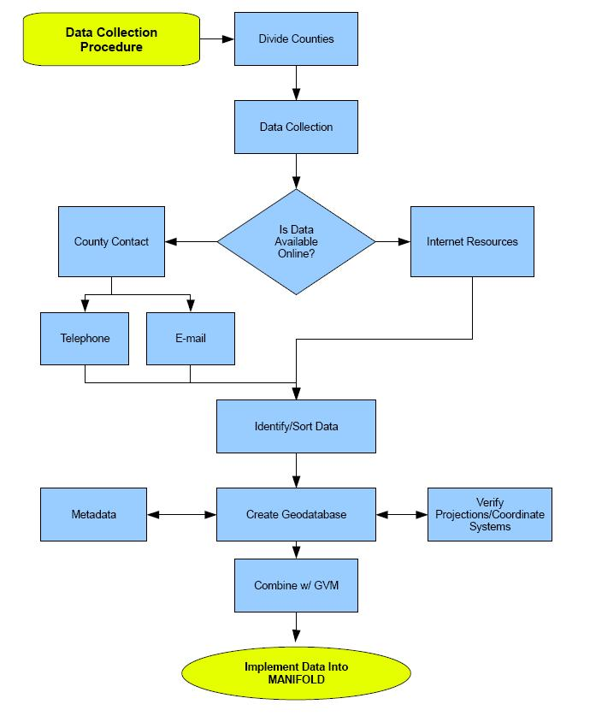
Fig. 1 Procedural Flow Chart

5.0 Results
Acquisition of all proposed data layers for the project has proven to be a difficult undertaking. Many layers however have been acquired for the final product. All data that was available was compiled in a manner that allows future updates. Other layers not considered at the beginning of the project can be added in the future to enhance the use of the database for concerned citizens. We began the project by assigning each member of the group a set of three or four counties. Each member was responsible for independently acquiring data for each of their counties. This method resulted in mixed success for each team member’s endeavors. Parcel data has been acquired for a majority of the counties. The main reason we are lacking parcel data is due to the fact that some of the counties have not yet digitized their records. It is unfeasible for TerraCorps to undertake this task considering the time frame in which we are working.
Other parcel data, specifically Edwards County, has been contracted out to private companies and will need to be purchased to be added to the database. A layer of MUD data was acquired from TCEQ, however it is important to note that upon receiving this data, the agency made a note that, this was neither official, nor spatially accurate. Groundwater Conservation Districts were added to the database as well. This layer falls outside the boundaries of the Hill Country Alliance; so an additional layer showing the counties which these Districts serve outside the seventeen Hill country counties will also be added as a separate layer for possible future collaboration or expansion in the network. A starting point upon which to build a professional GIS infrastructure has been added. The data acquired will need to be added upon later to give a complete representation. Existing Vast Open lands Conservation Easements and publicly held land will not be added to the database due to time constraints and lack of cooperation. However contacts will be provided for future development to acquire this data. Depicted below are two maps that show the types of maps that will display on the website.
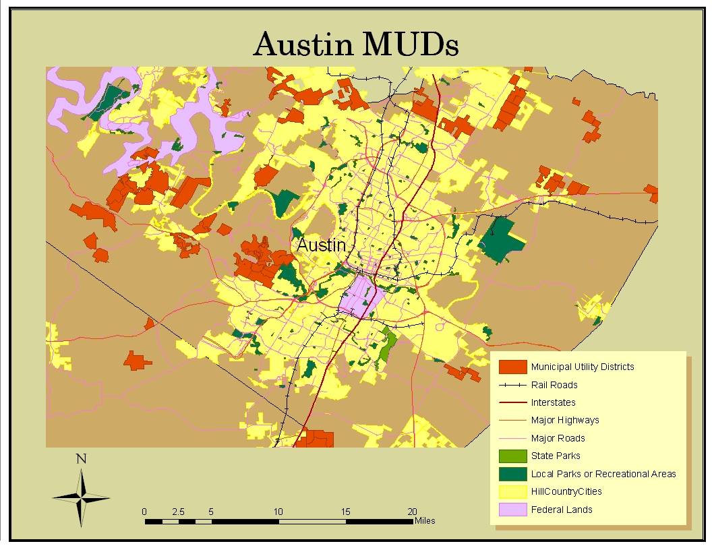
Fig. 2(Austin MUDS, ArcMap)
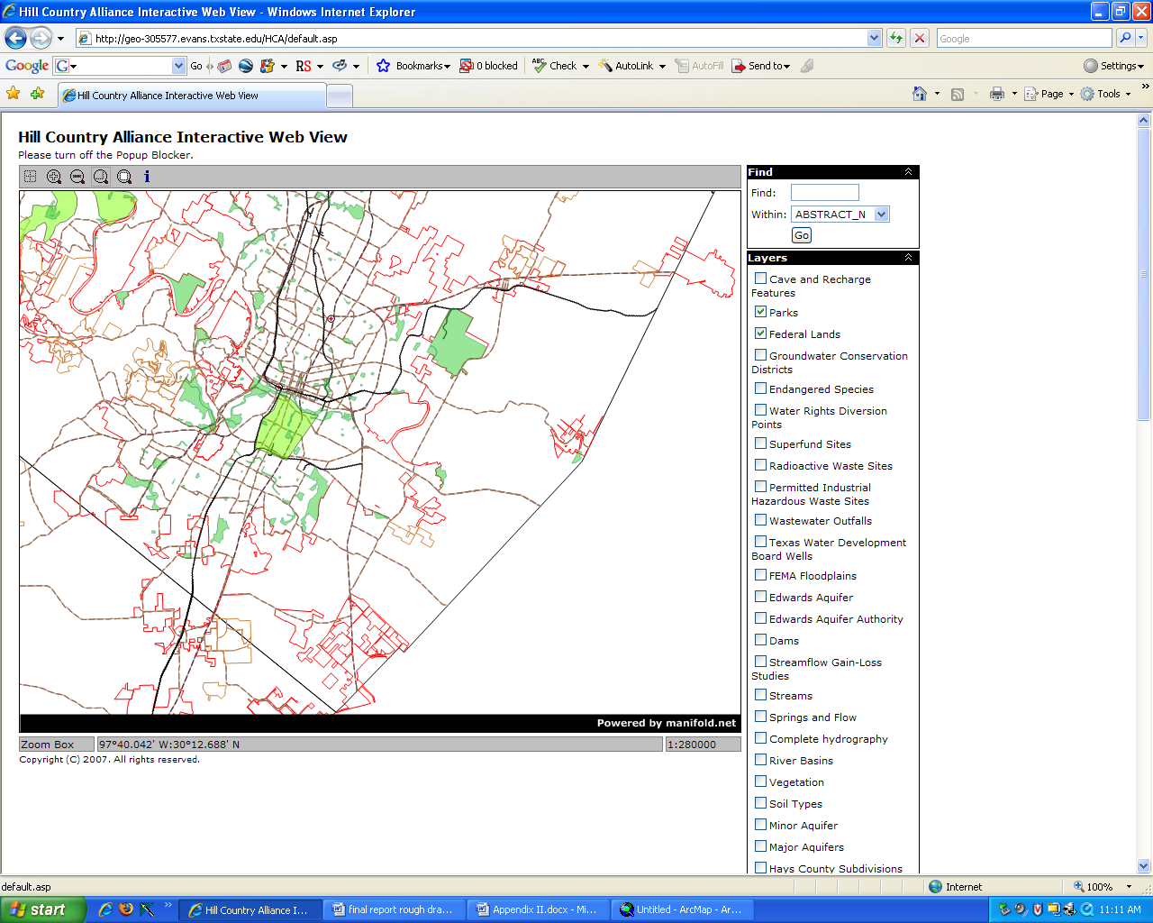
Fig 3. (Austin MUDS, Manifold IMS)
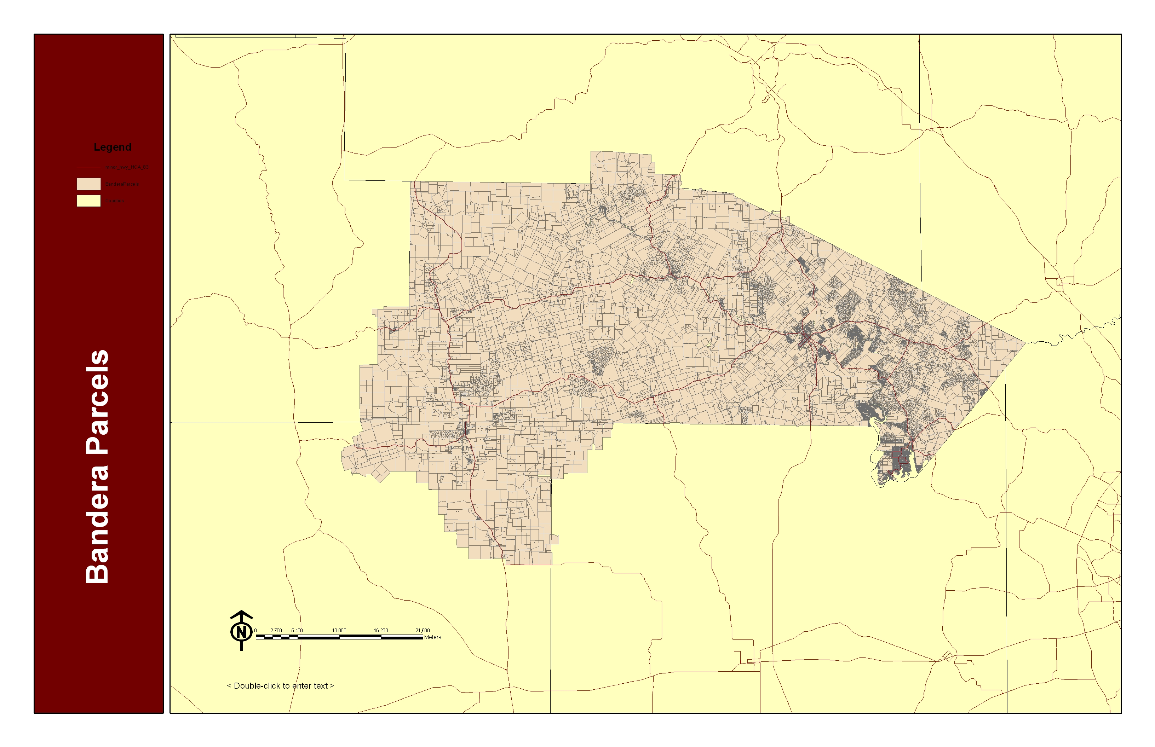
Fig 4. (Bandera Parcels, ArcMap)

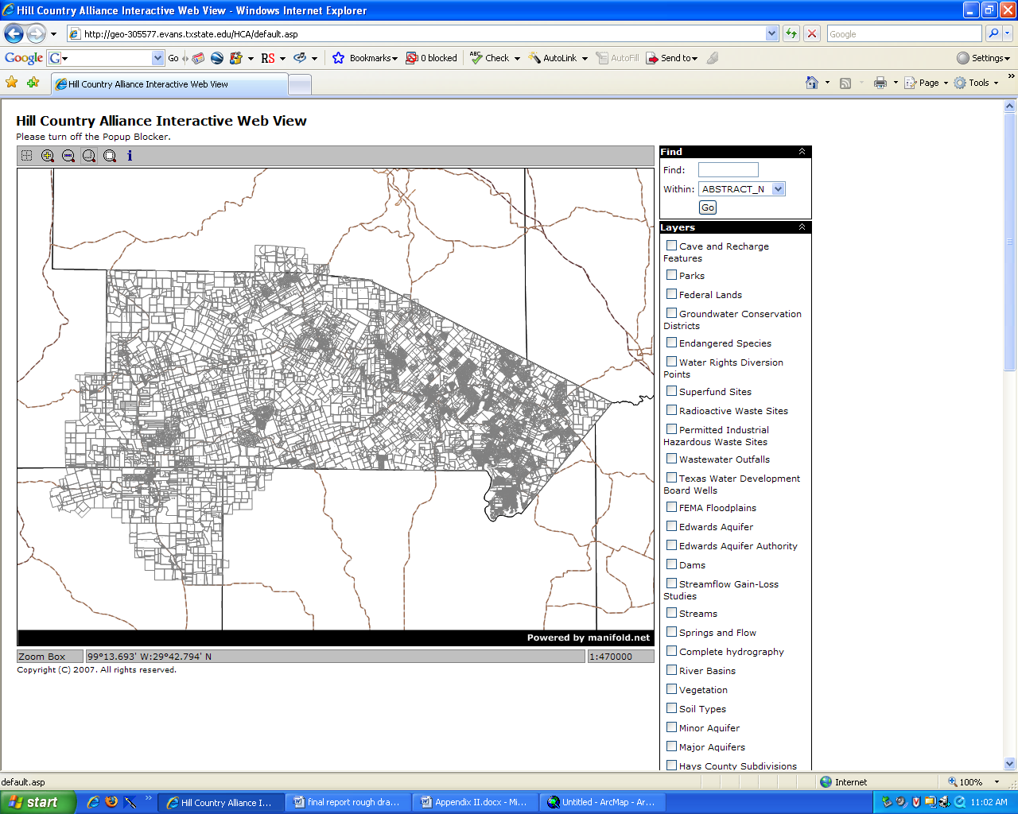
Fig 5. (Bandera Parcels, Manifold IMS)

The above screenshots illustrate the differences in viewing quality between ArcMap and Manifold IMS. Both programs are displaying the same layers, (i.e. roads, county boundaries).

6.0 Discussion
The success of our data acquisition greatly exceeded our initial expectations. Some Data which we expected not to be in a digital format turned out to be already digitized. Some difficulty resulted in attempting to project the acquired data into the proper projection because most data acquired from individual counties was lacking spatial reference information. Initially we had many problems attempting to fix this, but we eventually worked out all the kinks and got everything to project correctly.
Combining our data with aquaKESKA resulted in a large database that provides an excellent tool for concerned citizens to use. With the groundwork laid for this project, any person who has an interest in obtaining geographic information about the Texas Hill Country will be able to use the website as a reference. Because Terra Corps collected only secondary data we cannot guarantee the accuracy or completeness of the data. However, we feel confident that the data collected is the most accurate available and provides a useable approximation. With the extensive number of layers available for viewing on the IMS, this project will expand the knowledge of the general public. For example, a citizen will have the ability to locate the parcel on which they live and view its geographic relationship to environmental factors such as watersheds, radioactive waste depositories, sensitive recharge zones, and endangered species.
It will be interesting to watch how the project will be perceived by the public and how it impacts development and conservation policy. The initial scope of the project was revised due to the difficulty in acquiring some of the layers. Every member in Terra Corps and aquaKESKA has put forth exceptional effort in making this project a success and have come very far. Even with all the effort spent on this project there is still the need to expand upon and enhance what has been created. There was some difficulty in acquiring data for a number of reasons, namely, a lack of understanding about the project, the motivations for the project, unwillingness to help, or just outright suspicion about the nature of the project. Even with the difficulties we have faced in this endeavor we have achieved overall success. The original layers requested from the client served as the preliminary stage in setting up a large geodatabase which can be expanded upon and updated as required. Hopefully, many counties will see the benefit of this project and will choose to make it more useful by contributing updated data in the future.
This project is unique in that nothing of this kind has been done for this size study area. All of the data collected has been available, but has never been compiled in this way. Taking this step will hopefully encourage other students or professionals to follow suit and expand upon the idea of public participation in GIS.
An IMS was chosen for its ease of use when deciding how to deliver our project to the public. However, due to our lack of experience working with an IMS system the final product is not without its flaws. We were unable to utilize the full potential of the program due to our unfamiliarity with the product. Many of the features we would like to have included require an extensive knowledge of software and programming. Some of the features that are not included are a pan feature, place and feature names being displayed, unrefined search options, scrolling menu, legend display and the ability to turn off all layers selected when program is loaded. We feel that with correct resources and time, these drawbacks can be improved upon.

7.0 Conclusion
This project has taught every member of this team very valuable lessons that we will most certainly take with us into our careers and will benefit from greatly. It has given us insight into our futures in the working world and has shown us how essential team work and communication is vital to the delivery of a good product. In our pursuit of secondary data we learned that dealing with people who have no interest in what we are trying to accomplish is very time consuming, very stressful and very disconcerting.
This project raised our awareness of our immediate surroundings and reminded us that we live in an exceptionally beautiful area that not only needs to be, but deserves to be preserved and cherished. It was very interesting to see the connection between natural boundaries and political boundaries. We found that these boundaries rarely correspond and development often occurs within minimal regard for natural boundaries. There seems to be a clear trend of showing little to no concern by developers to the preservation of the Texas Hill Country.
The value of the project completed by aquaKESKA and Terra Corps will prove invaluable to the Texas Hill Country Alliance. However it will be necessary for the database to be updated as further development ensues. We are proud to have been part of a great cause and a great project. We look forward to seeing our work flourish and make a difference in the fight for the preservation of the Texas Hill Country.
This project was done for the Hill Country Alliance in an effort to marry science with policy.

References
Austin City Connection. 2003. 2003 Land Use Inventory Overview and Methodology. <http://www.ci.austin.tx.us/landuse/survey2003.htm> [accessed 5 Sep. 2007].
Department of Zoning City of Chicago. 2007. Mapping Home. <http://maps. cityofchicago.org/website/zoning/> [accessed 5 Sep. 2007].
Fitzpatrick, T. 2007. ESRI: Sharing Interactive Maps. <http://www.esri.com/news/ arcuser/1002/interactive.html> [accessed 7 Sep. 2007].
Sudhira, H.S., Ramachandra, T.V., and Jagadish, K.S. Urban Sprawl Pattern Recognition and Modeling Using GIS. <http://www.gisdevelopment.net/application/urban/ sprawl/mi03142.htm>. [accessed 8 Sep. 2007].

Appendix I: Metadata
Austin ETJ
Keywords
Theme: ETJ, Extra Territorial Juristictions
Place: Austin, Travis, County

Description
Abstract
Extra Territorial Juristicions

Purpose
Display Extra Territorial Juristictaion

Status of the data
In work
Data update frequency: Quarterly
Time period for which the data is relevant
Date and time: 03/26/2007 at time unknown
Date and time: 07/23/2007 at time unknown
Description: ground condition

Publication Information
Who created the data: City of Austin's Communication and Technology Management Department
Date and time: Unknown

Data storage and access information
File name: Austin_ETJ
Type of data: vector digital data
Location of the data: \\Geoserve\Data\G4427YL\GroupTwo\Final_Database\travis_county\Austin_ETJ .shp
Data processing environment: Microsoft Windows XP Version 5.1 (Build 2600) Service Pack 2; ESRI ArcCatalog 9.2.2.1350

Accessing the data
Size of the data: 2.733 MB
Data transfer size: 2.733 MB
Network location:
ftp://coageoid01.ci.austin.tx.us/GIS-Data/Regional/coa_gis.html

Constraints on accessing and using the data
Access constraints: Data accessible to public through website.
Use constraints: No known constraints.

Details about this document
Contents last updated: 20071130 at time 14554000

Who completed this document
Jan Schneider
Terra Corps (under Texas State University at San Marcos Advanced GIS II)
js1208@txstate.edu
Standards used to create this document
Standard name: FGDC Content Standards for Digital Geospatial Metadata
Standard version: FGDC-STD-001-1998
Time convention used in this document: local time
Metadata profiles defining additonal information
ESRI Metadata Profile: http://www.esri.com/metadata/esriprof80.html

Spatial Data
Horizontal coordinate system
Projected coordinate system name: NAD_1983_UTM_Zone_14N
Geographic coordinate system name: GCS_North_American_1983
Details

Altitude System Definition
Resolution: 1.000000
Encoding Method: Explicit elevation coordinate included with horizontal coordinates

Bounding coordinates
Horizontal
In decimal degrees
West: -98.888803
East: -96.857310
North: 31.228875
South: 29.248616
In projected or local coordinates
Left: 510802.877959
Right: 704124.467167
Top: 3454972.980244
Bottom: 3237359.352548

Groundwater Conservation Districts
Keywords
Theme: Groundwater Conservation Districts
Place: Texas

Description
Abstract
* Contact TCEQ for metadata information.
Marcia Workman : 239-4510

Purpose
To show the Boundaries of Groundwater Conservation Districts in Texas.

Status of the data
In work
Data update frequency: Continually

Time period for which the data is relevant
Date and time: unknown at time unknown
Description:
publication date

Data storage and access information
File name: groundwater_conservation_districts
Type of data: vector digital data
Location of the data:
\\Geoserve\Data\G4427YL\GroupFour\Final_data_layers\groundwater_conservati on_districts.shp
Data processing environment: Microsoft Windows XP Version 5.1 (Build 2600) Service Pack 2; ESRI ArcCatalog 9.2.2.1350

Accessing the data
Size of the data: 0.636 MB
Data transfer size: 0.636 MB

Details about this document
Contents last updated: 20071130 at time 15103300

Who completed this document
Marcia Workman
TCEQ
(512) 239-4510 (voice)
mark.hayes@twdb.state.tx.us
Standards used to create this document
Standard name: FGDC Content Standards for Digital Geospatial Metadata
Standard version: FGDC-STD-001-1998
Time convention used in this document: local time
Metadata profiles defining additonal information
ESRI Metadata Profile: http://www.esri.com/metadata/esriprof80.html

1990 Census Block Groups

Keywords
Theme: Block Groups
Place: United States
Temporal: 1990

Description
Abstract
Block Group Census Data for the year 1990
Purpose
A block group (BG) is a cluster of census blocks having the same first digit of their four-digit identifying numbers within a census tract. For example, block group 3 (BG 3) within a census tract includes all blocks numbered from 3000 to 3999. BGs generally contain between 600 and 3,000 people, with an optimum size of 1,500 people. Most BGs were delineated by local participants as part of the U.S. Census Bureau's Participant Statistical Areas Program. The U.S. Census Bureau delineated BGs only where a local, state, or tribal government declined to participate or where the U.S. Census Bureau could not identify a potential local or tribal participant.

BGs never cross the boundaries of states, counties, or statistically equivalent entities, except for a BG delineated by American Indian tribal authorities, and then only when tabulated within the American Indian hierarchy. BGs never cross the boundaries of census tracts, but may cross the boundary of any other geographic entity required as a census block boundary (see "CENSUS BLOCK").

In decennial census data tabulations, a BG may be split to present data for every unique combination of American Indian area, Alaska Native area, Hawaiian home land, congressional district, county subdivision, place, voting district, or other tabulation entity shown in the data products. For example, if BG 3 is partly in a city and partly outside the city, there are separate tabulated records for each portion of BG 3. BGs are used in tabulating data nationwide, as was done for the 1990 census, for all block-numbered areas in the 1980 census, and for selected areas in the 1970 census. For purposes of data presentation, BGs are a substitute for the enumeration districts (EDs) used for reporting data in many parts of the United States for the 1970 and 1980 censuses and in all areas before 1970.
Supplementary Information
The cartographic boundary files are available in three file formats:
ARC/INFO Export (.e00) format
Arcview Shapefile format
ARC/INFO Generate (ASCII) format

Status of the data
Complete
Data update frequency: Every 10 years

Time period for which the data is relevant
Date and time: January 19th, 1999
Description:
publication date

Publication Information
Who created the data: U.S. Census Bureau
Date and time: 19990119

Data storage and access information
File name: BlockGroups1990
Type of data: vector digital data
Location of the data:
\\Geoserve\Data\G4427YL\GroupFour\Final_data_layers\BlockGroups1990.shp
Data processing environment: Microsoft Windows XP Version 5.1 (Build 2600) Service Pack 2; ESRI ArcCatalog 9.2.2.1350
Accessing the data
Size of the data: 0.609 MB
Data transfer size: 0.609 MB
Constraints on accessing and using the data
Access constraints: None
Use constraints:
Publicly available

Details about this document
Contents last updated: 20071130 at time 15421900
Who completed this document
Department of Commerce
U.S. Bureau of the Census
18005848332 (voice)
Standards used to create this document
Standard name: FGDC Content Standards for Digital Geospatial Metadata
Standard version: FGDC-STD-001-1998
Time convention used in this document: local time
Metadata profiles defining additonal information
ESRI Metadata Profile: http://www.esri.com/metadata/esriprof80.html

Spatial Data
Horizontal coordinate system
Geographic coordinate system name: GCS_North_American_1983
Details
Geographic Coordinate System
Latitude Resolution: 0.000000
Longitude Resolution: 0.000000
Geographic Coordinate Units: Decimal degrees

Geodetic Model
Horizontal Datum Name: North American Datum of 1927
Ellipsoid Name: Geodetic Reference System 80
Semi-major Axis: 6378137.000000
Denominator of Flattening Ratio: 298.257222

Bounding coordinates
Horizontal
In decimal degrees
West: -101.185287
East: -97.239731
North: 31.266493
South: 28.778715
In projected or local coordinates
Left: -101.185287
Right: -97.239731
Top: 31.266493
Bottom: 28.778715

Appendix II. Contribution of Each Team Member

Wesley Poehlmann

GIS Developer

Project Proposal
- Budget
- Final Deliverables

Final Report
- Results
- Discussion
- Appendix II: Contribution of Team Members

Development and Map Products
- Acquired Parcel data for Bexar County
- Attempted to acquire data for Edwards County
- Attempted to acquire data for Real County
- Created ETJ’s of smaller towns
- Acquired MUD data
- Metadata for 1990 census data and Water Conservation Districts

Project Poster Design and Compilation
- Revised Paragraphs
- Screen Shots

Derek Smith

GIS Developer

Project Proposal
- Timeline
- Timetable
- Scope Map

Final Report
- Abstract
- Flowchart
- Appendix II: Contribution of Team Members

Development and Map Products
- Acquired data for Comal County
- Acquired data for Kerr County
- Acquired data for Kendall County
- Acquired data for Hays County
- Projected all acquired data for preparation of geodatabase and IMS

Project Poster Design and Compilation
- Abstract
- Overall layout and design

Aja Davidson

Project Manager

Project Proposal
- Introduction
- Budget
- Participation
- Table of Contents
- Layout

Final Report
- Introduction
- Literature Review
- Editing
- Final format
- Appendix II: Contribution of Team Members

Development and Map Products
- Acquired data for Gillespie County
- Attempted to acquire data for Mason County
- Attempted to acquire data for Kimble County
- Acquired federal lands, parks, CCN water, CCN sewer, and Groundwater Conservation Districts
- Projected all acquired data for preparation of geodatabase and IMS

Project Poster Design and Compilation
- Background
- Scope
- Data Layers
- Data Sources
- Overall layout and design

Jan Schneider

Webmaster

Created and maintained group website.

Project Proposal
- Data
- Conclusion
- Editing
Final Report
- Data
- Conclusion
- Editing

Development and Map Products
- Acquired data for Burnet County
- Acquired data for Burnet County
- Attempted to acquire data for Blanco County
- Attempted to acquire data for Llano County
- Projected all acquired data for preparation of geodatabase and IMS

Clint Carpenter

Assistant Project Manager

Project Proposal
- Methodology
- Implications
- Editing

Final Report
- Procedure
- Editing
- Appendix II: Contribution of Team Members

Development and Map Products
- Acquired data for Medina County
- Acquired data for Bexar County
- Attempted to acquire data for Uvalde County
- Acquired data for Hays County
- Projected all acquired data for preparation of geodatabase and IMS
- Edited all Metadata for all acquired data

