

**Final Report**

**James Thomas**

*Manager*

**Chris Faulkner**

*Assistant Manager/Web Designer*

**Paul Kaiser**

**Jordan Stanley**

**Logan Weller-Alexander**

*Analysts*

GIS Development and Implementation Woodcreek, Texas.

Prepared By:

Spatial Consulting Services

*Abstract*

Woodcreek, Texas is a small city located in Hays County just northwest of Wimberley. It was incorporated in 1984 with a population of 600. As the city has grown in population, it has become apparent that there is a need for a formal mapping system to organize the city’s infrastructure and map documents. Geographic Information Systems (GIS) is a powerful tool that can be used to design a spatial database for Woodcreek.

The city requested that Spatial Consulting Services (SCS) update map products that are more professional and useable than current documents. In addition to updated maps, SCS has developed an interactive map viewer through the use of Google Earth. This viewer will allow Woodcreek officials and citizens to view and make maps quickly and accurately. With this system, citizens of Woodcreek will be able to report any future problems with infrastructure or signage to city officials.

Contents

[*1.0 Introduction* 4](#_Toc184463764)

[1.1 Background 4](#_Toc184463765)

[1.2 Purpose 4](#_Toc184463766)

[1.3 Scope 5](#_Toc184463767)

[1.4 Problem Statement 6](#_Toc184463768)

[*2.0 Literature Review* 7](#_Toc184463769)

[*3.0 Data* 8](#_Toc184463770)

[3.1 Primary Data 8](#_Toc184463771)

[3.2 Secondary Data 8](#_Toc184463772)

*4.0 Methodology……………………………………………………………………………………………………………………………………*13

*5.0 Results……………………………………………………………………………………………………………………………………………..*17

*6.0 Conclusion……………………………………………………………………………………………………………………………………….*19

*7.0 References………………………………………………………………………………………………………………………….……………*20

[*Appendix I. Metadata* 21](#_Toc184463773)

*Appendix II. Group Participation…………………….........…………………………………………………………..………………….*31

*Appendix III. Guide to Google Earth……………………………………………………………………………………..….….…………*32

# *1.0 Introduction*

1.1 Background

The City of Woodcreek was incorporated in 1984 as a Type-B General Law City. In 1989 with a population of 600, the city became a Type-A General Law City and currently has a population of 1300. As the city has increased in population, the needs for the resources of a Geographic Information System (GIS) became apparent. Utilization of the tools offered through GIS systems will benefit the overall organization and execution of city processes. The organization of city planning tools such as zoning and infrastructure maintenance helps to expedite decisions that become increasingly more difficult as the population grows. This GIS system will help the various commissions and committees visualize Woodcreek’s area with more data availability in order to perform their duties more effectively. Conveying information through map displays to the citizens of Woodcreek during public hearings can make presentations more productive and effective. By using the GIS, any changes to current land use or infrastructure can be updated quickly. GIS has helped plan orderly development for other small cities and governments. Many cities have developed online mapping services that allow for citizens to have access to public geographic data for reference. For instance, the City of Nanaimo, British Columbia has integrated some of its public data using Google Earth and has found GIS to be very helpful (Letham, 2005). This type of interactive mapping service is going to be beneficial to the City of Woodcreek.

1.2 Purpose

The purpose of our project is to build a formal mapping system for the City of Woodcreek, by developing a GIS database. This mapping system will display zoning regulations, administrative boundaries, topographic information, and infrastructure status. The system will greatly increase the efficiency of city functions. A GIS mapping system will display the spatial relationships with greater accuracy and functionality than current map documents.

1.3 Scope

Represented in **Figure 1.3** is the scope of our study area, which focuses upon The City of Woodcreek, located within Hays County, Texas. The city limits encompass 686 acres and the extraterritorial jurisdiction (ETJ) extends one half mile beyond the incorporated boundaries.

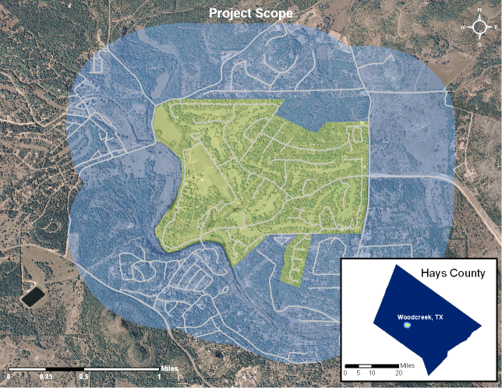

Figure 1.3

1.4 Problem Statement

The original mapping system for Woodcreek was a collection of lower quality paper maps with features delineated by different colors of permanent marker. With this type of system, problems arise in the update capabilities and conveyance to an audience such as a city council. The use of a digital mapping system could greatly improve the city’s grasp of their infrastructure and political policy status.

In order to update current map documents, SCS developed a methodology to convert the city’s spatial data into an updated and easier format to view. Time constraints did not allow SCS to collect GPS data for all traffic signs and fire hydrants. Instead, map originals were georeferenced and features were digitized into ArcView Shapefile format.

Woodcreek requested an inventory of commercial signage with photographs of each sign. SCS collected the information using GPS field methods and digital photography. The data collected were linked to the corresponding digital photo through service of a simple script.

In addition to conversion of map originals and new commercial sign inventory, the city is provided with many other digital datasets including an updated floodplain dataset and defined political boundaries that will greatly improve city functions. These datasets were obtained from reliable government agencies with the highest accuracy standards.

To easily display and edit data collected and modified for Woodcreek, SCS has utilized the functionality of Google Earth as an interactive map viewer. This viewer is available free of charge and easy to learn.

## *2.0 Literature Review*

Understanding the cost and benefits of starting a Geographic Information System (GIS) is the first step in the strategic planning process. Cost-benefit analysis is a powerful tool that aids in the decision making process by virtually eliminating personal opinion and emotions. Cost evaluation issues focus on unbiased determination of staff, equipment, and other costs relative to other viable options for any given city. Based on a given time period these options are weighted accordingly and present a clear cost-benefit result which can be used in the decision making process. Cost-benefit analysis is a great tool for comparing options particularly in a complex public sector where both political and financial issues must be considered in the final decision (Wilcox). With a relatively small annual budget, a city such as Woodcreek must use this type of analysis in order to make the critical decision to implement a GIS with more capabilities in the future.

A useful distinction for measuring benefits from the use of GIS technology is between efficiency benefits and effectiveness benefits (Gillespie 2000).

Efficiency benefits occur when a task is completed on data not previously done using GIS but produces a result at a much lower cost than the original. Effectiveness benefits result when GIS is used as an improvement on the quality of a current output or in the production of an output that was not previously available (Gillespie 2000). SCS used the effectiveness approach to create better quality maps for speed signs, stop signs, fire hydrants and road repairs. The City of Woodcreek's original paper maps have been updated by SCS to a digital format and are much more versatile and easy to update compared to the originals.

The town of Polk City, Iowa recently implemented a formal GIS mapping system after several years of realizing the overwhelming need. The town of 2500 people had many needs for a GIS such as emergency management, traffic flow control and infrastructure status (Schultz, 2006). The mapping system got its start from the work of a graduate student of Iowa State University (ISU). Upon seeing the benefits of the work done through GIS, the city soon budgeted for a GIS administration plan. The plan allowed students at Iowa State University to provide technical work for the city based on an hourly rate. This compact made with ISU has become a very beneficial relationship for Polk City (Schultz 2006).

Woodcreek, Texas as rural city of about 1200 people would see similar benefits from introducing GIS for local planning. The system created for Polk City was intended to be easy to use for the general public not trained in GIS, but was later realized that the technical communication gap was larger than expected (Schultz, 2007). Woodcreek has made a similar arrangement with Texas State University to begin preliminary implementation of GIS. SCS has provided an easy and cost effective way to display the map document created for Woodcreek through the use of Google Earth.

One project Polk City had was to map and photograph the 2,300 fire hydrants in the city using GPS units and record information such as manufacturer and flow specifications (Schultz, 2006). SCS used similar methods to collect locations for an inventory of commercial signage within the study area.

The use of the Google Earth technology has been used by other municipalities such as Nanaimo, British Columbia (Letham, 2005). The city has provided KML format versions of several geographic data layers that can be accessed from their website. SCS has provided Woodcreek with similar opportunity to share their geographic data through Google Earth with their citizens or potential visitors.

### *3.0 Data*

Both primary and secondary data were collected and needed for this project. Secondary data are collected and published for others to utilize. For this project, all secondary data were obtained from state and county agencies to ensure reliability and accuracy of data. Data were converted to Texas State Plane Coordinate System (SPCS), south central zone. Some data layers were in this projection originally, and others were converted to ensure accurate alignment.

3.1 Primary Data

Geographic coordinates of the local commercial signs were the primary data collected by SCS. Garmin eTrex Legend Global Positioning System (GPS) units provided by Texas State University were used to collect the location points. The accuracy ranged from 6 – 12 feet.

GPS waypoints were uploaded and converted to ArcView Shapefile format with DNR Garmin software. The unit collected data in WGS 1984 Coordinate system and had to be converted to Texas SPCS to match other datasets.

Digital photographs of each commercial sign were also taken by SCS. These photographs requested by Woodcreek will be used as a visual inventory of each commercial sign in the area.

### 3.2 Secondary Data

The secondary data collected include were found among various sources. There were four major sources for these datasets (**Table 3.1**). Datasets were downloaded in ArcView Shapefile format from each agency’s website with the exception of Woodcreek. Woodcreek provided hard copies of each dataset.

|  |  |
| --- | --- |
| Source | Datasets Acquired |
| Capital Area Council of Governments (CAPCOG) | Street Centerlines |
| Aerial Imagery |
| Property Parcels |
| Texas Natural Resource Information System (TNRIS) | Floodplain Data |
| Hays County | County Boundary |
| City Limit Boundary |
| City of Woodcreek | Traffic Sign Locations\* |
| Fire Hydrant Locations\* |
| Road Conditions\*  Zoning Regulations\* |

Table 3.1. Secondary data collected for the project.

\*indicates paper map original

Since Woodcreek had no formal mapping system, boundary and street centerlines data were integral pieces of information to start from. These were needed to show SCS the extent of the city in addition to complexity of the roads network.

Floodplain data, property parcels, and zoning regulations are very important for a developing city such as Woodcreek. It is important to know the extent of 100 year and 500 year floodplains for planning purposes. TNRIS has acquired Q3 vector floodplain data from the Federal Emergency Management Agency (FEMA) and made it available to the public by county. Property parcels and corresponding zoning regulations are also important for community planning.

In order to assess the infrastructure status of Woodcreek, initial baseline data are required. Location of traffic signs, fire hydrant utilities and current road conditions are important in assessing future infrastructure needs.

The traffic sign data provided were of relatively low quality because of the collection method. Points were plotted on a city map based on visual comparison on the ground.

Map originals, provided by Woodcreek were digitized and geo-referenced. Heads up digitizing was utilized in the creation of the point layers for: Fire Hydrants, Speed Signs, Stop and Yield Signs.

An assumption that each sign or fire hydrant is located about 15 feet from the street centerline was made. This assumption had to be made because of the inaccuracies in the original collection method.

Points were snapped to a 15 foot buffer, originating from the street centerlines. Finally, each location was spatially joined to the street centerlines to provide accurate road associations for identification purposes and greater functionality (**Figure 3.1**). Points were verified by SCS in the field to ensure correct topological placement.

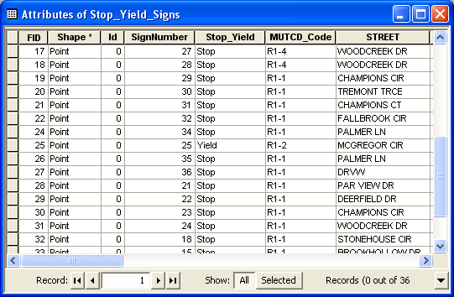

*Figure 3.1: Screen Capture of Stop\_Yield\_Signs Shapefile displaying naming convention and road associations.*

The Extraterritorial Jurisdiction definition was created by applying a 0.5 mile buffer to the City Limits layer obtained from Hays County.

Hays County Floodplain data were obtained from the TNRIS website and modified to display the entire scope of the Woodcreek project. Definitions for floodplain codes were found through FEMA in PDF format. The dataset was then overlaid on aerial imagery from CAPCOG for more effective visualization displaying both 100 year and 500 year floodplain zones.

Commercial Signage waypoints, inside the Woodcreek scope, were collected utilizing GPS field methods. Additionally, digital photographs were taken of each sign location. The waypoints and digital photographs were saved using standard naming conventions, for employment in a simple script to geographically match each location. This will allow the user to see the sign next to the waypoint within the map document.

Google Earth functionality was accomplished through a conversion process, altering all data layers into the appropriate KML format. Google Earth serves in this case as an interactive map viewer of all Woodcreek data for quick and easy reference.

*4.0 Methodology*

Map originals, provided by Woodcreek were digitized and geo-referenced. Heads up digitizing was utilized in the creation of the point layers for: Fire Hydrants, Speed Signs, Stop and Yield Signs.

An assumption that each sign or fire hydrant is located about 15 feet from the street centerline was made. This assumption had to be made because of the inaccuracies in the original collection method.

The Extraterritorial Jurisdiction layer was created by applying a 0.5 mile buffer to the City Limits layer obtained from Hays County. **Figure 4.1** below displays this process.

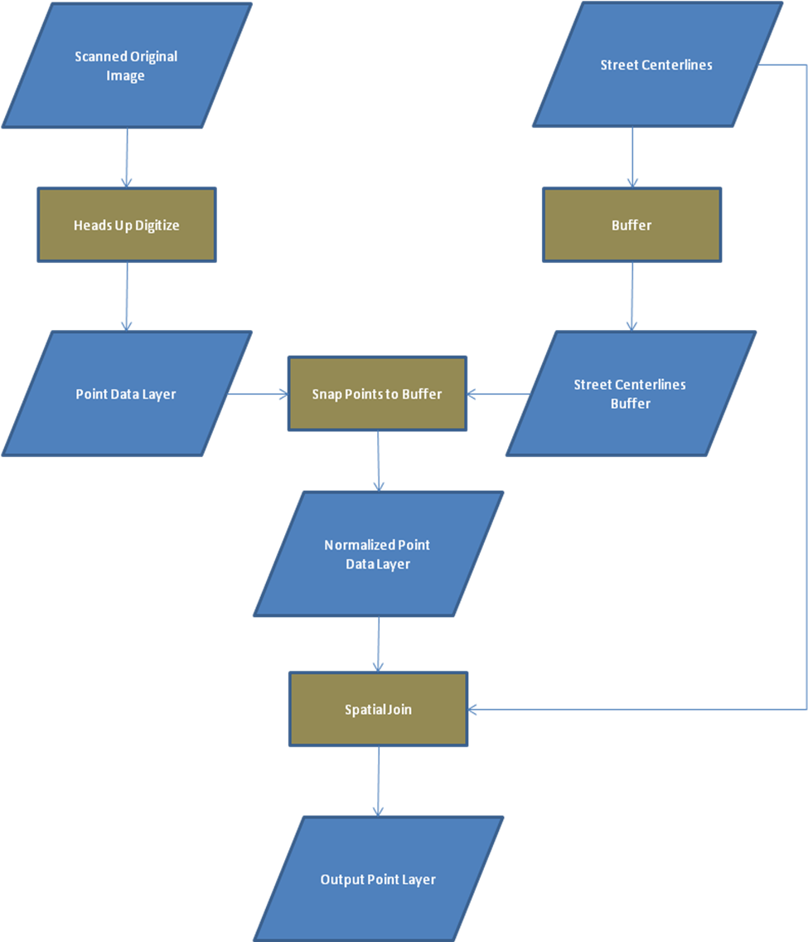

Figure 4.1

Hays County Floodplain data were obtained from the TNRIS website and modified to display the entire scope of the Woodcreek project. Definitions for floodplain codes were found through FEMA in PDF format. The dataset was then overlaid on aerial imagery from CAPCOG for more effective visualization displaying both 100 year and 500 year floodplain zones.

Commercial Signage waypoints, inside the Woodcreek scope, were collected utilizing GPS field methods. Additionally, digital photographs were taken of each sign location. The waypoints and digital photographs were saved using standard naming conventions, for employment in a simple script to geographically match each location. This will allow the user to see the sign next to the waypoint within the map document.

Google Earth functionality was accomplished through a conversion process, altering all data layers into the appropriate KML format. Google Earth serves in this case as an interactive map viewer of all Woodcreek data for quick and easy reference.

SCS received two hard copies of road maps from Woodcreek showing in **Figures 4.2** and **4.3**:

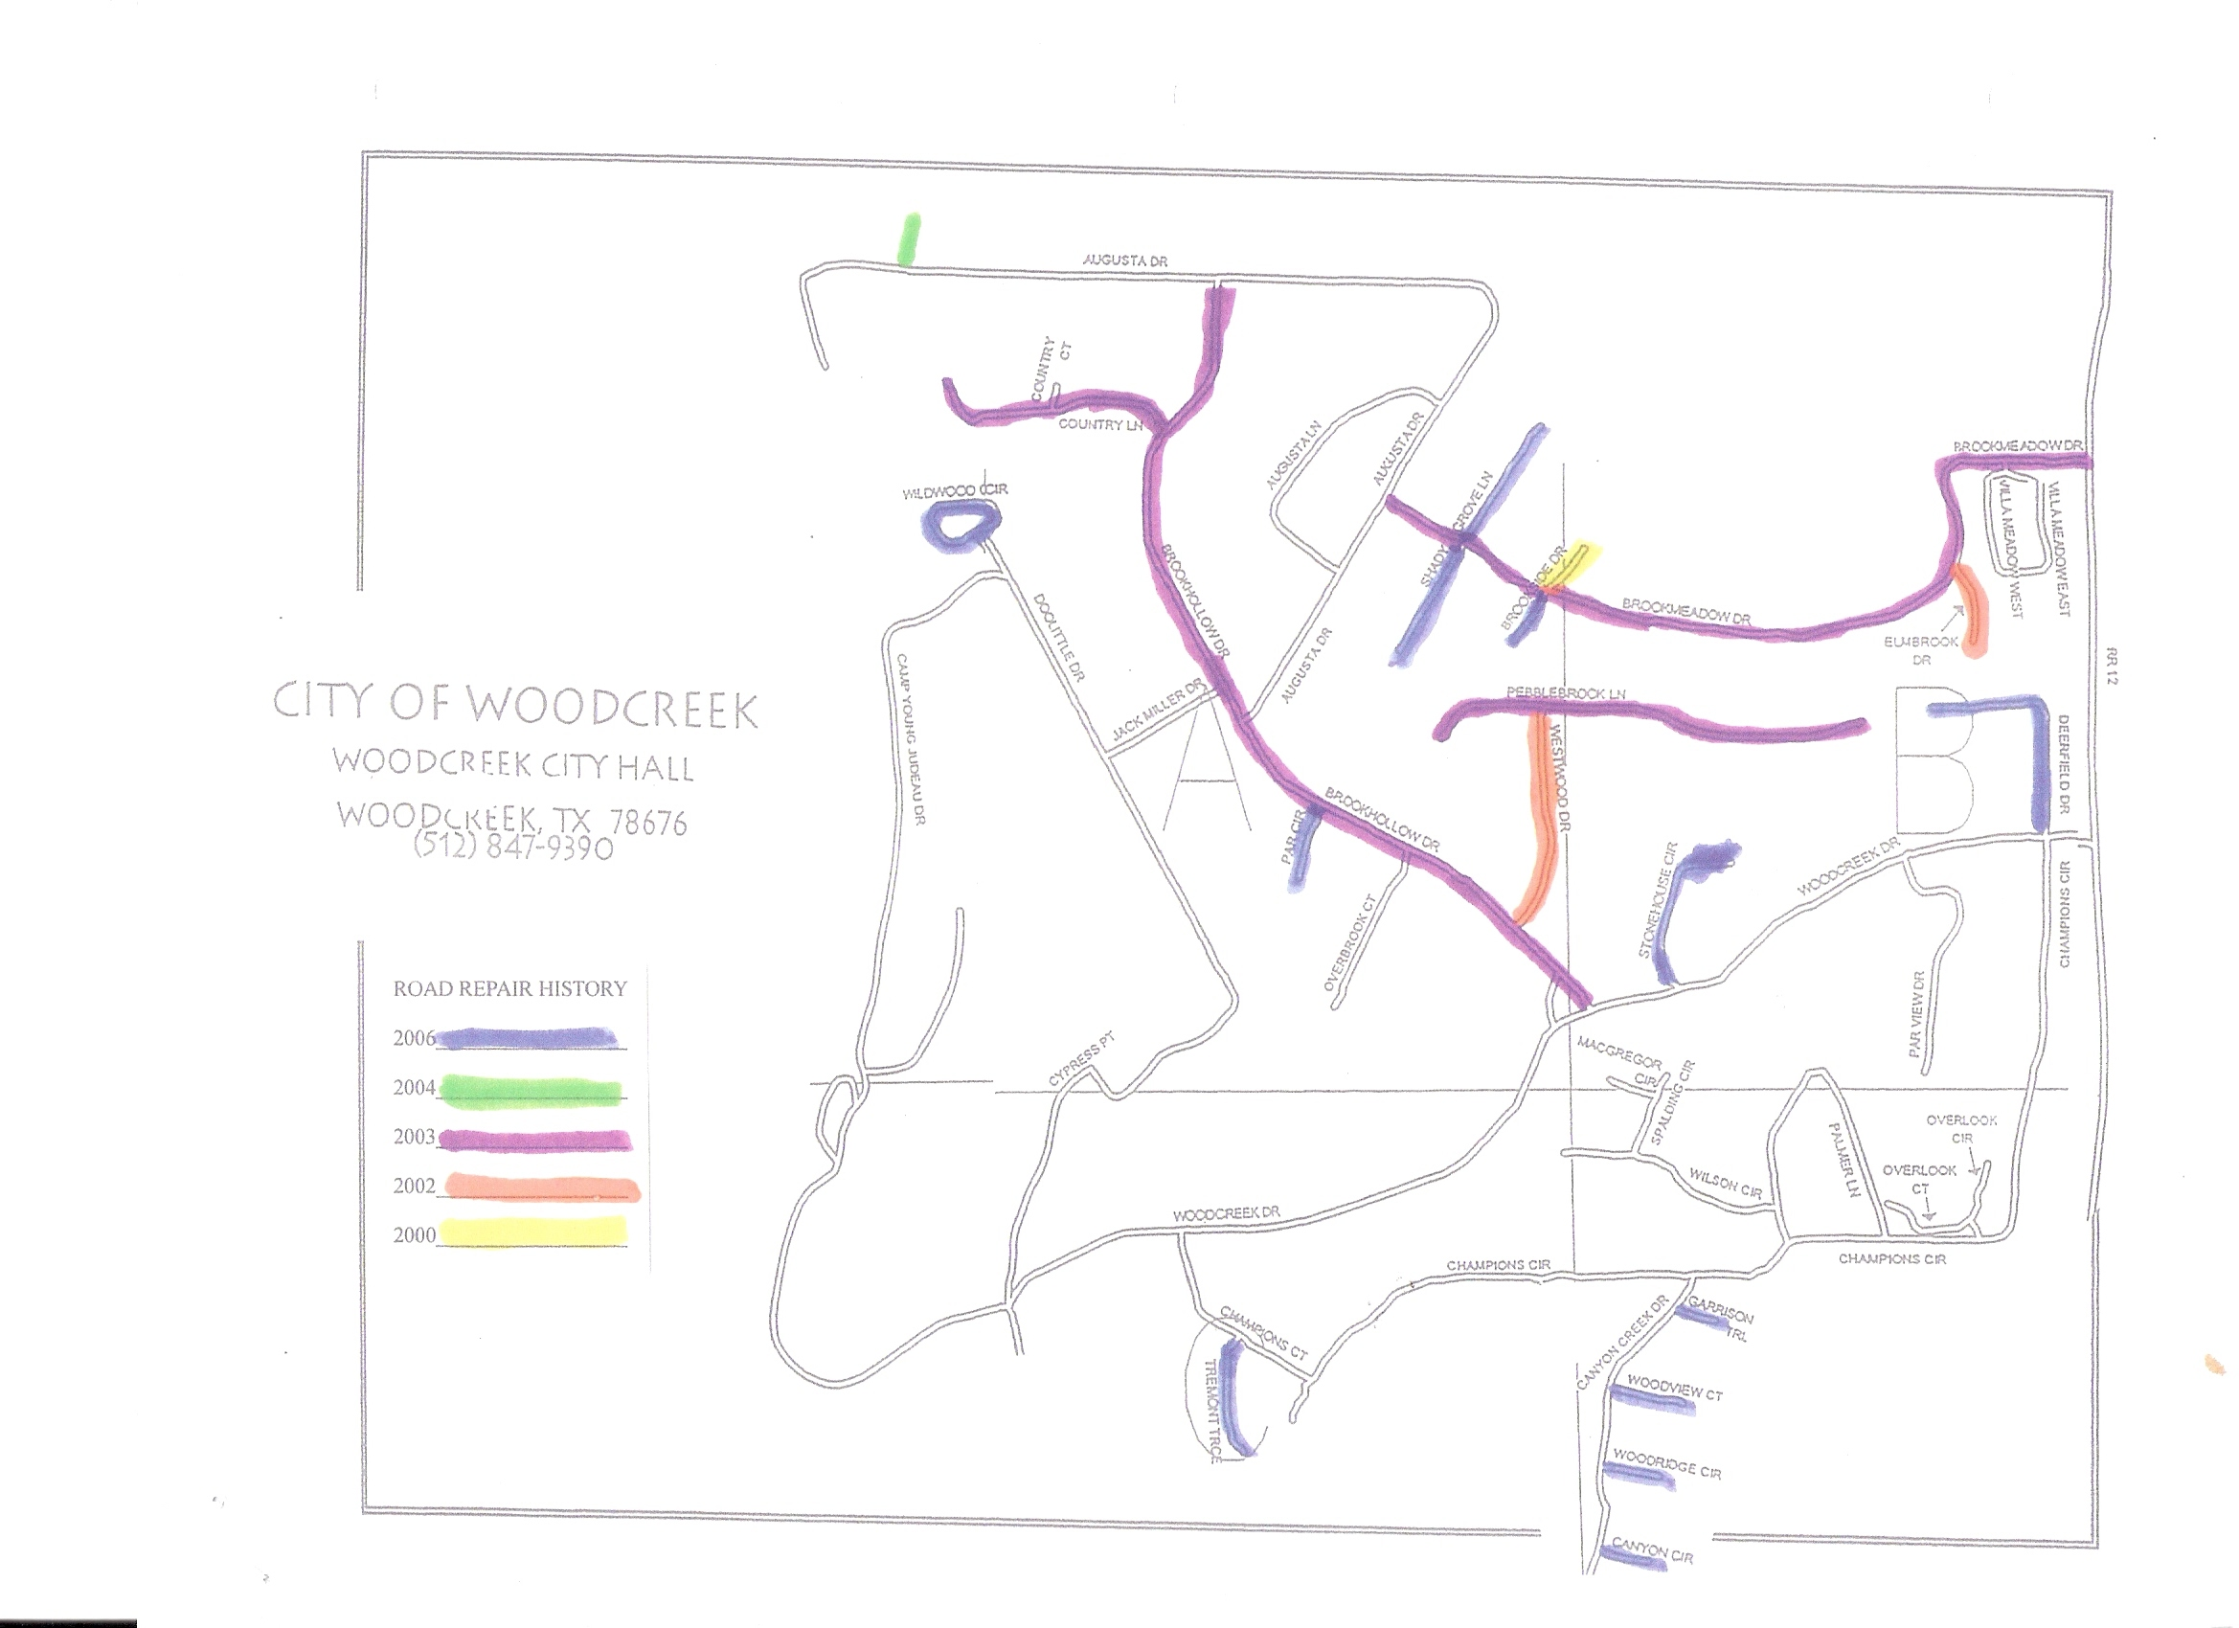

Fig. 4.2 Road Repair History

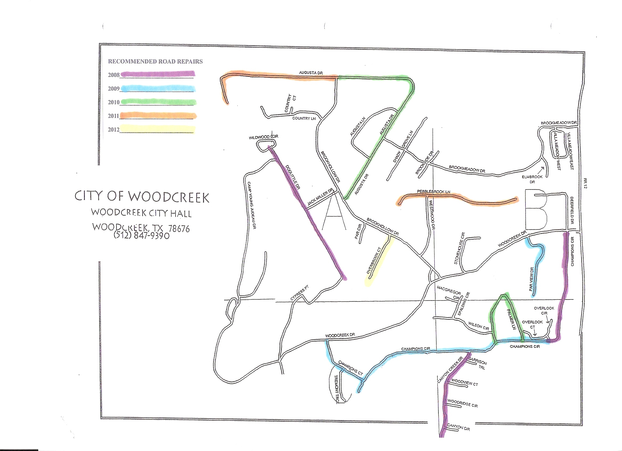

Fig. 4.3 Recommended Road Repairs

Our task was to convert these maps from paper to digital format in ArcGIS and later translate that into a web-based format in which the city and its citizens can access. Within ArcGIS, the process simply involved selecting the streets that correlated to the streets within the hard copies and apply their respective attributes to those in the system. The results of the conversions are displayed in **Figures 4.4** and **4.5** below.

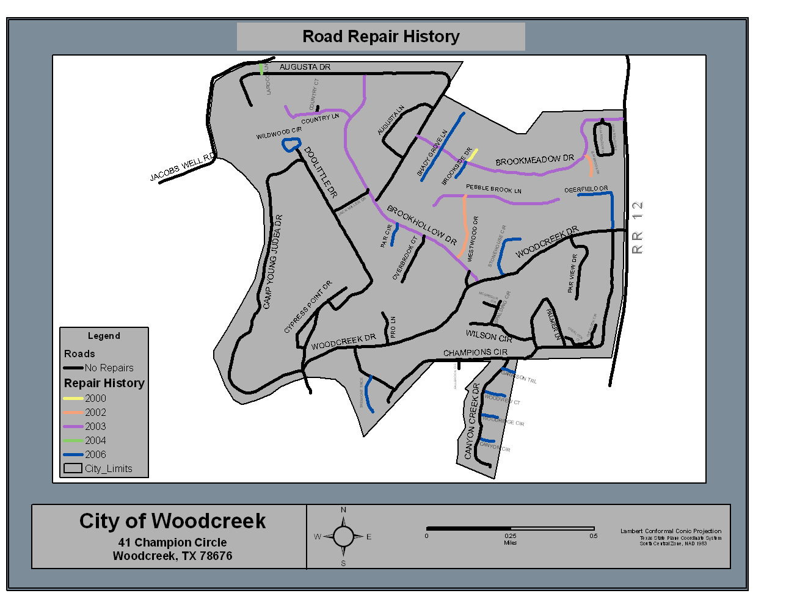

Fig. 4.4 Road Repair History

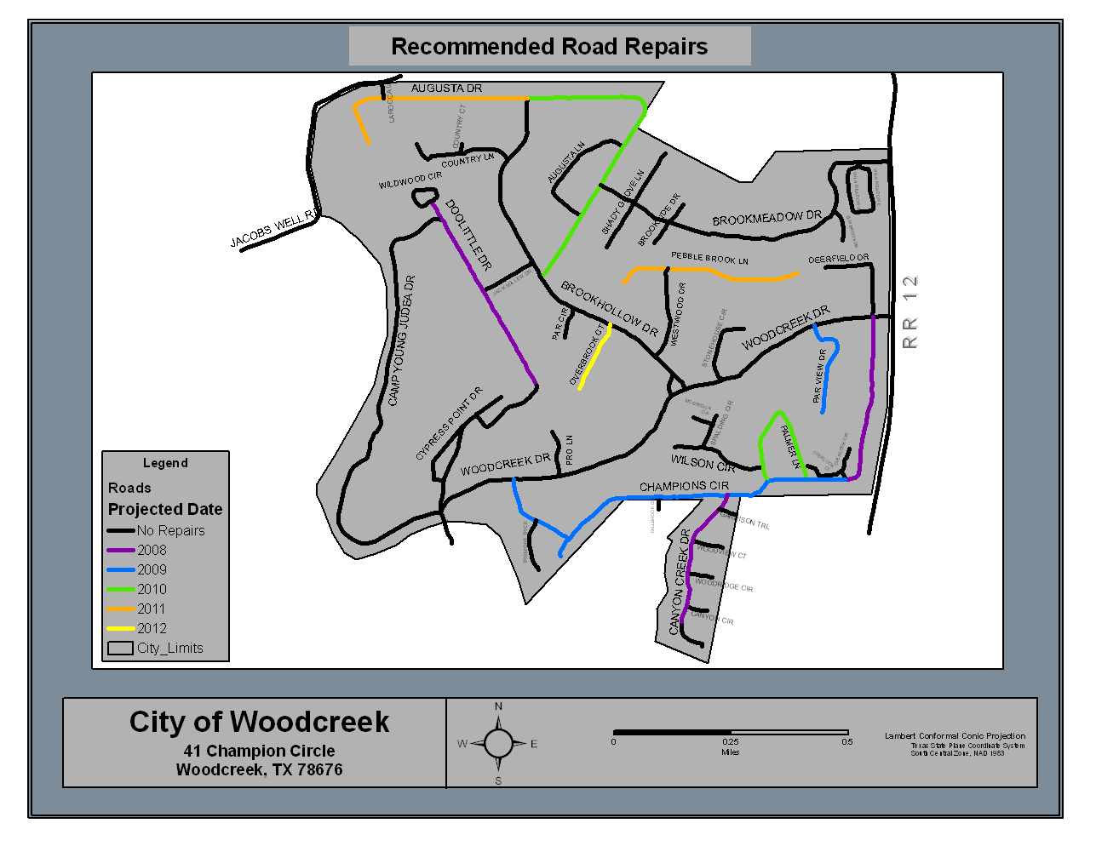

Fig. 4.5 Recommended Road Repairs

The City Woodcreek had available one hard copy of their zoning map in poster form. Though developed and last updated in 1985, this map was converted to digital form using current Texas parcel map data. All parcels within the digital version of the zoning map now have a zoning attribute specifying which type of zone each respective parcel is located in (**Fig.4.6**). Also, SCS created a separate, generalized version of the zoning data in which The City of Woodcreek may view without lot lines (**Fig 4.7**).

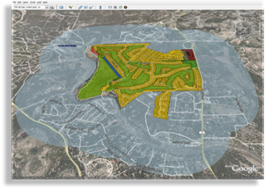

Fig. 4.6-Zoned Parcels

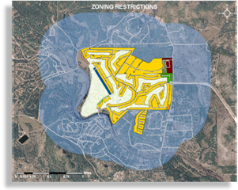

Fig 4.7-Zones (generalized)

Using these processes, SCS was able to successfully complete the tasks that The City of Woodcreek requested. The following is a list of completed data layers that will be accessible through the online, interactive map display:

* Road Repair History Map
* Recommended Road Repair Map
* Fire Hydrant Location Map
* Updated Floodplain Map
* Matching GPS points to the digital photographs
* Street Sign Map
* Zoning Map

*5.0 Results*

Upon completion of data processing, SCS is pleased to provide professional map documents to be utilized by the political framework of Woodcreek. Additionally, SCS has developed an interactive map viewer using the Google Earth software application. Provided below are side by side comparison of original map documents, maps created by SCS, in addition to Google Earth Screen captures.

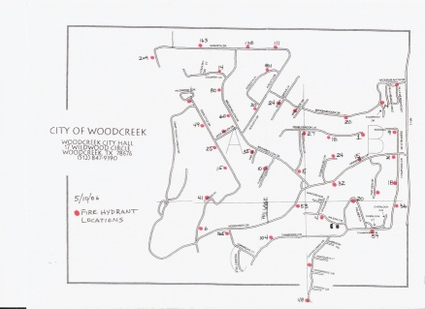

*Fig. 5.1 Original Fire Hydrant Map.*

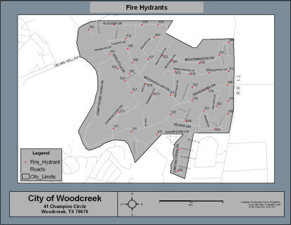

*Fig. 5.2 Updated SCS Fire Hydrant Map*

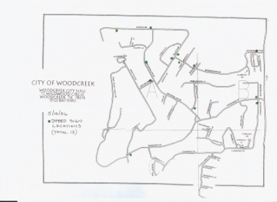

*Fig. 5.3 Original speed sign map.*



***Fig. 5.4*** *Updated SCS Speed Signs Map*

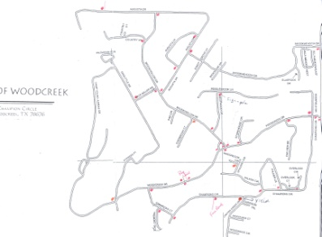

*Fig. 5.5 Original Stop Sign Map.*



*Fig. 5.6 Updated SCS Stop Sign Map*

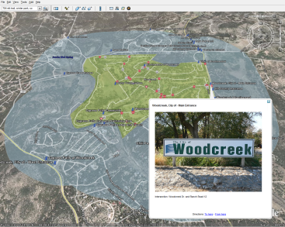

*Fig. 5.7 Commercial Signage Screen Capture*

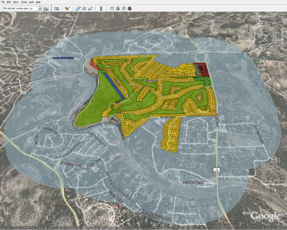

*Fig. 5.8 Updated SCS Stop Sign Map*

*6.0 Conclusion*

A Geographic Information System has been created by Spatial Consulting Services for the City of Woodcreek, TX. The GIS mapping system was created utilizing the tools in ESRI’s ArcMap. The Data consists of topographic information, administrative boundaries, zoning regulations, infrastructure status, and commercial sign locations. Future modifications to these documents are made available through the use of Google Earth. In addition to physical map documents that display the city’s attributes, we have designed a database which encompasses these features. The system has organized the city’s information in a way to be functional for the user. The user can look at many different data layers on a single map and decide which information to display. Overall, the functionality of presenting Woodcreek has been greatly enhanced. Visually enhancing the city’s ability to see its area will help in implementing positive changes to Woodcreek.

Lastly, Spatial Consulting Services is very proud of the work it completed for Woodcreek. We would like to thank the City of Woodcreek for the opportunity to bring GIS to their community. This opportunity served as an invaluable learning experience to the members of SCS and to Woodcreek’s future development.

*7.0 References*

Letham, Glenn. 17 Aug. 2005. Nanaimo BC puts the city on the map using Google Earth &

Google Map APIs. <http://www.gisuser.com/index2.php?option=content&task=view&id=6647>

Last Accessed 2 Dec. 2007.

Schultz, Bob. 2006. Perseverance Pays Off: How a small community in Iowa puts GIS to work. RGIS Innovator. March 2006.

Gillespie, Stephen R. 2000. An Empirical Approach to Estimating GIS Benefits*. URISA Journal* 12:1.

Wilcox, Darlene L. A Pragmatic Approach to the Cost-Benefit Analysis of GIS.

http://gis.esri.com/library/userconf/proc96/TO300/PAP282/P282.HTM

Last Accessed 2 Dec. 2007.

*Appendix I. Metadata*

This section contains metadata for three shapefiles: Floodplain (Secondary Data), Business Signs, and Speed Signs.

|  |  |
| --- | --- |
| **Floodplain** | |
| C:\DOCUME~1\PAULKA~1\LOCALS~1\Temp\tmp9E.tmp | **Data format:** Shapefile  **Coordinate system:** NAD\_1983\_StatePlane\_Texas\_South\_Central\_FIPS\_4204\_Feet  **Location:** file://\\ECS-VVCWM1U0KFE\C\Documents and Settings\Paul Kaiser\My Documents\Geography\4427\Final\_Data\ShapeFiles\Floodplain.shp |

**ISO and ESRI Metadata:**

* [Metadata Information](file:///C:\Documents%20and%20Settings\Paul%20Kaiser\Local%20Settings\Temp\metadata22.htm#Metadata_Information)
* [Resource Identification Information](file:///C:\Documents%20and%20Settings\Paul%20Kaiser\Local%20Settings\Temp\metadata22.htm#184690976)
* [Spatial Representation Information](file:///C:\Documents%20and%20Settings\Paul%20Kaiser\Local%20Settings\Temp\metadata22.htm#184695360)
* [Reference System Information](file:///C:\Documents%20and%20Settings\Paul%20Kaiser\Local%20Settings\Temp\metadata22.htm#184695168)
* [Distribution Information](file:///C:\Documents%20and%20Settings\Paul%20Kaiser\Local%20Settings\Temp\metadata22.htm#184694528)
* [Geoprocessing History](file:///C:\Documents%20and%20Settings\Paul%20Kaiser\Local%20Settings\Temp\metadata22.htm#Geoprocessing)
* [Binary Enclosures](file:///C:\Documents%20and%20Settings\Paul%20Kaiser\Local%20Settings\Temp\metadata22.htm#Binary_Enclosures)

Metadata elements shown with blue text are defined in the International Organization for Standardization's (ISO) document 19115 *Geographic Information - Metadata.* Elements shown with green text are defined by ESRI and will be documented as extensions to the ISO 19115. Elements shown with a green asterisk (\*) will be automatically updated by ArcCatalog.



**Metadata Information**

\***Metadata language:** English

\***Metadata character set:** utf8 - 8 bit UCS Transfer Format

\***Last update:** 20071202

\***Scope of the data described by the metadata:** dataset

\***Scope name:** dataset

\***Name of the metadata standard used:** ISO 19115 Geographic Information - Metadata

\***Version of the metadata standard:** DIS\_ESRI1.0

[Back to Top](file:///C:\Documents%20and%20Settings\Paul%20Kaiser\Local%20Settings\Temp\metadata22.htm#Top)



**Resource Identification Information:**

**Citation:**

\***Title:** Floodplain

\***Presentation format:** digital map

\***Dataset language:** English

\***Spatial representation type:** vector

\***Processing environment:** Microsoft Windows XP Version 5.1 (Build 2600) Service Pack 2; ESRI ArcCatalog 9.2.4.1420

**Resource's bounding rectangle:**

\***Extent type:** Full extent in decimal degrees

\***Extent contains the resource:** Yes

\***West longitude:** -98.130628

\***East longitude:** -98.09299

\***North latitude:** 30.041909

\***South latitude:** 30.00907

**Other extent information:**

**Geographic extent:**

**Bounding rectangle:**

\***Extent type:** Full extent in the data's coordinate system

\***Extent contains the resource:** Yes

\***West longitude:** 2243657.455359

\***East longitude:** 2255478.487324

\***North latitude:** 13927420.429421

\***South latitude:** 13915567.500486

[Back to Top](file:///C:\Documents%20and%20Settings\Paul%20Kaiser\Local%20Settings\Temp\metadata22.htm#Top)



**Spatial Representation - Vector:**

\***Level of topology for this dataset:** geometry only

**Geometric objects:**

\***Name:** Floodplain

\***Object type:** complexes

\***Object count:** 52

[Back to Top](file:///C:\Documents%20and%20Settings\Paul%20Kaiser\Local%20Settings\Temp\metadata22.htm#Top)



**Reference System Information:**

**Reference system identifier:**

\***Value:** NAD\_1983\_StatePlane\_Texas\_South\_Central\_FIPS\_4204\_Feet

[Back to Top](file:///C:\Documents%20and%20Settings\Paul%20Kaiser\Local%20Settings\Temp\metadata22.htm#Top)



**Distribution Information:**

**Distributor:**

**Available format:**

\***Format name:** Shapefile

**Transfer options:**

\***Transfer size:** 0.059

**Online source:**

\***Online location (URL):** file://\\ECS-VVCWM1U0KFE\C\Documents and Settings\Paul Kaiser\My Documents\Geography\4427\Final\_Data\ShapeFiles\Floodplain.shp

\***Connection protocol:** Local Area Network

**Description:** Downloadable Data

[Back to Top](file:///C:\Documents%20and%20Settings\Paul%20Kaiser\Local%20Settings\Temp\metadata22.htm#Top)



**Geoprocessing History:**

**Process:**

\***Process name:** Select\_334

\***Date:** 20050720

\***Time:** 190010

\***Tool location:** C:\Program Files\ArcGIS\ArcToolbox\Toolboxes\Analysis Tools.tbx\Select

\***Command issued:** Select "Database Connections\Huan\_IS\_PG\_as\_rmitchell.sde\IS\_PG.RMITCHELL.FEMA\_FP\IS\_PG.RMITCHELL.Q3\_TX" \\Samwise\Mitchell\Working\FEMAq3\Shp\FEMA\_Q3\_209.shp "FIPS = '48209'"

**Process:**

\***Process name:** Clip\_1

\***Date:** 20071031

\***Time:** 101052

\***Tool location:** C:\Program Files\ArcGIS\ArcToolbox\Toolboxes\Analysis Tools.tbx\Clip

\***Command issued:** Clip FEMA\_Q3\_209 citylimits\_Buffer W:\G4427YL\GroupOne\Data\Woodcreek\_Floodplain.shp #

[Back to Top](file:///C:\Documents%20and%20Settings\Paul%20Kaiser\Local%20Settings\Temp\metadata22.htm#Top)



|  |  |
| --- | --- |
| **Business\_Signs** | |
| **Data format:** ESRI data format, dependent upon request  **Coordinate system:** NAD\_1983\_StatePlane\_Texas\_South\_Central\_FIPS\_4204\_Feet  **Location:** file://\\ECS-VVCWM1U0KFE\C\Documents and Settings\Paul Kaiser\My Documents\Geography\4427\Final\_Data\ShapeFiles\Business\_Signs.shp |  |
| **Abstract:** Points depicting commercial signage locations were collected using Garmin eTrex Legend GPS units per request of Woodcreek, TX. | |

**ISO and ESRI Metadata:**

* [Metadata Information](file:///C:\\Documents%20and%20Settings\\Paul%20Kaiser\\Local%20Settings\\Temp\\metadata21.htm" \l "Metadata_Information)
* [Resource Identification Information](file:///C:\Documents%20and%20Settings\Paul%20Kaiser\Local%20Settings\Temp\metadata21.htm#184684576)
* [Spatial Representation Information](file:///C:\Documents%20and%20Settings\Paul%20Kaiser\Local%20Settings\Temp\metadata21.htm#184709984)
* [Reference System Information](file:///C:\Documents%20and%20Settings\Paul%20Kaiser\Local%20Settings\Temp\metadata21.htm#184709792)
* [Distribution Information](file:///C:\Documents%20and%20Settings\Paul%20Kaiser\Local%20Settings\Temp\metadata21.htm#184705664)
* [Geoprocessing History](file:///C:\Documents%20and%20Settings\Paul%20Kaiser\Local%20Settings\Temp\metadata21.htm#Geoprocessing)

Metadata elements shown with blue text are defined in the International Organization for Standardization's (ISO) document 19115 *Geographic Information - Metadata.* Elements shown with green text are defined by ESRI and will be documented as extensions to the ISO 19115. Elements shown with a green asterisk (\*) will be automatically updated by ArcCatalog.



**Metadata Information**

\***Metadata language:** English

\***Metadata character set:** utf8 - 8 bit UCS Transfer Format

\***Last update:** 20071202

**Metadata contact:**

**Individual's name:** Paul Kaiser

**Organization's name:** Spatial Consulting Services - Texas State University

**Contact's position:** GIS Analyst

**Contact's role:** point of contact

**Contact information:**

**Phone:**

**Voice:** 512-262-0189

**Fax:**

**Address:**

**Delivery point:**

601 University Drive

**City:** San Marcos

**Administrative area:** TX

**Postal code:** 78666

**e-mail address:**

\***Scope of the data described by the metadata:** dataset

\***Scope name:** dataset

\***Name of the metadata standard used:** ISO 19115 Geographic Information - Metadata

\***Version of the metadata standard:** DIS\_ESRI1.0

[Back to Top](file:///C:\Documents%20and%20Settings\Paul%20Kaiser\Local%20Settings\Temp\metadata21.htm#Top)



**Resource Identification Information:**

**Citation:**

**Title:** Business\_Signs

**Reference date:**

**Date:**

**Type of date:** creation

\***Presentation format:** digital map

**Themes or categories of the resource:** location

**Abstract:**

Points depicting commercial signage locations were collected using Garmin eTrex Legend GPS units per request of Woodcreek, TX.

\***Dataset language:** English

\***Spatial representation type:** vector

\***Processing environment:** Microsoft Windows XP Version 5.1 (Build 2600) Service Pack 2; ESRI ArcCatalog 9.2.4.1420

**Resource's bounding rectangle:**

\***Extent type:** Full extent in decimal degrees

\***Extent contains the resource:** Yes

\***West longitude:** -98.12648

\***East longitude:** -98.101312

\***North latitude:** 30.041733

\***South latitude:** 30.013006

**Other extent information:**

**Geographic extent:**

**Bounding rectangle:**

\***Extent type:** Full extent in the data's coordinate system

\***Extent contains the resource:** Yes

\***West longitude:** 2244959.852419

\***East longitude:** 2252845.90169

\***North latitude:** 13927366.075489

\***South latitude:** 13916978.47877

[Back to Top](file:///C:\Documents%20and%20Settings\Paul%20Kaiser\Local%20Settings\Temp\metadata21.htm#Top)



**Spatial Representation - Vector:**

\***Level of topology for this dataset:** geometry only

**Geometric objects:**

\***Name:** Business\_Signs

\***Object type:** point

\***Object count:** 49

[Back to Top](file:///C:\Documents%20and%20Settings\Paul%20Kaiser\Local%20Settings\Temp\metadata21.htm#Top)



**Reference System Information:**

**Reference system identifier:**

\***Value:** NAD\_1983\_StatePlane\_Texas\_South\_Central\_FIPS\_4204\_Feet

[Back to Top](file:///C:\Documents%20and%20Settings\Paul%20Kaiser\Local%20Settings\Temp\metadata21.htm#Top)



**Distribution Information:**

**Distributor:**

**Contact information:**

**Individual's name:** Paul Kaiser

**Organization's name:** Spatial Consulting Services - Texas State University

**Contact's position:** GIS Analyst

**Contact's role:** distributor

**Contact information:**

**Phone:**

**Voice:** 512-262-0189

**Fax:**

**Address:**

**Delivery point:**

601 University Drive

**City:** San Marcos

**Administrative area:** TX

**Postal code:** 78666

**e-mail address:**

**Available format:**

**Format name:** ESRI data format, dependent upon request

**Format version:** 9.2

**Transfer options:**

\***Transfer size:** 0.001

**Online source:**

\***Online location (URL):** file://\\ECS-VVCWM1U0KFE\C\Documents and Settings\Paul Kaiser\My Documents\Geography\4427\Final\_Data\ShapeFiles\Business\_Signs.shp

\***Connection protocol:** Local Area Network

**Description:** Downloadable Data

[Back to Top](file:///C:\Documents%20and%20Settings\Paul%20Kaiser\Local%20Settings\Temp\metadata21.htm#Top)



**Geoprocessing History:**

**Process:**

\***Process name:** Merge\_1

\***Date:** 20071125

\***Time:** 231641

\***Tool location:** C:\Program Files\ArcGIS\ArcToolbox\Toolboxes\Data Management Tools.tbx\Merge

\***Command issued:** Merge spiritsSign;BusinessSignPoints\_11\_23 J:\4427\MasterSignPhotos\Bus\_merge.shp "gps\_id gps\_id true false false 16 Double 6 15 ,First,#,spiritsSign,gps\_id,-1,-1,BusinessSignPoints\_11\_23,gps\_id,-1,-1;waypoint waypoint true false false 254 Text 0 0 ,First,#,spiritsSign,waypoint,-1,-1,BusinessSignPoints\_11\_23,waypoint,-1,-1;wpt\_pic wpt\_pic true false false 254 Text 0 0 ,First,#,spiritsSign,wpt\_pic,-1,-1,BusinessSignPoints\_11\_23,wpt\_pic,-1,-1;lat lat true false false 16 Double 6 15 ,First,#,spiritsSign,lat,-1,-1,BusinessSignPoints\_11\_23,lat,-1,-1;long long true false false 16 Double 6 15 ,First,#,spiritsSign,long,-1,-1,BusinessSignPoints\_11\_23,long,-1,-1;y\_proj y\_proj true false false 16 Double 6 15 ,First,#,spiritsSign,y\_proj,-1,-1,BusinessSignPoints\_11\_23,y\_proj,-1,-1;x\_proj x\_proj true false false 16 Double 6 15 ,First,#,spiritsSign,x\_proj,-1,-1,BusinessSignPoints\_11\_23,x\_proj,-1,-1;Desc\_ Desc\_ true false false 254 Text 0 0 ,First,#,spiritsSign,Desc\_,-1,-1,BusinessSignPoints\_11\_23,Desc\_,-1,-1;photo photo true false false 50 Text 0 0 ,First,#,spiritsSign,photo,-1,-1,BusinessSignPoints\_11\_23,photo,-1,-1"

|  |  |
| --- | --- |
| **Speed\_Signs** | |
| **Data format:** Shapefile  **Coordinate system:** NAD\_1983\_StatePlane\_Texas\_South\_Central\_FIPS\_4204\_Feet  **Location:** file://\\ECS-VVCWM1U0KFE\C\Documents and Settings\Paul Kaiser\My Documents\Geography\4427\Final\_Data\ShapeFiles\Speed\_Signs.shp |  |

**ISO and ESRI Metadata:**

* [Metadata Information](file:///C:\Documents%20and%20Settings\Paul%20Kaiser\Local%20Settings\Temp\metadata23.htm#Metadata_Information)
* [Resource Identification Information](file:///C:\Documents%20and%20Settings\Paul%20Kaiser\Local%20Settings\Temp\metadata23.htm#46894432)
* [Spatial Representation Information](file:///C:\Documents%20and%20Settings\Paul%20Kaiser\Local%20Settings\Temp\metadata23.htm#46897728)
* [Reference System Information](file:///C:\Documents%20and%20Settings\Paul%20Kaiser\Local%20Settings\Temp\metadata23.htm#46897536)
* [Distribution Information](file:///C:\Documents%20and%20Settings\Paul%20Kaiser\Local%20Settings\Temp\metadata23.htm#46896896)

Metadata elements shown with blue text are defined in the International Organization for Standardization's (ISO) document 19115 *Geographic Information - Metadata.* Elements shown with green text are defined by ESRI and will be documented as extensions to the ISO 19115. Elements shown with a green asterisk (\*) will be automatically updated by ArcCatalog.



**Metadata Information**

\***Metadata language:** English

\***Metadata character set:** utf8 - 8 bit UCS Transfer Format

\***Last update:** 20071202

\***Scope of the data described by the metadata:** dataset

\***Scope name:** dataset

\***Name of the metadata standard used:** ISO 19115 Geographic Information - Metadata

\***Version of the metadata standard:** DIS\_ESRI1.0

[Back to Top](file:///C:\Documents%20and%20Settings\Paul%20Kaiser\Local%20Settings\Temp\metadata23.htm#Top)



**Resource Identification Information:**

**Citation:**

\***Title:** Speed\_Signs

\***Presentation format:** digital map

\***Dataset language:** English

\***Spatial representation type:** vector

\***Processing environment:** Microsoft Windows XP Version 5.1 (Build 2600) Service Pack 2; ESRI ArcCatalog 9.2.4.1420

**Resource's bounding rectangle:**

\***Extent type:** Full extent in decimal degrees

\***Extent contains the resource:** Yes

\***West longitude:** -98.118671

\***East longitude:** -98.102047

\***North latitude:** 30.034095

\***South latitude:** 30.021437

**Other extent information:**

**Geographic extent:**

**Bounding rectangle:**

\***Extent type:** Full extent in the data's coordinate system

\***Extent contains the resource:** Yes

\***West longitude:** 2247408.311627

\***East longitude:** 2252634.36515

\***North latitude:** 13924606.816363

\***South latitude:** 13920043.049798

[Back to Top](file:///C:\Documents%20and%20Settings\Paul%20Kaiser\Local%20Settings\Temp\metadata23.htm#Top)



**Spatial Representation - Vector:**

\***Level of topology for this dataset:** geometry only

**Geometric objects:**

\***Name:** Speed\_Signs

\***Object type:** point

\***Object count:** 13

[Back to Top](file:///C:\Documents%20and%20Settings\Paul%20Kaiser\Local%20Settings\Temp\metadata23.htm#Top)



**Reference System Information:**

**Reference system identifier:**

\***Value:** NAD\_1983\_StatePlane\_Texas\_South\_Central\_FIPS\_4204\_Feet

[Back to Top](file:///C:\Documents%20and%20Settings\Paul%20Kaiser\Local%20Settings\Temp\metadata23.htm#Top)



**Distribution Information:**

**Distributor:**

**Available format:**

\***Format name:** Shapefile

**Transfer options:**

\***Transfer size:** 0.000

**Online source:**

\***Online location (URL):** file://\\ECS-VVCWM1U0KFE\C\Documents and Settings\Paul Kaiser\My Documents\Geography\4427\Final\_Data\ShapeFiles\Speed\_Signs.shp

\***Connection protocol:** Local Area Network

**Description:** Downloadable Data

[Back to Top](file:///C:\Documents%20and%20Settings\Paul%20Kaiser\Local%20Settings\Temp\metadata23.htm#Top)

*Appendix II. Group Participation*



*Appendix III – Guide to Google Earth*

*Before continuing with this guide to Google Earth, please pause, and insure you have the minimum system requirements. This guide and all related information pertain to* [*Google Earth 4.2+.*](http://earth.google.com/download-earth.html) *For more detailed information please visit the* [*Google Earth User Guide*](http://earth.google.com/intl/en/userguide/v4/) *(http://earth.google.com/intl/en/userguide/v4/).*

***Welcome to Google Earth!***

On behalf of Spatial Consulting Services and Texas State University, I would like to welcome you to the wonderful world of Google Earth.

Please follow this guide in order to use, modify, correct, and distribute the Google Earth datasets provided.

***Installation:***

Before beginning, please follow the link above to download Google Earth. Once your download has completed, locate the executable installation file and follow the on-screen instructions.

By default, Google Earth is optimized for performance, utilizing average comparisons of desktop computers. You may change the options in the *Tools->Options* menu toolbar to allow for higher resolutions (Figure 1).

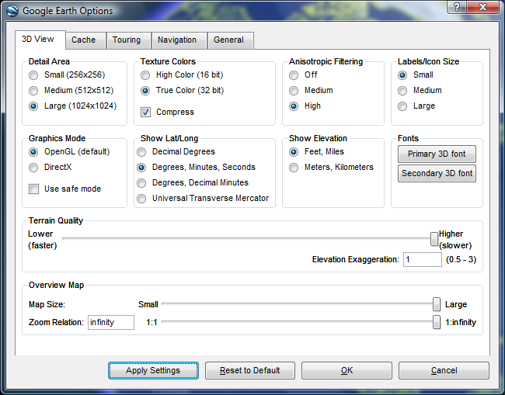

Figure 1

Higher resolutions and multiple layer files may decrease your overall performance. Please use these options at your discretion. For more detailed descriptions of each individual setting please refer to the [Google Earth User Guide](http://earth.google.com/intl/en/userguide/v4/).

***Initial Start-Up:***

Once you have Google Earth installed, locate and double-click on the Google Earth Icon.



Upon each successful load, Google Earth will play the last used animation settings. Upon installation, a default animation is chosen, which can be altered at your discretion (please refer to the Google Earth User Guide for more information). Allow the introduction animation to play.

***Loading Woodcreek, TX:***

Loading the Woodcreek, TX layer and map files is relatively easy. With Google Earth open, click on the *File* menu toolbar, and select *Open*. Upon selecting *Open*, a dialog box appears with your systems file structure.

Using this dialog box, locate and single-click on the Woodcreek.KMZ file and click the *Open* button (Figure 2).

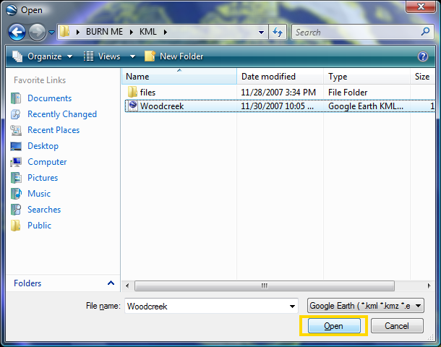

Figure 2

After clicking *Open*, Google Earth will automatically load and display all relevant information inside the Woodcreek.KMZ file. Loading any KMZ file will automatically cause Google Earth to zoom into the appropriate scope of your data selection (Figure 3).

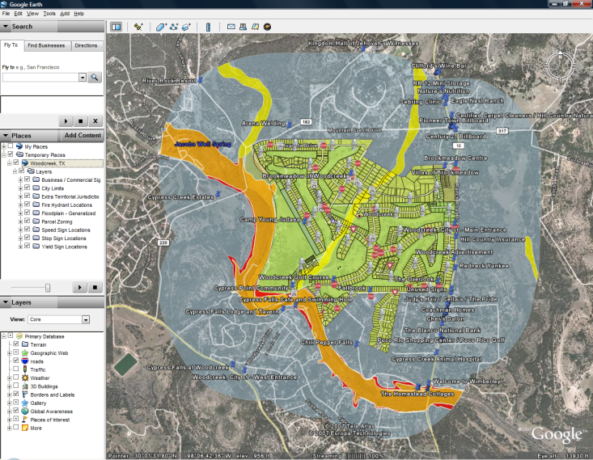

Figure 3

All associated layer files are turned to ‘On’ by default. You may uncheck / recheck any layers to turn them on or off (Figure 4).

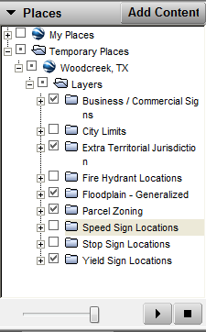

Figure 4

***Modifying the Woodcreek.KMZ file:***

Google Earth has many exciting and useful tools to alter any displayed KMZ files, should the need arise to modify, redistribute, or delete any information associated with one of the layers.

Point properties can be accessed in Google Earth, by simply right-clicking on the desired point and choosing ‘*Properties*.’ This will load the *Properties* *Dialog* Box (Figure 5).

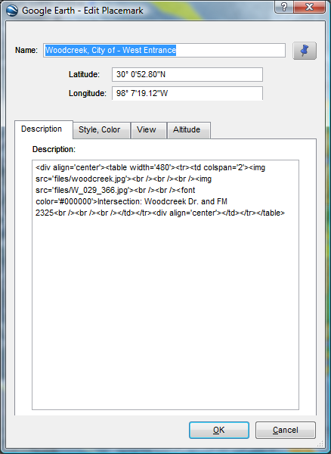

Figure 5

Upon loading the *Properties* *Dialog* box, you will see properties for *Name*, *Latitude*, and *Longitude*. Additional properties may be found by cycling through the four properties tabs: *Description*, *Style* */ Color*, *View*, and *Altitude*.

The *Description* properties options allow the user to alter the text which is displayed in a popup box upon clicking any point on the map. Should you wish to change the information displayed, simply delete the current description and type in the modification. There is no programming language requirement as Google Earth will automatically recreate any changes into code.

The *Style / Color* tab refers to the visualization of the point. Here you can modify the icon of the points using Google Earth’s built in icons, or by using your own images.

The *View* tab allows users to set the camera angle of their display. Upon setting this attribute, the camera will readjust itself to the stored position whenever a user clicks on the point (Figure 6).

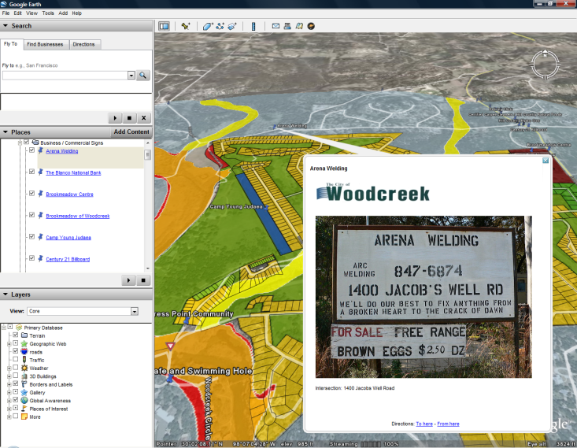

Figure 6

All non-point information must be changed by right-clicking on the name of the item under the *‘Places’* box (Figure 4). Any information that is not displayed as a point on the map will not have its description displayed through a pop-up. All descriptions are displayed under the name of the layer file (Figure 7).

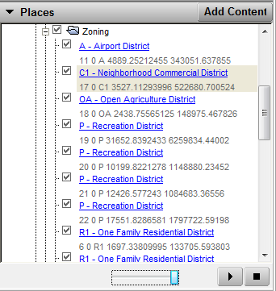

Figure 7

***Saving your modifications:***

There are many ways to save your modifications in Google Earth. In order to save any modifications done to any KMZ file, you must right-click on the main folder name in the *Places* dialog box and click *Save-As*. However, should you desire only one layer from a KMZ, right-click on the desired folder name, and click *Save-As* (Figure 8).

Figure 8

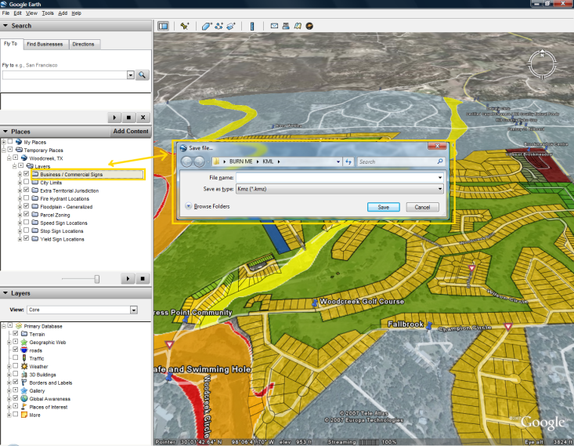

The second option will extract a single layer from a compilation of layers (KMZ file) and save it as an individual file for distribution.