Before continuing with this guide to Google Earth, please pause, and insure you have the minimum system requirements. This guide and all related information pertain to Google Earth 4.2+. For more detailed information please visit the Google Earth User Guide (http://earth.google.com/intl/en/userguide/v4/).
Welcome to Google Earth!
On behalf of Spatial Consulting Services and Texas State University, I would like to welcome you to the wonderful world of Google Earth.
Please follow this guide in order to use, modify, correct, and distribute the Google Earth datasets provided.
Installation:
Before beginning, please follow the link above to download Google Earth. Once your download has completed, locate the executable installation file and follow the on-screen instructions.
By default, Google Earth is optimized for performance, utilizing average comparisons of desktop computers. You may change the options in the Tools->Options menu toolbar to allow for higher resolutions (Figure 1). 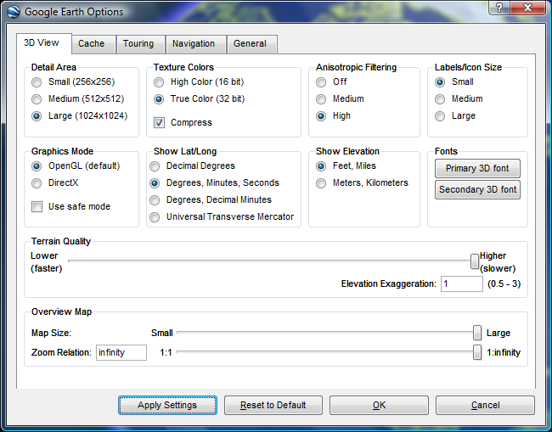
Figure 1
Higher resolutions and multiple layer files may decrease your overall performance. Please use these options at your discretion. For more detailed descriptions of each individual setting please refer to the Google Earth User Guide.
Initial Start-Up:
Once you have Google Earth installed, locate and double-click on the Google Earth Icon.
Upon each successful load, Google Earth will play the last used animation settings. Upon installation, a default animation is chosen, which can be altered at your discretion (please refer to the Google Earth User Guide for more information). Allow the introduction animation to play.
Loading Woodcreek, TX:
Loading the Woodcreek, TX layer and map files is relatively easy. With Google Earth open, click on the File menu toolbar, and select Open. Upon selecting Open, a dialog box appears with your systems file structure.
Using this dialog box, locate and single-click on the Woodcreek.KMZ file and click the Open button (Figure 2).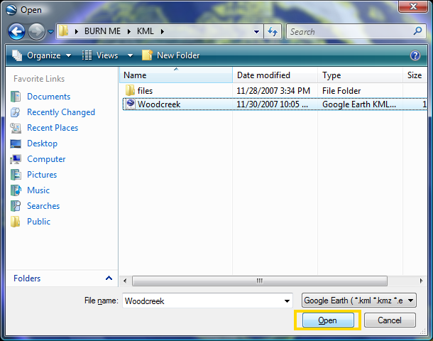
Figure 2
After clicking Open, Google Earth will automatically load and display all relevant information inside the Woodcreek.KMZ file. Loading any KMZ file will automatically cause Google Earth to zoom into the appropriate scope of your data selection (Figure 3).
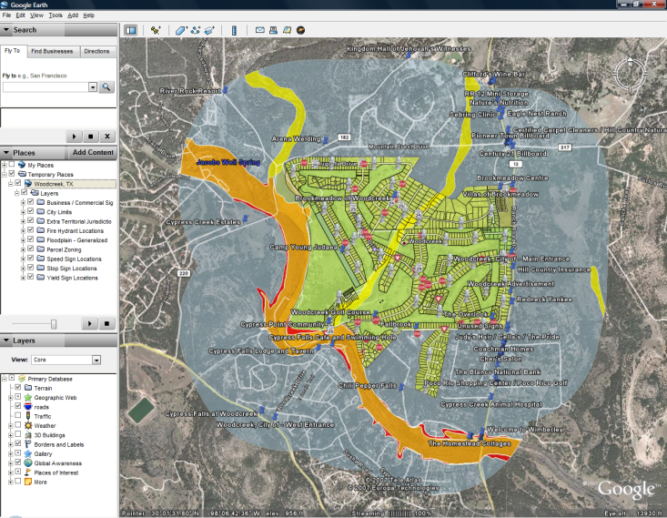
Figure 3
All associated layer files are turned to ‘On’ by default. You may uncheck / recheck any layers to turn them on or off (Figure 4).
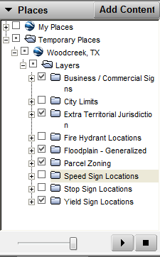
Figure 4

Modifying the Woodcreek.KMZ file:
Google Earth has many exciting and useful tools to alter any displayed KMZ files, should the need arise to modify, redistribute, or delete any information associated with one of the layers.
Point properties can be accessed in Google Earth, by simply right-clicking on the desired point and choosing ‘Properties.’ This will load the Properties Dialog Box (Figure 5).
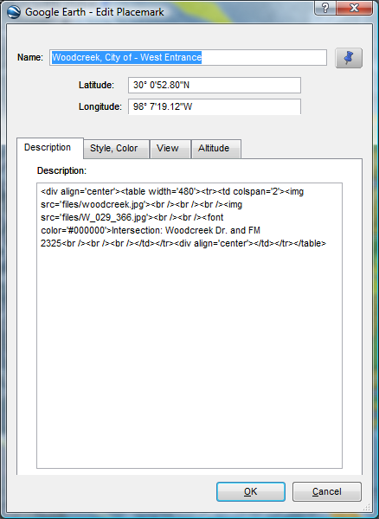
Figure 5
Upon loading the Properties Dialog box, you will see properties for Name, Latitude, and Longitude. Additional properties may be found by cycling through the four properties tabs: Description, Style / Color, View, and Altitude.
The Description properties options allow the user to alter the text which is displayed in a popup box upon clicking any point on the map. Should you wish to change the information displayed, simply delete the current description and type in the modification. There is no programming language requirement as Google Earth will automatically recreate any changes into code.
The Style / Color tab refers to the visualization of the point. Here you can modify the icon of the points using Google Earth’s built in icons, or by using your own images.
The View tab allows users to set the camera angle of their display. Upon setting this attribute, the camera will readjust itself to the stored position whenever a user clicks on the point (Figure 6).
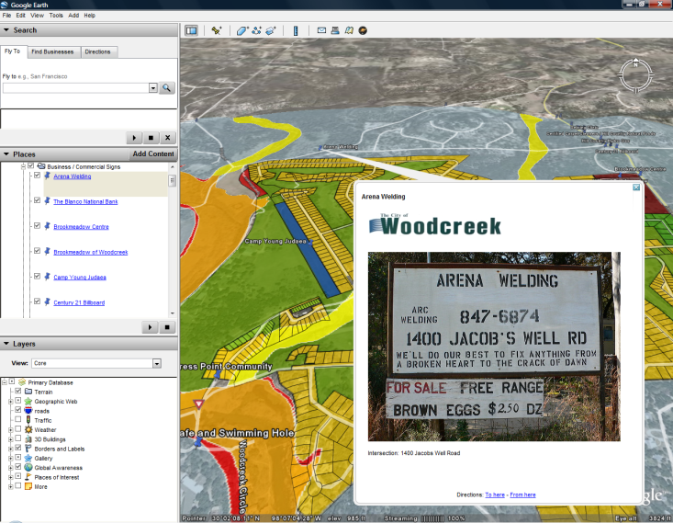
Figure 6
All non-point information must be changed by right-clicking on the name of the item under the ‘Places’ box (Figure 4). Any information that is not displayed as a point on the map will not have its description displayed through a pop-up. All descriptions are displayed under the name of the layer file (Figure 7).
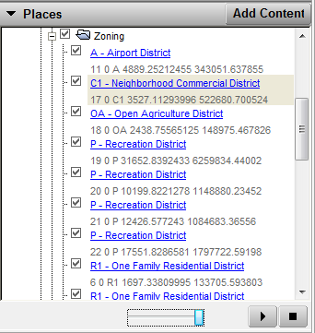
Figure 7
Saving your modifications:
There are many ways to save your modifications in Google Earth. In order to save any modifications done to any KMZ file, you must right-click on the main folder name in the Places dialog box and click Save-As. However, should you desire only one layer from a KMZ, right-click on the desired folder name, and click Save-As (Figure 8).
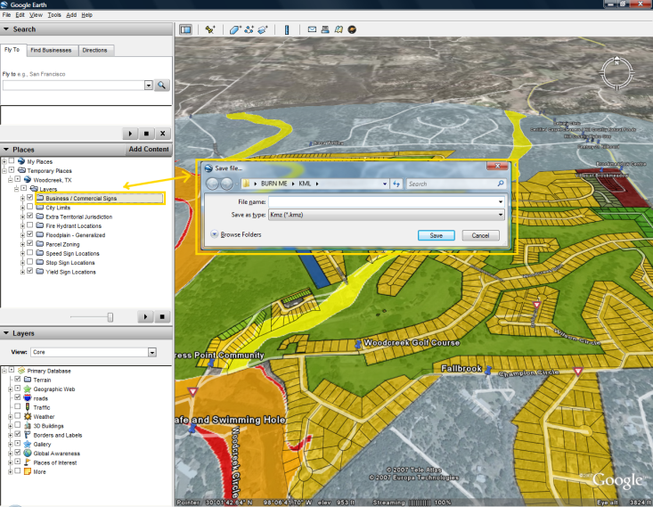
Figure 8
The second option will extract a single layer from a compilation of layers (KMZ file) and save it as an individual file for distribution.

