Project Manager
Kelly McDermott

Assistant Project Manager
Kyle Menasco

Web Site Administrator
Eric Madigan

Analysts
Scott Appleton
Alyssa Murphy

Hill Country Alliance Interactive Web Viewer

Prepared by
AquaKESKA

Pic of team

Table of Contents

Introduction
Summary
Purpose
Scope
Proposal
Data
Methodology/Analysis
Budget
Timetable
Final Deliverables
Consequences/Implications
Participation
About AquaKESKA

Introduction

Summary
The Hill Country of central Texas is an area roughly defined by the Edwards Plateau. The area runs from Austin in the northeast corner, down I-35 to San Antonio….The areas is characterized by hilly terrain, springs, rock outcrops and oak and juniper communities. Rare and unique plants and animals can be found here, and in some cases, nowhere else in the world (Campbell, Linda. 2003. Endangered and Threatened Animals of Texas: Their Life History and Management. Texas Parks and Wildlife). The beautiful scenery and small, sleepy towns found in the Hill Country have been a favorite of Texans for decades. In the last two decades, however, the rush of people moving to the Hill Country has threatened to degrade the very landscape that brought residents to the area.
The Hill Country Alliance (HCA) is a non-profit organization whose purpose is to raise public awareness and build community support around the need to preserve the natural resources and heritage of the Central Texas Hill Country.
HCA was formed in response to the escalating challenges brought to the Hill Country by rapid development. Concerned citizens began meeting in September of 2004 to share ideas about strengthening community activism and educating the public about regional planning, conservation development and a more responsible approach growth in the hill country.
The Alliance has participated in regional planning efforts, natural area and water quality bond initiatives and citizen advisory panels.

Purpose
The purpose of this project is to create a public portal for information regarding the environmental aspects of the Hill Country. The public can then access the information to visualize the environmental context of their area. This information will ideally be used by planners and developers to make better decisions regarding siting of future developments in the Hill Country. In addition to the public side of the project, AquaKESKA will provide data to the client, who will then use the data to create a model capable of determining groundwater vulnerability. Once the model is complete, the groundwater vulnerability model will be incorporated into the public website.

Scope
AquaKESKA was approached by HCA to develop an interactive website for the public to help them understand the vulnerabilities of the hill country. AquaKESKA will create an interactive internet mapping server, or IMS, to allow the public access and manipulate environmental data relative to the Hill Country. For the purpose of this project, the Hill Country is identified as the following seventeen counties: Bandera, Bexar, Blanco, Burnet, Comal, Edwards, Gillespie, Hays, Kendall, Kerr, Kimble, Llano, Mason, Medina, Real, Travis, Uvalde (Figure 1.).
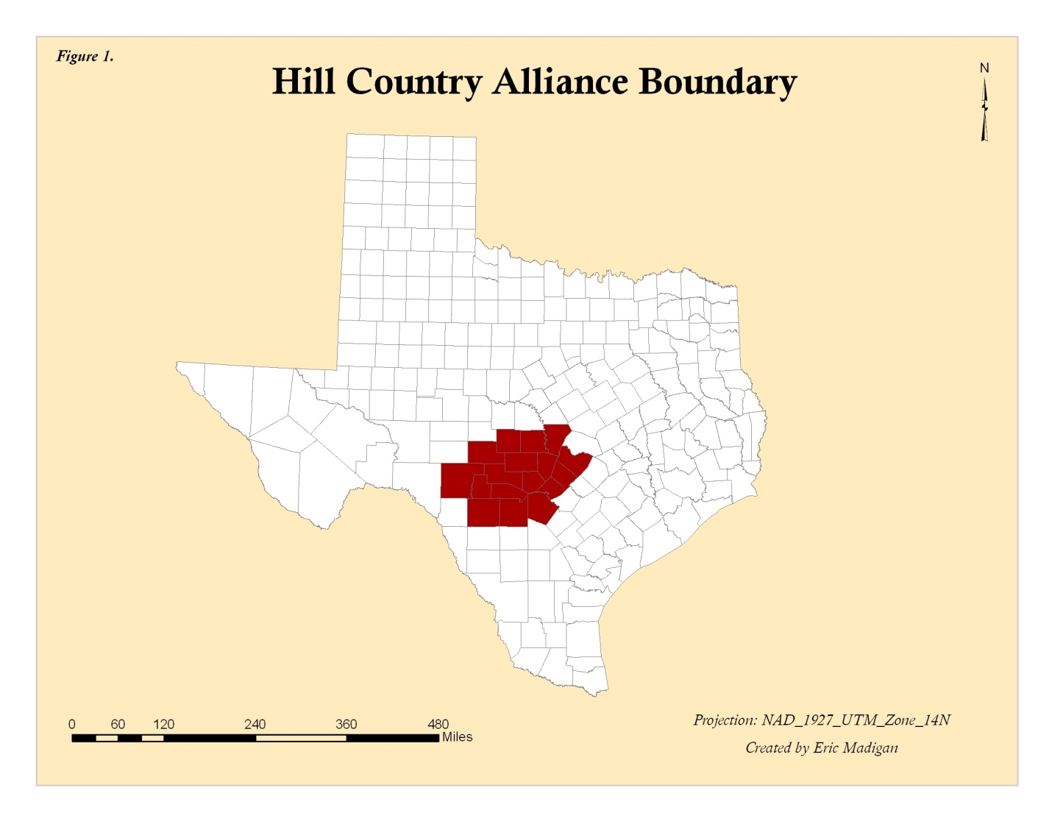
The data portion of the project will consist of gathering a predetermined set of data for the seventeen counties, and delivering it to the client in raster form.

Proposal

Data
Critical habitat/endangered species – USFWS - Ecological Services, Texas Parks & Wildlife
Dye tracer studies – Edwards Aquifer Authority, Barton Springs GCD
Caves and sinkholes – Texas Speleological Survey
Large groundwater withdrawals – Groundwater Conservation Districts and TWDB
Major and Minor Aquifers – Texas Water Development Board
Recharge Zone – Texas Water Development Board
Wastewater Disposal areas – City of Austin
Counties – Texas Natural Resource Information Service

Methodology/Analysis
This project is unique in that there will be very little analysis of the data. To create some of the data required for the website, such as contours, some analysis will be done with the raw data. However, the purpose of the website that will be created is to provide data to the public, so that they can then draw their own conclusions.
The second part of the project, the data DVD, will not require any further analysis either.

Budget

Timetable
17-Sep | 24-Sep | 1-Oct | 8-Oct | 15-Oct | 22-Oct | 29-Oct | 5-Nov | 12-Nov | 19-Nov | 26-Nov | 3-Dec
Scope & research
Proposal
 | Data Acquisition
 |  |  |  |  | Progress Report
 |  |  |  | Website Development
 |  |  |  |  |  |  | Final project report/poster |  |  |  | Project Presentation
Final Deliverables
AquaKESKA will deliver an interactive mapping website capable of use by the non-GIS using segment of the general public. In addition, the following will be provided:
•Final Report – 2 copies
•Poster for display in Geography Department
•DVDs (2) containing:
All data
Metadata
Final Report
Poster
PowerPoint Presentation
Instructions on how to use the DVD
•DVDs (2) containing:
Model data in raster form
Metadata

The client understands that once the website is delivered, HCA must purchase their own Manifold license to continue operating the website.

Consequences/Implications

Participation
Kelly McDermott – Manager, writer, researcher
Kyle Menasco – Assistant manager, writer, researcher
Eric Madigan – Writer, graphics, researcher
Scott Appleton – Editor, writer, researcher
Alyssa Murphy – Writer, budget analyst, researcher

About AquaKESKA

Project Manager – Kelly McDermott
Kelly McDermott has three years of experience using GIS software. She began her career in GIS in the US Fish & Wildlife Service providing wetland and endangered species data to the North Dakota Department of Transportation for use in planning projects. Kelly is currently employed by the Guadalupe County Groundwater Conservation District as a GIS Analyst/Manager in Training, where she uses MapInfo GIS software. Kelly has a BS in Environmental Science (1998) from West Texas A&M University, and a MS in Aquatic Biology from Southwest Texas State University (2000). She also has experience with Arc View/Arc GIS 8.x-9.2 and Manifold GIS/IMS 7.x software. Kelly will receive her Certificate in GIS from Texas State University in December 2007.

ETC
Existing/Similar Sites
USGS http://nmviewogc.cr.usgs.gov/viewer.htm.
City of San Antonio http://maps.sanantonio.gov/website/DevServices/Run.htm
City of New Braunfels
The USGS site is a viewer on a national (and in some cases international) scale. There is an abundance of data, but due to the scale of the site, it is not feasible to include many of the environmental features that are requested by HCA. The city websites are more local in scale, but again, many environmental features are missing.

While doing research, we discovered two pre-existing GIS models which have similar purposes to that of our study. The first is titled A GIS MODEL FOR ASSESSING RECHARGE POTENTIAL. This model studies the impact of population growth, specifically impervious cover, and its effect on the Trinity Aquifer recharge quantities as they relate to precipitation. The second related source is titled THE APPLICATION OF GIS IN SUPPORT OF LAND ACQUISTION FOR THE PROTECTION OF SENSITIVE GROUNDWATER RECHARGE PROPERTIES IN THE EDWARDS AQUIFER OF SOUTH-CENTRAL TEXAS. With this study, a GIS matrix was developed and applied in the process of prioritizing sensitive karst lands. Both of these experiments pertain to our project for the HCA, which is to show a hydrologic and environmental relationship to urban sprawl in the hill country of Texas. Both reports also show in full detail the layers and methods used in developing their model; therefore, we are quite certain that these GIS sources will be incredibly useful examples for the structure of our study.
“The Application of GIS in Support of Land Acquisition for the Protection of Sensitive Groundwater Recharge Properties in the Edwards Aquifer of South-Central Texas” Stone, Dan and Schindel, Geary M. Journal of Cave and Karst Studies 64(1): 38-44. 2002. National Speleological Society.
“A GIS Model for Assessing the Recharge Potential” Hammond Jr.,Weldon W. and Hardberger, Amy

